This Word module should be used for all taxonomic proposals.



Please complete **Part 1** and:

either **Part 3** for proposals to create new taxa or change existing taxa

or **Part 2** for proposals of a general nature.

Submit the completed Word module, together with the accompanying Excel module named in Part 3, to the appropriate ICTV Subcommittee Chair.

For guidance, see the notes written in blue, below, and the help notes in file Taxonomic_Proposals_Help_2018.

**Part 1:** **TITLE, AUTHORS, etc**

|  |  |  |  |
| --- | --- | --- | --- |
| **Code assigned:** | ***2018.106B*** | | (to be completed by ICTV officers) |
| **Short title:**  **To add eleven (11) new species to the genus *Friunavirus* (renamed from Fri1virus in proposal 2018.007B*)*, in the subfamily *Autographivirinae*, family *Podoviridae*** | | | |
|  | | | |
| **Author(s):** | | | |
| Dann Turner, University of the West of England (UK)  Evelien M. Adriaenssens, University of Liverpool (UK)  Andrew M. Kropinski, University of Guelph (Canada) | | | |
| **Corresponding author with e-mail address:** | | | |
| Dann Turner: dann2.turner@uwe.ac.uk | | | |
| **List the ICTV study group(s) that have seen this proposal:** | | | |
| A list of study groups and contacts is provided at <http://www.ictvonline.org/subcommittees.asp> . If in doubt, contact the appropriate subcommittee chair (there are six virus subcommittees: animal DNA and retroviruses, animal ssRNA-, animal ssRNA+, fungal and protist, plant, bacterial and archaeal) | |  | |
| **ICTV Study Group comments (if any) and response of the proposer:** | | | |
|  | | | |
|  | | | |
| Date first submitted to ICTV: | | | June 2018 |
| Date of this revision (if different to above): | | |  |

|  |
| --- |
| **ICTV-EC comments and response of the proposer:** |
|  |

**Part 2:** **NON-STANDARD**

Template for any proposal regarding ICTV procedures, rules or policy, not involving the creation of new taxonomy.

| **Text of proposal:** |
| --- |
|  |

**Part 3:** **PROPOSED TAXONOMY**

|  |
| --- |
| **Name of accompanying Excel module:** **2018.106B.N.v2.Friunavirus_11sp** |

The taxonomic changes you are proposing should be presented on an accompanying Excel module, 2017_TP_Template_Excel_module. Please enter the file name of the completed module in this box.

**Supporting material:**

| additional material in support of this proposal |
| --- |
| Please explain the reasons for the taxonomic changes you are proposing and provide evidence to support them. The following information should be provided, where relevant:   * **Species demarcation criteria**: Explain how new species differ from others in the genus and demonstrate that these differences meet the criteria previously established for demarcating between species. If no criteriahave previously been established, and if there will now be more than one species in the genus, please state the demarcation criteria you are proposing. * **Higher taxa**:   + There is no formal requirement to state demarcation criteria when proposing new genera or other higher taxa. However, a similar concept should apply in pursuit of a rational and consistent virus taxonomy.   + Please indicate the **origin of names** assigned to new taxa at genus level and above.   + For each new genus a **type species** must be designated to represent it. Please explain your choice. * **Supporting evidence**: The use of Figures and Tables is strongly recommended (note that copying from publications will require permission from the copyright holder). For phylogenetic analysis, try to provide a tree where branch length is related to genetic distance. |

**Species demarcation criteria**: We have chosen 95% DNA sequence identity as the criterion for demarcation of species in this new genus. The members of each proposed species differ from those of other species by more than 5% at the DNA level as confirmed with the BLASTN algorithm.

**BLASTN homologs**: Phages of the genus *Friunavirus* (renamed from *Fri1virus* in proposal 2018.007B) exhibit a relationship to *Acinetobacter* phages Petty (KF669656.1), F1245/05 (HH777814) and Acibel007 (KJ473423.1). Members of the genus *Friunavirus* (renamed from *Fri1virus* in proposal 2018.007B) are related to other clades within the subfamily *Autographivirinae*.

**Source of the name of this taxon**: The taxon was named first sequenced member of this genus with a full and accurate annotation.

**History:** *Acinetobacter* phages vB_AbaP_B1, B3 and B5, vB_Api_P1 and P2 were isolated by Oliveira et al., [1] from samples collected from a raw sewage wastewater treatment plant (Frossos, Braga, Portugal). Phages vB_AbaP_AS11 and vB_AbaP_AS12 were isolated from clinical materials (burn wound samples) from the I. I. Dzhanelidze Research Institute of Emergency Medicine in Russia.The specific source of phiAB6 is not detailed within the literature.This group of phages posses similar morphological features; isometric heads of 50-60 nm and short tails of 9-12 nm. The friunaviruses show significant synteny of genome orgainsation and sequence similarity despite being isolated in disperate geographic locations. Like other phages of the subfamily *Autographivirinae*, the Fri1-like viruses all encode their own single subunit RNA polymerase (RNAP) and share a common overall genomic organization with genes encoded solely on the forward strand. This clade of phages possess an average genome size and G+C content of 41.7 kbp and 40.15%, respectively.

**GenBank Summary**:

Table 1. GenBank details of additional phages to be included within the genus *Friunavirus* (renamed from *Fri1virus* in proposal 2018.007B)

|  |  |  |  |  |  |  |  |
| --- | --- | --- | --- | --- | --- | --- | --- |
| ***Acinetobacter* phage** | **RefSeq No.** | **INSDC Accession No.** | **Genome length (bp)** | **Genome (mol% G+C)** | **No. CDS** | **DNA (%sequence identity) \*** | **% Homologous proteins \*\*** |
| Fri1 | NC_028848.1 | KR149290.1 | 41805 | 39.29 | 54 | 100 | 100 |
| SH-Ab 15519 | - | KY082667.1 | 40493 | 39.46 | 51 | 78 | 81.5 |
| B1 | - | MF033347.1 | 40879 | 39.14 | 51 | 79 | 79.6 |
| B3 | - | MF033348.1 | 40598 | 39.28 | 49 | 77 | 75.9 |
| B5 | - | MF033349.1 | 41608 | 39.31 | 53 | 83 | 81.5 |
| AS11 | - | KY268296.1 | 41642 | 39.29 | 51 | 87 | 81.5 |
| AS12 | - | KY268295.1 | 41402 | 39.31 | 49 | 81 | 77.9 |
| P1 | - | MF033350.1 | 41208 | 39.2 | 49 | 84 | 79.6 |
| P2 | - | MF033351.1 | 41514 | 39.33 | 54 | 79 | 83.3 |
| WCHABP5 | - | KY888680.2 | 40409 | 39.38 | 47 | 81 | 77.8 |
| D2 | - | MH042230.1 | 39964 | 39.23 | 47 | 77 | 75.9 |
| phiAB6 | - | KT339321.1 | 40570 | 39.47 | 45 | 79 | 75.9 |

* Determined using BLASTN; ** Determined using CoreGenes3.5

**Phylogeny**:

Figure 2. The phylogenetic tree was constructed with VICTOR [5], using whole genome sequences of phages of the subfamily *Autographivirinae* at the nucleotide level.

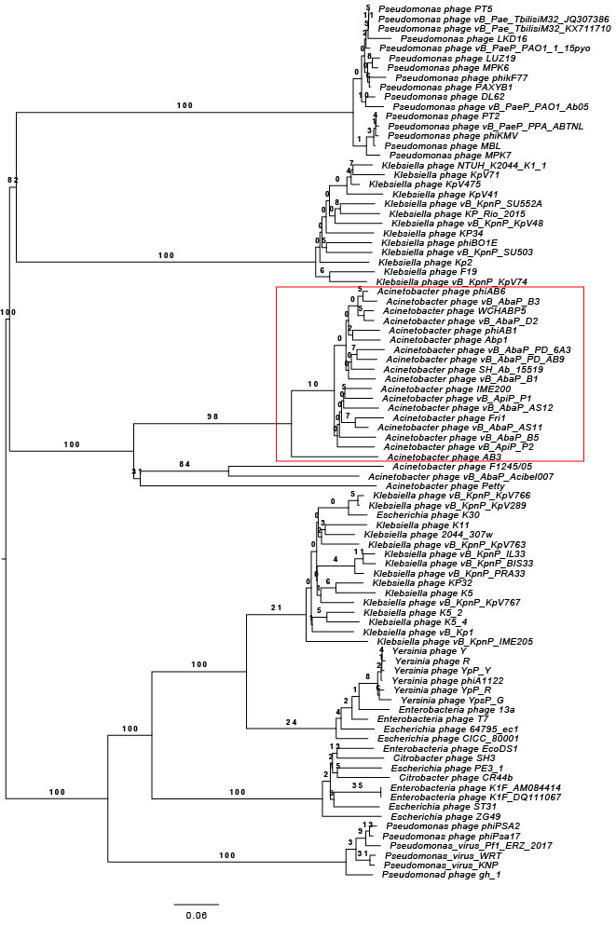

Figure 3. The phylogenetic tree was constructed, using phylogeny.fr [6], using the RNA polymerase proteins homologs of Fri1 and related phages (boxed in red). *Shewanella* phage Spp001 was used as the outgroup.

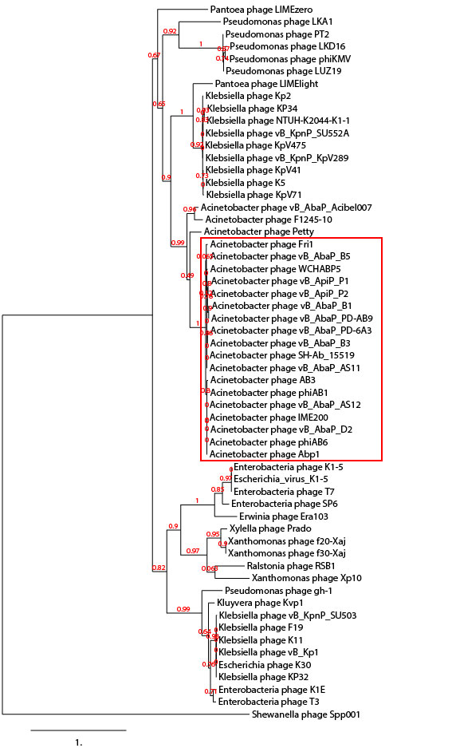

| **References:** |
| --- |
| 1. Oliveira H, Costa AR, Konstantinides N, Ferreira A, Akturk E, Sillankorva S, Nemec A, Shneider M, Dötsch A, Azeredo J. (2017) Ability of phages to infect Acinetobacter calcoaceticus-Acinetobacter baumannii complex species through acquisition of different pectate lyase depolymerase domains. *Environmental Microbiology* 19(12): 5060-5077 2. Popova AV, Lavysh DG, Klimuk EI, Edelstein MV, Bogun AG, Shneider MM, Goncharov AE, Leonov SV, Severinov KV (2017). Novel Fri1-like Viruses Infecting Acinetobacter baumannii-vB_AbaP_AS11 and vB_AbaP_AS12-Characterization, Comparative Genomic Analysis, and Host-Recognition Strategy. *Viruses* 9(7): E188 3. Turner D, Ackermann HW, Kropinski AM, Lavigne R, Sutton JM, Reynolds DM (2017). Comparative Analysis of 37 *Acinetobacter* bacteriophages. *Viruses* 10(1):E5 4. Lai MJ, Chang KC, Huang SW, Luo CH, Chiou PY, Wu CC, Lin NT (2016) The Tail Associated Protein of Acinetobacter baumannii Phage ΦAB6 Is the Host Specificity Determinant Possessing Exopolysaccharide Depolymerase Activity. *PLoS One* 11(4): e0153361 5. Meier-Kolthoff JP, Goeker M. VICTOR: genome-based phylogeny and classification of prokaryotic viruses. Bioinformatics. 2017; 33(21): 3396–3404. 6. Dereeper A.*, Guignon V.*, Blanc G., Audic S., Buffet S., Chevenet F., Dufayard J.F., Guindon S., Lefort V., Lescot M., Claverie J.M., Gascuel O. (2008) Phylogeny.fr: robust phylogenetic analysis for the non-specialist. *Nucleic Acids Research* 36(Web Server issue):W465-9. |