This Word module should be used for all taxonomic proposals.



Please complete **Part 1** and:

either **Part 3** for proposals to create new taxa or change existing taxa

or **Part 2** for proposals of a general nature.

Submit the completed Word module, together with the accompanying Excel module named in Part 3, to the appropriate ICTV Subcommittee Chair.

For guidance, see the notes written in blue, below, and the help notes in file Taxonomic_Proposals_Help_2018.

**Part 1:** **TITLE, AUTHORS, etc**

|  |  |  |  |
| --- | --- | --- | --- |
| **Code assigned:** | ***2018.107B*** | | (to be completed by ICTV officers) |
| **Short title: To create one (1) new genus *Lokivirus*, containing two (2) species in the family *Siphoviridae*** | | | |
|  | | | |
| **Author(s):** | | | |
| Dann Turner, University of the West of England (UK)  Evelien M. Adriaenssens, University of Liverpool (UK)  Andrew M. Kropinski, University of Guelph (Canada) | | | |
| **Corresponding author with e-mail address:** | | | |
| Dann Turner: dann2.turner@uwe.ac.uk | | | |
| **List the ICTV study group(s) that have seen this proposal:** | | | |
| A list of study groups and contacts is provided at <http://www.ictvonline.org/subcommittees.asp> . If in doubt, contact the appropriate subcommittee chair (there are six virus subcommittees: animal DNA and retroviruses, animal ssRNA-, animal ssRNA+, fungal and protist, plant, bacterial and archaeal) | |  | |
| **ICTV Study Group comments (if any) and response of the proposer:** | | | |
|  | | | |
|  | | | |
| Date first submitted to ICTV: | | | June 2018 |
| Date of this revision (if different to above): | | |  |

|  |
| --- |
| **ICTV-EC comments and response of the proposer:** |
|  |

**Part 2:** **NON-STANDARD**

Template for any proposal regarding ICTV procedures, rules or policy, not involving the creation of new taxonomy.

| **Text of proposal:** |
| --- |
|  |

**Part 3:** **PROPOSED TAXONOMY**

|  |
| --- |
| **Name of accompanying Excel module: 2018.107B.N.v1.Lokivirus** |

The taxonomic changes you are proposing should be presented on an accompanying Excel module, 2017_TP_Template_Excel_module. Please enter the file name of the completed module in this box.

**Supporting material:**

| additional material in support of this proposal |
| --- |
| Please explain the reasons for the taxonomic changes you are proposing and provide evidence to support them. The following information should be provided, where relevant:   * **Species demarcation criteria**: Explain how new species differ from others in the genus and demonstrate that these differences meet the criteria previously established for demarcating between species. If no criteriahave previously been established, and if there will now be more than one species in the genus, please state the demarcation criteria you are proposing. * **Higher taxa**:   + There is no formal requirement to state demarcation criteria when proposing new genera or other higher taxa. However, a similar concept should apply in pursuit of a rational and consistent virus taxonomy.   + Please indicate the **origin of names** assigned to new taxa at genus level and above.   + For each new genus a **type species** must be designated to represent it. Please explain your choice. * **Supporting evidence**: The use of Figures and Tables is strongly recommended (note that copying from publications will require permission from the copyright holder). For phylogenetic analysis, try to provide a tree where branch length is related to genetic distance. |

**Species demarcation criteria**: We have chosen 95% DNA sequence identity as the criterion for demarcation of species in this new genus. The members of each proposed species differ from those of other species by more than 5% at the DNA level as confirmed with the BLASTN algorithm.

**BLASTN homologs**: Loki and IME_AB3 may be related to the *Septima3virus* clade, but at this time we do not intend to create a higher taxon.

**History:** Loki was isolated from activated sludge sourced from CAM Valley sewage station, UK in 2016 following enrichment with *Acinetobacter baumannii* ATCC 17978 [1,2]. Phage IME_AB3 was isolated from sewage in 2013 in China, no further details are available. Electron micrographs show the Loki virion to possess an isometric capsid measuring 57 ± 4 nm across opposite apices. The non-contractile tail exhibits transverse striations, measures 176 ± 3 nm in length and 10 ± 0.9 nm in diameter with short tail spikes present at the tail terminus. Loki exhibits a limited host range and data suggests that a component of LPS is the target for adsorption to the host cell surface.

We note that a further phage, PAB25, is reported within the literature that exhibits similarity to IME_AB3 and Loki, but at this time the annotated sequence has not been published to the INSDC [3].

**Source of the name of this taxon**: The taxon name is derived from the first sequenced member of this genus with a full and accurate annotation.

**Electron Microscopy:**

Figure 1. Transmission electron micrograph of a single negatively stained Loki virion using 2% (w/v) uranyl acetate. Scale bar denotes 100 nm.

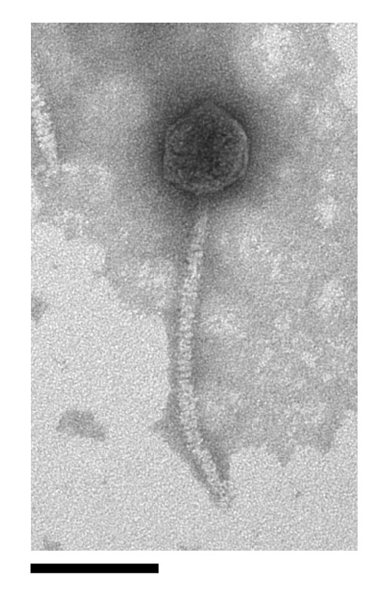

**GenBank Summary**:

Table 1. GenBank details of phages belonging to the genus *Lokivirus.*

|  |  |  |  |  |  |  |  |
| --- | --- | --- | --- | --- | --- | --- | --- |
| ***Acinetobacter* phage** | **RefSeq No.** | **INSDC Accession No.** | **Genome length (bp)** | **Genome (mol% G+C)** | **No. CDS** | **DNA (%sequence identity) \*** | **% Homologous proteins \*\*** |
| Loki | - | LN890663.1 | 41308 | 44.4 | 51 | 100 | 100 |
| IME_AB3 | NC_023590.1 | KF811200.1 | 43.05 | 45.5 | 57 | 47 | 86.3 |

* Determined using BLASTN; ** Determined using CoreGenes3.5

**Phylogeny**:

Figure 2. The phylogenetic tree was constructed with VICTOR [4], using whole genome sequences of Loki and related phages at the nucleotide level.

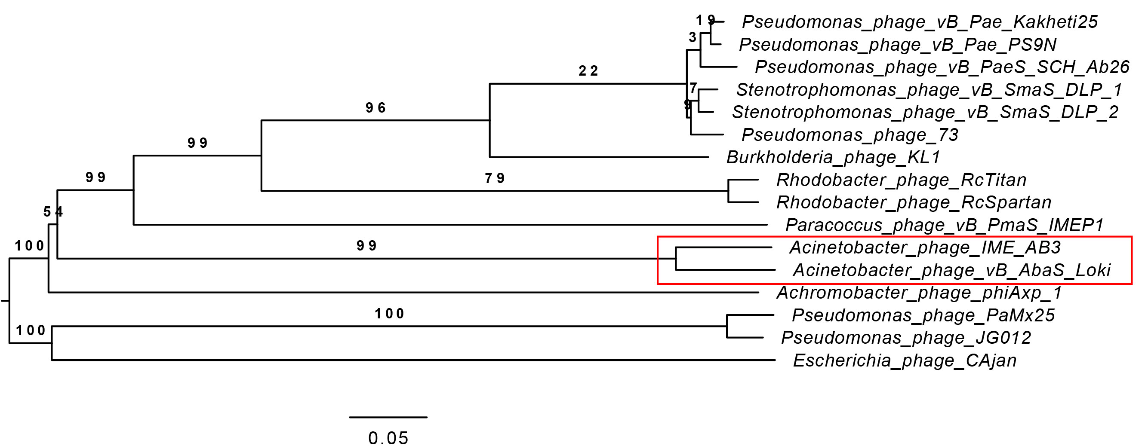

Figure 3. The phylogenetic tree was constructed, using phylogeny.fr [5], using the (A) large Terminase subunit protein and (B) major capsid protein homologs of Loki and related phages (boxed in red).

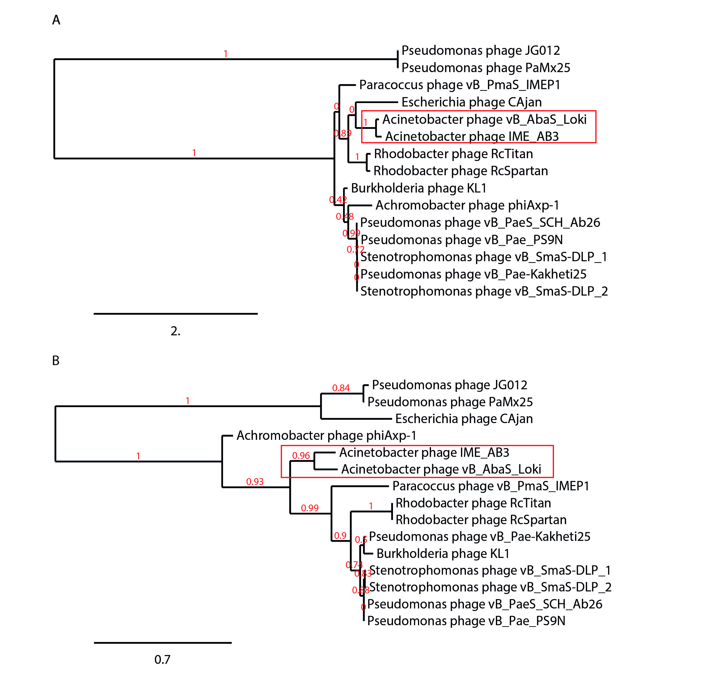

| **References:** |
| --- |
| 1. Turner D, Wand ME, Briers Y, Lavigne R, Sutton JM, Reynolds DM. (2017). Characterisation and genome sequence of the lytic *Acinetobacter baumannii* bacteriophage vB_AbaS_Loki. *PLoS One* 12(2): e0172303  2. Turner D, Ackermann H-W, Kropinski AM, Lavigne R, Sutton JM, Reynolds DM (2017). Comparative Analysis of 37 *Acinetobacter* bacteriophages. *Viruses* 10(1) E5  3. Cha K, Oh HK, Jang JY, Jo Y, Kim WK, Ha GU, Ko KS, Myung H (2018). Characterization of Two Novel Bacteriophages Infecting Multidrug-Resistant (MDR) *Acinetobacter baumannii* and Evaluation of Their Therapeutic Efficacy in Vivo. *Frontiers in Microbiology* 9:696  4. Meier-Kolthoff JP, Goeker M. VICTOR: genome-based phylogeny and classification of prokaryotic viruses. Bioinformatics. 2017; 33(21): 3396–3404.  5. Dereeper A.*, Guignon V.*, Blanc G., Audic S., Buffet S., Chevenet F., Dufayard J.F., Guindon S., Lefort V., Lescot M., Claverie J.M., Gascuel O. (2008) Phylogeny.fr: robust phylogenetic analysis for the non-specialist. Nucleic Acids Research 36(Web Server issue):W465-9. |
|  |