This Word module should be used for all taxonomic proposals.



Please complete **Part 1** and:

either **Part 3** for proposals to create new taxa or change existing taxa

or **Part 2** for proposals of a general nature.

Submit the completed Word module, together with the accompanying Excel module named in Part 3, to the appropriate ICTV Subcommittee Chair.

For guidance, see the notes written in blue, below, and the help notes in file Taxonomic_Proposals_Help_2018.

**Part 1:** **TITLE, AUTHORS, etc**

|  |  |  |  |
| --- | --- | --- | --- |
| **Code assigned:** | ***2018.108B*** | | (to be completed by ICTV officers) |
| **Short title: To create one (1) new genus *Metrivirus*, containing one (1) species in the family *Myoviridae*** | | | |
|  | | | |
| **Author(s):** | | | |
| Dann Turner, University of the West of England (UK)  Colin Buttimer, Cork Institute of Technology (Ireland)  Aidan Coffey, Cork Institute of Technology (Ireland)  Horst Neve, Max Rubner-Institut (Germany)  Evelien M. Adriaenssens, University of Liverpool (UK)  Andrew M. Kropinski, University of Guelph (Canada) | | | |
| **Corresponding author with e-mail address:** | | | |
| Dann Turner: dann2.turner@uwe.ac.uk | | | |
| **List the ICTV study group(s) that have seen this proposal:** | | | |
| A list of study groups and contacts is provided at <http://www.ictvonline.org/subcommittees.asp> . If in doubt, contact the appropriate subcommittee chair (there are six virus subcommittees: animal DNA and retroviruses, animal ssRNA-, animal ssRNA+, fungal and protist, plant, bacterial and archaeal) | |  | |
| **ICTV Study Group comments (if any) and response of the proposer:** | | | |
|  | | | |
|  | | | |
| Date first submitted to ICTV: | | | June 2018 |
| Date of this revision (if different to above): | | |  |

|  |
| --- |
| **ICTV-EC comments and response of the proposer:** |
|  |

**Part 2:** **NON-STANDARD**

Template for any proposal regarding ICTV procedures, rules or policy, not involving the creation of new taxonomy.

| **Text of proposal:** |
| --- |
|  |

**Part 3:** **PROPOSED TAXONOMY**

|  |
| --- |
| **Name of accompanying Excel module: 2018.108B.N.v1.Metrivirus** |

The taxonomic changes you are proposing should be presented on an accompanying Excel module, 2017_TP_Template_Excel_module. Please enter the file name of the completed module in this box.

**Supporting material:**

| additional material in support of this proposal |
| --- |
| Please explain the reasons for the taxonomic changes you are proposing and provide evidence to support them. The following information should be provided, where relevant:   * **Species demarcation criteria**: Explain how new species differ from others in the genus and demonstrate that these differences meet the criteria previously established for demarcating between species. If no criteriahave previously been established, and if there will now be more than one species in the genus, please state the demarcation criteria you are proposing. * **Higher taxa**:   + There is no formal requirement to state demarcation criteria when proposing new genera or other higher taxa. However, a similar concept should apply in pursuit of a rational and consistent virus taxonomy.   + Please indicate the **origin of names** assigned to new taxa at genus level and above.   + For each new genus a **type species** must be designated to represent it. Please explain your choice. * **Supporting evidence**: The use of Figures and Tables is strongly recommended (note that copying from publications will require permission from the copyright holder). For phylogenetic analysis, try to provide a tree where branch length is related to genetic distance. |

**Species demarcation criteria**: We have chosen 95% DNA sequence identity as the criterion for demarcation of species in this new genus. The members of each proposed species differ from those of other species by more than 5% at the DNA level as confirmed with the BLASTN algorithm.

**BLASTN homologs**: Genomic orphan or singleton.

**History:** Phage ME3 was isolated from effluent obtained from a wastewater treatment plant in Cork, Ireland using *Acinetobacter baumannii* strain DSM 30007 [1]. ME3 virions encapsulate a genome of 234.9 kb and encode 326 ORFs and 4 tRNAs.

**Source of the name of this taxon**: The taxon name is derived from the first sequenced member of this genus.

**Electron Microscopy:**

Figure 1. Transmission electron micrograph of a single negatively stained ME3 virion using 2% (w/v) uranyl acetate. Scale bar denotes 100 nm.

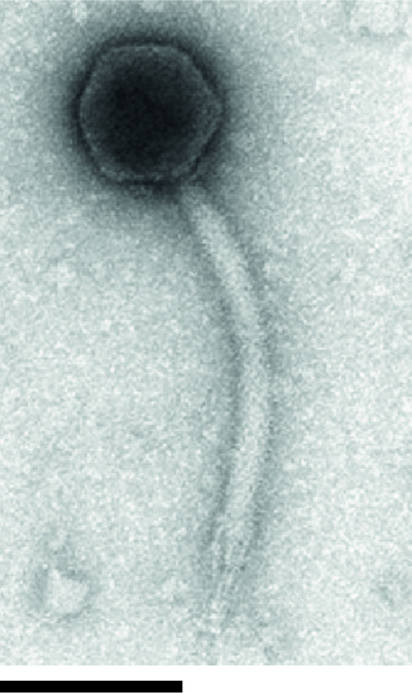

**GenBank Summary**:

Table 1. GenBank summary of phage ME3*.*

|  |  |  |  |  |  |  |
| --- | --- | --- | --- | --- | --- | --- |
| ***Acinetobacter* phage** | **RefSeq No.** | **INSDC Accession No.** | **Genome length (bp)** | **Genome (mol% G+C)** | **No. CDS** | **tRNA** |
| ME3 | - | KU935715.1 | 234.9 | 30.8 | 326 | 4 |

| **References:** |
| --- |
| 1. Buttimer C, O’Sullivan L, Elbreki M, Neve H, McAuliffe O, Ross PR, Hill C, O’Mahoney J, Coffey A. (2016) Genome Sequence of Jumbo Phage vB_AbaM_ME3 of *Acinetobacter baumanni*. *Genome Announcements* 4(4): e00431-16 |