This Word module should be used for all taxonomic proposals.



Please complete **Part 1** and:

either **Part 3** for proposals to create new taxa or change existing taxa

or **Part 2** for proposals of a general nature.

Submit the completed Word module, together with the accompanying Excel module named in Part 3, to the appropriate ICTV Subcommittee Chair.

For guidance, see the notes written in blue, below, and the help notes in file Taxonomic_Proposals_Help_2018.

**Part 1:** **TITLE, AUTHORS, etc**

|  |  |  |  |
| --- | --- | --- | --- |
| **Code assigned:** | ***2018.109B*** | | (to be completed by ICTV officers) |
| **Short title: To add four (4) additional species to the genus *Obolenskvirus*, in the family *Myoviridae*** | | | |
|  | | | |
| **Author(s):** | | | |
| Dann Turner, University of the West of England (UK)  Evelien M. Adriaenssens, University of Liverpool (UK)  Andrew M. Kropinski, University of Guelph (Canada) | | | |
| **Corresponding author with e-mail address:** | | | |
| Dann Turner: dann2.turner@uwe.ac.uk | | | |
| **List the ICTV study group(s) that have seen this proposal:** | | | |
| A list of study groups and contacts is provided at <http://www.ictvonline.org/subcommittees.asp> . If in doubt, contact the appropriate subcommittee chair (there are six virus subcommittees: animal DNA and retroviruses, animal ssRNA-, animal ssRNA+, fungal and protist, plant, bacterial and archaeal) | |  | |
| **ICTV Study Group comments (if any) and response of the proposer:** | | | |
|  | | | |
|  | | | |
| Date first submitted to ICTV: | | | June 2018 |
| Date of this revision (if different to above): | | |  |

|  |
| --- |
| **ICTV-EC comments and response of the proposer:** |
|  |

**Part 2:** **NON-STANDARD**

Template for any proposal regarding ICTV procedures, rules or policy, not involving the creation of new taxonomy.

| **Text of proposal:** |
| --- |
|  |

**Part 3:** **PROPOSED TAXONOMY**

|  |
| --- |
| **Name of accompanying Excel module:** **2018.109B.N.v2.Obolenskvirus_4sp** |

The taxonomic changes you are proposing should be presented on an accompanying Excel module, 2017_TP_Template_Excel_module. Please enter the file name of the completed module in this box.

**Supporting material:**

| additional material in support of this proposal |
| --- |
| Please explain the reasons for the taxonomic changes you are proposing and provide evidence to support them. The following information should be provided, where relevant:   * **Species demarcation criteria**: Explain how new species differ from others in the genus and demonstrate that these differences meet the criteria previously established for demarcating between species. If no criteriahave previously been established, and if there will now be more than one species in the genus, please state the demarcation criteria you are proposing. * **Higher taxa**:   + There is no formal requirement to state demarcation criteria when proposing new genera or other higher taxa. However, a similar concept should apply in pursuit of a rational and consistent virus taxonomy.   + Please indicate the **origin of names** assigned to new taxa at genus level and above.   + For each new genus a **type species** must be designated to represent it. Please explain your choice. * **Supporting evidence**: The use of Figures and Tables is strongly recommended (note that copying from publications will require permission from the copyright holder). For phylogenetic analysis, try to provide a tree where branch length is related to genetic distance. |

**Species demarcation criteria**: We have chosen 95% DNA sequence identity as the criterion for demarcation of species in this new genus. The members of each proposed species differ from those of other species by more than 5% at the DNA level as confirmed with the BLASTN algorithm.

**History:** The genus *Obolenskvirus* (renamed from *AP22virus* in proposal 2018.007B) was ratified by the ICTV in 2016 and comprised four species and two strains.Subsequently, four further bacteriophages have been sequenced that exhibit a phylogenetic relationship to this clade.Bacteriophages WCHABP1 and WCHABP12 were isolated in 2016 from sewage samples collected from the influx to a wastewater treatment plant at West China Hospital. Virion dimensions are reported as approximately a 75 nm diameter head and a contractile tail 105 nm in length [1]. Bacteriophage LZ35 was isolated from sewage effluent from the Jilin University First-Affiliated Hospital, China [2]. The reported morphology of LZ35 is that virions possess a 47-nm head diameter and a 56-nm-long contractile tail. There are obvious discrepancies between the virion measurements of WCHABP1, WCHABP12 and LZ35 considering the similar genome size. No details are available on the isolation source of AbP2. Phages of this genus possess genomes of approximately 45 kb, encode between 83 and 89 proteins and no tRNAs. Relative to each other they share a minimum of 40 % overall DNA sequence identity and between 61.5 and 100% of proteins [3].

**GenBank Summary**:

Table 1. GenBank details of additional phages belonging to the genus *Obolenskvirus* (renamed from *AP22virus* in proposal 2018.007B)*.*

|  |  |  |  |  |  |  |  |
| --- | --- | --- | --- | --- | --- | --- | --- |
| ***Acinetobacter* phage** | **RefSeq No.** | **INSDC Accession No.** | **Genome length (bp)** | **Genome (mol% G+C)** | **No. CDS** | **DNA (%sequence identity) \*** | **% Homologous proteins \*\*** |
| AP22 | NC_017984.1 | HE806280.1 | 46.39 | 37.7 | 89 | 100 | 100 |
| WCHABP1 | - | KY829116.2 | 45.89 | 37.6 | 89 | 54.6 | 74.2 |
| WCHABP12 | - | KY670595.1 | 45.42 | 37.6 | 88 | 54.9 | 75.3 |
| LZ35 | NC_031117.1 | KU510289.1 | 44.89 | 37.9 | 83 | 46.4 | 65.2 |
| AbP2 | - | MF346584.1 | 45.37 | 37.8 | 88 | 45 | 64.0 |

* Determined using BLASTN; ** Determined using CoreGenes3.5

**Phylogeny**:

Figure 2. The phylogenetic tree was constructed with VICTOR [4], using whole genome sequences of AP22 and related phages at the nucleotide level.

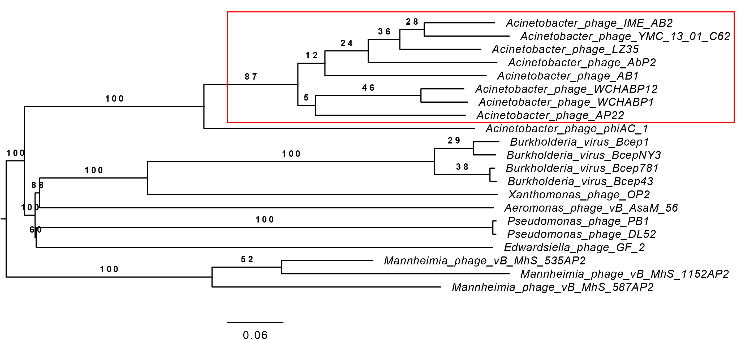

Figure 3. The phylogenetic tree was constructed, using phylogeny.fr [5], using the large Terminase subunit protein homologs of AP22 and related phages (boxed in red).

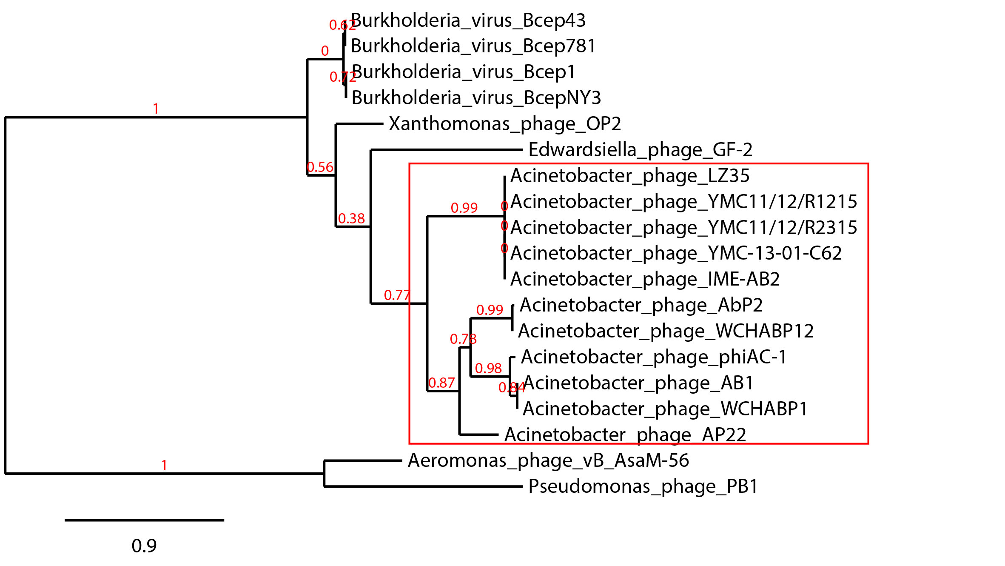

| **References:** |
| --- |
| 1. Zhou W, Feng Y, Zong Z (2018). Two New Lytic Bacteriophages of the *Myoviridae* Family Against Carbapenem-Resistant *Acinetobacter baumannii*. *Frontiers in Microbiology* 9:850 2. Guo Z, Huang H, Wu X, Hao Y, Sun Y (2016). Complete Genome Sequence of Lytic Bacteriophage LZ35 Infecting *Acinetobacter baumannii* Isolates. *Genome Announcements* 4(6): e01104-16 3. Turner D, Ackermann H-W, Kropinski AM, Lavigne R, Sutton JM, Reynolds DM (2017). Comparative Analysis of 37 *Acinetobacter* bacteriophages. *Viruses* 10(1) E5 4. Meier-Kolthoff JP, Goeker M. VICTOR: genome-based phylogeny and classification of prokaryotic viruses. Bioinformatics. 2017; 33(21): 3396–3404. 5. Dereeper A.*, Guignon V.*, Blanc G., Audic S., Buffet S., Chevenet F., Dufayard J.F., Guindon S., Lefort V., Lescot M., Claverie J.M., Gascuel O. (2008) Phylogeny.fr: robust phylogenetic analysis for the non-specialist. *Nucleic Acids Research* 36(Web Server issue):W465-9. |