This Word module should be used for all taxonomic proposals.

Please complete **Part 1** and:

either **Part 3** for proposals to create new taxa or change existing taxa

or **Part 2** for proposals of a general nature.

Submit the completed Word module, together with the accompanying Excel module named in Part 3, to the appropriate ICTV Subcommittee Chair.

For guidance, see the notes written in blue, below, and the help notes in file Taxonomic_Proposals_Help_2018.

**Part 1:** **TITLE, AUTHORS, etc**

|  |  |  |  |
| --- | --- | --- | --- |
| **Code assigned:** | ***2018.110B*** | | (to be completed by ICTV officers) |
| **Short title: To create one (1) new genus, *Phimunavirus*, containing four (4) species in the subfamily *Autographivirinae*, family *Podoviridae*** | | | |
|  | | | |
| **Author(s):** | | | |
| Colin Buttimer, Cork Institute of Technology (Ireland)  Dann Turner, University of the West of England, Bristol (UK)  Aidan Coffey, Cork Institute of Technology (Ireland)  Horst Neve, Max Rubner-Institut (Germany)  Andrew M. Kropinski, University of Guelph (Canada)  Evelien Adriaenssens, University of Liverpool (UK) | | | |
| **Corresponding author with e-mail address:** | | | |
| Andrew M. Kropinski Phage.Canada@gmail.com | | | |
| **List the ICTV study group(s) that have seen this proposal:** | | | |
| A list of study groups and contacts is provided at <http://www.ictvonline.org/subcommittees.asp> . If in doubt, contact the appropriate subcommittee chair (there are six virus subcommittees: animal DNA and retroviruses, animal ssRNA-, animal ssRNA+, fungal and protist, plant, bacterial and archaeal) | | **Bacterial and Archaeal Viruses Subcommittee** | |
| **ICTV Study Group comments (if any) and response of the proposer:** | | | |
|  | | | |
|  | | | |
| Date first submitted to ICTV: | | | June 2018 |
| Date of this revision (if different to above): | | |  |

|  |
| --- |
| **ICTV-EC comments and response of the proposer:** |
|  |

**Part 2:** **NON-STANDARD**

Template for any proposal regarding ICTV procedures, rules or policy, not involving the creation of new taxonomy.

| **Text of proposal:** |
| --- |
|  |

**Part 3:** **PROPOSED TAXONOMY**

|  |
| --- |
| **Name of accompanying Excel module: 2018.110B.N.v1.Phimunavirus** |

The taxonomic changes you are proposing should be presented on an accompanying Excel module, 2017_TP_Template_Excel_module. Please enter the file name of the completed module in this box.

**Supporting material:**

| additional material in support of this proposal |
| --- |
| Please explain the reasons for the taxonomic changes you are proposing and provide evidence to support them. The following information should be provided, where relevant:   * **Species demarcation criteria**: Explain how new species differ from others in the genus and demonstrate that these differences meet the criteria previously established for demarcating between species. If no criteriahave previously been established, and if there will now be more than one species in the genus, please state the demarcation criteria you are proposing. * **Higher taxa**:   + There is no formal requirement to state demarcation criteria when proposing new genera or other higher taxa. However, a similar concept should apply in pursuit of a rational and consistent virus taxonomy.   + Please indicate the **origin of names** assigned to new taxa at genus level and above.   + For each new genus a **type species** must be designated to represent it. Please explain your choice. * **Supporting evidence**: The use of Figures and Tables is strongly recommended (note that copying from publications will require permission from the copyright holder). For phylogenetic analysis, try to provide a tree where branch length is related to genetic distance. |

**Species demarcation criteria:** We have chosen 95% DNA sequence identity as the criterion for demarcation of species in this new genus. Each of the proposed species differs from the others with more than 5% at the DNA level as confirmed with the BLASTN algorithm.

**Genus demarcation:** *Pectobacterium* phagesφM1, CB5, Peat1 and PP90 are all phages of *Pectobacterium atrosepticum*. Phylogenetic and BLASTN analyses indicate that the proposed genus (Table 1 and Figure 2), *Phimunavirus*, is cohesive and distinct from other genera. On average, the genomes of members of this genus are 44.4 kb and encode between 52 and 61 proteins (Table 1). Bioinformatics analysis of these phage genomes demonstrates a high level of nucleotide identity (≥80%) with a conserved gene content (Table 1 and Figure 3). Each of these phages encodes genes solely on the Watson strand and exhibit a similar genome organisation. The presence of virion encoded single-subunit RNA polymerase, places these phages within the subfamily *Autographivirinae*.

Micrographs of phage CB5 show the phage belongs to the family of *Podoviridae* with an icosahedral head (63.1 ± 3.6 nm in diameter, n=25) with clearly distinguishable hexagonal outlines and a short non-contractile tail (13.1 ± 1.8 nm, n=11), and short appendices (length: ca. 10.1 ± 1.7 nm, n=10) visible at the head/tail connection site (Figure 1) [1].

**Source of the name of this taxon:** The genus is named after the first Isolated phage of this type, *Pectobacterium* phage φM1.

**History:**

Isolation source of phages of the proposed genus of *Phimunavirus*:

* Phage φM1 was isolated from mixed sewage (Finham sewage works, Coventry, Warwickshire, UK) by Toth *et al.* [2] with the phage later having its genome sequenced by Blower *et al* [3].
* CB5 was isolated from soil from potato fields (Co. Cork, Ireland in 2013) by Buttimer *et al.* [1].
* PP90 was isolated from potato washing waste water by Shneider *et al.* (isolation source detailed in Genbank file).
* Peat1 was isolated by Kalischuk *et al.* [4], its exact isolation source is unclear with its Genbank file detailing *Solanum tuberosum*.

**GenBank Summary:**

Table 1. Properties of four phages belonging to the genus Phimunavirus.

|  |  |  |  |  |  |  |  |
| --- | --- | --- | --- | --- | --- | --- | --- |
| Phage Name | INSDC accession number | Size (Kb) | Mol % G+C | No. CDS | tRNA | DNA sequence identity (%)* | Shared proteins (%)** |
| φM1 | JX290549.1 | 42,989 | 49.18 | 52 | 1 | 100 | 100 |
| CB5 | KY953156.1 | 44,262 | 48.98 | 60 | 0 | 84 | 73 |
| Peat1 | KR604693.1 | 45,633 | 48.86 | 61 | 0 | 82 | 87 |
| PP90 | KX278419.1 | 44,570 | 48.89 | 56 | 0 | 80 | 80 |

* Determined using BLASTN; ** Determined using CoreGenes3.5 [5]

**Electron microscopy:**

Figure 1. Transmission electron micrograph of negatively stained *Pectobacterium* phage CB5 [1], stained with 2% (w/v) uranyl acetate. Triangle indicates the short conical tail structure, and arrows indicate short appendages (whiskers) beneath the capsid. Scale bars represent 50 nm.

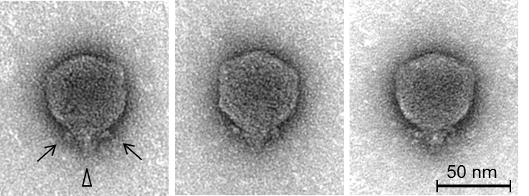

**Phylogeny:**

Figure 2. The major capsid proteins from phage φM1 and homologs were analysed using maximum likelihood (Whelan and Goldman substitution model), with 1000 bootstrap replicates using MEGA7[6]. Members of the *T7virus*, *SP6virus*, *KP34virus*, *Frivirus*, *Pradovirus*, *KP32virus* are illustrated.

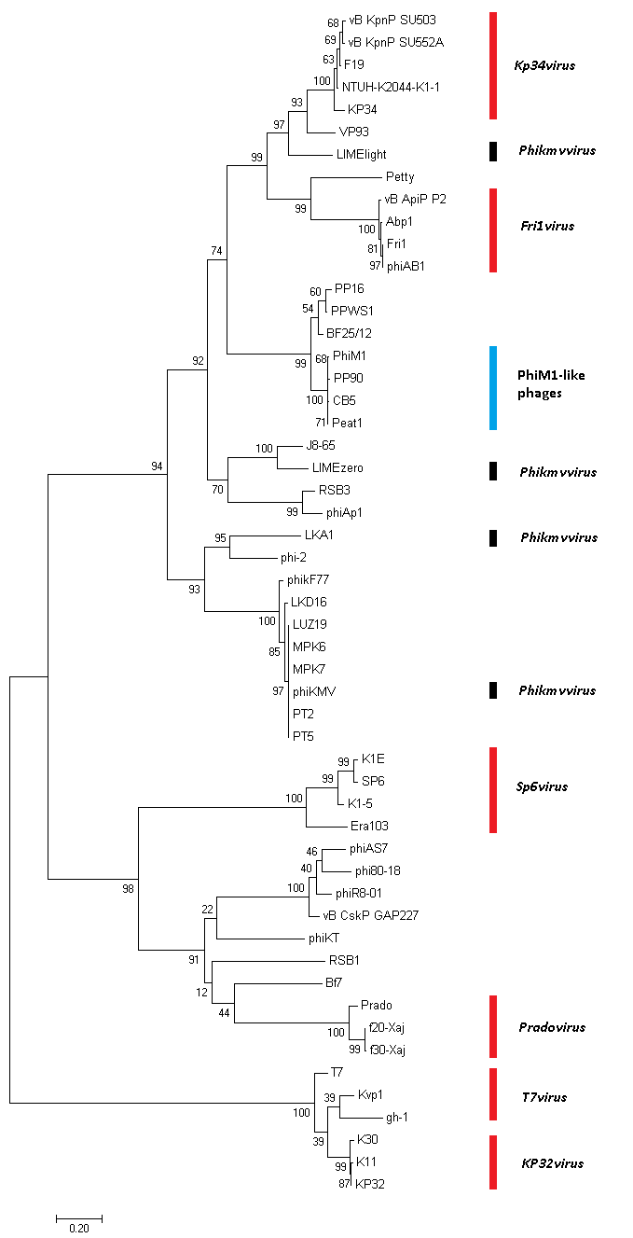

Figure 3. BLASTN synteny plot of the four species visualised with EasyFig [7]. The scale bar shows the level of nucleotide identity. Arrows have been color-coded describing their predicted roles (see key).

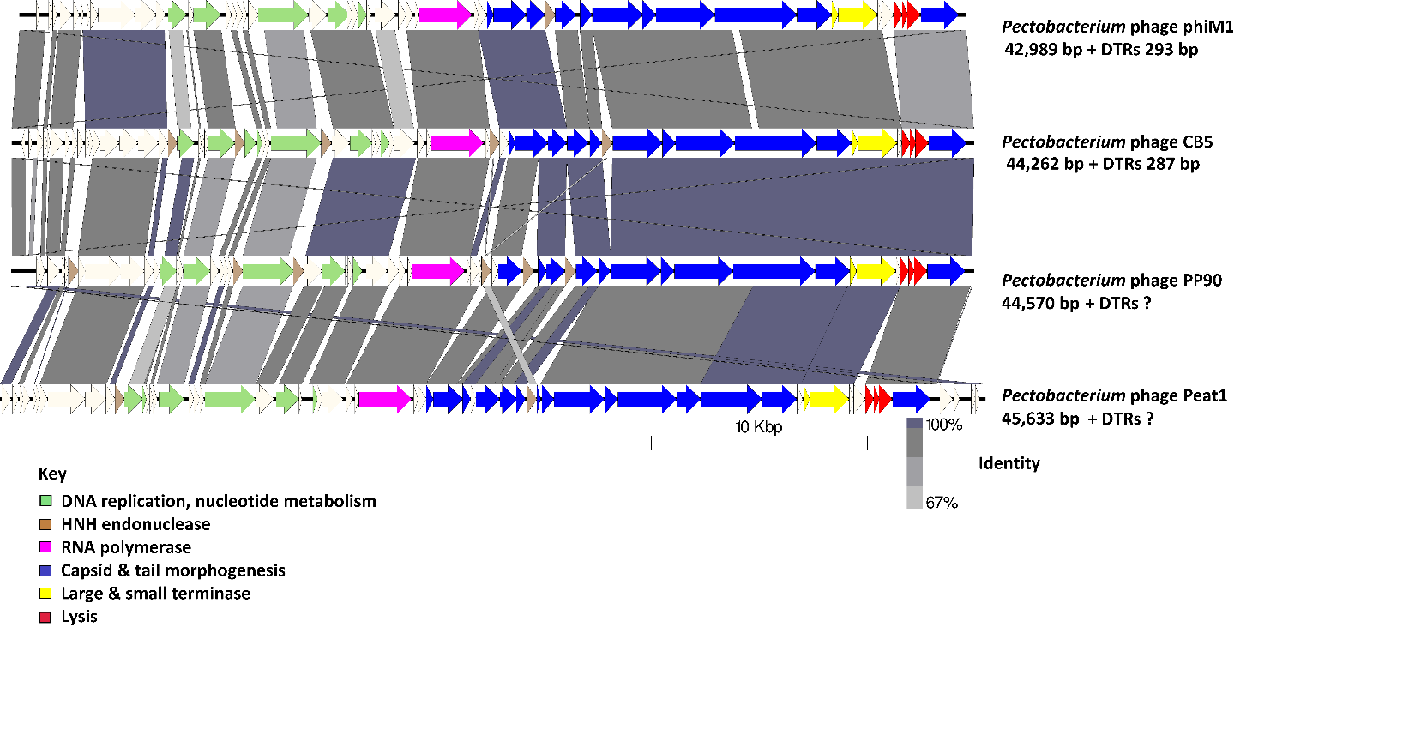

| **References:** |
| --- |
| 1. Buttimer C.; Lucid A.; Neve H.; Franz C.M.A.P.; O’Mahony J.; Turner, D.; Lavigne R.; Coffey A. Pectobacterium atrosepticum phage vB_PatP_CB5 a member of the proposed genus ‘Phimunavirus’. Viruses. 2018. In press  2. Toth, I. K.; Mulholland, V.; Cooper, V.; Bentley, S.; Shih, Y.; Perombelon, M. C. M.; Salmond, G. P. C. Generalized transduction in the potato blackleg pathogen Ewinia carotovora subsp. atroseptica by bacteriophage φM1. Microbiology 1997, 143, 2433–2438  3. Blower, T. R.; Chai, R.; Przybilski, R.; Chindhy, S.; Fang, X.; Kidman, S. E.; Tan, H.; Luisi, B. F.; Fineran, P. C.; Salmond, G. P. C. Evolution of Pectobacterium Bacteriophage ΦM1 To Escape Two Bifunctional Type III Toxin-Antitoxin and Abortive Infection Systems through Mutations in a Single Viral Gene. Appl. Environ. Microbiol. 2017, 83, AEM.03229-16, doi:10.1128/AEM.03229-16.  4. Kalischuk, M.; Hachey, J.; Kawchuk, L. Complete Genome Sequence of Phytopathogenic Pectobacterium atrosepticum Bacteriophage Peat1. Genome Announc. 2015, 3, doi:10.1128/genomeA.00760-15  5. Turner, D.; Reynolds, D.; Seto, D.; Mahadevan, P. CoreGenes3.5: a webserver for the determination of core genes from sets of viral and small bacterial genomes. BMC Res. Notes 2013, 6, 140, doi:10.1186/1756-0500-6-140  6. Kumar S.; Stecher G.; Tamura K.; MEGA7: Molecular Evolutionary Genetics Analysis Version 7.0 for Bigger Datasets. Mol. Biol. Evol. 2016,33, 1870–4, doi:10.1093/molbev/msw054.  7: Sullivan, M.J.; Petty, N.K.; Beatson, S.A. Easyfig: a genome comparison visualizer. Bioinformatics. 2011; 27(7): 1009-1010. |