This Word module should be used for all taxonomic proposals.



Please complete **Part 1** and:

either **Part 3** for proposals to create new taxa or change existing taxa

or **Part 2** for proposals of a general nature.

Submit the completed Word module, together with the accompanying Excel module named in Part 3, to the appropriate ICTV Subcommittee Chair.

For guidance, see the notes written in blue, below, and the help notes in file Taxonomic_Proposals_Help_2018.

**Part 1:** **TITLE, AUTHORS, etc**

|  |  |  |  |
| --- | --- | --- | --- |
| **Code assigned:** | ***2018.111B*** | | (to be completed by ICTV officers) |
| **Short title: To create one (1) new genus *Vieuvirus*, containing two (2) species in the family *Siphoviridae*** | | | |
|  | | | |
| **Author(s):** | | | |
| Dann Turner, University of the West of England (UK)  Evelien M. Adriaenssens, University of Liverpool (UK)  Andrew M. Kropinski, University of Guelph (Canada) | | | |
| **Corresponding author with e-mail address:** | | | |
| Dann Turner: dann2.turner@uwe.ac.uk | | | |
| **List the ICTV study group(s) that have seen this proposal:** | | | |
| A list of study groups and contacts is provided at http://www.ictvonline.org/subcommittees.asp . If in doubt, contact the appropriate subcommittee chair (there are six virus subcommittees: animal DNA and retroviruses, animal ssRNA-, animal ssRNA+, fungal and protist, plant, bacterial and archaeal) | |  | |
| **ICTV Study Group comments (if any) and response of the proposer:** | | | |
|  | | | |
|  | | | |
| Date first submitted to ICTV: | | | June 2018 |
| Date of this revision (if different to above): | | |  |

|  |
| --- |
| **ICTV-EC comments and response of the proposer:** |
|  |

**Part 2:** **NON-STANDARD**

Template for any proposal regarding ICTV procedures, rules or policy, not involving the creation of new taxonomy.

| **Text of proposal:** |
| --- |
|  |

**Part 3:** **PROPOSED TAXONOMY**

|  |
| --- |
| **Name of accompanying Excel module: 2018.111B.N.v1.Vieuvirus** |

The taxonomic changes you are proposing should be presented on an accompanying Excel module, 2017_TP_Template_Excel_module. Please enter the file name of the completed module in this box.

**Supporting material:**

| additional material in support of this proposal |
| --- |
| Please explain the reasons for the taxonomic changes you are proposing and provide evidence to support them. The following information should be provided, where relevant:   * **Species demarcation criteria**: Explain how new species differ from others in the genus and demonstrate that these differences meet the criteria previously established for demarcating between species. If no criteriahave previously been established, and if there will now be more than one species in the genus, please state the demarcation criteria you are proposing. * **Higher taxa**:   + There is no formal requirement to state demarcation criteria when proposing new genera or other higher taxa. However, a similar concept should apply in pursuit of a rational and consistent virus taxonomy.   + Please indicate the **origin of names** assigned to new taxa at genus level and above.   + For each new genus a **type species** must be designated to represent it. Please explain your choice. * **Supporting evidence**: The use of Figures and Tables is strongly recommended (note that copying from publications will require permission from the copyright holder). For phylogenetic analysis, try to provide a tree where branch length is related to genetic distance. |

**Species demarcation criteria**: We have chosen 95% DNA sequence identity as the criterion for demarcation of species in this new genus. The members of each proposed species differ from those of other species by more than 5% at the DNA level as confirmed with the BLASTN algorithm.

**BLASTN homologs**: B1215 and R3177 exhibit similarity to phages Ab105-3phi (partial genome, KT588073) and Ab105-2phi (KT288075). We note that similar sequences are found in a wide range of sequenced *A. baumannii* isolates, suggesting a widely disseminated prophage cluster.

**History:** Phage Βϕ-R3177 was isolated from the sewage water at a hospital (location not specified) [1]. Bϕ-B1251 (YMC/09/02/B1251 ABA BP), which was isolated from a sewage sample obtained from a university hospital in South Korea [2]. The two phages share 63.7 nucleotide sequence identity as determined by BLASTN and 67% homologous proteins (Table 1). The genomes are subject to localized differences. In the virion structural and morphogenesis gene module these non-homologous regions correspond to different head-tail joining proteins and a HicAB-like type II toxin-antitoxin cassette in R3177. Additionally, R3177 encodes an integrase, excisionase and transcriptional regulatory proteins that are absent in Bphi-B1251 indicating that, despite significant nucleotide and proteomic similarity, these two related phages undertake different lifestyles [3].

**Source of the name of this taxon**: The taxon name is derived from the last author of the second publication to observe this phage morphotype in *Acinetobacter spp*. J. F. Vieu has published extensive on bacteriophages and the host species *A. baumannii* between 1956 and 1991.

**Electron Microscopy:**

Electron micrographs of R3177 show a singular morphology, with virions consisting of a B2 prolate head and a non-contractile tail with multiple transverse disks [2]. This morphotype was first observed among the *Acinetobacter* phages in 1973 [4] for phage 531 and subsequently in 1974 for phage B9PP [5]. The 531-like phages exhibit a slightly elongated head of 73 x 59 nm and the 252 nm long tail is characterised by the presence of multiple transverse disks, spaced at an average periodicity of 16 nm that gives the tail a segmented appearance. Each disk carries small tail fibers of approximately 10 x 2 nm. Phages with transverse disks have been observed only rarely and include *Lactococcus* phage 1358 [6], *Sinorhizobium meliloti* phage NM1 [7], *Serratia marcesens* phages SLP and 170 [8,9], *Lactobacillus delbrueckii* subsp. *lactis* phage JCL-1032 [10], *Bacillus thuringiensis* phage Tb10 [11] and *Bacillus cereus* phage vB_BceS-IEBH [12]. No specific function has yet been determined for transverse tail disks.

**GenBank Summary**:

Table 1. GenBank details of phages belonging to the genus *Lokivirus.*

|  |  |  |  |  |  |  |  |
| --- | --- | --- | --- | --- | --- | --- | --- |
| ***Acinetobacter* phage** | **RefSeq No.** | **INSDC Accession No.** | **Genome length (bp)** | **Genome (mol% G+C)** | **No. CDS** | **DNA (%sequence identity) \*** | **% Homologous proteins \*\*** |
| Bphi-B1251 | NC_019541.1 | JX403940.1 | 45.36 | 39.1 | 62 | 100 | 100 |
| YMC11/11/R3177 | - | KP861230.1 | 47.58 | 39.8 | 80 | 63.7 | 67 |

* Determined using BLASTN; ** Determined using CoreGenes3.5

**Phylogeny**:

Figure 1. ProgressiveMauve [13] alignment of the annotated genomes of phages B1251 (top) and R3177 (bottom). Coloured blocks indicate the regions of best alignments, where rearrangement breakpoints indicated in a different colour. The degree of sequence similarity between regions is provided by a similarity plot within alignment blocks, where the height of the plot is proportional to the average nucleotide identity.

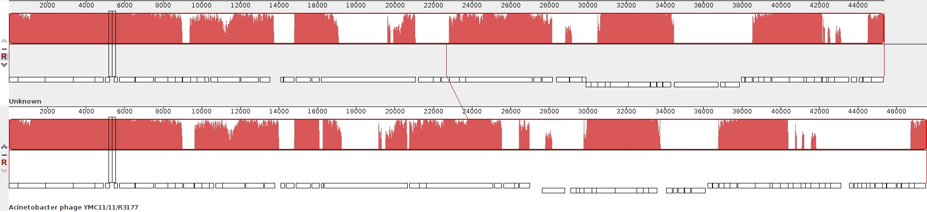

Figure 2. The phylogenetic tree was constructed, using the “one click” mode at phylogeny.fr [14], using the (A) major capsid protein and (B) large Terminase subunit protein homologs of Loki and related phages (boxed in red).

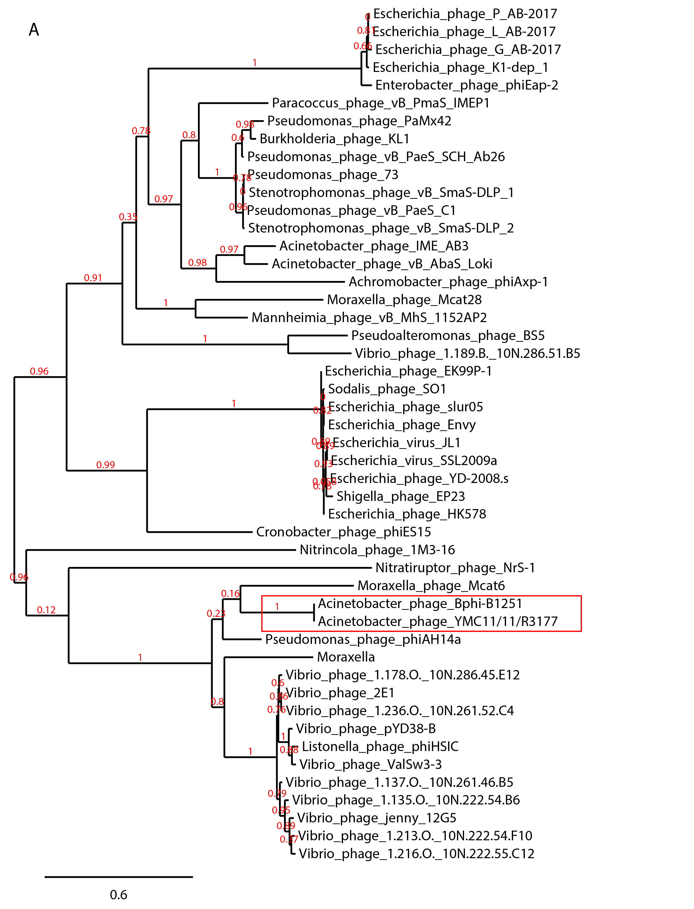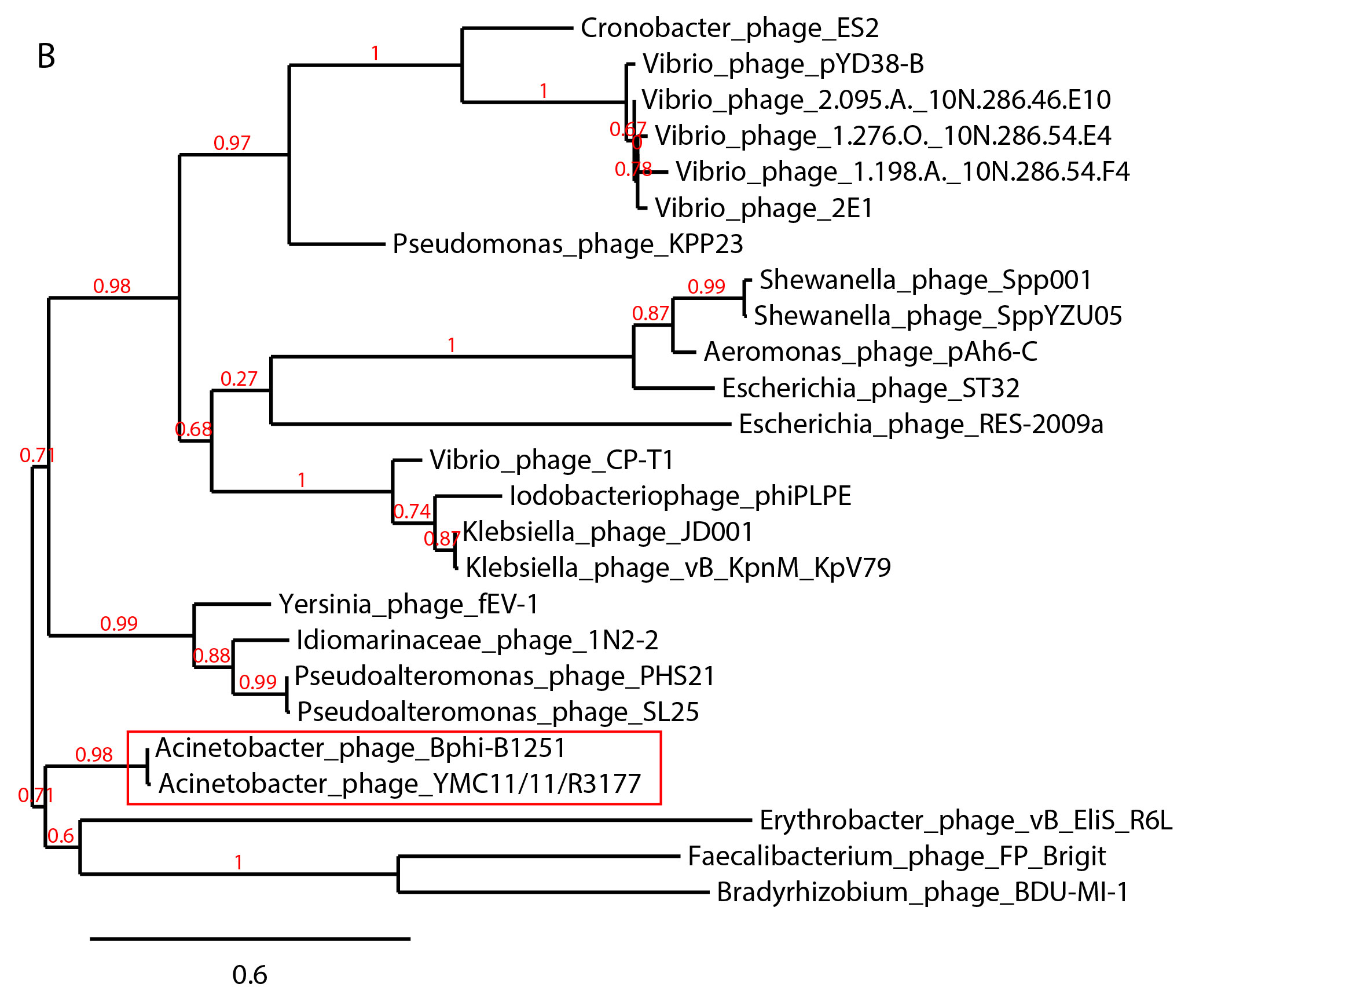

| **References:** |
| --- |
| 1. Jeon J, D'Souza R, Pinto N, Ryu CM, Park JH, Yong D, Lee K. (2015). Complete genome sequence of the siphoviral bacteriophage Βϕ-R3177, which lyses an OXA-66-producing carbapenem-resistant Acinetobacter baumannii isolate. *Archives of Virology* 160(12): 3157-60  2. Jeon J, Kim JW, Yong D, Lee K, Chong Y. (2012) Complete genome sequence of the podoviral bacteriophage YMC/09/02/B1251 ABA BP, which causes the lysis of an OXA-23-producing carbapenem-resistant Acinetobacter baumannii isolate from a septic patient. *Journal of Virology* 86(22):12437-8.  3. Turner D, Ackermann H-W, Kropinski AM, Lavigne R, Sutton JM, Reynolds DM (2017). Comparative Analysis of 37 *Acinetobacter* bacteriophages. *Viruses* 10(1) E5  4. Ackermann H.-W.; Brochu G.; Cherchel G. Structure de trois nouveaux phages de bacterium anitratum (groupe b5w). Journal de Microscopie 1973, 16, 215-224.  5. Bordini A, P.M., Vieu J-F. Sur une souche polylysogéne de moraxella (acinetobacter). C R Hebd Seances Acad Sci Ser D, Sci Natur (Paris) 1974, 278, 1907-1909.  6. Dupuis, M.-È.; Moineau, S. Genome organization and characterization of the virulent lactococcal phage 1358 and its similarities to listeria phages. Applied and Environmental Microbiology 2010, 76, 1623-1632. doi: 10.1128/aem.02173-09.  7. Werquin, M.; Ackermann, H.-W.; Levesque, R.C. A study of 33 bacteriophages of rhizobium meliloti. Applied and Environmental Microbiology 1988, 54, 188-196.  8. Grimont, F. Les bacteriophages des serratia et bacteries voisines. Taxonomie et lysotypie. Universite de Bordeaux II, France, 1977.  9. Viñas, M.C.; Gargallo, D.; Lorén, J.G.; Guinea, J. Morphological characterization of the serratia marcescens bacteriophage slp. Journal of Basic Microbiology 1985, 25, 285-288. doi: 10.1002/jobm.3620250415.  10. Forsman, P. Characterization of a prolate-headed bacteriophage of lactobacillus delbrueckii subsp. Lactis, and its DNA homology with isometric-headed phages. Archives of Virology 1993, 132, 321-330. doi: 10.1007/BF01309542.  11. Ackermann, H.W.; Azizbekyan, R.R.; Emadi Konjin, H.P.; Lecadet, M.M.; Seldin, L.; Yu, M.X. New bacillus bacteriophage species. Arch Virol 1994, 135, 333-344.  12. Smeesters, P.R.; Drèze, P.-A.; Bousbata, S.; Parikka, K.J.; Timmery, S.; Hu, X.; Perez-Morga, D.; Deghorain, M.; Toussaint, A.; Mahillon, J., et al. Characterization of a novel temperate phage originating from a cereulide-producing bacillus cereus strain. Research in Microbiology 2011, 162, 446-459. doi: 10.1016/j.resmic.2011.02.009.  13. Darling AE, Mau B, Perna NT (2010) progressiveMauve: multiple genome alignment with gene gain, loss and rearrangement. *PLoS One* 5(6): e11147  14. Dereeper A.*, Guignon V.*, Blanc G., Audic S., Buffet S., Chevenet F., Dufayard J.F., Guindon S., Lefort V., Lescot M., Claverie J.M., Gascuel O. (2008) Phylogeny.fr: robust phylogenetic analysis for the non-specialist. Nucleic Acids Research 36(Web Server issue):W465-9. |