This Word module should be used for all taxonomic proposals.

Please complete **Part 1** and:

either **Part 3** for proposals to create new taxa or change existing taxa

or **Part 2** for proposals of a general nature.

Submit the completed Word module, together with the accompanying Excel module named in Part 3, to the appropriate ICTV Subcommittee Chair.

For guidance, see the notes written in blue, below, and the help notes in file Taxonomic_Proposals_Help_2018.

**Part 1:** **TITLE, AUTHORS, etc**

|  |  |  |  |
| --- | --- | --- | --- |
| **Code assigned:** | ***2018.112B*** | | (to be completed by ICTV officers) |
| **Short title:** (e.g. “6 new species in the genus *Zetavirus”*)  **To create one (1) new genus, *Delepquintavirus*, containing a single species in the family *Siphoviridae*** | | | |
|  | | | |
| **Author(s):** | | | |
| Andrew M. Kropinski, University of Guelph, Canada  Evelien M. Adriaenssens, University of Liverpool, UK  Danielle L. Peters, University of Alberta, Canada  Jonathan J. Dennis, University of Alberta, Canada | | | |
| **Corresponding author with e-mail address:** | | | |
| Andrew M. Kropinski Phage.Canada@gmail.com | | | |
| **List the ICTV study group(s) that have seen this proposal:** | | | |
| A list of study groups and contacts is provided at <http://www.ictvonline.org/subcommittees.asp> . If in doubt, contact the appropriate subcommittee chair (there are six virus subcommittees: animal DNA and retroviruses, animal ssRNA-, animal ssRNA+, fungal and protist, plant, bacterial and archaeal) | | **Bacterial and Archaeal Viruses Subcommittee** | |
| **ICTV Study Group comments (if any) and response of the proposer:** | | | |
|  | | | |
|  | | | |
| Date first submitted to ICTV: | | | June 2018 |
| Date of this revision (if different to above): | | |  |

|  |
| --- |
| **ICTV-EC comments and response of the proposer:** |
|  |

**Part 2:** **NON-STANDARD**

Template for any proposal regarding ICTV procedures, rules or policy, not involving the creation of new taxonomy.

| **Text of proposal:** |
| --- |
|  |

**Part 3:** **PROPOSED TAXONOMY**

|  |
| --- |
| **Name of accompanying Excel module: 2018.112B.N.v1.Delepquintavirus** |

The taxonomic changes you are proposing should be presented on an accompanying Excel module, 2017_TP_Template_Excel_module. Please enter the file name of the completed module in this box.

**Supporting material:**

| additional material in support of this proposal |
| --- |
| Please explain the reasons for the taxonomic changes you are proposing and provide evidence to support them. The following information should be provided, where relevant:   * **Species demarcation criteria**: Explain how new species differ from others in the genus and demonstrate that these differences meet the criteria previously established for demarcating between species. If no criteriahave previously been established, and if there will now be more than one species in the genus, please state the demarcation criteria you are proposing. * **Higher taxa**:   + There is no formal requirement to state demarcation criteria when proposing new genera or other higher taxa. However, a similar concept should apply in pursuit of a rational and consistent virus taxonomy.   + Please indicate the **origin of names** assigned to new taxa at genus level and above.   + For each new genus a **type species** must be designated to represent it. Please explain your choice. * **Supporting evidence**: The use of Figures and Tables is strongly recommended (note that copying from publications will require permission from the copyright holder). For phylogenetic analysis, try to provide a tree where branch length is related to genetic distance. |

**Species demarcation criteria** We have chosen 95% DNA sequence identity as the criterion for demarcation of species in this new genus. Each of the proposed species differs from the others with more than 5% at the DNA level as confirmed with the BLASTN algorithm.

**Source of the name of this taxon**: It is derived from the name of the first isolate of its type Stenotrophomonas phage vB_SmaS_DLP_5

**History:** Isolated by Danielle Peters (University of Alberta, Edmonton, Canada) on its ability to lyse Stenotrophomonas maltophilia. Bacteriophage DLP5 was isolated on Stentrophomonas maltophilia D1585. Transmission electron micrographs identify DLP5 as a B1 morphotype Siphoviridae phage. DLP5 possesses relatively narrow tropism, infecting 5/27 S. maltophilia clinical isolates tested. DLP5 forms clear plaques with defined boarders with an approximate average size of 0.5 mm. One-step growth curves exhibit an average burst size of 36 particles. As a prophage, DLP5 was discovered to replicate as a phagemid. Restriction fragment length polymorphism analysis suggests that DLP5 DNA is heavily modified, with only 4/36 endonucleases tested digesting the phage DLP5 genome. The DLP5 genome is 96,542 bp in length encoding 149 ORFS including four tRNAs. The GC content of DLP5 is 58.4%, which is lower than the average S. maltophilia genome GC content of 67%. Only 39/149 ORFs were determined to encode proteins with putative functions. Predicted structural proteins include portal protein, large terminase subunit, major capsid protein, three tail assembly proteins, tail fiber protein, a tape measure protein, and lysozyme. Predicted DNA replication, transcription, and repair proteins of interest include DNA polymerase I, DnaB, DnaG, DNA/RNA helicase, DNA ligase, RecA, RuvC, RNase E, two transcriptional regulators, thymidylate synthase, phosphoglycerate kinase, UDPglucose 4-epimerase, WcaG, tyrosine phosphatase, and pyruvate phosphate dikinase.

**Electron microscopy:** Negatively stained particle of Stenotrophomonas maltophilia bacteriophage DLP5 (kindly provided by Dr. Jonathan J. Dennis, Biological Sciences, University of Alberta, Edmonton, AB, Canada)

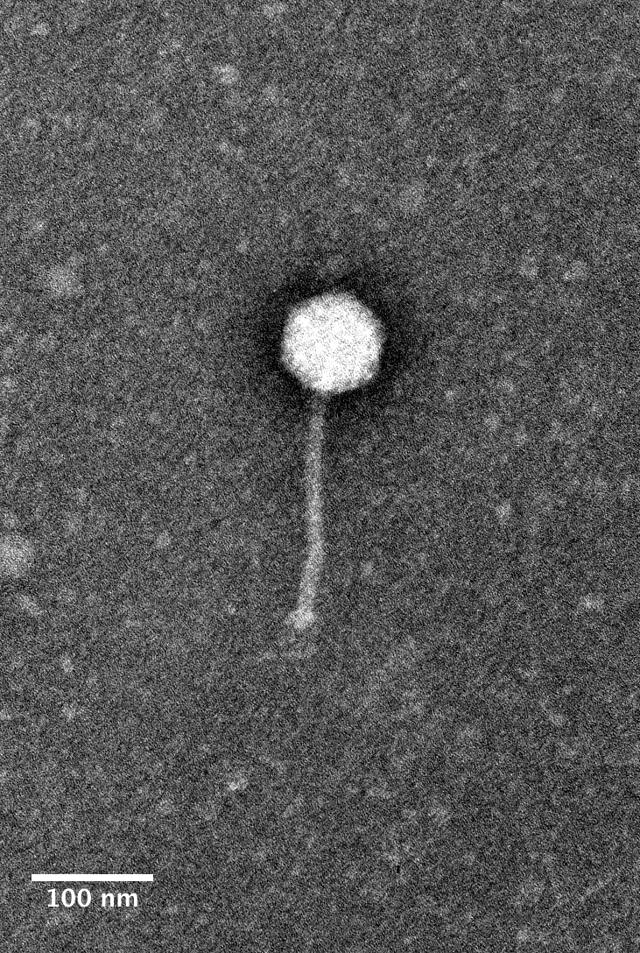

**GenBank Summary:**

|  |  |  |  |  |  |
| --- | --- | --- | --- | --- | --- |
| Phage name | INSDC | Size (Kb) | GC% | Protein | tRNA |
| vB_SmaS_DLP_5 | MG189906.1 | 96.54 | 58.4 | 149 | 4 |

**BLASTN homologs:** None; genomic orphan/singleton

**Phylogeny:** Phylogenetic tree, constructed using phylogeny.fr, of the DNA polymerase proteins of phage vB_SmaS_DLP_5 and its relatives



| **References:** |
| --- |
| Peters DL, Dennis JJ. [Complete genome sequence of temperate Stenotrophomonas maltophilia bacteriophage DLP5.](https://www.ncbi.nlm.nih.gov/pubmed/29496826) Genome Announc. 2018;6(9). pii: e00073-18. doi: 10.1128/genomeA.00073-18. PMID:29496826 |