This Word module should be used for all taxonomic proposals.

Please complete **Part 1** and:

either **Part 3** for proposals to create new taxa or change existing taxa

or **Part 2** for proposals of a general nature.

Submit the completed Word module, together with the accompanying Excel module named in Part 3, to the appropriate ICTV Subcommittee Chair.

For guidance, see the notes written in blue, below, and the help notes in file Taxonomic_Proposals_Help_2018.

**Part 1:** **TITLE, AUTHORS, etc**

|  |  |  |  |
| --- | --- | --- | --- |
| **Code assigned:** | ***2018.118B*** | | (to be completed by ICTV officers) |
| **Short title: To create one (1) new family, *Herelleviridae*, in the order *Caudovirales*** (e.g. “6 new species in the genus *Zetavirus”*) | | | |
|  | | | |
| **Author(s):** | | | |
| Jakub Barylski1, François Enault2, Bas E. Dutilh3,4, Margo B.P. Schuller3, Robert A. Edwards5, Annika Gillis6, Jochen Klumpp7, Petar Knezevic8, Mart Krupovic9, Jens H. Kuhn10, Rob Lavigne11, Hanna M. Oksanen12, Matthew B. Sullivan13, Ho Bin Jang13, Peter Simmonds14, Pakorn Aiewsakun14, Johannes Wittmann15, Igor Tolstoy16, J. Rodney Brister16, Andrew M. Kropinski17, Evelien M. Adriaenssens18  *1Adam Mickiewicz University, Institute of Experimental Biology, Department of Molecular Virology, Poznań, Poland*  *2Université Clermont Auvergne, CNRS, LMGE, F-63000, Clermont-Ferrand, France*  *3**Theoretical Biology and Bioinformatics, Department of Biology, Utrecht University, Utrecht, The Netherlands*  *4Theoretical Biology and Bioinformatics, Department of Biology, Utrecht University, Utrecht, The Netherlands*  *5Departments of Biology and Computer Science, San Diego State University, San Diego, CA, USA*  *6Laboratory of Food and Environmental Microbiology, Université Catholique de Louvain, Louvain-la-Neuve, Belgium*  *7Institute of Food, Nutrition and Health, ETH Zurich, Switzerland*  *8Department of Biology and Ecology, Faculty of Sciences, University of Novi Sad, Novi Sad, Serbia*  *9Unit of Molecular Biology of the Gene in Extremophiles, Department of Microbiology, Institut Pasteur, Paris, France*  *10Integrated Research Facility at Fort Detrick, National Institute of Allergy and Infectious Diseases, National Institutes of Health, Fort Detrick, Frederick, USA*  *11Laboratory of Gene Technology, KU Leuven, Belgium*  *12Molecular and Integrative Biosciences Research Programme, Faculty of Biological and Environmental Sciences, University of Helsinki, Helsinki, Finland*  *13Departments of Microbiology and Civil, Environmental, and Geodetic Engineering, The Ohio State University, Columbus, OH, USA*  *14 Nuffield Department of Medicine, University of Oxford, Peter Medawar Building, South Parks Road, Oxford, OX1 3SY, UK*  *15Leibniz-Institut DSMZ—Deutsche Sammlung von Mikroorganismen und Zellkulturen GmbH, Braunschweig, Germany*  *16National Center for Biotechnology Information, National Library of Medicine, National Institutes of Health, Bethesda, MD, USA*  *17Departments of Food Science, Molecular and Cellular Biology; and Pathobiology, University of Guelph, Guelph, Ontario, Canada*  *18Institute of Integrative Biology, University of Liverpool, Biosciences Building, Crown Street, Liverpool L69 7ZB, United Kingdom* | | | |
| **Corresponding author with e-mail address:** | | | |
| Evelien Adriaenssens - evelien.adriaenssens@gmail.com | | | |
| **List the ICTV study group(s) that have seen this proposal:** | | | |
| A list of study groups and contacts is provided at <http://www.ictvonline.org/subcommittees.asp> . If in doubt, contact the appropriate subcommittee chair (there are six virus subcommittees: animal DNA and retroviruses, animal ssRNA-, animal ssRNA+, fungal and protist, plant, bacterial and archaeal) | | **Bacterial and Archaeal Viruses Subcommittee** | |
| **ICTV Study Group comments (if any) and response of the proposer:** | | | |
|  | | | |
|  | | | |
| Date first submitted to ICTV: | | | June 2018 |
| Date of this revision (if different to above): | | |  |

|  |
| --- |
| **ICTV-EC comments and response of the proposer:** |
|  |

**Part 3:** **PROPOSED TAXONOMY**

|  |
| --- |
| **Name of accompanying Excel module: 2018.118B.N.v1.Herelleviridae** |

The taxonomic changes you are proposing should be presented on an accompanying Excel module, 2017_TP_Template_Excel_module. Please enter the file name of the completed module in this box.

**Supporting material:**

| additional material in support of this proposal |
| --- |
| Please explain the reasons for the taxonomic changes you are proposing and provide evidence to support them. The following information should be provided, where relevant:   * **Species demarcation criteria**: Explain how new species differ from others in the genus and demonstrate that these differences meet the criteria previously established for demarcating between species. If no criteriahave previously been established, and if there will now be more than one species in the genus, please state the demarcation criteria you are proposing. * **Higher taxa**:   + There is no formal requirement to state demarcation criteria when proposing new genera or other higher taxa. However, a similar concept should apply in pursuit of a rational and consistent virus taxonomy.   + Please indicate the **origin of names** assigned to new taxa at genus level and above.   + For each new genus a **type species** must be designated to represent it. Please explain your choice. * **Supporting evidence**: The use of Figures and Tables is strongly recommended (note that copying from publications will require permission from the copyright holder). For phylogenetic analysis, try to provide a tree where branch length is related to genetic distance.   **Species demarcation criteria.** We have chosen 95% DNA sequence identity as the criterion for demarcation of species in this new genus. Each of the proposed species differs from the others with more than 5% at the DNA level as confirmed with the BLASTN algorithm.  **New higher taxa and naming origins.**  *Herelleviridae*: Named in honor of the 100th anniversary of discovery of prokaryotic viruses by Félix d’Herelle.  *Bastillevirinae*: named after the type isolate of this subfamily, Bacillus phage Bastille, as suggested by Barylski et al (2014).  *Brockvirinae*: named in honor of Thomas D. Brock, renowned microbiologist who worked with *Streptococcus* phages early in his career.  *Twortvirinae*: named after the type isolate, Staphylococcus phage Twort, and in honor of Frederick William Twort who discovered prokaryotic viruses in 1915.  *Jasinkavirinae*: named in honor of Stanisława Jasińska-Lewandowska, one of the first researchers to study *Listeria* and its viruses  *Kochikohdavirus*: named after the place of origin of the type virus of this genus.  The existing alphanumerically named genera that belong this new family have been renamed in Taxonomy Proposal 2018.007B. |

**Supporting evidence**

The full analyses of the creation of this new family, including five subfamilies, is available from the preprint server BioRxiv DOI 10.1101/220434 (<https://www.biorxiv.org/content/early/2018/02/07/220434)>. All Materials & Methods and discussion of the work can be found in this paper, of which the relevant findings are summarised below.

Several network and meta-analyses conducted in the last couple of years have shown that the group of phages related to Bacillus phage SPO1 represent a distinct cluster within the dsDNA viruses (Iranzo et al 2016, 2017; Bolduc et al 2017). These phages were further investigated using comparative genomics, proteomics and marker gene phylogenies.

The genome-level comparisons [example Gegenees BLASTn (Agren et al., 2012) Fig.1] supported the existing genus-level classification [*Twortvirus, Sepunavirus* (renamed from *Sep1virus* in proposal 2018.007B)*, Silviavirus, Kayvirus, Okubovirus* (renamed from *Spo1virus* in proposal 2018.007B)*, Siminovitchvirus* (renamed from *Cp51virus* in proposal 2018.007B)*, Agatevirus, Bequatrovirus* (renamed from *B4virus* in proposal 2018.007B)*, Bastillevirus, Caeruleovirus* (renamed from *Bc431virus* in proposal 2018.007B)*, Nitunavirus* (renamed from *Nit1virus* in proposal 2018.007B)*, Tsarbombavirus, Wphvirus, Pecentumvirus* (renamed from *P100virus* in proposal 2018.007B)] and were used to demarcate a new genus *Kochikohdavirus* (Fig. 1). The existing species *Lactobacillus virus Lb338, Lactobacillus virus LP65* and the newly proposed new species *Brochotrix virus A9* are to be singleton species without genus or subfamily assignments. The subfamily *Bastillevirinae* is additionally assigned the singleton species *Bacillus virus Mater, Bacillus virus Moonbeam* and *Bacillus virus SIOphi*.

Five subfamilies, the existing family *Spounavirinae* and four new subfamilies, *Brockvirinae, Bastillevirinae, Twortvirinae* and *Jasinkavirinae*, were defined based on the genome, proteome and marker gene-based analyses (Figs. 1,2), which were all in agreement on the genus and subfamily demarcations.

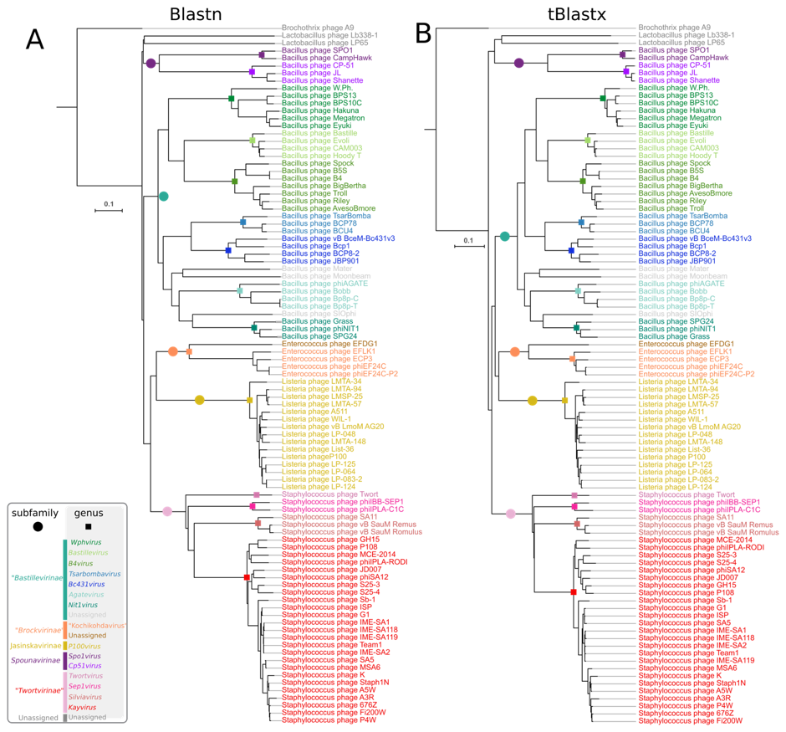

Figure 1: BLASTN-based clustering of the proposed herelleviruses. Cluster representation of heatmap generated with Gegenees (original names of genera used).

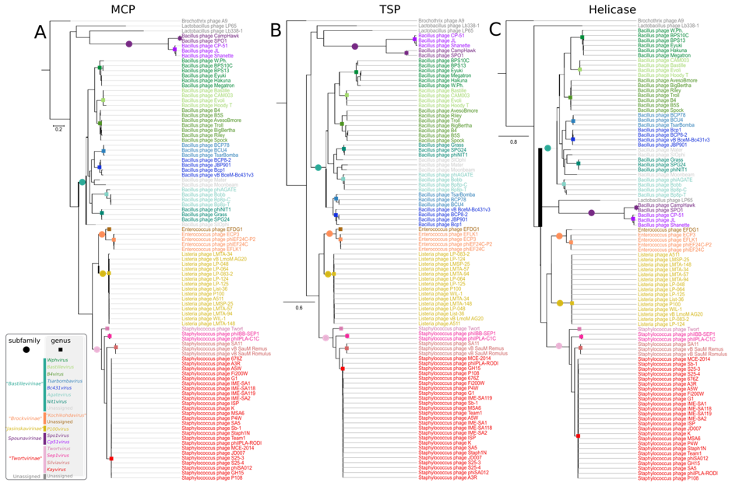

Figure 2: Maximum Likelihood phylogenetic tree of the major capsid protein amino acid sequence of herelleviruses (original names of genera used). The scale bar represents the number of substitutions per site.



Figure 3: Gegenees BLASTN heat map analysis of the phages which constitute the *Herelleviridae*. The black boxes indicate phage strains.



Figure 4: Gegenees TBLASTX heat map analysis of the phages which constitute the *Herelleviridae*. The blue boxed phages represent a subfamily.

| **References:** |
| --- |
| Ågren J., Sundström A., Håfström T., Segerman B. 2012. Gegenees: Fragmented alignment of multiple genomes for determining phylogenomic distances and genetic signatures unique for specified target groups. PLoS One. 7:e39107.  Barylski J., Nowicki G., Goździcka-Józefiak A. 2014. The discovery of phiAGATE, a novel phage infecting *Bacillus pumilus*, leads to new insights into the phylogeny of the subfamily *Spounavirinae*. PLoS One. 9:e86632.  Bolduc B., Jang H. Bin, Doulcier G., You Z.-Q., Roux S., Sullivan M.B. 2017a. vConTACT: an iVirus tool to classify double-stranded DNA viruses that infect Archaea and Bacteria. PeerJ. 5:e3243.  Iranzo J., Krupovic M., Koonin E. V. 2016. The double-stranded DNA virosphere as a modular hierarchical network of gene sharing. MBio. 7:e00978-16.  Iranzo J., Krupovic M., Koonin E. V. 2017. A network perspective on the virus world. Commun. Integr. Biol. 889:00–00. |