This Word module should be used for all taxonomic proposals.

Please complete **Part 1** and:

either **Part 3** for proposals to create new taxa or change existing taxa

or **Part 2** for proposals of a general nature.

Submit the completed Word module, together with the accompanying Excel module named in Part 3, to the appropriate ICTV Subcommittee Chair.

For guidance, see the notes written in blue, below, and the help notes in file Taxonomic_Proposals_Help_2018.

**Part 1:** **TITLE, AUTHORS, etc**

|  |  |  |  |
| --- | --- | --- | --- |
| **Code assigned:** | ***2018.119B*** | | (to be completed by ICTV officers) |
| **Short title:** To create one (1) new genus, *Gorganvirus*, including one (1) type species within the family *Siphoviridae*.(e.g. “6 new species in the genus *Zetavirus”*) | | | |
|  | | | |
| **Author(s):** | | | |
| Mahsa Yazdi – University of Isfahan (Iran)  Majid Bouzari - University of Isfahan (Iran)  Ezzat Allah Ghaemi - Golestan University of Medical Sciences (Iran)  Evelien Adriaenssens - University of Liverpool (UK)  Andrew Kropinski - University of Guelph (Canada) | | | |
| **Corresponding author with e-mail address:** | | | |
| Majid Bouzari [bouzari@sci.ui.ac.ir](mailto:bouzari@sci.ui.ac.ir) | | | |
| **List the ICTV study group(s) that have seen this proposal:** | | | |
| A list of study groups and contacts is provided at <http://www.ictvonline.org/subcommittees.asp> . If in doubt, contact the appropriate subcommittee chair (there are six virus subcommittees: animal DNA and retroviruses, animal ssRNA-, animal ssRNA+, fungal and protist, plant, bacterial and archaeal) | | **Bacterial and Archaeal Viruses Subcommittee** | |
| **ICTV Study Group comments (if any) and response of the proposer:** | | | |
|  | | | |
|  | | | |
| Date first submitted to ICTV: | | | June 2018 |
| Date of this revision (if different to above): | | |  |

|  |
| --- |
| **ICTV-EC comments and response of the proposer:** |
|  |

**Part 3:** **PROPOSED TAXONOMY**

|  |
| --- |
| **Name of accompanying Excel module: 2018.119B.N.v2.Gorganvirus** |

The taxonomic changes you are proposing should be presented on an accompanying Excel module, 2017_TP_Template_Excel_module. Please enter the file name of the completed module in this box.

**Supporting material:**

| additional material in support of this proposal |
| --- |
| Please explain the reasons for the taxonomic changes you are proposing and provide evidence to support them. The following information should be provided, where relevant:   * **Species demarcation criteria**: Explain how new species differ from others in the genus and demonstrate that these differences meet the criteria previously established for demarcating between species. If no criteriahave previously been established, and if there will now be more than one species in the genus, please state the demarcation criteria you are proposing. * **Higher taxa**:   + There is no formal requirement to state demarcation criteria when proposing new genera or other higher taxa. However, a similar concept should apply in pursuit of a rational and consistent virus taxonomy.   + Please indicate the **origin of names** assigned to new taxa at genus level and above.   + For each new genus a **type species** must be designated to represent it. Please explain your choice. * **Supporting evidence**: The use of Figures and Tables is strongly recommended (note that copying from publications will require permission from the copyright holder). For phylogenetic analysis, try to provide a tree where branch length is related to genetic distance. |

**Species demarcation criteria** We have chosen 95% DNA sequence identity as the criterion for demarcation of species in this new genus. Each of the proposed species differs from the others with more than 5% at the DNA level as confirmed with the BLASTN algorithm.

**Source of the name of this taxon:** Based on the name of the city where the type isolate, Proteus phage vB_PmiS_Isfahan was studied.

ProteusphagevB_PmiS-Isfahan was isolated from sewage in Gorgan, Iran, using *Proteus mirabilis* (TH) (Accession No.: KX446920) as the host. Its physico-chemical characteristics are listed in Table 1.

The relatedness of the phage was confirmed using BLASTp (1); progressiveMauve (2) (Fig.1); and, by phylogenetic analysis through the “One Click” server (3) of the annotated major capsid proteins (MCP) and large subunit terminase proteins (Fig.2).We chose MCP protein and large subunit terminase proteins sequences to identify the relationship between this phage and other tailed phages (taxid:28883), as the phage is known to have tail (Fig.3; Electron microscopy). The similarity and identity of the BLASTp results were 97% and 60-61% for major capsid protein, and 99% and 60% for large terminase protein respectively. The results were for the phages *Salmonella* phages vB_SenS_Sasha, FSL SP-062, and 9NA, all belong in the family *Siphoviridae*.

BLASTn (Table 1) and phylogenetic analyses (Fig. 2) (3) all indicate thatProteus phage vB_PmiS-Isfahan, is significantly different, and distinct from other genera. Therefore, we propose a new genus, *Gorganvirus,* with *Proteus virus Isfahan* as the prototype species of the genus within the family *Siphoviridae*.

|  |  |  |  |  |  |  |  |  |  |  |  |  |  |  |  |  |  |  |  |  |  |  |  |  |  |  |  |  |  |  |  |  |  |  |  |  |
| --- | --- | --- | --- | --- | --- | --- | --- | --- | --- | --- | --- | --- | --- | --- | --- | --- | --- | --- | --- | --- | --- | --- | --- | --- | --- | --- | --- | --- | --- | --- | --- | --- | --- | --- | --- | --- |
| **Table 1.** Properties of the Proteus phage vB_PmiS-Isfahan   |  |  |  |  |  |  |  |  | | --- | --- | --- | --- | --- | --- | --- | --- | | Proteus phage | |  | | --- | | GenBank Accession No. | | Genome length (kbp) | Genome (mol% G+C) | No. CDS | No. tRNAs | DNA (% sequence identity) * | | vB_PmiS-Isfahan | KY742649.2 | 54.84 | 36.1%. | 91 | 0 | 100 | | Salmonella phage Solent | MH586730.1 | 55.98 | 43.5 | 92 | 0 | 14.5 | | Salmonella phage Sergei | KY002061 | 56.05 | 43.5 | 91 | 0 | 14.5 | | Salmonella phage Sasha | KX987158 | 53.26 | 43.7 | 81 | 0 | 14.5 |   * Determined using BLASTn at NCBI  **Fig.1**  Fig. 1. Mauve alignment of the annotated complete genomes of Proteus phage vB_PmiS-Isfahan with Salmonella phage 9NA, Salmonella phage FSL SP-062, and Salmonella phage vB_SenS_Sasha (from top to bottom). The degree of sequence similarity between regions is given by a similarity plot within the colored blocks with the height of the plot proportional to the average nucleotide identity.   1. **Major capsid proteins**   new mahsa2 |
| 1. **Terminase, large subunit** |

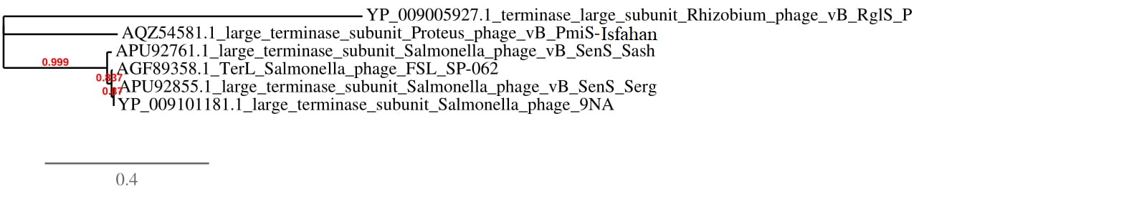Fig. 2. Phylogenetic analysis of (A) major capsid proteins (B) and large subunit terminase proteins of Proteus phage vB_PmiS-Isfahan and a variety of other siphovirus proteins constructed using “one click” at phylogeny.fr (3). "The "One Click mode" is for the users that do not like to deal with program and parameter selection. It is a "default" mode which proposes a pipeline already set up to run and connect programs recognized for their accuracy and speed (MUSCLE for multiple alignment and PhyML for phylogeny) to reconstruct a robust phylogenetic tree from a set of sequences. It also includes the use of Gblocks to eliminate poorly aligned positions and divergent regions. "The usual bootstrapping procedure is replaced by a new confidence index that is much faster to compute. See: "Anisimova M., Gascuel O. Approximate likelihood ratio test for branches: A fast, accurate and powerful alternative (Syst Biol. 2006; 55(4):539-52)" for more details.

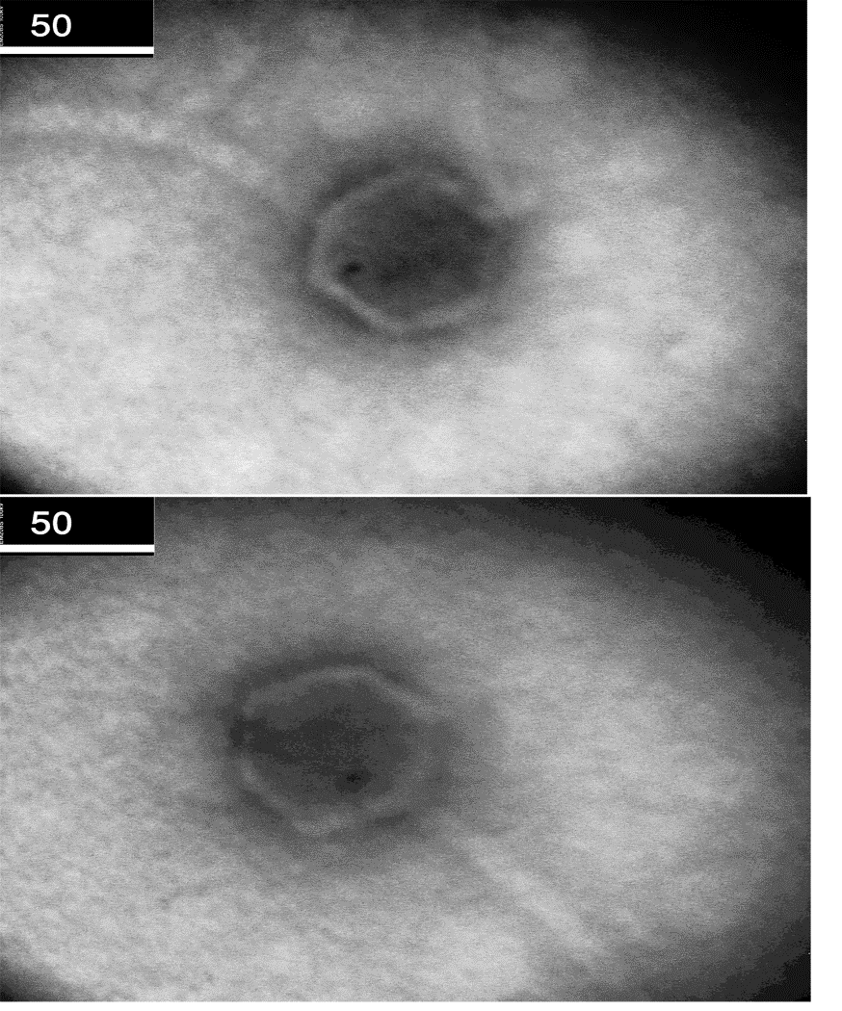

Fig. 3. Electron micrograph of negatively stained (2% uranyl acetate) *Proteus* phage vB_PmiS-Isfahan

| **References:** |
| --- |
| 1. Altschul SF, Gish W, Miller W, Myers EW, Lipman DJ. Basic local alignment search tool. Journal of Molecular Biology. 1990;215(3):403-10.  2. Darling AC, Mau B, Blattner FR, Perna NT. Mauve: multiple alignment of conserved genomic sequence with rearrangements. Genome Research. 2004;14(7):1394-403.  3. Dereeper A, Guignon V, Blanc G, Audic S, Buffet S, Chevenet F, et al. Phylogeny. fr: robust phylogenetic analysis for the non-specialist. Nucleic Acids Research. 2008;36(suppl_2):W465-W9. |