This Word module should be used for all taxonomic proposals.

Please complete **Part 1** and:

either **Part 3** for proposals to create new taxa or change existing taxa

or **Part 2** for proposals of a general nature.

Submit the completed Word module, together with the accompanying Excel module named in Part 3, to the appropriate ICTV Subcommittee Chair.

For guidance, see the notes written in blue, below, and the help notes in file Taxonomic_Proposals_Help_2018.

**Part 1:** **TITLE, AUTHORS, etc**

|  |  |  |  |
| --- | --- | --- | --- |
| **Code assigned:** | ***2018.123B*** | | (to be completed by ICTV officers) |
| **Short title: One (1) new species, *Pseudoalteromonas virus Cr39582*, in the genus *Corticovirus*, in the family *Corticoviridae***  (e.g. “6 new species in the genus *Zetavirus”*) | | | |
|  | | | |
| **Author(s):** | | | |
| Brittany A. Leigha,b*, Mya Breitbarta, Dennis H. Bamfordc, Larry J. Dishawb, Evelien Adriaenssensd, Andrew Kropinskie and Hanna M. Oksanenc  aCollege of Marine Science, University of South Florida, St. Petersburg, Florida, USA  bDepartment of Pediatrics, Children’s Research Institute, University of South Florida, St. Petersburg, Florida, USA  cMolecular and Integrative Research Programme, Faculty of Biological and Environmental Sciences, University of Helsinki, Helsinki, Finland  dUniversity of Liverpool, UK  eUniversity of Guelph, Canada  *Current address: Department of Biological Sciences, Vanderbilt University, Nashville, TN, USA | | | |
| **Corresponding author with e-mail address:** | | | |
| Hanna M. Oksanen, hanna.oksanen@helsinki.fi | | | |
| **List the ICTV study group(s) that have seen this proposal:** | | | |
| A list of study groups and contacts is provided at <http://www.ictvonline.org/subcommittees.asp> . If in doubt, contact the appropriate subcommittee chair (there are six virus subcommittees: animal DNA and retroviruses, animal ssRNA-, animal ssRNA+, fungal and protist, plant, bacterial and archaeal) | | **Bacterial and Archaeal Viruses Subcommittee** | |
| **ICTV Study Group comments (if any) and response of the proposer:** | | | |
|  | | | |
|  | | | |
| Date first submitted to ICTV: | | | June 6, 2018 |
| Date of this revision (if different to above): | | |  |

|  |
| --- |
| **ICTV-EC comments and response of the proposer:** |
|  |

**Part 2:** **NON-STANDARD**

Template for any proposal regarding ICTV procedures, rules or policy, not involving the creation of new taxonomy.

| **Text of proposal:** |
| --- |
|  |

**Part 3:** **PROPOSED TAXONOMY**

|  |
| --- |
| **Name of accompanying Excel module: 2018.123B.N.v1.Corticovirus_sp** |

The taxonomic changes you are proposing should be presented on an accompanying Excel module, 2017_TP_Template_Excel_module. Please enter the file name of the completed module in this box.

**Supporting material:**

| additional material in support of this proposal |
| --- |
| Please explain the reasons for the taxonomic changes you are proposing and provide evidence to support them. The following information should be provided, where relevant:   * **Species demarcation criteria**: Explain how new species differ from others in the genus and demonstrate that these differences meet the criteria previously established for demarcating between species. If no criteriahave previously been established, and if there will now be more than one species in the genus, please state the demarcation criteria you are proposing. * **Higher taxa**:   + There is no formal requirement to state demarcation criteria when proposing new genera or other higher taxa. However, a similar concept should apply in pursuit of a rational and consistent virus taxonomy.   + Please indicate the **origin of names** assigned to new taxa at genus level and above.   + For each new genus a **type species** must be designated to represent it. Please explain your choice. * **Supporting evidence**: The use of Figures and Tables is strongly recommended (note that copying from publications will require permission from the copyright holder). For phylogenetic analysis, try to provide a tree where branch length is related to genetic distance. |

**Species demarcation criteria:** We propose to have 95% nucleotide sequence identity as the criterion for demarcation of species in the genus *Corticovirus*. The proposed species *Pseudoalteromonas virus Cr39582* differs from the type species *Pseudoalteromonas virus PM2* by ~15% at the nucleotide level as confirmed by the full genome alignment by Mauve (Darling et al., 2010) and MUSCLE (Edgar, 2004) nucleotide alignments (Leigh et al., 2018). *Pseudoalteromonas virus PM2* is currently the only species in the genus *Corticovirus*, the family *Corticoviridae* (Oksanen, 2017).

**Supporting evidence:** The Cr39582 and PM2 genomes are syntenous sharing sequence homology throughout their genome lengths (Figures 1 and 2) (Leigh et al., 2018). The only exception is the Cr39582 ORF (nucleotides 7982-9430) encoding for the putative spike protein which is not homologous with PM2 spike protein P1. The nucleotide sequence identity between Cr39582 and PM2 spike encoding genes is ~37%. Pairwise nucleotide identities between Cr39582 and PM2 in the 5’ and 3’ regions flanking the spike protein gene are ~91% and ~96%, respectively.

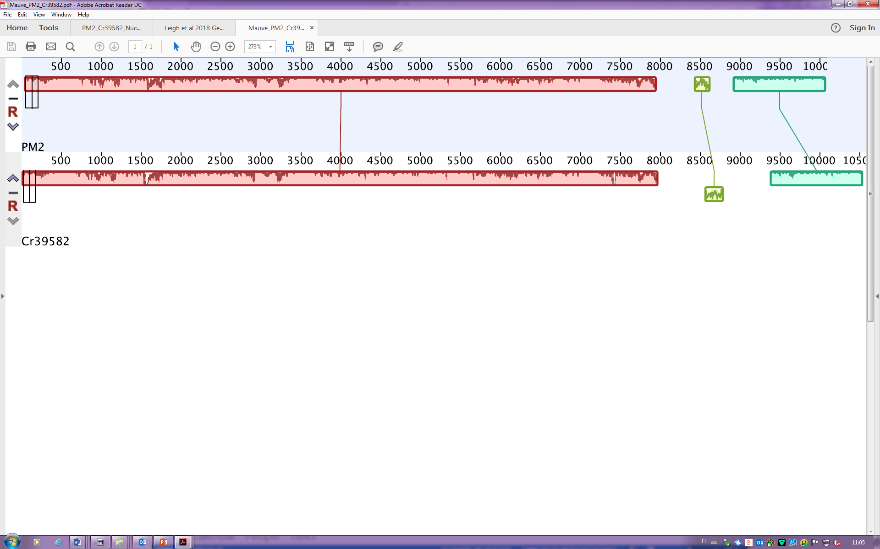

**Figure 1.** Multiple genome alignment between the genomes of PM2 and Cr39582 (Mauve, Darling et al., 2010). Colored boxes indicate blocks of the genomes with high sequence identity, and regions lacking homology appear as white.





**Figure 2.** Nucleotide alignment between the genomes of PM2 and Cr39582 (Edward, 2004). Nucleotide sequences of both Cr39582 and PM2 were pairwise aligned with the MUSCLE alignment tool. Green bars indicate 100% nucleotide identity, brown indicates no similarity, and red indicates a gap at the nucleotide position. Both the alignment and the resulting dot plot highlight the similarity of the two genomes aside from the spike protein (positions 7982-9430).

| **References:** |
| --- |
| Darling AE, Mau B, Perna N. 2010. progressiveMauve: multiple genome alignment with gene gain, loss and rearrangement. PLoS One 5:e11147  Edgar, R. C. 2004. MUSCLE: multiple sequence alignment with high accuracy and high throughput. Nucleic Acids Res. 32: 1792-1797.  Leigh BA, Breitbart M, Oksanen HM, Bamford DH, Dishaw LJ. 2018. [Genome sequence of PM2-like phage Cr39582, induced from a *Pseudoalteromonas* sp. isolated from the gut of *Ciona robusta*.](https://www.ncbi.nlm.nih.gov/pubmed/29798916) Genome Announc. 6:e00368-18.  Oksanen HM, ICTV Report Consortium. 2017. [ICTV Virus Taxonomy Profile: *Corticoviridae*.](https://www.ncbi.nlm.nih.gov/pubmed/28581380) J Gen Virol. 98:888-889. |