This Word module should be used for all taxonomic proposals.

Please complete **Part 1** and:

either **Part 3** for proposals to create new taxa or change existing taxa

or **Part 2** for proposals of a general nature.

Submit the completed Word module, together with the accompanying Excel module named in Part 3, to the appropriate ICTV Subcommittee Chair.

The Word module explains and justifies your proposal. The Excel module is a critical document that will be used to implement the proposed taxonomic changes once they are approved and ratified. If proposals presented in the Word module are not presented accurately in the Excel module, the taxonomic changes cannot proceed.

For guidance, see the notes written in blue, below, and the Help Notes in file Taxonomic_Proposals_Help_2019.

**Part 1:** **TITLE, AUTHORS, etc**

| **Code assigned:** | ***2019.043B*** | |  |
| --- | --- | --- | --- |
| **Short title:** Create one new genus (*Baoshanvirus*) including two new species in the subfamily *Twortvirinae,* family *Herelleviridae* | | | |
|  | | | |
| **Author(s) and email address(es):** | | | |
| List authors in a single line *Archives of Virology* citation format (e.g. Smith AB, Huang C-L, Santos, F) | | Provide email address for each author in a single line separated by semi-colons | |
| Łobocka M, Kropinski AM, Adriaenssens EM | | [lobocka@ibb.waw.pl](mailto:Phage.Canada@gmail.com)  [Phage.Canada@gmail.com](mailto:Phage.Canada@gmail.com); Evelien.adriaenssens@quadram.ac.uk | |
| **Author(s) institutional address(es) (optional):**   |  | | --- | | Provide institutional addresses, each on a single line followed by author(s) initials (e.g. University of Woolloomooloo [SAB, HCL]) | | **Institute of Biochemistry and Biophysics, PAS, Poland [ML]**  **University of Guelph, Canada [AMK]**  **Quadram Institute Bioscience, UK [EMA]** | | | | |
| **Corresponding author** | | | |
| Andrew M. Kropinski | | | |
| **List the ICTV study group(s) that have seen this proposal:** | | | |
| A list of study groups and contacts is provided at <http://www.ictvonline.org/subcommittees.asp> . If in doubt, contact the appropriate subcommittee chair (there are six virus subcommittees: animal DNA and retroviruses, animal ssRNA-, animal ssRNA+, fungal and protist, plant, bacterial and archaeal) | | **Bacterial and Archaeal Viruses Subcommittee**  **Caudovirales Study Group** | |
| **ICTV Study Group comments (if any) and response of the proposer:** | | | |
|  | | | |
|  | | | |
| Date first submitted to ICTV: | | |  |
| Date of this revision (if different to above): | | |  |

|  |
| --- |
| **ICTV-EC comments and response of the proposer:** |
|  |

**Part 2:** **NON-STANDARD**

Template for any proposal regarding ICTV procedures, rules or policy, not involving the creation of new taxonomy.

| **Text of proposal:** |
| --- |
|  |

**Part 3:** **PROPOSED TAXONOMY**

|  |
| --- |
| **Name of accompanying Excel module:** 2019.043B.A.v1.Baoshanvirus_1gen2sp.xlsx |

The taxonomic changes you are proposing should be presented on an accompanying Excel module, 2019_TP_Template_Excel_module. Please enter the file name of the completed module in this box.

**Supporting material:**

| additional material in support of this proposal |
| --- |
| Please explain the reasons for the taxonomic changes you are proposing and provide evidence to support them. The following information should be provided, where relevant:   * **Species demarcation criteria**: Explain how new species differ from others in the genus and demonstrate that these differences meet the criteria previously established for demarcating between species. If no criteriahave previously been established, and if there will now be more than one species in the genus, please state the demarcation criteria you are proposing. * **Higher taxa**:   + There is no formal requirement to state demarcation criteria when proposing new genera or other higher taxa. However, a similar concept should apply in pursuit of a rational and consistent virus taxonomy.   + Please indicate the **origin of names** assigned to new taxa at genus level and above.   + For each new genus a **type species** must be designated to represent it. Please explain your choice. * **Supporting evidence**: The use of Figures and Tables is strongly recommended (note that copying from publications will require permission from the copyright holder). For phylogenetic analysis, please provide a tree where branch length is **proportional to genetic** distance, generated using an appropriate algorithm (Neighbour-Joining, Maximum Likelihood, or Bayesian) and provide evidence of the reliability of the branching (e.g., by bootstrapping).   Please refer to the Help Notes file (Taxonomic_Proposals_Help_2019) for more information. |

**Species demarcation criteria** We have chosen 95% DNA sequence identity as the criterion for demarcation of species in this new genus. Representatives of the proposed species differ no more than 5% from each other at the DNA level as confirmed with the BLASTN algorithm.

**Source of the name of this taxon:** The genus is named after the name of Chinese district Baoshan, where the phages of this genus were isolated.

**History:** At present the subfamily *Twortvirinae* consists of four staphylococcal phage genera,*Twortvirus, Silviavirus, Sepunavirus* and *Kayvirus*and three orphan species - *Brochothrix virus A9*, *Lactobacillus virus Lb338-1* and *Lactobacillus virus LP65* (1). This TaxoProp proposes the creation of a new genus *Baoshanvirus* containing two species with representative phages phiSA_BS1 and phiSA_BS2 of *Staphylococcus* viruses, respectively. *Staphylococcus* phages phiSA_BS1 and phiSA_BS2 were isolated in dairy farm in Shanghai, at the Baoshan district in China. There is no evidence to suggest that these phages are temperate. *Staphylococcus* phage phiSA_BS2 has been selected as the type species phage of *Baoshanvirus* genus.

**Comparisons of *Staphylococcus Twortvirinae* phages genomes:** The genomes were compared using Gegenees 3.0 (2). Comparisons of all-against-all genomic fragments were performed with the BLASTn (3, 4) algorithm with fragment size of 50 nt and sliding step size of 25 nt, as recommended for viral and plasmid genomes. Resulting matrices obtained were sorted by Gegenees tool Autosort. Representatives of proposed genus *Baoshanvirus* are boxed.

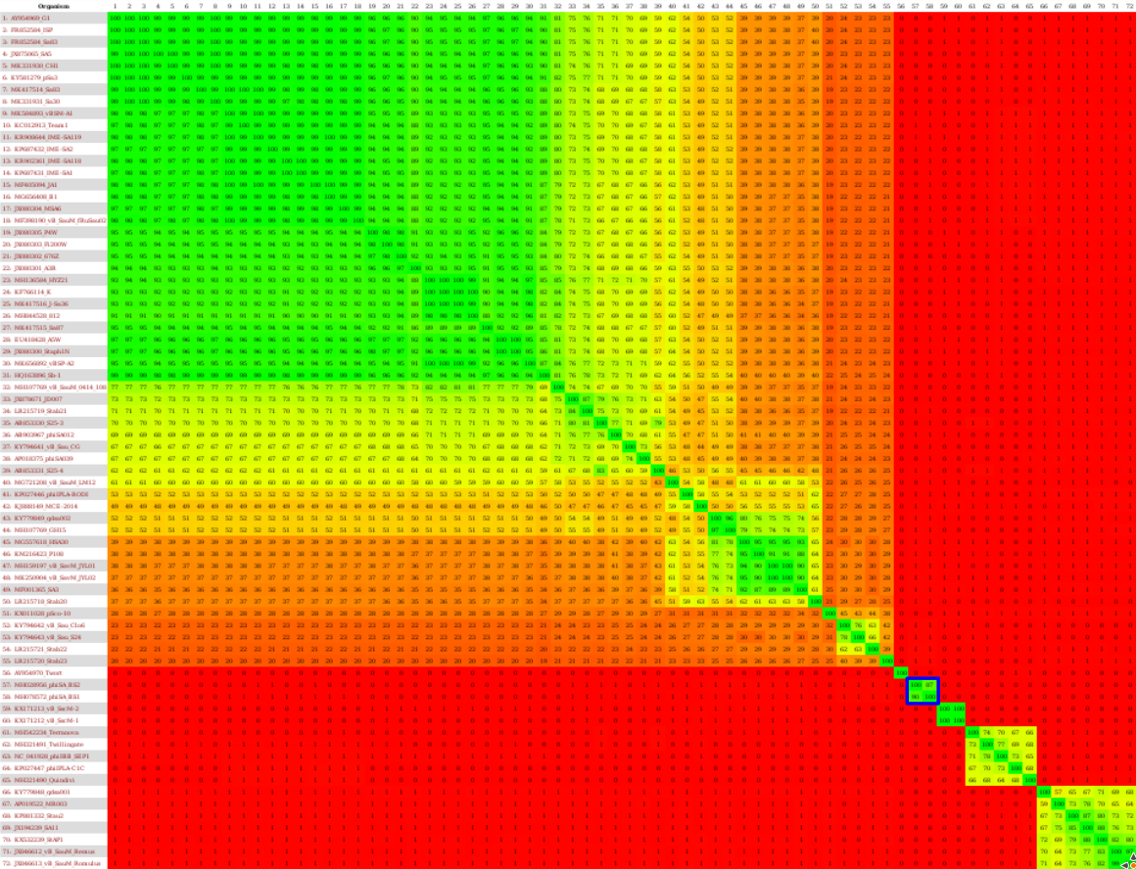

**GenBank Summary:** Overall properties of *Baoshanvirus* genus phages.

|  |  |  |  |  |  |  |  |  |
| --- | --- | --- | --- | --- | --- | --- | --- | --- |
| Phage name | RefSeq No. | INSDC | Size* (Kb) | GC% | Protein | tRNA** | Overall DNA sequence identity (***) | % common proteins (****) |
| *Staphylococcus* phage phiSA_BS2 |  | MH028956.1 | 149229 | 29.6 | 210 | 1 | 100% | 100 |
| *Staphylococcus* phage  phiSA_BS1 |  | MH078572.1 | 142978 | 29.8 | 201 | 1 | 93% | 90 |

**\* The sequences deposited in GenBank may be shorter than the real sequences of virion DNAs of both phages, as the former do not contain the second copy of terminal repeat region, which is likely to be present in these phages virion DNA, by analogy to related phages**

**\*\* None indicated in GenBank file summary; discovered using tRNAscan-SE2 set for bacterial sequence as a source (5)**

**\*\*\* Determined using BLASTn at NCBI (3, 4)**

**\*\*\*\* Determined using CoreGenes3.5 at** [**http://binf.gmu.edu:8080/CoreGenes3.5/**](http://binf.gmu.edu:8080/CoreGenes3.5/) **(6)**

**BLASTN homologs:** The next most closely related phage of phiSA_BS2 is *Staphylococcus* phage Stab23 with which phiSA_B2 shares 27.4% DNA sequence relatedness. The following is a neighbour joining tree derived from the NCBI BLASTn results:

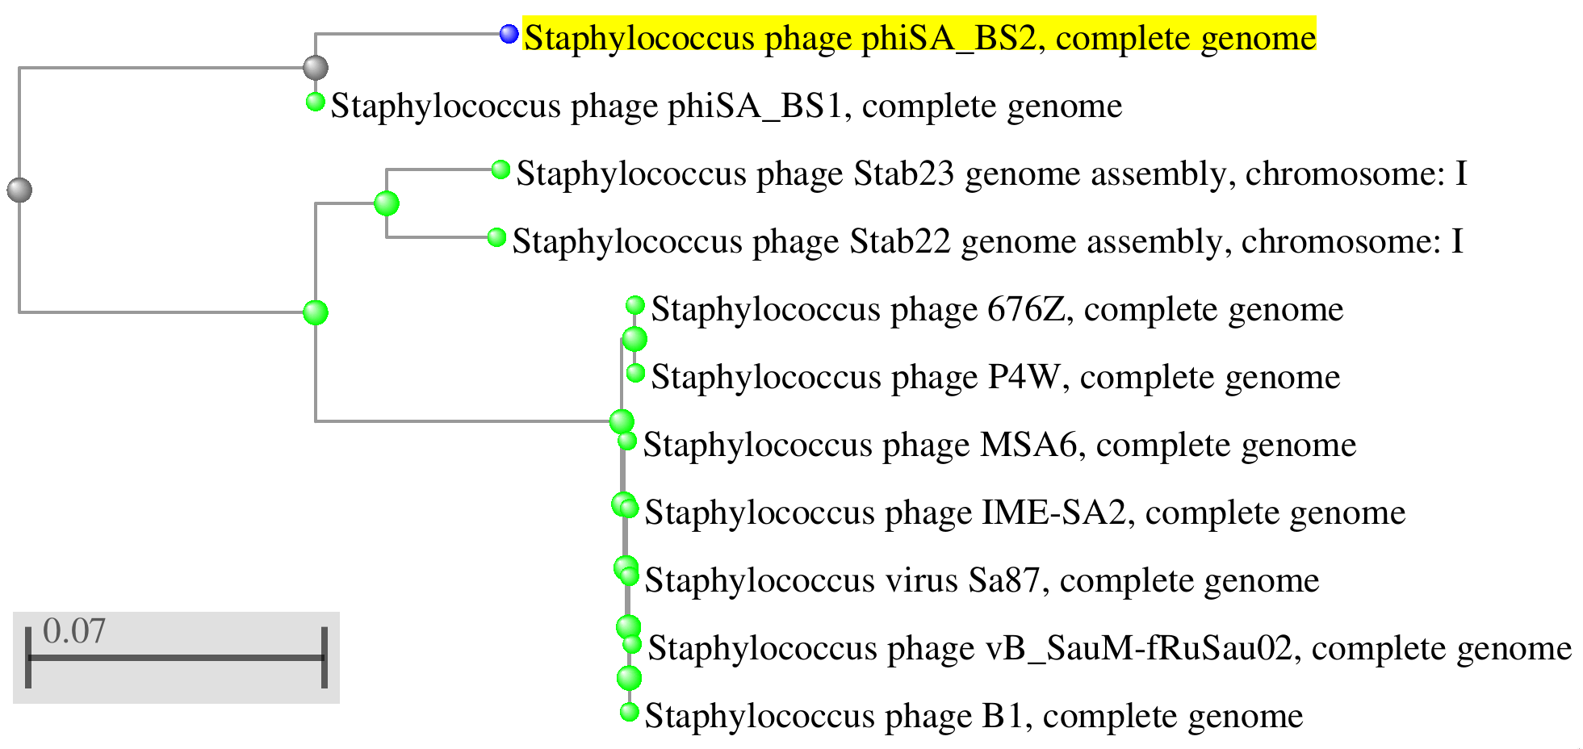

**Electron micrograph:** None available.

**Phylogeny:** The phylogenetic tree was constructed using the major capsid protein homologs of phiSA_BS2 and related phages with phylogeny.fr in “one click” mode (6). "The "One Click mode" targets users that do not wish to deal with program and parameter selection. By default, the pipeline is already set up to run and connect programs recognized for their accuracy and speed (MUSCLE for multiple

alignment and PhyML for phylogeny) to reconstruct a robust phylogenetic tree from a set of

sequences." It also includes the use of Gblocks to eliminate poorly aligned positions and divergent

regions. "The usual bootstrapping procedure is replaced by a new confidence index that is much

faster to compute. See (7) for details."

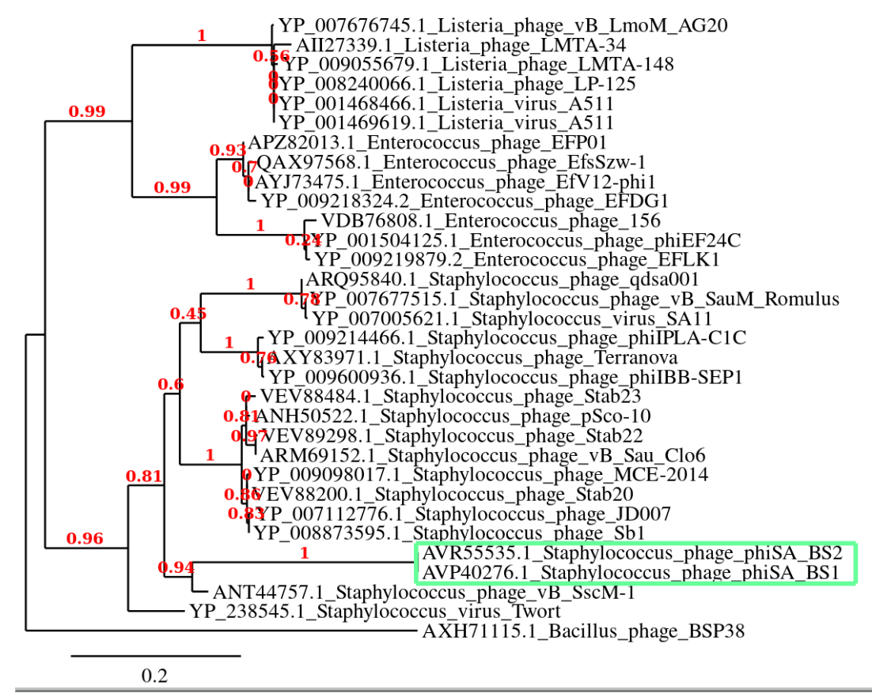

| **References:** |
| --- |
| 1. Barylski, J., Enault, F., Dutilh, B. E., Schuller, M. B. P., Edwards, R. A., Gillis, A., Klumpp, J., Knezevic, P., Krupovic, M., Kuhn, J. H., Lavigne, R., Oksanen, H. M., Sullivan, M. B., Jang, H. B., Simmonds, P., Aiewsakun, P., Wittmann, J., Tolstoy, I., Brister, J. R., Kropinski, A. M. & Adriaenssens, E. M. Analysis of Spounaviruses as a Case Study for the Overdue Reclassification of Tailed Phages. *Syst Biol.* **25,** pii: syz036 (2019). 2. Agren, J., Sundström, A., Håfström, T. & Segerman, B. Gegenees: fragmented alignment of multiple genomes for determining phylogenomic distances and genetic signatures unique for specified target groups. *PLoS One*. **7**(6):e39107 (2012). 3. Brister, J. R., Ako-adjei, D., Bao, Y. & Blinkova, O. NCBI Viral Genomes Resource. *Nucleic Acids Res.* **43**, D571–D577 (2015). 4. Zhang, Z., Schwartz, S., Wagner, L. & Miller, W. A greedy algorithm for aligning DNA sequences", *J Comput Biol.* **7** (1-2), 203-214 (2000). 5. Lowe, T. M. & Eddy, S. R. tRNAscan-SE: a program for improved detection of transfer RNA genes in genomic sequence. *Nucleic Acids Res* **25**, (1997). 6. Mahadevan, P., King, J. F. & Seto, D. CGUG: in silico proteome and genome parsing tool for the determination of ‘core’ and unique genes in the analysis of genomes up to ca. 1.9 Mb. *BMC Res. Notes* **2**, 168 (2009). 7. Dereeper, A. *et al.* Phylogeny.fr: robust phylogenetic analysis for the non-specialist. *Nucleic Acids Res.* **36**, W465-469 (2008). |