
This Word module should be used for all taxonomic proposals.
Please complete Part 1 and:
either Part 3 for proposals to create new taxa or change existing taxa
or Part 2 for proposals of a general nature.
Submit the completed Word module, together with the accompanying Excel module named in Part 3, to the appropriate ICTV Subcommittee Chair.
The Word module explains and justifies your proposal. The Excel module is a critical document that will be used to implement the proposed taxonomic changes once they are approved and ratified. If proposals presented in the Word module are not presented accurately in the Excel module, the taxonomic changes cannot proceed.
For guidance, see the notes written in blue, below, and the Help Notes in file Taxonomic_Proposals_Help_2019.
Part 1: TITLE, AUTHORS, etc

Code assigned: | 2019.047B
Short title: Create one new family (Chaseviridae) including six new genera in the order Caudovirales
Author(s) and email address(es):
List authors in a single line Archives of Virology citation format (e.g. Smith AB, Huang C-L, Santos, F) |  | Provide email address for each author in a single line separated by semi-colons
Kropinski AM, Anany, H, Adriaenssens EM |  | Phage.Canada@gmail.com;  hany.anany@canada.ca;  Evelien.Adriaenssens@quadram.ac.uk
Author(s) institutional address(es) (optional):
Provide institutional addresses, each on a single line followed by author(s) initials (e.g. University of Woolloomooloo [SAB, HCL])
University of Guelph, Canada [AMK]
Agriculture & AgriFood Canada [HA]
Quadram Institute Bioscience, UK [EMA]

Corresponding author
Andrew M. Kropinski
List the ICTV study group(s) that have seen this proposal:
A list of study groups and contacts is provided at http://www.ictvonline.org/subcommittees.asp . If in doubt, contact the appropriate subcommittee chair (there are six virus subcommittees: animal DNA and retroviruses, animal ssRNA-, animal ssRNA+, fungal and protist, plant, bacterial and archaeal) |  | Bacterial and Archaeal Viruses Subcommittee  Caudovirales Study Group
Authority to use the name of a living person:
Please provide the following information if you propose taxon name(s) which are derived from the name of a living person or persons. Please attach documents to verify that permission has been obtained.
Taxon name | Person from whom the name is derived | Permission obtained (Y/N)
Carltongylesvirus | Carlton Gyles | Y
Loessnervirus | Martin J. Loessner | Y

ICTV Study Group comments (if any) and response of the proposer:
Date first submitted to ICTV:
Date of this revision (if different to above):

ICTV-EC comments and response of the proposer:

Part 2: NON-STANDARD
Template for any proposal regarding ICTV procedures, rules or policy, not involving the creation of new taxonomy.
Text of proposal:

Part 3: PROPOSED TAXONOMY

Name of accompanying Excel module: 2019.047B.A.v1.Chaseviridae_1fam6gen.xlsx
The taxonomic changes you are proposing should be presented on an accompanying Excel module, 2019_TP_Template_Excel_module. Please enter the file name of the completed module in this box.
Supporting material:
additional material in support of this proposal
Please explain the reasons for the taxonomic changes you are proposing and provide evidence to support them. The following information should be provided, where relevant:
- Species demarcation criteria: Explain how new species differ from others in the genus and demonstrate that these differences meet the criteria previously established for demarcating between species. If no criteria have previously been established, and if there will now be more than one species in the genus, please state the demarcation criteria you are proposing.
- Higher taxa:
  - There is no formal requirement to state demarcation criteria when proposing new genera or other higher taxa. However, a similar concept should apply in pursuit of a rational and consistent virus taxonomy.
  - Please indicate the origin of names assigned to new taxa at genus level and above.
  - For each new genus a type species must be designated to represent it. Please explain your choice.
- Supporting evidence: The use of Figures and Tables is strongly recommended (note that copying from publications will require permission from the copyright holder). For phylogenetic analysis, please provide a tree where branch length is proportional to genetic distance, generated using an appropriate algorithm (Neighbour-Joining, Maximum Likelihood, or Bayesian) and provide evidence of the reliability of the branching (e.g., by bootstrapping).
Please refer to the Help Notes file (Taxonomic_Proposals_Help_2019) for more information.

References:
1: Sayers EW, Agarwala R, Bolton EE, Brister JR, Canese K, Clark K, et al. Database resources of the National Center for Biotechnology Information. Nucleic Acids Res. 2019;47(D1):D23-D28.

2: Tolstoy I, Kropinski AM, Brister JR. Bacteriophage Taxonomy: An Evolving Discipline. Methods Mol Biol. 2018;1693:57-71.

3: O'Leary NA, Wright MW, Brister JR, Ciufo S, Haddad D, McVeigh R, et al. Reference sequence (RefSeq) database at NCBI: current status, taxonomic expansion, and functional annotation. Nucleic Acids Res. 2016;44(D1):D733-45.

4: Agren J, Sundström A, Håfström T, Segerman B. Gegenees: fragmented alignment of multiple genomes for determining phylogenomic distances and genetic signatures unique for specified target groups. PLoS One. 2012;7(6):e39107.

5: Chan PP, Lowe TM. tRNAscan-SE: Searching for tRNA Genes in Genomic Sequences. Methods Mol Biol. 2019;1962:1-14.

6: Turner D, Reynolds D, Seto D, Mahadevan P. CoreGenes3.5: a webserver for the determination of core genes from sets of viral and small bacterial genomes. BMC Res Notes. 2013;6:140.

7: Darling AE, Mau B, Perna NT. progressiveMauve: multiple genome alignment with gene gain, loss and rearrangement. PLoS One. 2010;5(6):e11147.

8: Dereeper A, Guignon V, Blanc G, Audic S, Buffet S, Chevenet F, Dufayard JF, Guindon S, Lefort V, Lescot M, Claverie JM, Gascuel O. Phylogeny.fr: robust phylogenetic analysis for the non-specialist. Nucleic Acids Res. 2008;36(Web Server issue):W465-9.

9: Anisimova M, Gascuel O. Approximate likelihood-ratio test for branches: A fast, accurate, and powerful alternative. Syst Biol. 2006;55(4):539-52.

10: Jamalludeen N, Johnson RP, Friendship R, Kropinski AM, Lingohr EJ, Gyles CL. Isolation and characterization of nine bacteriophages that lyse O149 enterotoxigenic Escherichia coli. Vet Microbiol. 2007;124(1-2):47-57.

11: Jamalludeen N, Kropinski AM, Johnson RP, Lingohr E, Harel J, Gyles CL. Complete genomic sequence of bacteriophage phiEcoM-GJ1, a novel phage that has myovirus morphology and a podovirus-like RNA polymerase. Appl Environ Microbiol. 2008; 74(2):516-25.

12: Lim JA, Shin H, Lee DH, Han SW, Lee JH, Ryu S, Heu S. Complete genome sequence of the Pectobacterium carotovorum subsp. carotovorum virulent bacteriophage PM1. Arch Virol. 2014; 159(8):2185-7. [PM1]

13: Born Y, Fieseler L, Marazzi J, Lurz R, Duffy B, Loessner MJ. Novel virulent and broad-host-range Erwinia amylovora bacteriophages reveal a high degree of mosaicism and a relationship to Enterobacteriaceae phages. Appl Environ Microbiol. 2011;77(17):5945-54. [vB_EamM-Y2]

14: Farris JS: Estimating phylogenetic trees from distance matrices. Am Nat 1972, 106:645-667.

15: Göker M, García-Blázquez G, Voglmayr H, Tellería MT, Martín MP: Molecular taxonomy of phytopathogenic fungi: A case study in Peronospora. PLoS One 2009, 4:8-10.

16: Lefort V, Desper R, Gascuel O: FastME 2.0: A comprehensive, accurate, and fast distance-based phylogeny inference program. Mol Biol Evol 2015, 32:2798-2800.

17: Meier-Kolthoff JP, Auch AF, Klenk H-P, Göker M: Genome sequence-based species delimitation with confidence intervals and improved distance functions. BMC Bioinformatics 2013, 14:60.

18: Meier-Kolthoff JP, Göker M. VICTOR: Genome-based Phylogeny and Classification of Prokaryotic Viruses. Bioinformatics 2017, 33:3396-3404.

19: Meier-Kolthoff JP, Hahnke RL, Petersen J, Scheuner C, Michael V, Fiebig A, Rohde C, Rohde M, Fartmann B, Goodwin L a., Chertkov O, Reddy TBK, Pati A, Ivanova NN, Markowitz V, Kyrpides NC, Woyke T, Göker M, Klenk H-P: Complete genome sequence of DSM 30083T, the type strain (U5/41T) of Escherichia coli, and a proposal for delineating subspecies in microbial taxonomy. Stand Genomic Sci 2014, 9:2.

20: Rambaut A. FigTree 1.4.3 - a graphical viewer of phylogenetic trees and a program for producing publication-ready figures. 2006. URL: http://tree.bio.ed.ac.uk/software/figtree/
Species demarcation criteria We have chosen 95% DNA sequence identity as the criterion for demarcation of species in this new genus. Each of the proposed species differs from the others with more than 5% at the DNA level as confirmed with the BLASTN algorithm.

Source of the name of this taxon: The name of this family honour “Martha Cowles Chase (1927 – 2003), also known as Martha C. Epstein, was an American geneticist known for having in 1952, with Alfred Hershey, experimentally helped to confirm that DNA rather than protein is the genetic material of life” (https://en.wikipedia.org/wiki/Martha_Chase)

Proposal A: To create a new genus, Carltongylesvirus, containing two species in this family.

Source of the name of this taxon: This genus is named in honour of Dr. Carlton Gyles (University Professor Emeritus, University of Guelph (Ontario, Canada)) in whose laboratory Escherichia phage phiEcoM-GJ1 was isolated and studied [10,11].

History: Escherichia phage phiEcoM-GJ1 was isolated in 2004 from fresh Ontario pig farm sewage and a a mixture of 10 recently isolated O149:H10:F4 ETEC strains. Escherichia phage ST32 was isolated in Beijing, China using Escherichia coli H21 as the host bacterium. Phage GJ1 has a broad host range lysing 99% of O149:H10 ETEC strains and 68% of the ECOR collection [10]. Morphologically, its head measures 63X55nm and its tail 120x23nm (Figure 1). The genome is circularly permuted. A unique feature of this phage is that it encodes, as do the T7-like phages (Autographivirinae), an RNA polymerase.

Electron micrograph of phage GJ1: (Bar: 50 nm)
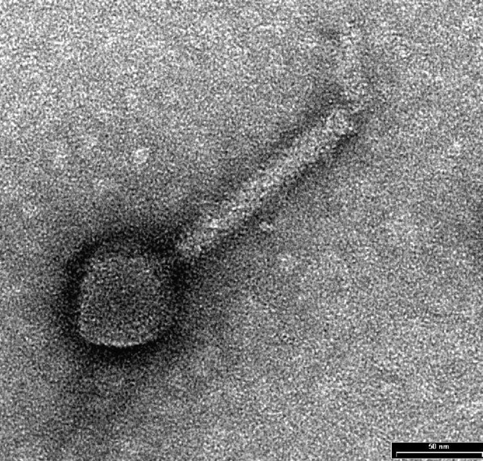

GenBank Summary:

Phage name | RefSeq No. | INSDC | Size (Kb) | GC% | Protein | tRNA | Overall DNA sequence identity (**) | % common proteins (**)
Enterobacteria phage phiEcoM-GJ1 | NC_010106.1 | EF460875.1 | 52.98 | 44.0 | 75 | 1 | 100% | 100
Escherichia phage ST32 |  | MF044458.2 | 53.09 | 44.1 | 79 | 1(*) | 84.6 | 89.3
* None indicated in GenBank genome summary; discovered using tRNAscan-SE (http://lowelab.ucsc.edu/tRNAscan-SE/)
** Determined using BLASTn at NCBI [1-3]
*** Determined using CoreGenes 3.5 at http://binf.gmu.edu:8080/CoreGenes3.5/ [6]

BLASTN homologs: The next most closely related phage is Erwinia phage Faunus which shares 42.3% identity with GJ1 [1-3].

Phylogeny: The phylogenetic tree was constructed using A. the large subunit terminase protein homologs and B. The RNA polymerases of GJ1 and related phages with phylogeny.fr in “one click” mode [8]. "The "One Click mode" targets users that do not wish to deal with program and parameter selection. By default, the pipeline is already set up to run and connect programs recognized for their accuracy and speed (MUSCLE for multiple alignment and PhyML for phylogeny) to reconstruct a robust phylogenetic tree from a set of sequences." It also includes the use of Gblocks to eliminate poorly aligned positions and divergent
regions. "The usual bootstrapping procedure is replaced by a new confidence index that is much
faster to compute. See: Anisimova M., Gascuel O. Approximate likelihood ratio test for branches:
A fast, accurate and powerful alternative [9] for details."

- TerL proteins

- RNAP proteins

Proposal B: to create a new genus, Faunusvirus, containing a single species in this family

Source of the name of this taxon: This genus is named after the first phage of its type, Erwinia phage Faunus.

History: Erwinia phage Faunus was isolated in Denmark from organic waste using Erwinia amylovora as the host bacterium. [No publication].

Electron micrograph: None available

GenBank Summary:

Phage name | RefSeq No. | INSDC | Size (Kb) | GC% | Protein | tRNA
Erwinia phage Faunus |  | MH191398.1 | 54.07 | 43.6 | 78 | 0

BLASTN homologs: The next most closely related phage is Escherichia phage phiEcoM-GJ1 which shares 41.6% identity with Faunus [1-3].

Phylogeny: The phylogenetic tree was constructed using A. the large subunit terminase protein homologs and B. The RNA polymerases of GJ1 and related phages with phylogeny.fr in “one click” mode [8]. "The "One Click mode" targets users that do not wish to deal with program and parameter selection. By default, the pipeline is already set up to run and connect programs recognized for their accuracy and speed (MUSCLE for multiple alignment and PhyML for phylogeny) to reconstruct a robust phylogenetic tree from a set of sequences." It also includes the use of Gblocks to eliminate poorly aligned positions and divergent
regions. "The usual bootstrapping procedure is replaced by a new confidence index that is much
faster to compute. See: Anisimova M., Gascuel O. Approximate likelihood ratio test for branches:
A fast, accurate and powerful alternative [9] for details."

- TerL proteins

- RNAP proteins

Proposal C: To create a new genus, Suwonvirus, containing two species in this family

Source of the name of this taxon: This genus is named after Suwon, the capital of Gyeonggi Province, in north-western South Korea where phage PM1 was first isolated.
.
History: Pectobacterium phage PM1 was isolated from “soil in which Chinese cabbages had grown for a long period of time”.using Pectobacterium carotovorum subsp. carotovorum as the host bacterium. [12]. “The tail length was ~120 nm, and the head diameter was ~55 nm. The genome of bacteriophage PM1 consists of 52,433 bp with a terminal repeat of 2,665 bp.”

Electron micrograph: None available

GenBank Summary:

Phage name | RefSeq No. | INSDC | Size (Kb) | GC% | Protein | tRNA | Overall DNA sequence identity (**) | % common proteins (**)
Pectobacterium phage PM1 | NC_023865 | KF534715.1 | 55.10 | 44.9 | 63 | 1 | 100% | 100
Pectobacterium phage PP101 |  | KY087898.2 | 53.33 | 44.9 | 80 | 0 | 92.1 | 96.8
** Determined using BLASTn at NCBI [1-3]
*** Determined using CoreGenes 3.5 at http://binf.gmu.edu:8080/CoreGenes3.5/ [6]

BLASTN homologs: The next most closely related phage is Escherichia phage phiEcoM-GJ1 which shares 41.5% identity with PM1 [1-3].

Phylogeny: The phylogenetic tree was constructed using A. the large subunit terminase protein homologs and B. The RNA polymerases of PM1 and related phages with phylogeny.fr in “one click” mode [8]. "The "One Click mode" targets users that do not wish to deal with program and parameter selection. By default, the pipeline is already set up to run and connect programs recognized for their accuracy and speed (MUSCLE for multiple alignment and PhyML for phylogeny) to reconstruct a robust phylogenetic tree from a set of sequences." It also includes the use of Gblocks to eliminate poorly aligned positions and divergent
regions. "The usual bootstrapping procedure is replaced by a new confidence index that is much
faster to compute. See: Anisimova M., Gascuel O. Approximate likelihood ratio test for branches:
A fast, accurate and powerful alternative [9] for details."

- TerL proteins

- RNAP proteins

Proposal D: To create a new genus, Yushanvirus, containing two species in this family

Source of the name of this taxon: This genus is named after Yushan Road, the location of the Ocean University of China, College of Food Science & Engineering where Shewanella phage Spp001 was isolated.
.
History: Shewanella phage Spp001 and Shewanella phage SppYZU05 were both isolated in China using Shewanella putrefaciens as the host bacterium.

Electron micrograph: None available

GenBank Summary:

Phage name | RefSeq No. | INSDC | Size (Kb) | GC% | Protein | tRNA | Overall DNA sequence identity (**) | % common proteins (**)
Shewanella phage Spp001 | NC_023594.2 | KJ002054.2 | 54.79 | 49.4 | 67 | 0 | 100% | 100
Shewanella phage SppYZU05 |  | KY709296.1 | 54.32 | 50.6 | 69 | 0 | 69.4 | 88.1
** Determined using BLASTn at NCBI [1-3]
*** Determined using CoreGenes 3.5 at http://binf.gmu.edu:8080/CoreGenes3.5/ [6]
N.B. There is an internal stop codon in the Shewanella phage SppYZU05 gene for RNA polymerase.

BLASTN homologs: The next most closely related phage is Aeromonas phage pAh6-C which shares 23.2% identity with Spp001 [1-3].

Phylogeny: The phylogenetic tree was constructed using A. the large subunit terminase protein homologs and B. The RNA polymerases of Spp001 and related phages with phylogeny.fr in “one click” mode [8]. "The "One Click mode" targets users that do not wish to deal with program and parameter selection. By default, the pipeline is already set up to run and connect programs recognized for their accuracy and speed (MUSCLE for multiple alignment and PhyML for phylogeny) to reconstruct a robust phylogenetic tree from a set of sequences." It also includes the use of Gblocks to eliminate poorly aligned positions and divergent regions. "The usual bootstrapping procedure is replaced by a new confidence index that is much
faster to compute. See: Anisimova M., Gascuel O. Approximate likelihood ratio test for branches:
A fast, accurate and powerful alternative [9] for details."

- TerL proteins

- RNAP proteins

Proposal E: To create a new genus, Pahsextavirus, containing a single species in this family

Source of the name of this taxon: This genus is derived from that of the first virus of this type, Aeromonas phage pAh6-C.
.
History: Aeromonas phage pAh6-C was isolated in South Korea using Aeromonas hydrophila JUNAH as the host bacterium. [no publication]

Electron micrograph: None available

GenBank Summary:

Phage name | RefSeq No. | INSDC | Size (Kb) | GC% | Protein | tRNA
Aeromonas phage pAh6-C | NC_025459.1 | KJ858521.1 | 53.74 | 52.8 | 86 | 0

BLASTN homologs: The next most closely related phage is Shewanella phage SppYZU05 which shares 23.9% identity with pAh6-C [1-3].

Phylogeny: The phylogenetic tree was constructed using A. the large subunit terminase protein homologs and B. The RNA polymerases of pAh6-C and related phages with phylogeny.fr in “one click” mode [8]. "The "One Click mode" targets users that do not wish to deal with program and parameter selection. By default, the pipeline is already set up to run and connect programs recognized for their accuracy and speed (MUSCLE for multiple alignment and PhyML for phylogeny) to reconstruct a robust phylogenetic tree from a set of sequences." It also includes the use of Gblocks to eliminate poorly aligned positions and divergent regions. "The usual bootstrapping procedure is replaced by a new confidence index that is much
faster to compute. See: Anisimova M., Gascuel O. Approximate likelihood ratio test for branches:
A fast, accurate and powerful alternative [9] for details."

- TerL proteins

- RNAP proteins

Proposal F: To create a new genus, Loessnervirus, containing a single species in this family

Source of the name of this taxon: This genus is named in honour of Prof. Dr. Martin J. Loessner (ETH Zurich, Switzerland) in whose laboratory Erwinia phage vB_EamM-Y2 was first isolated and studied.
.
History: Virulent Erwinia phage vB_EamM-Y2 was isolated from a soil sample in Switzerland using Erwinia amylovora as the host bacterium. [13] The phage Y2 genome has “invariable genome ends and long direct terminal repeats of 2,608 bp.” Its proteome has been characterized [13]. By electron microscopy the capsid is 67nm in diameter and the tail 124 nm long.

Electron micrograph: Kindly provides by Prof. Dr. Martin Loessner, Laboratory of Food Microbiology, ETH Zurich, Switzerland.

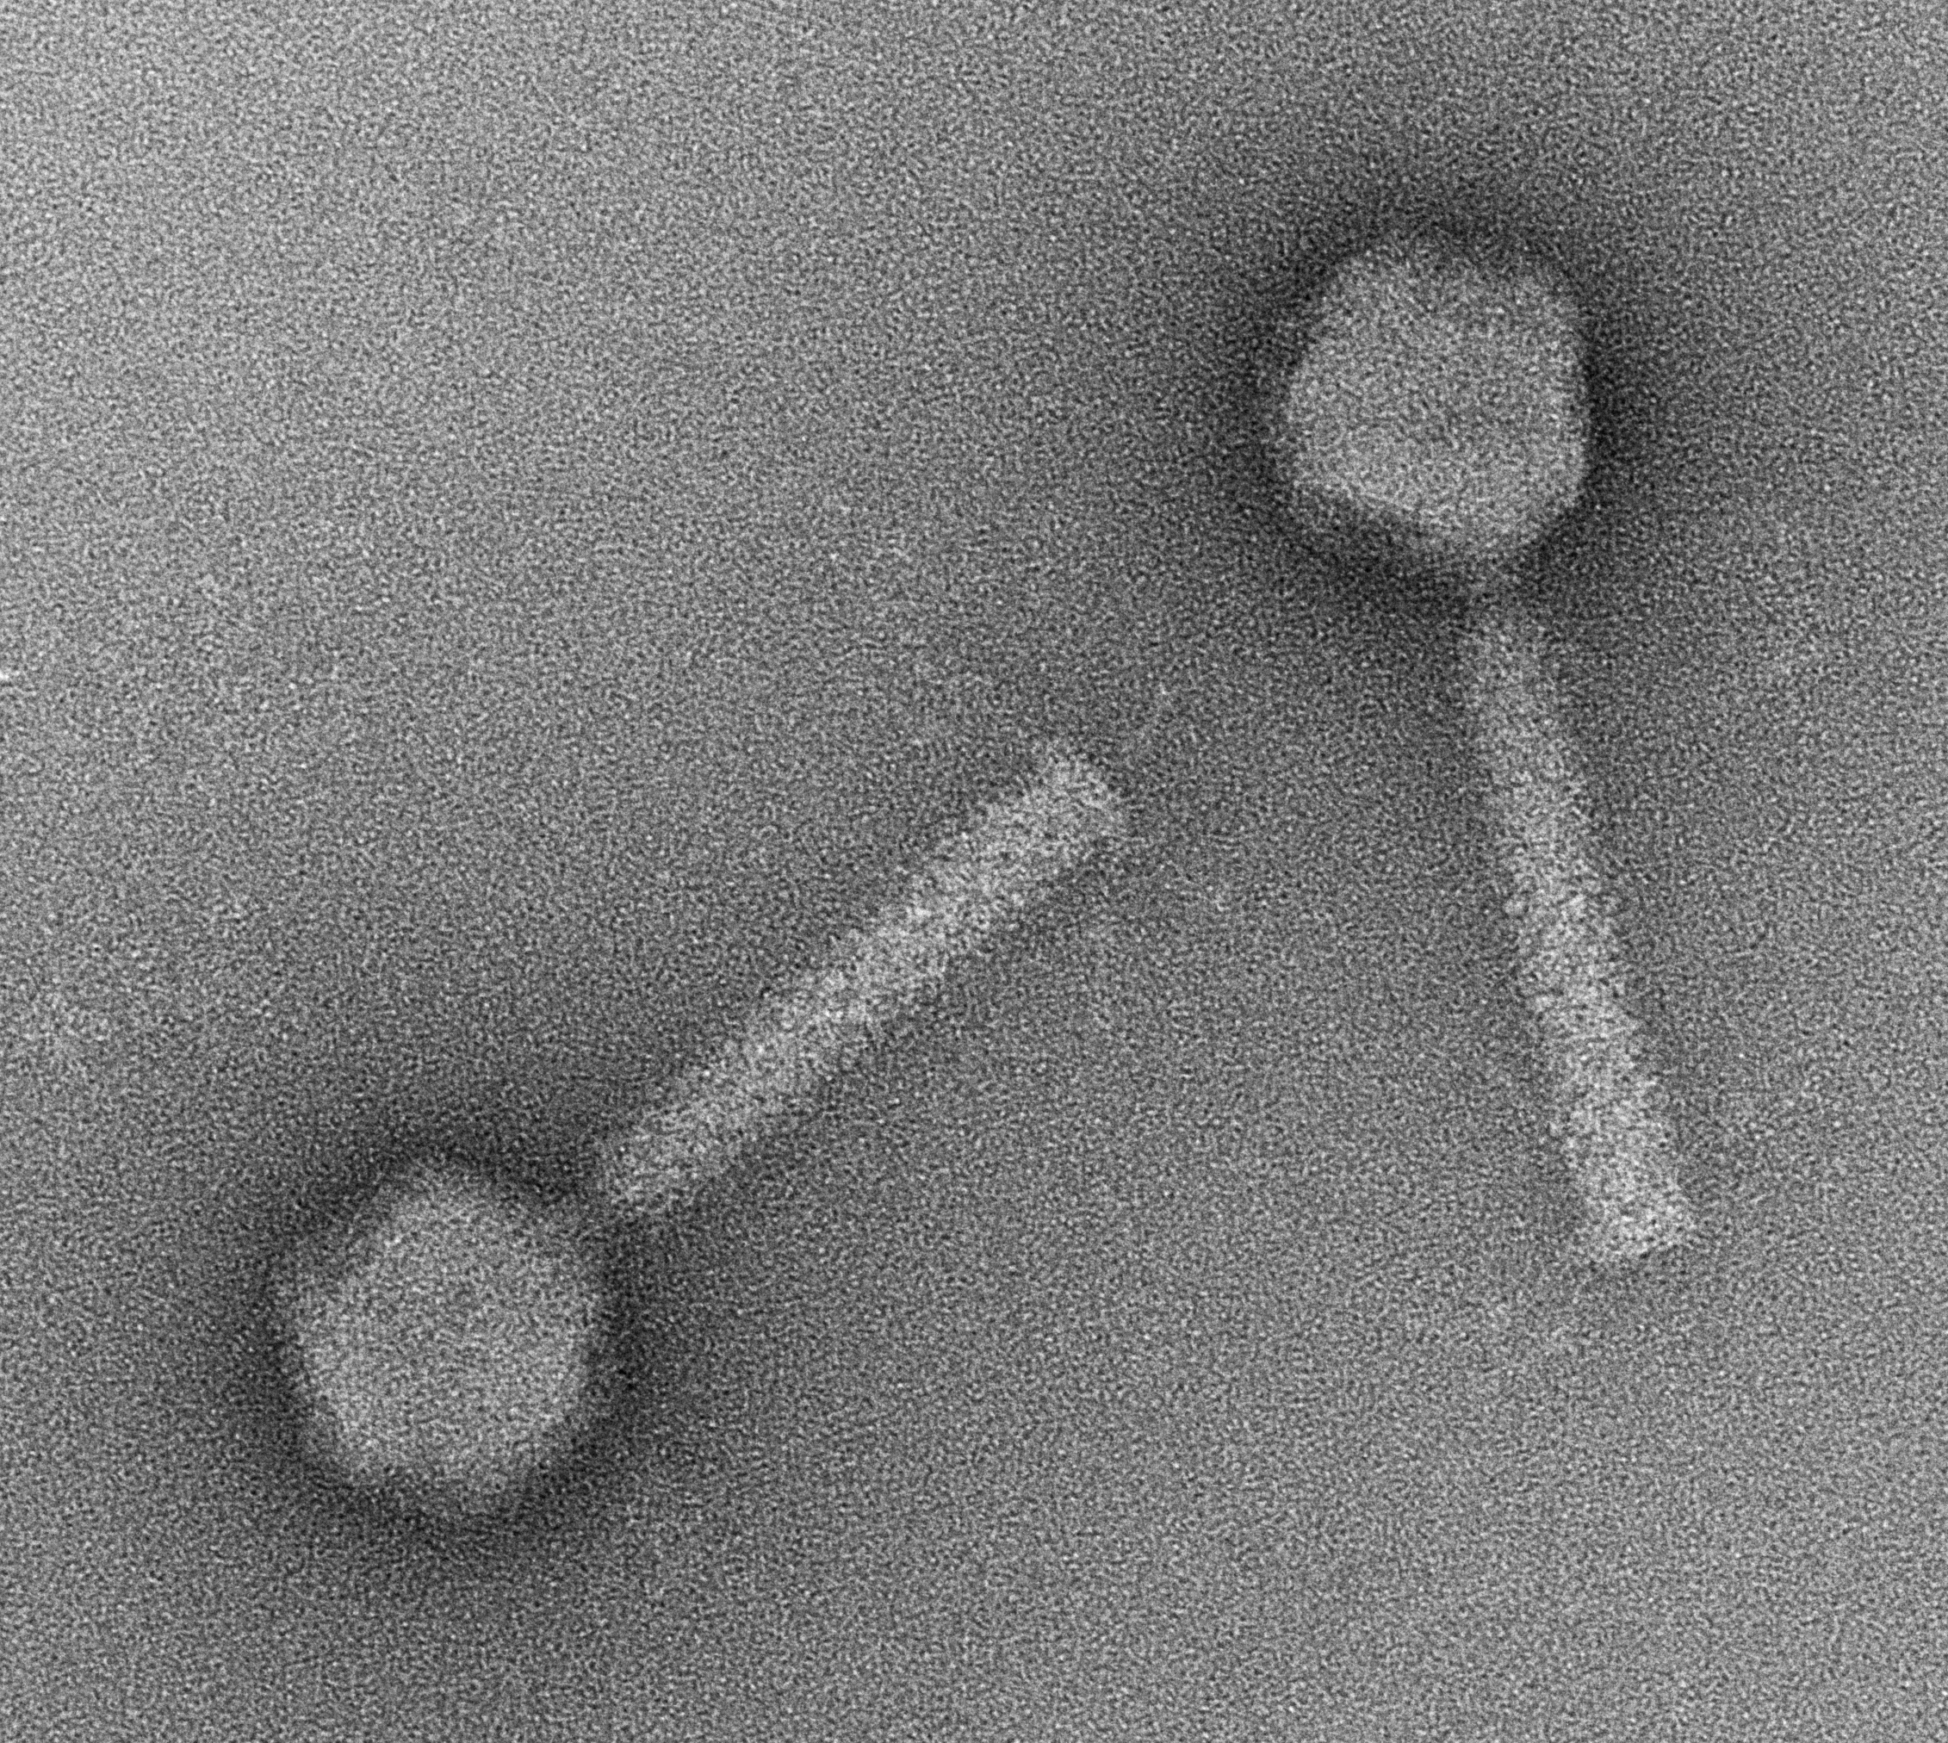

GenBank Summary:

Phage name | RefSeq No. | INSDC | Size (Kb) | GC% | Protein | tRNA
Erwinia phage vB_EamM-Y2 | NC_019504.1 | HQ728264.1 | 56.62 | 44.2 | 92 | 0

BLASTN homologs: The next most closely related phage is Escherichia phage ST32 which shares 38.7% identity with Y2 [1-3].

Phylogeny: The phylogenetic tree was constructed using A. the large subunit terminase protein homologs and B. The RNA polymerases of Y2 and related phages with phylogeny.fr in “one click” mode [8]. "The "One Click mode" targets users that do not wish to deal with program and parameter selection. By default, the pipeline is already set up to run and connect programs recognized for their accuracy and speed (MUSCLE for multiple alignment and PhyML for phylogeny) to reconstruct a robust phylogenetic tree from a set of sequences." It also includes the use of Gblocks to eliminate poorly aligned positions and divergent regions. "The usual bootstrapping procedure is replaced by a new confidence index that is much
faster to compute. See: Anisimova M., Gascuel O. Approximate likelihood ratio test for branches:
A fast, accurate and powerful alternative [9] for details."

- TerL proteins

- RNAP proteins

Properties of the family Chaseviridae Members of this family are myoviruses with isometric heads ~62 nm in diameter and contractile tails ~120nm in length. The hosts which represent Escherichia, Erwinia, Pectobacterium, Shewanella and Aeromonas are all members of the taxon – Gammaproteobacteria. The genomes possess ~2600 bp direct terminal repeats; are on average 54.2 kb (46.5 mol% G+C) and encode about 77 proteins and 0-1 tRNA. Except where we have identified genera with two species, this group as a whole displays very little overall DNA sequence relatedness, presumably because the GC-content varies from 43.6 to 52.8 mol%. At the protein level Erwinia phage vB_EamM-Y2 and Shewanella phage SppYZU05 share 34.8% homologs. Common proteins include the novel RNA polymerase, DNA polymerase, primase and exonuclease. vConTACT 2.0 clusters Aeromonas_phage_pAh6-C, Enterobacteria_phage_phiEcoM-GJ1, Erwinia_phage_vB_EamM-Y2, Pectobacterium_phage_PM1, and Shewanella_phage_Spp001 into one cluster (VC 244_0). Our analysis suggests the presence of two subfamilies: A. Y2, PM1, PP101, GJ1, ST32 and Faunus; and, B. Spp001, SppYZU05, and pAh6-C, but we are unwilling to create subfamilies at this time.

MEME analysis (http://alternate.meme-suite.org) of caudoviral RNA polymerases revealed that the current family possesses two high scoring motifs which are not found in T7 or N4 RNA polymerases.
- Motif 1 – Sequence logo/sequences

- Motif 2 – Sequence logo/sequences

Reference: Bailey TL, Johnson J, Grant CE, Noble WS. The MEME Suite. Nucleic Acids Res.
2015;43(W1):W39-49.

VICTOR analysis [14-19] of the proteins (A) and nucleic acid sequence (B) of these phages

- Amino acid analysis

B. Nucleotide analysis

