This Word module should be used for all taxonomic proposals.

Please complete **Part 1** and:

either **Part 3** for proposals to create new taxa or change existing taxa

or **Part 2** for proposals of a general nature.

Submit the completed Word module, together with the accompanying Excel module named in Part 3, to the appropriate ICTV Subcommittee Chair.

The Word module explains and justifies your proposal. The Excel module is a critical document that will be used to implement the proposed taxonomic changes once they are approved and ratified. If proposals presented in the Word module are not presented accurately in the Excel module, the taxonomic changes cannot proceed.

For guidance, see the notes written in blue, below, and the Help Notes in file Taxonomic_Proposals_Help_2019.

**Part 1:** **TITLE, AUTHORS, etc**

|  |  |  |  |
| --- | --- | --- | --- |
| **Code assigned:** | ***2019.054B*** | |  |
| **Short title:** Move four genera, rename two species and one genus; and, delete one genus in the order *Caudovirales* | | | |
|  | | | |
| **Author(s) and email address(es):** | | | |
| List authors in a single line *Archives of Virology* citation format (e.g. Smith AB, Huang C-L, Santos, F) | | Provide email address for each author in a single line separated by semi-colons | |
| Kropinski AM, Adriaenssens EM, Tolstoy I | | [Phage.Canada@gmail.com](mailto:Phage.Canada@gmail.com);  [evelien.adriaenssens@quadram.ac.uk](mailto:evelien.adriaenssens@quadram.ac.uk);  [tolstoy@ncbi.nlm.nih.gov](mailto:tolstoy@ncbi.nlm.nih.gov) | |
| **Author(s) institutional address(es) (optional):**   |  | | --- | | Provide institutional addresses, each on a single line followed by author(s) initials (e.g. University of Woolloomooloo [SAB, HCL]) | | University of Guelph, Canada [AMK]  Quadram Institute Bioscience, UK [EMA]  National Institutes of Health [IT] | | | | |
| **Corresponding author** | | | |
| Andrew M. Kropinski | | | |
| **List the ICTV study group(s) that have seen this proposal:** | | | |
| A list of study groups and contacts is provided at <http://www.ictvonline.org/subcommittees.asp> . If in doubt, contact the appropriate subcommittee chair (there are six virus subcommittees: animal DNA and retroviruses, animal ssRNA-, animal ssRNA+, fungal and protist, plant, bacterial and archaeal) | | **Bacterial and Archaeal Viruses Subcommittee**  **Caudovirales Study Group** | |
| **ICTV Study Group comments (if any) and response of the proposer:** | | | |
|  | | | |
|  | | | |
| Date first submitted to ICTV: | | |  |
| Date of this revision (if different to above): | | |  |

|  |
| --- |
| **ICTV-EC comments and response of the proposer:** |
|  |

**Part 2:** **NON-STANDARD**

Template for any proposal regarding ICTV procedures, rules or policy, not involving the creation of new taxonomy.

| **Text of proposal:** |
| --- |
|  |

**Part 3:** **PROPOSED TAXONOMY**

|  |
| --- |
| **Name of accompanying Excel module:** 2019.054B.A.v2.Caudovirales_mov4gen_renam2sp.xlsx |

The taxonomic changes you are proposing should be presented on an accompanying Excel module, 2019_TP_Template_Excel_module. Please enter the file name of the completed module in this box.

**Supporting material:**

| additional material in support of this proposal |
| --- |
| Please explain the reasons for the taxonomic changes you are proposing and provide evidence to support them. The following information should be provided, where relevant:   * **Species demarcation criteria**: Explain how new species differ from others in the genus and demonstrate that these differences meet the criteria previously established for demarcating between species. If no criteriahave previously been established, and if there will now be more than one species in the genus, please state the demarcation criteria you are proposing. * **Higher taxa**:   + There is no formal requirement to state demarcation criteria when proposing new genera or other higher taxa. However, a similar concept should apply in pursuit of a rational and consistent virus taxonomy.   + Please indicate the **origin of names** assigned to new taxa at genus level and above.   + For each new genus a **type species** must be designated to represent it. Please explain your choice. * **Supporting evidence**: The use of Figures and Tables is strongly recommended (note that copying from publications will require permission from the copyright holder). For phylogenetic analysis, please provide a tree where branch length is **proportional to genetic** distance, generated using an appropriate algorithm (Neighbour-Joining, Maximum Likelihood, or Bayesian) and provide evidence of the reliability of the branching (e.g., by bootstrapping).   Please refer to the Help Notes file (Taxonomic_Proposals_Help_2019) for more information. |

| **References:** |
| --- |
| 1: Sayers EW, Agarwala R, Bolton EE, Brister JR, Canese K, Clark K, et al. Database resources of the National Center for Biotechnology Information. Nucleic Acids Res. 2019;47(D1):D23-D28.  2: Tolstoy I, Kropinski AM, Brister JR. Bacteriophage Taxonomy: An Evolving Discipline. Methods Mol Biol. 2018;1693:57-71.  3: O'Leary NA, Wright MW, Brister JR, Ciufo S, Haddad D, McVeigh R, et al. Reference sequence (RefSeq) database at NCBI: current status, taxonomic expansion, and functional annotation. Nucleic Acids Res. 2016;44(D1):D733-45.  4: Söding J, Biegert A, Lupas AN. The HHpred interactive server for protein homology detection and structure prediction. Nucleic Acids Res. 2005; 33(Web Server issue):W244-8.  5: Darling AE, Mau B, Perna NT. progressiveMauve: multiple genome alignment with gene gain, loss and rearrangement. PLoS One. 2010; 5(6):e11147. |

Igor Tolstoy at NCBI has developed BLAST-based tools [1-3] which he has used to group all the viruses in GenBank. Occasionally he notes problems where “his taxonomy” is at variance with the “ICTV taxonomy” and brings this to he attention of the Bacterial and Archaeal Viruses Subcommittee. We then reassess the situation, and in these cases recommend changes to the existing taxonomy.

**ITEM 1:** ***Tabernariusvirus***: This genus contains a single member *Pseudomonas virus tabernarius* which is described as being part of the family *Podoviridae*.

progressiveMauve [5] analysis reveals that its closest relative are members of the *Pbunavirus*, which is part of the *Myoviridae* (Figure 1). In addition, HHpred [4] analysis of proteins ATW57890.1 and ATW57903.1, reveal them to be tail sheath, and baseplate wedge homologs – two diagnostic myoviral proteins.

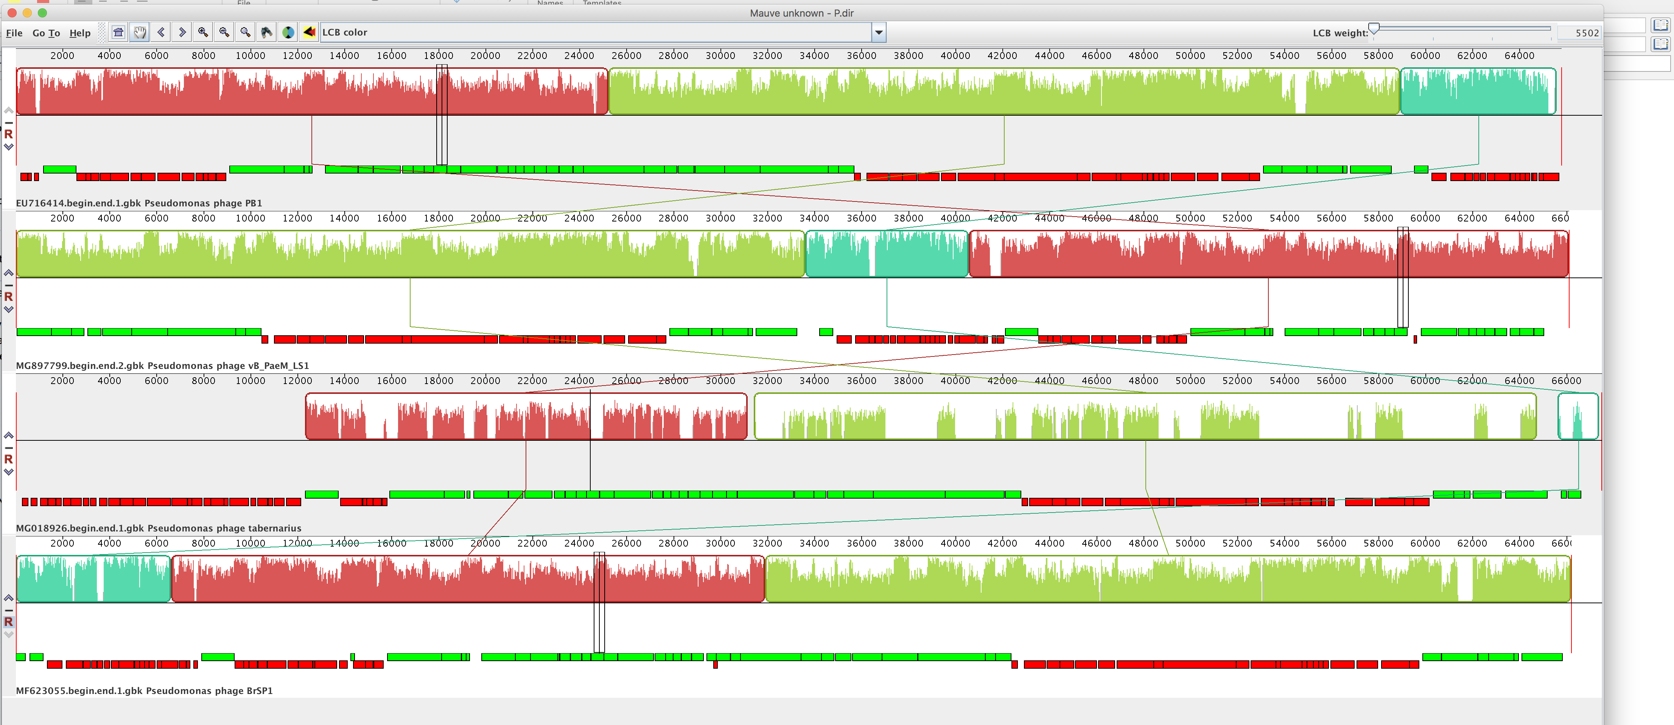

Figure 1. progressiveMauve analysis of Pseudomonas phage PB1 (top track) and Pseudomonas phage tabernarius (third track)

**Proposal 1:** To transfer the genus *Tabernariusvirus* to the family *Myoviridae*.

**ITEM 2:** According to the analysis presented in <https://talk.ictvonline.org/files/ictv_official_taxonomy_updates_since_the_8th_report/m/prokaryote-official/8177> *Paenibacillus virus Lily*, and its genus *Lilyvirus* are in the family *Siphoviridae*.

But alignment results (Figure 2/3) suggest that the origin of the left end of Lily is different from the right end.

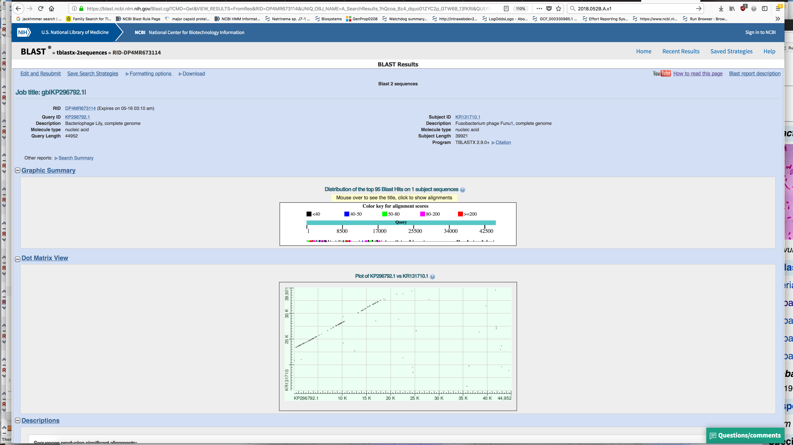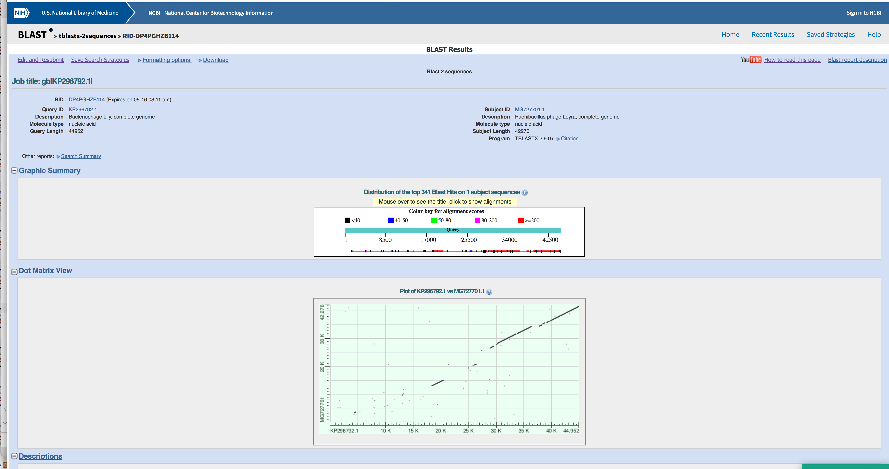

Protein AJK27737.1 (locus_tag="LILY_13") is identified as a tail sheath protein, which was confirmed by HHpred analysis, as was analysis of AJK27747.1 (locus_tag="LILY_23") which is a baseplate wedge protein. It appears that the left end of the Lily genome is of myoviral origin while the right end is more closely related to *Paenibacillus* siphoviral genomes.

**Proposal 2:** To transfer the genus *Lilyvirus* to the order Caudovirales.

**ITEM 3:** The genus *Bendigovirus* (2018.009b) wrongly classified to the family *Siphoviridae*

Gordonia phage GMA6 is classified to Cluster DQ in The Actinobacteriophage Database (<https://phagesdb.org/>) along with Gordonia phages Gray and Chidiebere. Protein YP_009273523.1 is a baseplate J protein, while YP_009273511.1 is the tail sheath protein this confirming GMA6’s association with the family *Myoviridae*.

**Proposal 3:** Transfer the genus *Bendigovirus* to the family *Myoviridae*.

**ITEM 4:** In the genus *Lederbergvirus* there is a species called *Salmonella virus HK620* – this is an incorrect name.

While TaxoProp 2008.040B established phage HK620 as being part of the then “P22-like phages” no host was given, and it then appeared as *Salmonella phage HK620* in 2019. The following three manuscripts clearly reveal that it is an Escherichia coli phage:

1: Clark AJ, Inwood W, Cloutier T, Dhillon TS. Nucleotide sequence of coliphage HK620 and the evolution of lambdoid phages. J Mol Biol. 2001 Aug 24;311(4):657-79. PubMed PMID: 11518522.

2: Dhillon TS, Poon AP, Chan D, Clark AJ. General transducing phages like Salmonella phage P22 isolated using a smooth strain of Escherichia coli as host. FEMS Microbiol Lett. 1998 Apr 1;161(1):129-33. PubMed PMID: 9561740.

3: Barbirz S, Müller JJ, Uetrecht C, Clark AJ, Heinemann U, Seckler R. Crystal structure of Escherichia coli phage HK620 tailspike: podoviral tailspike endoglycosidase modules are evolutionarily related. Mol Microbiol. 2008 Jul;69(2):303-16. doi: 10.1111/j.1365-2958.2008.06311.x. PubMed PMID: 18547389.

**Proposal 4:** To rename *Salmonella virus HK620* to *Escherichia virus HK620*.

**ITEM 5:** *Salmonella virus HB2014* and *Salmonella virus SP116* are identical species.

**Proposal 5:** To delete *Salmonella virus* HB2014 from the MSL

**ITEM 6:** There has been a request made of the Bacterial and Archaeal Viruses Subcommittee to release the name of Anne Vidaver (*Vidavervirus*) to that it can be used for the new Class *Vidaverviricetes.*

**Proposal 6:** To rename *Vidavervirus Naesvirus* after the institution, Nebraska

Agricultural Experiment Station, where Dr. Vidaver isolated phage Phi6.

**OTHER ITEMS:**

Corrected spelling mistake in the species name *Delftia virus phiW14.*

Moved the genus *Nazgulvirus* and its constituent species into the family *Siphoviridae*, consistent with its description in literature.