This Word module should be used for all taxonomic proposals.

Please complete **Part 1** and:

either **Part 3** for proposals to create new taxa or change existing taxa

or **Part 2** for proposals of a general nature.

Submit the completed Word module, together with the accompanying Excel module named in Part 3, to the appropriate ICTV Subcommittee Chair.

The Word module explains and justifies your proposal. The Excel module is a critical document that will be used to implement the proposed taxonomic changes once they are approved and ratified. If proposals presented in the Word module are not presented accurately in the Excel module, the taxonomic changes cannot proceed.

For guidance, see the notes written in blue, below, and the Help Notes in file Taxonomic_Proposals_Help_2019.

**Part 1:** **TITLE, AUTHORS, etc**

|  |  |  |  |
| --- | --- | --- | --- |
| **Code assigned:** | ***2019.055B*** | |  |
| **Short title:** Create one new genus (*Feofaniavirus*)including two new species in the family *Siphoviridae* | | | |
|  | | | |
| **Author(s) and email address(es):** | | | |
| List authors in a single line *Archives of Virology* citation format (e.g. Smith AB, Huang C-L, Santos, F) | | Provide email address for each author in a single line separated by semi-colons | |
| Zlatohurska MA, GorbTY, Romaniuk LV, Korol NA, Faidiuk YV, Kropinski AM, Kushkina AI, Tovkach FI | | [zlatohurska@gmail.com](mailto:zlatohurska@gmail.com); [tanyagorb@gmail.com](mailto:tanyagorb@gmail.com); [lyuromanyuk@gmail.com](mailto:lyuromanyuk@gmail.com); [natalia@korol.biz](mailto:natalia@korol.biz); [i.v.faidiuk@gmail.com](mailto:i.v.faidiuk@gmail.com); [phage.Canada@gmail.com](mailto:phage.Canada@gmail.com); [a.kushkina@gmail.com](mailto:a.kushkina@gmail.com); [fedir.i.tovkach@gmail.com](mailto:fedir.i.tovkach@gmail.com) | |
| **Author(s) institutional address(es) (optional):**   |  | | --- | | Provide institutional addresses, each on a single line followed by author(s) initials (e.g. University of Woolloomooloo [SAB, HCL]) | | Zabolotny Institute of Microbiology and Virology, Ukraine [ZMA, GTY, RLV, KNA, FYV, KAI, TFI]  University of Guelph, Canada [AMK] | | | | |
| **Corresponding author** | | | |
| Zlatohurska MA | | | |
| **List the ICTV study group(s) that have seen this proposal:** | | | |
| A list of study groups and contacts is provided at <http://www.ictvonline.org/subcommittees.asp> . If in doubt, contact the appropriate subcommittee chair (there are six virus subcommittees: animal DNA and retroviruses, animal ssRNA-, animal ssRNA+, fungal and protist, plant, bacterial and archaeal) | | **Bacterial and Archaeal Viruses Subcommittee, Caudovirales Study Group** | |
| **ICTV Study Group comments (if any) and response of the proposer:** | | | |
|  | | | |
|  | | | |
| Date first submitted to ICTV: | | |  |
| Date of this revision (if different to above): | | |  |

|  |
| --- |
| **ICTV-EC comments and response of the proposer:** |
|  |

**Part 2:** **NON-STANDARD**

Template for any proposal regarding ICTV procedures, rules or policy, not involving the creation of new taxonomy.

| **Text of proposal:** |
| --- |
|  |

**Part 3:** **PROPOSED TAXONOMY**

|  |
| --- |
| **Name of accompanying Excel module:** 2019.055B.A.v1.Feofaniavirus_1gen2sp.xlsx |

The taxonomic changes you are proposing should be presented on an accompanying Excel module, 2019_TP_Template_Excel_module. Please enter the file name of the completed module in this box.

**Supporting material:**

| additional material in support of this proposal |
| --- |
| Please explain the reasons for the taxonomic changes you are proposing and provide evidence to support them. The following information should be provided, where relevant:   * **Species demarcation criteria**: Explain how new species differ from others in the genus and demonstrate that these differences meet the criteria previously established for demarcating between species. If no criteriahave previously been established, and if there will now be more than one species in the genus, please state the demarcation criteria you are proposing. * **Higher taxa**:   + There is no formal requirement to state demarcation criteria when proposing new genera or other higher taxa. However, a similar concept should apply in pursuit of a rational and consistent virus taxonomy.   + Please indicate the **origin of names** assigned to new taxa at genus level and above.   + For each new genus a **type species** must be designated to represent it. Please explain your choice. * **Supporting evidence**: The use of Figures and Tables is strongly recommended (note that copying from publications will require permission from the copyright holder). For phylogenetic analysis, please provide a tree where branch length is **proportional to genetic** distance, generated using an appropriate algorithm (Neighbour-Joining, Maximum Likelihood, or Bayesian) and provide evidence of the reliability of the branching (e.g., by bootstrapping).   Please refer to the Help Notes file (Taxonomic_Proposals_Help_2019) for more information. |

| **References:** |
| --- |
| Zlatohurska M, GorbT, Romaniuk L, Korol N, Faidiuk Y, Kropinski A, Kushkina A, Tovkach F. Complete genome sequence analysis of temperate *Erwinia* bacteriophages 49 and 59. J Basic Microbiol 2019. Accepted, in press. |

**Supporting material:**

**Species demarcation criteria**. The new genus contains two species

*Erwinia virus Eho49* and *Erwinia virus Eho59.* Each species is represented by one phage isolate. We have used 95% DNA sequence identity as the criterion for species demarcation in genus*.*Distinctive feature of these phages is that their genomes have identical nucleotide sequences encoding proteins of DNA assembly, head morphogenesis and lysis. This results in almost identical capsid organization (apart from distal tail ends) and in48% DNA sequence similarity between phage genomes.

**Source of the taxon name.** The name of new genus is originated from the place-name, Feofania, where its representatives were isolated and characterized. The type species of the genus is *Erwinia virus Eho59* since the preparations of this species are more stable.

**History:** The representatives of the genus *Feofaniavirus* were isolated in 1984 by the staff of the Zabolotny Institute of Microbiology and Virology (Kyiv, Ukraine) from the polylysogenic culture of *Erwinia horticola*, the causative agent of beech black bacteriosis in Ukraine.

**Genome Summary:**

|  |  |  |  |  |  |  |
| --- | --- | --- | --- | --- | --- | --- |
| Species name | Strain | Accession | Size (Kb) | GC% | Protein | tRNA |
| *Erwinia virus Eho49* | Erwinia phage vB_EhrS_49 | MH443100 | 46.83 | 50.8 | 80 | 0 |
| *Erwinia virus Eho59* | Erwinia phage vB_EhrS_59 | MH443101 | 47.11 | 50.4 | 80 | Arg |

**BLASTN homologs:** The genomes ofErwinia phage vB_EhrS_49 and *Erwinia phage vB_EhrS_59* reveal no significant similarity to that of any previously reported viruses of Enterobacteriaceae. Low genome similarity was determined between Erwinia phage vB_EhrS_49 and *Salmonella* phage ES18 which shares 26.25% of total sequence identity. In case of Erwinia phage vB_EhrS_59, the next most closely related phage is *Cronobacter* phage ENT47670 with query coverage of 25% and sequence identity of 72%.

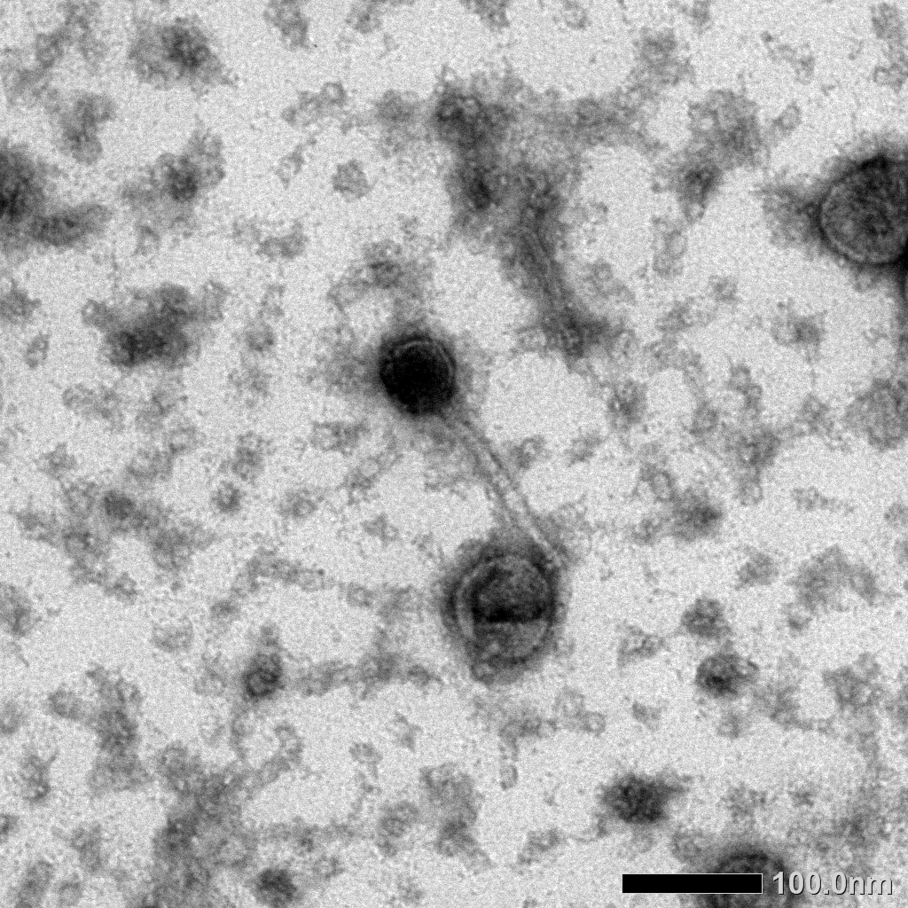**Electron micrograph:** Electron micrographs of negatively stained Erwinia phage vB_EhrS_49 (a) and Erwinia phage vB_EhrS_59 (b).

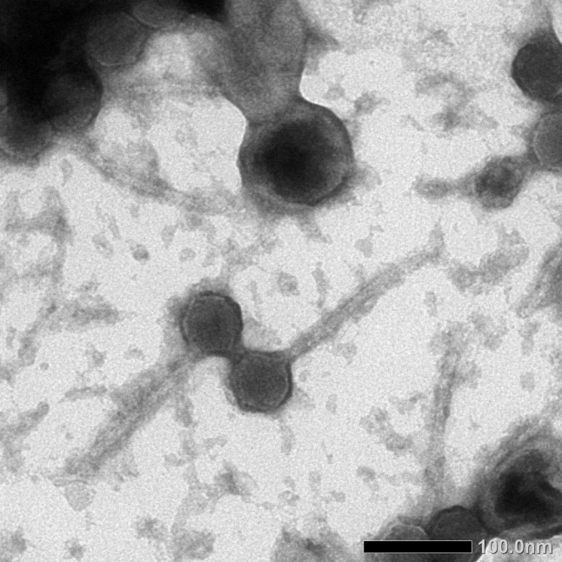 a b

**Phylogeny:** Phylogenetic analysis was carried out based on the TerL proteins from the main members of lambdoid super-family [Grose, 2014]. The multiple sequence alignment was performed with ClustalW. The phylogenetic tree was constructed using the maximum likelihood algorithm and evaluated with the bootstrap test (500). The genes of TerL protein are identical for both species.

