This Word module should be used for all taxonomic proposals.

Please complete **Part 1** and:

either **Part 3** for proposals to create new taxa or change existing taxa

or **Part 2** for proposals of a general nature.

Submit the completed Word module, together with the accompanying Excel module named in Part 3, to the appropriate ICTV Subcommittee Chair.

The Word module explains and justifies your proposal. The Excel module is a critical document that will be used to implement the proposed taxonomic changes once they are approved and ratified. If proposals presented in the Word module are not presented accurately in the Excel module, the taxonomic changes cannot proceed.

For guidance, see the notes written in blue, below, and the Help Notes in file Taxonomic_Proposals_Help_2019.

**Part 1:** **TITLE, AUTHORS, etc**

| **Code assigned:** | ***2019.078B*** | |  |
| --- | --- | --- | --- |
| **Short title:** Create one new subfamily (*Rakietenvirinae*) including two new genera in the family *Podoviridae* | | | |
|  | | | |
| **Author(s) and email address(es):** | | | |
| List authors in a single line *Archives of Virology* citation format (e.g. Smith AB, Huang C-L, Santos, F) | | Provide email address for each author in a single line separated by semi-colons | |
| Łobocka M, Głowacka-Rutkowska A, Kropinski AM, Adriaenssens EM | | [lobocka@ibb.waw.pl](mailto:Phage.Canada@gmail.com);  glowacka@ibb.waw.pl;  [Phage.Canada@gmail.com](mailto:Phage.Canada@gmail.com); Evelien.adriaenssens@quadram.ac.uk | |
| **Author(s) institutional address(es) (optional):**   |  | | --- | | Provide institutional addresses, each on a single line followed by author(s) initials (e.g. University of Woolloomooloo [SAB, HCL]) | | Institute of Biochemistry and Biophysics, PAS, Poland [ML]  Institute of Biochemistry and Biophysics, PAS, Poland [AG-R]  University of Guelph, Canada [AMK]  Quadram Institute Bioscience [EMA] | | | | |
| **Corresponding author** | | | |
| Malgorzata Łobocka | | | |
| **List the ICTV study group(s) that have seen this proposal:** | | | |
| A list of study groups and contacts is provided at <http://www.ictvonline.org/subcommittees.asp> . If in doubt, contact the appropriate subcommittee chair (there are six virus subcommittees: animal DNA and retroviruses, animal ssRNA-, animal ssRNA+, fungal and protist, plant, bacterial and archaeal) | | **Bacterial and Archaeal Viruses Subcommittee**  **Caudovirales Study Group** | |
| **ICTV Study Group comments (if any) and response of the proposer:** | | | |
|  | | | |
|  | | | |
| Date first submitted to ICTV: | | |  |
| Date of this revision (if different to above): | | |  |

|  |  |  |  |
| --- | --- | --- | --- |
| **Authority to use the name of a living person:**  Please provide the following information if you propose taxon name(s) which are derived from the name of a living person or persons*.* Please attach documents to verify that permission has been obtained. | | | |
| **Taxon name** | **Person from whom the name is derived** | **Permission obtained (Y/N)** | |
| *Fischettivirus* | Vincent A. Fischetti | Y | |
|  |  |  | |
|  |  |  | |
|  | | | |
| **ICTV-EC comments and response of the proposer:** | | |
|  | | |

**Part 2:** **NON-STANDARD**

Template for any proposal regarding ICTV procedures, rules or policy, not involving the creation of new taxonomy.

| **Text of proposal:** |
| --- |
|  |

**Part 3:** **PROPOSED TAXONOMY**

|  |
| --- |
| **Name of accompanying Excel module:** 2019.078B.A.v1.Andhravirus_1newfam.xlsx |

The taxonomic changes you are proposing should be presented on an accompanying Excel module, 2019_TP_Template_Excel_module. Please enter the file name of the completed module in this box.

**Supporting material:**

| additional material in support of this proposal |
| --- |
| Please explain the reasons for the taxonomic changes you are proposing and provide evidence to support them. The following information should be provided, where relevant:   * **Species demarcation criteria**: Explain how new species differ from others in the genus and demonstrate that these differences meet the criteria previously established for demarcating between species. If no criteriahave previously been established, and if there will now be more than one species in the genus, please state the demarcation criteria you are proposing. * **Higher taxa**:   + There is no formal requirement to state demarcation criteria when proposing new genera or other higher taxa. However, a similar concept should apply in pursuit of a rational and consistent virus taxonomy.   + Please indicate the **origin of names** assigned to new taxa at genus level and above.   + For each new genus a **type species** must be designated to represent it. Please explain your choice. * **Supporting evidence**: The use of Figures and Tables is strongly recommended (note that copying from publications will require permission from the copyright holder). For phylogenetic analysis, please provide a tree where branch length is **proportional to genetic** distance, generated using an appropriate algorithm (Neighbour-Joining, Maximum Likelihood, or Bayesian) and provide evidence of the reliability of the branching (e.g., by bootstrapping).   Please refer to the Help Notes file (Taxonomic_Proposals_Help_2019) for more information. |
| **General References:** |
| 1. Lavigne, R., Seto, D., Mahadevan, P., Ackermann, H. W. & Kropinski, A. M. Unifying classical and molecular taxonomic classification: analysis of the *Podoviridae* using BLASTP-based tools. *Res Microbiol.* **159,** 406-414 (2008). 2. Cater, K., Dandu, V.S., Bari, S. M., Lackey, K., Everett, G. F. & Hatoum-Aslan, A. A Novel Staphylococcus Podophage Encodes a Unique Lysin with Unusual Modular Design. *mSphere*. **22,** 2(2). pii: e00040-17 (2017). 3. Culbertson, E. K., Bari, S. M. N., Dandu, V. S., Kriznik, J. M., Scopel, S. E., Stanley, S. P., Lackey, K., Hernandez, A. C. & Hatoum-Aslan. A. Draft Genome Sequences of *Staphylococcus* Podophages JBug18, Pike, Pontiff, and Pabna. *Microbiol Resour* *Announc.* **8,** (8). pii: e00054-19 (2019). 4. Agren, J., Sundström, A., Håfström, T. & Segerman, B. Gegenees: fragmented alignment of multiple genomes for determining phylogenomic distances and genetic signatures unique for specified target groups. *PLoS One*. **7**(6):e39107 (2012). 5. Brister, J. R., Ako-adjei, D., Bao, Y. & Blinkova, O. NCBI Viral Genomes Resource. *Nucleic Acids Res.* **43**, D571–D577 (2015). 6. Zhang, Z., Schwartz, S., Wagner, L. & Miller, W. A greedy algorithm for aligning DNA sequences", *J Comput Biol.* **7** (1-2), 203-214 (2000). 7. Lowe, T. M. & Eddy, S. R. tRNAscan-SE: a program for improved detection of transfer RNA genes in genomic sequence. *Nucleic Acids Res* **25**, (1997). 8. Mahadevan, P., King, J. F. & Seto, D. CGUG: in silico proteome and genome parsing tool for the determination of ‘core’ and unique genes in the analysis of genomes up to ca. 1.9 Mb. *BMC Res. Notes* **2**, 168 (2009). 9. Dereeper, A. *et al.* Phylogeny.fr: robust phylogenetic analysis for the non-specialist. *Nucleic Acids Res.* **36**, W465-469 (2008). 10. Sayers EW, Agarwala R, Bolton EE, Brister JR, Canese K, Clark K, et al. Database resources of the National Center for Biotechnology Information. Nucleic Acids Res. 2019;47(D1):D23-D28. 11. Tolstoy I, Kropinski AM, Brister JR. Bacteriophage Taxonomy: An Evolving Discipline. Methods Mol Biol. 2018;1693:57-71. 12. O'Leary NA, Wright MW, Brister JR, Ciufo S, Haddad D, McVeigh R, et al. Reference sequence (RefSeq) database at NCBI: current status, taxonomic expansion, and functional annotation. Nucleic Acids Res. 2016;44(D1):D733-45. |

**Species demarcation criteria** We have chosen 95% DNA sequence identity as the criterion for demarcation of species in this new genus. Representatives of the proposed species differ no more than 5% from each other at the DNA level as confirmed with the BLASTN algorithm.

**History:** Staphylococcal phages of the *Picovirinae* subfamily of family *Podoviridae*, were initially classified within the 44AHJD-like genus (1), which was recently renamed to *Rosenblumvirus* genus. In this TaxoProp we propose the addition of 12 species to the latter genus. Furthermore, we propose the creation of a new genus *Andhravirus,* containing two species that infect *Staphylococcus epidermidis*. The latter genus will include five bacteriophages: Andhra, St-134, Pontiff, Pike and JBug18, all but two of them strains (2,3). They are obligatorily lytic. Andhra was isolated by coculturing S. epidermidis strain RP62a with raw sewage, while the other four phages were isolated from a sample of wastewater collected at the Hilliard Fletcher Wastewater Treatment Plant in Tuscaloosa, Alabama, on 25 August 2015, as propagating in cells of S*taphylococcus epidermidis.* Staphylococcusphage Andhra has been selected as the type species phage of *Andhravirus* genus. The consequence of this proposal is that the genus *Rosenblumvirus* is removed from the *Picovirinae*.

**Comparisons of *Staphylococcus* phages currently classified to the *Picovirinae*:** The genomes were compared using Gegenees 3.0 (4). Comparisons of all-against-all genomic fragments were performed with the BLASTn (5, 6) algorithm with fragment size of 50 nt and sliding step size of 25 nt, as recommended for viral and plasmid genomes. Resulting matrices obtained were sorted by Gegenees tool Autosort. Representatives of proposed genus *Andhravirus* belong to separate but cohesive group. They are boxed.

**Proposal A. Creation of new genus, *Andhravirus***

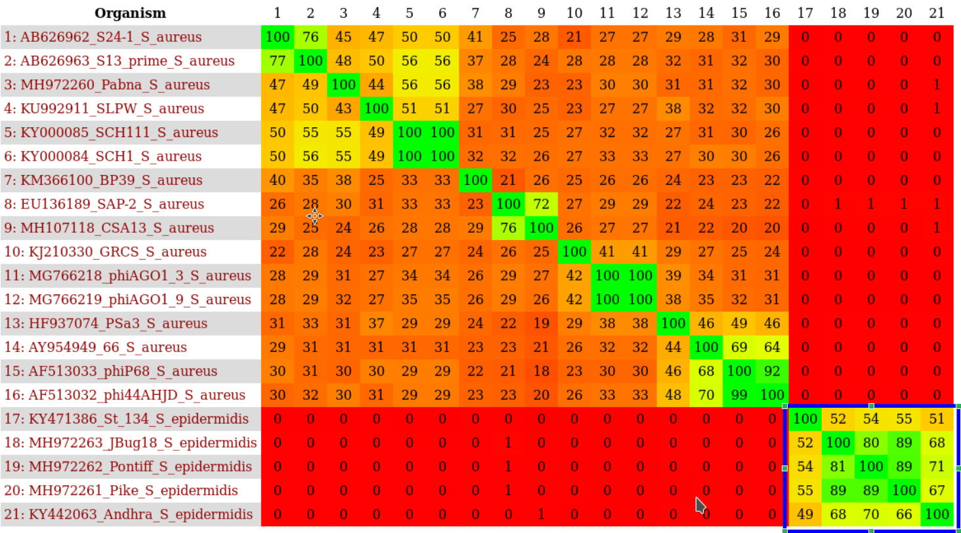

**GenBank Summary:** Overall properties of *Andhravirus* genus phages.

|  |  |  |  |  |  |  |  |  |
| --- | --- | --- | --- | --- | --- | --- | --- | --- |
| Phage name | RefSeq No. | INSDC | Size (Kb) | GC% | Protein | tRNA  (*) | Overall DNA sequence identity (**) | % common proteins (***) |
| *Staphylococcus* phage Andhra |  | KY442063.1 | 18.546 | 29.8 | 20 | 0 | 100 | 100 |
| *Staphylococcus* phage St 134 |  | KY471386.1 | 18.275 | 30.1 | 21 | 0 | 91.6 | 95.2 |

**N.B. Staphylococcus phage Pike, Staphylococcus phage Pontiff and Staphylococcus phage JBug18 should be considered strains of Andhra**

**\* None indicated in GenBank file summary and none discovered using tRNAscan-SE2 set for bacterial sequence as a source (5)**

**\*\* Determined using BLASTn at NCBI (6, 7))**

**\*\*\* Determined using CoreGenes3.5 at** [**http://binf.gmu.edu:8080/CoreGenes3.5/**](http://binf.gmu.edu:8080/CoreGenes3.5/) **(8)**

**BLASTN homologs:** The next most closely related phage of Andhra is *Staphylococcus* phage 66 with which Andhra shares 37.8% DNA sequence relatedness [10-12]. The following is a neighbour joining tree derived from the NCBI BLASTn results. While this is sufficient to be considered part of a subfamily we do not choose to create one at this time. BLASTN tree: “BLAST computes a pairwise alignment between a query and the database sequences searched. It does not explicitly compute an alignment between the different database sequences (i.e., does not perform a multiple alignment). For purposes of this sequence tree presentation an implicit alignment between the database sequences is constructed, based upon the alignment of those (database) sequences to the query. It may often occur that two database sequences align to different parts of the query, so that they barely overlap each other or do not overlap at all. In that case it is not possible to calculate a distance between these two sequences and only the higher scoring sequence is included in the tree.”.

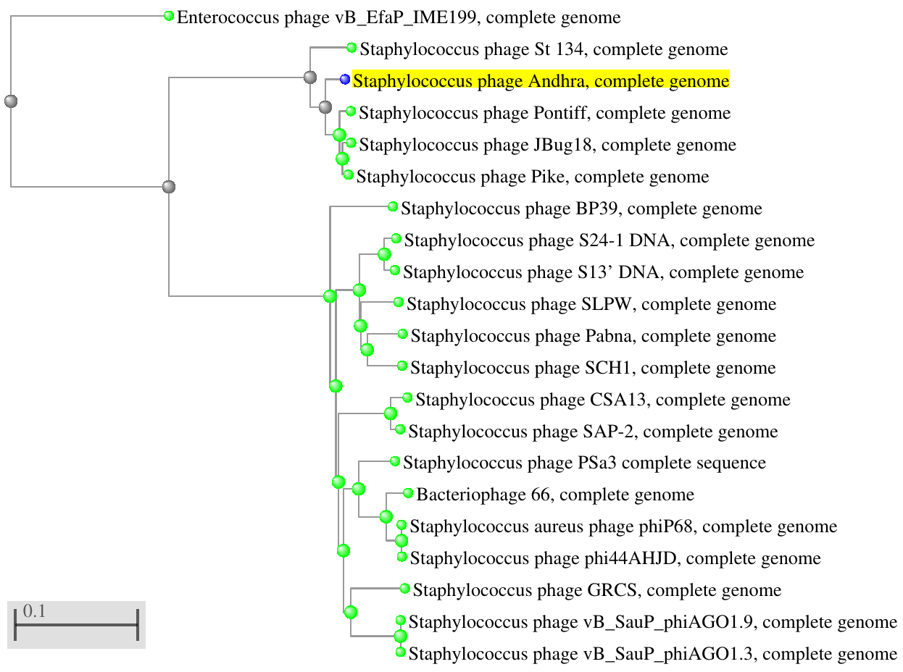

**Electron micrograph:** None available for this proposal.

**Phylogeny:** The phylogenetic tree was constructed using the major capsid protein homologs of Andhra and related phages with phylogeny.fr in “one click” mode (6). "The "One Click mode" targets users that do not wish to deal with program and parameter selection. By default, the pipeline is already set up to run and connect programs recognized for their accuracy and speed (MUSCLE for multiple alignment and PhyML for phylogeny) to reconstruct a robust phylogenetic tree from a set of sequences." It also includes the use of Gblocks to eliminate poorly aligned positions and divergent regions. "The usual bootstrapping procedure is replaced by a new confidence index that is much faster to compute. See (9) for details."

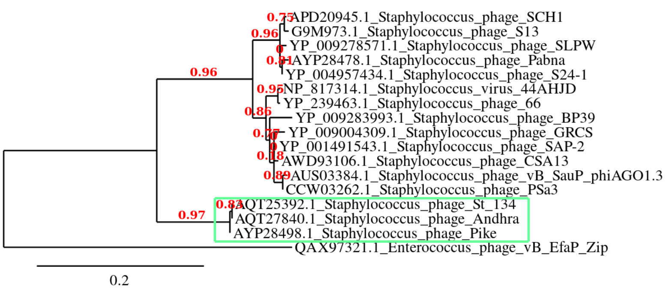**Proposal B (three items).** The removal of *Rosenblumvirus* from the subfamily Picovirinae, The removal of *Streptococcus virus C1* from the genus *Rosenblumvirus.* The addition of 11 species to this genus.

|  |  |  |  |  |  |  |  |
| --- | --- | --- | --- | --- | --- | --- | --- |
| Phage name | RefSeq No. | INSDC | Size (Kb) | GC% | Proteins | Overall DNA sequence identity (**) | % common proteins (***) |
| Staphylococcus phage phi44AHJD (**type phage**) | [NC_004678.1](https://www.ncbi.nlm.nih.gov/nuccore/NC_004678.1) | [AF513032.1](https://www.ncbi.nlm.nih.gov/nuccore/AF513032.1) | 16.78 | 29.6 | 21 | 100 | 100 |
| Staphylococcus phage Pabna |  | MH972260.1 | 17.7 | 29.4 | 21 | 90.3 | 90.5 |
| Bacteriophage 66 | NC_007046.1 | AY954949.1 | 18.2 | 29.3 | 27 | 94.7 | 90.5 |
| Staphylococcus phage S24-1 DNA | NC_016565.1 | AB626962.1 | 18.17 | 28.9 | 21 | 89.9 | 95.2 |
| Staphylococcus phage GRCS | NC_023550.1 | KJ210330.1 | 17.87 | 28.9 | 21 | 89.8 | 95.2 |
| Staphylococcus phage BP39 | NC_031046.1 | KM366100.1 | 17.64 | 29.0 | 20 | 89.4 | 85.7 |
| Staphylococcus phage SCH1 |  | KY000084.1 | 18.02 | 29.3 | 21 | 89.8 | 90.5 |
| Staphylococcus phage vB_SauP_phiAGO1.3 |  | MG766218.1 | 17.6 | 29.0 | 20 | 89.4 | 90.5 |
| Staphylococcus phage SAP-2 | NC_009875.1 | EU136189.1 | 17.94 | 28.9 | 20 | 87.3 | 90.5 |
| Staphylococcus phage PSa3 |  | HF937074.1 | 17.6 | 29.6 | 20 | 91.3 | 85.7 |
| Staphylococcus phage SLPW | NC_031008.1 | KU992911.1 | 17.86 | 29.4 | 20 | 87.7 | 85.7 |
| Staphylococcus phage CSA13 |  | MH107118.1 | 17.03 | 29.0 | 18 | 86.7 | 80.9 |

**N.B. Staphylococcus phage Staphylococcus phage S13' is a strain of S24-1, Staphylococcus aureus phage phiP68 ids a strain of phi44AHJD, Staphylococcus phage SCH111 is a strain of Staphylococcus phage SCH1, Staphylococcus phage vB_SauP_phiAGO1.9 is a strain of phiAGO1.3**

**\*\* Determined using BLASTn at NCBI [10-12]**

**\*\*\* Ddetermined using CoreGenes 3.5 at** [**http://binf.gmu.edu:8080/CoreGenes3.5/**](http://binf.gmu.edu:8080/CoreGenes3.5/) **[8]**

**Proposal C:** To create a new subfamily, *Rakietenvirinae*, containing *Rosenblumvirus* and *Andhravirus*.

**Rationale:** supported by genomic and phylogenetic data. *Streptococcus virus C1* exhibits little DNA sequence relatedness to members of either genus.

**Source of the name for this genus:** Named in honour of one of the pioneer Staphylococcus phage scientists, Morris L. Rakieten MD (d. 1984, Department of Protobiology, Yale University School of Medicine)

**Proposal D:** To create a new genus, *Fischettivirus* in the family *Podoviridae* containing a single species

**Rationale:** *Streptococcus virus C1* exhibits little DNA sequence relatedness to any other characterized phage.

History: Lytic streptococcal C1 bacteriophage was isolated in 1925 from a sewage plant in Milwaukee, Wis., by Clark and Clark [1926]. Phage C1 was isolated by Richard M. Krause and has been worked on by Dr. Fischetti for his entire career.

**Source of the name for this genus:** Named in honour of the preeminent American microbiologist, Vincent A. Fischetti (b. 1940; Professor and Head, Laboratory of Bacterial Pathogenesis and Immunology, The Rockefeller University, NY, USA; twice recipient of the NIH MERIT Award) who pioneered research on the use of phage lysins as therapeutics.

**Phylogeny:** The phylogenetic tree was constructed using the DNA polymerase protein homologs of phage C1 and related phages with phylogeny.fr in “one click” mode (6). "The "One Click mode" targets users that do not wish to deal with program and parameter selection. By default, the pipeline is already set up to run and connect programs recognized for their accuracy and speed (MUSCLE for multiple alignment and PhyML for phylogeny) to reconstruct a robust phylogenetic tree from a set of sequences." It also includes the use of Gblocks to eliminate poorly aligned positions and divergent regions. "The usual bootstrapping procedure is replaced by a new confidence index that is much faster to compute. See (9) for details."

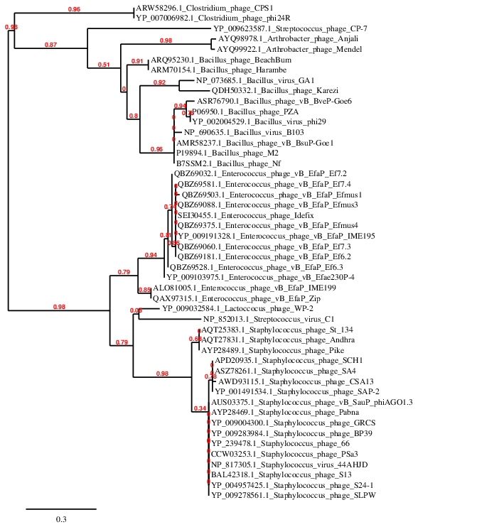

**Phage C1 references:**

1: Nelson D, Schuch R, Zhu S, Tscherne DM, Fischetti VA. Genomic sequence of C1,

the first streptococcal phage. J Bacteriol. 2003;185(11):3325-32.

2: Fischetti VA, Barron B, Zabriskie JB. Studies on streptococcal bacteriophages.

I. Burst size and intracellular growth of group A and group C streptococcal

bacteriophages. J Exp Med. 1968;127(3):475-88.

3: Fischetti VA, Zabriskie JB. Studies on streptococcal bacteriophages. II.

Adsorption studies on group A and group C streptococcal bacteriophages. J Exp

Med. 1968;127(3):489-505.

4: Pomrenke ME, Ferretti JJ. Physical maps of the streptococcal bacteriophage A25

and C1 genomes. J Basic Microbiol. 1989;29(6):395-8.

5: Köller T, Nelson D, Nakata M, Kreutzer M, Fischetti VA, Glocker MO, Podbielski

A, Kreikemeyer B. PlyC, a novel bacteriophage lysin for compartment-dependent

proteomics of group A streptococci. Proteomics. 2008;8(1):140-8.

6: Aksyuk AA, Bowman VD, Kaufmann B, Fields C, Klose T, Holdaway HA, Fischetti

VA, Rossmann MG. Structural investigations of a Podoviridae streptococcus phage

C1, implications for the mechanism of viral entry. Proc Natl Acad Sci U S A. 2012;109(35):14001-6.

7: Riley BT, Broendum SS, Reboul CF, Cowieson NP, Costa MG, Kass I, Jackson C,

Perahia D, Buckle AM, McGowan S. Dynamic Motion and Communication in the

Streptococcal C1 Phage Lysin, PlyC. PLoS One. 2015;10(10):e0140219.

8: Clark, P. F., and A. S. Clark. 1926. A “bacteriophage” active against a hemolytic streptococcus. J. Bacteriol. 11:89.