This Word module should be used for all taxonomic proposals.

Please complete **Part 1** and:

either **Part 3** for proposals to create new taxa or change existing taxa

or **Part 2** for proposals of a general nature.

Submit the completed Word module, together with the accompanying Excel module named in Part 3, to the appropriate ICTV Subcommittee Chair.

The Word module explains and justifies your proposal. The Excel module is a critical document that will be used to implement the proposed taxonomic changes once they are approved and ratified. If proposals presented in the Word module are not presented accurately in the Excel module, the taxonomic changes cannot proceed.

For guidance, see the notes written in blue, below, and the Help Notes in file Taxonomic_Proposals_Help_2019.

**Part 1:** **TITLE, AUTHORS, etc**

|  |  |  |  |
| --- | --- | --- | --- |
| **Code assigned:** | ***2019.080B*** | |  |
| **Short title:** Create one new species (*Raoultella virus RP180*) in the genus *Kagunavirus*, subfamily *Guernseyvirinae,* family *Siphoviridae* | | | |
|  | | | |
| **Author(s) and email address(es):** | | | |
| List authors in a single line *Archives of Virology* citation format (e.g. Smith AB, Huang C-L, Santos, F) | | Provide email address for each author in a single line separated by semi-colons | |
| Morozova VV, Fofanov MV, Kozlova YN, Tikunov AY, Babkin IV, Tikunova NV | | [morozova@niboch.nsc.ru](mailto:morozova@niboch.nsc.ru); [mvfofanov@mail.ru](mailto:mvfofanov@mail.ru); [ulona@ngs.ru](mailto:ulona@ngs.ru); [arttik@ngs.ru](mailto:arttik@ngs.ru); [i_babkin@mail.ru](mailto:i_babkin@mail.ru); [tikunova@niboch.nsc.ru](mailto:tikunova@niboch.nsc.ru) | |
| **Author(s) institutional address(es) (optional):**   |  | | --- | | Provide institutional addresses, each on a single line followed by author(s) initials (e.g. University of Woolloomooloo [SAB, HCL]) | | Institute of Chemical Biology and Fundamental Medicine SB RAS [MAV, FMV,KYN, TAY, BIV, TNV] | | | | |
| **Corresponding author** | | | |
| Morozova VV | | | |
| **List the ICTV study group(s) that have seen this proposal:** | | | |
| A list of study groups and contacts is provided at <http://www.ictvonline.org/subcommittees.asp> . If in doubt, contact the appropriate subcommittee chair (there are six virus subcommittees: animal DNA and retroviruses, animal ssRNA-, animal ssRNA+, fungal and protist, plant, bacterial and archaeal) | | **Bacterial and Archaeal Viruses Subcommitee**  **Caudovirales study group** | |
| **ICTV Study Group comments (if any) and response of the proposer:** | | | |
|  | | | |
|  | | | |
| Date first submitted to ICTV: | | |  |
| Date of this revision (if different to above): | | |  |

|  |
| --- |
| **ICTV-EC comments and response of the proposer:** |
|  |

**Part 2:** **NON-STANDARD**

Template for any proposal regarding ICTV procedures, rules or policy, not involving the creation of new taxonomy.

| **Text of proposal:** |
| --- |
|  |

**Part 3:** **PROPOSED TAXONOMY**

|  |
| --- |
| **Name of accompanying Excel module:** 2019.080B.A.v1.Kagunavirus_1sp.xlsx |

**Supporting material:**

Genome of a novel *Raoultella* phage RP180 was deposited in GenBank database of NCBI with accession number [MK737937]. Phage RP180 isolation and characterization was described in the submitted paper “Raoultella bacteriophage RP180, a new member of the genus Kagunavirus, subfamily Guernseyvirinae” [1]. According to BLASTn search, the RP180 genome demonstrated the highest similarity to the genomes of the phages, belonging to the subfamily *Guernseyvirinae,* family *Siphoviridae.* Comparative analysis of the RP180 genome and genomes of the phage K1G, phage Jersey, and phage FSL-SP031, revealed that RP180 genome possessed gene synteny typical for members of the subfamily *Guernseyvirinae* (Fig. 1). Genome sequences of the phage RP180 and 20 related phages were aligned using MAFFT software [2] and their nucleotide sequence identity was calculated using BioEdit software [3]. Nucleotide sequence identity of the RP180 genome to those of phages representing three genera of the subfamily *Guernseyvirinae* was 61% for Escherichia phage K1G (*Kagunavirus*), 49% for Salmonella phage Jersey (*Jerseyvirus*), and 40.6% for Salmonella phage FSL-SP031 (*Cornellvirus*). Phylogenetic analysis of the RP180 genome along with other similar phage genomes revealed that phage RP180 was a new member of the genus *Kagunavirus* (Fig. 2).

In conclusion, we propose to add Raoultella virus RP180 as a new species to the genus *Kagunavirus,* subfamily *Guernseyvirinae*.

**Supporting evidence:**

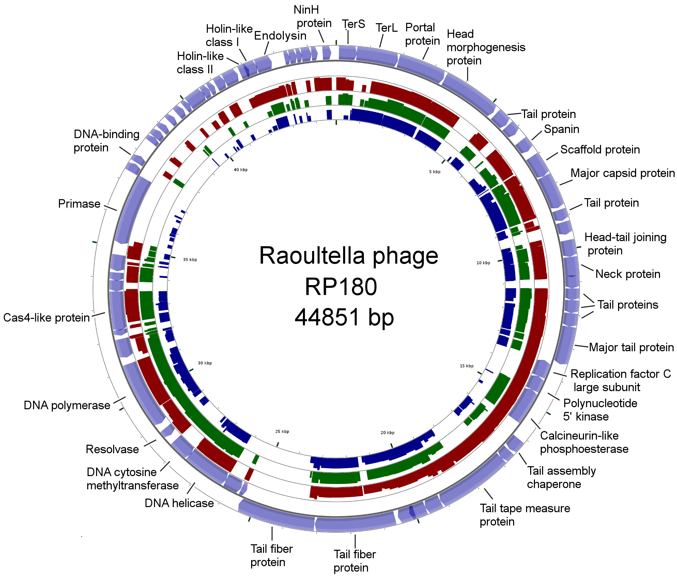

**Fig. 1** The CGView server [4] was used for comparative analysis of the RP180 genome [MK737937] and genomes of phages K1G [GU196277], Jersey [KF148055], and FSL-SP031 [KC139518]. For sequence similarity comparisons, TBLASTX was used versus K1G (red), Jersey (dark green) and FSL-SP031 (dark blue).

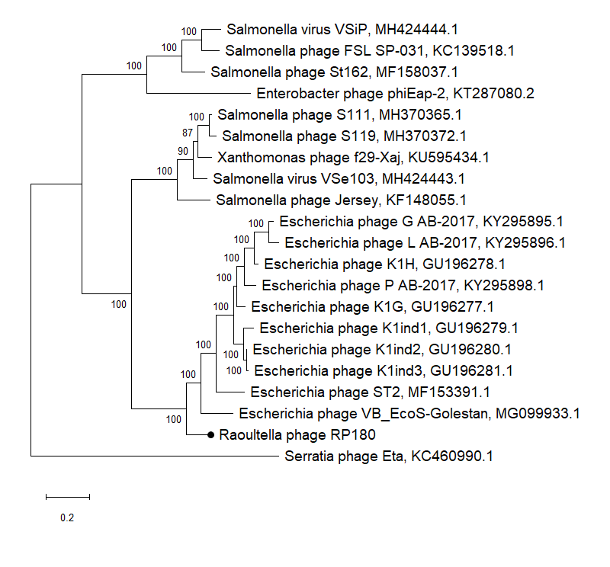

**Fig. 2** Phylogenetic analysis performed on the genomes of RP180 and 20 related phages using PhyML3.0 [5]. GenBank identifiers for the sequences are indicated. Investigated sequence is marked with black circle. Analysis was performed using the maximum-likelihood (ML) method. Bootstrap values are given at nodes.

| additional material in support of this proposal |
| --- |
| **References:** |
| 1. Fofanov MV, Morozova VV, Kozlova YN, Tikunov AY, Babkin IV, Poletaeva YE, Ryabchikova EI, Tikunova NV. *Raoultella* bacteriophage RP180, a new member of the genus *Kagunavirus*, subfamily *Guernseyvirinae.* Submitted. Archives of Virology. 2. Katoh K, Rozewicki J and Yamada KD (2017) MAFFT online service: multiple sequence alignment, interactive sequence choice and visualization. Brief Bioinform 18:1–7 3. Phillips JL and Gnanakaran S (2015) BioEdit: An important software for molecular biology. Proteins Struct Funct Bioinform 83(1):46–65 4. Grant JR and Stothard P (2008) The CGView Server: a comparative genomics tool for circular genomes. Nucleic Acids Res 36:181–184 5. Guindon S, Dufayard J, Lefort V et al (2010) New algorithms and methods to estimate maximim-likelihood phylogenies assessing the performance of PhyML 3.0. Syst Biol 59(3):1–37 |