This Word module should be used for all taxonomic proposals.

Please complete **Part 1** and:

either **Part 3** for proposals to create new taxa or change existing taxa

or **Part 2** for proposals of a general nature.

Submit the completed Word module, together with the accompanying Excel module named in Part 3, to the appropriate ICTV Subcommittee Chair.

The Word module explains and justifies your proposal. The Excel module is a critical document that will be used to implement the proposed taxonomic changes once they are approved and ratified. If proposals presented in the Word module are not presented accurately in the Excel module, the taxonomic changes cannot proceed.

For guidance, see the notes written in blue, below, and the Help Notes in file Taxonomic_Proposals_Help_2019.

**Part 1:** **TITLE, AUTHORS, etc**

|  |  |  |  |
| --- | --- | --- | --- |
| **Code assigned:** | ***2019.092B*** | |  |
| **Short title:** Create one new family (*Thaspiviridae*) including one new genus (*Nitmarvirus*) and one new species for spindle-shaped viruses infecting mesophilic archaea | | | |
|  | | | |
| **Author(s) and email address(es):** | | | |
| List authors in a single line *Archives of Virology* citation format (e.g. Smith AB, Huang C-L, Santos, F) | | Provide email address for each author in a single line separated by semi-colons | |
| Kim JG, Krupovic M, Rhee SK | | jjonggul2@gmail.com;  [mart.krupovic@pasteur.fr](mailto:mart.krupovic@pasteur.fr);  rhees@chungbuk.ac.kr | |
| **Author(s) institutional address(es) (optional):**   |  | | --- | | Provide institutional addresses, each on a single line followed by author(s) initials (e.g. University of Woolloomooloo [SAB, HCL]) | | Chungbuk National University, South Korea [JGK, SKR]  Institut Pasteur, France [MK] | | | | |
| **Corresponding author** | | | |
| Mart Krupovic,  Sung-Keun Rhee | | | |
| **List the ICTV study group(s) that have seen this proposal:** | | | |
| A list of study groups and contacts is provided at <http://www.ictvonline.org/subcommittees.asp> . If in doubt, contact the appropriate subcommittee chair (there are six virus subcommittees: animal DNA and retroviruses, animal ssRNA-, animal ssRNA+, fungal and protist, plant, bacterial and archaeal) | | **Bacterial and Archaeal Viruses Subcommittee** | |
| **ICTV Study Group comments (if any) and response of the proposer:** | | | |
|  | | | |
|  | | | |
| Date first submitted to ICTV: | | |  |
| Date of this revision (if different to above): | | |  |

|  |
| --- |
| **ICTV-EC comments and response of the proposer:** |
| EC comments: amend Excel module to mention dsDNA genome (“composition”), Word module to show full virus names.  Response: Both Excel and Word modules have been corrected. |

**Part 2:** **NON-STANDARD**

Template for any proposal regarding ICTV procedures, rules or policy, not involving the creation of new taxonomy.

| **Text of proposal:** |
| --- |
|  |

**Part 3:** **PROPOSED TAXONOMY**

|  |
| --- |
| **Name of accompanying Excel module:** 2019.092B.A.v1.Thaspiviridae_1nfam.xlsx |

The taxonomic changes you are proposing should be presented on an accompanying Excel module, 2019_TP_Template_Excel_module. Please enter the file name of the completed module in this box.

**Supporting material:**

Viruses with spindle-shaped virions are exclusive to archaea and have been previously shown to infect hyperthermophilic (family *Fuselloviridae*) and extremely halophilic (genus *Salterprovirus*) hosts (Krupovic et al., 2014). Recently, three viruses with spindle-shaped virions and infecting a mesophilic marine archaeon of the phylum Thaumarchaeota, *Nitrosopumilus maritimus* SCM1, have been isolated (Kim et al., 2019). These are the first virus isolates infecting mesophilic archaea. The virions of Nitrosopumilus spindle-shaped viruses 1, 2 and 3 (NSV1, NSV2 and NSV3, respectively) measure 64 ± 3 nm in diameter and 112 ± 6 nm in length, with a short tail at one pole (Figure 1). This morphology is closely similar to that of fuselloviruses and salterprovirus His1.

The genomes of NSVs are linear double-stranded DNA molecules of 27.5-29 kbp, terminating with 176-bp inverted repeats (Figure 2). Among spindle-shaped viruses such genome organization is found only in salterprovirus His1, whereas all known fuselloviruses contain circular dsDNA genomes. Genomes of the three NSVs are >95% identical to each other and thus should be considered strains of the same species. The numbers of open reading frames (ORFs) in the genomes of NSV1, NSV2 and NSV3 were predicted to be 48, 51, and 48, respectively. With the exception of the protein-primed family B DNA polymerase (pPolB), NSV proteins do not display appreciable sequence similarity to the proteins of other known archaeal or bacterial viruses in BLASTP searches (E value cut-off: 0.001). Only 9 out of 48 (18.7%) NSV1 ORFs yielded significant matches in the non-redundant sequence databases to known cellular proteins. Notably, however, the pPolB of NSVs is shared with several groups of archaeal viruses and non-viral mobile genetic elements, which, like NSV, have linear genomes with terminal inverted repeats. These include the haloarchaeal spindle-shaped (genus *Salterprovirus*) and pleomorphic (family *Pleolipoviridae*, genus *Gammapleolipovirus*) viruses His1 (Bath et al., 2006) and His2 (Bath et al., 2006), respectively; hyperthermophilic bottle-shaped (family *Ampullaviridae*) (Prangishvili et al., 2018) and ellipsoid (family *Ovaliviridae*) (Wang et al., 2018) viruses; and casposons, which integrate into the genomes of diverse thaumarchaea (Krupovic et al., 2017). Maximum likelihood phylogenetic analysis showed that pPolB sequences from NSVs form a sister group to the clade that includes halophilic viruses His1 and His2, as well as sequences from marine sediment metagenomes. At the base of this clade are casposons from the marine members of the Thaumarchaeota. These results suggest horizontal exchange of the pPolB genes between casposons, NSVs, and haloarchaeal viruses. Phylogenetic analysis also suggests that pPolB genes of thaumarchaeal mobile elements are ancestral to those of His1-like viruses of halophilic archaea.

Despite shared virion morphology and genome replication mechanism (likely mediated by homologous pPolB), NSVs and His1 infect widely distinct hosts, belonging to different phyla of archaea (Thaumarchaeota and Euryarchaeota, respectively). Furthermore, the genomes of NSVs are approximately twice longer than that of His1 (Figure 2) and, accordingly, encode different proteins. Thus, although distantly related, NSVs and His1 should not be classified into the same family. Thus, for classification of NSVs, we propose creating a separate family with a single genus and a single species. We propose naming the family and genus *Thaspiviridae* (*Tha*- for thaumarchaeal, *spi*- for spindle-shaped viruses) and *Nitmarvirus* (for *Nitrosopumilus maritimus*), respectively. Among the three NSVs, NSV1 has been more extensively characterized (Kim et al., 2019) and we chose this virus as an exemplar for the type species, *Nitmarvirus NSV1*.

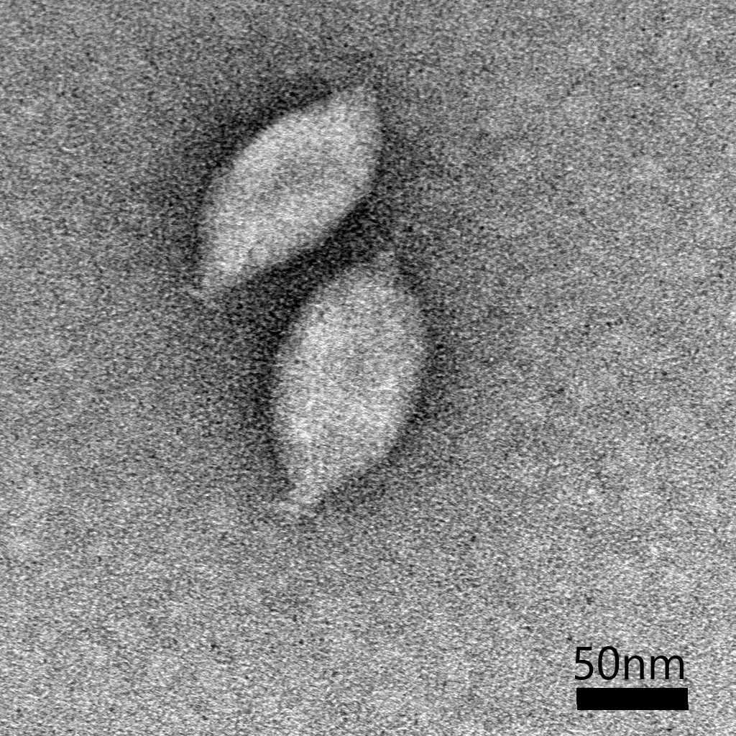

**Figure 1.** Transmission electron micrograph of negatively stained NSV1 virions. Scale bar: 50 nm.



**Figure 2.** Genome maps of NSV1, NSV2 and salterprovirus His1. Shared ORFs are connected by shaded areas based on sequence identity. Functionally equivalent (but not necessarily homologous) genes are indicated with matching colors. Abbreviations: pPolB, protein-primed family B DNA polymerase; MCP, major capsid protein (putative); wHTH, winged helix-turn-helix; GTase, glycosyltransferase; MTase, DNA methyltransferase; PCNA, proliferating cell nuclear antigen.



**Figure 3.** Maximum likelihood phylogenetic analysis of pPolB sequences from bacterial and archaeal viruses, and non-viral mobile genetic elements. In this tree, archaeal viruses comprise the following taxa: *Ampullaviridae*, *Pleolipoviridae*, *Ovaliviridae* and *Salterprovirus*. Sequences originating from classified archaeal and bacterial viruses are highlighted with light blue and black, whereas sequences from metagenomic datasets are indicated with grey font. Metagenomic sequences were retrieved from the MGnify website (<https://www.ebi.ac.uk/metagenomics/>) and are named MGYPXXX. NSVs and related contigs (scaffold98 and scaffold83) are shown in red. The sequences were aligned using MUSCLE (Edgar, 2004). Poorly aligned (low information content) positions were removed using trimAl v1.2 (Capella-Gutiérrez et al., 2009) with a gap threshold of 0.2. The final alignment contained 705 positions. The maximum likelihood phylogenetic tree was constructed using the PhyML program (Guindon et al., 2010) with automatic selection of the best-fit substitution model for a given alignment. The best model identified by PhyML was VT+G+I+F. The tree was midpoint rooted for convenient visualisation. The branch support was assessed using aBayes implemented in PhyML.

| **References:** |
| --- |
| Bath C, Cukalac T, Porter K, Dyall-Smith ML. His1 and His2 are distantly related, spindle-shaped haloviruses belonging to the novel virus group, Salterprovirus. Virology. 2006; 350(1):228–239.  Capella-Gutiérrez S, Silla-Martínez JM, & Gabaldón T. trimAl: a tool for automated alignment trimming in large-scale phylogenetic analyses. Bioinformatics. 2009; 25:1972-1973.  Edgar RC (2004) MUSCLE: a multiple sequence alignment method with reduced time and space complexity. BMC Bioinformatics 19:113.  Guindon S, et al. New algorithms and methods to estimate maximum-likelihood phylogenies: assessing the performance of phyML 3.0. Syst Biol. 2010: 59:307-321.  Kim JG, Kim SJ, Cvirkaite-Krupovic V, Yu WJ, Gwak JH, López-Pérez M, Rodriguez-Valera F, Krupovic M, Cho JC, Rhee SK. Spindle-shaped viruses infect marine ammonia-oxidising thaumarchaea. 2019. Proc Natl Acad Sci U S A. 2019; 116(31):15645-15650.  Krupovic M, Béguin P, Koonin EV. Casposons: mobile genetic elements that gave rise to the CRISPR-Cas adaptation machinery. Curr Opin Microbiol. 2017; 38:36-43.  Krupovic M, Quemin ER, Bamford DH, Forterre P, Prangishvili D. Unification of the globally distributed spindle-shaped viruses of the Archaea. J Virol. 2014; 88(4):2354-8.  Prangishvili D, Krupovic M, ICTV Report Consortium. ICTV Virus Taxonomy Profile: Ampullaviridae. J Gen Virol. 2018; 99(3):288-289.  Wang H, Guo Z, Feng H, Chen Y, Chen X, Li Z, Hernández-Ascencio W, Dai X, Zhang Z, Zheng X, Mora-López M, Fu Y, Zhang C, Zhu P, Huang L. Novel Sulfolobus Virus with an Exceptional Capsid Architecture. J Virol. 2018;92(5): e01727-17. |