This Word module should be used for all taxonomic proposals.

Please complete **Part 1** and:

either **Part 3** for proposals to create new taxa or change existing taxa

or **Part 2** for proposals of a general nature.

Submit the completed Word module, together with the accompanying Excel module named in Part 3, to the appropriate ICTV Subcommittee Chair.

The Word module explains and justifies your proposal. The Excel module is a critical document that will be used to implement the proposed taxonomic changes once they are approved and ratified. If proposals presented in the Word module are not presented accurately in the Excel module, the taxonomic changes cannot proceed.

For guidance, see the notes written in blue, below, and the Help Notes in file Taxonomic_Proposals_Help_2019.

**Part 1:** **TITLE, AUTHORS, etc**

|  |  |  |  |
| --- | --- | --- | --- |
| **Code assigned:** | ***2019.106B*** | |  |
| **Short title:** Create one new genus *Alphalipothrixvirus* including two new species, and one new species in the genus *Deltalipothrixvirus*, in the family *Lipothrixviridae* | | | |
|  | | | |
| **Author(s) and email address(es):** | | | |
| List authors in a single line *Archives of Virology* citation format (e.g. Smith AB, Huang C-L, Santos, F) | | Provide email address for each author in a single line separated by semi-colons | |
| Liu Y, Prangishvili D, Krupovic M | | [ying.liu@pasteur.fr](mailto:ying.liu@pasteur.fr); [david.prangishvili@pasteur.fr](mailto:david.prangishvili@pasteur.fr);  [krupovic@pasteur.fr](mailto:krupovic@pasteur.fr) | |
| **Author(s) institutional address(es) (optional):**   |  | | --- | | Provide institutional addresses, each on a single line followed by author(s) initials (e.g. University of Woolloomooloo [SAB, HCL]) | | Institut Pasteur, France [YL, DP, MK] | | | | |
| **Corresponding author** | | | |
| Mart Krupovic  David Prangishvili | | | |
| **List the ICTV study group(s) that have seen this proposal:** | | | |
| A list of study groups and contacts is provided at <http://www.ictvonline.org/subcommittees.asp> . If in doubt, contact the appropriate subcommittee chair (there are six virus subcommittees: animal DNA and retroviruses, animal ssRNA-, animal ssRNA+, fungal and protist, plant, bacterial and archaeal) | | **Bacterial and archaeal viruses subcommittee** | |
| **ICTV Study Group comments (if any) and response of the proposer:** | | | |
|  | | | |
|  | | | |
| Date first submitted to ICTV: | | | June 19, 2019 |
| Date of this revision (if different to above): | | |  |

|  |
| --- |
| **ICTV-EC comments and response of the proposer:** |
|  |

**Part 2:** **NON-STANDARD**

Template for any proposal regarding ICTV procedures, rules or policy, not involving the creation of new taxonomy.

| **Text of proposal:** |
| --- |
|  |

**Part 3:** **PROPOSED TAXONOMY**

|  |
| --- |
| **Name of accompanying Excel module:** 2019.106B.A.v1. Lipothrixviridae_1gen3sp.xlsx |

**Supporting material:**

A novel enveloped filamentous virus, *Sulfolobus* filamentous virus 1 (SFV1; Figure 1), infecting hyperthermophilic archaeon *Sulfolobus shibatae,* has been reported (Liu et al., 2018). SFV1 has a linear double-stranded DNA genome of 37,311 bp with 337 bp-long terminal inverted repeats. The virus encodes 66 predicted open reading frames (ORFs), only 12 (~18%) of which could be functionally annotated using a combination of BLASTP and HHpred analyses (Figure 1). Eight ORFs have homologs in members of the *Lipothrixviridae* (Figure 2).

Furthermore, similar to lipothrixviruses, SFV1 virion contains two major capsid proteins (MCPs), VP4 and VP5. Although the two MCPs did not display apparent sequence similarity to each other or to any other proteins in databases, cryo-electron microscopy reconstruction of the SFV1 virion at 3.7Å resolution showed that the two MCPs form a nearly symmetrical heterodimer, which wraps around A-form DNA (Figure 3), similar to the nucleoprotein structure of gammalipothrixvirus AFV1 and rudivirus SIRV2 (Liu et al., 2018; Kasson et al., 2017; DiMaio et al., 2015). Thus, the gene content and virion organization (enveloped, filamentous virions constructed from two homologous MCPs) suggest that SFV1 is related to members of the family *Lipothrixviridae*.

Three additional virus genomes, *Sulfolobales* Beppu filamentous viruses 1, 2 and 3 (SBFV1, SBFV2 and SBFV3, respectively), were obtained by metagenomic sequencing from the same enrichment culture from which SFV1 was isolated (Liu et al., 2019). SBFV1 and SBFV2 display close sequence similarity to SFV1. Whereas SBFV1 shows an overall 97% nucleotide sequence identity to SFV1 (Figure 2), SBFV2 is more divergent: about one third of the SFV1 and SBFV2 genomic sequences, mainly distributed in regions between ~12 kb and 36 kb, share ~50% identity. However, protein sequence analysis showed that ~75% of the putative proteins in SFV1 and SBFV2 are homologous (Figure 2). We propose to follow the practice used for bacterial viruses and use 95% nucleotide sequence identity threshold as a species demarcation. Accordingly, SBFV1 should be considered as a strain of SFV1 and SBFV2 as a separate species in the same taxon.

By contrast, SBFV3 showed the closest similarity to virus *Acidianus* filamentous virus 2

(AFV2; Häring et al., 2005), the sole representative of the genus *Deltalipothrixvirus* (family *Lipothrixviridae*), with which it shares 29 out of 54 encoded ORFs (Figure 4), although no appreciable sequence similarity was found at the nucleotide level.

To explore the taxonomic position of SFV1, SBFV2 and SBFV3 within the family *Lipothrixviridae*, we calculated pairwise intergenomic distances between all sequenced members of the order *Ligamenvirales* (*Rudiviridae* and *Lipothrixviridae*) with the Genome-BLAST Distance Phylogeny (GBDP) method using VICTOR (<https://victor.dsmz.de>), a tool recently tested and validated for classification of bacterial viruses (Barylski et al., 2019). This genome-wide comparison showed that SFV1 and SBFV2 form a clade that is distinct from the currently recognized genera in the *Lipothrixviridae* (Figure 5), whereas SBFV3 clustered with the deltalipothrixvirus AFV2.

Thus, we propose to classify SFV1 and SBFV2 viruses into two new species within a new genus, *Alphalipothrixvirus*, in the virus family *Lipothrixviridae*, and assign SFV1 as the type species. SBFV3 is proposed to be classified into a new species within the *Deltalipothrixvirus* genus.

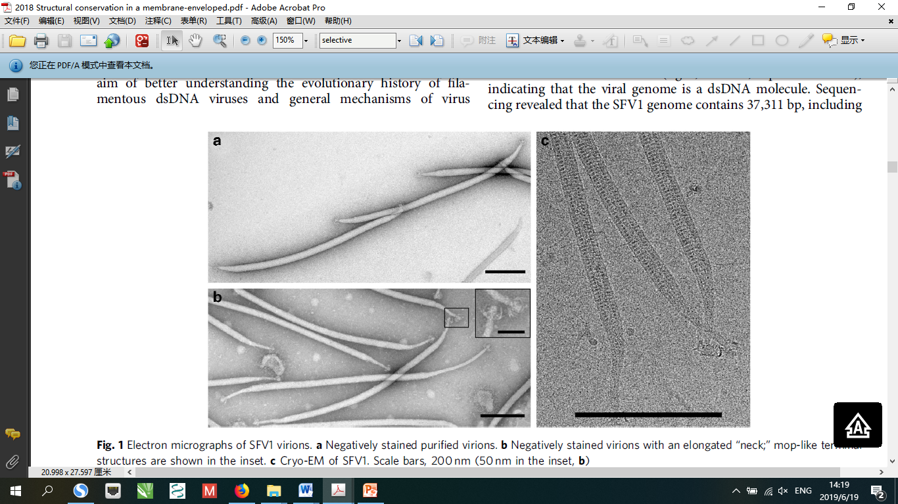

Figure 1. Electron micrographs of SFV1 virions. (a) Negatively stained purified virions. (b) Negatively stained virions with an elongated “neck”; mop-like terminal structures are shown in the inset. (c) Cryo-EM of SFV1. Scale bars, 200 nm (50 nm in the inset, b).

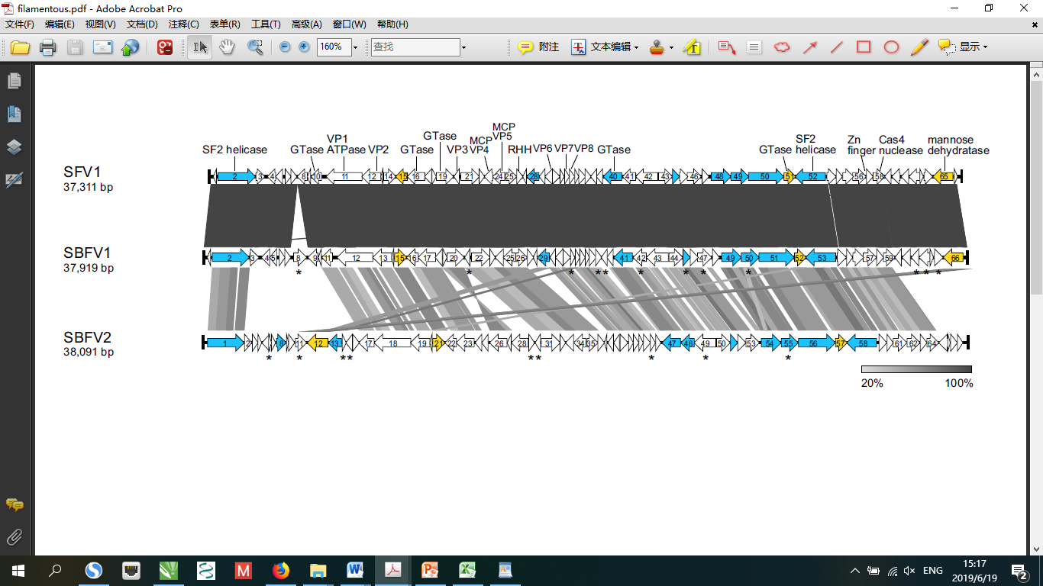

Figure 2. Graphical alignment of the linear genomes of filamentous viruses SFV1, SBFV1 and SBFV2. The ORFs are represented with arrows that indicate the direction of transcription. The blue arrows denote ORFs homologous in viruses of the family *Lipothrixviridae*, and the yellow arrows denote ORFs with homologues in archaeal or bacterial cells. The predicted transmembrane proteins are indicted by asterisks. The terminal inverted repeats (TIRs) are depicted by black bars. The homologous genes shared between viruses are connected by shading of different degrees of grey based on the aa-sequence identity represented in the bar in the right below.

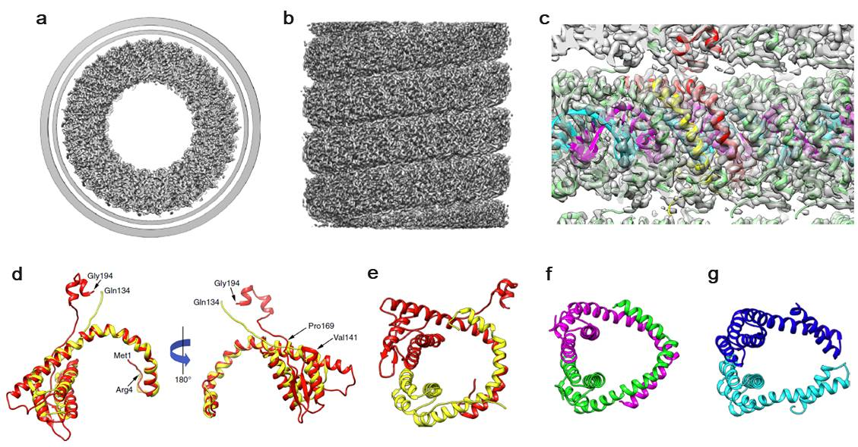

Figure 3. Three-dimensional reconstruction of SFV1 and structural conservation and divergence among capsid proteins of ligamenviruses. A top view (a) shows the membrane enveloping the nucleoprotein core. In the side view (b) the membrane has been removed. (c) A view from within the lumen of the virion shows the atomic model built into the density. The asymmetric unit contains VP5 (red), VP4 (yellow) and 12 basepairs of DNA. One strand of DNA is shown in magenta, the other in cyan. (d) VP5 and VP4 from SFV1 have been aligned to each other. The SFV1 heterodimer (e) is similar to SIRV2 homodimer (f) and AFV1 heterodimer (g).

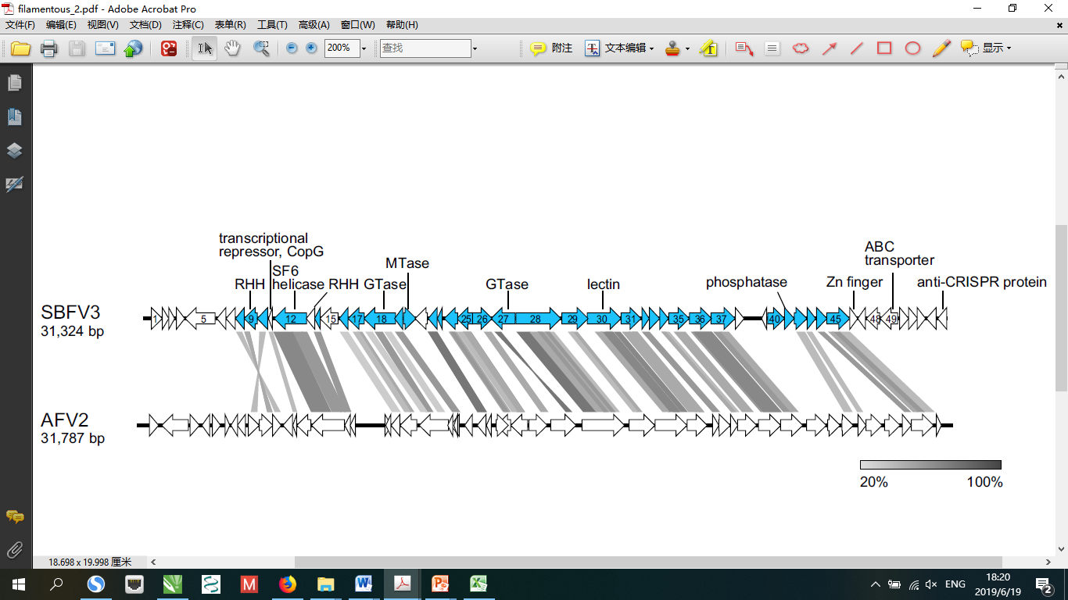

Figure 4. Genome alignment of SBFV3 and deltalipothrixvirus AFV2. The ORFs are represented with arrows that indicate the direction of transcription. The blue arrows denote ORFs homologous in viruses of the order *Sulfolobales*. The homologous genes shared between viruses are connected by shading of different degrees of grey based on the aa-sequence identity represented in the bar in the right below.

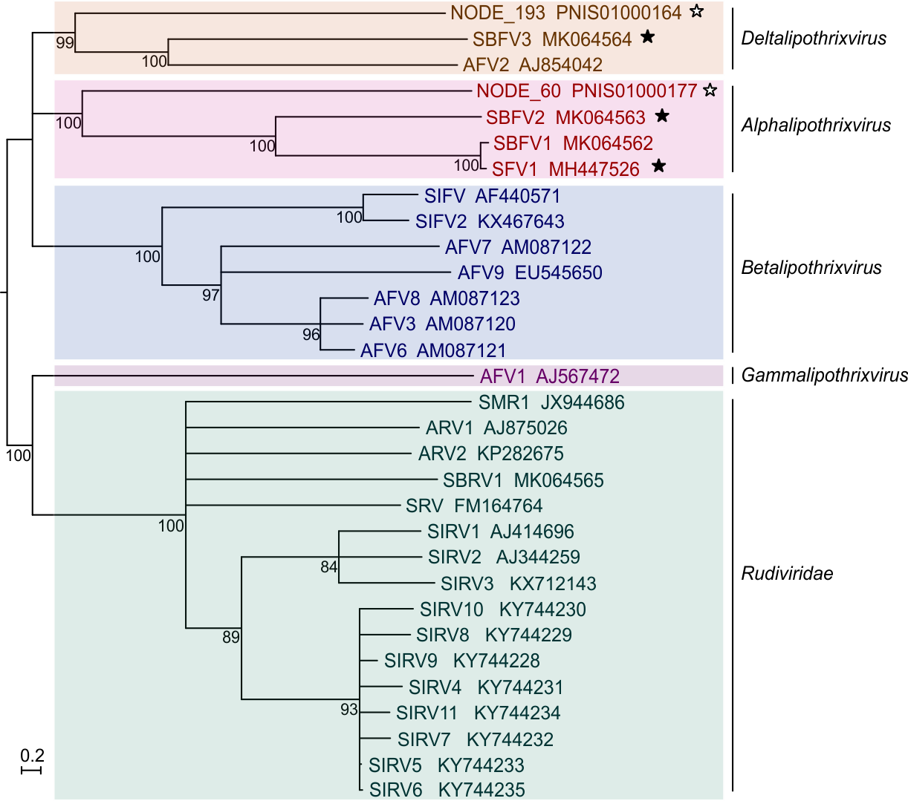

Figure 5. Inferred phylogenetic tree of archaeal filamentous and rod-shaped viruses based on whole genome VICTOR analysis at the amino acid level. The tree is rooted at mid-point, and the branch length is scaled in terms of the Genome BLAST Distance Phylogeny (GBDP) distance

formula D6. The branch which support value >70% is shown. For each genome, the virus name and the GenBank accession number are indicated. The viruses of newly proposed species are marked by filled stars, and ones newly identified from public metagenomics databases are marked by open stars.

| **References:** |
| --- |
| Barylski J, Enault F, Dutilh BE, Schuller MBP, Edwards RA, Gillis A, Klumpp J, Knezevic P, Krupovic M, Kuhn JH, Lavigne R, Oksanen HM, Sullivan MB, Jang HB, Simmonds P, Aiewsakun P, Wittmann J, Tolstoy I, Brister JR, Kropinski AM, Adriaenssens EM. 2019. Analysis of Spounaviruses as a Case Study for the Overdue Reclassification of Tailed Phages. Syst Biol. doi: 10.1093/sysbio/syz036.  DiMaio F, Yu X, Rensen E, Krupovic M, Prangishvili D, Egelman EH. 2015. A virus that infects a hyperthermophile encapsidates A-form DNA. Science. 348(6237):914-917.  Häring M, Vestergaard G, Brügger K, Rachel R, Garrett RA, Prangishvili D. 2005. Structure and genome organization of AFV2, a novel archaeal lipothrixvirus with unusual terminal and core structures. J Bacteriol. 187(11):3855-8.  Krupovic M, Prangishvili D. 2012. A new proposed taxon for double-stranded DNA viruses, the order “Ligamenvirales”. Arch Virol. 157:791-795.  Kasson P, DiMaio F, Yu X, Lucas-Staat S, Krupovic M, Schouten S, Prangishvili D, Egelman EH. 2017. Model for a novel membrane envelope in a filamentous hyperthermophilic virus. Elife. 6,e26268.  Liu Y, Osinski T, Wang F, Krupovic M, Schouten S, Kasson P, Prangishvili D, Egelman EH. 2018. Structural conservation in a membrane-enveloped filamentous virus infecting a hyperthermophilic acidophile. Nat Commun. 9(1):3360.  Liu Y, Brandt D, Ishino S, Ishino Y, Koonin EV, Kalinowski J, Krupovic M, Prangishvili D. 2019. New archaeal viruses discovered by metagenomics analysis of viral communities in enrichment cultures. Environ Microbiol. 21(6):2002-2014.  Prangishvili D, Bamford HD, Forterre P, Iranzo J, Koonin EV, Krupovic M. 2017. The enigmatic archaeal virosphere. Nat Rev Microbiol. 15(12):724-739. |