This Word module should be used for all taxonomic proposals.

Please complete **Part 1** and:

either **Part 3** for proposals to create new taxa or change existing taxa

or **Part 2** for proposals of a general nature.

Submit the completed Word module, together with the accompanying Excel module named in Part 3, to the appropriate ICTV Subcommittee Chair.

The Word module explains and justifies your proposal. The Excel module is a critical document that will be used to implement the proposed taxonomic changes once they are approved and ratified. If proposals presented in the Word module are not presented accurately in the Excel module, the taxonomic changes cannot proceed.

For guidance, see the notes written in blue, below, and the Help Notes in file Taxonomic_Proposals_Help_2019.

**Part 1:** **TITLE, AUTHORS, etc**

|  |  |  |  |
| --- | --- | --- | --- |
| **Code assigned:** | ***2019.107B*** | |  |
| **Short title:** Create one new species in the genus *Alphaportoglobovirus,* family *Portogloboviridae* | | | |
|  | | | |
| **Author(s) and email address(es):** | | | |
| List authors in a single line *Archives of Virology* citation format (e.g. Smith AB, Huang C-L, Santos, F) | | Provide email address for each author in a single line separated by semi-colons | |
| Liu Y, Prangishvili D, Krupovic M | | [ying.liu@pasteur.fr](mailto:ying.liu@pasteur.fr)  [david.prangishvili@pasteur.fr](mailto:david.prangishvili@pasteur.fr)  [krupovic@pasteur.fr](mailto:krupovic@pasteur.fr) | |
| **Author(s) institutional address(es) (optional):**   |  | | --- | | Provide institutional addresses, each on a single line followed by author(s) initials (e.g. University of Woolloomooloo [SAB, HCL]) | | Institut Pasteur, France [YL, MK, DP] | | | | |
| **Corresponding author** | | | |
| Mart Krupovic  David Prangishvili | | | |
| **List the ICTV study group(s) that have seen this proposal:** | | | |
| A list of study groups and contacts is provided at <http://www.ictvonline.org/subcommittees.asp> . If in doubt, contact the appropriate subcommittee chair (there are six virus subcommittees: animal DNA and retroviruses, animal ssRNA-, animal ssRNA+, fungal and protist, plant, bacterial and archaeal) | | **Bacterial and archaeal viruses subcommittee** | |
| **ICTV Study Group comments (if any) and response of the proposer:** | | | |
|  | | | |
|  | | | |
| Date first submitted to ICTV: | | | June 19, 2019 |
| Date of this revision (if different to above): | | |  |

|  |
| --- |
| **ICTV-EC comments and response of the proposer:** |
|  |

**Part 3:** **PROPOSED TAXONOMY**

|  |
| --- |
| **Name of accompanying Excel module:** 2019.107B.A.v1.Alphaportoglobovirus_1sp.xlsx |

**Supporting material:**

| additional material in support of this proposal |
| --- |

The family *Portogloboviridae* is represented by a single virus, Sulfolobus polyhedral virus 1 (SPV1), which has a circular double-stranded DNA (dsDNA) genome of 20,222 bp and infects hyperthermophilic archaeon *Sulfolobus shibatae* (Liu et al., 2017).

Metagenomic sequencing of an enrichment culture has yielded a circular dsDNA genome of 20,424 bp, which displays overall ~92% nucleotide sequence identity to SPV1 (Figure 1) (Liu et al., 2019). The corresponding virus has been named Sulfolobus polyhedral virus 2 (SPV2). SPV2 encodes 46 open reading frames (ORFs), among which 43 have homologs in SPV1. There are there insertions, two deletions and one duplication in the SPV2 genome, compared to SPV1 (Figure 1). We propose to follow the practice applied for bacterial viruses and use 95% nucleotide sequence identity threshold as a species demarcation. Accordingly, SPV2 should be considered as a new species in the genus *Alphaportoglobovirus*.

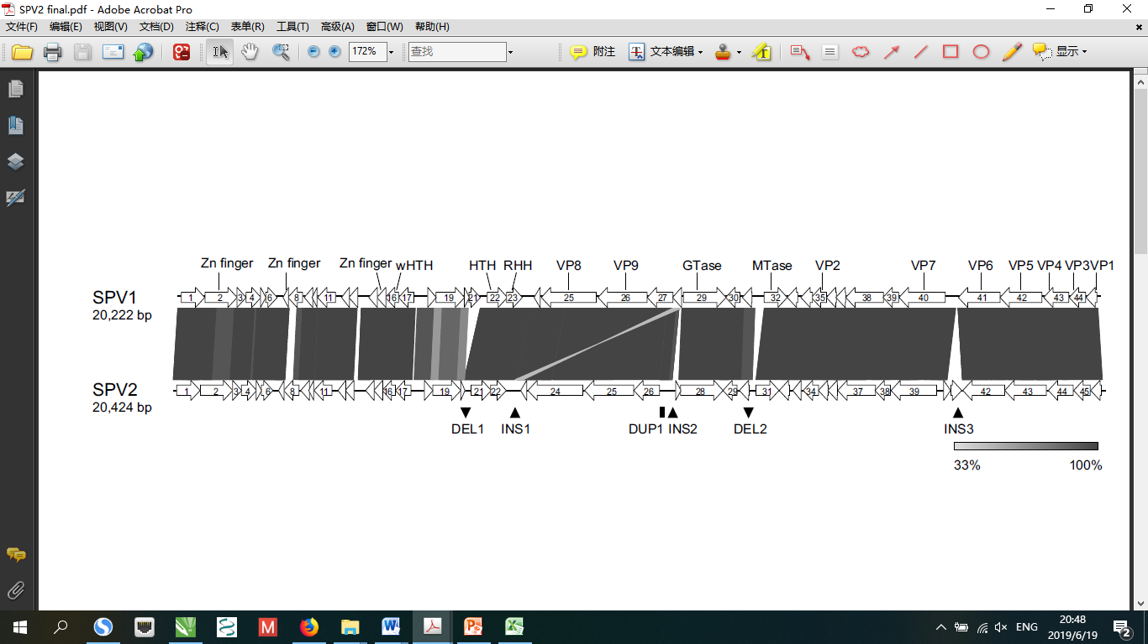

Figure 1. Graphical comparison of SPV1 and SPV2 genomes. The deletions (DEL), insertions (INS) and duplication (DUP) of sequences in SPV2 compared to SPV1 are marked. Annotations are shown above the corresponding ORFs.

| **References:** |
| --- |
| Liu Y, Ishino S, Ishino Y, Pehau-Arnaudet G, Krupovic M, Prangishvili. 2017. A novel type of polyhedral viruses infecting hyperthermophilic archaea. J Virol 91(13):e005819-17.  Liu Y, Brandt D, Ishino S, Ishino Y, Koonin EV, Kalinowski J, Krupovic M, Prangishvili D. 2019. New archaeal viruses discovered by metagenomics analysis of viral communities in enrichment cultures. Environ Microbiol. 21(6):2002-2014. |