

**Part 1:** **TITLE, AUTHORS, APPROVALS, etc**

|  |  |  |
| --- | --- | --- |
| **Code assigned:** | ***2022.002B*** |  |
| **Short title:** Create a new class *Ainoaviricetes* and a new order *Lautamovirales* in the phylum *Preplasmiviricota* (Realm *Varidnaviria*, kingdom *Bamfordvirae*), for single-stranded DNA viruses encoding vertical double jelly roll major capsid proteins | | |
|  | | |

**Author(s) and email address(es)**

|  |  |
| --- | --- |
| Laanto E, Mäntynen S, Sundberg L-R, Poranen MM, Oksanen HM | elina.laanto@helsinki.fi;  sari.mantynen@helsinki.fi;  lotta-riina.sundberg@jyu.fi;  minna.poranen@helsinki.fi;  hanna.oksanen@helsinki.fi |

**Author(s) institutional address(es) (optional)**

|  |
| --- |
| University of Helsinki, Finland (EL, SM, MMP, HMO)  University of Jyväskylä, Finland (EL, LRS) |

**Corresponding author**

|  |
| --- |
| Hanna Oksanen |

**List the ICTV Study Group(s) that have seen this proposal**

|  |
| --- |
| Bacterial Viruses Subcommittee Chair Evelien Adriaenssens, *Corticoviridae* and *Cystoviridae* Study Groups |

**ICTV Study Group comments and response of proposer**

|  |
| --- |
|  |

**ICTV Study Group votes on proposal**

|  |  |  |  |
| --- | --- | --- | --- |
| **Study Group** | **Number of members** | | |
| **Votes support** | **Votes against** | **No vote** |
|  |  |  |  |
|  |  |  |  |

**Authority to use the name of a living person**

|  |  |
| --- | --- |
| **Is any taxon name used here derived from that of a living person (Y/N)** | N |

|  |  |  |
| --- | --- | --- |
| **Taxon name** | **Person from whom the name is derived** | **Permission attached (Y/N)** |
|  |  |  |
|  |  |  |
|  |  |  |

**Submission dates**

|  |  |
| --- | --- |
| Date first submitted to SC Chair | May 6th, 2022 |
| Date of this revision (if different to above) | August 15th, 2022 |

**ICTV-EC comments and response of the proposer**

|  |
| --- |
| ICTV-EC comments: The demarcation criteria are the same for the two new ranks. Choose one of the ranks for the demarcation criterion, other rank should be created with more specific criteria or indicate that there are currently no specific criteria.  Proposer: The demarcation criteria determine the class level. There are currently no criteria for the order. Demarcation criteria for the order are created if necessary, when new species are described. |

**Part 2:** **NON-TAXONOMIC PROPOSAL**

**Text of proposal**

|  |
| --- |
|  |

**Part 3:** **TAXONOMIC PROPOSAL**

**Name of accompanying Excel module**

|  |
| --- |
| 2022.002B.A.v1.Ainoaviricetes_Finnlakeviridae_nc.xlsx |

**Abstract**

|  |
| --- |
| The unassigned family *Finnlakeviridae* currently includes a single genus *Finnlakevirus* and one species *Finnlakevirus FLiP*. Members of the family have a single-stranded DNA genome and encode a major capsid protein (MCP) that has a vertical double jelly roll (DJR) topology. In the ICTV classification, DNA viruses that encode a MCP with a vertical jelly roll fold are assigned to the *Varidnaviria* realm whose current members are dsDNA viruses. The realm is divided into two kingdoms: *Bamfordvirae*, characterized by a single MCP with a DJR fold, and *Helvetiavirae,* characterized by two MCPs, both containing a single jelly roll fold. Thus, ssDNA viruses with DJR MCP topology should be accommodated in the kingdom *Bamfordvirae.* Here we propose to create a new class *Ainoaviricetes* and a new order *Lautamovirales* in the phylum *Preplasmiviricota* (comprising the members with smaller virion size in the kingdom *Bamfordvirae)*, for single-stranded DNA viruses encoding double jelly roll-type MCPs. |

**Text of proposal**

|  |  |
| --- | --- |
| |  | | --- | | Flavobacterium phage FLiP is the first described single-stranded DNA (ssDNA) virus with an icosahedrally symmetric capsid and an internal membrane (Laanto et al., 2017). The size of the virion is about 60 nm. FLiP is currently the only described ssDNA virus that encodes a major capsid protein (MCP) with a vertical double jelly roll (DJR) topology (Figure 1). However, genomic and metagenomic database searches have identified a group of contigs encoding homologs of the FLiP MCP, along with a variant of a replication protein homologous to rolling-circle replication endonuclease (RCRE) in filamentous ssDNA viruses (M13-like inoviruses) (Yutin et al., 2018), indicating the presence of ssDNA viruses with DJR MCP in the sequenced environmental samples.  The unassigned family *Finnlakeviridae* currently includes a single genus *Finnlakevirus* and one species *Finnlakevirus FLiP* (Mäntynen et al., 2020). Members of the family have a ssDNA genome and encode a MCP that has a vertical DJR topology and arranges into pseudohexameric trimers (Laanto et al., 2017; Mäntynen et al., 2020). In the ICTV classification, DNA viruses that encode a MCP with a vertical jelly roll fold are assigned to the *Varidnaviria* realm. In fact, in the taxonomy proposal for *Varidnaviria* (Koonin et al., 2019, ratified 2020)*,* it was emphasized that *Finnlakeviridae* should be accommodated in the megataxonomic framework of DNA viruses with a DJR MCP in the realm *Varidnaviria* (Koonin et al., 2019). All current members of the realm *Varidnaviria* are dsDNA viruses. The realm is divided into two kingdoms: *Bamfordvirae*, characterized by a single MCP with a DJR fold, and *Helvetiavirae,* characterized by two MCPs, both containing a single jelly roll fold (Koonin et al., 2020; Woo et al., 2021). Members of the kingdom *Bamfordvirae* vary notably in size.In the current ICTV taxonomy, *Bamfordvirae* has been divided into two phyla: *Nucleocytoviricota,* comprising giant viruses of the kingdom,and *Preplasmiviricota,* including those members of the kingdom that have smaller virions. Phylum *Preplasmiviricota* currently contains three (dsDNA virus) classes: *Maveriviricetes*, *Polintoviricetes* and *Tectiliviricetes*.  Here we propose to create   * a new order *Lautamovirales* in a new class *Ainoaviricetes* in the phylum *Preplasmiviricota* for viruses with a ssDNA genome encoding a vertical DJR MCP   **Proposed taxon demarcation criteria:**   * *Ainoaviricetes*: A virus belonging to phylum *Preplasmiviricota* is a member of the class *Ainoaviricetes* if it has a ssDNA genome encoding a vertical DJR MCP. * *Lautamovirales*: There are currently no demarcation criteria.   **Etymology of proposed taxa:**   * *Ainoaviricetes;* from Finnish word ´ainoa´, meaning ´only´, ´single´ — a reference to the single-stranded DNA genome of the viruses in this taxon; and the suffix -*viricetes* for class taxa * *Lautamovirales;* after Jaana K.H. Bamford † (nee Lautamo) who established phage research at the University of Jyväskylä, Finland, where the sole member of *Finnlakeviridae* was isolated and characterized; and the suffix -*virales* for order taxa | |

**Supporting evidence**

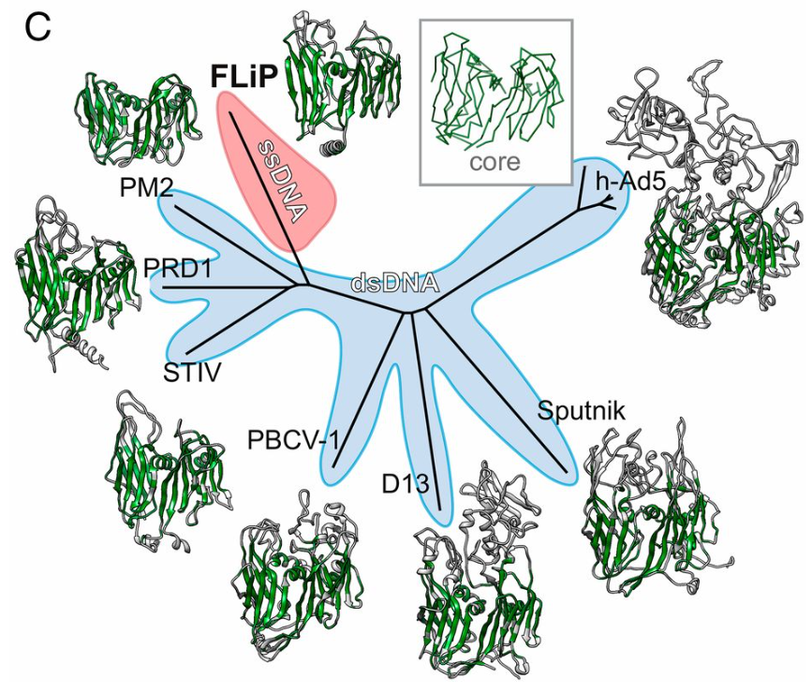

**Figure 1.** Structure-based phylogenetic tree (from Laanto et al., 2017) derived from structural alignment of MCPs from FLiP, bacteriophage PM2 (PDB code: 2WOC), bacteriophage PRD1 (PDB ID code: 1HX6), Sulfolobus turreted icosahedral virus (STIV; PDB ID code: 2BBD), Paramecium bursaria chlorella virus 1 (PBCV-1; PDB ID code: 1M3Y), vaccinia virus Western Reserve D13 (D13; PDB ID code: 2YGB), Sputnik virophage (PDB ID code: 3J26), and human adenovirus 5 (h-Ad5; PDB ID code 1P30). The structurally equivalent region used in the structure-based comparison is shown in green. A generalized fold for the common structural core is shown as a C-α trace in the Inset. Branches corresponding to viruses with dsDNA genomes are shaded light blue. The branch corresponding to FLiP, the only characterized member the lineage with an ssDNA genome, is highlighted in red.

**References**

Koonin EV, Dolja VV, Krupovic M, Varsani A, Wolf YI, Yutin N, Zerbini FM, Kuhn JH. Create a megataxonomic framework, filling all principal taxonomic ranks, for DNA viruses encoding vertical jelly roll-type major capsid proteins. 2020, ICTV Online: International Committee on Taxonomy of Viruses (ICTV). International Committee on Taxonomy of Viruses (ICTV)

Koonin EV, Dolja VV, Krupovic M, Varsani A, Wolf YI, Yutin N, Zerbini FM, Kuhn JH. Global Organization and Proposed Megataxonomy of the Virus World. Microbiol Mol Biol Rev. 2020 Mar 4;84(2):e00061-19. doi: 10.1128/MMBR.00061-19. PMID: 32132243; PMCID: PMC7062200.

Laanto E, Mäntynen S, De Colibus L, Marjakangas J, Gillum A, Stuart DI, Ravantti JJ, Huiskonen JT, Sundberg LR. Virus found in a boreal lake links ssDNA and dsDNA viruses. Proc Natl Acad Sci U S A. 2017 Aug 1;114(31):8378-8383. doi: 10.1073/pnas.1703834114. Epub 2017 Jul 17. PMID: 28716906; PMCID: PMC5547622.

Mäntynen S, Laanto E, Sundberg LR, Poranen MM, Oksanen HM, Report Consortium I. ICTV Virus Taxonomy Profile: *Finnlakeviridae*. J Gen Virol. 2020 Sep;101(9):894-895. doi: 10.1099/jgv.0.001488. PMID: 32840474; PMCID: PMC7654751.

Woo AC, Gaia M, Guglielmini J, Da Cunha V, Forterre P. Phylogeny of the Varidnaviria Morphogenesis Module: Congruence and Incongruence With the Tree of Life and Viral Taxonomy. Front Microbiol. 2021 Jul 16;12:704052. doi: 10.3389/fmicb.2021.704052. PMID: 34349745; PMCID: PMC8328091.

Yutin N, Bäckström D, Ettema TJG, Krupovic M, Koonin EV. Vast diversity of prokaryotic virus genomes encoding double jelly-roll major capsid proteins uncovered by genomic and metagenomic sequence analysis. Virol J. 2018 Apr 10;15(1):67. doi: 10.1186/s12985-018-0974-y. PMID: 29636073; PMCID: PMC5894146.