

**Part 1:** **TITLE, AUTHORS, APPROVALS, etc**

|  |  |  |
| --- | --- | --- |
| **Code assigned:** | ***2022.005B*** |  |
| **Short title:** Create two subfamilies (*Andregratiavirinae* and *Joanripponvirinae*) and seven new genera (*Caudoviricetes*) | | |
|  | | |

**Author(s) and email address(es)**

|  |  |
| --- | --- |
| Barylski J, Turner D, Moraru C, Kropinski AM | jakub.barylski@gmail.com; Dann2.Turner@uwe.ac.uk; liliana.cristina.moraru@uol.de; Phage.Canada@gmail.com |

**Author(s) institutional address(es) (optional)**

|  |
| --- |
| Adam Mickiewicz University, Poznań, Poland [JB] University of the West of England, Bristol, UK [DT] Carl von Ossietzky Universität Oldenburg, Germany [CM] University of Guelph, Canada [AMK] |

**Corresponding author**

|  |
| --- |
| Andrew M. Kropinski |

**List the ICTV Study Group(s) that have seen this proposal**

|  |
| --- |
| Bacterial Viruses Subcommittee, Caudoviricetes Study Group |

**ICTV Study Group comments and response of proposer**

|  |
| --- |
|  |

**ICTV Study Group votes on proposal**

|  |  |  |  |
| --- | --- | --- | --- |
| **Study Group** | **Number of members** | | |
| **Votes support** | **Votes against** | **No vote** |
|  |  |  |  |
|  |  |  |  |

**Authority to use the name of a living person**

|  |  |
| --- | --- |
| **Is any taxon name used here derived from that of a living person (Y/N)** | N |

|  |  |  |
| --- | --- | --- |
| **Taxon name** | **Person from whom the name is derived** | **Permission attached (Y/N)** |
|  |  |  |
|  |  |  |
|  |  |  |

**Submission dates**

|  |  |
| --- | --- |
| Date first submitted to SC Chair | May 2022 |
| Date of this revision (if different to above) |  |

**ICTV-EC comments and response of the proposer**

|  |
| --- |
| ICTV-EC: Please add subfamily annotations to heatmap and phylogenetic tree for clarification. Please check with relevant scientists whether the name Kenyata (derived from a politician) is appropriate.  Proposer: Annotations added. Upon consultation with other scientists, no name change will be made. |

**Part 2:** **NON-TAXONOMIC PROPOSAL**

**Text of proposal**

|  |
| --- |
|  |

**Part 3:** **TAXONOMIC PROPOSAL**

**Name of accompanying Excel module**

|  |
| --- |
| 2022.005B.N.v1.Andregratiavirinae\_Joanripponvirinae\_nsf.xlsx |

**Abstract**

|  |
| --- |
| We propose to create two subfamilies and seven genera of *Bacillus* siphoviruses. These viruses are probably temperate (all these phages carry multiple genes encoding tyrosine integrases/recombinases of the Cre/XERD type and *Bacillus* phage vB\_BanS-Tsamsa was isolated by induction of prophages with mitomycin C, and may possess terminally redundant genomes. All the members of this group encode ParM-like proteins which are involved in plasmid segregation. |

**Text of proposal**

|  |  |
| --- | --- |
| |  | | --- | | **Species demarcation criteria:** Two phages are assigned to the same species if their genomes are more than 95% identical over their genome length for isolates.  These values can be calculated by a number of tools, such as BLASTn [1] – usually calculated using intergenomic distance calculator VIRIDIC [2].  **Genus demarcation criteria:** In search for criteria that create cohesive and distinct genera that are reproducible and monophyletic, the Bacterial Viruses Subcommittee has established 70% nucleotide identity of the genome length as the cut-off for genera. Genus-level groupings should always be monophyletic in the signature genes, as tested with a phylogenetic tree. [8]  **Subfamily demarcation criteria:** Subfamilies are to be created when two or more genera are related below the family level. In practical terms, this usually means that they share a low degree of sequence similarity (usually about 40-50%) and that the genera form a clade in a marker tree phylogeny. [8] | |

**Supporting evidence**

**VIRIDIC heat map:** VIRIDIC (Virus Intergenomic Distance Calculator; VIRIDIC (Virus Intergenomic Distance Calculator; [2]; http://rhea.icbm.uni-oldenburg.de/VIRIDIC/) computes pairwise intergenomic distances/similarities amongst phage genomes. The new genera are indicated in coloured highlights in the first column, the two new subfamilies are indicated by coloured bars on the right (*Andregratiavirinae* blue, *Joanripponvirinae* yellow).

****

**ViPTree analysis:** ViPTree analysis ([https://www.genome.jp/viptree/](about:blank); [3]) is based upon Rohwer and Edwards (2002) famous Phage Proteomic Tree [4]. The phages of interest are indicated with **red stars**.

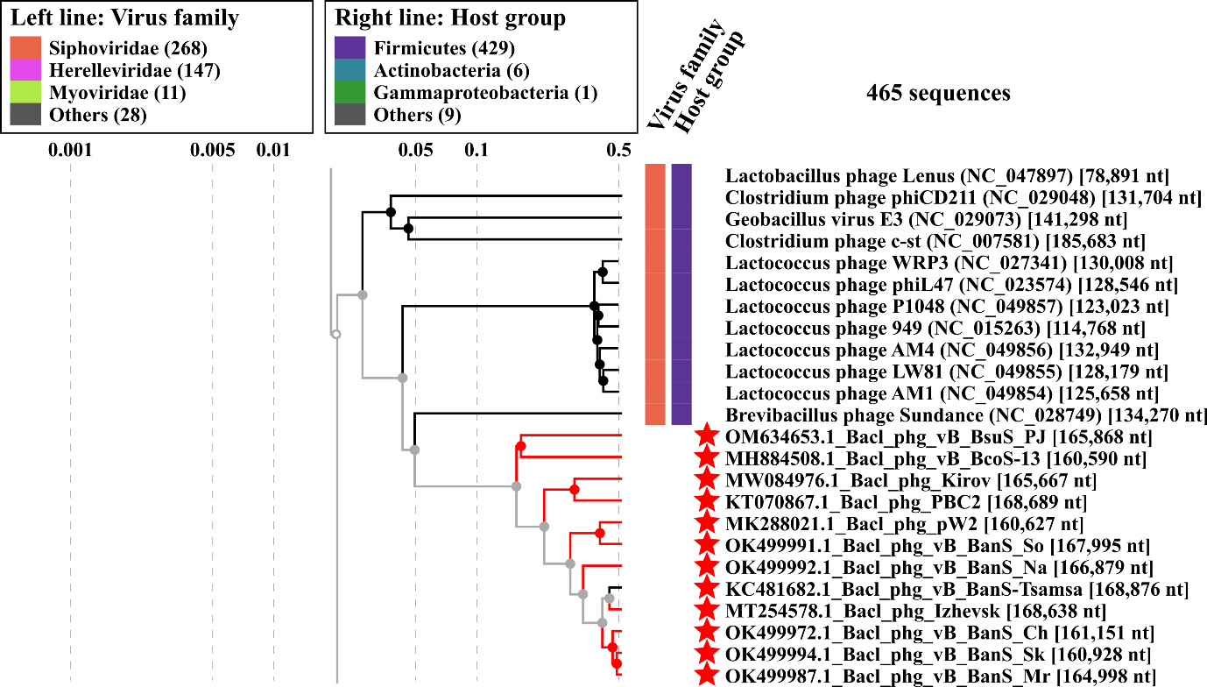

**Phylogeny:** The phylogenetic tree was constructed using the TerL proteins from these *Bacillus* siphoviruses and related phages with phylogeny.fr in “one click” mode [6]. "The "One Click mode" targets users that do not wish to deal with program and parameter selection. By default, the pipeline is already set up to run and connect programs recognized for their accuracy and speed (MUSCLE for multiple alignment and PhyML for phylogeny) to reconstruct a robust phylogenetic tree from a set of sequences." It also includes the use of Gblocks to eliminate poorly aligned positions and divergent regions. "The usual bootstrapping procedure is replaced by a new confidence index that is much faster to compute. See: Anisimova M., Gascuel O. Approximate likelihood ratio test for branches: A fast, accurate and powerful alternative [7] for details." The two new subfamilies are indicated by coloured bars on the right (*Andregratiavirinae* blue, *Joanripponvirinae* yellow)

****

**Proposals:**

1. **Create a new genus, *Haetaevirus* with a single species**
2. **Create a new genus, *Kirovvirus* with a single species**
3. **Create a subfamily, *Andregratiavirinae*, with two (2) genera  
   (*Haetaevirus* and *Kirovvirus*)**
4. **Create a new genus, *Sophritavirus* with two (2) species**
5. **Create a new genus, *Natevirus* with a single species**
6. **Create a new genus, *Tsamsavirus* with five (5) species**
7. **Create a new subfamily, *Joanripponvirinae*, with three (3) genera  
   (*Sophritavirus, Natevirus* and *Tsamsavirus*)**
8. **Create a new genus, *Kenyattavirus* with a single species**
9. **Create a new genus, *Zhangjivirus* with a single species**
10. **Create a new genus, *Haetaevirus* with a single species**

**Origin of the name of this taxon:** The name of this taxon is taken from the mythological Korean creature, Haetae (pronounced HEH-the), which has the body and head of a lion, curled horns and armour-like scales. It is the official symbol of Seoul where this virus was isolated ([https://www.90daykorean.com/korean-myths/](about:blank))..

**Historical aspects:** This temperate *Bacillus cereus* siphophage was isolated in Korea

**Electron micrograph:** N/A

**Genome summary:**

|  |  |  |  |  |  |  |  |
| --- | --- | --- | --- | --- | --- | --- | --- |
| Phage name | INSDC | Size (Kb) | GC% | Protein | tRNA | Overall % DNA sequence identity (\*) | Overall % homologous proteins (\*\*) |
| Bacillus phage PBC2 | [KT070867.1](about:blank) | 168.69 | 34.4 | [251](about:blank#!/proteins/62787/465412|Bacillus phage PBC2/viral segment/) | 17 | 100 | 100 |

**(\*) determined using BLASTn [1] or VIRIDIC [2]**

**(\*\*) determined using CoreGenes 3.5 [5]**

1. **Create a new genus, *Kirovvirus* with a single species**

**Origin of the name of this taxon:** This taxon is named after the first virus of its type, *Bacillus* phage Kirov

**Historical aspects:** This lytic phage was isolated against *Bacillus cereus* from Moscow soil. Its genome possesses 284 bp direct terminal repeats

**Electron micrograph:** N/A

**Genome summary:**

|  |  |  |  |  |  |  |  |
| --- | --- | --- | --- | --- | --- | --- | --- |
| Phage name | INSDC | Size (Kb) | GC% | Protein | tRNA | Overall % DNA sequence identity (\*) | Overall % homologous proteins (\*\*) |
| Bacillus phage Kirov | [MW084976.1](about:blank) | 165.67 | 35.5 | [275](about:blank#!/proteins/96615/1483854|Bacillus phage Kirov/viral segment/) | 5 | 100 | 100 |

**(\*) determined using BLASTn [1] or VIRIDIC [2]**

**(\*\*) determined using CoreGenes 3.5 [5]**

1. **Create a subfamily, *Andregratiavirinae* with two (2) genera   
   (*Haetaevirus* and *Kirovvirus*)**

**Origin of the name of this taxon:** This taxon is named in honour of André Gratia (b 1893 – d.1950). During his research at the Rockefeller Institute, he demonstrated that the phenomena described by Twort in 1915 and by d’Hérelle in 1917 were two manifestations of the same type of agent later identified as bacteriophages. He also isolated the first bacteriophage of staphylococci (1921) becoming the pioneer of phage studies in the United States.

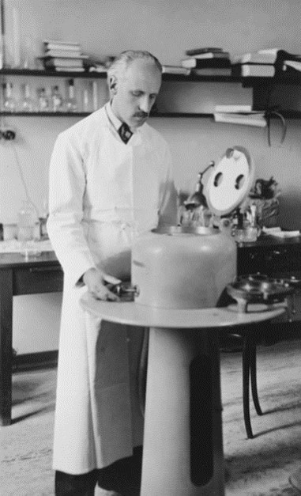

(reproduced from from: [https://belsocmicrobio.be/famous-belgian-microbiologists/andre-gratia/](about:blank))

**Historical aspects:** The two genera *Haetaevirus* and *Kirovvirus* share 58.6% DNA sequence similarity (see VIRIDIC heatmap) and 72.1 overall percent protein homologs [5]. These values are well within the expected range for members of a subfamily. In addition, they form a well-supported clade in the TerL phylogenetic tree.

1. **Create a new genus, *Sophritavirus* with two (2) species**

**Origin of the name of this taxon:** This taxon is named after *Bacillus* phage vB\_BanS\_Sophrita

**Historical aspects:** This phage was isolated against *Bacillus anthracis* Sterne in the United States. *Bacillus* phage pW2 was isolated in China against *Bacillus anthracis* [11]

**Electron micrograph:** N/A

**Genome summary:**

|  |  |  |  |  |  |  |  |
| --- | --- | --- | --- | --- | --- | --- | --- |
| Phage name | INSDC | Size (Kb) | GC% | Protein | tRNA | Overall % DNA sequence identity (\*) | Overall % homologous proteins (\*\*) |
| Bacillus phage vB\_BanS\_Sophrita | [OK499991.1](about:blank) | 168 | 32.4 | [262](about:blank#!/proteins/109256/1760521|Bacillus phage vB_BanS_Sophrita/viral segment/) | 4 | 100 | 100 |
| Bacillus phage pW2 | [MK288021.1](about:blank) | 160.63 | 32.5 | [172](about:blank#!/proteins/75191/437892|Bacillus phage pW2/viral segment/) | 4 | 76.8 | 58.8 |

**(\*) determined using BLASTn [1] or VIRIDIC [2]**

**(\*\*) determined using CoreGenes 3.5 [5]**

1. **Create a new genus, *Natevirus* with a single species**

**Origin of the name of this taxon:** This taxon is named after *Bacillus* phage vB\_BanS\_Nate

**Historical aspects:** This phage Bacillus phage vB\_BanS\_Nate was isolated against *Bacillus anthracis* Sterne in the USA.

**Electron micrograph:** N/A

**Genome summary:**

|  |  |  |  |  |  |  |  |
| --- | --- | --- | --- | --- | --- | --- | --- |
| Phage name | INSDC | Size (Kb) | GC% | Protein | tRNA | Overall % DNA sequence identity (\*) | Overall % homologous proteins (\*\*) |
| Bacillus phage vB\_BanS\_Nate | [OK499992.1](about:blank) | 166.88 | 33.6 | [267](about:blank#!/proteins/109257/1760522|Bacillus phage vB_BanS_Nate/viral segment/) | 19 | 100 | 100 |

**(\*) determined using BLASTn [1] or VIRIDIC [2]**

**(\*\*) determined using CoreGenes 3.5 [5]**

1. **Create a new genus,** ***Tsamsavirus* with five (5) species**

**Origin of the name of this taxon:** This taxon is named after *Bacillus* phage vB\_BanS-Tsamsa

**Historical aspects:** This “temperate” phage was isolated using *Bacillus anthracis* in Switzerland [12]. Tsamsa phage is a large siphovirus featuring a long, flexible and non-contractile tail of 440 nm (not including baseplate structure) and an isometric head of 82 nm in diameter. Other phages for this proposed genus include *Bacillus* phage Izhevsk that was isolated in Russia from soil with *Bacillus cereus* as a host [13]; Skywalker, MrDarsey, and Chewbecca were all isolated in the USA using *Bacillus anthracis* Sterne.

**Electron micrograph:** N/A

**Genome summary:**

|  |  |  |  |  |  |  |  |
| --- | --- | --- | --- | --- | --- | --- | --- |
| Phage name | INSDC | Size (Kb) | GC% | Protein | tRNA | Overall % DNA sequence identity (\*) | Overall % homologous proteins (\*\*) |
| *Bacillus* phage vB\_BanS-Tsamsa | [KC481682.1](about:blank) | 168.88 | 34.3 | [272](about:blank#!/proteins/30772/460562|Bacillus phage vB_BanS-Tsamsa/viral segment Unknown/) | 19 | 100 | 100 |
| *Bacillus* phage Izhevsk | [MT254578.1](about:blank) | 168.64 | 34.3 | [255](about:blank#!/proteins/89110/889225|Bacillus phage Izhevsk/viral segment/) | 18 | 87.7 | 82.0 |
| *Bacillus* phage vB\_BanS\_Skywalker | [OK499994.1](about:blank) | 160.93 | 34.3 | [236](about:blank#!/proteins/109181/1760446|Bacillus phage vB_BanS_Skywalker/viral segment/) | 21 | 79.8 | 75.7 |
| *Bacillus* phage vB\_BanS\_MrDarsey | [OK499987.1](about:blank) | 165 | 34.2 | [247](about:blank#!/proteins/109243/1760508|Bacillus phage vB_BanS_MrDarsey/viral segment/) | 19 | 81.4 | 80.5 |
| *Bacillus* phage vB\_BanS\_Chewbecca | [OK499972.1](about:blank) | 161.15 | 34.3 | [237](about:blank#!/proteins/109234/1760499|Bacillus phage vB_BanS_Chewbecca/viral segment/) | 20 | 80.9 | 77.2 |

**(\*) determined using BLASTn [1] or VIRIDIC [2]**

**(\*\*) determined using CoreGenes 3.5 [5]**

1. **Create a new subfamily, *Joanripponvirinae*, with three (3) genera (*Sophritavirus*, *Natevirus* and *Tsamsavirus*)**

**Origin of the name of this taxon:** This taxon is named in honour of Dr. Joan E. Rippon (Staphylococcal Reference Laboratory, Central Public Health Laboratory, Colindale, UK) an expert on *Staphylococcus* and phage typing who, in 1949, published a paper entitled “*Bacillus polymyxa* and its bacteriophages”.

**Historical aspects:** The genera *Sophritavirus, Natevirus* and *Tsamsavirus* share 55.1 % DNA sequence similarity; and, using CoreGenes 5.0 ([https://coregenes.ngrok.io/](about:blank)) and its Bidirectional Best Hit algorithm 162 homologs (63.0% homologs).

1. **Create a new genus, *Kenyattavirus* with a single species**

**Origin of the name of this taxon:** This taxon is named after Jomo Kenyatta University of

Agriculture and Technology (Nairobi, Kenya) where *Bacillus* phage vB\_BcoS-136 was isolated

**Historical aspects:** *Bacillus* phage vB\_BcoS-136is anovel haloalkaliphilic bacteriophage isolated from Lake Elmenteita, Kenya

**Electron micrograph:** N/A

**Genome summary:**

|  |  |  |  |  |  |  |  |
| --- | --- | --- | --- | --- | --- | --- | --- |
| Phage name | INSDC | Size (Kb) | GC% | Protein | tRNA | Overall % DNA sequence identity (\*) | Overall % homologous proteins (\*\*) |
| *Bacillus* phage vB\_BcoS-136 | [MH884508.1](about:blank) | 160.59 | 32.2 | [238](about:blank#!/proteins/73744/418182|Bacillus phage vB_BcoS-136/viral segment/) | 17 | 100 | 100 |

**(\*) determined using BLASTn [1] or VIRIDIC [2]**

**(\*\*) determined using CoreGenes 3.5 [5]**

1. **Create a new genus, *Zhangjivirus* with a single species**

**Origin of the name of this taxon:** This taxon is named in honour of Zhang Zhongjing (Chinese: 張仲景; 150–219), formal name Zhang Ji (張機), a Chinese pharmacologist, physician, inventor, and writer of the Eastern Han dynasty and one of the most eminent Chinese physicians during the later years of the Han dynasty ([https://en.wikipedia.org/wiki/Zhang\_Zhongjing](about:blank)).

**Historical aspects:** This *Bacillus subtilis* phage was isolated in China from waste water.

**Electron micrograph:** N/A

**Genome summary:**

|  |  |  |  |  |  |  |  |
| --- | --- | --- | --- | --- | --- | --- | --- |
| Phage name | INSDC | Size (Kb) | GC% | Protein | tRNA | Overall % DNA sequence identity (\*) | Overall % homologous proteins (\*\*) |
| *Bacillus* phage vB\_BsuS\_PJN02 | [OM634653.1](about:blank) | 165.87 | 33.6 | [230](about:blank#!/proteins/111732/1813520|Bacillus phage vB_BsuS_PJN02/viral segment/) | 11(\*\*\*) | 100 | 100 |

**(\*) determined using BLASTn [1] or VIRIDIC [2]**

**(\*\*) determined using CoreGenes 3.5 [5]**

**(\*\*\*) None indicated in the GenBank Replicon Info. These discovered using tRNAscan-SE at** [**http://lowelab.ucsc.edu/tRNAscan-SE/**](about:blank) **[14]**

**References**

1. Sayers EW, Beck J, Bolton EE, Bourexis D, Brister JR, Canese K, Comeau DC, Funk K, Kim S, Klimke W, Marchler-Bauer A, Landrum M, Lathrop S, Lu Z, Madden TL, O'Leary N, Phan L, Rangwala SH, Schneider VA, Skripchenko Y, Wang J, Ye J, Trawick BW, Pruitt KD, Sherry ST. Database resources of the National Center for Biotechnology Information. Nucleic Acids Res. 2021 Jan 8;49(D1):D10-D17. doi: 10.1093/nar/gkaa892. PMID: 33095870
2. Moraru C, Varsani A, Kropinski AM. VIRIDIC-A Novel Tool to Calculate the Intergenomic Similarities of Prokaryote-Infecting Viruses. Viruses. 2020 Nov 6;12(11):1268. doi: 10.3390/v12111268. PMID: 33172115; PMCID: PMC7694805. [http://kronos.icbm.uni-oldenburg.de/viridic/](about:blank)
3. Nishimura Y, Yoshida T, Kuronishi M, Uehara H, Ogata H, Goto S. ViPTree: the viral proteomic tree server. Bioinformatics. 2017; 33(15):2379-2380. doi:10.1093/bioinformatics/btx157. PubMed PMID: 28379287. [https://www.genome.jp/viptree/](about:blank)
4. Rohwer F, Edwards R. The Phage Proteomic Tree: a genome-based taxonomy for phage. J Bacteriol. 2002 Aug;184(16):4529-35. PubMed PMID: 12142423
5. Turner D, Reynolds D, Seto D, Mahadevan P. CoreGenes3.5: a webserver for the determination of core genes from sets of viral and small bacterial genomes. BMC Res Notes. 2013;6:140. doi: 10.1186/1756-0500-6-140. PMID: 23566564.
6. Dereeper A, Guignon V, Blanc G, Audic S, Buffet S, Chevenet F, Dufayard JF, Guindon S, Lefort V, Lescot M, Claverie JM, Gascuel O. Phylogeny.fr: robust phylogenetic analysis for the non-specialist. Nucleic Acids Res. 2008;36(Web Server issue):W465-9. doi: 10.1093/nar/gkn180. Epub 2008 Apr 19. PMID: 18424797.
7. Anisimova M, Gascuel O. Approximate likelihood-ratio test for branches: A fast, accurate, and powerful alternative. Syst Biol. 2006;55(4):539-52. PMID: 16785212. DOI: 10.1080/10635150600755453.
8. Turner D, Kropinski AM, Adriaenssens EM. A Roadmap for Genome-Based Phage Taxonomy. Viruses. 2021 Mar 18;13(3):506. doi: 10.3390/v13030506. PMID: 33803862; PMCID: PMC8003253.
9. O'Leary NA, Wright MW, Brister JR, Ciufo S, Haddad D, McVeigh R, et al. Reference sequence (RefSeq) database at NCBI: current status, taxonomic expansion, and functional annotation. Nucleic Acids Res. 2016;44(D1):D733-45. doi: 10.1093/nar/gkv1189. PMID: 26553804.
10. Olsen NS, Hendriksen NB, Hansen LH and Kot W. A New High-Throughput Screening Method for Phages: Enabling Crude Isolation and Fast Identification of Diverse Phages with Therapeutic Potential. Phage (New Rochelle) 1 (3), 137-148 (2020) [https://www.liebertpub.com/doi/10.1089/phage.2020.0016](about:blank)
11. Wan X, Geng P, Sun J, Yuan Z, Hu X. Characterization of two newly isolated bacteriophages PW2 and PW4 and derived endolysins with lysis activity against Bacillus cereus group strains. Virus Research 2021, 302, 198489.
12. Ganz HH, Law C, Schmuki M, Eichenseher F, Calendar R, Loessner MJ, Getz WM, Korlach J, Beyer W, Klumpp J. Novel giant siphovirus from Bacillus anthracis features unusual genome characteristics. PLoS One. 2014 Jan 27;9(1):e85972. doi: 10.1371/journal.pone.0085972. PMID: 24475065; PMCID: PMC3903500.
13. Skorynina AV, Piligrimova EG, Kazantseva OA, Kulyabin VA, Baicher SD, Ryabova NA, Shadrin AM. Bacillus-infecting bacteriophage Izhevsk harbors thermostable endolysin with broad range specificity. PLoS One. 2020 Nov 24;15(11):e0242657. doi: 10.1371/journal.pone.0242657. PMID: 33232350; PMCID: PMC7685451.
14. Lowe TM, Eddy SR. tRNAscan-SE: a program for improved detection of transfer RNA genes in genomic sequence. Nucleic Acids Res. 1997 Mar 1;25(5):955-64. doi: 10.1093/nar/25.5.955. PMID: 9023104; PMCID: PMC146525.