

**Part 1:** **TITLE, AUTHORS, APPROVALS, etc**

| **Code assigned:** | ***2022.008B*** |  |
| --- | --- | --- |
| **Short title:** Create one new species in the genus *Berlinvirus* (*Autographiviridae*) and one new species in the genus *Epseptimavirus* (*Demerecviridae*) (*Caudoviricetes*) | | |
|  | | |

* **P pbv mhgg**
* **Bh httm m Author(s) and email address(es)**

| Imklin N, Nasanit R | faiimklin@gmail.com; nasanit_r@su.ac.th |
| --- | --- |

**Author(s) institutional address(es) (optional)**

| Department of Biotechnology, Silpakorn University, Thailand [NI, RN] |
| --- |

**Corresponding author**

| Rujikan Nasanit |
| --- |

**List the ICTV Study Group(s) that have seen this proposal**

|  |
| --- |

**ICTV Study Group comments and response of proposer**

|  |
| --- |

**ICTV Study Group votes on proposal**

| **Study Group** | **Number of members** | | |
| --- | --- | --- | --- |
| **Votes support** | **Votes against** | **No vote** |
|  |  |  |  |
|  |  |  |  |

**Authority to use the name of a living person**

| **Is any taxon name used here derived from that of a living person (Y/N)** | N |
| --- | --- |

| **Taxon name** | **Person from whom the name is derived** | **Permission attached (Y/N)** |
| --- | --- | --- |
|  |  |  |
|  |  |  |
|  |  |  |

**Submission dates**

| Date first submitted to SC Chair | Feb 16, 2022 |
| --- | --- |
| Date of this revision (if different to above) |  |

**ICTV-EC comments and response of the proposer**

|  |
| --- |

**Part 2:** **NON-TAXONOMIC PROPOSAL**

**Text of proposal**

|  |
| --- |

**Part 3:** **TAXONOMIC PROPOSAL**

**Name of accompanying Excel module**

| 2022.008B.N.v1.Autographiviridae_2nsp.xlsx |
| --- |

**Abstract**

| Genomes ofSalmonella phage vB_STy-RN5i1 and Salmonella phage vB_STy-RN5i1 were fully sequenced and identified as two novel species to be included in the genus *Berlinvirus* and *Epseptimavirus*, respectively. |
| --- |

**Text of proposal**

| | **Species demarcation criteria:**  We have chosen 95% DNA sequence identity as the criterion for demarcation of species in a genus. Each of the proposed species differs from the others with more than 5% at the DNA level as confirmed with the BLASTN algorithm. | | --- | |
| --- | --- |

**Supporting evidence**

**Proposal 1: To create new species *Salmonella virus RN5i1* in the genus *Berlinvirus* (*Autographiviridae*)**

**History:** Salmonella phage vB_STy-RN5i1 was isolated from a drain water sample collected from an open market in Nakhon Pathom province, Thailand. Phage isolation and propagation used SalmonellaTyphimurium ATCC13311, DMST 562.

**Specific Reference:** Imklin N, Nasanit R (2020) Characterization of *Salmonella* bacteriophages and their potential use in dishwashing materials. J Appl Microbiol 129:266–277. DOI: 10.1111/jam.14617. PMID: 32073713

**GenBank Summary:** Salmonella phage vB_STy-RN5i1 and its closely related sequences in *Berlinvirus* [1]

| Phage name | RefSeq | INSDC | Size (kb) | GC% | No. of CDSs | No. tRNA | % nt seq. ident. with RN5i1  ** |
| --- | --- | --- | --- | --- | --- | --- | --- |
| Erwinia phage FE44 | NC_022744.1 | KF700371.1 | 39.86 | 48.6 | 51 | 0 | 81.00 |
| Salmonella phage BP12A | NC_031258.1 | KM366096.1 | 39.70 | 49.0 | 47 | 0 | 80.49 |
| Salmonella phage BSP161 | NC_048105.1 | MG471392.1 | 39.69 | 48.7 | 49 | 0 | 80.43 |
| Enterobacteria phage BA14 | NC_011040.1 | EU734171.1 | 39.82 | 48.8 | 52 | 0 | 79.99 |
| Enterobacteria phage 285P | NC_015249.1 | GQ468526.1 | 39.27 | 48.7 | 47 | 0 | 79.55 |
| Escherichia phage vB_EcoP_S523 | NC_047984.1 | MH031343.1 | 39.83 | 48.8 | 45 | 0 | 79.36 |
| Yersinia phage PYPS50 | NC_048108.1 | MH809534.1 | 39.65 | 48.7 | 44 | 0 | 79.00 |
| Escherichia phage PhiV-1 | - | MT542512.1 | 39.46 | 48.7 | 49 | 0 | 78.58 |
| Salmonella phage LPST144 | - | MN252582.1 | 39.05 | 49.1 | 43 | 0 | 78.57 |
| Salmonella phage vB_SalM-LPST153 | - | MK907285.1 | 39.18 | 49.1 | 48 | 0 | 78.39 |
| Salmonella phage vB_STy-RN5i1 | - | OL800603.1 | 39.43 | 48.4 | 47 | 0* |  |

**\*** Aragorn (v1∙2∙41) was employed to find tRNAs on the genome (http://www.ansikte.se/ARAGORN/) [2]

** The overall nucleotide identity was obtained by PAirwise Sequence Comparison (PASC) [3]

**BLASTN homologs:** A neighbour joining tree between complete genome sequence of Salmonella phage vB_STy-RN5i1 and its closely related sequences in *Berlinvirus* was constructed on the basis of BLASTN analysis at NCBI.

**Phylogeny:** Phylogenetic analyses of the major capsid proteins (A) and terminase large subunit (B) of Salmonella phage vB_STy-RN5i1, other closely related phages in *Berlinvirus* and other genera. All sequences were aligned using MUSCLE [4]. The trees were constructed by MEGA7 [5] running on neighbor-joining method with 1,000 bootstrap replication [6]. Numbers on branches represent the bootstrap percentage greater than 50%.

**A) MCP**

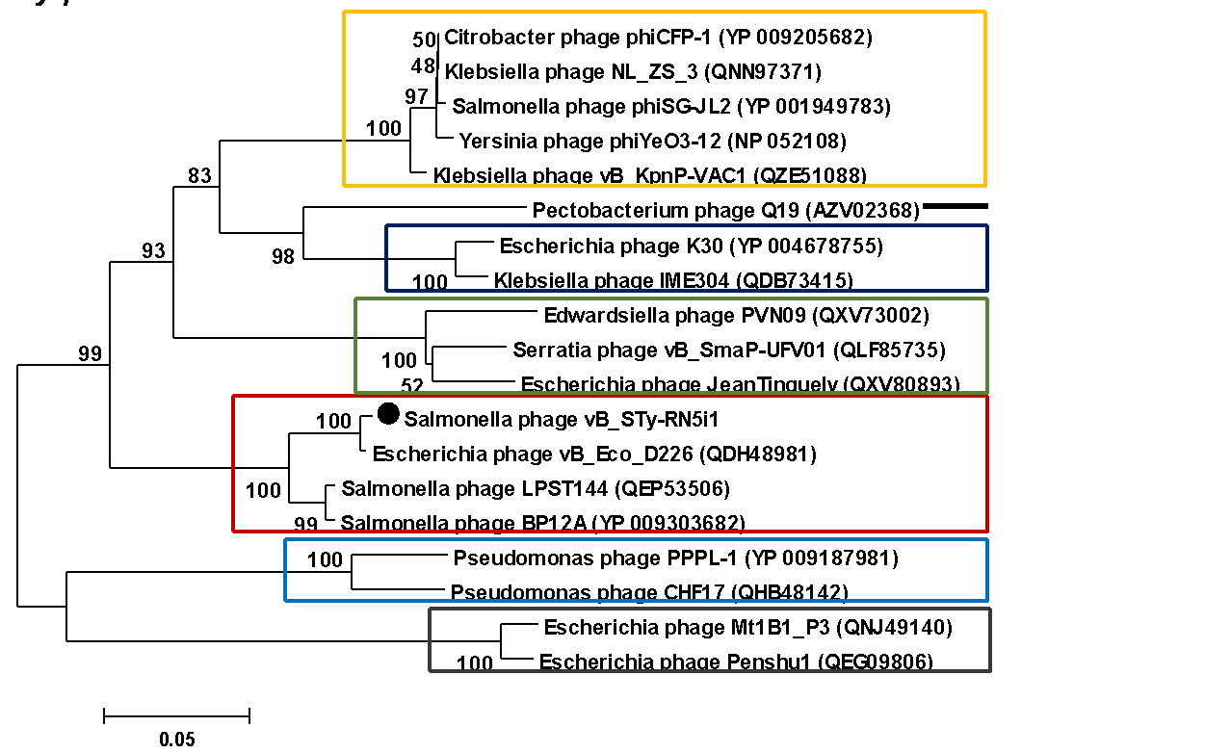

**B) TerL**

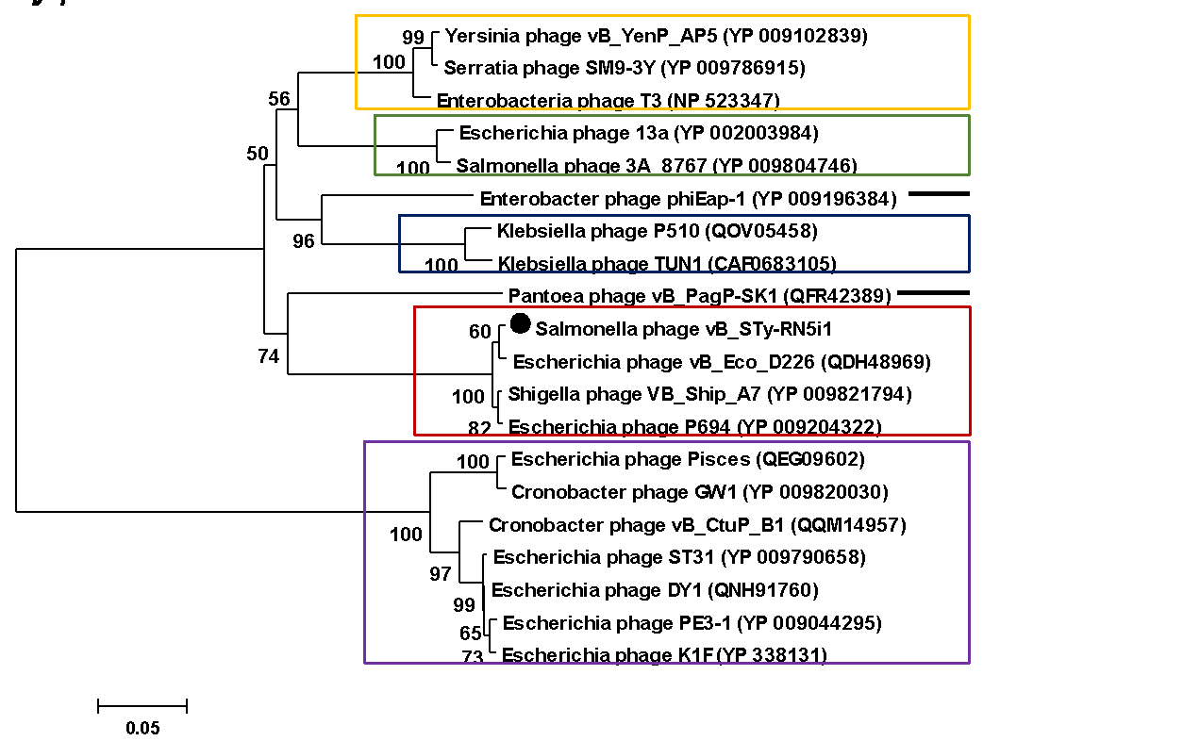

**Proposal 2: To create new species *Salmonella* *virus RN29* in the genus *Epseptimavirus* (*Demerecviridae*)**

**History:** Salmonella phage vB_STy-RN29 was isolated from a drain water sample collected from an open market in Nonthaburi province, Thailand. Phage isolation and propagation used SalmonellaTyphimurium ATCC13311, DMST 562.

**Specific Reference:** Imklin N, Nasanit R (2020) Characterization of Salmonella bacteriophages and their potential use in dishwashing materials. J Appl Microbiol 129:266–277. DOI: 10.1111/jam.14617. PMID: 32073713

**GenBank Summary:** Salmonella phage vB_STy-RN29 and its closely related sequences in *Epseptimavirus* [1]

| Phage name | RefSeq | INSDC | Size (kb) | GC% | No. of CDSs | No. tRNA | % nt seq. ident. with RN29  ** |
| --- | --- | --- | --- | --- | --- | --- | --- |
| Salmonella phage STWB21 | - | MW567727.1 | 112.83 | 40.4 | 166 | 22 | 81.95 |
| Salmonella phage STG2 | NC_048089.1 | MK005300.1 | 114.28 | 40.1 | 161 | 30 | 77.47 |
| Salmonella phage S124 | NC_048013.1 | MH370375.1 | 112.56 | 40.1 | 156 | 28 | 77.38 |
| Salmonella phage Seabear | - | MK728824.1 | 112.47 | 40.4 | 178 | 29 | 77.32 |
| Salmonella phage faergetype | NC_048867.1 | MT074450.1 | 110.18 | 40.0 | 161 | 23 | 76.81 |
| Salmonella phage Seafire | NC_048110.1 | MK050846.2 | 111.85 | 40.0 | 172 | 28 | 76.68 |
| Salmonella phage vB_SenS_SB13 | NC_048781.1 | MK947459.1 | 112.51 | 39.9 | 207 | 15 | 76.57 |
| Escherichia coli phage vB_EcoS_Ace | - | MT833283.1 | 112.79 | 40.0 | 165 | 29 | 76.55 |
| Salmonella phage oselot | NC_048871.1 | MT074465.1 | 113.5 | 39.9 | 171 | 28 | 75.91 |
| Salmonella phage Stitch | NC_027297.1 | KM236244.1 | 123.48 | 40.3 | 179 | 25 | 74.40 |
| Salmonella phage vB_STy-RN29 | - | OL800604.1 | 110.59 | 39.6 | 162 | 19* |  |

**\*** Aragorn (v1∙2∙41) was employed to find tRNAs on the genome (http://www.ansikte.se/ARAGORN/) [2]

** The overall nucleotide identity was obtained by PAirwise Sequence Comparison (PASC) [3]

**BLASTN homologs:** A neighbour joining tree between complete genome sequence of Salmonella phage vB_STy-RN29 and its closely related sequences in *Epseptimavirus* was constructed on the basis of BLASTN analysis at NCBI.

**Phylogeny:** Phylogenetic analyses of the major capsid proteins (A) and terminase large subunit (B) of Salmonella phage vB_STy-RN29, other closely related phages in *Epseptimavirus* and other genera. All sequences were aligned using MUSCLE [4]. The trees were constructed by MEGA7 [5] running on neighbor-joining method with 1,000 bootstrap replication [6]. Numbers on branches represent the bootstrap percentage greater than 50%.

**A) MCP**

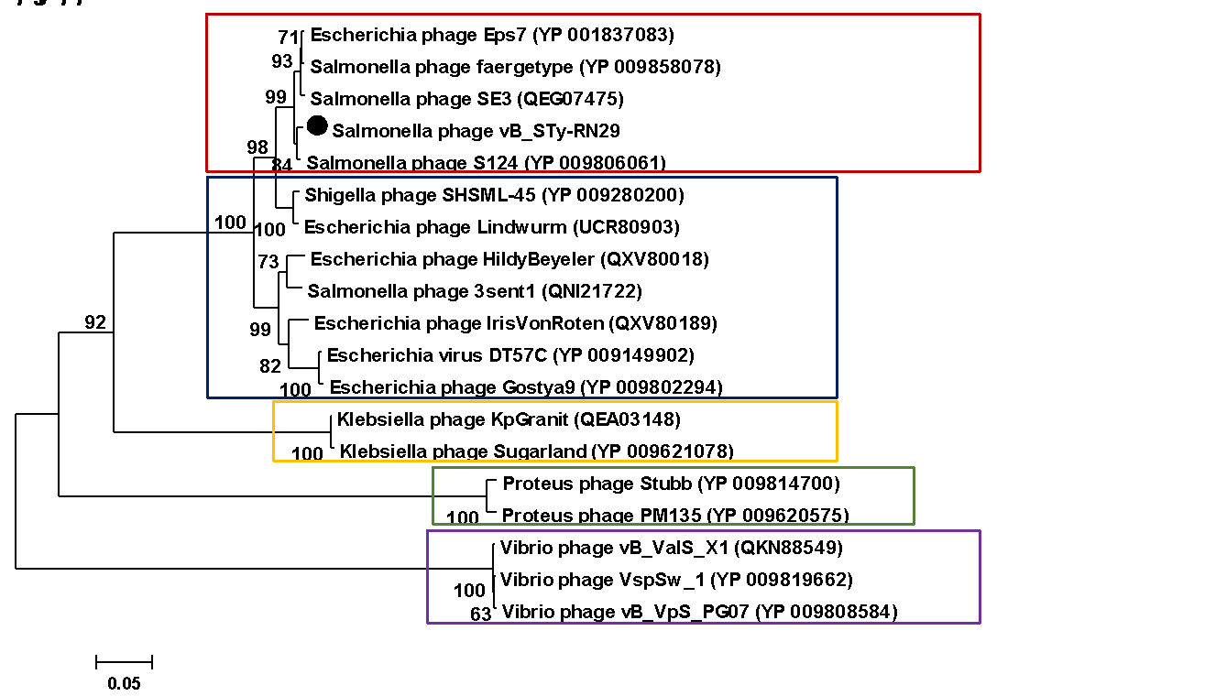

**B) TerL**

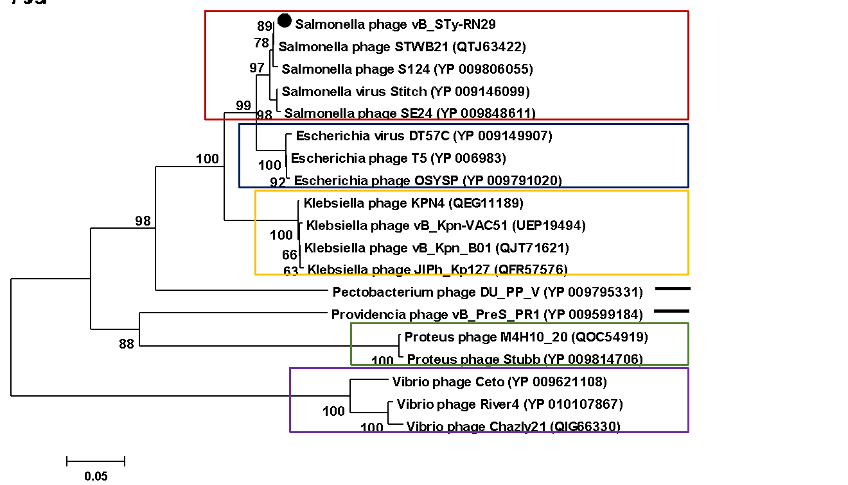

**References**

1. Sayers EW, Beck J, Brister JR, Bolton EE, Canese K, Comeau DC, et al. (2020) Database resources of the National Center for Biotechnology Information. Nucleic Acids Res 48:D9-D16. doi: 10.1093/nar/gkz899. PMID: 31602479.

2. Laslett D, Canback B (2004) ARAGORN, a program to detect tRNA genes and tmRNA genes in nucleotide sequences. Nucleic Acids Res 32: 11–16. DOI: 10.1093/nar/gkh152. PMID: 14704338

3. Bao Y, Chetvernin V, Tatusova T (2014) Improvements to pairwise sequence comparison (PASC): a genome-based web tool for virus classification. Arch Virol 159: 3293–3304. DOI: 10.1007/s00705-014-2197-x. PMID: 25119676

4. Edgar RC (2004) MUSCLE: multiple sequence alignment with high accuracy and high throughput. Nucleic Acids Res 32:1792–1797. DOI: 10.1093/nar/gkh340.

5. Kumar S, Stecher G, Tamura K (2016) MEGA7: Molecular Evolutionary Genetics Analysis version 7.0 for bigger datasets. Mol Biol Evol 33: 1870–1874. DOI: 10.1093/molbev/msw054. PMID: 27004904

6. Felsenstein J (1985) Confidence limits on phylogenies: an approach using the bootstrap. Evolution 39:783–791. DOI: 10.2307/2408678.