

**Part 1:** **TITLE, AUTHORS, APPROVALS, etc**

|  |  |  |
| --- | --- | --- |
| **Code assigned:** | ***2022.022B*** |  |
| **Short title:** Create a new genus (*Chaoshanvirus*) including a new species (*Chaoshanvirus* ZPAH34) (*Caudoviricetes*) | | |
|  | | |

**Author(s) and email address(es)**

|  |  |
| --- | --- |
| Li J-Q | lijinquan2017@163.com |

**Author(s) institutional address(es) (optional)**

|  |
| --- |
| Huazhong Agriculture University, China [LJQ] |

**Corresponding author**

|  |
| --- |
| Li JQ (lijinquan2017@163.com) |

**List the ICTV Study Group(s) that have seen this proposal**

|  |
| --- |
| Bacterial Virus Subcommittee |

**ICTV Study Group comments and response of proposer**

|  |
| --- |
|  |

**ICTV Study Group votes on proposal**

|  |  |  |  |
| --- | --- | --- | --- |
| **Study Group** | **Number of members** | | |
| **Votes support** | **Votes against** | **No vote** |
|  |  |  |  |
|  |  |  |  |

**Authority to use the name of a living person**

|  |  |
| --- | --- |
| **Is any taxon name used here derived from that of a living person (Y/N)** | N |

|  |  |  |
| --- | --- | --- |
| **Taxon name** | **Person from whom the name is derived** | **Permission attached (Y/N)** |
|  |  |  |

**Submission dates**

|  |  |
| --- | --- |
| Date first submitted to SC Chair | April 2022 |
| Date of this revision (if different to above) |  |

**ICTV-EC comments and response of the proposer**

|  |
| --- |
|  |

**Part 2:** **NON-TAXONOMIC PROPOSAL**

**Text of proposal**

|  |
| --- |
|  |

**Part 3:** **TAXONOMIC PROPOSAL**

**Name of accompanying Excel module**

|  |
| --- |
| 2022.022B.N.v1.Chaoshanvirus_ng.xlsx |

**Abstract**

|  |
| --- |
| We isolated a novel *Aeromonas* phage ZPAH34. VIRIDIC and ViPTree analysis showed that ZPAH34 belonged to a novel genus *Chaoshanvirus* that was different significantly from other genus (less than 70% identity with phages of other genera). This proposal will create a new genus, *Chaoshanvirus*. The genome of *Aeromonas* phage ZPAH34 has been submitted to the NCBI GenBank database (Accession Number: OM810292). |

**Text of proposal**

|  |  |
| --- | --- |
| |  | | --- | | **Species demarcation criteria:** Two phages are assigned to the same species if their genomes are more than 95% identical over their genome length for isolates.  These values can be calculated by a number of tools, such as BLASTn – usually calculated using intergenomic distance calculator VIRIDIC [1].  **Genus demarcation criteria:** In search for criteria that create cohesive and distinct genera that are reproducible and monophyletic, the Bacterial Viruses Subcommittee has established 70% nucleotide identity of the genome length as the cut-off for genera. Genus-level groupings should always be monophyletic in the signature genes, as tested with a phylogenetic tree [2]. | |

**Supporting evidence**

**ViPTree analysis:** ViPTree analysis (https://www.genome.jp/viptree/; [3]) is based upon Rohwer and Edwards (2002) famous Phage Proteomic Tree [4]. The phages of interest are indicated with **red box**.

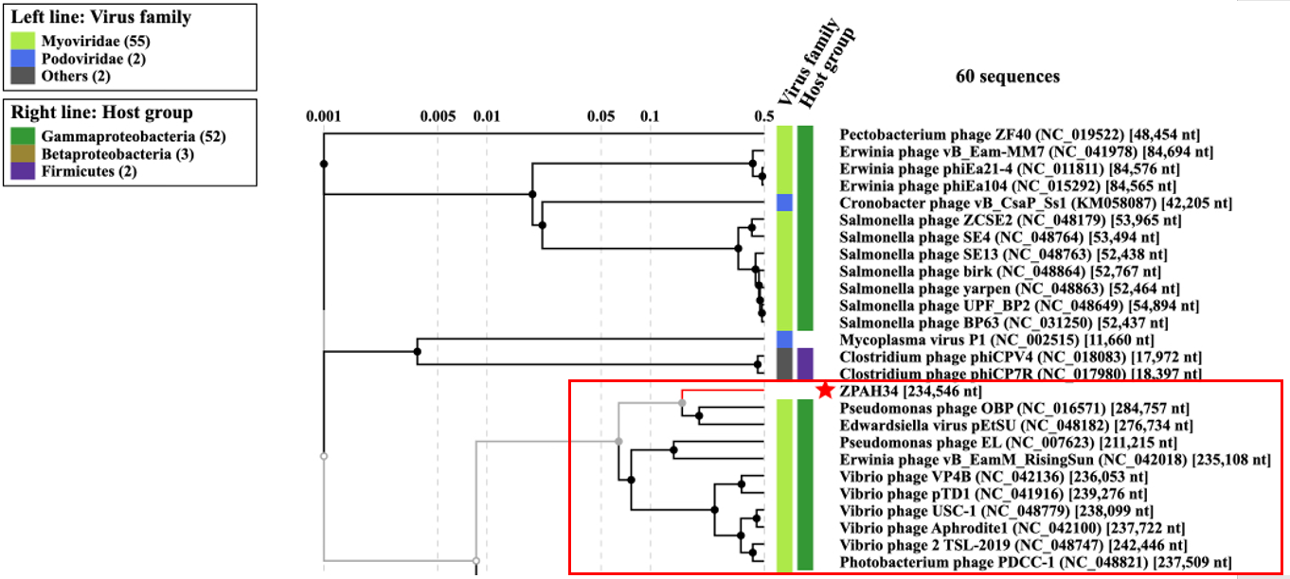

**VIRIDIC heat map:** VIRIDIC (Virus Intergenomic Distance Calculator; [1]; http://rhea.icbm.uni-oldenburg.de/VIRIDIC/)computes pairwise intergenomic distances/similarities amongst phage genomes.

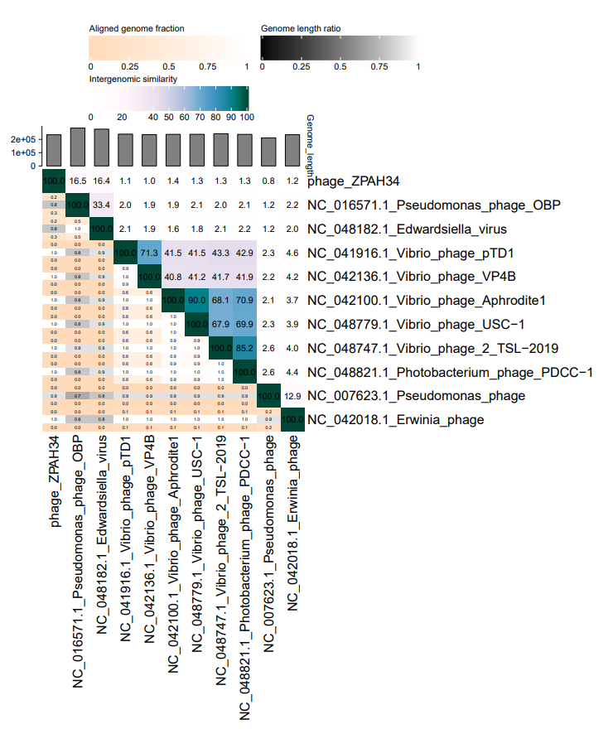

**Phylogeny:** The phylogenetic tree was constructed using the major capsid proteins of these phages with phylogeny. MUSCLE was used for multiple alignment and MEGA (v11.0.10) was used for building phylogenetic tree using maximum-likelihood method with 500 bootstrap [5]. The red box represents the phage of the new proposed genus and red star represents new species.

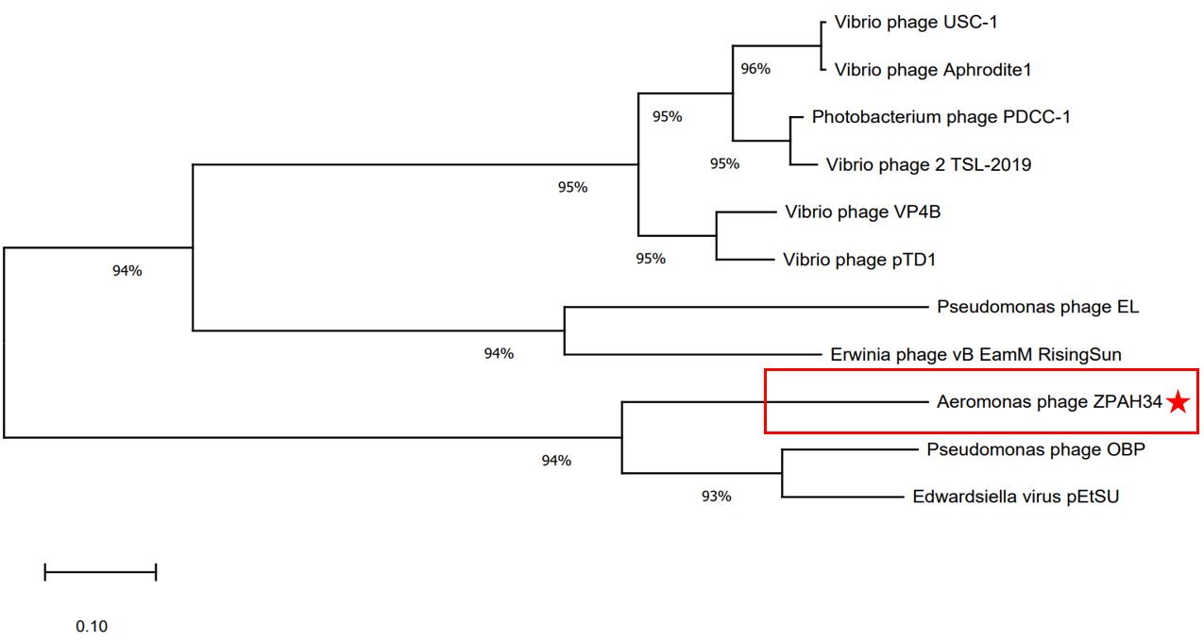

**Origin of the name of this taxon:** This genus is named *Chaoshanvirus* according to the Chaoshan area that located in southern China*.*

**Historical aspects:** *Aeronomas* phage ZPAH34 collected from the lake by Huazhong Agricultural University in 2018, using *Aeromonas hydrophila* as the host bacterium.

**Specific References:** None

**Genome summary:**

|  |  |  |  |  |  |  |  |  |
| --- | --- | --- | --- | --- | --- | --- | --- | --- |
| Phage name | RefSeq No. | INSDC | Size (Kb) | GC% | Protein | tRNA | Overall % DNA sequence identity (*) | Overall % homologous proteins (**) |
| Aeronomas phage ZPAH34 |  | OM810292 | 234 | 36 | 234 | 2 | 100 | 100 |

**(*) Determined using VIRIDIC [1]**

**(**) Determined using CoreGenes 3.5 at http://binf.gmu.edu:8080/CoreGenes3.5/ [6]**

**References**

1: Moraru C, Varsani A, Kropinski AM. VIRIDIC-A Novel Tool to Calculate the Intergenomic Similarities of Prokaryote-Infecting Viruses. Viruses. 2020 Nov 6;12(11):1268. doi: 10.3390/v12111268. PMID: 33172115.

2: Turner D, Kropinski AM, Adriaenssens EM. A Roadmap for Genome-Based Phage Taxonomy. Viruses. 2021 Mar 18;13(3):506. doi: 10.3390/v13030506. PMID: 33803862.

3: Nishimura Y, Yoshida T, Kuronishi M, Uehara H, Ogata H, Goto S. ViPTree: the viral proteomic tree server. Bioinformatics. 2017 Aug 1;33(15):2379-2380. doi: 10.1093/bioinformatics/btx157. PMID: 28379287.

4: Rohwer F, Edwards R. The Phage Proteomic Tree: a genome-based taxonomy for phage. J Bacteriol. 2002 Aug;184(16):4529-35. doi: 10.1128/jb.184.16.4529-4535.2002. PMID: 12142423.

5:Tamura K, Stecher G, Kumar S. MEGA11: Molecular Evolutionary Genetics Analysis Version 11. Molecular biology and evolution. 2021; 38(7), 3022-3027. doi: 10.1093/molbev/msab120. PMID:  33892491.

6:Turner D, Reynolds D, Seto D, Mahadevan P. CoreGenes3.5: a webserver for the determination of core genes from sets of viral and small bacterial genomes. BMC Res Notes. 2013;6:140. doi: 10.1186/1756-0500-6-140. PMID: 23566564.