

**Part 1:** **TITLE, AUTHORS, APPROVALS, etc**

|  |  |  |
| --- | --- | --- |
| **Code assigned:** | ***2022.026B*** |  |
| **Short title:** Create one new species in the genus *Copernicusvirus*, subfamily *Sarlesvirinae* (*Caudoviricetes*: *Rountreeviridae*) | | |
|  | | |

**Author(s) and email address(es)**

|  |  |
| --- | --- |
| Łobocka M, Stefańczyk E, Adriaenssens EM, Kropinski AM, Turner D | lobocka@ibb.waw.pl;  e.stefanczyk@ibb.waw.pl;  evelien.adriaenssens@quadram.ac.uk;  Phage.Canada@gmail.com; dann2.turner@uwe.ac.uk |

**Author(s) institutional address(es) (optional)**

|  |
| --- |
| Institute of Biochemistry and Biophysics of the Polish Academy of Sciences Poland [MŁ]  Institute of Biochemistry and Biophysics of the Polish Academy of Sciences Poland [ES]  Quadram Institute Bioscience, UK [EMA]  University of Guelph, Canada [AMK]  University of the West of England [DT] |

**Corresponding author**

|  |
| --- |
| Malgorzata Łobocka |

**List the ICTV Study Group(s) that have seen this proposal**

|  |
| --- |
| *Salasmaviridae, Rountreeviridae, Guelinviridae* Study Group, Bacterial Viruses Subcommittee |

**ICTV Study Group comments and response of proposer**

|  |
| --- |
|  |

**ICTV Study Group votes on proposal**

|  |  |  |  |
| --- | --- | --- | --- |
| **Study Group** | **Number of members** | | |
| **Votes support** | **Votes against** | **No vote** |
|  | 2 | 0 | 0 |
|  |  |  |  |

**Authority to use the name of a living person**

|  |  |
| --- | --- |
| **Is any taxon name used here derived from that of a living person (Y/N)** | N |

|  |  |  |
| --- | --- | --- |
| **Taxon name** | **Person from whom the name is derived** | **Permission attached (Y/N)** |
|  |  |  |
|  |  |  |
|  |  |  |

**Submission dates**

|  |  |
| --- | --- |
| Date first submitted to SC Chair | May 2022 |
| Date of this revision (if different to above) |  |

**ICTV-EC comments and response of the proposer**

|  |
| --- |
|  |

**Part 2:** **NON-TAXONOMIC PROPOSAL**

**Text of proposal**

|  |
| --- |
|  |

**Part 3:** **TAXONOMIC PROPOSAL**

**Name of accompanying Excel module**

|  |
| --- |
| 2022.026B.N.v1.Copernicusvirus_1nsp.xlsx |

**Abstract**

|  |
| --- |
| In a complete review of the enterococcal phages belonging to the *Sarlesvirinae* subfamily of *Rountreeviridae* using VIRIDIC and ViPTree we have discovered one more species in the genus *Copernicusvirus*.These phages share almost all properties with other phages of this genus, but differ significantly enough (less than 95% identity with phages of other *Copernicusvirus* species) to classify them as separate species of this genus. |

**Text of proposal**

|  |  |
| --- | --- |
| |  | | --- | | **Species demarcation criteria:** We have chosen 95% DNA sequence identity as the criterion for demarcation of species in this new genus. Each of the proposed species differs from the others with more than 5% at the DNA level as confirmed with the BLASTN and Viridic algorithm | |

**Supporting evidence**

**History:** This genus was established via Taxonomy Proposal 2020.140B.R.Rountreeviridae.zip

**Specific References:**  None. References concerning general description of *Copernicusvirus* genus were included in Taxonomy Proposal 2020.140B.R.Rountreeviridae.zip.

**GenBank Summary:**

|  |  |  |  |  |  |  |  |  |
| --- | --- | --- | --- | --- | --- | --- | --- | --- |
| Phage name | RefSeq No. | INSDC | Size (Kb) | GC% | Protein | tRNAs* | Overall % DNA sequence identity (**) | Overall % homologous proteins (***) |
| MDA1 |  | MW623430 | 18.06 | 33.0 | 25 | 0 | 85.6 | 88.0 |

N.B.Exemplar representative of *Copernicusvirus* genus is Enterococcus phage vB_Efae230P-4 (JQ309827.1).

(*) determined using RNAscan-SE [1]

(**) determined using Viridic [2] and compared to Enterococcus phage vB_Efae230P-4

(***) determined using CoreGenes 5.0 [3,4] and compared to Enterococcus phage vB_Efae230P-4

**BLASTN homologs:** VIRIDIC analysis reveals that the closest relative besides other phages of *Copernicusvirus* genus is Enterococcus virus v_EfaP_IME199 [KT945995.1] of *Minhovirus* genus of *Sarlesvirinae* subfamily, *Rountreeviridae* family. It shares 21% DNA sequence with Enterococcus phage MDA1.

**VIRIDIC heat map:** VIRIDIC (Virus Intergenomic Distance Calculator; [2]) computes pairwise intergenomic distances/similarities amongst phage genomes. The comparison below provides the results of DNA sequence comparison of strains of known and proposed new species of enterococcal *Copernicusvirus* genus phages. The phage names correspond to phages of existing species or, when indicated by an arrow, to newly proposed species that will be added through this TaxoProp.

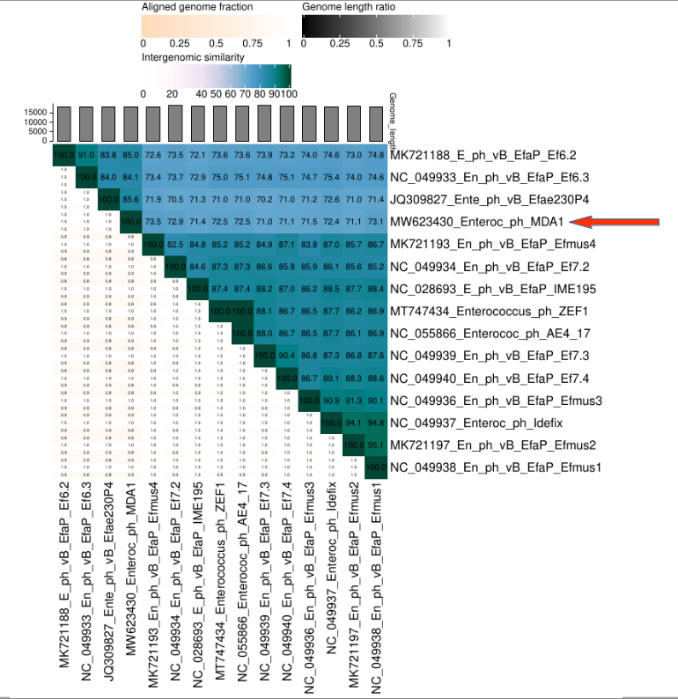

**ViPTree analysis:** ViPTree analysis (<https://www.genome.jp/viptree/>; [5]) is based upon Rohwer and Edwards (2002) famous Phage Proteomic Tree [6]. The **red** asterisk points to the new species of *Copernicusvirus* genus. The **red** and **blue** arrowhead point to *Copernicusvirus* genus and to *Sarlesvirinae* subfamily, respectively.

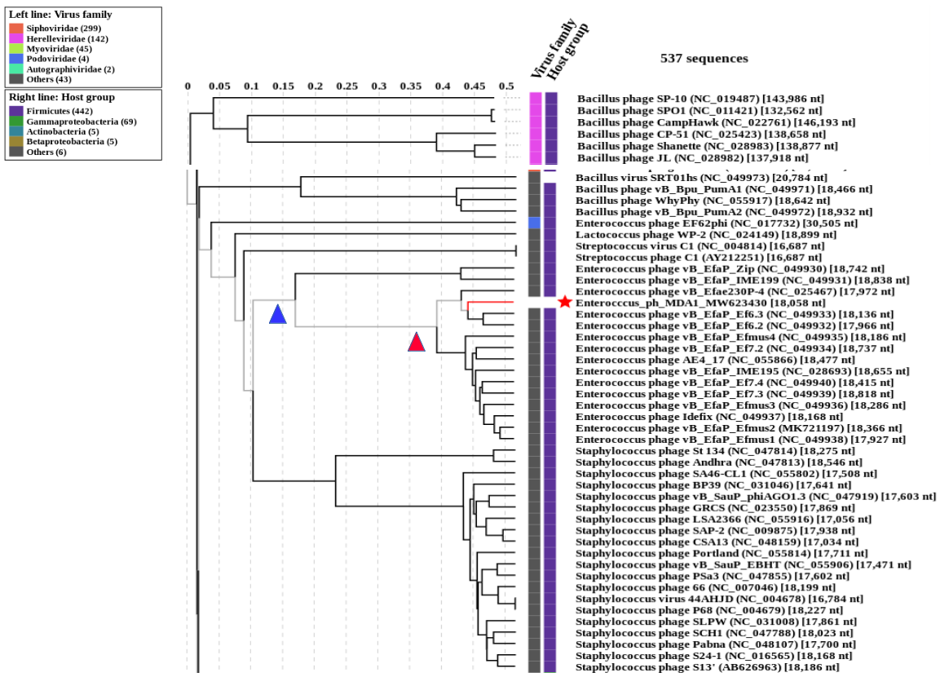

**Phylogeny:** The phylogenetic trees weres constructed using the major capsid protein and DNA polymerase homologs of Enterococcus phage MDA1 and related phages by employing the Tamura–Nei genetic distance model and a neighbour-joining tree-build method using the Geneious Tree Builder included in the Geneious Prime 2022 software. As an outgroup, a sequence of corresponding gene (DNA polymerase or major head/capsid protein) of closely related species was used, that was selected based on prior VipTree results. Proteins of phages of proposed new species are pointed with arrows.

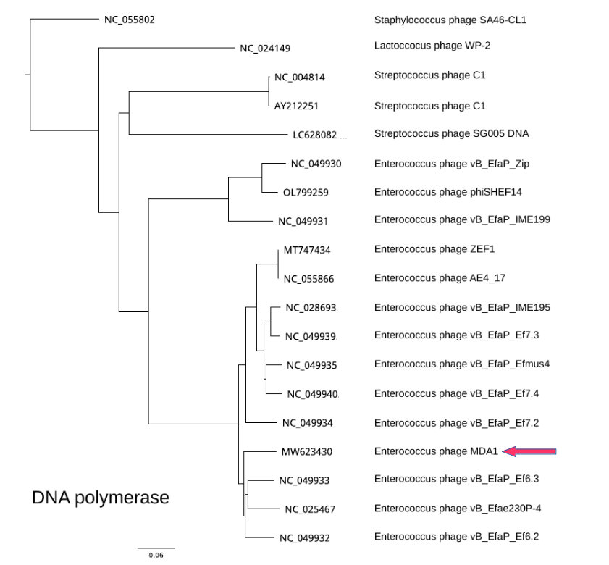

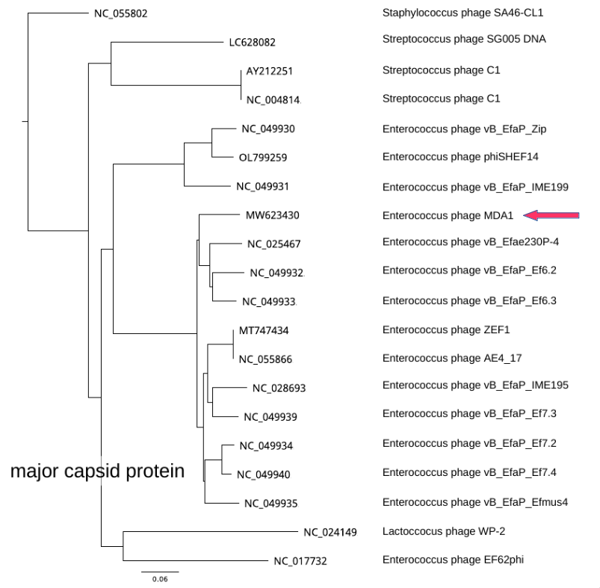

**References**

1: Chan PP, Lowe TM (2019) tRNAscan-SE: Searching for tRNA Genes in Genomic Sequences. Methods Mol Biol 1962:1-14. https://doi.org/10.1007/978-1-4939-9173-0_1. PMID: 31020551.

2: Moraru C (2020) VIRIDIC (Virus Intergenomic Distance Calculator) computes pairwise intergenomic distances/similarities amongst phage genomes. <http://kronos.icbm.uni-oldenburg.de/viridic/>

3: Turner D, Reynolds D, Seto D, Mahadevan P. (2013) CoreGenes3.5: a webserver for the determination of core genes from sets of viral and small bacterial genomes. BMC Res Notes 6:140. https://doi.org/10.1186/1756-0500-6-140. PMID: 23566564.

4: Contreras-Moreira, B., & Vinuesa, P. (2013). GET_HOMOLOGUES, a versatile software package for scalable and robust microbial pangenome analysis. Appl Environ Microbiol 79:7696-7701.

5: Nishimura Y, Yoshida T, Kuronishi M, Uehara H, Ogata H, Goto S. ViPTree: the viral proteomic tree server. (2017) Bioinformatics 33:2379-2380. https://doi.org/10.1093/bioinformatics/btx157. PubMed PMID: 28379287.

6: Rohwer F, Edwards R (2002) The Phage Proteomic Tree: a genome-based taxonomy for phage. J Bacteriol 184:4529-35. PubMed PMID: 12142423