

**Part 1:** **TITLE, AUTHORS, APPROVALS, etc**

|  |  |  |
| --- | --- | --- |
| **Code assigned:** | ***2022.033B*** |  |
| **Short title:** Create a new family (*Fredfastierviridae)* with a single genus (*Jamesmcgillvirus*) (*Caudoviricetes*) | | |
|  | | |

**Author(s) and email address(es)**

|  |  |
| --- | --- |
|  |  |
| Turner D, Guarneros G, Moraru C, Adriaenssens EM, Kropinski AM | Dann2.Turner@uwe.ac.uk; gguarner@cinvestav.mx; liliana.cristina.moraru@uol.de; evelien.adriaenssens@quadram.ac.uk; Phage.Canada@gmail.com |

**Author(s) institutional address(es) (optional)**

|  |
| --- |
| University of the West of England, Bristol, UK [DT]  CINVESTAV, México [GG]  Carl von Ossietzky Universität Oldenburg, Germany [CM]  Quadram Institute Bioscience, UK [EMA]  University of Guelph, Canada [AMK] |

**Corresponding author**

|  |
| --- |
| Andrew M. Kropinski |

**List the ICTV Study Group(s) that have seen this proposal**

|  |
| --- |
| Bacterial Viruses Subcommittee, Caudoviricetes Study Group |

**ICTV Study Group comments and response of proposer**

|  |
| --- |
|  |

**ICTV Study Group votes on proposal**

|  |  |  |  |
| --- | --- | --- | --- |
| **Study Group** | **Number of members** | | |
| **Votes support** | **Votes against** | **No vote** |
|  |  |  |  |
|  |  |  |  |

**Authority to use the name of a living person**

|  |  |
| --- | --- |
| **Is any taxon name used here derived from that of a living person (Y/N)** | N |

|  |  |  |
| --- | --- | --- |
| **Taxon name** | **Person from whom the name is derived** | **Permission attached (Y/N)** |
|  |  |  |
|  |  |  |
|  |  |  |

**Submission dates**

|  |  |
| --- | --- |
| Date first submitted to SC Chair | May 2022 |
| Date of this revision (if different to above) | October 2022 |

**ICTV-EC comments and response of the proposer**

|  |
| --- |
| ICTV-EC: a phylogenetic tree with outgroups is not necessary when no appropriate outgroup is available, i.e. when the newly defined taxon is too divergent from its closest relatives. Please remove terL tree.  Proposer: terL tree removed. |

**Part 2:** **NON-TAXONOMIC PROPOSAL**

**Text of proposal**

|  |
| --- |
|  |

**Part 3:** **TAXONOMIC PROPOSAL**

**Name of accompanying Excel module**

|  |
| --- |
| 2022.033B.A.v1.Fredfastierviridae_nf.xlsx |

**Abstract**

|  |
| --- |
| The group of podoviruses which were isolated in China (PaP2), Australia (119X), and Mexico (PaMx series) are unique at the DNA, protein, and phylogenetic level. Because they are deeply branched within prokaryotic viruses, we have moved genus *Jamesmcgillvirus* to a new family, *Fredfasterviridae*. |

**Text of proposal**

|  |  |
| --- | --- |
| |  | | --- | | **Species demarcation criteria:** Two phages are assigned to the same species if their genomes are more than 95% identical over their genome length for isolates.  These values can be calculated by a number of tools, such as BLASTn [1] – usually calculated using intergenomic distance calculator VIRIDIC [2].  **Genus demarcation criteria:** In search for criteria that create cohesive and distinct genera that are reproducible and monophyletic, the Bacterial Viruses Subcommittee has established 70% nucleotide identity of the genome length as the cut-off for genera. Genus-level groupings should always be monophyletic in the signature genes, as tested with a phylogenetic tree. [8]  **Family demarcation criteria:** The family is represented by a cohesive and monophyletic group in the main predicted proteome-based clustering tools (ViPTree, GRAViTy dendrogram, vConTACT2 network). Members of the family share a significant number of orthologous genes (the number will depend on the genome sizes and number of coding sequences of members of the family). [8] | |

**Supporting evidence – molecular data**

**VIRIDIC heat map:** VIRIDIC (Virus Intergenomic Distance Calculator; VIRIDIC (Virus Intergenomic Distance Calculator; [2]; http://rhea.icbm.uni-oldenburg.de/VIRIDIC/) computes pairwise intergenomic distances/similarities amongst phage genomes. The black box delineates strains. The genome of 119X is probably incomplete.



**ViPTree analysis:** ViPTree analysis (https://www.genome.jp/viptree/; [3]) is based upon Rohwer and Edwards (2002) famous Phage Proteomic Tree [4]. The phages of interest are indicated with a **blue rectangle**.





**Proposal A. Create a new family, *Fredfastierviridae*.**

**Origin of the name of this taxon:** This taxon is named in honour of Frederick (Fred) Noel Fastier (b. 1920 in Dunedin; d. 2021). After earning a DPhil from Oxford, Professor Fastier taught pharmacology at the University of Otago (New Zealand) between 1949 and 1980 and was the inaugural professor of Pharmacology. He was made the first honorary member of the Pharmaceutical Society of New Zealand in 1969 for his significant contribution to the development of pharmacy education. Though nominally retired in 1980 he remained associated with the University until his death, earning an MA in Philosophy. He is one of the first scientists to isolate Pseudomonas aeruginosa phages [16].

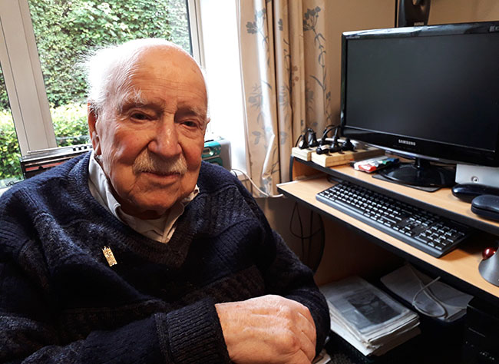

(photographed in 2018; reproduced from <https://www.otago.ac.nz/alumni/news/fredfastier98.html>)

**Rationale:** This group of podoviruses which were isolated in China (PaP2), Australia (119X), and Mexico (PaMx series) are unique at the DNA, protein and phylogenetic level.

**Proposal B. To move the genus, *Jamesmcgillvirus* to the new family**

**Origin of the name of this taxon:** This taxon is created via Taxonomy Proposal 2021.040B

**Historical aspects:** The first phage of its type, Pseudomonas phage 119X was probably isolated in Australia but became part of the Lányi phage typing set [12] and was the first sequenced [13]. This was deposited without annotation, and subsequently annotated by AMK (NC_007807.1). For the most completely characterized 119x-like virus we have chosen Pseudomonas phage PaMx41 [14]. This virus was isolated in 2006 from environmental water in Mexico. Its genome contains ca. 2kb terminal direct repeats which are not noted in the GenBank record.

**Electron micrograph:** Kindly provided by:Gabriel Guarneros Peña Ph. D., Profesor Emérito, Departamento de Genética y Biología Molecular, Centro de Investigación y de Estudios Avanzados, CDMX, México. N.B. PaMx32, is the archetypal phage of the group to which PaMx41 belongs. In addition to the morphological identity, the group shares RFLP and hybridization patterns.

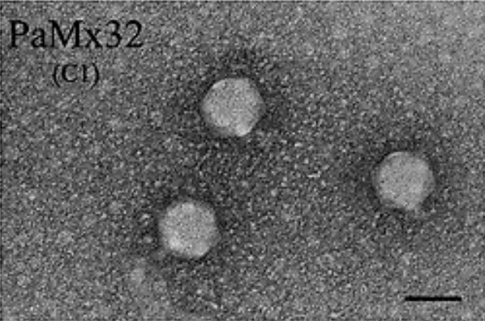

**Genome summary:**

|  |  |  |  |  |  |  |  |
| --- | --- | --- | --- | --- | --- | --- | --- |
| Phage name | INSDC | Size (Kb) | GC% | Protein | tRNA | Overall % DNA sequence identity (*) | Overall % homologous proteins (**) |
| Pseudomonas phage PaMx41 | [KU884563.1](https://www.ncbi.nlm.nih.gov/nuccore/KU884563.1) | 43.49 | 45.2 | [55](https://www.ncbi.nlm.nih.gov/genome/browse/#!/proteins/79700/530743|Pseudomonas phage PaMx41/viral segment/) | 0 | 100 | 100 |

**(*) determined using BLASTn [1] or VIRIDIC [2]**

**(**) determined using CoreGenes 3.5 [5]**

**References**

1. Sayers EW, Beck J, Bolton EE, Bourexis D, Brister JR, Canese K, Comeau DC, Funk K, Kim S, Klimke W, Marchler-Bauer A, Landrum M, Lathrop S, Lu Z, Madden TL, O'Leary N, Phan L, Rangwala SH, Schneider VA, Skripchenko Y, Wang J, Ye J, Trawick BW, Pruitt KD, Sherry ST. Database resources of the National Center for Biotechnology Information. Nucleic Acids Res. 2021 Jan 8;49(D1):D10-D17. doi: 10.1093/nar/gkaa892. PMID: 33095870
2. Moraru C, Varsani A, Kropinski AM. VIRIDIC-A Novel Tool to Calculate the Intergenomic Similarities of Prokaryote-Infecting Viruses. Viruses. 2020 Nov 6;12(11):1268. doi: 10.3390/v12111268. PMID: 33172115; PMCID: PMC7694805. <http://kronos.icbm.uni-oldenburg.de/viridic/>
3. Nishimura Y, Yoshida T, Kuronishi M, Uehara H, Ogata H, Goto S. ViPTree: the viral proteomic tree server. Bioinformatics. 2017; 33(15):2379-2380. doi:10.1093/bioinformatics/btx157. PubMed PMID: 28379287. <https://www.genome.jp/viptree/>
4. Rohwer F, Edwards R. The Phage Proteomic Tree: a genome-based taxonomy for phage. J Bacteriol. 2002 Aug;184(16):4529-35. PubMed PMID: 12142423
5. Turner D, Reynolds D, Seto D, Mahadevan P. CoreGenes3.5: a webserver for the determination of core genes from sets of viral and small bacterial genomes. BMC Res Notes. 2013;6:140. doi: 10.1186/1756-0500-6-140. PMID: 23566564.
6. Dereeper A, Guignon V, Blanc G, Audic S, Buffet S, Chevenet F, Dufayard JF, Guindon S, Lefort V, Lescot M, Claverie JM, Gascuel O. Phylogeny.fr: robust phylogenetic analysis for the non-specialist. Nucleic Acids Res. 2008;36(Web Server issue):W465-9. doi: 10.1093/nar/gkn180. Epub 2008 Apr 19. PMID: 18424797.
7. Anisimova M, Gascuel O. Approximate likelihood-ratio test for branches: A fast, accurate, and powerful alternative. Syst Biol. 2006;55(4):539-52. PMID: 16785212. DOI: 10.1080/10635150600755453.
8. Turner D, Kropinski AM, Adriaenssens EM. A Roadmap for Genome-Based Phage Taxonomy. Viruses. 2021 Mar 18;13(3):506. doi: 10.3390/v13030506. PMID: 33803862; PMCID: PMC8003253.
9. O'Leary NA, Wright MW, Brister JR, Ciufo S, Haddad D, McVeigh R, et al. Reference sequence (RefSeq) database at NCBI: current status, taxonomic expansion, and functional annotation. Nucleic Acids Res. 2016;44(D1):D733-45. doi: 10.1093/nar/gkv1189. PMID: 26553804.
10. van den Ende J. Marinus van den Ende. SAMJ, S. Afr. med. j. vol.99 n.1 Pretoria Jan. 2009; <http://www.scielo.org.za/scielo.php?script=sci_arttext&pid=S0256-95742009000100010>
11. Don PA, van den Ende M. A preliminary study of the bacteriophages of Pseudomonas aeruginosa. J Hyg (Lond). 1950 Jun;48(2):196-214. doi: 10.1017/s0022172400015011. PMID: 20475810; PMCID: PMC2234979.
12. Kiss P, Lantos J, Lányi B, Fodré Z. Characterization of Pseudomonas aeruginosa isolated from drinking water by serogrouping, phage sensitivity and pyocin pattern. Acta Microbiol Hung. 1985;32(1):99-106. PMID: 3929555.
13. Kwan T, Liu J, Dubow M, Gros P, Pelletier J. Comparative genomic analysis of 18 Pseudomonas aeruginosa bacteriophages. J Bacteriol. 2006 Feb;188(3):1184-7. doi: 10.1128/JB.188.3.1184-1187.2006. PMID: 16428425; PMCID: PMC1347338.
14. Cruz-Plancarte I, Cazares A, Guarneros G. Genomic and Transcriptional Mapping of PaMx41, Archetype of a New Lineage of Bacteriophages Infecting Pseudomonas aeruginosa. Appl Environ Microbiol. 2016 Oct 27;82(22):6541-6547. doi: 10.1128/AEM.01415-16. PMID: 27590812; PMCID: PMC5086548.
15. Sepúlveda-Robles O, Kameyama L, Guarneros G. High diversity and novel species of Pseudomonas aeruginosa bacteriophages. Appl Environ Microbiol. 2012 Jun;78(12):4510-5. doi: 10.1128/AEM.00065-12. Epub 2012 Apr 13. PMID: 22504803; PMCID: PMC3370533.
16. Fastier LB. A Bacteriophage for Pseudomonas pyocyanea (Pseudomonas aeruginosa). J Bacteriol. 1945 Sep;50(3):301-3. doi: 10.1128/JB.50.3.301-303.1945. PMID: 16561002; PMCID: PMC374141.