

Part 1: TITLE, AUTHORS, APPROVALS, etc

Code assigned: | 2022.034B
Short title: Create a new subfamily (Gordonclarkvirinae) with three genera (Caudoviricetes)

Author(s) and email address(es)
Moraru C, Tong Y, Mahadevan P, Adriaenssens EM, Kropinski AM, Turner D | liliana.cristina.moraru@uol.de; Tong.yigang@gmail.com; PMAHADEVAN@ut.edu; evelien.adriaenssens@quadram.ac.uk; Phage.Canada@gmail.com; Dann2.Turner@uwe.ac.uk
Author(s) institutional address(es) (optional)

Carl von Ossietzky Universität Oldenburg, Germany [CM]
Beijing University of Chemical Technology, Beijing, China [YT]
The University of Tampa, FL USA [PM]
Quadram Institute, Norwich, UK [EMA]
University of Guelph, Canada [AMK]
University of the West of England, Bristol, UK [DT]

Corresponding author
Andrew M. Kropinski
List the ICTV Study Group(s) that have seen this proposal

Bacterial Viruses Subcommittee, Caudoviricetes Study Group

ICTV Study Group comments and response of proposer

ICTV Study Group votes on proposal

Study Group | Number of members
 | Votes support | Votes against | No vote
Authority to use the name of a living person

Is any taxon name used here derived from that of a living person (Y/N) | N

Taxon name | Person from whom the name is derived | Permission attached (Y/N)

Submission dates
Date first submitted to SC Chair | May 2022
Date of this revision (if different to above)
ICTV-EC comments and response of the proposer

Part 2: NON-TAXONOMIC PROPOSAL

Text of proposal

Part 3: TAXONOMIC PROPOSAL
Name of accompanying Excel module
2022.034B.A.v2.Gordonclarkvirinae_nsf.xlsx
Abstract

Our genomic (VIRIDIC), proteomic (CoreGenes, VirClust, and vConTACT) and phylogenetic data all confirm that the genera Kuravirus, Suseptimavirus and Nieuwekanaalvirus can be classified together into a higher taxon to which we have given the name Gordonclarkvirinae. At the molecular level the average genome characteristics are 76.9 kb (42.3 mol%G+C) encoding 124 proteins and one tRNA. The members share ≥49.2% DNA sequence similarity. Using CoreGenes 5.0 with its bidirectional best hit algorithm (https://coregenes.ngrok.io/) 86 homologs (69.3%) conserved proteins were observed. Some of the latter include: TerS, TerL, portal protein, scaffolding protein, major capsid protein, tail fiber protein, holin, endolysin, O-spannin, DNA injection protein, DNA polymerase, PhoH protein, thymidylate synthase, primase/helicase, deoxycytidine triphosphate deaminase, and glutamine amidotransferase.

Text of proposal
Species demarcation criteria: Two phages are assigned to the same species if their genomes are more than 95% identical over their genome length for isolates.
These values can be calculated by a number of tools, such as BLASTn [1] – usually calculated using intergenomic distance calculator VIRIDIC [2].

Genus demarcation criteria: In search for criteria that create cohesive and distinct genera that are reproducible and monophyletic, the Bacterial Viruses Subcommittee has established 70% nucleotide identity of the genome length as the cut-off for genera. Genus-level groupings should always be monophyletic in the signature genes, as tested with a phylogenetic tree. [8]

Subfamily demarcation criteria: Subfamilies are to be created when two or more genera are related below the family level. In practical terms, this usually means that they share a low degree of sequence similarity (usually about 40-50%) and that the genera form a clade in a marker tree phylogeny. [8]

Supporting evidence

Proposal A. Create a new genus, Nieuwekanaalvirus, with two (2) species
Proposal B. Create a new genus, Suseptimavirus with five (5) species
Proposal C. Create a new subfamily, Gordonclarkvirinae
Proposal D. Transfer Kuravirus with ten (10) new species to Gordonclarkvirinae

Common molecular data:

VIRIDIC heat map: VIRIDIC (Virus Intergenomic Distance Calculator; VIRIDIC (Virus Intergenomic Distance Calculator; [2]; http://rhea.icbm.uni-oldenburg.de/VIRIDIC/) computes pairwise intergenomic similarities amongst phage genomes.

ViPTree analysis: ViPTree analysis (https://www.genome.jp/viptree/; [3]) is based upon Rohwer and Edwards (2002) famous Phage Proteomic Tree [4]. The phages of interest are indicated with blue rectangle.
.

Phylogeny: The phylogenetic tree was constructed using the TerL proteins from phiEco32 and related phages with phylogeny.fr in “one click” mode [6]. "The "One Click mode" targets users that do not wish to deal with program and parameter selection. By default, the pipeline is already set up to run and connect programs recognized for their accuracy and speed (MUSCLE for multiple alignment and PhyML for phylogeny) to reconstruct a robust phylogenetic tree from a set of sequences." It also includes the use of Gblocks to eliminate poorly aligned positions and divergent regions. "The usual bootstrapping procedure is replaced by a new confidence index that is much faster to compute. See: Anisimova M., Gascuel O. Approximate likelihood ratio test for branches: A fast, accurate and powerful alternative [7] for details." The members of the Gordonclarkvirinae are indicated with a blue rectangle.

vConTACT v.2.0: is a network-based application utilizing whole genome gene-sharing profiles for virus taxonomy that integrates distance-based hierarchical clustering and confidence scores for all taxonomic predictions [16-18]. VC_746_0, VC_746_1
and VC_746_2 are coloured. The members of Kuravirus belong to cluster VC_747_0, and the Aeromonas phages to VC_541_0.
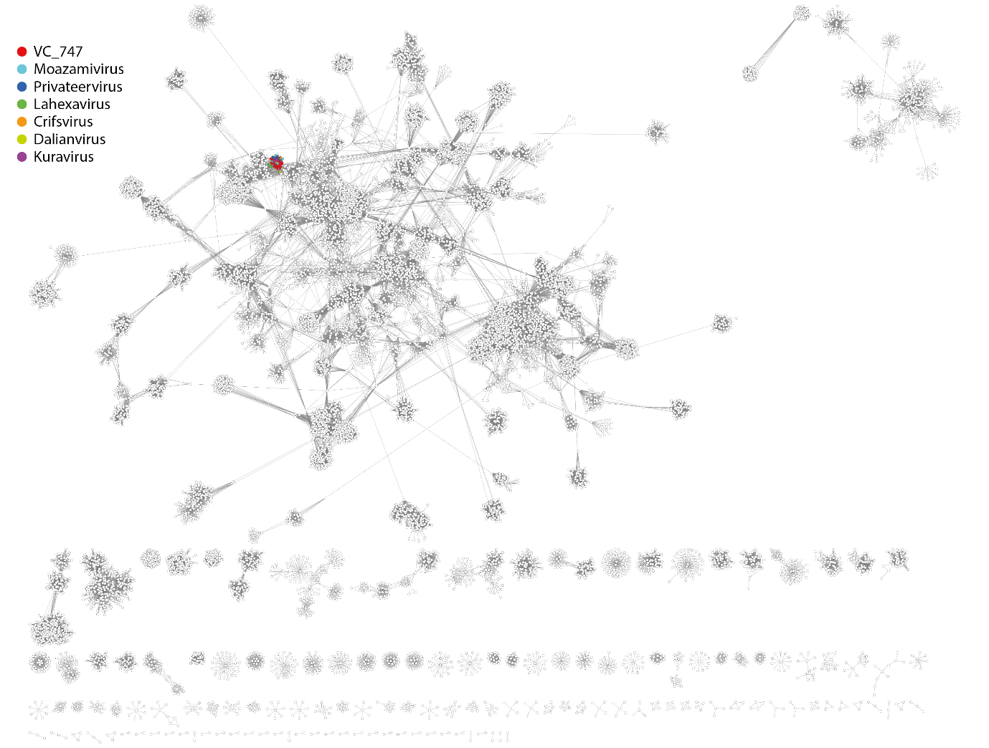
VirClust. At its core VirClust groups viral proteins into clusters of three different levels: (a) proteins are grouped based on their reciprocal BLASTP similarities into protein clusters, or PCs; (b) PCs are then grouped based on their Hidden Markov Model (HMM) similarities into protein superclusters, or PSCs; and, (c) PSCs are grouped based on their HMM similarities into protein super-superclusters, or PSSC. https://rhea.icbm.uni-oldenburg.de/VIRCLUST/. Top, members of Grimontviridae; bottom, members of Gordonclarkvirinae. The Grimontviridae cluster separately from the Gordonclarkvirinae in the dataset. But, using stringent parameters for protein clustering (coverage 70%, bitscore 30, eval 0.0001), they have 17 proteins in common (13.5%).

Proposal A. Create a new genus, Nieuwekanaalvirus, with two (2) species
Origin of the name of this taxon: This taxon is named after the location (Nieuwe kanaal 7P, Wageningen, Gelderland 6709PA, The Netherlands) where at the Micreos Food
Safety B.V., Escherichia phage EP335 was isolated.

Historical aspects: Escherichia phage KBNP1711 will be transferred from Kuravirus.

Electron micrograph: N/A

Genome summary:

Phage name | INSDC | Size (Kb) | GC% | Protein | tRNA | Overall % DNA sequence identity (*) | Overall % homologous proteins (**)
Escherichia phage EP335 | MG748548.1 | 76.62 | 42.5 | 125 | 1 | 100 | 100
Escherichia phage KBNP1711 | KF981730.1 | 76.18 | 42.4 | 126 | 1(***) | 85.8 | 88.8
(*) determined using BLASTn [1] or VIRIDIC [2]
(**) determined using CoreGenes 3.5 [5]
(***) none indicated in the NCBI Relicon Info. This one was discovered using tRNAscan-SE at http://lowelab.ucsc.edu/tRNAscan-SE/ [14]

Proposal B. Create a new genus, Suseptimavirus with five (5) species
Origin of the name of this taxon: The name of this taxon derives from that of Escherichia phage vB_EcoP_SU7

Historical aspects: Escherichia phage vB_EcoP_SU7 was isolated in 2016 from the Käppala wastewater treatment plant located 15 km East of Stockholm, Sweden. It has an elongated head, with a length of 134 nm and width of 44 nm and a very short non-contractile tail. Occurring in less than 1% of Podoviridae virions, this rare morphotype has been observed among phages belonging to the Kuravirus genus (previously referred to as PhiEco32viruses) [19].

Phage ECBP2 is currently recognized as a member of the Kuravirus, and will be transferred. It was isolated from a chicken farm located in Yesan, South Korea [20].

Escherichia phage EK010 and Escherichia phage IME267 were isolated in China; Escherichia phage vB_EcoP-101114UKE3 from Austria.

Genome summary:

Phage name | INSDC | Size (Kb) | GC% | Protein | tRNA | Overall % DNA sequence identity (*) | Overall % homologous proteins (**)
Escherichia phage vB_EcoP_SU7 | MZ342906.1 | 76.63 | 42.1 | 118 | 1 | 100 | 100
Escherichia phage ECBP2 | JX415536.1 | 77.32 | 42.4 | 120 | 1 | 77.2 | 89.8
Escherichia phage EK010 | LC553734.1 | 78.08 | 42.1 | 116 | 1 | 83.6 | 86.4
Escherichia phage vB_EcoP-101114UKE3 | MZ234017.1 | 75.75 | 42.0 | 145 | 1 | 91.7 | 91.5
Escherichia phage IME267 | MZ398243.1 | 76.63 | 42.0 | 120 | 1 | 87.3 | 89.0
(*) determined using BLASTn [1] or VIRIDIC [2]
(**) determined using CoreGenes 3.5 [5]

Proposal C. Create a new subfamily, Gordonclarkvirinae
Origin of the name of this taxon: The subfamily is named in honour of George ("G. L.") Lindenberg Clark (d 1892 Anderson, Indiana - d. 1969). PhD (1918) from the University of Chicago, where he studied chemistry and physics. After completing his formal education, Clark was associate professor at Vanderbilt University (1919-21); national research fellow at Harvard (1922-24); and assistant professor of applied chemical research at Massachusetts Institute of Technology (MIT) (1924-27), where he established the first analytical X-ray laboratory in the United States. He joined the faculty at UI in 1927 as professor and head of analytical chemistry. He was professor emeritus (1953-69) at the University of Illinois (UI). He was a renowned analytical chemist and X-ray scientist best known for his pioneering development of X-ray technologies and instrumentation methods for use in scientific research and analysis. He wrote over 360 research papers in addition to publishing Applied X-Rays (1927); A Basic Course in Theory and Practice of Quantitative Chemical Analysis (1949); and (as editor) the Encyclopedia of Chemistry (1956). Clark was active in his field, including as a fellow of the American Association for the Advancement of Science (AAAS); honorary member of the Radiological Society of North America; and founder and chairman of the Electron Microscope Society (1942). Clark was widely recognized, including with the Grasselli Medal from the Society of Chemical Industry (1932); an honorary doctorate from DePauw University (1937); and the Mehl Medal from the Congress of Metals (1944). The UI's first dedicated X-ray laboratory (the George L. Clark X-Ray Facility) was named in his honor in 1952. (copied from: https://archon.library.illinois.edu/?p=creators/creator&id=1032). We have chosen to honour Professor Clark because of his 1940s studies on bacteriophages.

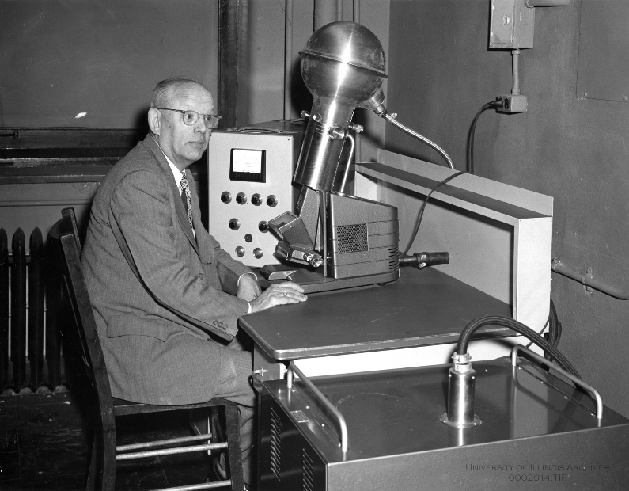
(Courtesy of the University of Illinois Archives; Chemistry Prof. G.L. Clark c. 1954)

Rationale: Our genomic (VIRIDIC), proteomic (CoreGenes, VirClust, and vConTACT) and phylogenetic data all confirm that the Kuravirus, Suseptimavirus and Nieuwekanaalvirus can be classified to a higher taxon to which we have given the name Gordonclarkvirinae. At the molecular level the average genome characteristics are 76.9 kb (42.3 mol%G+C) encoding 124 proteins and one tRNA. The members share ≥49.2% DNA sequence similarity. Using CoreGenes 5.0 with bidirectional best hit algorithm (https://coregenes.ngrok.io/) 86 homologs (69.3%) conserved proteins were observed. Some of the latter include: TerS, TerL, portal protein, scaffolding protein, major capsid protein, tail fiber protein, holin, endolysin, O-spannin, DNA injection protein, DNA polymerase, PhoH protein, thymidylate synthase, primase/helicase, deoxycytidine triphosphate deaminase, and glutamine amidotransferase.

Proposal D. Transfer Kuravirus with ten (10) new species to Gordonclarkvirinae
Origin of the name of this taxon: N/A

Historical aspects: This genus was created originally via Taxonomy Proposal 2008.001a-eB

Electron micrograph: N/A

Genome summary:

Phage name | INSDC | Size (Kb) | GC% | Protein | tRNA | Overall % DNA sequence identity (*) | Overall % homologous proteins (**)
Escherichia phage phiEco32 | EU330206.1 | 77.55 | 42.3 | 128 | 1 | 100 | 100
Escherichia phage ES17 | MN508615.2 | 75.01 | 42.1 | 123 | 1(***) | 81.4 | 88.3
Escherichia phage O18-011 | LC553735.1 | 75.65 | 42.1 | 120 | 1 | 79.9 | 78.1
Escherichia phage vB_EcoP_EcoN5 | MN715356.1 | 76.08 | 42.1 | 127 | 1 | 79.4 | 80.5
Escherichia phage MN05 | MT129655.1 | 76.9 | 42.2 | 126 | 1 | 81.5 | 83.6
Shigella phage SGF2 | MN148435.1 | 76.96 | 42.3 | 118 | 1 | 84.0 | 82.0
Escherichia phage vB_EcoP-CHD5UKE1 | MZ234028.1 | 77.36 | 42.2 | 152 | 1 | 89.6 | 90.6
Escherichia phage MN03 | MT129653.1 | 77.19 | 42.2 | 124 | 1 | 88.1 | 88.3
Escherichia phage vB_EcoP_WFI101126 | MK373770.1 | 77.31 | 42.1 | 135 | 1 | 81.4 | 88.3
Escherichia phage Paul | MN045231.1 | 79.43 | 42.0 | 133 | 1 | 81.9 | 88.3
Escherichia phage vB_EcoP_IMEP8 | MZ648214.1 | 75.81 | 42.1 | 121 | 1 | 81.1 | 82.0
(*) determined using BLASTn [1] or VIRIDIC [2]
(**) determined using CoreGenes 3.5 [5]
(***) none are recorded in the NCBI Replicon Info. This one was discovered using tRNAscan-SE [14]

References
- Sayers EW, Beck J, Bolton EE, Bourexis D, Brister JR, Canese K, Comeau DC, Funk K, Kim S, Klimke W, Marchler-Bauer A, Landrum M, Lathrop S, Lu Z, Madden TL, O'Leary N, Phan L, Rangwala SH, Schneider VA, Skripchenko Y, Wang J, Ye J, Trawick BW, Pruitt KD, Sherry ST. Database resources of the National Center for Biotechnology Information. Nucleic Acids Res. 2021 Jan 8;49(D1):D10-D17. doi: 10.1093/nar/gkaa892. PMID: 33095870
- Moraru C, Varsani A, Kropinski AM. VIRIDIC-A Novel Tool to Calculate the Intergenomic Similarities of Prokaryote-Infecting Viruses. Viruses. 2020 Nov 6;12(11):1268. doi: 10.3390/v12111268. PMID: 33172115; PMCID: PMC7694805. http://kronos.icbm.uni-oldenburg.de/viridic/
- Nishimura Y, Yoshida T, Kuronishi M, Uehara H, Ogata H, Goto S. ViPTree: the viral proteomic tree server. Bioinformatics. 2017; 33(15):2379-2380. doi:10.1093/bioinformatics/btx157. PubMed PMID: 28379287. https://www.genome.jp/viptree/
- Rohwer F, Edwards R. The Phage Proteomic Tree: a genome-based taxonomy for phage. J Bacteriol. 2002 Aug;184(16):4529-35. PubMed PMID: 12142423
- Turner D, Reynolds D, Seto D, Mahadevan P. CoreGenes3.5: a webserver for the determination of core genes from sets of viral and small bacterial genomes. BMC Res Notes. 2013;6:140. doi: 10.1186/1756-0500-6-140. PMID: 23566564.
- Dereeper A, Guignon V, Blanc G, Audic S, Buffet S, Chevenet F, Dufayard JF, Guindon S, Lefort V, Lescot M, Claverie JM, Gascuel O. Phylogeny.fr: robust phylogenetic analysis for the non-specialist. Nucleic Acids Res. 2008;36(Web Server issue):W465-9. doi: 10.1093/nar/gkn180. Epub 2008 Apr 19. PMID: 18424797.
- Anisimova M, Gascuel O. Approximate likelihood-ratio test for branches: A fast, accurate, and powerful alternative. Syst Biol. 2006;55(4):539-52. PMID: 16785212. DOI: 10.1080/10635150600755453.
- Turner D, Kropinski AM, Adriaenssens EM. A Roadmap for Genome-Based Phage Taxonomy. Viruses. 2021 Mar 18;13(3):506. doi: 10.3390/v13030506. PMID: 33803862; PMCID: PMC8003253.
- O'Leary NA, Wright MW, Brister JR, Ciufo S, Haddad D, McVeigh R, et al. Reference sequence (RefSeq) database at NCBI: current status, taxonomic expansion, and functional annotation. Nucleic Acids Res. 2016;44(D1):D733-45. doi: 10.1093/nar/gkv1189. PMID: 26553804.
- Olsen NS, Hendriksen NB, Hansen LH and Kot W. A New High-Throughput Screening Method for Phages: Enabling Crude Isolation and Fast Identification of Diverse Phages with Therapeutic Potential. Phage (New Rochelle) 1 (3), 137-148 (2020) https://www.liebertpub.com/doi/10.1089/phage.2020.0016
- Abbasifar R. Biocontrol of Cronobacter spp. using Bacteriophage in Infant Formula. PhD thesis 2013, University of Guelph. https://atrium.lib.uoguelph.ca/xmlui/bitstream/handle/10214/7414/Abbasifar_Reza_201308_PhD.pdf
- Moazamie N, Ackermann HW, Murthy MR. Characterization of two Salmonella newport bacteriophages. Can J Microbiol. 1979 Sep;25(9):1063-72. doi: 10.1139/m79-163. PMID: 540262.
- Kwon J, Kim SG, Giri SS, Kim HJ, Kim SW, Kang JW, Lee SB, Jung WJ, Chi C, Park SC. Genomic characterization of bacteriophage pSal-SNUABM-01, a novel elongated-head phage infecting Salmonella sp. Arch Virol. 2022 Feb;167(2):655-658. doi: 10.1007/s00705-021-05342-1. Epub 2022 Jan 19. PMID: 35043229.
- Chan PP, Lowe TM. tRNAscan-SE: Searching for tRNA Genes in Genomic Sequences. Methods Mol Biol. 2019;1962:1-14. doi: 10.1007/978-1-4939-9173-0_1. PMID: 31020551; PMCID: PMC6768409.
- Ren H, Li Z, Xu L, Li X, Wang L, Xu Y. Genome sequence analysis of Vibrio parahaemolyticus lytic phage Vp_R1 with a C3 morphotype. Arch Virol. 2019 Nov;164(11):2865-2871. doi: 10.1007/s00705-019-04364-0. Epub 2019 Aug 10. PMID: 31401694.
- Bin Jang H, Bolduc B, Zablocki O, Kuhn JH, Roux S, Adriaenssens EM, Brister JR, Kropinski AM, Krupovic M, Lavigne R, Turner D, Sullivan MB. Taxonomic assignment of uncultivated prokaryotic virus genomes is enabled by gene-sharing networks. Nat Biotechnol. 2019 Jun;37(6):632-639. doi: 10.1038/s41587-019-0100-8. Epub 2019 May 6. PMID: 31061483.
- Bolduc B, Jang HB, Doulcier G, You ZQ, Roux S, Sullivan MB. vConTACT: an iVirus tool to classify double-stranded DNA viruses that infect Archaea and Bacteria. PeerJ. 2017 May 3;5:e3243. doi: 10.7717/peerj.3243. PMID: 28480138; PMCID: PMC5419219.
- vConTACT2 User Guide https://bitbucket.org/MAVERICLab/vcontact2/wiki/Home
- Koonjan S, Cooper CJ, Nilsson AS. Complete Genome Sequence of vB_EcoP_SU7, a Podoviridae Coliphage with the Rare C3 Morphotype. Microorganisms. 2021 Jul 24;9(8):1576. doi: 10.3390/microorganisms9081576. PMID: 34442655; PMCID: PMC8399022.
- Nho SW, Ha MA, Kim KS, Kim TH, Jang HB, Cha IS, Park SB, Kim YK, Jung TS. Complete genome sequence of the bacteriophages ECBP1 and ECBP2 isolated from two different Escherichia coli strains. J Virol. 2012 Nov;86(22):12439-40. doi: 10.1128/JVI.02141-12. PMID: 23087106; PMCID: PMC3486491.

