

**Part 1:** **TITLE, AUTHORS, APPROVALS, etc**

|  |  |  |
| --- | --- | --- |
| **Code assigned:** | ***2022.035B*** |  |
| **Short title:** Create a new family (*Grimontviridae)* with five genera (*Caudoviricetes*) | | |
|  | | |

**Author(s) and email address(es)**

|  |  |
| --- | --- |
|  |  |
| Moraru C, Tong Y, Tian F, Mahadevan P, Adriaenssens EM, Kropinski AM, Turner D | liliana.cristina.moraru@uol.de; Tong.yigang@gmail.com; 13051927500@163.com; PMAHADEVAN@ut.edu; evelien.adriaenssens@quadram.ac.uk; Phage.Canada@gmail.com; Dann2.Turner@uwe.ac.uk |

**Author(s) institutional address(es) (optional)**

|  |
| --- |
| Carl von Ossietzky Universität Oldenburg, Germany [CM]  Beijing University of Chemical Technology, Beijing, China [YT, FT]  The University of Tampa, FL USA [PM]  Quadram Institute, Norwich, UK [EMA]  University of Guelph, Canada [AMK]  University of the West of England, Bristol, UK [DT] |

**Corresponding author**

|  |
| --- |
| Andrew M. Kropinski |

**List the ICTV Study Group(s) that have seen this proposal**

|  |
| --- |
| Bacterial Viruses Subcommittee, Caudoviricetes Study Group |

**ICTV Study Group comments and response of proposer**

|  |
| --- |
|  |

**ICTV Study Group votes on proposal**

|  |  |  |  |
| --- | --- | --- | --- |
| **Study Group** | **Number of members** | | |
| **Votes support** | **Votes against** | **No vote** |
|  |  |  |  |
|  |  |  |  |

**Authority to use the name of a living person**

|  |  |
| --- | --- |
| **Is any taxon name used here derived from that of a living person (Y/N)** | Y |

|  |  |  |
| --- | --- | --- |
| **Taxon name** | **Person from whom the name is derived** | **Permission attached (Y/N)** |
| Grimontviridae | Francine Grimont | Y |
| Moazamivirus | Nasrin Moazami | Y |
|  |  |  |

**Submission dates**

|  |  |
| --- | --- |
| Date first submitted to SC Chair | April 2022 |
| Date of this revision (if different to above) |  |

**ICTV-EC comments and response of the proposer**

|  |
| --- |
|  |

**Part 2:** **NON-TAXONOMIC PROPOSAL**

**Text of proposal**

|  |
| --- |
|  |

**Part 3:** **TAXONOMIC PROPOSAL**

**Name of accompanying Excel module**

|  |
| --- |
| 2022.035B.N.v1.Grimontviridae\_nf.xlsx |

**Abstract**

|  |
| --- |
| We have now created taxa for both groups of rare C3-morphotype podoviruses. The new family *Grimontviridae*, named in honour of Francine Grimont, contains six genera. On average the genomes in this family are 91.1kb (41.1 mol%G+C) and encode 137 proteins and 2-7 tRNA. |

**Text of proposal**

|  |  |
| --- | --- |
| |  | | --- | | **Species demarcation criteria:** Two phages are assigned to the same species if their genomes are more than 95% identical over their genome length for isolates.  These values can be calculated by a number of tools, such as BLASTn [1] – usually calculated using intergenomic distance calculator VIRIDIC [2].  **Genus demarcation criteria:** In search for criteria that create cohesive and distinct genera that are reproducible and monophyletic, the Bacterial Viruses Subcommittee has established 70% nucleotide identity of the genome length as the cut-off for genera. Genus-level groupings should always be monophyletic in the signature genes, as tested with a phylogenetic tree. [8]  **Family demarcation criteria:** The family is represented by a cohesive and monophyletic group in the main predicted proteome-based clustering tools (ViPTree, GRAViTy dendrogram, vConTACT2 network). Members of the family share a significant number of orthologous genes (the number will depend on the genome sizes and number of coding sequences of members of the family). [8] | |

**Supporting evidence**

**Proposal A. Create a new genus, *Crifsvirus*, with two (2) species**

**Proposal B. Create a new genus, *Moazamivirus* with three (3) species**

**Proposal C. To add two (2) species to the genus *Privateervirus***

**Proposal** **D.** **Create a new genus, *Libingvirus*, with one (1) species**

**Proposal E. Create a new genus, *Dalianvirus*, with one (1) species**

**Proposal F. Create a new family, *Grimontviridae* with these five genera.**

**Common molecular data:**

**VIRIDIC heat map:** VIRIDIC (Virus Intergenomic Distance Calculator; VIRIDIC (Virus Intergenomic Distance Calculator; [2]; http://rhea.icbm.uni-oldenburg.de/VIRIDIC/) computes pairwise intergenomic similarities amongst phage genomes.

****

**ViPTree analysis:** ViPTree analysis ([https://www.genome.jp/viptree/](about:blank); [3]) is based upon Rohwer and Edwards (2002) famous Phage Proteomic Tree [4]. The phages of interest are indicated with **red stars**.

  


**Phylogeny:** The phylogenetic tree was constructed using the TerL proteins from 7-11 and related phages with phylogeny.fr in “one click” mode [6]. "The "One Click mode" targets users that do not wish to deal with program and parameter selection. By default, the pipeline is already set up to run and connect programs recognized for their accuracy and speed (MUSCLE for multiple alignment and PhyML for phylogeny) to reconstruct a robust phylogenetic tree from a set of sequences." It also includes the use of Gblocks to eliminate poorly aligned positions and divergent regions. "The usual bootstrapping procedure is replaced by a new confidence index that is much faster to compute. See: Anisimova M., Gascuel O. Approximate likelihood ratio test for branches: A fast, accurate and powerful alternative [7] for details." The members of the *Grimontviridae* are indicated with a **blue rectangle**.

****

**vConTACT v.2.0:** is a network-based application utilizing whole genome gene-sharing profiles for virus taxonomy that integrates distance-based hierarchical clustering and confidence scores for all taxonomic predictions [16-18]. VC\_746\_0, VC\_746\_1

and VC\_746\_2 are coloured. The members of *Kuravirus* belong to cluster VC\_747\_0, and the Aeromonas phages to VC\_541\_0.

**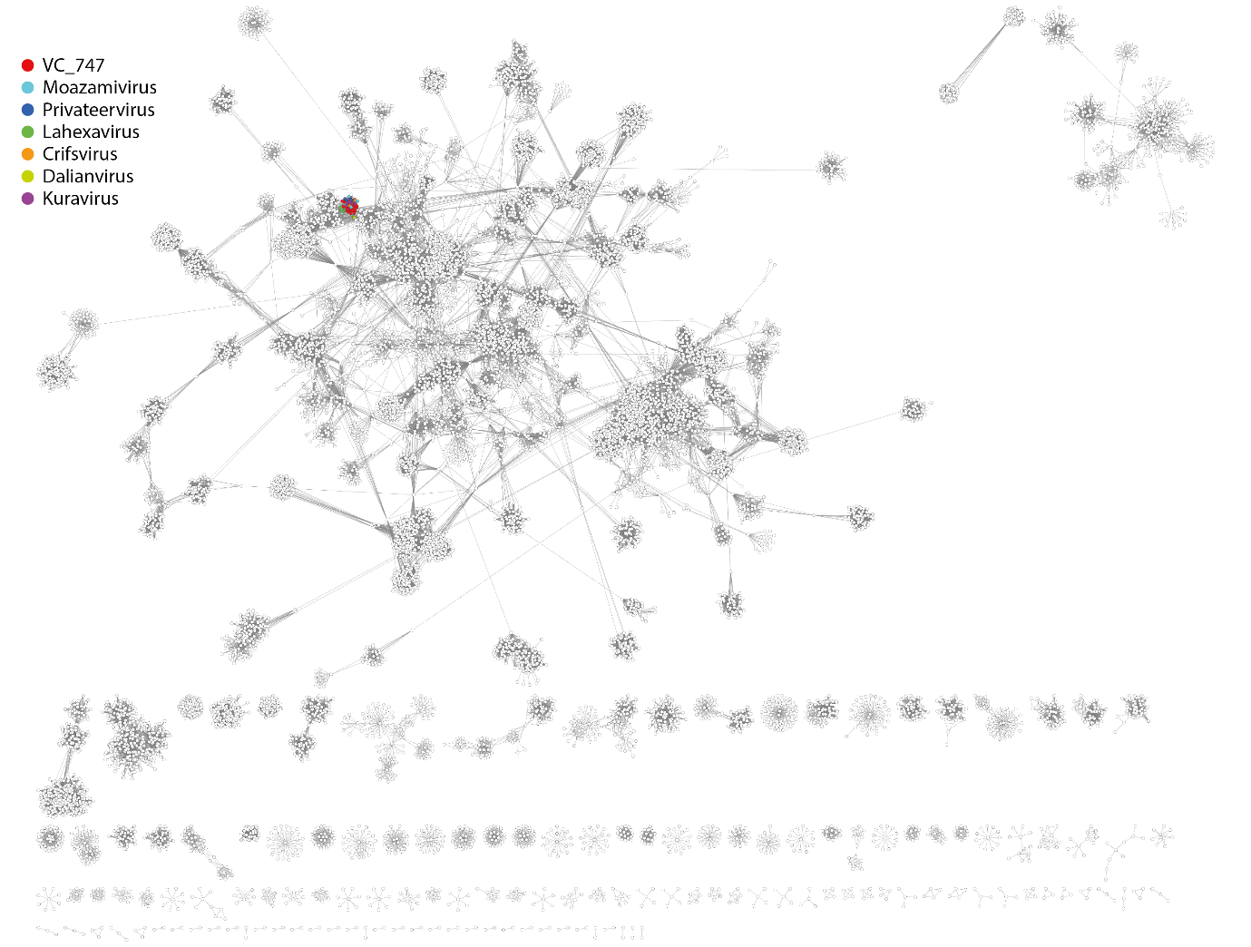**

**VirClust.** At its core VirClust groups viral proteins into clusters of three different levels: (a) proteins are grouped based on their reciprocal BLASTP similarities into protein clusters, or PCs; (b) PCs are then grouped based on their Hidden Markov Model (HMM) similarities into protein superclusters, or PSCs; and, (c) PSCs are grouped based on their HMM similarities into protein super-superclusters, or PSSC. <https://rhea.icbm.uni-oldenburg.de/VIRCLUST/>. Top, members of *Grimontviridae*; bottom, members of *Kuravirus*. The *Grimontviridae* cluster separately from the *Kuravirus* in the dataset. But, using stringent parameters for protein clustering (coverage 70%, bitscore 30, eval 0.0001), they have 17 proteins in common (13.5%).



**Proposal A. Create a new genus, *Crifsvirus*, with two (2) species**

**Origin of the name of this taxon:** This taxon is named in honour of the Canadian Research Institute in Food Safety (CRIFS) in which Reza Abbasifar isolated Cronobacter phage Gap52.

**Historical aspects:** In 2008, lytic Cronobacter phage vB\_CsaP\_GAP52 was isolated in Guelph, Ontario, Canada on Cronobacter sakazakii [11]. It possesses and elongated head (139 x 47 nm) and a short tail (12 x 10 nm). Cronobacter phage A24 was isolated from river water in Yuexiu, Guangzhou, China.

On average the genomes in the genus are 75.9 kb (44.1 mol%G+C) and encode 11 proteins and 2-3 tRNA

**Electron micrograph:** Transmission electron micrographs of negatively stained (UA) of phage GAP52 (permission to reproduce from [11] kindly provided by Reza Abbasifar, DVM, PhD).

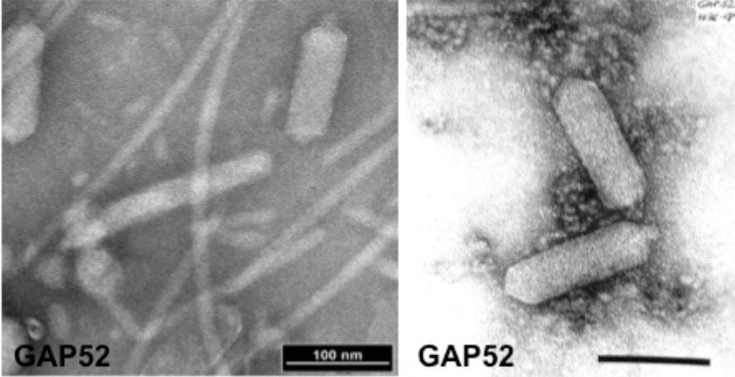

**Genome summary:**

|  |  |  |  |  |  |  |  |
| --- | --- | --- | --- | --- | --- | --- | --- |
| Phage name | INSDC | Size (Kb) | GC% | Protein | tRNA | Overall % DNA sequence identity (\*) | Overall % homologous proteins (\*\*) |
| Cronobacter phage vB\_CsaP\_GAP52 | [JN882286.1](https://www.ncbi.nlm.nih.gov/nuccore/JN882286.1) | 76.63 | 44.2 | [115](https://www.ncbi.nlm.nih.gov/genome/browse/#!/proteins/15410/459747|Cronobacter phage vB_CsaP_GAP52/viral segment Unknown/) | 2 | 100 | 100 |
| Cronobacter phage A24 | [MW343794.1](https://www.ncbi.nlm.nih.gov/nuccore/MW343794.1) | 75.11 | 44.1 | [108](https://www.ncbi.nlm.nih.gov/genome/browse/#!/proteins/97732/1535491|Cronobacter phage A24/viral segment/) | 3 | 86.0 | 92.2 |

**(\*) determined using BLASTn [1] or VIRIDIC [2]**

**(\*\*) determined using CoreGenes 3.5 [5]**

**Proposal B. Create a new genus, *Moazamivirus,* with three (3) species**

**Origin of the name of this taxon:** This taxon is named in honour of the Iranian biologist and biofuel technological pioneer, Professor Nasrin Moazami (b. 1945). In 1976 she received her Ph.D. in Medical Microbiology from Université Laval in Canada. Her doctoral research involved the full characterization of Salmonella Newport phage 7-11. Dean of Academic, Medical Faculty, Isfahan University 1976- 1977. In 1995 she founded the Persian Gulf Biotechnology Research Center at the Persian Gulf island of Qeshm, the first Iranian center for applied marine biotechnology. The same year

she was awarded the Chevalier de L’Ordre des Palmes Académiques for her outstanding research. In 2016 she was appointed to UNESCO’s International Basic Sciences Program (IBSP). Moazami is a scientist with the Iranian Research Organization for Science and Technology (IROST) and Head of its Biotechnology Center, 1983-2004. Curator of Persian Type Culture Collection, PTCC, 1983- present (<http://en.womenrightful.com/professor-nasrin-moazamibiotechnology-pioneer/>; <http://fpv.sdsgroup.org/Pages/view.aspx?PostID=265>).

****

(Professor Nasrin Moazami from http://fpv.sdsgroup.org/Pages/view.aspx?PostID=265)

**Historical aspects:** Salmonella Newport phage 7-11 was thoroughly characterized by Moazami et al. [12]. It is a C3 morphotype podovirus with an elongated head of 154 × 40 nm and a tail of 12 × 9 nm [12]. 7-11 has a buoyant density in CsCl of 1.48 g/mL and particle weights of 204 x 106. Salmonella phage pSal-SNUABM-01 was isolated from the Nam

River in Jinju City, South Korea. It also possesses an elongated head (length, 134 nm; width, 37.2 nm) and a short tail (length, 13 nm). It possesses a circularly permuted genome [13]. The last phage in this genus, SE131, was also isolated in Korea against Salmonella enterica subsp. enterica serovar Enteritidis.

On average the genomes in the genus are 89.8 kb (44.4 mol%G+C) and encode 150 proteins and 6-8 tRNA

**Electron micrograph:** Electron micrograph of phage 7-11 negatively stained with

2% uranyl acetate. The bar indicates 100 nm [12]

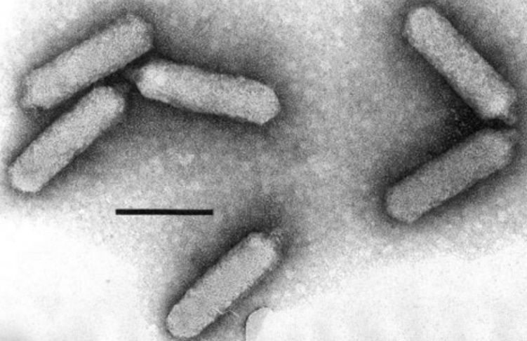

**Genome summary:**

|  |  |  |  |  |  |  |  |
| --- | --- | --- | --- | --- | --- | --- | --- |
| Phage name | INSDC | Size (Kb) | GC% | Protein | tRNA | Overall % DNA sequence identity (\*) | Overall % homologous proteins (\*\*) |
| Salmonella phage 7-11 | [HM997019.1](https://www.ncbi.nlm.nih.gov/nuccore/HM997019.1) | 89.92 | 44.1 | [151](https://www.ncbi.nlm.nih.gov/genome/browse/#!/proteins/10614/459574|Salmonella phage 7-11/viral segment Unknown/) | 6 | 100 | 100 |
| Salmonella phage pSal-SNUABM-01 | [MW296032.1](https://www.ncbi.nlm.nih.gov/nuccore/MW296032.1) | 89.5 | 45.0 | [154](https://www.ncbi.nlm.nih.gov/genome/browse/#!/proteins/97817/1539418|Salmonella phage pSal-SNUABM-01/viral segment/) | 8 | 77.6 | 87.4 |
| Salmonella phage SE131 | [MG873442.1](https://www.ncbi.nlm.nih.gov/nuccore/MG873442.1) | 89.91 | 44.2 | [147](https://www.ncbi.nlm.nih.gov/genome/browse/#!/proteins/68540/369689|Salmonella phage SE131/viral segment/) | 7 | 92.9 | 88.1 |

**(\*) determined using BLASTn [1] or VIRIDIC [2]**

**(\*\*) determined using CoreGenes 3.5 [5]**

**Proposal C. To add two (2) species to the genus *Privateervirus***

**Historical aspects:** The genus *Privateervirus* was created by Taxonomy Proposal 2020.124B. It originally contained two species: *Proteus virus Privateer* and *Cronobacter virus 009*. Here based upon DNA sequence relatedness we add two new species - Proteus phage Vb\_PmiP-P59.

On average the genomes in the genus are 90.4 kb (34.6 mol% G+C) and encode 137 proteins and 4 tRNA

**Electron micrograph:** N/A

**Genome summary:**

|  |  |  |  |  |  |  |  |
| --- | --- | --- | --- | --- | --- | --- | --- |
| Phage name | INSDC | Size (Kb) | GC% | Protein | tRNA | Overall % DNA sequence identity (\*) | Overall % homologous proteins (\*\*) |
| Proteus phage Privateer | [MT028297.1](https://www.ncbi.nlm.nih.gov/nuccore/MT028297.1) | 90.71 | 34.5 | [144](https://www.ncbi.nlm.nih.gov/genome/browse/#!/proteins/88377/838838|Proteus phage Privateer/viral segment/) | 4 | 100 | 100 |
| Proteus phage Vb\_PmiP-P59 | [MT664722.1](https://www.ncbi.nlm.nih.gov/nuccore/MT664722.1) | 90.19 | 34.7 | [136](https://www.ncbi.nlm.nih.gov/genome/browse/#!/proteins/93839/972061|Proteus phage Vb_PmiP-P59/viral segment/) | 4 (\*\*\*) | 83.6 | 91.0 |
| Proteus phage 3H10\_20 | [MT740244.1](https://www.ncbi.nlm.nih.gov/nuccore/MT740244.1) | 90.38 | 34.6 | [131](https://www.ncbi.nlm.nih.gov/genome/browse/#!/proteins/95611/1470100|Proteus phage 3H10_20/viral segment/) | 4 | 81.9 | 87.5 |

**(\*) determined using BLASTn [1] or VIRIDIC [2]**

**(\*\*) determined using CoreGenes 3.5 [5]**

**(\*\*\*) None indicated in GenBank record, these discovered using tRNAscan-SE [14] at** [**http://lowelab.ucsc.edu/tRNAscan-SE/**](http://lowelab.ucsc.edu/tRNAscan-SE/)

**Proposal D. Create a new genus, *Libingvirus*, with one (1) species**

**Origin of the name of this taxon:** This taxon is named in honour of Qin-era hydrologist Li Bing (李冰) who is revered for his work on the Dujiangyan River Control System, which both controlled flooding and provided irrigation water year-round, greatly increasing the productivity of the valley.

**Historical aspects:** This lytic podophage, isolated in China, infects Aeromonas veronii.

The single member of this genus has a 86.3 kb genome (42.2 mol%G+C) which encodes 127 proteins and 7 tRNA

**Electron micrograph:** N/A

**Genome summary:**

|  |  |  |  |  |  |  |  |
| --- | --- | --- | --- | --- | --- | --- | --- |
| Phage name | INSDC | Size (Kb) | GC% | Protein | tRNA | Overall % DNA sequence identity (\*) | Overall % homologous proteins (\*\*) |
| Aeromonas phage BUCT695 | [OL799327.1](https://www.ncbi.nlm.nih.gov/nuccore/OL799327.1) | 86.29 | 42.2 | [127](https://www.ncbi.nlm.nih.gov/genome/browse/#!/proteins/109846/1767594|Aeromonas phage BUCT695/viral segment/) | 7 | 100 | 100 |
|  |  |  |  |  |  |  |  |

**(\*) determined using BLASTn [1] or VIRIDIC [2]**

**(\*\*) determined using CoreGenes 3.5 [5]**

**Proposal E. Create a new genus, *Dalianvirus*, with one (1) species**

**Origin of the name of this taxon:** This taxon is named in honour of Dalian University of Technology (People's Republic of China) where the first phage of its type was isolated.

**Historical aspects:** This lytic C3 podophage infects Vibrio parahaemolyticus. It possesses an elongated head with a diameter of 190 nm and an ultrashort tail with a length of 9 nm [15].

The single member of this genus has a 112.1 kb genome (40.3mol%G+C) which encodes 147 proteins and 4 tRNA

**Electron micrograph:** N/A

**Genome summary:**

|  |  |  |  |  |  |  |  |
| --- | --- | --- | --- | --- | --- | --- | --- |
| Phage name | INSDC | Size (Kb) | GC% | Protein | tRNA | Overall % DNA sequence identity (\*) | Overall % homologous proteins (\*\*) |
| Vibrio phage Vp\_R1 | [MG603697.1](https://www.ncbi.nlm.nih.gov/nuccore/MG603697.1) | 112.13 | 40.3 | [147](https://www.ncbi.nlm.nih.gov/genome/browse/#!/proteins/68307/369454|Vibrio phage Vp_R1/viral segment/) | 4(\*\*\*) | 100 | 100 |
|  |  |  |  |  |  |  |  |

**(\*) determined using BLASTn [1] or VIRIDIC [2]**

**(\*\*) determined using CoreGenes 3.5 [5]**

**(\*\*\*) None indicated in GenBank record, these discovered using tRNAscan-SE [14] at** [**http://lowelab.ucsc.edu/tRNAscan-SE/**](http://lowelab.ucsc.edu/tRNAscan-SE/)

**Proposal F. Create a new family, *Grimontviridae* with these five genera.**

**Origin of the name of this taxon:** This taxon is named in honour of French microbiologists Francine Grimont (b. 1941). In 1977 she was awarded a Ph.D. (Doctorat d’Etat en Pharmacie), for her thesis "Les bactériophages des Serratia et bactéries voisines. Taxonomie et lysotypie". From 1971-1977 she was on staff at the Université de Bordeaux II, Laboratoire de Bactériologie-Virologie, and Centre Hospitalier Régional, Bordeaux. Hôpital Pellegrin, Laboratoire de Virologie. In 1978 she moved to INSERM (Institut National de la Santé et de la Recherche Médicale), Unité des Entérobactéries located at the Institut Pasteur (retired 2007). Dr. Grimont extensively studied phages, particularly the C3 morphotype viruses. She was a member of the ICTV Study Group on Tailed Phages of Enterobacteria (1977 -1988) and its chair from 1978-1981.

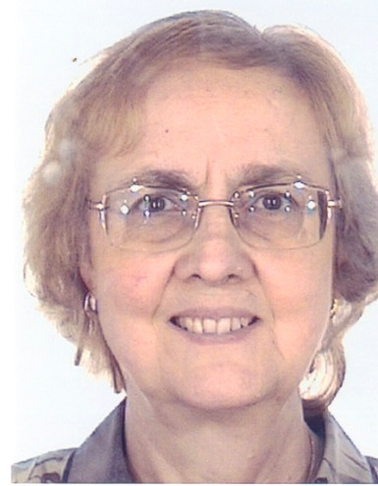

**Genome summary:** The proteomes of members of each genus were compared using CoreGenes5.0 (<https://coregenes.ngrok.io/>) using the Bidirectional Best Hitapproach reveals 29 homologous proteins (23.0% common proteins) which include TerL, portal, scaffolding, major capsid, DNA injection, endonuclease I, DNA ligase, 5'-3' exonuclease, ECF sigma factor, DNA polymerase, DNA-binding protein, gamma-glutamyl cyclotransferase, and endolysin.

The phages of the genus *Kuravirus* (phiEco32-like phages Taxonomy Proposal 2015.014aB) possess C3 morphology i.e. elongated capsids and a genome of ca. 77.1 kb (42.2 mol%G+C), and encode 122 proteins and 0-1 tRNAs; they share >61% DNA sequence identity and >69% protein homology. We think that these two groups of viruses could be combined at the Order level but choose not to do so at this time.

**References**

1. Sayers EW, Beck J, Bolton EE, Bourexis D, Brister JR, Canese K, Comeau DC, Funk K, Kim S, Klimke W, Marchler-Bauer A, Landrum M, Lathrop S, Lu Z, Madden TL, O'Leary N, Phan L, Rangwala SH, Schneider VA, Skripchenko Y, Wang J, Ye J, Trawick BW, Pruitt KD, Sherry ST. Database resources of the National Center for Biotechnology Information. Nucleic Acids Res. 2021 Jan 8;49(D1):D10-D17. doi: 10.1093/nar/gkaa892. PMID: 33095870
2. Moraru C, Varsani A, Kropinski AM. VIRIDIC-A Novel Tool to Calculate the Intergenomic Similarities of Prokaryote-Infecting Viruses. Viruses. 2020 Nov 6;12(11):1268. doi: 10.3390/v12111268. PMID: 33172115; PMCID: PMC7694805. <http://kronos.icbm.uni-oldenburg.de/viridic/>
3. Nishimura Y, Yoshida T, Kuronishi M, Uehara H, Ogata H, Goto S. ViPTree: the viral proteomic tree server. Bioinformatics. 2017; 33(15):2379-2380. doi:10.1093/bioinformatics/btx157. PubMed PMID: 28379287. <https://www.genome.jp/viptree/>
4. Rohwer F, Edwards R. The Phage Proteomic Tree: a genome-based taxonomy for phage. J Bacteriol. 2002 Aug;184(16):4529-35. PubMed PMID: 12142423
5. Turner D, Reynolds D, Seto D, Mahadevan P. CoreGenes3.5: a webserver for the determination of core genes from sets of viral and small bacterial genomes. BMC Res Notes. 2013;6:140. doi: 10.1186/1756-0500-6-140. PMID: 23566564.
6. Dereeper A, Guignon V, Blanc G, Audic S, Buffet S, Chevenet F, Dufayard JF, Guindon S, Lefort V, Lescot M, Claverie JM, Gascuel O. Phylogeny.fr: robust phylogenetic analysis for the non-specialist. Nucleic Acids Res. 2008;36(Web Server issue):W465-9. doi: 10.1093/nar/gkn180. Epub 2008 Apr 19. PMID: 18424797.
7. Anisimova M, Gascuel O. Approximate likelihood-ratio test for branches: A fast, accurate, and powerful alternative. Syst Biol. 2006;55(4):539-52. PMID: 16785212. DOI: 10.1080/10635150600755453.
8. Turner D, Kropinski AM, Adriaenssens EM. A Roadmap for Genome-Based Phage Taxonomy. Viruses. 2021 Mar 18;13(3):506. doi: 10.3390/v13030506. PMID: 33803862; PMCID: PMC8003253.
9. O'Leary NA, Wright MW, Brister JR, Ciufo S, Haddad D, McVeigh R, et al. Reference sequence (RefSeq) database at NCBI: current status, taxonomic expansion, and functional annotation. Nucleic Acids Res. 2016;44(D1):D733-45. doi: 10.1093/nar/gkv1189. PMID: 26553804.
10. Olsen NS, Hendriksen NB, Hansen LH and Kot W. A New High-Throughput Screening Method for Phages: Enabling Crude Isolation and Fast Identification of Diverse Phages with Therapeutic Potential. Phage (New Rochelle) 1 (3), 137-148 (2020) <https://www.liebertpub.com/doi/10.1089/phage.2020.0016>
11. Abbasifar R. Biocontrol of Cronobacter spp. using Bacteriophage in Infant Formula. PhD thesis 2013, University of Guelph. <https://atrium.lib.uoguelph.ca/xmlui/bitstream/handle/10214/7414/Abbasifar_Reza_201308_PhD.pdf>
12. Moazamie N, Ackermann HW, Murthy MR. Characterization of two Salmonella newport bacteriophages. Can J Microbiol. 1979 Sep;25(9):1063-72. doi: 10.1139/m79-163. PMID: 540262.
13. Kwon J, Kim SG, Giri SS, Kim HJ, Kim SW, Kang JW, Lee SB, Jung WJ, Chi C, Park SC. Genomic characterization of bacteriophage pSal-SNUABM-01, a novel elongated-head phage infecting Salmonella sp. Arch Virol. 2022 Feb;167(2):655-658. doi: 10.1007/s00705-021-05342-1. Epub 2022 Jan 19. PMID: 35043229.
14. Chan PP, Lowe TM. tRNAscan-SE: Searching for tRNA Genes in Genomic Sequences. Methods Mol Biol. 2019;1962:1-14. doi: 10.1007/978-1-4939-9173-0\_1. PMID: 31020551; PMCID: PMC6768409.
15. Ren H, Li Z, Xu L, Li X, Wang L, Xu Y. Genome sequence analysis of Vibrio parahaemolyticus lytic phage Vp\_R1 with a C3 morphotype. Arch Virol. 2019 Nov;164(11):2865-2871. doi: 10.1007/s00705-019-04364-0. Epub 2019 Aug 10. PMID: 31401694.
16. Bin Jang H, Bolduc B, Zablocki O, Kuhn JH, Roux S, Adriaenssens EM, Brister JR, Kropinski AM, Krupovic M, Lavigne R, Turner D, Sullivan MB. Taxonomic assignment of uncultivated prokaryotic virus genomes is enabled by gene-sharing networks. Nat Biotechnol. 2019 Jun;37(6):632-639. doi: 10.1038/s41587-019-0100-8. Epub 2019 May 6. PMID: 31061483.
17. Bolduc B, Jang HB, Doulcier G, You ZQ, Roux S, Sullivan MB. vConTACT: an iVirus tool to classify double-stranded DNA viruses that infect Archaea and Bacteria. PeerJ. 2017 May 3;5:e3243. doi: 10.7717/peerj.3243. PMID: 28480138; PMCID: PMC5419219.
18. vConTACT2 User Guide <https://bitbucket.org/MAVERICLab/vcontact2/wiki/Home>