

**Part 1:** **TITLE, AUTHORS, APPROVALS, etc**

|  |  |  |
| --- | --- | --- |
| **Code assigned:** | ***2022.041B*** |  |
| **Short title:** Create one new species in the genus *Janusvirus* (*Caudoviricetes*: *Arquatrovirinae*) | | |
|  | | |

**Author(s) and email address(es)**

|  |  |
| --- | --- |
| Ongenae V, Rozen DE, Briegel A, Claessen D, Kropinski AM. | v.m.a.ongenae@biology.leidenuniv.nl;  d.e.rozen@biology.leidenuniv.nl;  a.briegel@biology.leidenuniv.nl;  d.claessen@biology.leidenuniv.nl;  Phage.Canada@gmail.com |

**Author(s) institutional address(es) (optional)**

|  |
| --- |
| Leiden University, The Netherlands [VO], [DER], [AB], [DC]  University of Guelph, Canada [AMK] |

**Corresponding author**

|  |
| --- |
| Véronique Ongenae |

**List the ICTV Study Group(s) that have seen this proposal**

|  |
| --- |
| Bacterial Viruses Subcommittee, Actinophages Study Group |

**ICTV Study Group comments and response of proposer**

|  |
| --- |
|  |

**ICTV Study Group votes on proposal**

|  |  |  |  |
| --- | --- | --- | --- |
| **Study Group** | **Number of members** | | |
| **Votes support** | **Votes against** | **No vote** |
|  |  |  |  |
|  |  |  |  |

**Authority to use the name of a living person**

|  |  |
| --- | --- |
| **Is any taxon name used here derived from that of a living person (Y/N)** | N |

|  |  |  |
| --- | --- | --- |
| **Taxon name** | **Person from whom the name is derived** | **Permission attached (Y/N)** |
|  |  |  |
|  |  |  |
|  |  |  |

**Submission dates**

|  |  |
| --- | --- |
| Date first submitted to SC Chair | February 2022 |
| Date of this revision (if different to above) |  |

**ICTV-EC comments and response of the proposer**

|  |
| --- |
|  |

**Part 2:** **NON-TAXONOMIC PROPOSAL**

**Text of proposal**

|  |
| --- |
|  |

**Part 3:** **TAXONOMIC PROPOSAL**

**Name of accompanying Excel module**

|  |
| --- |
| 2022.041B.N.v1.Janusvirus_1nsp.xlsx |

**Abstract**

|  |
| --- |
| We have proposed a new species, *Janusvirus pablito*, for a phage (Streptomyces phage Pablito) isolated from host *Streptomyces lividans* from soil samples in the Netherlands at longitude N52°23’31” and latitude E4°34’49”*.* This janusvirus contains linear ds DNA genomes of, on average, 48.49 kb (66.4 mol%G+C) and encode for 76 proteins. This new species can be included in the genus *Janusvirus* together with Streptomyces phage Hank144. |

**Text of proposal**

|  |  |
| --- | --- |
| |  | | --- | | **Species demarcation criteria:** Two phages are assigned to the same species if their genomes are more than 95% identical over their genome length for isolates.  These values can be calculated by a number of tools, such as BLASTn [1] – usually calculated using intergenomic distance calculator VIRIDIC [2].  **Genus demarcation criteria:** In search for criteria that create cohesive and distinct genera that are reproducible and monophyletic, the Bacterial Viruses Subcommittee has established 70% nucleotide identity of the genome length as the cut-off for genera. Genus-level groupings should always be monophyletic in the signature genes, as tested with a phylogenetic tree. [6]  **Family demarcation criteria:** The family is represented by a cohesive and monophyletic group in the main predicted proteome-based clustering tools (ViPTree, GRAViTy dendrogram, vConTACT2 network). Members of the family share a significant number of orthologous genes (the number will depend on the genome sizes and number of coding sequences of members of the family; usually ca. 10%). [6] | |

**Supporting evidence**

**Proposals:**

1. **To add one new species (*Janusvirus pablito*) to *Janusvirus***

**Origin of the name of this taxon:** The name of the new species has originated from my dearest British short hair cat, called Pablo.

**Historical aspects:** This lytic phages was isolated in the Netherlands against *Streptomyces lividans*. It was originally called phage LA7 [3].

**Electron micrograph:** N/A

**Genome summary:**

|  |  |  |  |  |  |  |  |
| --- | --- | --- | --- | --- | --- | --- | --- |
| Phage name | RefSeq No. | INSDC | Size (Kb) | GC% | Protein | Overall % DNA sequence identity (*) | Overall % homologous proteins (**) |
| Streptomyces phage Janus | [NC_054660.1](https://www.ncbi.nlm.nih.gov/nuccore/NC_054660.1) | [MK392366.1](https://www.ncbi.nlm.nih.gov/nuccore/MK392366.1) | 50.63 | 67.0 | [78](https://www.ncbi.nlm.nih.gov/genome/browse/#!/proteins/76023/446681|Streptomyces phage Janus/viral segment/) | 100 | 100 |
| Streptomyces phage Pablito |  | OK412919.1 | 49.49 | 66.4 | 76 | 70.0 | 88.5 |
| Streptomyces phage Hank144 | [NC_054661.1](https://www.ncbi.nlm.nih.gov/nuccore/NC_054661.1) | [MH669004.1](https://www.ncbi.nlm.nih.gov/nuccore/MH669004.1) | 50.55 | 66.3 | [78](https://www.ncbi.nlm.nih.gov/genome/browse/#!/proteins/72119/400255|Streptomyces phage Hank144/viral segment/) | 72.8 | 85.9 |

**(*) determined using VIRIDIC [2]**

**(**) determined using CoreGenes 3.5 [5]**

**VIRIDIC heat map:** VIRIDIC (Virus Intergenomic Distance Calculator; VIRIDIC (Virus Intergenomic Distance Calculator; [2]; http://rhea.icbm.uni-oldenburg.de/VIRIDIC/) computes pairwise intergenomic distances/similarities amongst phage genomes.

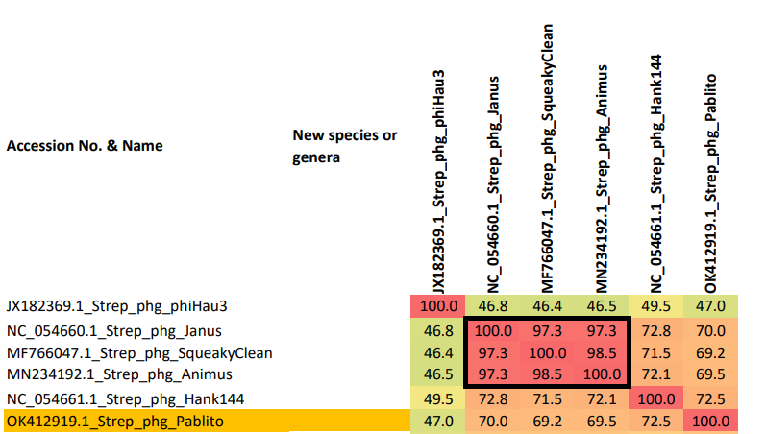

**Phylogenetic tree analysis:** MEGAX analysis [4] was used to create a phylogenetic tree of the closely related species. The phage of interest is indicated with a **red star**.

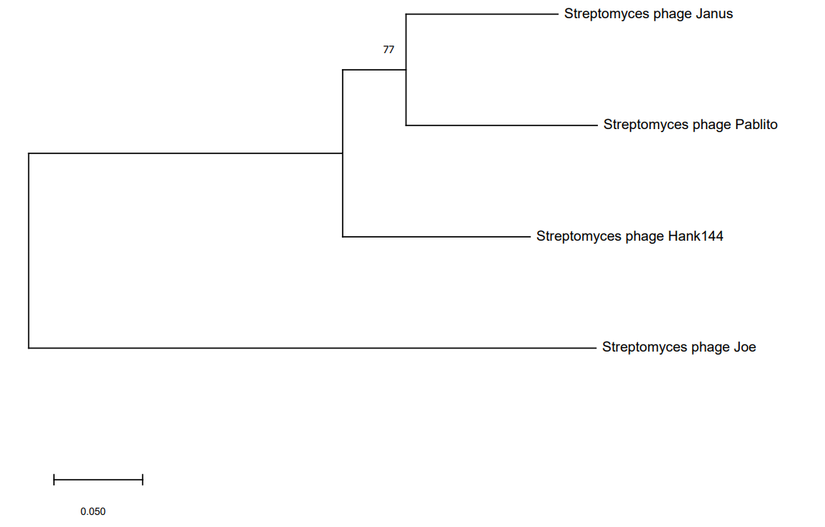

*

**Phylogeny:** The phylogenetic tree was constructed using the major capsid head proteins from phages belonging to the genus *Janusvirus*. Streptomyces phage joe was chosen as an outlier. MUSCLE was used for multiple alignment and MEGAX to construct the maximum likelihood phylogenetic tree with 100 bootstraps

**References**

1. Sayers EW, Beck J, Bolton EE, Bourexis D, Brister JR, Canese K, Comeau DC, Funk K, Kim S, Klimke W, Marchler-Bauer A, Landrum M, Lathrop S, Lu Z, Madden TL, O'Leary N, Phan L, Rangwala SH, Schneider VA, Skripchenko Y, Wang J, Ye J, Trawick BW, Pruitt KD, Sherry ST. Database resources of the National Center for Biotechnology Information. Nucleic Acids Res. 2021 Jan 8;49(D1):D10-D17. doi: 10.1093/nar/gkaa892. PMID: 33095870
2. Moraru C, Varsani A, Kropinski AM. VIRIDIC-A Novel Tool to Calculate the Intergenomic Similarities of Prokaryote-Infecting Viruses. Viruses. 2020 Nov 6;12(11):1268. doi: 10.3390/v12111268. PMID: 33172115; PMCID: PMC7694805. <http://kronos.icbm.uni-oldenburg.de/viridic/>
3. Ongenae, V., Mabrouk, A. S., Crooijmans, M., Rozen, D., Briegel, A., & Claessen, D. (2021). Reversible bacteriophage resistance by shedding the bacterial cell wall. *bioRxiv*. doi: https://doi.org/10.1101/2021.11.17.468999
4. Sudhir Kumar, Glen Stecher, Michael Li, Christina Knyaz, and Koichiro Tamura (2018) MEGA X: Molecular Evolutionary Genetics Analysis across computing platforms. *Molecular Biology and Evolution* 35:1547-1549
5. Turner D, Reynolds D, Seto D, Mahadevan P. CoreGenes3.5: a webserver for the determination of core genes from sets of viral and small bacterial genomes. BMC Res Notes. 2013;6:140. doi: 10.1186/1756-0500-6-140. PMID: 23566564.
6. Turner D, Kropinski AM, Adriaenssens EM. A Roadmap for Genome-Based Phage Taxonomy. Viruses. 2021 Mar 18;13(3):506. doi: 10.3390/v13030506. PMID: 33803862; PMCID: PMC8003253.