

**Part 1:** **TITLE, AUTHORS, APPROVALS, etc**

|  |  |  |
| --- | --- | --- |
| **Code assigned:** | 2022.042B |  |
| **Short title:** Create a new family (*Kleczkowskaviridae)* with a single genus (*Caudoviricetes*) | | |
|  | | |

**Author(s) and email address(es)**

|  |  |
| --- | --- |
| Millard A, Turner D, Moraru C, Adriaenssens EM, Kropinski AM | adm39@leicester.ac.uk; Dann2.Turner@uwe.ac.uk; liliana.cristina.moraru@uol.de; evelien.adriaenssens@quadram.ac.uk; Phage.Canada@gmail.com |

**Author(s) institutional address(es) (optional)**

|  |
| --- |
| University of Leicester, Leicester, UK [AM]  University of the West of England, Bristol, UK [DT]  Carl von Ossietzky Universität Oldenburg, Germany [CM]  Quadram Institute Bioscience, UK [EMA]  University of Guelph, Canada [AMK] |

**Corresponding author**

|  |
| --- |
| Andrew M. Kropinski |

**List the ICTV Study Group(s) that have seen this proposal**

|  |
| --- |
| Bacterial Viruses Subcommittee, Caudoviricetes Study Group |

**ICTV Study Group comments and response of proposer**

|  |
| --- |
|  |

**ICTV Study Group votes on proposal**

|  |  |  |  |
| --- | --- | --- | --- |
| **Study Group** | **Number of members** | | |
| **Votes support** | **Votes against** | **No vote** |
|  |  |  |  |
|  |  |  |  |

**Authority to use the name of a living person**

|  |  |
| --- | --- |
| **Is any taxon name used here derived from that of a living person (Y/N)** | N |

|  |  |  |
| --- | --- | --- |
| **Taxon name** | **Person from whom the name is derived** | **Permission attached (Y/N)** |
|  |  |  |
|  |  |  |
|  |  |  |

**Submission dates**

|  |  |
| --- | --- |
| Date first submitted to SC Chair | March 2022 |
| Date of this revision (if different to above) |  |

**ICTV-EC comments and response of the proposer**

|  |
| --- |
|  |

**Part 2:** **NON-TAXONOMIC PROPOSAL**

**Text of proposal**

|  |
| --- |
|  |

**Part 3:** **TAXONOMIC PROPOSAL**

**Name of accompanying Excel module**

|  |
| --- |
| 2022.042B.A.v1.Kleczkowskaviridae\_nf.xlsx |

**Abstract**

|  |
| --- |
| A group of Mexican myoviruses is sufficiently different from other characterized Rhizobium phages to warrant classification to a new genus *Cuauhnahuacvirus* and a new family  *Kleczkowskaviridae.* On average the genomes of these phages are 207.22 kb (41.1mol%G+C) and encode 364 proteins and 20 tRNA. |

**Text of proposal**

|  |  |
| --- | --- |
| |  | | --- | | **Species demarcation criteria:** Two phages are assigned to the same species if their genomes are more than 95% identical over their genome length for isolates.  These values can be calculated by a number of tools, such as BLASTn [1] – usually calculated using intergenomic distance calculator VIRIDIC [2].  **Genus demarcation criteria:** In search for criteria that create cohesive and distinct genera that are reproducible and monophyletic, the Bacterial Viruses Subcommittee has established 70% nucleotide identity of the genome length as the cut-off for genera. Genus-level groupings should always be monophyletic in the signature genes, as tested with a phylogenetic tree. [8]  **Subfamily demarcation criteria:** Subfamilies are to be created when two or more genera are related below the family level. In practical terms, this usually means that they share a low degree of sequence similarity (usually about 40-50%) and that the genera form a clade in a marker tree phylogeny. [8]  **Family demarcation criteria:** The family is represented by a cohesive and monophyletic group in the main predicted proteome-based clustering tools (ViPTree, GRAViTy dendrogram, vConTACT2 network). Members of the family share a significant number of orthologous genes (the number will depend on the genome sizes and number of coding sequences of members of the family). [8] | |

**Supporting evidence**

**VIRIDIC heat map:** VIRIDIC (Virus Intergenomic Distance Calculator; VIRIDIC (Virus Intergenomic Distance Calculator; [2]; http://rhea.icbm.uni-oldenburg.de/VIRIDIC/) computes pairwise intergenomic distances/similarities amongst phage genomes. The black box delineates strains.

****

**ViPTree analysis:** ViPTree analysis ([https://www.genome.jp/viptree/](about:blank); [3]) is based upon Rohwer and Edwards (2002) famous Phage Proteomic Tree [4]. The phages of interest are indicated with **red stars** and a **blue rectangle**.



****

**Proposals:**

**Proposal A. Create a new genus, *Cuauhnahuacvirus*, with two (2) species**

**Proposal B. Create a new family, *Kleczkowskaviridae***

**Proposal A. Create a new genus, *Cuauhnahuacvirus*, with two (2) species**

**Origin of the name of this taxon:** This taxon is named after the region “Cuauhnahuac“ in Nahuátl, the language of ancient people in Mesoamerica, where at the Centro de Ciencias Genomicas UNAM these phages were isolated.

**Historical aspects:** These lytic myoviruses were isolated from agricultural plots in Central Mexico (Tepoztlán and Yautepec) [11-13]

**Electron micrograph:** N/A

**Genome summary:**

|  |  |  |  |  |  |  |  |
| --- | --- | --- | --- | --- | --- | --- | --- |
| Phage name | INSDC | Size (Kb) | GC% | Protein | tRNA | Overall % DNA sequence identity (\*) | Overall % homologous proteins (\*\*) |
| Rhizobium phage RHph\_TM30 | [MN988521.1](https://www.ncbi.nlm.nih.gov/nuccore/MN988521.1) | 207.62 | 41.0 | [364](https://www.ncbi.nlm.nih.gov/genome/browse/#!/proteins/98394/1553844|Rhizobium phage RHph_TM30/viral segment/) | 20 | 100 | 100 |
| Rhizobium phage RHph\_Y65 | [MN988525.1](https://www.ncbi.nlm.nih.gov/nuccore/MN988525.1) | 206.82 | 41.2 | [364](https://www.ncbi.nlm.nih.gov/genome/browse/#!/proteins/98415/1553865|Rhizobium phage RHph_Y65/viral segment/) | 20 | 82.7 | 96.1 |

**(\*) determined using BLASTn [1] or VIRIDIC [2]**

**(\*\*) determined using CoreGenes 3.5 [5]**

**N.B. phages Rhizobium phage RHph\_TM21B, Rhizobium phage RHph\_TM39 and Rhizobium phage RHph\_TM61 belong to this genus but have partially sequenced genomes.**

**Proposal B. Create a new family, *Kleczkowskaviridae***

**Origin of the name of this taxon:** This taxon is in honour of the pioneering Rhizobium phage researcher Janina Kleczkowska (d. 1972) who arrived at the Rothamsted Experimental Station (UK) in 1939 as a visiting worker and had been a member of the staff of the Soil Microbiology Department since 1943.

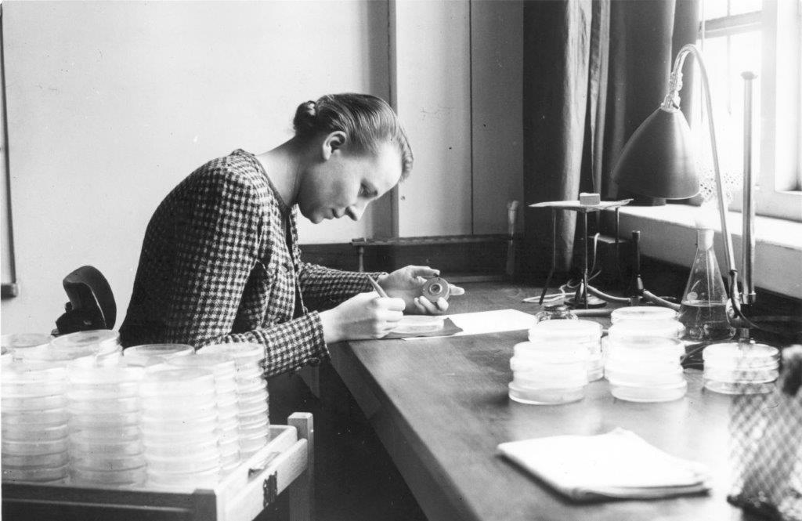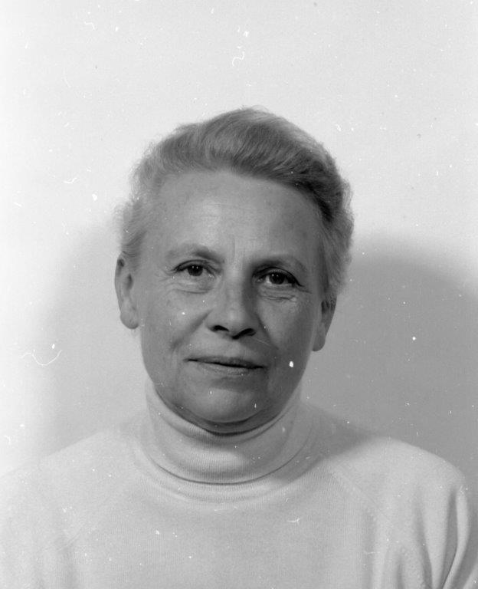

(Photographs of Janina Kleczkowska in 1941 (top) and 1969 (bottom) kindly provided by Rothamsted Research, Harpenden, United Kingdom)

**Rationale for creating this taxon:** VIRIDIC, ViPTree, vCONTACT and phylogenetic analyses all reveal that this is a unique and cohesive taxon. HHpred analysis [17] of some interesting proteins reveals that these phages encode: NAD-dependent epimerase/dehydratase, antitermination protein Q homologs, and pyruvyl transferase 1. They all belong to a single vCONTACT 2.0 viral cluster (VC\_1090) [14-16].

**References**

1. Sayers EW, Beck J, Bolton EE, Bourexis D, Brister JR, Canese K, Comeau DC, Funk K, Kim S, Klimke W, Marchler-Bauer A, Landrum M, Lathrop S, Lu Z, Madden TL, O'Leary N, Phan L, Rangwala SH, Schneider VA, Skripchenko Y, Wang J, Ye J, Trawick BW, Pruitt KD, Sherry ST. Database resources of the National Center for Biotechnology Information. Nucleic Acids Res. 2021 Jan 8;49(D1):D10-D17. doi: 10.1093/nar/gkaa892. PMID: 33095870
2. Moraru C, Varsani A, Kropinski AM. VIRIDIC-A Novel Tool to Calculate the Intergenomic Similarities of Prokaryote-Infecting Viruses. Viruses. 2020 Nov 6;12(11):1268. doi: 10.3390/v12111268. PMID: 33172115; PMCID: PMC7694805. <http://kronos.icbm.uni-oldenburg.de/viridic/>
3. Nishimura Y, Yoshida T, Kuronishi M, Uehara H, Ogata H, Goto S. ViPTree: the viral proteomic tree server. Bioinformatics. 2017; 33(15):2379-2380. doi:10.1093/bioinformatics/btx157. PubMed PMID: 28379287. <https://www.genome.jp/viptree/>
4. Rohwer F, Edwards R. The Phage Proteomic Tree: a genome-based taxonomy for phage. J Bacteriol. 2002 Aug;184(16):4529-35. PubMed PMID: 12142423
5. Turner D, Reynolds D, Seto D, Mahadevan P. CoreGenes3.5: a webserver for the determination of core genes from sets of viral and small bacterial genomes. BMC Res Notes. 2013;6:140. doi: 10.1186/1756-0500-6-140. PMID: 23566564.
6. Dereeper A, Guignon V, Blanc G, Audic S, Buffet S, Chevenet F, Dufayard JF, Guindon S, Lefort V, Lescot M, Claverie JM, Gascuel O. Phylogeny.fr: robust phylogenetic analysis for the non-specialist. Nucleic Acids Res. 2008;36(Web Server issue):W465-9. doi: 10.1093/nar/gkn180. Epub 2008 Apr 19. PMID: 18424797.
7. Anisimova M, Gascuel O. Approximate likelihood-ratio test for branches: A fast, accurate, and powerful alternative. Syst Biol. 2006;55(4):539-52. PMID: 16785212. DOI: 10.1080/10635150600755453.
8. Turner D, Kropinski AM, Adriaenssens EM. A Roadmap for Genome-Based Phage Taxonomy. Viruses. 2021 Mar 18;13(3):506. doi: 10.3390/v13030506. PMID: 33803862; PMCID: PMC8003253.
9. O'Leary NA, Wright MW, Brister JR, Ciufo S, Haddad D, McVeigh R, et al. Reference sequence (RefSeq) database at NCBI: current status, taxonomic expansion, and functional annotation. Nucleic Acids Res. 2016;44(D1):D733-45. doi: 10.1093/nar/gkv1189. PMID: 26553804.
10. Olsen NS, Hendriksen NB, Hansen LH and Kot W. A New High-Throughput Screening Method for Phages: Enabling Crude Isolation and Fast Identification of Diverse Phages with Therapeutic Potential. Phage (New Rochelle) 1 (3), 137-148 (2020) <https://www.liebertpub.com/doi/10.1089/phage.2020.0016>
11. Santamaría RI, Bustos P, Van Cauwenberghe J, González V. Hidden diversity of double-stranded DNA phages in symbiotic Rhizobium species. Philos Trans R Soc Lond B Biol Sci. 2022 Jan 17;377(1842):20200468. doi: 10.1098/rstb.2020.0468. Epub 2021 Nov 29. PMID: 34839703; PMCID: PMC8628074.
12. Van Cauwenberghe J, Santamaría RI, Bustos P, Juárez S, Ducci MA, Fleming TF, Etcheverry AV, González V. Correction to: Spatial patterns in phage-Rhizobium coevolutionary interactions across regions of common bean domestication. ISME J. 2021 Jul;15(7):2167. doi: 10.1038/s41396-021-00963-5. Erratum for: ISME J. 2021 Jul;15(7):2092-2106. PMID: 33854191; PMCID: PMC8245540.
13. Van Cauwenberghe J, Santamaría RI, Bustos P, Juárez S, Ducci MA, Figueroa Fleming T, Etcheverry AV, González V. Spatial patterns in phage-Rhizobium coevolutionary interactions across regions of common bean domestication. ISME J. 2021 Jul;15(7):2092-2106. doi: 10.1038/s41396-021-00907-z. Epub 2021 Feb 8. Erratum in: ISME J. 2021 Apr 14;: PMID: 33558688; PMCID: PMC8245606.
14. Bin Jang H, Bolduc B, Zablocki O, Kuhn JH, Roux S, Adriaenssens EM, Brister JR, Kropinski AM, Krupovic M, Lavigne R, Turner D, Sullivan MB. Taxonomic assignment of uncultivated prokaryotic virus genomes is enabled by gene-sharing networks. Nat Biotechnol. 2019 Jun;37(6):632-639. doi: 10.1038/s41587-019-0100-8. Epub 2019 May 6. PMID: 31061483.
15. Bolduc B, Jang HB, Doulcier G, You ZQ, Roux S, Sullivan MB. vConTACT: an iVirus tool to classify double-stranded DNA viruses that infect Archaea and Bacteria. PeerJ. 2017 May 3;5:e3243. doi: 10.7717/peerj.3243. PMID: 28480138; PMCID: PMC5419219.
16. vConTACT2 User Guide <https://bitbucket.org/MAVERICLab/vcontact2/wiki/Home>
17. Söding J, Biegert A, Lupas AN. The HHpred interactive server for protein homology detection and structure prediction. Nucleic Acids Res. 2005 Jul 1;33(Web Server issue):W244-8. doi: 10.1093/nar/gki408. PMID: 15980461; PMCID: PMC1160169.