

**Part 1:** **TITLE, AUTHORS, APPROVALS, etc**

|  |  |  |
| --- | --- | --- |
| **Code assigned:** | ***2022.047B*** |  |
| **Short title:** Create one new genus (*Mareflavirus*) including one new species (*Caudoviricetes*) | | |
|  | | |

**Author(s) and email address(es)**

|  |  |
| --- | --- |
| Wang Z, Liang Y, Wang M | wzy6636@stu.ouc.edu.cn;  liangyantao@ouc.edu.cn; mingwang@ouc.edu.cn |

**Author(s) institutional address(es) (optional)**

|  |
| --- |
| Ocean University of China [WZ, LY, WM] |

**Corresponding author**

|  |
| --- |
| Wang Z |

**List the ICTV Study Group(s) that have seen this proposal**

|  |
| --- |
| Bacterial Viruses Subcommittee  *Caudoviricetes* Study Group |

**ICTV study group comments and response of proposer**.

|  |
| --- |
|  |

**ICTV Study Group votes on proposal**

|  |  |  |  |
| --- | --- | --- | --- |
| **Study Group** | **Number of members** | | |
| **Votes support** | **Votes against** | **No vote** |
|  |  |  |  |
|  |  |  |  |

**Authority to use the name of a living person**

|  |  |
| --- | --- |
| **Is any taxon name used here derived from that of a living person (Y/N)** | N |

|  |  |  |
| --- | --- | --- |
| **Taxon name** | **Person from whom the name is derived** | **Permission attached (Y/N)** |
|  |  |  |
|  |  |  |
|  |  |  |

**Submission dates**

|  |  |
| --- | --- |
| Date first submitted to SC Chair | May 2022 |
| Date of this revision (if different to above) |  |

**ICTV-EC comments and response of the proposer**

|  |
| --- |
|  |

**Part 2:** **NON-TAXONOMIC PROPOSAL**

**Text of proposal**

|  |
| --- |
|  |

**Part 3:** **TAXONOMIC PROPOSAL**

**Name of accompanying Excel module**

|  |
| --- |
| 2022.047B.N.v1.Mareflavirus_ng.xlsx |

**Abstract**

|  |
| --- |
| A novel podovirus ZP6 was isolated from surface coastal waters of Qingdao, China, which can infecting a marine bacterium *Alteromonas confluentis* DSSK2-12(T). Here, we combined the results from OrthoANI (Average Nucleotide Identity by Ortholoy) (1) analysis, network analysis by vConTACT 2.0 (2), marker gene phylogenies and genome-wide comparisons to provide a comprehensive overview of the evolutionary status of ZP6 and to propose a new genus *Mareflavirus* with the type species ZP6. |

**Text of proposal**

|  |  |  |
| --- | --- | --- |
| |  | | --- | | A novelAlteromonas phage, ZP6, was isolated from surface coastal waters of Qingdao, China. ZP6 has 38,080 bp in length with 50.1% G+C content and 48 ORFs in the phage genome while no tRNA genes were found. The complete genome of ZP6 has been deposited in the GenBank database under the accession number MK203850.  Similar viruses of ZP6 were identified by use of BLASTn and ViPTree (https://www.genome.jp/viptree) based on genomic sequences (3). However, only 32 bp of the entire genome exhibited similarity to *Alteromonas* phage vB_AmeM_PT11-V22. Therefore, more similar viruses were inferred from the protein-level comparison using the online ViPTree server. As a result, ZP6 is similar to *Enhodamvirus* when compared to 2,687 reference virus genomes, but formed a separate clade (Figure 1), implying ZP6 represents a new genus and species.  The ANI values between ZP6 and the nine typical *Enhodamvirus*, which were the most closely related to ZP6 in the phylogenetic tree, were calculated by OrthoANI (1)(Figure 2). The ANI value between ZP6 and the other nine *Enhodamviruses* ranged from 61.92 to 64.46, which falls below the genus demarcation threshold of 70% sequence similarity.  Pairwise comparisons of shared phage proteins were performed using Orthofinder (4, 5) with 408 prodovirus genomes from NCBI RefSeq database and all 15 Alteromonasphages belong to different virus families (threshold: E-value < 1e-5, percentage identity > 30, and query coverage > 50%). ZP6 was found to be most similar to Vibrio phages within the genus *Enhodamvirus* but possessed less than 30% (27.3% ~ 29.1%) shared proteins (Figure 3).  Phylogenetic trees were also constructed using hallmark viral proteins, including terminase large subunit (*terl)*, major capsid protein (*mcp*), DNA polymerase and portal protein (Figure 4). Results indicated that ZP6 is monophyletic in marker gene phylogenies, however, it showed weak clustering with *Enhodamviruses* while clustering with unassigned Stenotrophomonas phage BUCT555 for the *terl* gene*.*  The whole-genome comparisons between ZP6 and species of the *Enhodamviruses* (Figure 5) by the ViPTree server. Taking ZP6 and *Vibrio* phage phiVC8 as examples, only in the packaging module, *terl* (amino acid identity of 32.96%, calculated by BLASTP), the portal protein (45.04%); the DNA replication module, integrase (45.1%), DNA polymerase I (52.61%), superfamily II DNA/RNA helicase (43.24%) and the iconic AMG of *Enhodamvirus*, diaminopurine synthetase (52.61%) reflect this pattern. In the structural modules, *mcp* (37.54%) and the major tail subunit (30.1%) were homologous to *Enhodamvirus,* but these genes did not follow the uniform gene arrangement of *Enhodamvirus* and were distributed in different loci. The main difference between ZP6 and *Enhodamvirus* is the module related to host lysis; *Enhodamvirus* does not contain a gene related to host lysis, but ZP6 contains a complete lysis system.  Virus Classification and Tree Building Online Resource (https://ggdc.dsmz.de/victor.php，VICTOR) (6) were used to determine the taxonomic position of ZP6 within viruses exhibiting a podovirus morphology. A total of 99 strains of podoviruses from 45 different genera were selected from the ICTV taxonomy releases to construct a phylogenetic tree with ZP6. (Fig. 6). The results are implied that ZP6 did not belong to any of the identified genera.  All analysis showed that the ZP6 is distinct from other bacteriophages and represents a new clade of bacterial viruses. Based on the above result, we proposed here a new bacteriophage genus, Mareflavirus. Alteromonas phage ZP6 was chosen as the exemplar species given that it was the first sequenced phage of this genus and the name of this new genus was based on the isolation site of ZP6. | |  | |

**Supporting evidence**

**Figure 1**. Phylogenetic and comparative genomic analysis of *Alteromonas* phage ZP6. The left part was the phylogenetic tree of *Alteromonas* phage ZP6 and 2,687 reference virus genomes. The coloured outer rings represents the virus family (inner ring) and host group (outer ring). The right panel presents the phylogenetic tree of *Alteromonas* phage ZP6 and 30 most closed virus genomes.



**Figure 2.** The OrthoANI values Heatmap of ZP6 and typical *Enhodamviruses,* the values calculated by OAT software.

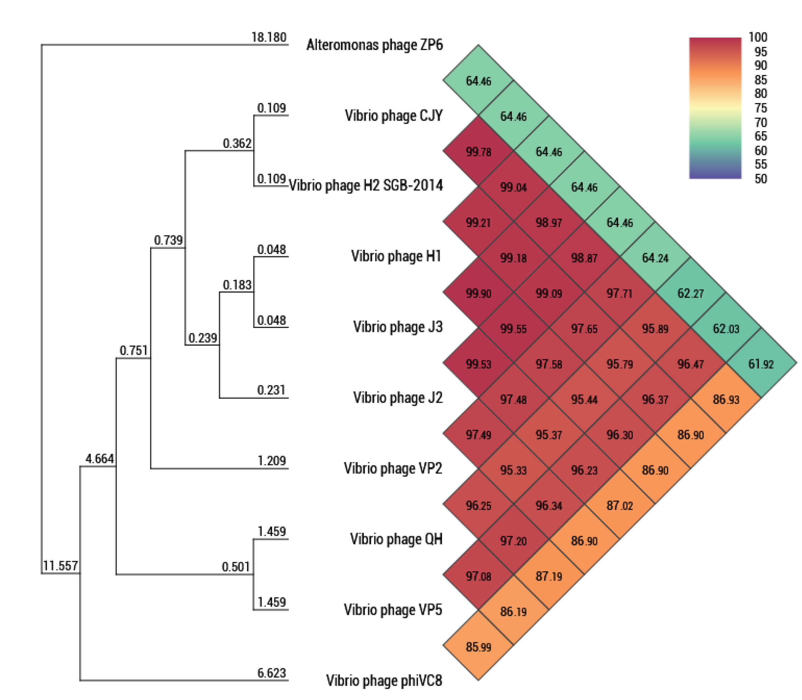

**Figure 3**. Pairwise comparisons of shared proteins between ZP6 and other compared phages.



**Figure 4** Maximum likelihood phylogenetic tree based on the amino-acid sequences of terminase large subunit, major capsid protein, DNA polymerase and portal protein with 1,000 bootstrap replicates using IQtree (7). Phage ZP6 was highlighted in red and *Enhodamviruses* were highlighted in blue.

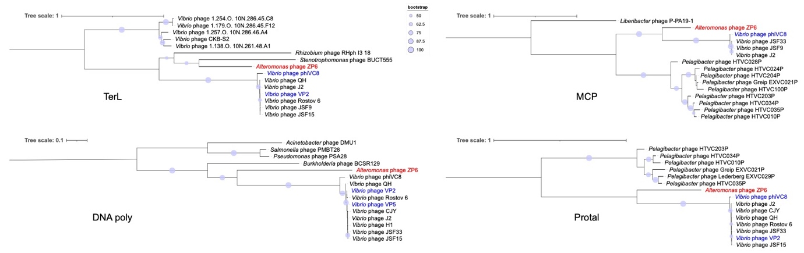

**Figure 5** Comparisons of ZP6 with typical *Enhodamviruses.* The shading indicates sequence similarities between the genomes, different colors represent the level of similarity. The predicted functions of proteins are indicated by different colors.

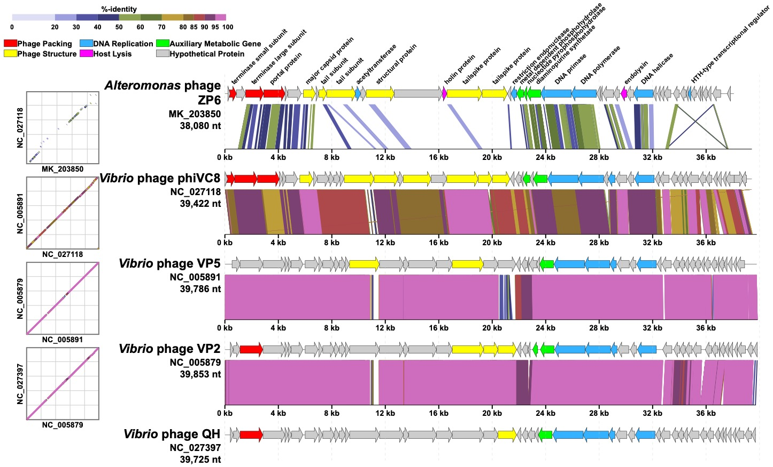

**Figure 6** Whole-genome-based phylogenetic tree constructed by VICTOR with the formula d6. ICTV and OPTSIL clusters at the genus and family levels. Each genus is indicated by a unique color. ZP6 were shown in red. The bootstrap value of ≥50 were shown.

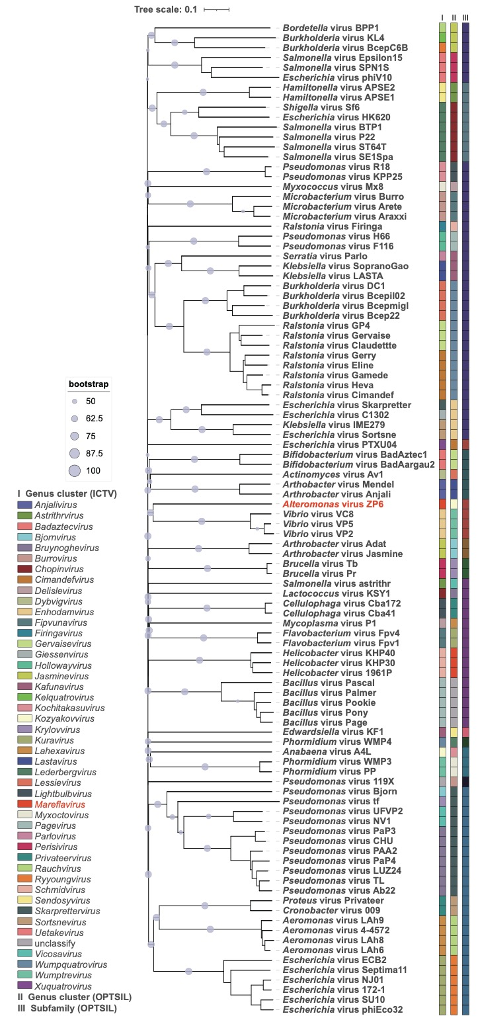

**References**

1. Lee I, Ouk Kim Y, Park SC, Chun J.2016. OrthoANI: An improved algorithm and software for calculating average nucleotide identity. Int J Syst Evol Microbiol 66:1100-1103.

2. Bolduc B, Jang HB, Doulcier G, You ZQ, Roux S, Sullivan MB.2017. vConTACT: an iVirus tool to classify double-stranded DNA viruses that infect Archaea and Bacteria. PeerJ 5:e3243.

3. Nishimura Y, Yoshida T, Kuronishi M, Uehara H, Ogata H, Goto S.2017. ViPTree: the viral proteomic tree server. Bioinformatics 33:2379-2380.

4. Emms DM, Kelly S.2015. OrthoFinder: solving fundamental biases in whole genome comparisons dramatically improves orthogroup inference accuracy. Genome Biol 16:157.

5. Emms DM, Kelly S.2019. OrthoFinder: phylogenetic orthology inference for comparative genomics. Genome Biol 20:238.

6. Meier-Kolthoff JP, Göker M.2017. VICTOR: genome-based phylogeny and classification of prokaryotic viruses. Bioinformatics 33:3396-3404.

7. Nguyen LT, Schmidt HA, von Haeseler A, Minh BQ.2015. IQ-TREE: a fast and effective stochastic algorithm for estimating maximum-likelihood phylogenies. Mol Biol Evol 32:268-74.