

**Part 1:** **TITLE, AUTHORS, APPROVALS, etc**

|  |  |  |
| --- | --- | --- |
| **Code assigned:** | ***2022.055B*** |  |
| **Short title:** Create a new genus (*Nanhuvirus*) in the family *Straboviridae* including a new species *Nanhuvirus LPCS28* (*Caudoviricetes*) | | |
|  | | |

**Author(s) and email address(es)**

|  |  |
| --- | --- |
| Li J-Q | lijinquan2017@163.com |

**Author(s) institutional address(es) (optional)**

|  |
| --- |
| Huazhong Agriculture University [LJQ] |

**Corresponding author**

|  |
| --- |
| lijinquan2017@163.com |

**List the ICTV Study Group(s) that have seen this proposal**

|  |
| --- |
| Bacterial Viruses Subcommittee |

**ICTV study group comments and response of proposer**

|  |
| --- |
|  |

**ICTV Study Group votes on proposal**

|  |  |  |  |
| --- | --- | --- | --- |
| **Study Group** | **Number of members** | | |
| **Votes support** | **Votes against** | **No vote** |
|  |  |  |  |
|  |  |  |  |

**Authority to use the name of a living person**

|  |  |
| --- | --- |
| **Is any taxon name used here derived from that of a living person (Y/N)** | N |

|  |  |  |
| --- | --- | --- |
| **Taxon name** | **Person from whom the name is derived** | **Permission attached (Y/N)** |
|  |  |  |
|  |  |  |
|  |  |  |

**Submission dates**

|  |  |
| --- | --- |
| Date first submitted to SC Chair | April 2022 |
| Date of this revision (if different to above) |  |

**ICTV-EC comments and response of the proposer**

|  |
| --- |
|  |

**Part 2:** **NON-TAXONOMIC PROPOSAL**

**Text of proposal**

|  |
| --- |
|  |

**Part 3:** **TAXONOMIC PROPOSAL**

**Name of accompanying Excel module**

|  |
| --- |
| 2022.055B.N.v1.Nanhuvirus_ng.xlsx |

**Abstract**

|  |
| --- |
| We isolated a novel Cronobacter phage LPCS28, it has 99.2% identity with Cronobacter phage S13, but this record is marked as unverified in GenBank and so cannot be assigned as an exemplar species..  Based on the analysis of VIRIDIC and ViPTree, LPCS28 and S13 were significantly different from other genera, exhibiting less than 70% identity with phages of other genera within the family *Straboviridae*. Thus, this proposal will create a new genus *Nanhuvirus* including a new species *Nanhuvirus* LPCS28. |

**Text of proposal**

|  |  |
| --- | --- |
| |  | | --- | | **Species demarcation criteria:** Two phages are assigned to the same species if their genomes are more than 95% identical over their genome length for isolates.  These values can be calculated by a number of tools, such as BLASTn – usually calculated using intergenomic distance calculator VIRIDIC [1].  **Genus demarcation criteria:** In search for criteria that create cohesive and distinct genera that are reproducible and monophyletic, the Bacterial Viruses Subcommittee has established 70% nucleotide identity of the genome length as the cut-off for genera. Genus-level groupings should always be monophyletic in the signature genes, as tested with a phylogenetic tree. [2] | |

**Supporting evidence**

**ViPTree analysis:** ViPTree analysis (https://www.genome.jp/viptree/; [3]) is based upon Rohwer and Edwards (2002) famous Phage Proteomic Tree [4]. The phages of interest are indicated with **red box**.

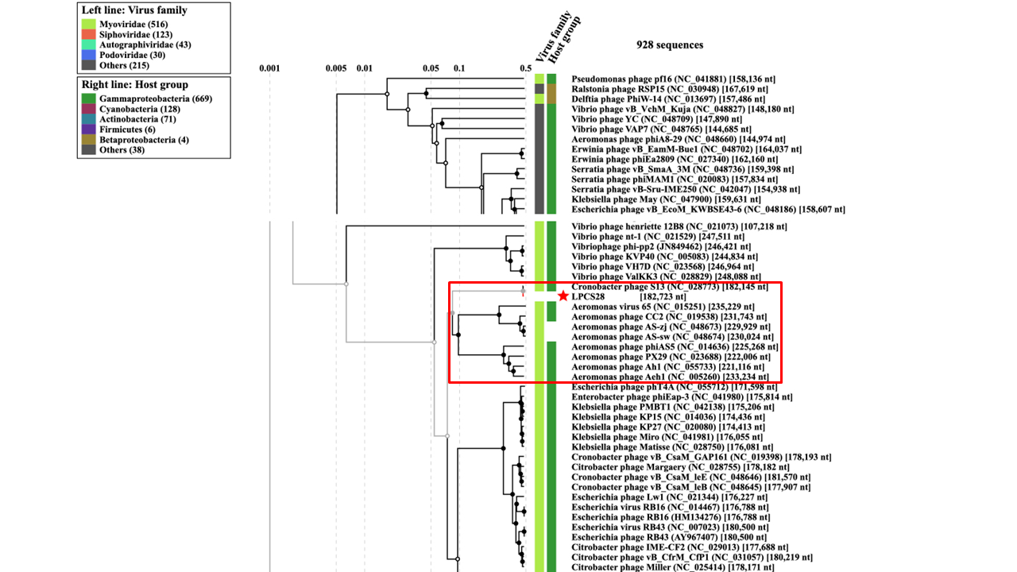  
  
**VIRIDIC heat map:** VIRIDIC (Virus Intergenomic Distance Calculator [1]; http://rhea.icbm.uni-oldenburg.de/VIRIDIC/) computes pairwise intergenomic distances/similarities amongst phage genomes.

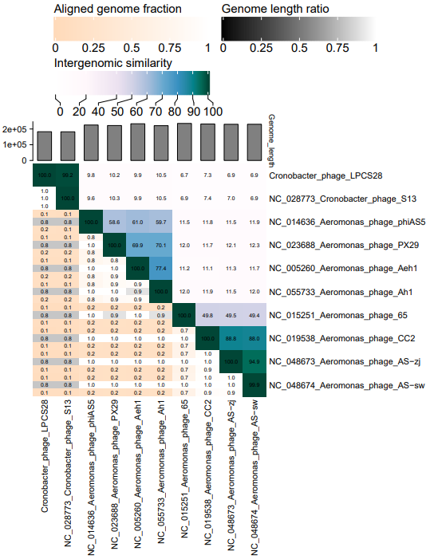

**Phylogeny:** The phylogenetic tree was constructed using the major capsid proteins of phages [5]. MUSCLE was used for multiple alignment and MEGA(v11.0.10) was used for building phylogenetic tree using maximum-likelihood method with 500 bootstrap replicates [6].The new genus is indicated with red box and new species is indicated with red star.

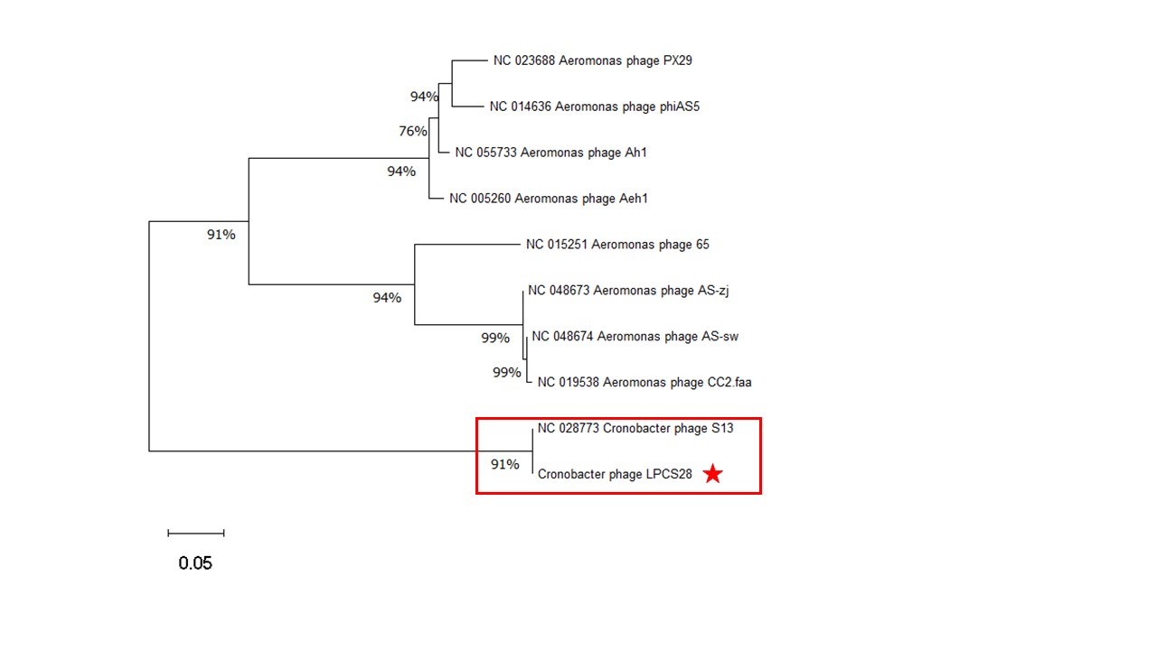

**Origin of the name of this taxon:** This genus is named based on Nanhu lake located in Wuhan City where the sample was obtained.

**Historical aspects:** Cronobacter phage LPCS28 was isolated in 2021 by Huazhong Agricultural University from lake water, using *Cronobacter sakazakii* as the host bacterium.

**Specific References:** None

**Genome summary:**

|  |  |  |  |  |  |  |  |  |
| --- | --- | --- | --- | --- | --- | --- | --- | --- |
| Phage name | RefSeq No. | INSDC | Size (Kb) | GC% | Protein | tRNA | Overall % DNA sequence identity (*) | Overall % homologous proteins (**) |
| *Cronobacter* phage LPCS28 |  | OM638103 | 182.723 | 40.18 | [266](https://www.ncbi.nlm.nih.gov/genome/browse/#!/proteins/84820/708377%7CMycobacterium%20phage%20Anthony/viral%20segment/) | 24 | 100 | 100 |

**(*) Determined using VIRIDIC [1]**

**(**) Determined using CoreGenes 3.5 at** [**http://binf.gmu.edu:8080/CoreGenes3.5/**](http://binf.gmu.edu:8080/CoreGenes3.5/) **[7]**

**References**

1: Moraru C, Varsani A, Kropinski AM. VIRIDIC-A Novel Tool to Calculate the Intergenomic Similarities of Prokaryote-Infecting Viruses. Viruses. 2020 Nov 6;12(11):1268. doi: 10.3390/v12111268. PMID: 33172115.

2: Turner D, Kropinski AM, Adriaenssens EM. A Roadmap for Genome-Based Phage Taxonomy. Viruses. 2021 Mar 18;13(3):506. doi: 10.3390/v13030506. PMID: 33803862.

3: Nishimura Y, Yoshida T, Kuronishi M, Uehara H, Ogata H, Goto S. ViPTree: the viral proteomic tree server. Bioinformatics. 2017 Aug 1;33(15):2379-2380. doi: 10.1093/bioinformatics/btx157. PMID: 28379287.

4: Rohwer F, Edwards R. The Phage Proteomic Tree: a genome-based taxonomy for phage. J Bacteriol. 2002 Aug;184(16):4529-35. doi: 10.1128/jb.184.16.4529-4535.2002. PMID: 12142423.

5: Dereeper A, Guignon V, Blanc G, Audic S, Buffet S, Chevenet F, Dufayard JF, Guindon S, Lefort V, Lescot M, Claverie JM, Gascuel O. Phylogeny.fr: robust phylogenetic analysis for the non-specialist. Nucleic Acids Res. 2008;36(Web Server issue):W465-9. doi: 10.1093/nar/gkn180. Epub 2008 Apr 19. PMID: 18424797.

6: Anisimova M, Gascuel O. Approximate likelihood-ratio test for branches: A fast, accurate, and powerful alternative. Syst Biol. 2006;55(4):539-52. doi: 10.1080/10635150600755453. PMID: 16785212.

7: Turner D, Reynolds D, Seto D, Mahadevan P. CoreGenes3.5: a webserver for the determination of core genes from sets of viral and small bacterial genomes. BMC Res Notes. 2013;6:140. doi: 10.1186/1756-0500-6-140. PMID: 23566564.