

**Part 1:** **TITLE, AUTHORS, APPROVALS, etc**

|  |  |  |
| --- | --- | --- |
| **Code assigned:** | ***2022.062B*** |  |
| **Short title:** Create 6 new genera and 19 new species to the family *Peduoviridae* (*Caudoviricetes*) | | |
|  | | |

**Author(s) and email address(es)**

|  |  |
| --- | --- |
| Lueder MR, Van Zyl LJ, Adriaenssens EM | luederm@mail.gvsu.edu; vanzyllj@gmail.com;  Evelien.adriaenssens@quadram.ac.uk |

**Author(s) institutional address(es) (optional)**

|  |
| --- |
| Department of Pathology and Laboratory Medicine, The Children’s Hospital of Philadelphia [MRL]  Institute for Microbial Biotechnology and Metagenomics, University of the Western Cape, ZAR  Quadram Institute Bioscience, UK [EMA] |

**Corresponding author**

|  |
| --- |
| Leonardo Joaquim van Zyl – lvanzyl@uwc.ac.za |

**List the ICTV Study Group(s) that have seen this proposal**

|  |
| --- |
| Peduoviridae Study Group |

**ICTV Study Group comments and response of proposer**

|  |
| --- |
|  |

**ICTV Study Group votes on proposal**

|  |  |  |  |
| --- | --- | --- | --- |
| **Study Group** | **Number of members** | | |
| **Votes support** | **Votes against** | **No vote** |
|  |  |  |  |
|  |  |  |  |

**Authority to use the name of a living person**

|  |  |
| --- | --- |
| **Is any taxon name used here derived from that of a living person (Y/N)** | N |

|  |  |  |
| --- | --- | --- |
| **Taxon name** | **Person from whom the name is derived** | **Permission attached (Y/N)** |
|  |  |  |
|  |  |  |
|  |  |  |

**Submission dates**

|  |  |
| --- | --- |
| Date first submitted to SC Chair | May 2022 |
| Date of this revision (if different to above) |  |

**ICTV-EC comments and response of the proposer**

|  |
| --- |
|  |

**Part 2:** **NON-TAXONOMIC PROPOSAL**

**Text of proposal**

|  |
| --- |
|  |

**Part 3:** **TAXONOMIC PROPOSAL**

**Name of accompanying Excel module**

|  |
| --- |
| 2022.062B.N.v1.Peduoviridae_6ng_19nsp.xlsx |

**Abstract**

|  |
| --- |
| In this proposal we analyze phage genomes released on the Genbank database since April 2022 comparing them to the current ICTV virus classification to determine if they represent new phyla. Based on both nucleotide identity over the length of the genome as determined using VIRIDIC and protein similarity of the core genes (terminase large and small subunit -, portal -, capsid completion -, capsid scaffolding - and major capsid proteins) we find that there are 6 genera and 16 new species that belong to the family *Peduoviridae*. |

**Text of proposal**

|  |  |  |  |  |  |  |  |  |  |  |  |  |  |  |  |  |  |  |  |  |  |  |  |  |  |  |  |  |  |  |  |  |  |  |  |  |  |  |  |  |  |  |  |  |  |  |  |  |  |  |  |  |  |  |  |  |  |  |  |  |  |  |  |  |  |  |  |  |  |  |  |  |  |  |  |  |  |  |  |  |  |  |  |  |  |  |  |  |  |  |  |  |  |  |  |  |  |  |  |  |  |  |  |  |  |  |  |  |  |  |  |  |  |  |  |  |  |  |  |  |  |  |  |  |  |  |  |  |  |  |  |  |  |  |  |  |  |  |  |  |  |  |  |  |  |  |  |  |  |  |  |  |  |  |  |  |  |  |  |  |  |  |  |  |  |  |  |  |  |  |  |  |  |  |  |  |  |  |  |  |  |  |  |  |  |  |  |  |  |  |  |  |  |  |  |  |  |  |  |  |  |  |  |  |  |  |  |  |  |  |  |  |  |  |  |  |  |  |  |  |  |  |  |
| --- | --- | --- | --- | --- | --- | --- | --- | --- | --- | --- | --- | --- | --- | --- | --- | --- | --- | --- | --- | --- | --- | --- | --- | --- | --- | --- | --- | --- | --- | --- | --- | --- | --- | --- | --- | --- | --- | --- | --- | --- | --- | --- | --- | --- | --- | --- | --- | --- | --- | --- | --- | --- | --- | --- | --- | --- | --- | --- | --- | --- | --- | --- | --- | --- | --- | --- | --- | --- | --- | --- | --- | --- | --- | --- | --- | --- | --- | --- | --- | --- | --- | --- | --- | --- | --- | --- | --- | --- | --- | --- | --- | --- | --- | --- | --- | --- | --- | --- | --- | --- | --- | --- | --- | --- | --- | --- | --- | --- | --- | --- | --- | --- | --- | --- | --- | --- | --- | --- | --- | --- | --- | --- | --- | --- | --- | --- | --- | --- | --- | --- | --- | --- | --- | --- | --- | --- | --- | --- | --- | --- | --- | --- | --- | --- | --- | --- | --- | --- | --- | --- | --- | --- | --- | --- | --- | --- | --- | --- | --- | --- | --- | --- | --- | --- | --- | --- | --- | --- | --- | --- | --- | --- | --- | --- | --- | --- | --- | --- | --- | --- | --- | --- | --- | --- | --- | --- | --- | --- | --- | --- | --- | --- | --- | --- | --- | --- | --- | --- | --- | --- | --- | --- | --- | --- | --- | --- | --- | --- | --- | --- | --- | --- | --- | --- | --- | --- | --- | --- | --- | --- | --- | --- | --- |
| |  |  |  |  |  |  |  |  |  |  |  |  |  |  |  |  |  |  |  |  |  |  |  |  |  |  |  |  |  |  |  |  |  |  |  |  |  |  |  |  |  |  |  |  |  |  |  |  |  |  |  |  |  |  |  |  |  |  |  |  |  |  |  |  |  |  |  |  |  |  |  |  |  |  |  |  |  |  |  |  |  |  |  |  |  |  |  |  |  |  |  |  |  |  |  |  |  |  |  |  |  |  |  |  |  |  |  |  |  |  |  |  |  |  |  |  |  |  |  |  |  |  |  |  |  |  |  |  |  |  |  |  |  |  |  |  |  |  |  |  |  |  |  |  |  |  |  |  |  |  |  |  |  |  |  |  |  |  |  |  |  |  |  |  |  |  |  |  |  |  |  |  |  |  |  |  |  |  |  |  |  |  |  |  |  |  |  |  |  |  |  |  |  |  |  |  |  |  |  |  |  |  |  |  |  |  |  |  |  |  |  |  |  |  |  |  |  |  |  |  |  |  |  | | --- | --- | --- | --- | --- | --- | --- | --- | --- | --- | --- | --- | --- | --- | --- | --- | --- | --- | --- | --- | --- | --- | --- | --- | --- | --- | --- | --- | --- | --- | --- | --- | --- | --- | --- | --- | --- | --- | --- | --- | --- | --- | --- | --- | --- | --- | --- | --- | --- | --- | --- | --- | --- | --- | --- | --- | --- | --- | --- | --- | --- | --- | --- | --- | --- | --- | --- | --- | --- | --- | --- | --- | --- | --- | --- | --- | --- | --- | --- | --- | --- | --- | --- | --- | --- | --- | --- | --- | --- | --- | --- | --- | --- | --- | --- | --- | --- | --- | --- | --- | --- | --- | --- | --- | --- | --- | --- | --- | --- | --- | --- | --- | --- | --- | --- | --- | --- | --- | --- | --- | --- | --- | --- | --- | --- | --- | --- | --- | --- | --- | --- | --- | --- | --- | --- | --- | --- | --- | --- | --- | --- | --- | --- | --- | --- | --- | --- | --- | --- | --- | --- | --- | --- | --- | --- | --- | --- | --- | --- | --- | --- | --- | --- | --- | --- | --- | --- | --- | --- | --- | --- | --- | --- | --- | --- | --- | --- | --- | --- | --- | --- | --- | --- | --- | --- | --- | --- | --- | --- | --- | --- | --- | --- | --- | --- | --- | --- | --- | --- | --- | --- | --- | --- | --- | --- | --- | --- | --- | --- | --- | --- | --- | --- | --- | --- | --- | --- | --- | --- | --- | --- | --- | --- | | **Species demarcation criteria:** We have chosen 95% DNA sequence identity as the criterion for demarcation of species in each genus. Each of the proposed species differs from the others by more than 5% at the DNA level as confirmed with the BLASTn algorithm.  **Genus demarcation criteria (updated):** The defining criterion for membership in a genus is that the species display 70-95% DNA sequence identity to one another. This was previously set to 50-95%. Membership to existing genera is adjusted to meet this new criterion within this proposal. All genera are monophyletic in the marker gene trees.  **Family demarcation criteria:** All members of *Peduoviridae* encode a set of 6 orthologous core genes:   |  |  | | --- | --- | | Orthogroup 1 | Terminase, large subunit | | Orthogroup 2 | Portal protein | | Orthogroup 3 | Capsid scaffolding protein | | Orthogroup 4 | Major capsid protein | | Orthogroup 5 | Terminase, small subunit | | Orthogroup 6 | Capsid completion/stabilization protein |   Members of *Peduoviridae* have genome sizes between 28 kb and 41kb.  **Proposal 1:** To create seven new species and assign them to the genus *Peduovirus*.  **Background/History:** Escherichia phage 11W was isolated from an *E. coli* lysogenic strain. The Escherichia phages, AC1, DC1, SIAC10 and SIDE7were isolated from a *E. coli* strains in Eligo Bioscience’s strain collection (Rousset et al., 2022). Phage P37 was isolated from a rat cecum sample and infects *Yersinia pestis* EV76, while HQ103 infects *Yersinia pestis* EV76-CN. Both were isolated in China however the exact source material is currently unknown.  **Source of name of this taxon:** The species names are derived from the Genbank entry exemplar virus name.  **Genome Summary Table:**   |  |  |  |  |  |  |  | | --- | --- | --- | --- | --- | --- | --- | | Exemplar  Genbank Accession | Exemplar  RefSeq  Accession | Species Name | Genome Length | GC Content | Number of tRNAs* | Number of ORFs** | | OM475429 | N/A | *Peduovirus 11W* | 31,564bp | 51.4% | 0 | 47 | | OV192280 | N/A | *Peduuovirus AC1* | 33,349bp | 50.7% | 0 | 42 | | OU784549 | N/A | *Peduovirus SIAC10* | 33,562bp | 51.5% | 0 | 43 | | OU784750 | N/A | *Peduovirus DC1* | 32541bp | 51.6% | 0 | 42 | | OU784746 | N/A | *Peduovirus SIDE7* | 31,490bp | 52.5% | 0 | 40 | | MT239398 | N/A | *Peduovirus P37* | 33,007bp | 51.7% | 0 | 42 | | MZ420230 | N/A | *Peduovirus HQ103* | 35,113bp | 51.5% | 0 | 53 |   *\* Determined using tRNAscan-SE*  *\*\* Determined using PHANOTATE* or GenBank entry  **References:**  Rousset F, Depardieu F, Miele S, Dowding J, Laval A-L, Lieberman E, Garry D, Rocha EPC, Bernheim A, Bikard D (2022) Phages and their satellites encode hotspots of antiviral systems. Cell Host & Microbe 30: 740–753 PMID: 35316646  **Proposal 2:** To create a new species in the genus *Elveevirus*.  **Background/History:** The exemplar for *Elveevirus cartapus*is a temperate phage from the Crohn’s disease associated *E. coli* LF82. The genome present on the Genbank database represents the encapsidated form of the virus.  **Source of name of this taxon:** The species name is derived from the Genbank entry exemplar virus name.  **Genome Summary Table:**   |  |  |  |  |  |  |  | | --- | --- | --- | --- | --- | --- | --- | | Exemplar  Genbank Accession | Exemplar  RefSeq  Accession | Species Name | Genome Length | GC Content | Number of tRNAs* | Number of ORFs** | | OV696611 | N/A | *Elveevirus cartapus* | 33,368bp | 51.0% | 1 | 47 |   *\* Determined using tRNAscan-SE*  *\*\* Determined using PHANOTATE* or GenBank entry  **Proposal 3:** To create a new species in the genus *Kisquattuordecimvirus*.  **Background/History:** The exemplar for*Kisquattuordecimvirus FLC10* is a virus that infects *Burkholderia glumae* and was isolated in Sendai Japan. The source material from which it was isolated is currently unknown.  **Source of name of this taxon:** The species name is derived from the Genbank entry exemplar virus name.  **Genome Summary Table:**   |  |  |  |  |  |  |  | | --- | --- | --- | --- | --- | --- | --- | | Exemplar  Genbank Accession | Exemplar  RefSeq  Accession | Species Name | Genome Length | GC Content | Number of tRNAs* | Number of ORFs** | | LC667452 | N/A | *Kisquattuordecimvirus FLC10* | 32,867bp | 61.3% | 0 | 43 |   *\* Determined using tRNAscan-SE*  *\*\* Determined using PHANOTATE* or GenBank entry  **Proposal 4:** To create a new species in the genus *Eganvirus*.  **Background/History:** The exemplar for*Eganvirus BIS20* was isolated in Pakistan from retail poultry tissue samples suspected of *Salmonella* infection using *Salmonella Typhimurium* strain SE-BS17 (Sattar et al., 2022).  **Source of name of this taxon:** The species name is derived from the Genbank entry exemplar virus name.  **Genome Summary Table:**   |  |  |  |  |  |  |  | | --- | --- | --- | --- | --- | --- | --- | | Exemplar  Genbank Accession | Exemplar  RefSeq  Accession | Species Name | Genome Length | GC Content | Number of tRNAs* | Number of ORFs** | | MZ520833 | N/A | *Eganvirus BIS20* | 29,512bp | 53.2% | 1 | 39 |   *\* Determined using tRNAscan-SE*  *\*\* Determined using PHANOTATE* or GenBank entry  **References:**  Sattar S, Ullah I, Khanum S et al. (2022) Phenotypic characterization and genome analysis of a novel *Salmonella typhimurium* phage having unique tail fiber genes. Sci Rep 12: 5732 PMID: 35388062  **Proposal 5:** To create a new species in the genus *Tigrvirus.*and a new species*, Tigrvirus BP822*  **Background/History:** The exemplar for *Tigrvirus BP822* is a prophage resident in *Burkholderia pseudomallei* BP8, a derivative of 1026b, which is an Select Agent exempt strain obtained from H. Schweizer Lab at UF.  **Source of name of this taxon:** The species name is derived from the Genbank entry exemplar virus name.  **Genome Summary Table:**   |  |  |  |  |  |  |  | | --- | --- | --- | --- | --- | --- | --- | | Exemplar  Genbank Accession | Exemplar  RefSeq  Accession | Species Name | Genome Length | GC Content | Number of tRNAs* | Number of ORFs** | | OM304382 | N/A | *Tigrvirus BP822* | 36,280bp | 64.8% | 0 | 54 |   *\* Determined using tRNAscan-SE*  *\*\* Determined using PHANOTATE* or GenBank entry  **Proposal 6:** To create a new genus, *Firavirus*, and a new species, *Firavirus* *YenM4218*.  **Background/History:** The exemplar for*Firavirus YenM4218* was isolated in Germany from unknown source material and infects *Yersinia enterocolitica*.  **Source of name of this taxon:** The genus name is derived from the organisation that isolated the virus (Federal Institute for Risk Assessment - FIRA) and the species name from the Genbank entry exemplar virus name.  **Genome Summary Table:**   |  |  |  |  |  |  |  | | --- | --- | --- | --- | --- | --- | --- | | Exemplar  Genbank Accession | Exemplar  RefSeq  Accession | Species Name | Genome Length | GC Content | Number of tRNAs* | Number of ORFs** | | OM046624 | N/A | *Firavirus YenM4218* | 36,481bp | 46.4% | 0 | 54 |   *\* Determined using tRNAscan-SE*  *\*\* Determined using PHANOTATE* or GenBank entry  **Proposal 7:** To create a new genus, *Duonihilunusvirus*, and three new species in the genus namely *Duonihilunusvirus YenM20116*, *Duonihilunusvirus YenM5617*, *Duonihilunusvirus* *YenM06162*.  **Background/History:** All three exemplar viruses were isolated in Germany from unknown source material and infect *Yersinia enterocolitica*.  **Source of name of this taxon:** The genus name is derived from the name given to this virus (vB_YenM_201.16) by the discoverers, while the species name is derived from the Genbank entry exemplar virus name.  **Genome Summary Table:**   |  |  |  |  |  |  |  | | --- | --- | --- | --- | --- | --- | --- | | Exemplar  Genbank Accession | Exemplar  RefSeq  Accession | Species Name | Genome Length | GC Content | Number of tRNAs* | Number of ORFs** | | OM046628 | N/A | *Duonihilunusvirus YenM20116* | 30,280bp | 51.3% | 0 | 52 | | OM046627 | N/A | *Duonihilunusvirus YenM5617* | 33,247bp | 49.7% | 0 | 55 | | OM046626 | N/A | *Duonihilunusvirus YenM06162* | 29,546bp | 50.6% | 0 | 44 |   *\* Determined using tRNAscan-SE*  *\*\* Determined using PHANOTATE* or GenBank entry  **Proposal 8:** To create a new genus, *Tresduoquattuorvirus*, and a new species, *Tresduoquattuorvirus* *YenM324*.  **Background/History:** The exemplar for*Tresduoquattuorvirus YenM324* was isolated in Germany from unknown source material and infects *Yersinia enterocolitica* 324.  **Source of name of this taxon:** The genus name is derived from the name given to this virus (vB_YenM_324) by the discoverers, while the species name is derived from the Genbank entry exemplar virus name.  **Genome Summary Table:**   |  |  |  |  |  |  |  | | --- | --- | --- | --- | --- | --- | --- | | Exemplar  Genbank Accession | Exemplar  RefSeq  Accession | Species Name | Genome Length | GC Content | Number of tRNAs* | Number of ORFs** | | OM095401 | N/A | *Tresduoquattuorvirus YenM324* | 29,180bp | 49.6% | 0 | 39 |   *\* Determined using tRNAscan-SE*  *\*\* Determined using PHANOTATE* or GenBank entry  **Proposal 9:** To create a new genus, *Graikaemvirus*, and a new species, *Graikaemvirus* *YenM3117*.  **Background/History:** The exemplar for *Graikaemvirus YenM3117* was isolated in Germany from unknown source material and infects *Yersinia enterocolitica*.  **Source of name of this taxon:** The genus name is derived from the name given to this virus (vB_YenM_31.17) by the discoverers, while the species name is derived from the Genbank entry exemplar virus name.  **Genome Summary Table:**   |  |  |  |  |  |  |  | | --- | --- | --- | --- | --- | --- | --- | | Exemplar  Genbank Accession | Exemplar  RefSeq  Accession | Species Name | Genome Length | GC Content | Number of tRNAs* | Number of ORFs** | | OM140653 | N/A | *Graikaemvirus YenM324* | 32,949bp | 49.0% | 0 | 44 |   *\* Determined using tRNAscan-SE*  *\*\* Determined using PHANOTATE* or GenBank entry  **Proposal 10:** To create a new genus, *Piscesmortuivirus*, and a new species, *Piscesmortuivirus* *LPM4*.  **Background/History:** The exemplar for *Piscesmortuivirus LPM4* was isolated from a deceased fish (Hosseini et al., 2021).  **Source of name of this taxon:** The genus name is derived from the isolation source material (deceased fish), while the species name for the virus is derived from the Genbank entry exemplar virus name.  **Genome Summary Table:**   |  |  |  |  |  |  |  | | --- | --- | --- | --- | --- | --- | --- | | Exemplar  Genbank Accession | Exemplar  RefSeq  Accession | Species Name | Genome Length | GC Content | Number of tRNAs* | Number of ORFs** | | OL348188 | N/A | *Piscesmortuivirus LPM4* | 37,312bp | 58.1% | 0 | 55 |   *\* Determined using tRNAscan-SE*  *\*\* Determined using PHANOTATE* or GenBank entry  **References:**  Hosseini N, Paquet VE, Chehreghani M, Moineau S, Charette SJ (2021) Phage cocktail development against *Aeromonas salmonicida* subsp. *salmonicida* strains is compromised by a prophage. Viruses 13: 2241 PMID: 34835047  **Proposal 11:** To create a new genus, *Arsenicumvirus*, and a new species, *Arsenicumvirus M163*.  **Background/History:** The exemplar for *Arsenicumvirus M163* was isolated from arsenic-containing microbial mats and infects *Shewanella* sp. M16 (Bujak et al., 2021).  **Source of name of this taxon:** The genus name is derived from isolation source material (arsenic-containing microbial mats), while the species name for the virus is derived from the Genbank entry exemplar virus name.  **Genome Summary Table:**   |  |  |  |  |  |  |  | | --- | --- | --- | --- | --- | --- | --- | | Exemplar  Genbank Accession | Exemplar  RefSeq  Accession | Species Name | Genome Length | GC Content | Number of tRNAs* | Number of ORFs** | | MZ568829 | N/A | *Arsenicumvirus M163* | 40,166bp | 46.8% | 0 | 63 |   *\* Determined using tRNAscan-SE*  *\*\* Determined using PHANOTATE* or GenBank entry  **References:**  Bujak K, Decewicz P, Rosinska JM, Radlinska M (2021) Genome study of a novel virulent phage vB_SspS_KASIA and Mu-like prophages of *Shewanella* sp. M16 provides insights into the genetic diversity of the *Shewanella* virome. Int J Mol Sci. 22: 11070 PMID: 34681734 | |

**Supporting evidence**

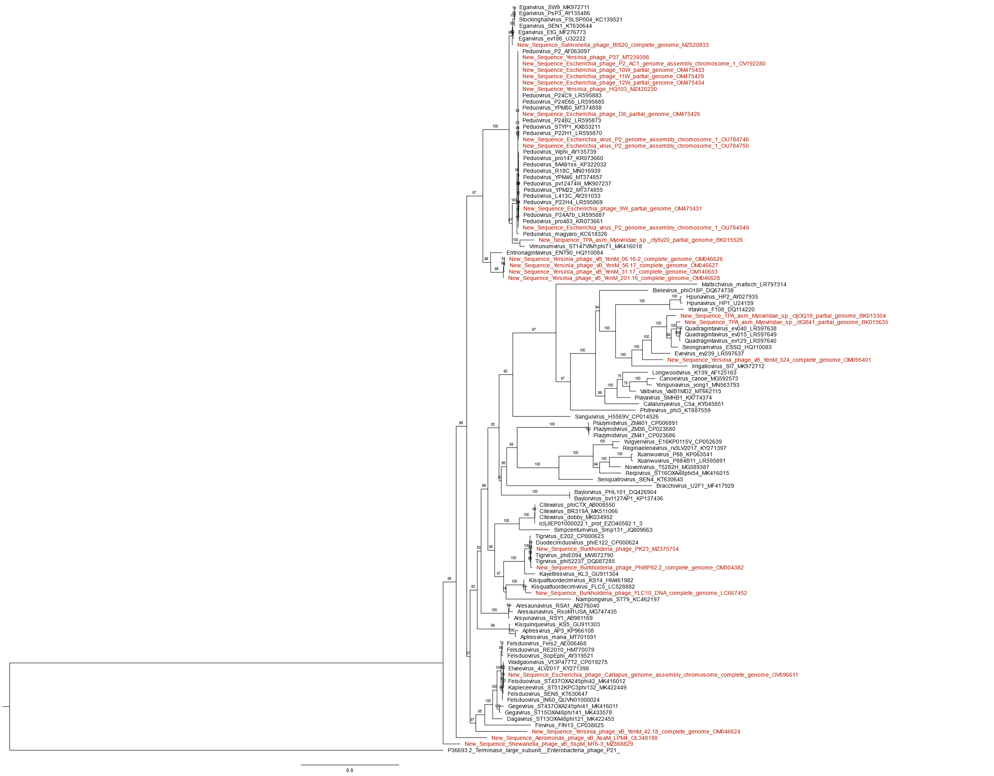

**Figure 1.** Peduoviridae large terminase subunit phylogeny created with Clustal Omega, BMGE, and IQ-Tree using the model LG+I+G4 and 2,500 bootstrap replicates. The large terminase of Enterobacteria phage P21 is used as an outgroup. Outgroup determined with HHpred. Tree visualized with FigTree.

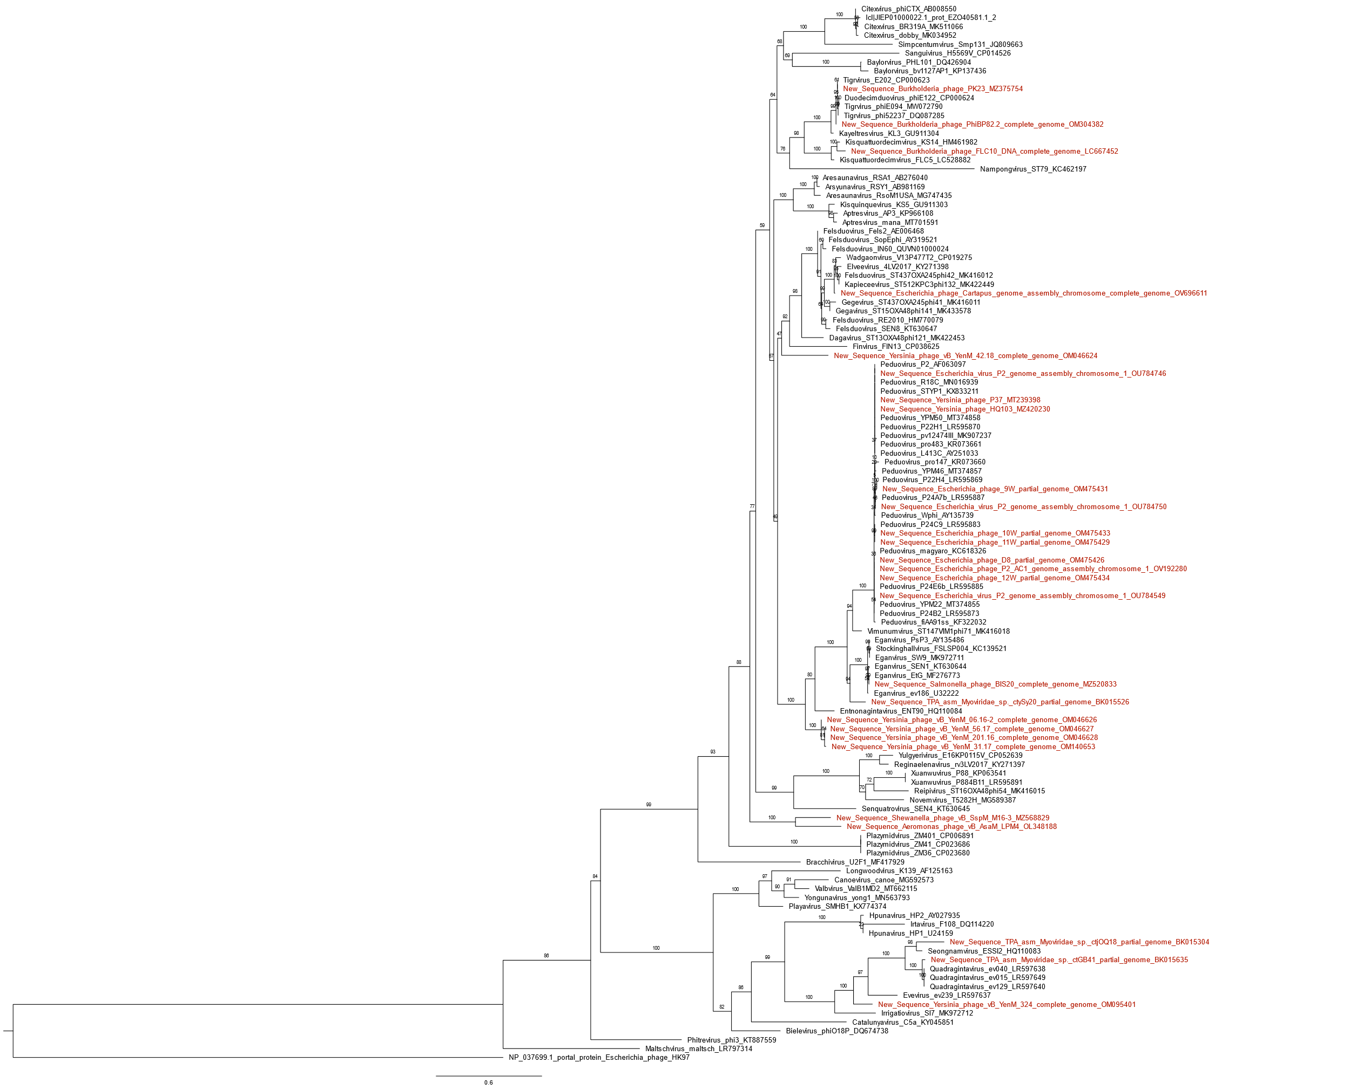

**Figure 2.** Peduoviridae portal protein phylogeny created with Clustal Omega, BMGE, and IQ-Tree using the model LG+I+G4 and 2,500 bootstrap replicates. Portal proteins from Enterobacteria phage HK97 are used as an outgroup. Outgroup determined with PSI-BLAST and HHpred. Tree visualized with FigTree.

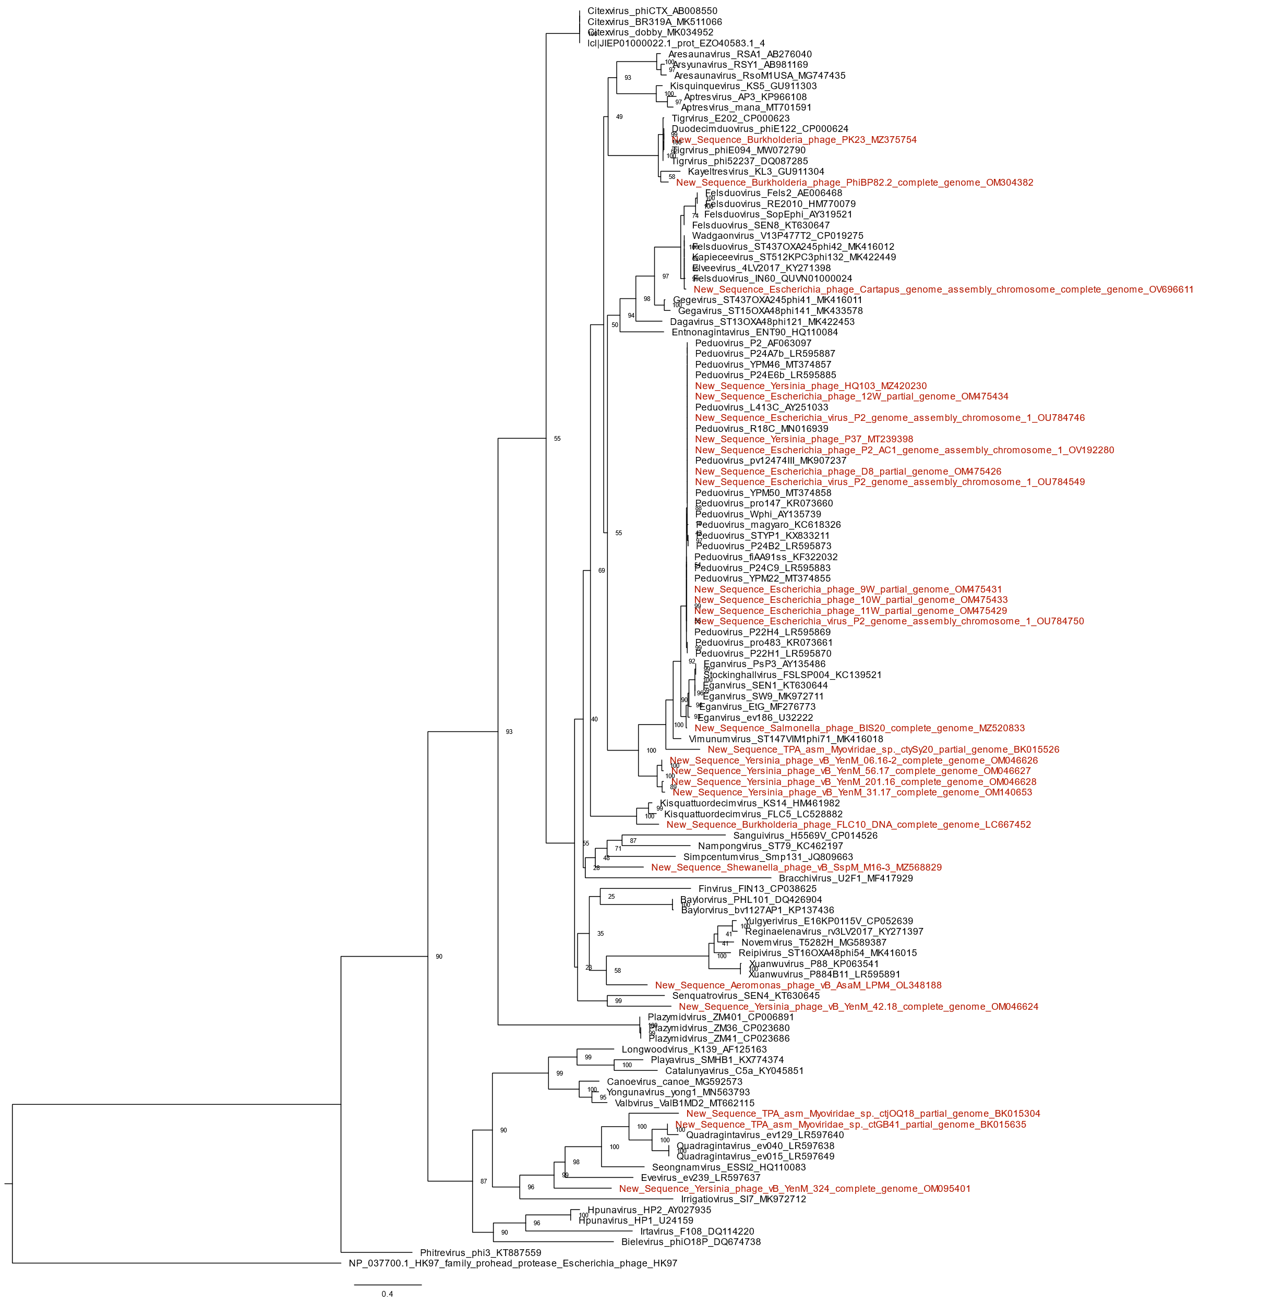

**Figure 3.** Peduoviridae capsid scaffolding protein phylogeny created with Clustal Omega, BMGE, and IQ-Tree using the model LG+I+G4 and 2,500 bootstrap replicates. Proteases from Enterobacteria phage HK97. Outgroup determined with HHpred. Tree visualized with ETE 3. Tree visualized with FigTree.

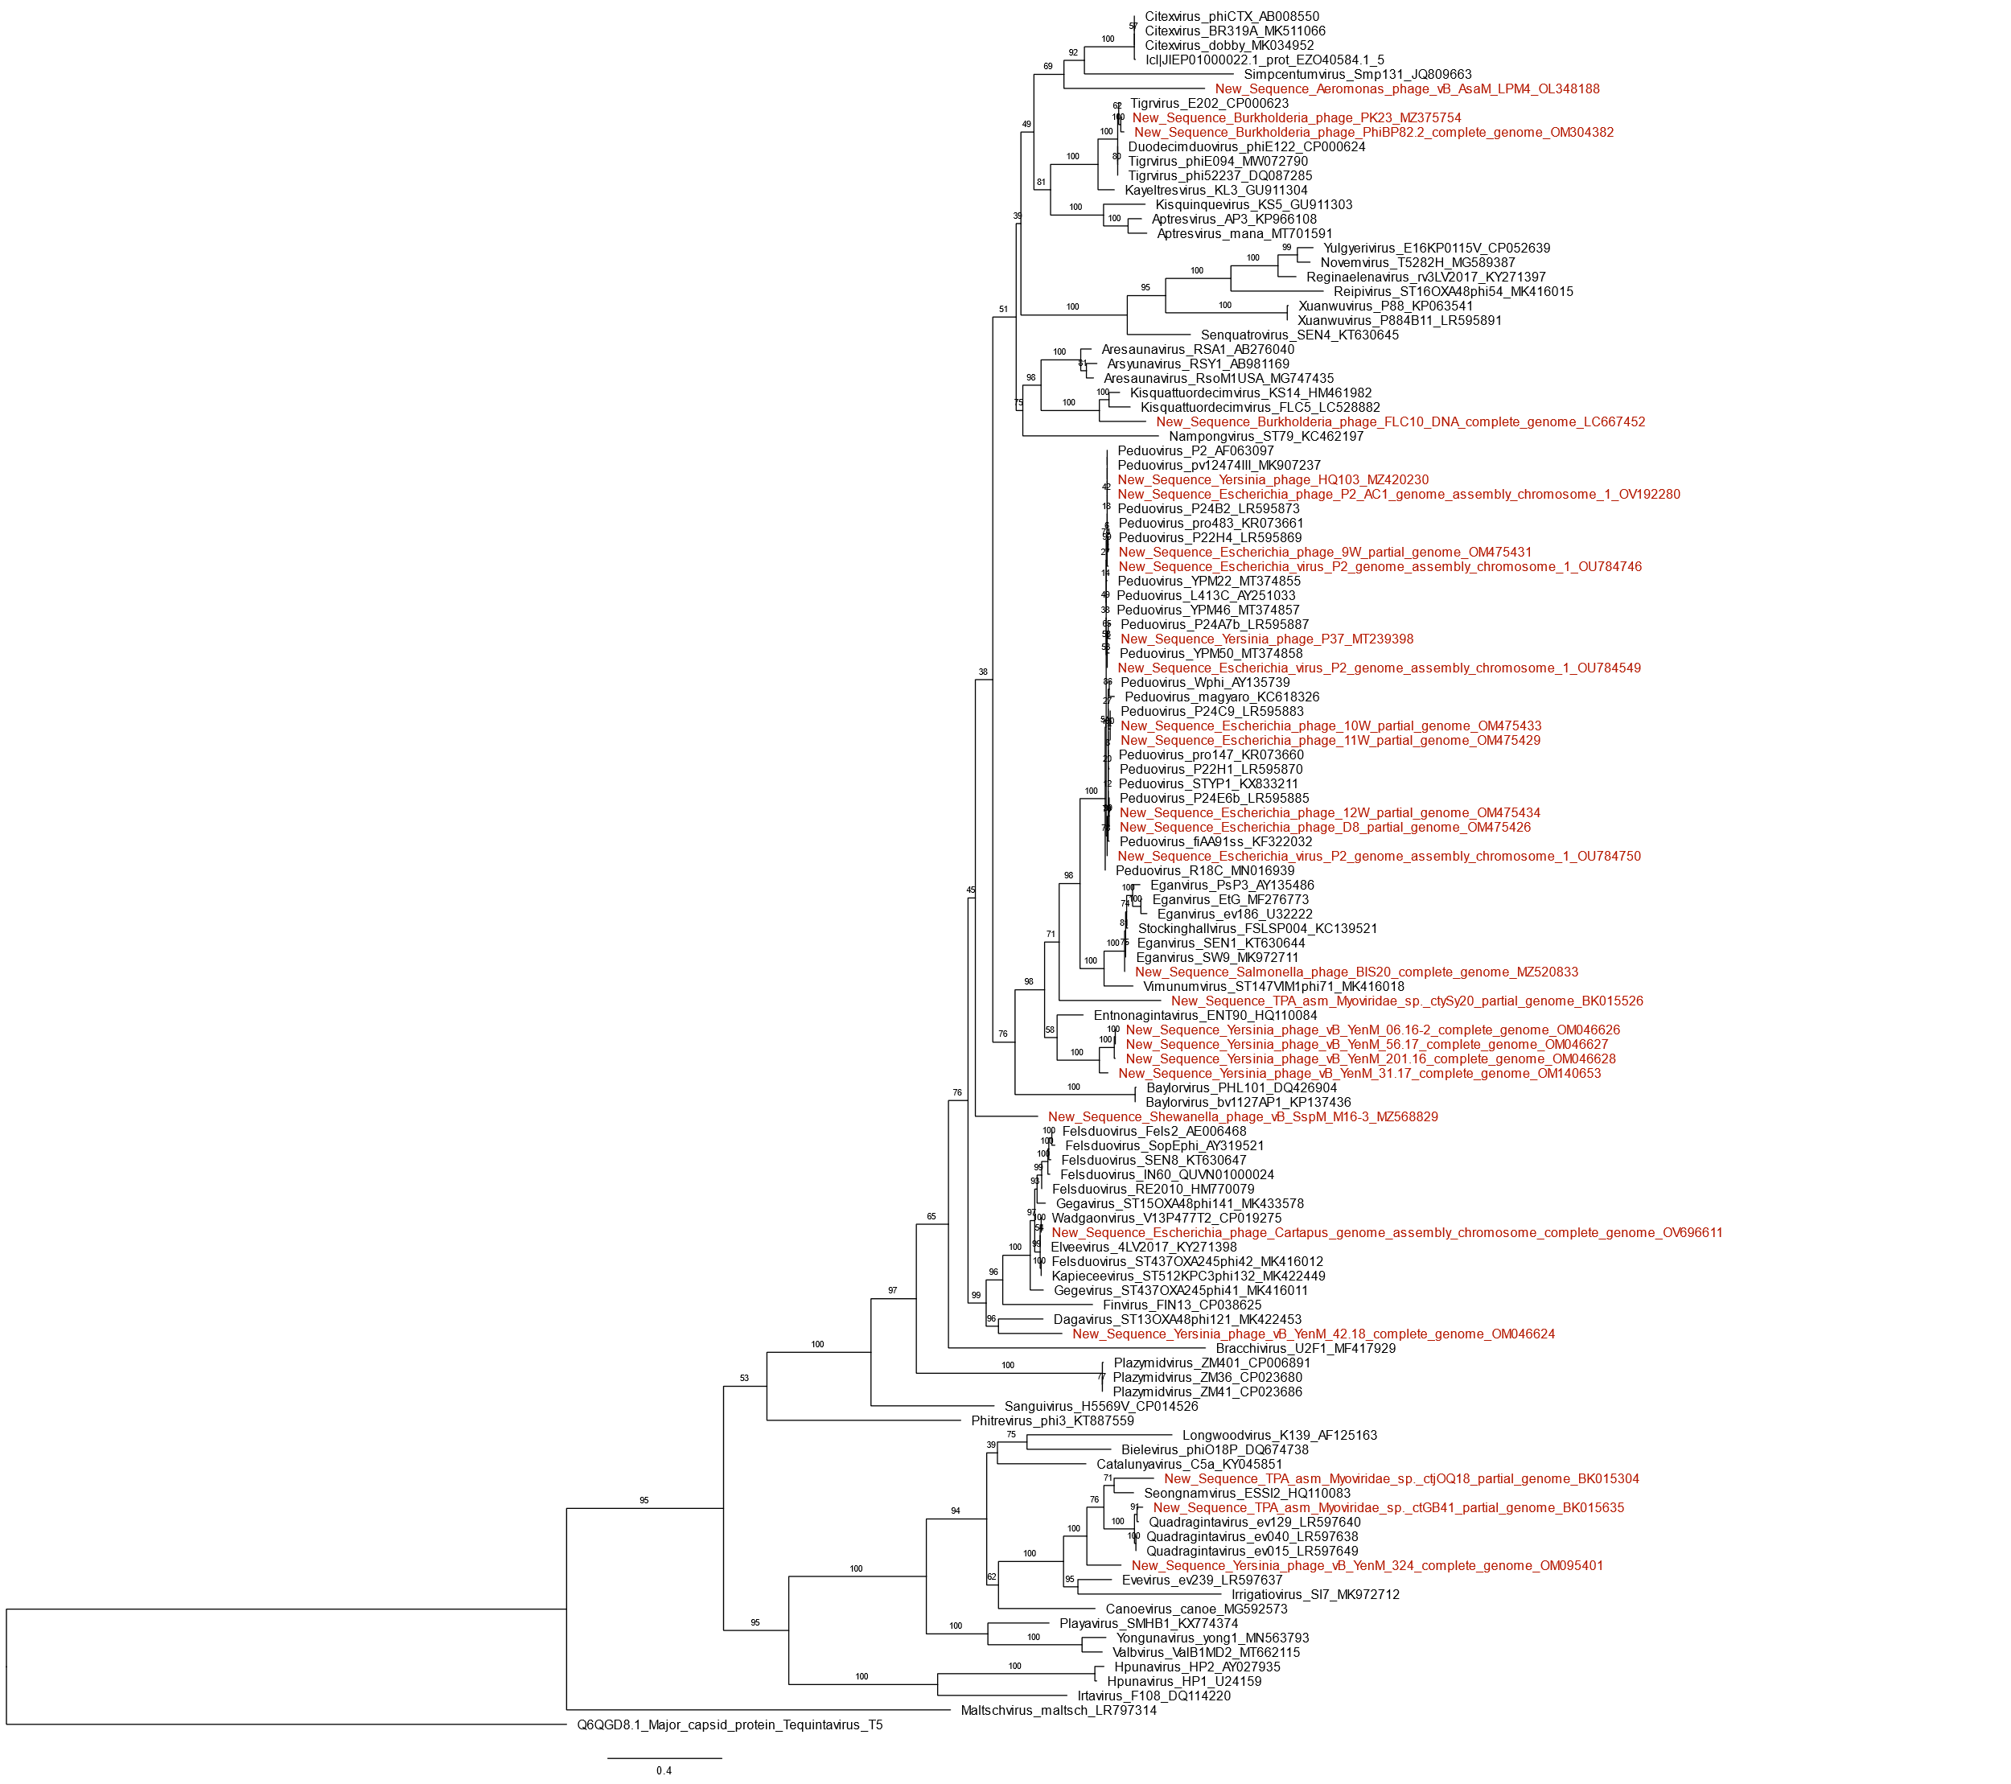

**Figure 4.** Peduoviridae major capsid protein phylogeny created with Clustal Omega, BMGE, and IQ-Tree using the model LG+I+G4 and 2,500 bootstrap replicates. The major capsid protein of Escherichia phage T5 is used as an outgroup. Outgroup determined with HHpred. Tree visualized with FigTree.

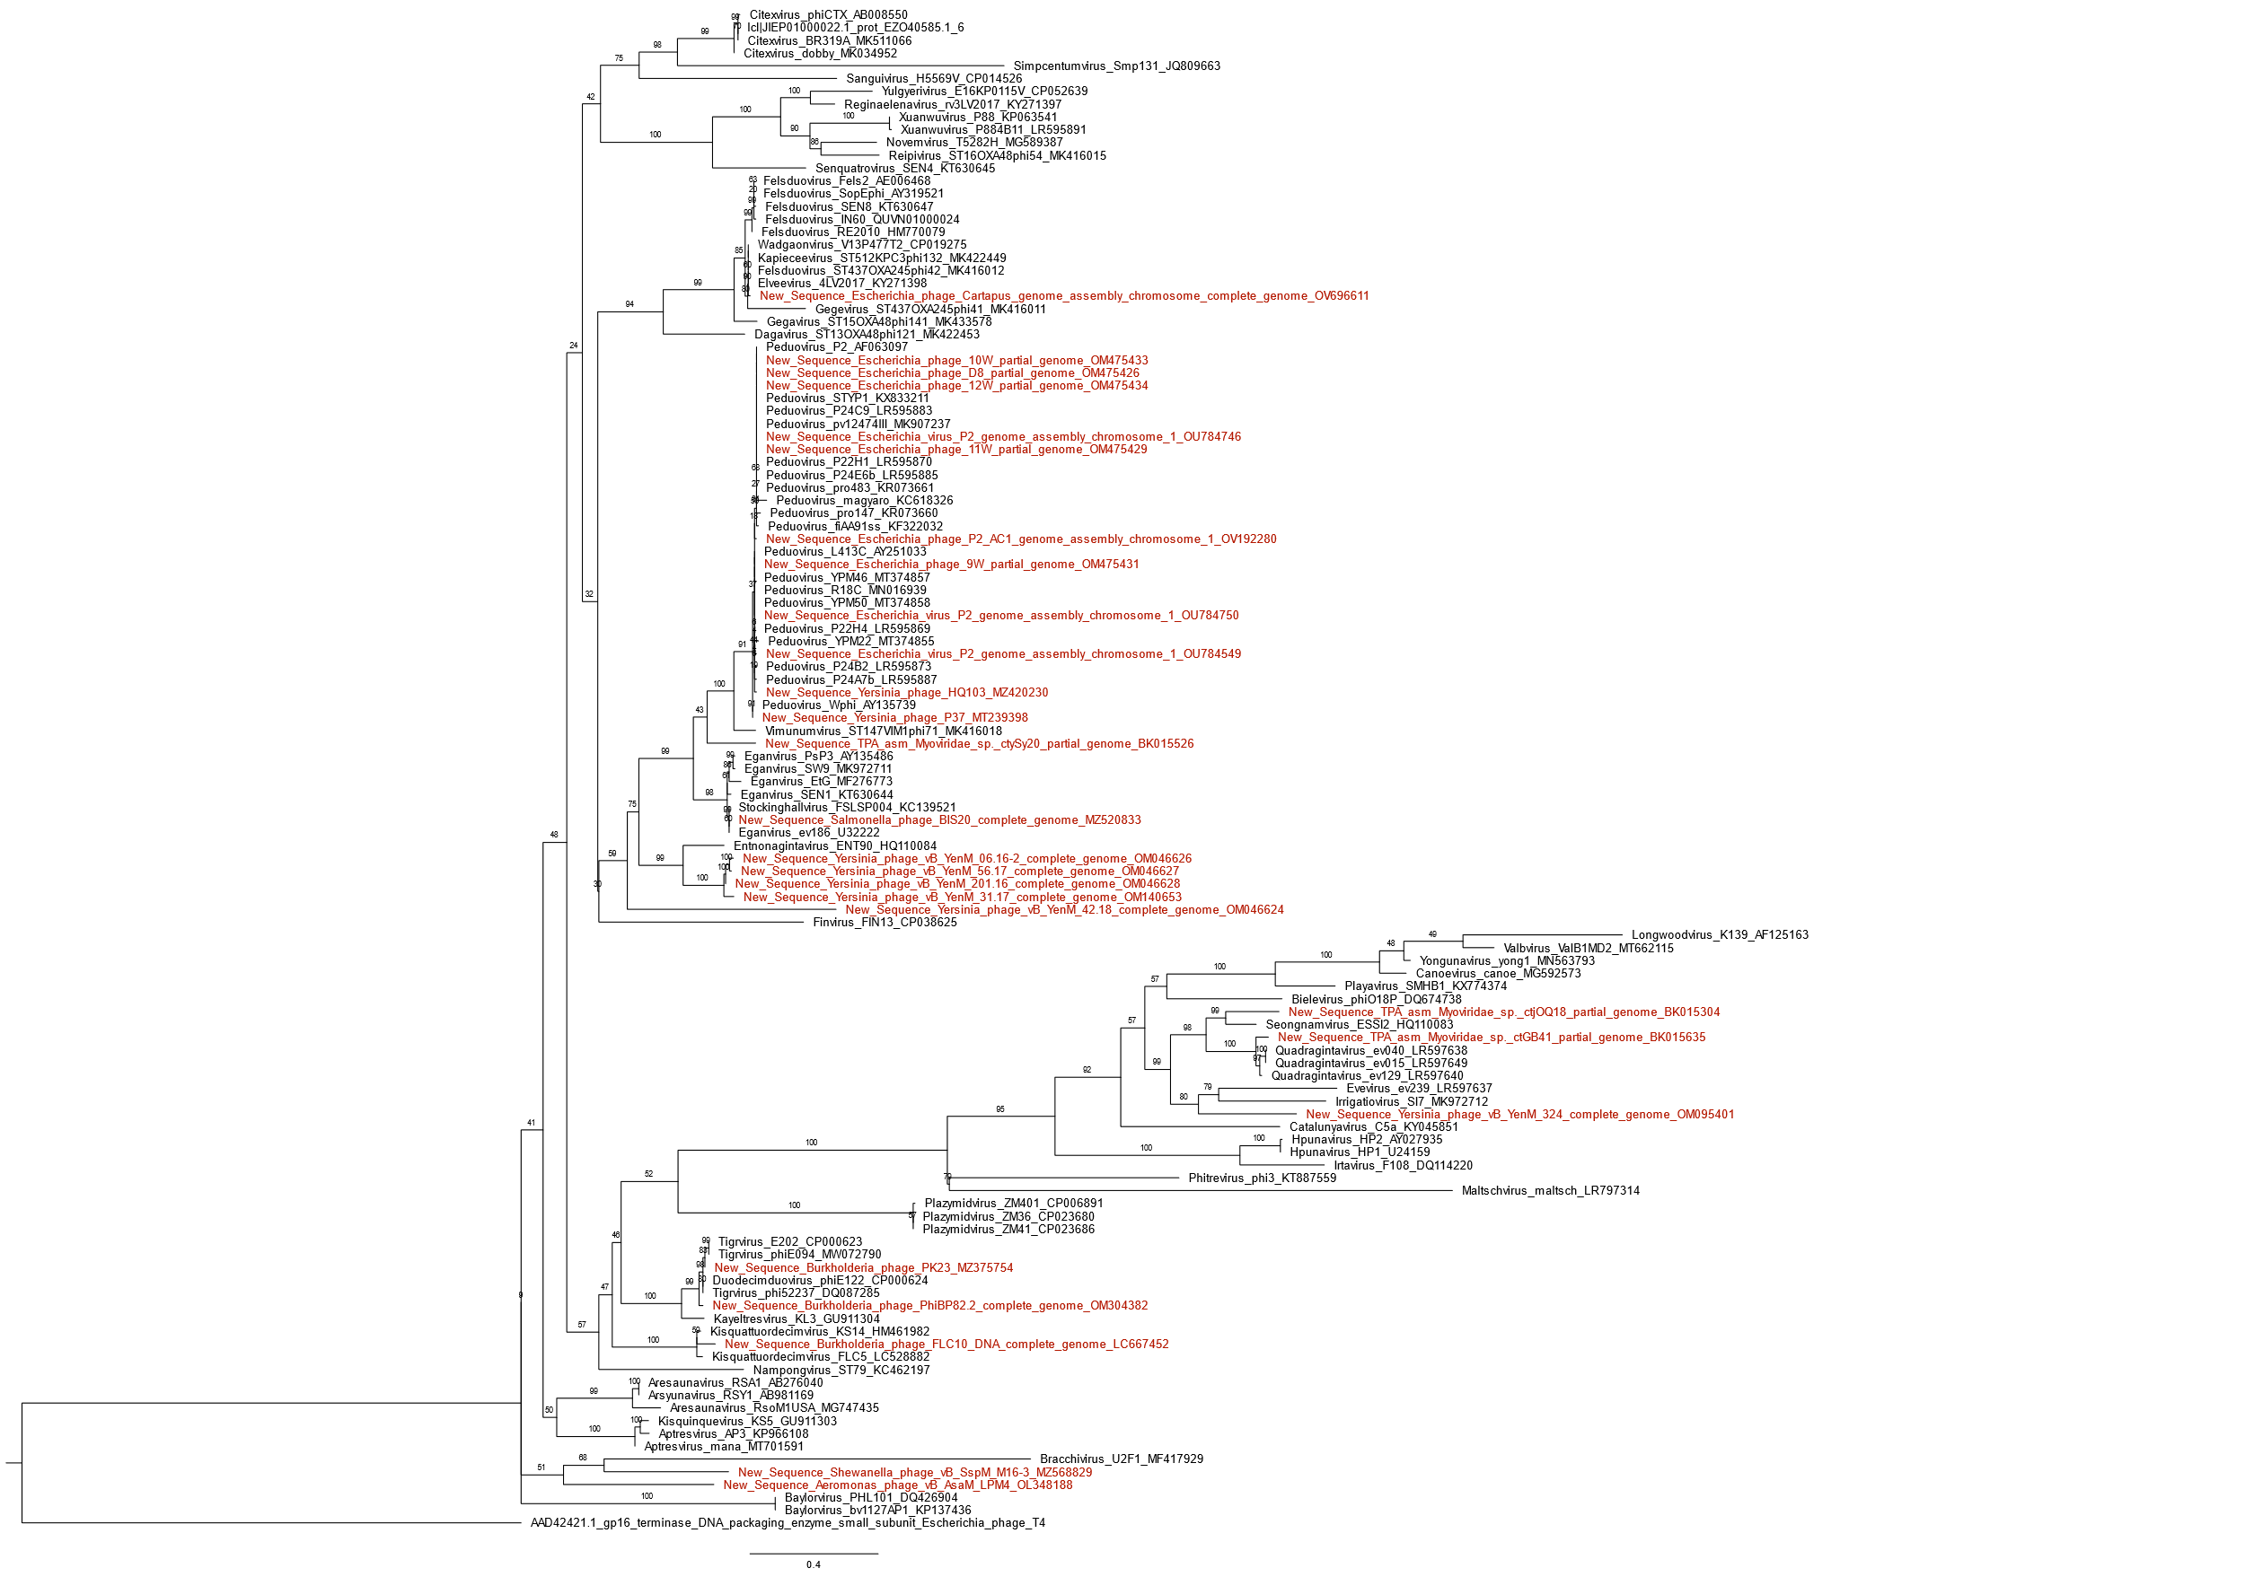

**Figure 5.**  Peduoviridae small terminase subunit phylogeny created created with Clustal Omega, BMGE, and IQ-Tree using the model LG+I+G4 and 2,500 bootstrap replicates. The small terminase of Escherichia phage T4 is used as an outgroup. Tree visualized with FigTree.

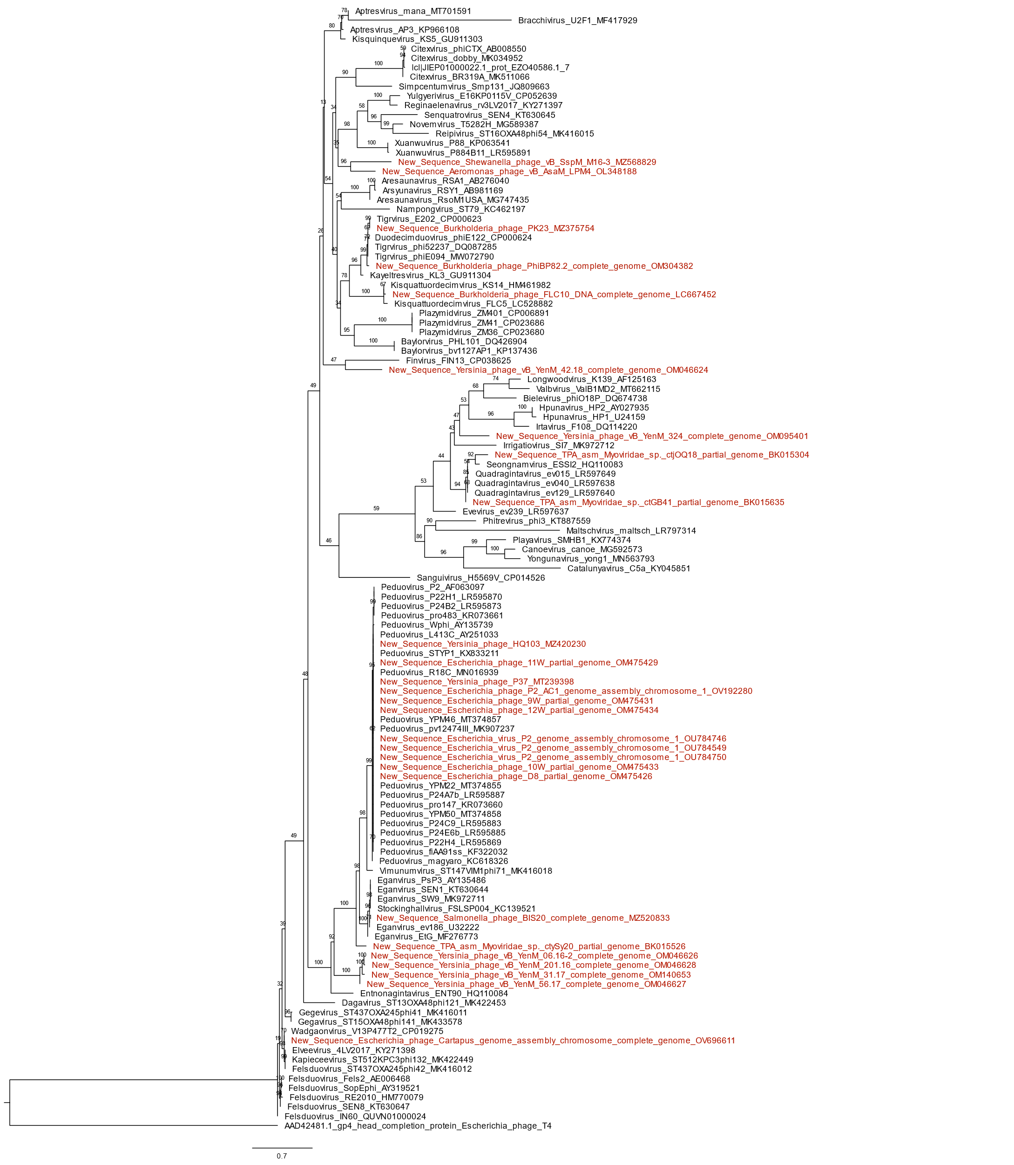

**Figure 6.** Peduoviridae capsid completion/stabilization protein phylogeny created with Clustal Omega, BMGE, and IQ-Tree using the model LG+I+G4 and 2,500 bootstrap replicates. The head completion protein of Escherichia phage T4 is used as an outgroup. Tree visualized with FigTree.

**References**

1. Rousset F, Depardieu F, Miele S, Dowding J, Laval A-L, Lieberman E, Garry D, Rocha EPC, Bernheim A, Bikard D (2022) Phages and their satellites encode hotspots of antiviral systems. Cell Host & Microbe 30: 740–753 PMID: 35316646
2. Sattar S, Ullah I, Khanum S et al. (2022) Phenotypic characterization and genome analysis of a novel *Salmonella typhimurium* phage having unique tail fiber genes. Sci Rep 12: 5732 PMID: 35388062
3. Hosseini N, Paquet VE, Chehreghani M, Moineau S, Charette SJ (2021) Phage cocktail development against *Aeromonas salmonicida* subsp. *salmonicida* strains is compromised by a prophage. Viruses 13: 2241 PMID: 34835047
4. Bujak K, Decewicz P, Rosinska JM, Radlinska M (2021) Genome study of a novel virulent phage vB_SspS_KASIA and Mu-like prophages of *Shewanella* sp. M16 provides insights into the genetic diversity of the *Shewanella* virome. Int J Mol Sci. 22: 11070 PMID: 34681734