

**Part 1:** **TITLE, AUTHORS, APPROVALS, etc**

|  |  |  |
| --- | --- | --- |
| **Code assigned:** | ***2022.067B*** |  |
| **Short title:** | | |
| Create a new genus (*Purivirus*) with a single species (*Caudoviricetes*) | | |

**Author(s) and email address(es)**

|  |  |
| --- | --- |
| Vidigal PMP, Hungaro HM, Gontijo MTP, Lopez MES | pedro.vidigal@ufv.br; humberto.hungaro@farmacia.ufjf.br; pardinibiotech@gmail.com; mesoto@correo.unicordoba.edu.co |

**Author(s) institutional address(es) (optional)**

|  |
| --- |
| Universidade Federal de Viçosa [PMPV], Universidade Federal de Juiz de Fora [HMH], Universidade Estadual de Campinas [MTPG], Universidade de Córdoba [MESL] |

**Corresponding author**

|  |
| --- |
| Vidigal PMP, [pedro.vidigal@ufv.br](mailto:pedro.vidigal@ufv.br) |

**List the ICTV Study Group(s) that have seen this proposal**

|  |
| --- |
| Bacterial Viruses Subcommittee |

**ICTV Study Group comments and response of proposer**

|  |
| --- |
|  |

**ICTV Study Group votes on proposal**

|  |  |  |  |
| --- | --- | --- | --- |
| **Study Group** | **Number of members** | | |
| **Votes support** | **Votes against** | **No vote** |
|  |  |  |  |
|  |  |  |  |

**Authority to use the name of a living person**

|  |  |
| --- | --- |
| **Is any taxon name used here derived from that of a living person (Y/N)** | N |

|  |  |  |
| --- | --- | --- |
| **Taxon name** | **Person from whom the name is derived** | **Permission attached (Y/N)** |
|  |  |  |

**Submission dates**

|  |  |
| --- | --- |
| Date first submitted to SC Chair | 2022-05-04 |
| Date of this revision (if different to above) |  |

**ICTV-EC comments and response of the proposer**

|  |
| --- |
|  |

**Part 2:** **NON-TAXONOMIC PROPOSAL**

**Text of proposal**

|  |
| --- |
|  |

**Part 3:** **TAXONOMIC PROPOSAL**

**Name of accompanying Excel module**

|  |
| --- |
| 2022.067B.N.v1.Purivirus_ng.xlsx |

**Abstract**

|  |
| --- |
| This taxonomy proposal refers to creating a new genus *Purivirus* in the class *Caudoviricetes*, which will include the distinct genomic features of *Pseudomonas* phage UFJF_PfDIW6. This isolate originated from dairy industry wastewater and is a lytic phage showing great potential for *Pseudomonas fluorescens* biocontrol. The genome of the UFJF_PfDIW6 phage is available in the GenBank database [accession OM418631.1] and was characterised in detail and compared to other phages and prophages. All performed analyses confirmed that UFJF_PfDIW6 represents a new genus of *Caudoviricetes* that shares low genomic similarity with a small set of *Pseudomonas* phages and prophages. The *Purivirus* genus is a tribute to the Puri people, an indigenous population that has inhabited the geographic region where the UFJF_PfDIW6 phage was isolated. |

**Text of proposal**

|  |  |
| --- | --- |
| |  | | --- | | Here, we propose the creation of a new genus *Purivirus* of class *Caudoviricetes*, which will represent the species *Purivirus UFJF_PfDIW6*. The *Pseudomonas* phage UFJF_PfDIW6 is a lytic phage isolated from dairy industry wastewater that could control *Pseudomonas fluorescens* growth and reduce casein hydrolysis in raw milk [1].  The genome of the UFJF_PfDIW6 phage is available in the GenBank database [accession OM418631.1] and was analysed in detail to propose its taxonomic classification [2]. This genome comprises 42,322 bp of linear double-stranded DNA with a GC content of 58.3%. Its sequence has a bidirectional organisation and a gene density of 1.38 gene/Kb, including 58 coding DNA sequences distributed into five functional modules [2].  Evidence presented by Hungaro et al. [2] supports that the specie *Purivirus UFJF_PfDIW6* is the representative of a novel genus *Purivirus* of class *Caudoviricetes*:  (1) Comparative genomic analysis confirmed that the genome of UFJF_PfDIW6 is significantly different from other viral genomes available in the GenBank database. Alignments obtained using the BLASTn tool showed that the genome of UFJF_PfDIW6 displays a maximum coverage of 5% with other viral genomes. In addition, a prophage genome located in the chromosome of *Pseudomonas* sp. HN8-3 [CP086206:863875-3906644:42770 bp] aligned with maximum coverage of 49%.  (2) The intergenomic similarity matrix was calculated using VIRIDIC and placed UFJF_PfDIW6 in different species and genus clusters from other viral and prophages genomes. The genome of prophage identified in *Pseudomonas* sp. HN8-3 was the most similar to the genome of the UFJF_PfDIW6 phage, with 47.81% of identity. The genomes of *Pseudomonas* phage AF [NC_019923] and *Pseudomonas* phage HU1 [AP019415] showed 6.83% and 10.22% of genomic similarity, respectively.  (3) A Maximum Likelihood phylogenetic tree was inferred using the terminase large subunits (TerL) protein sequences from UFJF_PfDIW6 and other *Pseudomonas* phages as evolutionary markers. The phage UFJF_PfDIW6 is into a monophyletic cluster of unclassified viruses in the *Podoviridae* clade (ICTV release 2020).  (4) The viral proteomic tree (ViPTree) calculated from the reference genomes of the *Podoviridae* family (ICTV release 2020) also placed the genome of UFJF_PfDIW6 phage in a distinct monophyletic cluster of unclassified viruses.  The etymology of the *Purivirus* genus:  The name *Purivirus* is a tribute to the Puri people. This indigenous population has inhabited the geographic region of Juiz de Fora (Minas Gerais state, Brazil), where *Pseudomonas* phage UFJF_PfDIW6 was isolated. Puri is a term from the indigenous language “Coroado” that means dared. The Puri people are now extinct, and their name refers to their mobility among the valleys of mountain regions and ability to attack their enemies furtively [3]. | |

**Supporting evidence**

The supporting evidence presented here was published by Hungaro et al. [2].

**(1) Table S1.** Similarity searches between UFJF_PfDIW6 genome sequence and genomes available in the NCBI database. Sequences were aligned using the BLASTn tool of BLAST. An E-value threshold ≤ 1e-10 was considered for selecting significant alignments.

|  |  |  |  |  |  |  |
| --- | --- | --- | --- | --- | --- | --- |
| **NCBI ID** | **Description** | **Length (nt)** | **NCBI Taxid** | Coverage | E-value | % identity |
| **UFJF_PfDIW6 vs Nucleotide Database (nt); Viruses (Taxonomy ID:10239)** | | | | | | |
| MF417920.1 | Uncultured *Caudovirales* phage clone 10F_8 | 37831 | 2100421 | 5,0% | 0,00E+00 | 0,97 |
| MF417918.1 | Uncultured *Caudovirales* phage clone 7F_17 | 37831 | 2100421 | 5,0% | 0,00E+00 | 0,97 |
| MF417916.1 | Uncultured *Caudovirale*s phage clone 7S_13 | 37831 | 2100421 | 5,0% | 0,00E+00 | 0,97 |
| MF417915.1 | Uncultured *Caudovirales* phage clone 8AX_8 | 37831 | 2100421 | 5,0% | 0,00E+00 | 0,97 |
| MF417914.1 | Uncultured *Caudovirales* phage clone 8S_2 | 37831 | 2100421 | 5,0% | 0,00E+00 | 0,97 |
| MF417913.1 | Uncultured *Caudovirales* phage clone 9S_2 | 37831 | 2100421 | 5,0% | 0,00E+00 | 0,97 |
| MF417912.1 | Uncultured *Caudovirales* phage clone 10AX_4 | 38064 | 2100421 | 5,0% | 0,00E+00 | 0,97 |
| MF417911.1 | Uncultured *Caudovirales* phage clone 9AX_3 | 38103 | 2100421 | 5,0% | 0,00E+00 | 0,97 |
| MF417910.1 | Uncultured *Caudovirales* phage clone 2AX_5 | 38191 | 2100421 | 5,0% | 0,00E+00 | 0,97 |
| MF417898.1 | Uncultured *Caudovirales* phage clone 7AX_6 | 37833 | 2100421 | 5,0% | 0,00E+00 | 0,97 |
| MF417896.1 | Uncultured *Caudovirales* phage clone 3S_18 | 37831 | 2100421 | 5,0% | 0,00E+00 | 0,97 |
| MF417931.1 | Uncultured *Caudovirales* phage clone 3S_7 | 34508 | 2100421 | 4,0% | 0,00E+00 | 0,91 |
| MF417884.1 | Uncultured *Caudovirales* phage clone 8AX_2 | 48904 | 2100421 | 4,0% | 0,00E+00 | 0,91 |
| MF417883.1 | Uncultured *Caudovirales* phage clone 7F_11 | 49331 | 2100421 | 4,0% | 0,00E+00 | 0,91 |
| MF417882.1 | Uncultured *Caudovirales* phage clone 10F_10 | 49390 | 2100421 | 4,0% | 0,00E+00 | 0,91 |
| MF417873.1 | Uncultured *Caudovirales* phage clone 7S_5 | 49229 | 2100421 | 4,0% | 0,00E+00 | 0,91 |
| MF417839.1 | Uncultured *Caudovirales* phage clone 2AX_2 | 34785 | 2100421 | 4,0% | 0,00E+00 | 0,91 |
| MF417872.1 | Uncultured phage clone 7AX_2 | 49489 | 278008 | 4,0% | 0,00E+00 | 0,91 |
| KU708004.1 | *Pseudomonas* phage phiAH14a | 55060 | 1805958 | 5,0% | 3,00E-168 | 0,84 |
| NC_019923.1 | *Pseudomonas* phage AF | 42689 | 1235689 | 2,0% | 1,00E-146 | 0,76 |
| KJ507100.1 | *Pseudomonas* phage phiPSA1 | 51090 | 1500757 | 0,0% | 7,00E-75 | 0,88 |
| MZ348425.1 | *Pseudomonas* phage psageB2 | 50739 | 2859562 | 0,0% | 7,00E-75 | 0,88 |
| MF975720.1 | *Pseudomonas* phage VW-6S | 37917 | 2041487 | 0,0% | 3,00E-49 | 0,92 |
| MN855976.1 | *Siphoviridae* sp. isolate 68 | 26455 | 2170413 | 0,0% | 4,00E-17 | 0,98 |
| AP019415.2 | *Pseudomonas* phage HU1 | 42551 | 2056127 | 0,0% | 6,00E-16 | 0,98 |
| **UFJF_PfDIW6 vs RefSeq Genome Database; Bacteria (Taxonomy ID:2); "complete genomes"** | | | | | | |
| NZ_CP086206.1 | *Pseudomonas* sp. HN8-3 chromosome: 3863875-3906644 | 42770 | 2886361 | 49% | 0,00E+00 | 0,94 |
| NZ_CP032618.1 | *Pseudomonas fluorescens* strain PF08 chromosome: 1504792-1548170 | 43379 | 294 | 47,0% | 0,00E+00 | 0,87 |
| NZ_CP054868.1 | *Pseudomonas chlororaphis* strain PCLAR04 chromosome: 1826223-1867950 | 41728 | 587753 | 42,0% | 0,00E+00 | 0,87 |
| NZ_CP027743.1 | *Pseudomonas chlororaphis* subsp. *aurantiaca* strain CW2 chromosome: 5609197-5654498 | 45302 | 86192 | 38,0% | 0,00E+00 | 0,95 |
| NZ_CP058644.1 | *Pseudomonas yamanorum* strain GZD14026 chromosome: 3898468-3951640 | 53173 | 515393 | 38,0% | 0,00E+00 | 0,86 |

**(2) Table S9.** Genome sequences were compared by VIRIDIC and clustered, considering a genomic similarity threshold of 95% for species assignment and 70% for the genus.

|  |  |  |  |  |
| --- | --- | --- | --- | --- |
| Genome | Specie | Similarity to UFJF_PfDIW6 | Species cluster | Genus cluster |
| UFJF_PfDIW6 | *Purivirus* UFJF_PfDIW6 | 100 | 6 | 6 |
| CP086206  RC:863875-3906644  42770 bp | *Pseudomonas* sp. HN8-3 chromosome | 47,81 | 3 | 3 |
| CP032618  1504792-548170  43379 bp | *Pseudomonas fluorescens* strain PF08 | Prophage | 44,61 | 5 | 5 |
| CP054868  RC:1826223-1867950  41728 bp | *Pseudomonas chlororaphis* strain PCLAR04 | Prophage | 39,95 | 4 | 4 |
| CP027743  RC:5609197-5654498  45302 bp | *Pseudomonas chlororaphis* subsp. *aurantiaca* strain CW2 | Prophage | 38,23 | 1 | 1 |
| CP058644  RC:3898468-3951640  53173 bp | *Pseudomonas yamanorum* strain GZD14026 | Prophage | 32,91 | 2 | 2 |
| AP019415  RC:42551 bp | *Pseudomonas* phage HU1 | 10,22 | 7 | 7 |
| NC_019923  42689 bp | *Pseudomonas* phage AF | 6,83 | 8 | 8 |

**(3) Figure 2.** Maximum likelihood tree of the large terminase subunit of phages infecting the genus *Pseudomonas*. The midpoint rooted maximum likelihood (ML) tree was obtained by analysing terminase large subunit (TerL) amino acid sequences from UFJF_PfDIW6 and other *Pseudomonas* phages available in the NCBI RefSeq database. The bootstrap values (expressed as percentages) calculated from 1000 replicates are shown beside each node. The monophyletic clades corresponding to each genus are shown in different colours. The genomes of *Pseudomonas* phages were clustered by VIRIDIC using the genomic similarity threshold of 70% for genus assignment (Genus cluster) and 95% for species assignment (Species’ cluster).

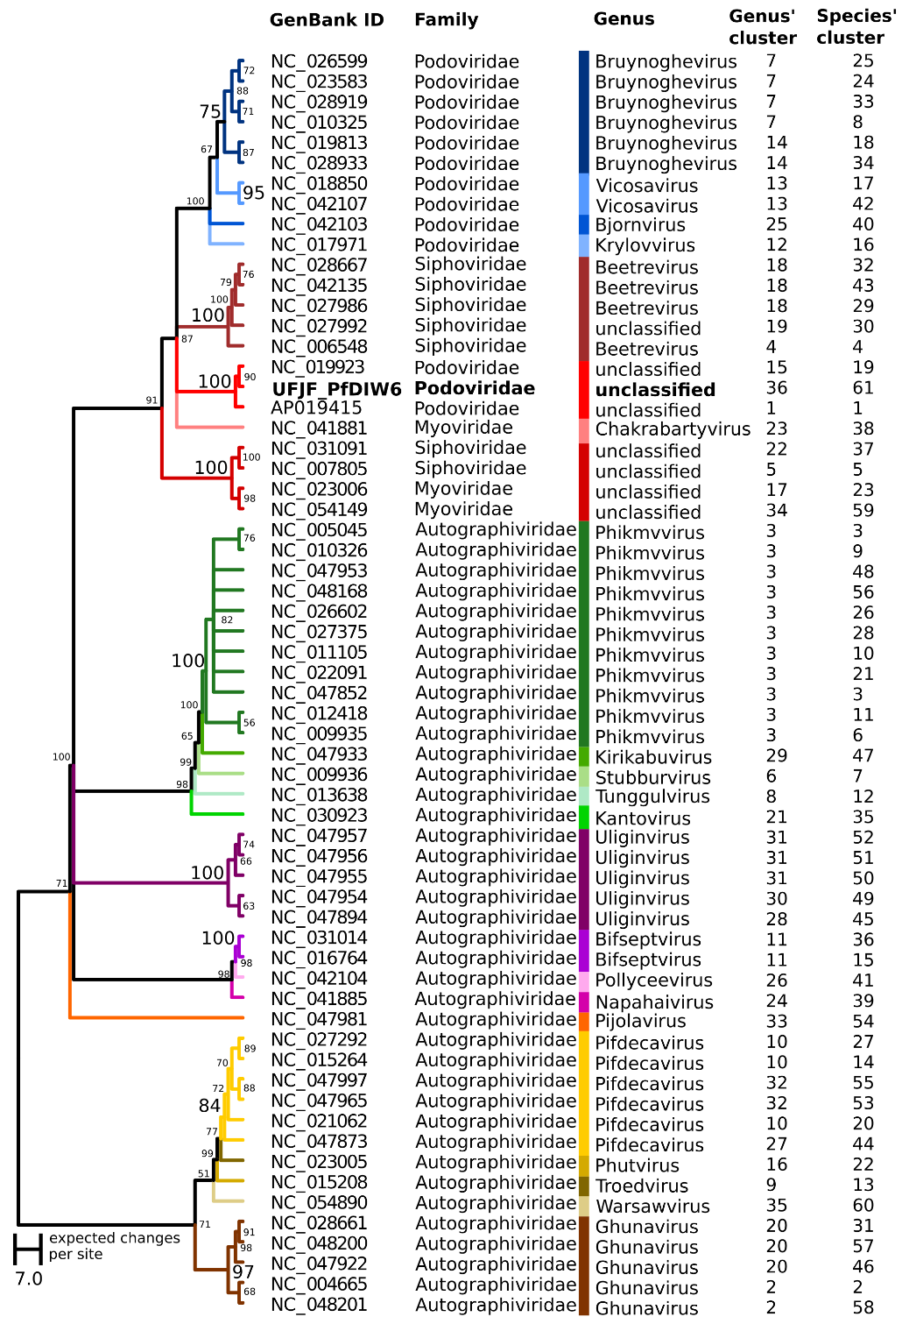

**(4) Figure 3.** Viral proteomic tree of reference genomes for *Podoviridae* family. The proteomic tree was obtained from UFJF_PfDIW6 and 130 reference genomes for the genus of *Podoviridae* phages. The genomes were aligned all-against-all using ViPTree, and the genomic similarity scores (SG) were computed. The cluster, including UFJF_PfDIW6, is highlighted in red. The genomes of *Podoviridae* phages were also clustered by VIRIDIC using the genomic similarity threshold of 70% for genus assignment (Genus cluster) and 95% for species assignment (Species’ cluster).

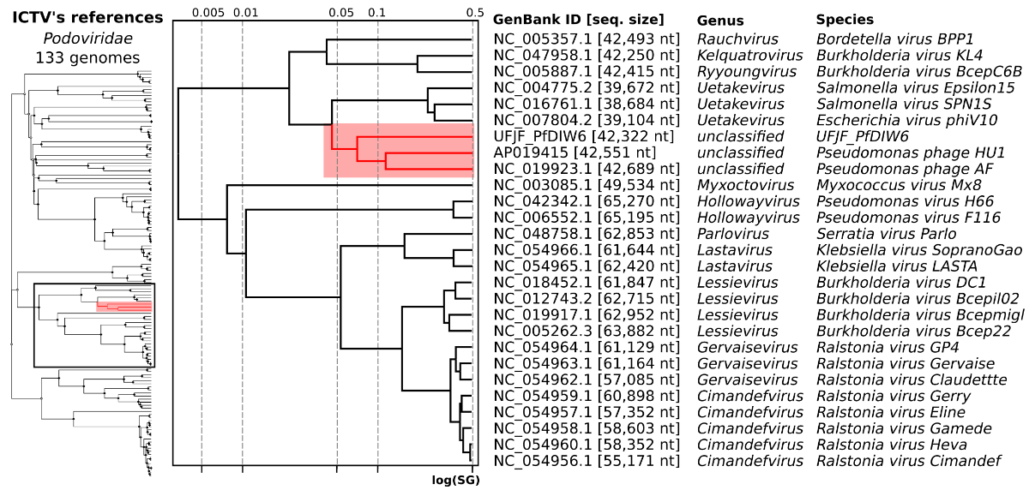

**References**

1. Nascimento EC do, Sabino MC, Corguinha L da R, et al (2022) Lytic bacteriophages UFJF_PfDIW6 and UFJF_PfSW6 prevent Pseudomonas fluorescens growth in vitro and the proteolytic-caused spoilage of raw milk during chilled storage. Food Microbiol 101:103892. <https://doi.org/10.1016/J.FM.2021.103892>. PMID: 34579852.

2. Hungaro HM, Vidigal PMP, do Nascimento EC, et al (2022) Genomic Characterisation of UFJF_PfDIW6: A Novel Lytic Pseudomonas fluorescens-Phage with Potential for Biocontrol in the Dairy Industry. Viruses 14:629. <https://doi.org/10.3390/V14030629>. PMID: 35337036.

3. Aguiar JO (2010) Quem eram os índios Puri-Coroado da mata central de Minas Gerais no início dos oitocentos? Contribuições dos relatos de Eschwege e Freyreiss para uma polêmica (1813-1836). Revista Mosaico 4:197-211. <http://dx.doi.org/10.18224/mos.v4i2.2382>.

4. Moraru C, Varsani A, Kropinski AM. VIRIDIC-A Novel Tool to Calculate the Intergenomic Similarities of Prokaryote-Infecting Viruses. Viruses. 2020 Nov 6;12(11):1268. doi: 10.3390/v12111268. PMID: 33172115.

5. Nishimura Y, Yoshida T, Kuronishi M, Uehara H, Ogata H, Goto S. ViPTree: the viral proteomic tree server. Bioinformatics. 2017; 33(15):2379-2380. doi:10.1093/bioinformatics/btx157. PubMed PMID: 28379287. https://www.genome.jp/viptree/