

**Part 1:** **TITLE, AUTHORS, APPROVALS, etc**

|  |  |  |
| --- | --- | --- |
| **Code assigned:** | ***2022.068B*** |  |
| **Short title:** Create one new species in the genus *Rosenblumvirus* and two new species in the genus *Andhravirus* of *Rakietenvirinae* subfamily (*Caudoviricetes*: *Rountreeviridae*) | | |
|  | | |

**Author(s) and email address(es)**

|  |  |
| --- | --- |
| Łobocka M, Stefańczyk E, Adriaenssens EM, Kropinski AM, Turner D | lobocka@ibb.waw.pl;  e.stefanczyk@ibb.waw.pl;  evelien.adriaenssens@quadram.ac.uk;  Phage.Canada@gmail.com; dann2.turner@uwe.ac.uk |

**Author(s) institutional address(es) (optional)**

|  |
| --- |
| Institute of Biochemistry and Biophysics of the Polish Academy of Sciences Poland [MŁ]  Institute of Biochemistry and Biophysics of the Polish Academy of Sciences Poland [ES]  Quadram Institute Bioscience, UK [EMA]  University of Guelph, Canada [AMK]  University of the West of England [DT] |

**Corresponding author**

|  |
| --- |
| Malgorzata Łobocka |

**List the ICTV Study Group(s) that have seen this proposal**

|  |
| --- |
| *Salasmaviridae, Rountreeviridae, Guelinviridae* Study Group, Bacterial Viruses Subcommittee |

**ICTV Study Group comments and response of proposer**

|  |
| --- |
|  |

**ICTV Study Group votes on proposal**

|  |  |  |  |
| --- | --- | --- | --- |
| **Study Group** | **Number of members** | | |
| **Votes support** | **Votes against** | **No vote** |
| *Salasmaviridae, Rountreeviridae, Guelinviridae* Study Group | 2 | 0 | 0 |

**Authority to use the name of a living person**

|  |  |
| --- | --- |
| **Is any taxon name used here derived from that of a living person (Y/N)** | N |

|  |  |  |
| --- | --- | --- |
| **Taxon name** | **Person from whom the name is derived** | **Permission attached (Y/N)** |
|  |  |  |
|  |  |  |
|  |  |  |

**Submission dates**

|  |  |
| --- | --- |
| Date first submitted to SC Chair | May 2022 |
| Date of this revision (if different to above) |  |

**ICTV-EC comments and response of the proposer**

|  |
| --- |
|  |

**Part 2:** **NON-TAXONOMIC PROPOSAL**

**Text of proposal**

|  |
| --- |
|  |

**Part 3:** **TAXONOMIC PROPOSAL**

**Name of accompanying Excel module**

|  |
| --- |
| 2022.068B.N.v1.Rakietenvirinae_3nsp.xlsx |

**Abstract**

|  |
| --- |
| In a complete review of the staphylococcal phages belonging to the *Rakietenvirinae* subfamily using VIRIDIC and ViPTree we have discovered one new species in the genus *Rosenblumvirus* and two new species in the genus *Andhravirus*.These phages share almost all properties with other phages of their genera, respectively, but differ significantly enough (less than 95% identity with phages of other *Rakietenvirinae* species) to classify them as separate species of this subfamily. |

**Text of proposal**

|  |  |
| --- | --- |
| |  | | --- | | **Species demarcation criteria:** We have chosen 95% DNA sequence identity as the criterion for demarcation of species in this new genus. Each of the proposed species differs from the others with more than 5% at the DNA level as confirmed with the BLASTN and Viridic algorithm | |

**Supporting evidence**

1) Create one new species, *Rosenblumvirus JPL50,* in the genus *Rosenblumvirus* of *Rakietenvirinae* subfamily

**History:** This subfamily was established via Taxonomy Proposal 2019.078B.A.Andhravirus.zip

**Specific References:**  None. References concerning general description of *Rakietenvirinae* subfamily genera were included in Taxonomy Proposal 2019.078B.A.Andhravirus.zip

**GenBank Summary:**

|  |  |  |  |  |  |  |  |  |
| --- | --- | --- | --- | --- | --- | --- | --- | --- |
| Phage name | RefSeq No. | INSDC | Size (Kb) | GC% | Protein | tRNAs* | Overall % DNA sequence identity (**) | Overall % homologous proteins (***) |
| JPL-50 |  | MZ35909 | 16.93 | 29.3 | 29 | 0 | 86.7 | 88.0 |

N.B. Exemplar representative of *Resenblumvirus* genus is Staphylococcus phage 44AHJD (AF513032.1).

(*) determined using RNAscan-SE [1]

(**) determined using Viridic [2] and compared to Staphylococcus phage phi44AHJD (AF513032)

(***) determined using CoreGenes 5.0 [3,4] and compared to Staphylococcus phage phi44AHJD (AF513032)

**BLASTN homologs:** VIRIDIC analysis reveals that the closest relative besides other phages of *Rosenblumvirus* genus is Staphylococcus virus BESEP3 [MT596500] of *Andhravirus andhra* species of *Andhravirus* genus of *Rekietenvirinae* subfamily. It shares 45% DNA sequence with Staphylococcus phage JPL-50.

2) Create two new species, *Andhravirus besep3* and *Andhravirus sealphi* with single representativesin the *Andhravirus* genus of *Rakietenvirinae* subfamily

**History:** This subfamily was established via Taxonomy Proposal2019.078B.A.Andhravirus.zip

**Specific References:**  None. References concerning general description of *Rakietenvirinae* subfamily genera were included in Taxonomy Proposal 2019.078B.A.Andhravirus.zip

**GenBank Summary:**

|  |  |  |  |  |  |  |  |  |
| --- | --- | --- | --- | --- | --- | --- | --- | --- |
| Phage name | RefSeq No. | INSDC | Size (Kb) | GC% | Protein | tRNAs* | Overall % DNA sequence identity (**) | Overall % homologous proteins (***) |
| BESEP3 |  | MT596500.1 | 18.27 | 30.0 | 20 | 0 | 88.7 | 95 |
| SeAlphi |  | MZ152915.1 | 18.29 | 29.9 | 20 | 0 | 89.1 | 95 |

N.B. Exemplar representative of *Andhravirus* genus is Staphylococcus phage Andhra of *Andhravirus andhra* species [[NC_047813.1](https://www.ncbi.nlm.nih.gov/nucleotide/NC_047813.1?report=genbank&log$=nucltop&blast_rank=35&RID=87BW8T3F01N)].

(*) determined using RNAscan-SE [1]

(**) determined using Viridic [2] and compared to Staphylococcus phage *Andhra* of *Andhravirus andhra* species [[NC_047813.1](https://www.ncbi.nlm.nih.gov/nucleotide/NC_047813.1?report=genbank&log$=nucltop&blast_rank=35&RID=87BW8T3F01N)].

(***) determined using CoreGenes 5.0 [3,4] and compared to Staphylococcus phage *Andhra* of *Andhravirus andhra* species [[NC_047813.1](https://www.ncbi.nlm.nih.gov/nucleotide/NC_047813.1?report=genbank&log$=nucltop&blast_rank=35&RID=87BW8T3F01N)].

**BLASTN homologs:** VIRIDIC analysis reveals that the closest relative of BESEP3 besides other phages of *Andhravirus* genus is Staphylococcus virus SA46-CTH4 [MK922548] of *Rosenblumvirus* *SA46CL1* species of *Rosenblumvirus* genus of *Rekietenvirinae* subfamily. It shares 45% DNA sequence with Staphylococcus phage BESEP3. The closest relative of SeAlphi besides other phages of *Andhravirus* genus is Staphylococcus virus SA46-CTH4 [MK922548] of *Rosenblumvirus* *SA46CL1* species of *Rosenblumvirus* genus of *Rekietenvirinae* subfamily. It shares 45% DNA sequence with Staphylococcus phage BESEP3.

**VIRIDIC heat map:** VIRIDIC (Virus Intergenomic Distance Calculator; [2]) computes pairwise intergenomic distances/similarities amongst phage genomes. The comparison below provides the results of DNA sequence comparison of strains of known and proposed new species of staphylococcal *Rakietenvirinae* phages. The phage names correspond to phages of existing species or, when indicated by an arrow, to newly proposed species that will be added through this TaxoProp.

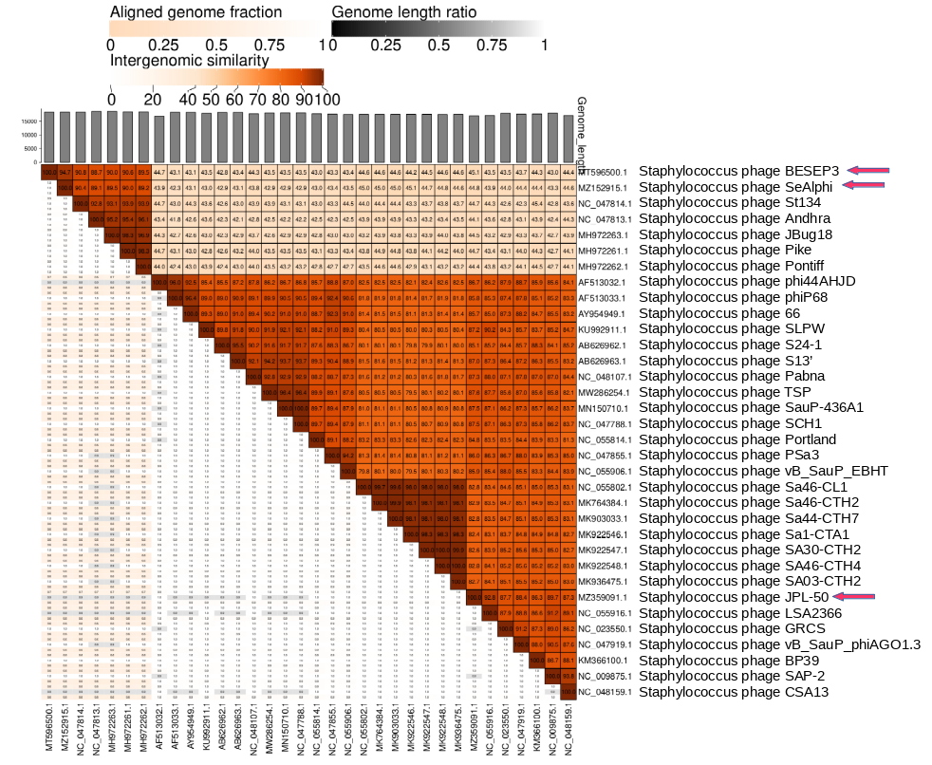

**ViPTree analysis:** ViPTree analysis (<https://www.genome.jp/viptree/>; [5]) is based upon Rohwer and Edwards (2002) famous Phage Proteomic Tree [6]. The **red** **stars** point to the new species of *Rakietenvirinae* subfamily. The blue arrowheads point to the genus *Andhravirus* and *Rosenblumvirus* of *Rakietenvirinae* subfamily.

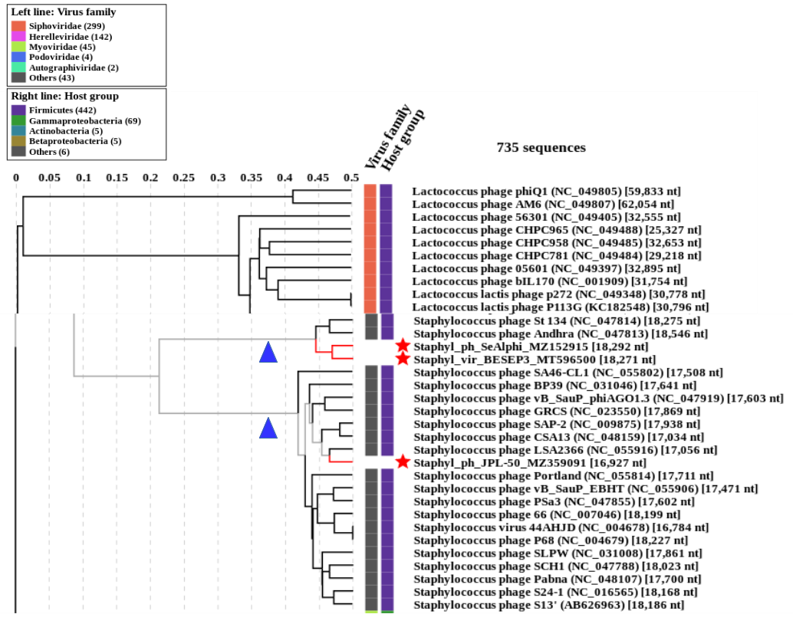

**Phylogeny:** The phylogenetic trees weres constructed using the major capsid protein and DNA polymerase homologs of Staphylococcus phage 44AHJD and related phages by employing the Tamura–Nei genetic distance model and a neighbour-joining tree-build method using the Geneious Tree Builder included in the Geneious Prime 2022 software. As an outgroup, a sequence of corresponding gene (DNA polymerase or major head/capsid protein) of closely related species was used, that was selected based on prior VipTree results. Proteins of phages of proposed new species are pointed with arrows.

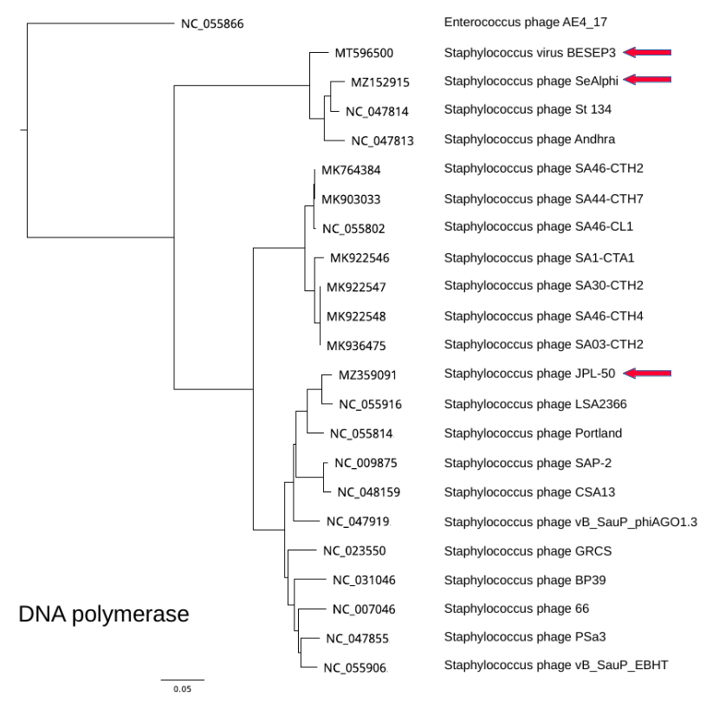

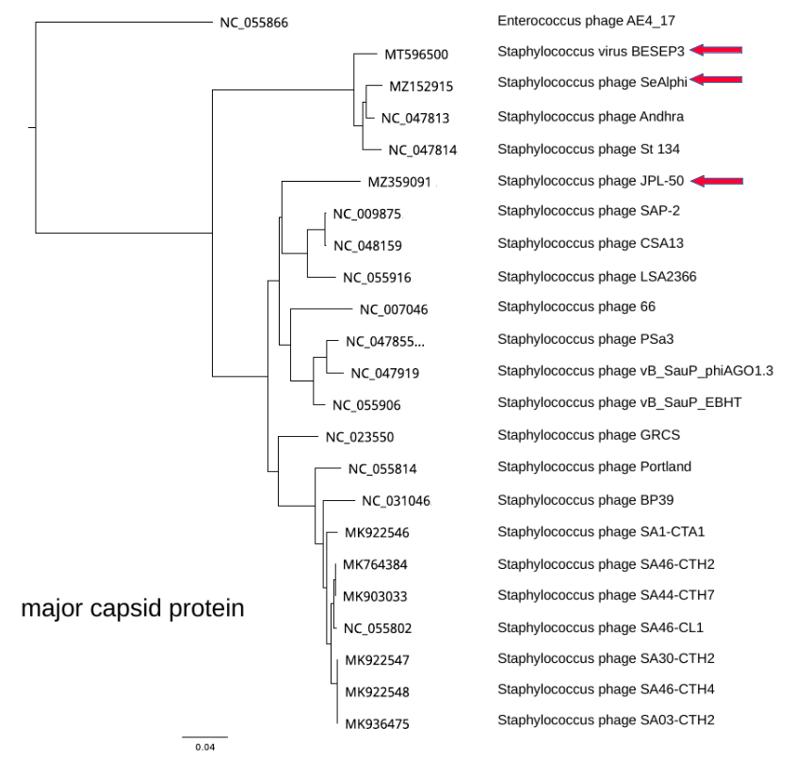

**References**

1. Chan PP, Lowe TM (2019) tRNAscan-SE: Searching for tRNA Genes in Genomic Sequences. Methods Mol Biol 1962:1-14. https://doi.org/10.1007/978-1-4939-9173-0_1. PMID: 31020551.

2. Moraru C (2020) VIRIDIC (Virus Intergenomic Distance Calculator) computes pairwise intergenomic distances/similarities amongst phage genomes. <http://kronos.icbm.uni-oldenburg.de/viridic/>   
3: Turner D, Reynolds D, Seto D, Mahadevan P. (2013) CoreGenes3.5: a webserver for the determination of core genes from sets of viral and small bacterial genomes. BMC Res Notes 6:140. https://doi.org/10.1186/1756-0500-6-140. PMID: 23566564.

4. Contreras-Moreira, B., & Vinuesa, P. (2013). GET_HOMOLOGUES, a versatile software package for scalable and robust microbial pangenome analysis. Appl Environ Microbiol 79:7696-7701.

5. Nishimura Y, Yoshida T, Kuronishi M, Uehara H, Ogata H, Goto S. ViPTree: the viral proteomic tree server. (2017) Bioinformatics 33:2379-2380. https://doi.org/10.1093/bioinformatics/btx157. PubMed PMID: 28379287.

6. Rohwer F, Edwards R (2002) The Phage Proteomic Tree: a genome-based taxonomy for phage. J Bacteriol 184:4529-35. PubMed PMID: 12142423