

**Part 1:** **TITLE, AUTHORS, APPROVALS, etc**

|  |  |  |
| --- | --- | --- |
| **Code assigned:** | ***2022.075B*** |  |
| **Short title:** Create a new subfamily (*Sejongvirinae*) and two new genera (*Basiliskvirus* and *Yihwangvirus*) (*Caudoviricetes*) | | |
|  | | |

**Author(s) and email address(es)**

|  |  |
| --- | --- |
| Barylski J, Turner D, Moraru C, Kropinski AM | jakub.barylski@gmail.com; Dann2.Turner@uwe.ac.uk; liliana.cristina.moraru@uol.de; Phage.Canada@gmail.com |

**Author(s) institutional address(es) (optional)**

|  |
| --- |
| Adam Mickiewicz University, Poznań, Poland [JB]  University of the West of England, Bristol, UK [DT]  Carl von Ossietzky Universität Oldenburg, Germany [CM]  University of Guelph, Canada [AMK] |

**Corresponding author**

|  |
| --- |
| Andrew M. Kropinski |

**List the ICTV Study Group(s) that have seen this proposal**

|  |
| --- |
| Bacterial Viruses Subcommittee, Caudoviricetes Study Group |

**ICTV Study Group comments and response of proposer**

|  |
| --- |
|  |

**ICTV Study Group votes on proposal**

|  |  |  |  |
| --- | --- | --- | --- |
| **Study Group** | **Number of members** | | |
| **Votes support** | **Votes against** | **No vote** |
|  |  |  |  |
|  |  |  |  |

**Authority to use the name of a living person**

|  |  |
| --- | --- |
| **Is any taxon name used here derived from that of a living person (Y/N)** | N |

|  |  |  |
| --- | --- | --- |
| **Taxon name** | **Person from whom the name is derived** | **Permission attached (Y/N)** |
|  |  |  |
|  |  |  |

**Submission dates**

|  |  |
| --- | --- |
| Date first submitted to SC Chair | May 2022 |
| Date of this revision (if different to above) |  |

**ICTV-EC comments and response of the proposer**

|  |
| --- |
|  |

**Part 2:** **NON-TAXONOMIC PROPOSAL**

**Text of proposal**

|  |
| --- |
|  |

**Part 3:** **TAXONOMIC PROPOSAL**

**Name of accompanying Excel module**

|  |
| --- |
| 2022.075B.N.v1.Sejongvirinae\_nsf.xlsx |

**Abstract**

|  |
| --- |
| We propose to create a subfamily of *Bacillus* siphoviruses containing two genera. These viruses are potentially temperate (they all encode tyrosine recombinase that is thought to be integrase) and may possess terminally redundant genomes. All the members of this group encode ParM-like proteins. |

**Text of proposal**

|  |  |
| --- | --- |
| |  | | --- | | **Species demarcation criteria:** Two phages are assigned to the same species if their genomes are more than 95% identical over their genome length for isolates. These values can be calculated by a number of tools, such as BLASTn [1] – usually calculated using intergenomic distance calculator VIRIDIC [2].  **Genus demarcation criteria:** In search for criteria that create cohesive and distinct genera that are reproducible and monophyletic, the Bacterial Viruses Subcommittee has established 70% nucleotide identity of the genome length as the cut-off for genera. Genus-level groupings should always be monophyletic in the signature genes, as tested with a phylogenetic tree [8]. | |

**Supporting evidence**

**VIRIDIC heat map:** VIRIDIC (Virus Intergenomic Distance Calculator; VIRIDIC (Virus Intergenomic Distance Calculator; [2]; http://rhea.icbm.uni-oldenburg.de/VIRIDIC/) computes pairwise intergenomic distances/similarities amongst phage genomes. The black box delineates strains.

****

**ViPTree analysis:** ViPTree analysis ([https://www.genome.jp/viptree/](about:blank); [3]) is based upon Rohwer and Edwards (2002) famous Phage Proteomic Tree [4]. The phages of interest areindicated with **red stars**.

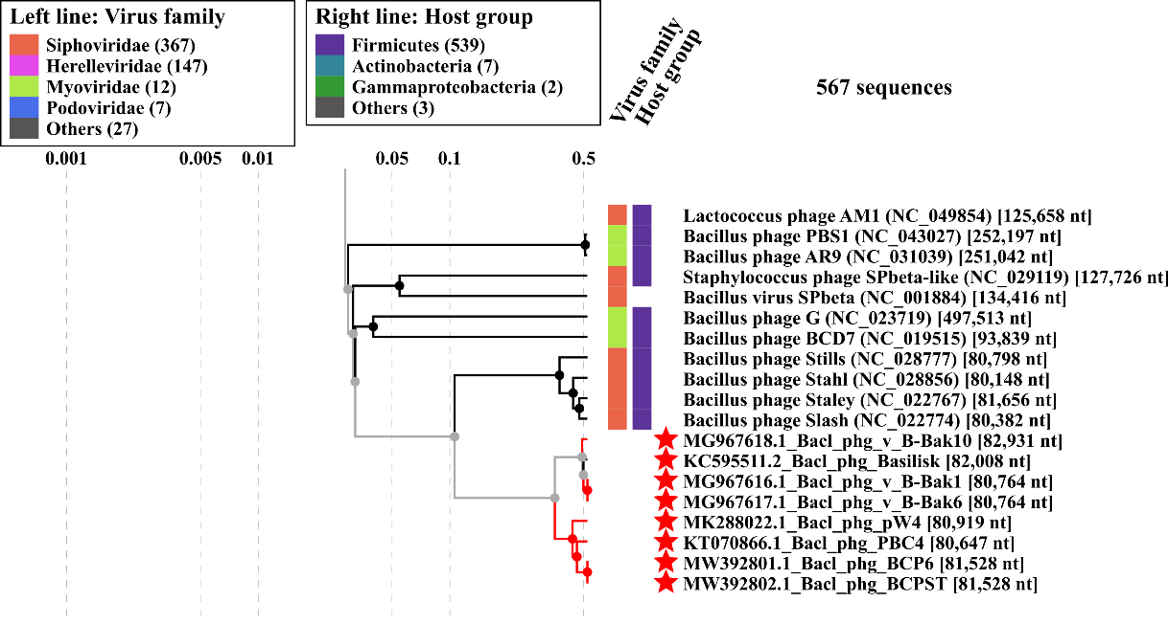

**Phylogeny:** The phylogenetic tree was constructed using the TerL proteins from Bacillus siphoviruses and related phages with phylogeny.fr in “one click” mode [6]. It also includes the use of Gblocks to eliminate poorly aligned positions and divergent regions. See: Anisimova M., Gascuel O. Approximate likelihood ratio test for branches: A fast, accurate and powerful alternative [7] for details. The members under discussion in this document are indicated with a **blue rectangle**.

****

**Proposals:**

**Proposal A: Create a new genus, *Basiliskvirus* with two species**

**Proposal B: Create a new genus, *Yihwangvirus* with three species**

**Proposal C: Create a new subfamily, *Sejongvirinae* with two genera (*Basiliskvirus and Yihwangvirus*)**

**Proposal A: Create a new genus, *Basiliskvirus* with two species**

**Origin of the name of this taxon:** This taxon is named after *Bacillus* phage Basilisk

**Historical aspects:** *Bacillus* phage Basilisk was isolated from soil samples taken at the bases of fruit trees in Utah County, Utah (USA) against *Bacillus cereus* BGSC 6E1.   
Bacillus phage v\_B-Bak10 was isolated in Georgia against *Bacillus anthracis*. Its genome has 219 bp direct terminal repeats; phage Basilisk has 218 bp DTRs [11].

**Electron micrograph:** N/A

**Genome summary:**

|  |  |  |  |  |  |  |  |
| --- | --- | --- | --- | --- | --- | --- | --- |
| Phage name | INSDC | Size (Kb) | GC% | Protein | tRNA | Overall % DNA sequence identity (\*) | Overall % homologous proteins (\*\*) |
| Bacillus phage Basilisk | [KC595511.2](https://www.ncbi.nlm.nih.gov/nuccore/KC595511.2) | 82.01 | 33.9 | [138](https://www.ncbi.nlm.nih.gov/genome/browse/#!/proteins/62650/465274|Bacillus phage Basilisk/viral segment/) | 2 | 100 | 100 |
| Bacillus phage v\_B-Bak10 | [MG967618.1](https://www.ncbi.nlm.nih.gov/nuccore/MG967618.1) | 82.93 | 33.8 | [115](https://www.ncbi.nlm.nih.gov/genome/browse/#!/proteins/72467/406859|Bacillus phage v_B-Bak10/viral segment/) | 2 | 94.3 | 83.3 |

**(\*) determined using BLASTn [1] or VIRIDIC [2]**

**(\*\*) determined using CoreGenes 3.5 [5]**

**Proposal B: Create a new genus, *Yihwangvirus* with three species**

**Origin of the name of this taxon:** This taxon is named in honour of the Korean philosopher, writer, and Confucian scholar Yi Hwang (1501–1570).

**Historical aspects:** *Bacillus* phage PBC4 was isolated in Korea in 2016 against *Bacillus cereus* [12]. Bacillus phage pW4 was isolated in China, while *Bacillus* phage BCPST was also isolated in Korea.

**Electron micrograph:** N/A

**Genome summary:**

|  |  |  |  |  |  |  |  |
| --- | --- | --- | --- | --- | --- | --- | --- |
| Phage name | INSDC | Size (Kb) | GC% | Protein | tRNA | Overall % DNA sequence identity (\*) | Overall % homologous proteins (\*\*) |
| Bacillus phage PBC4 | [KT070866.1](https://www.ncbi.nlm.nih.gov/nuccore/KT070866.1) | 80.65 | 34.0 | [123](https://www.ncbi.nlm.nih.gov/genome/browse/#!/proteins/62786/465411|Bacillus phage PBC4/viral segment/) | 2 | 100 | 100 |
| Bacillus phage pW4 | [MK288022.1](https://www.ncbi.nlm.nih.gov/nuccore/MK288022.1) | 80.92 | 34.0 | [106](https://www.ncbi.nlm.nih.gov/genome/browse/#!/proteins/75193/437894|Bacillus phage pW4/viral segment/) | 2 | 83.3 | 78.0 |
| Bacillus phage BCPST | [MW392802.1](https://www.ncbi.nlm.nih.gov/nuccore/MW392802.1) | 81.53 | 33.9 | [114](https://www.ncbi.nlm.nih.gov/genome/browse/#!/proteins/109071/1760336|Bacillus phage BCPST/viral segment/) | 2 | 87.3 | 78.0 |

**(\*) determined using BLASTn [1] or VIRIDIC [2]**

**(\*\*) determined using CoreGenes 3.5 [5]**

**Proposal C: Create a new subfamily, *Sejongvirinae* with two genera (*Basiliskvirus* and *Yihwangvirus*)**

**Origin of the name of this taxon:** This taxon is named in honour of the Korean King Sejong the Great (1397-1450) that personally created Hangul (the Korean alphabet) and encouraged advancements of science and technology (<https://en.wikipedia.org/wiki/Sejong_the_Great>).

**Historical aspects:** The two genera that make up this subfamily share ≥67.1% overall DNA sequence similarity and 138 (69.6%) conserved proteins.

**References**

1. Sayers EW, Beck J, Bolton EE, Bourexis D, Brister JR, Canese K, Comeau DC, Funk K, Kim S, Klimke W, Marchler-Bauer A, Landrum M, Lathrop S, Lu Z, Madden TL, O'Leary N, Phan L, Rangwala SH, Schneider VA, Skripchenko Y, Wang J, Ye J, Trawick BW, Pruitt KD, Sherry ST. Database resources of the National Center for Biotechnology Information. Nucleic Acids Res. 2021 Jan 8;49(D1):D10-D17. doi: 10.1093/nar/gkaa892. PMID: 33095870
2. Moraru C, Varsani A, Kropinski AM. VIRIDIC-A Novel Tool to Calculate the Intergenomic Similarities of Prokaryote-Infecting Viruses. Viruses. 2020 Nov 6;12(11):1268. doi: 10.3390/v12111268. PMID: 33172115; PMCID: PMC7694805. <http://kronos.icbm.uni-oldenburg.de/viridic/>
3. Nishimura Y, Yoshida T, Kuronishi M, Uehara H, Ogata H, Goto S. ViPTree: the viral proteomic tree server. Bioinformatics. 2017; 33(15):2379-2380. doi:10.1093/bioinformatics/btx157. PubMed PMID: 28379287. <https://www.genome.jp/viptree/>
4. Rohwer F, Edwards R. The Phage Proteomic Tree: a genome-based taxonomy for phage. J Bacteriol. 2002 Aug;184(16):4529-35. PubMed PMID: 12142423
5. Turner D, Reynolds D, Seto D, Mahadevan P. CoreGenes3.5: a webserver for the determination of core genes from sets of viral and small bacterial genomes. BMC Res Notes. 2013;6:140. doi: 10.1186/1756-0500-6-140. PMID: 23566564.
6. Dereeper A, Guignon V, Blanc G, Audic S, Buffet S, Chevenet F, Dufayard JF, Guindon S, Lefort V, Lescot M, Claverie JM, Gascuel O. Phylogeny.fr: robust phylogenetic analysis for the non-specialist. Nucleic Acids Res. 2008;36(Web Server issue):W465-9. doi: 10.1093/nar/gkn180. Epub 2008 Apr 19. PMID: 18424797.
7. Anisimova M, Gascuel O. Approximate likelihood-ratio test for branches: A fast, accurate, and powerful alternative. Syst Biol. 2006;55(4):539-52. PMID: 16785212. DOI: 10.1080/10635150600755453.
8. Turner D, Kropinski AM, Adriaenssens EM. A Roadmap for Genome-Based Phage Taxonomy. Viruses. 2021 Mar 18;13(3):506. doi: 10.3390/v13030506. PMID: 33803862; PMCID: PMC8003253.
9. O'Leary NA, Wright MW, Brister JR, Ciufo S, Haddad D, McVeigh R, et al. Reference sequence (RefSeq) database at NCBI: current status, taxonomic expansion, and functional annotation. Nucleic Acids Res. 2016;44(D1):D733-45. doi: 10.1093/nar/gkv1189. PMID: 26553804.
10. Olsen NS, Hendriksen NB, Hansen LH and Kot W. A New High-Throughput Screening Method for Phages: Enabling Crude Isolation and Fast Identification of Diverse Phages with Therapeutic Potential. Phage (New Rochelle) 1 (3), 137-148 (2020) <https://www.liebertpub.com/doi/10.1089/phage.2020.0016>
11. Grose JH, Jensen JD, Merrill BD, Fisher JN, Burnett SH, Breakwell DP. Genome Sequences of Three Novel Bacillus cereus Bacteriophages. Genome Announc. 2014 Jan 23;2(1):e01118-13. doi: 10.1128/genomeA.01118-13. PMID: 24459255; PMCID: PMC3900887.
12. Na H, Kong M, Ryu S. Characterization of LysPBC4, a novel Bacillus cereus-specific endolysin of bacteriophage PBC4. FEMS Microbiol Lett. 2016 Jun;363(12):fnw092. doi: 10.1093/femsle/fnw092. Epub 2016 Apr 11. PMID: 27190165.