

**Part 1:** **TITLE, AUTHORS, APPROVALS, etc**

|  |  |  |
| --- | --- | --- |
| **Code assigned:** | ***2022.076B*** |  |
| **Short title:** Create a new genus *Shantouvirus* in the family *Chaseviridae* including a new species *Shantouvirus* ZPAH14 (*Caudoviricetes*) | | |
|  | | |

**Author(s) and email address(es)**

|  |  |
| --- | --- |
| Li J-Q | lijinquan2017@163.com |

**Author(s) institutional address(es) (optional)**

|  |
| --- |
| Huazhong Agricultural University [LJQ] |

**Corresponding author**

|  |
| --- |
| Li J-Q (lijinquan2017@163.com) |

**List the ICTV Study Group(s) that have seen this proposal**

|  |
| --- |
| Bacterial & Archaeal Virus Subcommittee |

**ICTV Study Group comments and response of proposer**

|  |
| --- |
|  |

**ICTV Study Group votes on proposal**

|  |  |  |  |
| --- | --- | --- | --- |
| **Study Group** | **Number of members** | | |
| **Votes support** | **Votes against** | **No vote** |
|  |  |  |  |
|  |  |  |  |

**Authority to use the name of a living person**

|  |  |
| --- | --- |
| **Is any taxon name used here derived from that of a living person (Y/N)** | N |

|  |  |  |
| --- | --- | --- |
| **Taxon name** | **Person from whom the name is derived** | **Permission attached (Y/N)** |
|  |  |  |

**Submission dates**

|  |  |
| --- | --- |
| Date first submitted to SC Chair | April 2022 |
| Date of this revision (if different to above) |  |

**ICTV-EC comments and response of the proposer**

|  |
| --- |
|  |

**Part 2:** **NON-TAXONOMIC PROPOSAL**

**Text of proposal**

|  |
| --- |
|  |

**Part 3:** **TAXONOMIC PROPOSAL**

**Name of accompanying Excel module**

|  |
| --- |
| 2022.076B.N.v1.Shantouvirus_ng.xlsx |

**Abstract**

|  |
| --- |
| We isolated a new *Aeromonas* phage named ZPAH14, and ViPTree analysis classified as a member of the family *Chaseviridae.* Based on the VIRIDIC and phylogenetic analysis, we found that ZPAH14fell within a clade that separated from the other genera of the family.  Therefore, we propose a new genus *Shantouvirus*, and a new species *Shantouvirus* *ZPAH14*. The genome of ZPAH14 had been submitted to the NCBI GenBank database and is available under the accession number OM810291. |

**Text of proposal**

|  |  |
| --- | --- |
| |  | | --- | | **Species demarcation criteria:** Two phages are assigned to the same species if their genomes are more than 95% identical over their genome length for isolates.  These values can be calculated by a number of tools, such as BLASTn – usually calculated using intergenomic distance calculator VIRIDIC [1].  **Genus demarcation criteria:** In search for criteria that create cohesive and distinct genera that are reproducible and monophyletic, the Bacterial Viruses Subcommittee has established 70% nucleotide identity of the genome length as the cut-off for genera. Genus-level groupings should always be monophyletic in the signature genes, as tested with a phylogenetic tree [2]. | |

**Supporting evidence**

**ViPTree analysis:** ViPTree analysis (https://www.genome.jp/viptree/; [3]) is based upon Rohwer and Edwards (2002) famous Phage Proteomic Tree [4]. The phages of interest are indicated with **red arrow and box**.

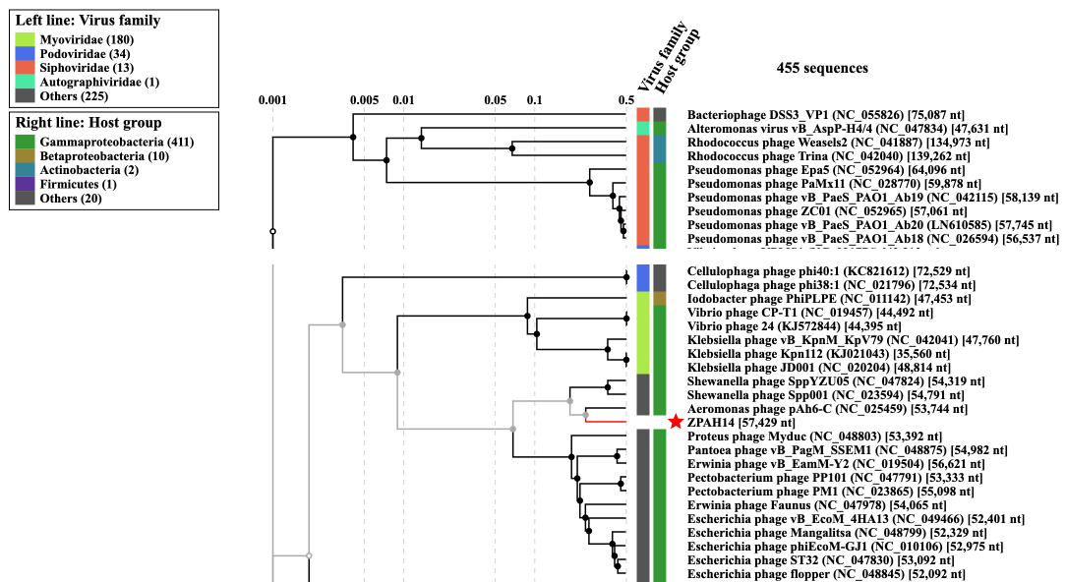

**VIRIDIC heat map:** VIRIDIC (Virus Intergenomic Distance Calculator; [1]; http://rhea.icbm.uni-oldenburg.de/VIRIDIC/) computes pairwise intergenomic distances/similarities amongst phage genomes.

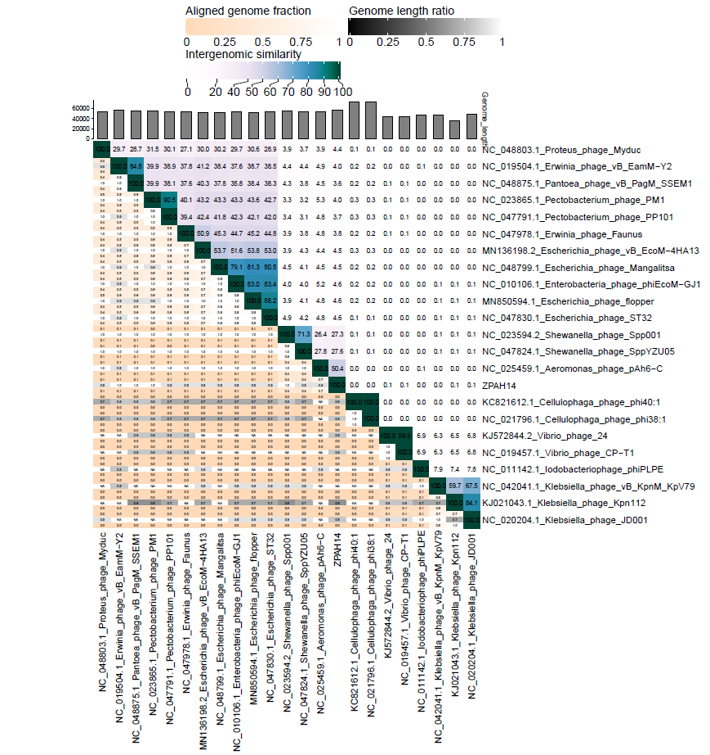

**Phylogeny:** The phylogenetic tree was constructed using the major capsid proteins of phages [5]. MUSCLE was used for multiple alignment and MEGA(v11.0.10) was used for building phylogenetic tree using maximum-likelihood method with 500 bootstrap replicates [6]. The new genus is indicated with **red box** and new species is indicated with **red arrow.**

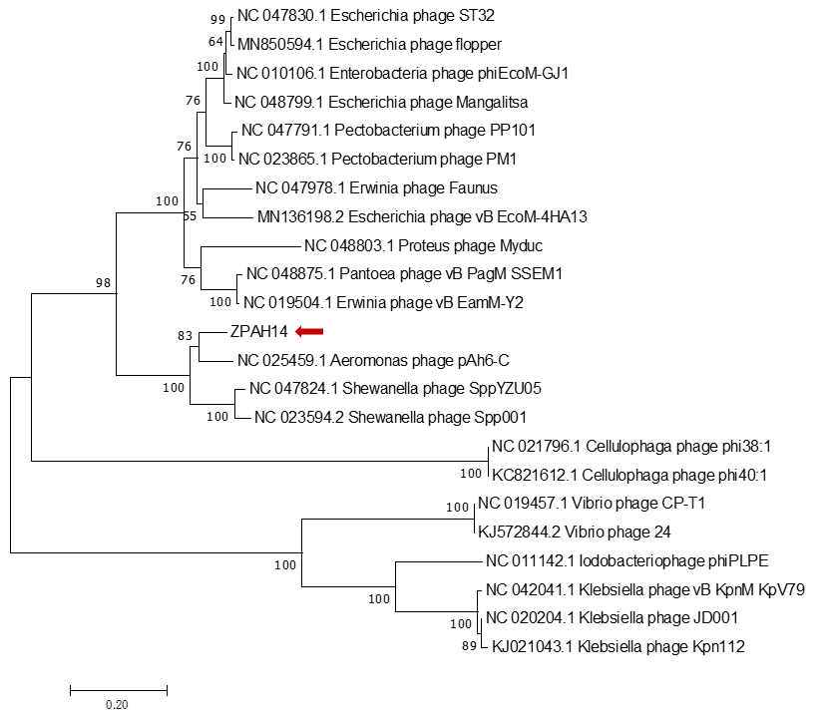

**Origin of the name of this taxon:** This genus is named based on Shantou, a city located in southern China*.*

**Historical aspects:** The phage ZPAH14 was isolated in 2018 by our team from lake water, using *Aeromonas hydrophila* as the host bacterium.

**Specific References:** None

**Genome summary:**

|  |  |  |  |  |  |  |  |  |
| --- | --- | --- | --- | --- | --- | --- | --- | --- |
| Phage name | RefSeq No. | INSDC | Size (Kb) | GC% | Protein | tRNA | Overall % DNA sequence identity (*) | Overall % homologous proteins (**) |
| *Aeromonas* phage ZPAH14 |  | OM80291 | 57.4 | 56.8 | 71 | 1 | 100 | 100 |

**(*) Determined using VIRIDIC [1]**

**(**) Determined using CoreGenes 3.5 at** [**http://binf.gmu.edu:8080/CoreGenes3.5/**](http://binf.gmu.edu:8080/CoreGenes3.5/)**[7]**

**References**

1: Moraru C, Varsani A, Kropinski AM. VIRIDIC-A Novel Tool to Calculate the Intergenomic Similarities of Prokaryote-Infecting Viruses. Viruses. 2020 Nov 6;12(11):1268. doi: 10.3390/v12111268. PMID: 33172115.

2: Turner D, Kropinski AM, Adriaenssens EM. A Roadmap for Genome-Based Phage Taxonomy. Viruses. 2021 Mar 18;13(3):506. doi: 10.3390/v13030506. PMID: 33803862.

3: Nishimura Y, Yoshida T, Kuronishi M, Uehara H, Ogata H, Goto S. ViPTree: the viral proteomic tree server. Bioinformatics. 2017 Aug 1;33(15):2379-2380. doi: 10.1093/bioinformatics/btx157. PMID: 28379287.

4: Rohwer F, Edwards R. The Phage Proteomic Tree: a genome-based taxonomy for phage. J Bacteriol. 2002 Aug;184(16):4529-35. doi: 10.1128/jb.184.16.4529-4535.2002. PMID: 12142423.

5: Dereeper A, Guignon V, Blanc G, Audic S, Buffet S, Chevenet F, Dufayard JF, Guindon S, Lefort V, Lescot M, Claverie JM, Gascuel O. Phylogeny.fr: robust phylogenetic analysis for the non-specialist. Nucleic Acids Res. 2008;36(Web Server issue):W465-9. doi: 10.1093/nar/gkn180. Epub 2008 Apr 19. PMID: 18424797.

6: Anisimova M, Gascuel O. Approximate likelihood-ratio test for branches: A fast, accurate, and powerful alternative. Syst Biol. 2006;55(4):539-52. doi: 10.1080/10635150600755453. PMID: 16785212.

7: Turner D, Reynolds D, Seto D, Mahadevan P. CoreGenes3.5: a webserver for the determination of core genes from sets of viral and small bacterial genomes. BMC Res Notes. 2013;6:140. doi: 10.1186/1756-0500-6-140. PMID: 23566564.