

**Part 1:** **TITLE, AUTHORS, APPROVALS, etc**

|  |  |  |
| --- | --- | --- |
| **Code assigned:** | ***2022.080B*** |  |
| **Short title:** Create six new genera for Arthrobacter phages (*Caudoviricetes*) | | |
|  | | |

**Author(s) and email address(es)**

|  |  |
| --- | --- |
|  |  |
| Kurtböke I,Turner D, Moraru C, Kropinski AM | ikurtbok@usc.edu.au; Dann2.Turner@uwe.ac.uk; liliana.cristina.moraru@uol.de; Phage.Canada@gmail.com |

**Author(s) institutional address(es) (optional)**

|  |
| --- |
| University of the Sunshine Coast, Australia [IK]  University of the West of England, Bristol, UK [DT]  Carl von Ossietzky Universität Oldenburg, Germany [CM]  University of Guelph, Canada [AMK] |

**Corresponding author**

|  |
| --- |
| Andrew M. Kropinski |

**List the ICTV Study Group(s) that have seen this proposal**

|  |
| --- |
| Bacterial Viruses Subcommittee, Actinophage Study Group |

**ICTV Study Group comments and response of proposer**

|  |
| --- |
|  |

**ICTV Study Group votes on proposal**

|  |  |  |  |
| --- | --- | --- | --- |
| **Study Group** | **Number of members** | | |
| **Votes support** | **Votes against** | **No vote** |
|  |  |  |  |
|  |  |  |  |

**Authority to use the name of a living person**

|  |  |
| --- | --- |
| **Is any taxon name used here derived from that of a living person (Y/N)** | N |

|  |  |  |
| --- | --- | --- |
| **Taxon name** | **Person from whom the name is derived** | **Permission attached (Y/N)** |
|  |  |  |
|  |  |  |
|  |  |  |

**Submission dates**

|  |  |
| --- | --- |
| Date first submitted to SC Chair | May 2022 |
| Date of this revision (if different to above) |  |

**ICTV-EC comments and response of the proposer**

|  |
| --- |
| Error corrected: Genus *Seahorsevirus* was already proposed in separate proposal and renamed to *Seamegvirus*. |

**Part 2:** **NON-TAXONOMIC PROPOSAL**

**Text of proposal**

|  |
| --- |
|  |

**Part 3:** **TAXONOMIC PROPOSAL**

**Name of accompanying Excel module**

|  |
| --- |
| 2022.080B.N.v1.Caudoviricetes_6ng.xlsx |

**Abstract**

|  |
| --- |
| On the basis of DNA sequence similarity we have resolved The Actinobacteriophage Database Cluster AY into six genera: *Richievirus, Hestiavirus, Persistencevirus, Isoladevirus, Seamegvirus* and *Fajavirus*. |

**Text of proposal**

|  |  |
| --- | --- |
| |  | | --- | | **Species demarcation criteria:** Two phages are assigned to the same species if their genomes are more than 95% identical over their genome length for isolates.  These values can be calculated by a number of tools, such as BLASTn [1] – usually calculated using intergenomic distance calculator VIRIDIC [2].  **Genus demarcation criteria:** In search for criteria that create cohesive and distinct genera that are reproducible and monophyletic, the Bacterial Viruses Subcommittee has established 70% nucleotide identity of the genome length as the cut-off for genera. Genus-level groupings should always be monophyletic in the signature genes, as tested with a phylogenetic tree. [8] | |

**Supporting evidence – molecular data**

**VIRIDIC heat map:** VIRIDIC (Virus Intergenomic Distance Calculator; VIRIDIC (Virus Intergenomic Distance Calculator; [2]; http://rhea.icbm.uni-oldenburg.de/VIRIDIC/) computes pairwise intergenomic distances/similarities amongst phage genomes.



**ViPTree analysis:** ViPTree analysis (https://www.genome.jp/viptree/; [3]) is based upon Rohwer and Edwards (2002) famous Phage Proteomic Tree [4]. The phages of interest are indicated with **red stars**.





**Phylogeny:** The phylogenetic tree was constructed using the MCPs from Richie and related phages with phylogeny.fr in “one click” mode [6]. It also includes the use of Gblocks to eliminate poorly aligned positions and divergent regions. See Anisimova M., Gascuel O. Approximate likelihood ratio test for branches: A fast, accurate and powerful alternative [7] for details. The members of this group of phages are indicated with **blue rectangles**.



**progressiveMauve:** This method uses a novel alignment objective score called a sum-of-pairs breakpoint score, which facilitates accurate detection of rearrangement breakpoints when genomes have unequal gene content. We also apply a probabilistic alignment filtering method to remove erroneous alignments of unrelated sequences, which are commonly observed in other genome alignment methods. We describe new metrics for quantifying genome alignment accuracy which measure the quality of rearrangement breakpoint predictions and indel predictions.[10]

We applied this technique to analyzing relationships since the phylogenetic tree and the Actinobacteriophage Database indicate all these phages are related. This indicates that there are two regions of the genomes which are related, one of which includes the MCP-encoding genes.



**Proposals:**

1. **Create a new genus, *Richievirus*, with two species**
2. **Create a new genus, *Hestiavirus*, with one species**
3. **Create a new genus, *Persistencevirus*, with one species**
4. **Create a new genus, *Isoldevirus*, with one species**
5. **Create a new genus, *Seamegvirus*, with one species**
6. **Create a new genus, Fajavirus, with one species**

**Details:**

1. **Create a new genus, *Richievirus*, with two species**

**Origin of the name of this taxon:** This taxon is named after Arthrobacter phage Richie

**Historical aspects:** This temperate siphophage was isolated in 2017 by Megan Ulbrich (University of Pittsburgh, PA, USA) against Arthrobacter globiformis B-2979 from soil as part of the Phage Hunters Integrating Research and Education program. The genome is has 9 nt 3’-cohesive termini. The Actinobacteriophage Database classified Richie to Cluster AY which we are now subdividing*.*

**Electron micrograph:** Electron micrographs of negatively stained Arthrobacter phage Richie (https://phagesdb.org/phages/Richie/). Limited permission was granted by The Actinobacteriophages Database (https://phagesdb.org/), funded by the Howard Hughes Medical Institute, to use this electron micrograph for this taxonomy proposal; it cannot be reused without permission of The Actinobacteriophages Database.

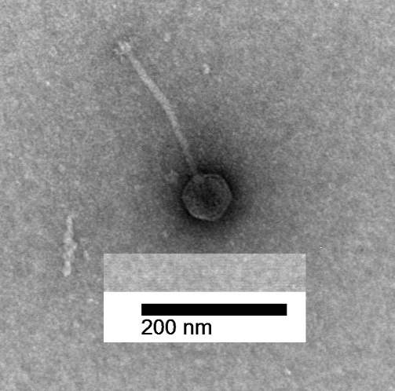

**Genome summary:**

|  |  |  |  |  |  |  |  |
| --- | --- | --- | --- | --- | --- | --- | --- |
| Phage name | INSDC | Size (Kb) | GC% | Protein | tRNA | Overall % DNA sequence identity (*) | Overall % homologous proteins (**) |
| Arthrobacter phage Richie | MH834625.1 | 53.87 | 62.7 | 98 | 1 | 100 | 100 |
| Arthrobacter phage Auxilium | MH834598.1 | 49.45 | 62.6 | 93 | 0 | 73.7 | 73.5 |

**(*) determined using BLASTn [1] or VIRIDIC [2]**

**(**) determined using CoreGenes 3.5 [5]**

1. **Create a new genus, *Hestiavirus*, with one species**

**Origin of the name of this taxon:** This taxon is named after Arthrobacter phage Hestia

**Historical aspects:** This temperate siphophage was isolated in 2017 by Megan Ulbrich (University of Pittsburgh, PA, USA) against Arthrobacter globiformis B-2979 from moist soil as part of the Phage Hunters Integrating Research and Education program. The genome is has 9 nt 3’-cohesive termini (CGCCGGTGA). The Actinobacteriophage Database classified Richie to Cluster AY which we are now subdividing.

**Electron micrograph:** N/A

**Genome summary:**

|  |  |  |  |  |  |  |  |
| --- | --- | --- | --- | --- | --- | --- | --- |
| Phage name | INSDC | Size (Kb) | GC% | Protein | tRNA | Overall % DNA sequence identity (*) | Overall % homologous proteins (**) |
| Arthrobacter phage Hestia | MH910036.1 | 51.48 | 62.3 | 89 | 2 | 100 | 100 |

**(*) determined using BLASTn [1] or VIRIDIC [2]**

**(**) determined using CoreGenes 3.5 [5]**

1. **Create a new genus, *Persistencevirus*, with one species**

**Origin of the name of this taxon:** This taxon is named after Arthrobacter phage Persistence

**Historical aspects:** This temperate siphophage was isolated in 2019 by Madison Lee (College of Coastal Georgia, Brunswick, GA, USA) against Arthrobacter globiformis B-2979 from soil as part of the Science Education Alliance-Phage Hunters Advancing Genomics and Evolutionary Science program. The genome is has 9 nt 3’-cohesive termini (CGCCGGTGA). The Actinobacteriophage Database classified Richie to Cluster AY which we are now subdividing.

**Electron micrograph:** Electron micrographs of negatively stained Arthrobacter phage Persistence (https://phagesdb.org/phages/Persistence/). Limited permission was granted by The Actinobacteriophages Database (https://phagesdb.org/), funded by the Howard Hughes Medical Institute, to use this electron micrograph for this taxonomy proposal; it cannot be reused without permission of The Actinobacteriophages Database.

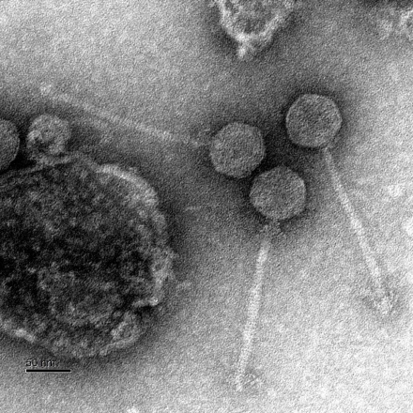

**Genome summary:**

|  |  |  |  |  |  |  |  |
| --- | --- | --- | --- | --- | --- | --- | --- |
| Phage name | INSDC | Size (Kb) | GC% | Protein | tRNA | Overall % DNA sequence identity (*) | Overall % homologous proteins (**) |
| Arthrobacter phage Persistence | MW712719.1 | 50.43 | 62.1 | 89 | 0 | 100 | 100 |

**(*) determined using BLASTn [1] or VIRIDIC [2]**

**(**) determined using CoreGenes 3.5 [5]**

1. **Create a new genus, *Isoldevirus*, with one species**

**Origin of the name of this taxon:** This taxon is named after Arthrobacter phage Isolde

**Historical aspects:** This temperate siphophage was isolated in 2017 by Kira Zack (University of Pittsburgh, PA, USA) against Arthrobacter globiformis B-2979 from soil as part of the Phage Hunters Integrating Research and Education program. The genome is has 9 nt 3’-cohesive termini (CGCCGGTGA). The Actinobacteriophage Database classified Richie to Cluster AY which we are now subdividing.

**Electron micrograph:** Electron micrographs of negatively stained Arthrobacter phage Isolde (https://phagesdb.org/phages/Isolde/). Limited permission was granted by The Actinobacteriophages Database (https://phagesdb.org/), funded by the Howard Hughes Medical Institute, to use this electron micrograph for this taxonomy proposal; it cannot be reused without permission of The Actinobacteriophages Database.

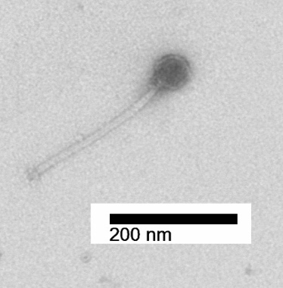

**Genome summary:**

|  |  |  |  |  |  |  |  |
| --- | --- | --- | --- | --- | --- | --- | --- |
| Phage name | INSDC | Size (Kb) | GC% | Protein | tRNA | Overall % DNA sequence identity (*) | Overall % homologous proteins (**) |
| Arthrobacter phage Isolde | MH910037.1 | 53.23 | 62.6 | 96 | 2 | 98 | 100 |

**(*) determined using BLASTn [1] or VIRIDIC [2]**

**(**) determined using CoreGenes 3.5 [5]**

1. **Create a new genus, *Seamegvirus*, with one species**

**Origin of the name of this taxon:** This taxon is named after Arthrobacter phage Seahorse, with an adaptation to account for the genus name *Seahorse* already proposed for another genus.

**Historical aspects:** This temperate siphophage Seahorse was isolated in 2017 by Megan Ulbrich (University of Pittsburgh, PA, USA) against Arthrobacter globiformis B-2979 from silty soil as part of the Phage Hunters Integrating Research and Education program. The genome is has 9 nt 3’-cohesive termini (CGCCGGTGA). The Actinobacteriophage Database classified Richie to Cluster AY which we are now subdividing.

**Electron micrograph:** N/A

**Genome summary:**

|  |  |  |  |  |  |  |  |
| --- | --- | --- | --- | --- | --- | --- | --- |
| Phage name | INSDC | Size (Kb) | GC% | Protein | tRNA | Overall % DNA sequence identity (*) | Overall % homologous proteins (**) |
| Arthrobacter phage Seahorse | MH910041.1 | 56.48 | 62.7 | 100 | 1 | 100 | 100 |

**(*) determined using BLASTn [1] or VIRIDIC [2]**

**(**) determined using CoreGenes 3.5 [5]**

1. **Create a new genus, Fajavirus, with one species**

**Origin of the name of this taxon:** This taxon is named after Arthrobacter phage Faja

**Historical aspects:** This temperate siphophage was isolated in 2017 by Megan Ulbrich (University of Pittsburgh, PA, USA) against Arthrobacter globiformis B-2979 from soil as part of the Phage Hunters Integrating Research and Education program. The genome is has 9 nt 3’-cohesive termini (CGCCGGTGA). The Actinobacteriophage Database classified Richie to Cluster AY which we are now subdividing.

**Electron micrograph:** Electron micrographs of negatively stained Arthrobacter phage Mollymur (https://phagesdb.org/phages/Mollymur/). Limited permission was granted by The Actinobacteriophages Database (https://phagesdb.org/), funded by the Howard Hughes Medical Institute, to use this electron micrograph for this taxonomy proposal; it cannot be reused without permission of The Actinobacteriophages Database.

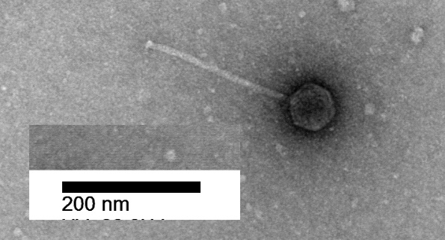

**Genome summary:**

|  |  |  |  |  |  |  |  |
| --- | --- | --- | --- | --- | --- | --- | --- |
| Phage name | INSDC | Size (Kb) | GC% | Protein | tRNA | Overall % DNA sequence identity (*) | Overall % homologous proteins (**) |
| Arthrobacter phage Faja | MH834612.1 | 52.49 | 63.1 | 95 | 1 | 100 | 100 |

**(*) determined using BLASTn [1] or VIRIDIC [2]**

**(**) determined using CoreGenes 3.5 [5]**

**References**

1. Sayers EW, Beck J, Bolton EE, Bourexis D, Brister JR, Canese K, Comeau DC, Funk K, Kim S, Klimke W, Marchler-Bauer A, Landrum M, Lathrop S, Lu Z, Madden TL, O'Leary N, Phan L, Rangwala SH, Schneider VA, Skripchenko Y, Wang J, Ye J, Trawick BW, Pruitt KD, Sherry ST. Database resources of the National Center for Biotechnology Information. Nucleic Acids Res. 2021 Jan 8;49(D1):D10-D17. doi: 10.1093/nar/gkaa892. PMID: 33095870
2. Moraru C, Varsani A, Kropinski AM. VIRIDIC-A Novel Tool to Calculate the Intergenomic Similarities of Prokaryote-Infecting Viruses. Viruses. 2020 Nov 6;12(11):1268. doi: 10.3390/v12111268. PMID: 33172115; PMCID: PMC7694805. http://kronos.icbm.uni-oldenburg.de/viridic/
3. Nishimura Y, Yoshida T, Kuronishi M, Uehara H, Ogata H, Goto S. ViPTree: the viral proteomic tree server. Bioinformatics. 2017; 33(15):2379-2380. doi:10.1093/bioinformatics/btx157. PubMed PMID: 28379287. https://www.genome.jp/viptree/
4. Rohwer F, Edwards R. The Phage Proteomic Tree: a genome-based taxonomy for phage. J Bacteriol. 2002 Aug;184(16):4529-35. PubMed PMID: 12142423
5. Turner D, Reynolds D, Seto D, Mahadevan P. CoreGenes3.5: a webserver for the determination of core genes from sets of viral and small bacterial genomes. BMC Res Notes. 2013;6:140. doi: 10.1186/1756-0500-6-140. PMID: 23566564.
6. Dereeper A, Guignon V, Blanc G, Audic S, Buffet S, Chevenet F, Dufayard JF, Guindon S, Lefort V, Lescot M, Claverie JM, Gascuel O. Phylogeny.fr: robust phylogenetic analysis for the non-specialist. Nucleic Acids Res. 2008;36(Web Server issue):W465-9. doi: 10.1093/nar/gkn180. Epub 2008 Apr 19. PMID: 18424797.
7. Anisimova M, Gascuel O. Approximate likelihood-ratio test for branches: A fast, accurate, and powerful alternative. Syst Biol. 2006;55(4):539-52. PMID: 16785212. DOI: 10.1080/10635150600755453.
8. Turner D, Kropinski AM, Adriaenssens EM. A Roadmap for Genome-Based Phage Taxonomy. Viruses. 2021 Mar 18;13(3):506. doi: 10.3390/v13030506. PMID: 33803862; PMCID: PMC8003253.
9. O'Leary NA, Wright MW, Brister JR, Ciufo S, Haddad D, McVeigh R, et al. Reference sequence (RefSeq) database at NCBI: current status, taxonomic expansion, and functional annotation. Nucleic Acids Res. 2016;44(D1):D733-45. doi: 10.1093/nar/gkv1189. PMID: 26553804.
10. Darling AE, Mau B, Perna NT. progressiveMauve: multiple genome alignment with gene gain, loss and rearrangement. PLoS One. 2010 Jun 25;5(6):e11147. doi: 10.1371/journal.pone.0011147. PMID: 20593022; PMCID: PMC2892488.