

Part 1: TITLE, AUTHORS, APPROVALS, etc

Code assigned: | 2022.084B
Short title: Create six new genera and 33 new species of Gordonia siphoviruses (Caudoviricetes)

Author(s) and email address(es)
Kurtböke I, Turner D, Moraru C, Adriaenssens EM, Kropinski AM | IKurtbok@usc.edu.au; Dann2.Turner@uwe.ac.uk; liliana.cristina.moraru@uol.de; evelien.adriaenssens@quadram.ac.uk; Phage.Canada@gmail.com
Author(s) institutional address(es) (optional)
University of the Sunshine Coast, Australia [IK]
University of the West of England, Bristol, UK [DT]
Carl von Ossietzky Universität Oldenburg, Germany [CM]
Quadram Institute Bioscience, UK [EMA]
University of Guelph, Canada [AMK]
Corresponding author
Andrew M. Kropinski
List the ICTV Study Group(s) that have seen this proposal

Bacterial Viruses Subcommittee, Actinophages Study Group

ICTV Study Group comments and response of proposer

ICTV Study Group votes on proposal

Study Group | Number of members
 | Votes support | Votes against | No vote
Actinophage Study group
Authority to use the name of a living person

Is any taxon name used here derived from that of a living person (Y/N) | N

Taxon name | Person from whom the name is derived | Permission attached (Y/N)

Submission dates
Date first submitted to SC Chair | March 2022
Date of this revision (if different to above) | September 2022
ICTV-EC comments and response of the proposer
ICTV-EC: Please provide more evidence that the proposed new family is monophyletic and rearrange the proposal structure.

Proposer: After re-examination of the data, we come to the conclusion that we need to perform additional analyses in support of the creation of the new family. At this time, we will only create the genera and species.

Part 2: NON-TAXONOMIC PROPOSAL

Text of proposal

Part 3: TAXONOMIC PROPOSAL
Name of accompanying Excel module
2022.084B.Uc.v2.Caudoviricetes_6ng_33nsp.xlsx
Abstract

Based upon genomic (VIRIDIC), proteomic (ViPTree) and phylogenetic analyses we have analyzed phages which belong to the Actinobacteriophage Database Cluster CZ and have defined five genera:, Beenievirus, Denisevirus, Howevirus, Powerballvirus, and Sidiousvirus. In addition, we have added species to the related Attisvirus, Baxterfoxvirus Nymphadoravirus,

On average the properties of viruses belonging to this as yet undefined higher taxon are that they are temperate siphoviruses with 49.5 kb (66.4 mol%G+C) dsDNA genomes possessing 10-11 nt 3’-cohesive termini which encode 78 proteins and usually no tRNAs.
Text of proposal
Species demarcation criteria: Two phages are assigned to the same species if their genomes are more than 95% identical over their genome length for isolates.
These values can be calculated by a number of tools, such as BLASTn [1] – usually calculated using intergenomic distance calculator VIRIDIC [2].

Genus demarcation criteria: In search for criteria that create cohesive and distinct genera that are reproducible and monophyletic, the Bacterial Viruses Subcommittee has established 70% nucleotide identity of the genome length as the cut-off for genera. Genus-level groupings should always be monophyletic in the signature genes, as tested with a phylogenetic tree. [8]

Proposal A. Add eight (8) new species to the genus Attisvirus
Proposal B. Rename and add one new species to the genus Baxterfoxvirus
Proposal C. Add nine (9) new species to the genus Nymphadoravirus
Proposal D. Create a new genus Powerballvirus with one species
Proposal E. Create a new genus Beenievirus with ten (10) species
Proposal F. Create a new genus Denisevirus with one species
Proposal G. Create a new genus Howevirus with two (2) species
Proposal H. Create a new genus Sidiousvirus with one species

Supporting evidence
Proposal A. Add eight (8) new species to the genus Attisvirus
Origin of the name of this taxon: This taxon is named after the first temperate phage of its type Gordonia phage Attis

Historical aspects: This taxon was created through Taxonomy Proposal 2017.005B. The Actinobacteriophage Database classifies this phage to Cluster CZ, subcluster CZ2.

Electron micrograph: N/A

Genome summary:

Phage name | INSDC | Size (Kb) | GC% | Protein | Overall % DNA sequence identity (*) | Overall % homologous proteins (**)
Gordonia phage Attis | KU963247.1 | 47.88 | 66.8 | 74 | 100 | 100
Gordonia phage Vasanti | MK359313.1 | 46.46 | 67.0 | 71 | 51.8 | 62.2
Gordonia phage Matteo | MT771342.1 | 44.08 | 66.6 | 68 | 52.7 | 64.9
Gordonia phage Pickett | OM203160.1 | 45.41 | 66.6 | 74 | 66.7 | 75.7
Gordonia phage Yeet412 | MZ150788.1 | 46.68 | 66.8 | 73 | 90.1 | 94.6
Gordonia phage Lamberg | MW055908.1 | 44.73 | 66.6 | 71 | 63.4 | 71.6
Gordonia phage Sahara | MZ171371.1 | 45.07 | 66.7 | 72 | 69.9 | 75.7
Gordonia phage Bjanes7 | MG099941.1 | 46.04 | 66.6 | 72 | 79.1 | 81.1
Gordonia phage Ebert | MH271295.1 | 46.65 | 66.6 | 78 | 70.1 | 75.7
(*) determined using BLASTn [1] or VIRIDIC [2]
(**) determined using CoreGenes 3.5 [5]

VIRIDIC heat map: VIRIDIC (Virus Intergenomic Distance Calculator; VIRIDIC (Virus Intergenomic Distance Calculator; [2]; http://rhea.icbm.uni-oldenburg.de/VIRIDIC/) computes pairwise intergenomic distances/similarities amongst phage genomes. The black box delineates strains, while the grey highlighted names correspond to new strains.

Phylogeny: The phylogenetic tree was constructed using the TerL proteins from Attis and related phages with phylogeny.fr in “one click” mode [6]. The usual bootstrapping procedure is replaced by a new confidence index that is much faster to compute. See: Anisimova M., Gascuel O. Approximate likelihood ratio test for branches: A fast, accurate and powerful alternative [7] for details. The members of the Attisvirus are indicated with a blue rectangle. Since creating this proposal, Gordonia phage MrBates was renamed to Gordonia phage Pickett.

Proposal B. Rename and add one new species to the genus Baxterfoxvirus

Origin of the name of this taxon: This taxon is named after the first phage of its type Gordonia phage BaxterFox. Originally the name of this genus was Baxtervirus. The current change brings it into agreement with the Actinobacteriophage Database.

Historical aspects: This temperate siphophages taxon was created through Taxonomy Proposal 2017.011B. The Actinobacteriophage Database classifies phages in this taxon to Cluster CZ, Subcluster CZ3. N.B. The capsid is isometric.

Electron micrograph: N/A

Genome summary:

Phage name | INSDC | Size (Kb) | GC% | Protein | tRNA | Overall % DNA sequence identity (*) | Overall % homologous proteins (**)
Gordonia phage BaxterFox | KU963263.1 | 53.72 | 66.5 | 86 | 0 | 100 | 100
Gordonia phage Ohgeesy | MT639650.1 | 53.47 | 66.3 | 85 | 0 | 67.9 | 67.4
(*) determined using BLASTn [1] or VIRIDIC [2]
(**) determined using CoreGenes 3.5 [5]

VIRIDIC heat map: VIRIDIC (Virus Intergenomic Distance Calculator; VIRIDIC (Virus Intergenomic Distance Calculator; [2]; http://rhea.icbm.uni-oldenburg.de/VIRIDIC/) computes pairwise intergenomic distances/similarities amongst phage genomes.

Phylogeny: The phylogenetic tree was constructed using the TerL proteins from BaxterFox and related phages with phylogeny.fr in “one click” mode [6]. The members of the Baxterfoxvirus are indicated with a blue rectangle.

Proposal C. Add nine (9) new species to the genus Nymphadoravirus
Origin of the name of this taxon: This taxon is named after the first phage of its type Gordonia phage Nymphadora

Historical aspects: This temperate siphophages taxon was created through Taxonomy Proposal 2017.011B. The Actinobacteriophage Database classifies phages in this taxon to Cluster CZ, Subcluster CZ1. N.B. The capsid morphology is different from other members of the CZ Cluster.

Electron micrograph: N/A

Genome summary:

Phage name | INSDC | Size (Kb) | GC% | Protein | tRNA | Overall % DNA sequence identity (*) | Overall % homologous proteins (**)
Gordonia phage Nymphadora | KU963255.1 | 53.43 | 66.6 | 84 | 0 | 100 | 100
Gordonia phage Bunnybear | MT723938.1 | 51.27 | 66.9 | 78 | 0 | 55.2 | 64.3
Gordonia phage Madeline | MK919469.1 | 51.67 | 66.3 | 75 | 1 | 62.5 | 64.3
Gordonia phage ThankyouJordi | MK801727.1 | 53.45 | 66.4 | 83 | 0 | 65.9 | 73.8
Gordonia phage Bosnia | MT952844.1 | 54.55 | 66.2 | 82 | 0 | 77.5 | 79.8
Gordonia phage Herod | MT889398.1 | 53.83 | 66.5 | 84 | 0 | 91.8 | 91.7
Gordonia phage Agueybana | MZ274304.1 | 52.81 | 66.8 | 85 | 0 | 69.0 | 73.8
Gordonia phage Polly | MK820642.1 | 49.78 | 66.6 | 76 | 0 | 71.7 | 72.6
Gordonia phage Maridalia | MK112547.1 | 51.63 | 66.7 | 83 | 0 | 70.6 | 73.8
Gordonia phage BoyNamedSue | MW712717.1 | 52.7 | 66.8 | 82 | 0 | 68.8 | 70.2
(*) determined using BLASTn [1] or VIRIDIC [2]
(**) determined using CoreGenes 3.5 [5]

VIRIDIC heat map: VIRIDIC (Virus Intergenomic Distance Calculator; VIRIDIC (Virus Intergenomic Distance Calculator; [2]; http://rhea.icbm.uni-oldenburg.de/VIRIDIC/) computes pairwise intergenomic distances/similarities amongst phage genomes. The black box delineates strains.

Phylogeny: The phylogenetic tree was constructed using the TerL proteins from Nymphadora and related phages with phylogeny.fr in “one click” mode [6]. The members of the Nymphadoravirus are indicated with a blue rectangle.

Proposal D. Create a new genus Powerballvirus with one species
Origin of the name of this taxon: This taxon is named after the first phage of its type Gordonia phage Powerball

Historical aspects: This temperate siphophage was isolated from soil in 2018 by Michael Lauer (University of Pittsburgh) against Gordonia terrae 3612 as part of the Phage Hunters Integrating Research and Education program. Its genome possesses 11 nt 3’-cohesive termini (TGCCAAGGGGA). The Actinobacteriophage Database classifies this phage to Cluster CZ, subcluster CZ4.

Electron micrograph: Electron micrographs of negatively stained Gordonia phage Powerball (https://phagesdb.org/phages/Powerball/). Limited permission was granted by The Actinobacteriophages Database (https://phagesdb.org/), funded by the Howard Hughes Medical Institute, to use this electron micrograph for this taxonomy proposal; it cannot be reused without permission of The Actinobacteriophages Database.

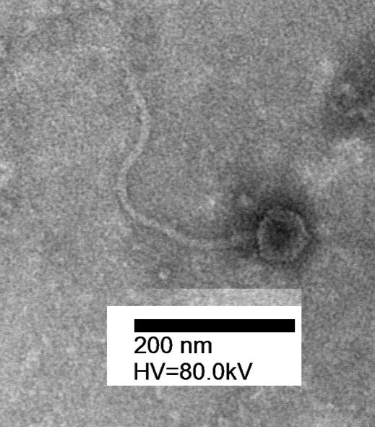

Genome summary:

Phage name | INSDC | Size (Kb) | GC% | Protein | Overall % DNA sequence identity (*) | Overall % homologous proteins (**)
Gordonia phage Powerball | MN234218.1 | 47.68 | 66.3 | 76 | 100 | 100
(*) determined using BLASTn [1] or VIRIDIC [2]
(**) determined using CoreGenes 3.5 [5]

VIRIDIC heat map: VIRIDIC (Virus Intergenomic Distance Calculator; VIRIDIC (Virus Intergenomic Distance Calculator; [2]; http://rhea.icbm.uni-oldenburg.de/VIRIDIC/) computes pairwise intergenomic distances/similarities amongst phage genomes. The black box delineates strains.

ViPTree analysis: ViPTree analysis (https://www.genome.jp/viptree/; [3]) is based upon Rohwer and Edwards (2002) famous Phage Proteomic Tree [4]. The phages of interest are indicated with red stars, and blue rectange.

Phylogeny: The phylogenetic tree was constructed using the TerL proteins from Powerball and related phages with phylogeny.fr in “one click” mode [6]. The members of the Powerballvirus are indicated with a blue rectangle.

Proposal E. Create a new genus Beenievirus with ten (10) species
Origin of the name of this taxon: This taxon is named after the first phage of its type Gordonia phage Beenie

Historical aspects: This temperate siphophage was isolated in 2017 by Gabrielle Giglietti (University of Pittsburgh) against Gordonia terrae 3612 as part of the Phage Hunters Integrating Research and Education program. Its genome possesses 11 nt 3’-cohesive termini (TGCCAAGGGGA). The Actinobacteriophage Database classifies this phage to Cluster CZ, subcluster CZ4.

Electron micrograph: Electron micrographs of negatively stained Gordonia phage Beenie (https://phagesdb.org/phages/Beenie/). Limited permission was granted by The Actinobacteriophages Database (https://phagesdb.org/), funded by the Howard Hughes Medical Institute, to use this electron micrograph for this taxonomy proposal; it cannot be reused without permission of The Actinobacteriophages Database.

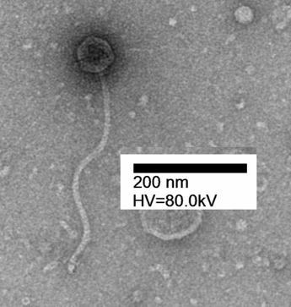
Genome summary:

Phage name | INSDC | Size (Kb) | GC% | Protein | Overall % DNA sequence identity (*) | Overall % homologous proteins (**)
Gordonia phage Beenie | MG845393.1 | 47.95 | 66.3 | 73 | 100 | 100
Gordonia phage Sekhmet | MK937609.1 | 47.74 | 66.1 | 79 | 78.2 | 86.3
Gordonia phage Dolores | MZ681517.1 | 47.34 | 66.6 | 80 | 67.2 | 79.4
Gordonia phage Dorito | MK279848.1 | 46.78 | 66.5 | 75 | 68.3 | 78.1
Gordonia phage DobbysSock | MN428048.1 | 48.2 | 66.3 | 73 | 70.0 | 76.7
Gordonia phage Clark | MK801729.1 | 47.72 | 66.5 | 78 | 84.2 | 94.5
Gordonia phage Samman98 | MZ456039.1 | 47.55 | 66.5 | 79 | 82.8 | 91.8
Gordonia phage MichaelScott | MT771346.1 | 48.40 | 66.0 | 80 | 86.5 | 93.1
Gordonia phage Easley | MH155867.1 | 46.72 | 66.6 | 77 | 61.2 | 72.6
Gordonia phage Suerte | MN428057.1 | 47.31 | 66.5 | 74 | 57.2 | 68.5
(*) determined using BLASTn [1] or VIRIDIC [2]
(**) determined using CoreGenes 3.5 [5]

VIRIDIC heat map: VIRIDIC (Virus Intergenomic Distance Calculator; VIRIDIC (Virus Intergenomic Distance Calculator; [2]; http://rhea.icbm.uni-oldenburg.de/VIRIDIC/) computes pairwise intergenomic distances/similarities amongst phage genomes. The black box delineates strains.

ViPTree analysis: ViPTree analysis (https://www.genome.jp/viptree/; [3]) is based upon Rohwer and Edwards (2002) famous Phage Proteomic Tree [4]. The phages of interest are indicated with red stars, and blue rectange.

Phylogeny: The phylogenetic tree was constructed using the TerL proteins from Beenie and related phages with phylogeny.fr in “one click” mode [6]. The members of the Howevirus are indicated with a blue rectangle.

Proposal F. Create a new genus Denisevirus with one species

Origin of the name of this taxon: This taxon is named after the first phage of its type Gordonia phage Denise

Historical aspects: This temperate siphophage was isolated from soil in 2017 by Rebecca Oberschmidt (University of Pittsburgh) against Gordonia terrae 3612 as part of the Science Education Alliance-Phage Hunters Advancing Genomics and Evolutionary Science program. Its genome possesses 11 nt 3’-cohesive termini (TACCAGGGGGA). The Actinobacteriophage Database classifies this phage to Cluster CZ, subcluster CZ5.

Electron micrograph: Electron micrographs of negatively stained Gordonia phage Denise (https://phagesdb.org/phages/Denise/). Limited permission was granted by The Actinobacteriophages Database (https://phagesdb.org/), funded by the Howard Hughes Medical Institute, to use this electron micrograph for this taxonomy proposal; it cannot be reused without permission of The Actinobacteriophages Database.

Genome summary:

Phage name | INSDC | Size (Kb) | GC% | Protein | Overall % DNA sequence identity (*) | Overall % homologous proteins (**)
Gordonia phage Denise | MN428053.1 | 45.04 | 65.4 | 78 | 100 | 100
(*) determined using BLASTn [1] or VIRIDIC [2]
(**) determined using CoreGenes 3.5 [5]

VIRIDIC heat map: VIRIDIC (Virus Intergenomic Distance Calculator; VIRIDIC (Virus Intergenomic Distance Calculator; [2]; http://rhea.icbm.uni-oldenburg.de/VIRIDIC/) computes pairwise intergenomic distances/similarities amongst phage genomes. The black box delineates strains.

Phylogeny: The phylogenetic tree was constructed using the TerL proteins from Denise and related phages with phylogeny.fr in “one click” mode [6]. The members of the Denisevirus are indicated with a blue rectangle.

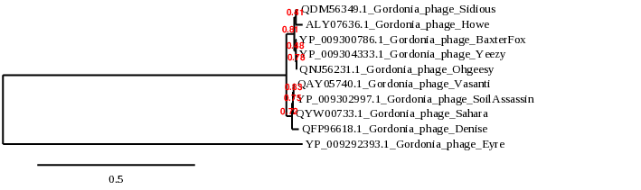

Proposal G. Create a new genus Howevirus with two (2) species
Origin of the name of this taxon: This taxon is named after the first phage of its type Gordonia phage Howe

Historical aspects: This temperate siphophage was isolated in 2014 by Matthew Montgomery (University of Pittsburgh) against Gordonia terrae 3612 as part of the Phage Hunters Integrating Research and Education program. Its genome possesses 11 nt 3’-cohesive termini (TGCCAAGGGGA). The Actinobacteriophage Database classifies this phage to Cluster CZ, subcluster CZ4.

Electron micrograph: Electron micrographs of negatively stained Gordonia phage Howe (https://phagesdb.org/phages/Howe/). Limited permission was granted by The Actinobacteriophages Database (https://phagesdb.org/), funded by the Howard Hughes Medical Institute, to use this electron micrograph for this taxonomy proposal; it cannot be reused without permission of The Actinobacteriophages Database.

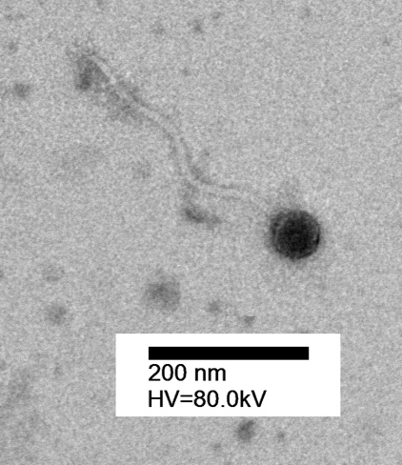

Genome summary:

Phage name | INSDC | Size (Kb) | GC% | Protein | Overall % DNA sequence identity (*) | Overall % homologous proteins (**)
Gordonia phage Howe | KU252585.1 | 53.18 | 65.6 | 80 | 100 | 100
Gordonia phage Mcklovin | MN428055.1 | 53.16 | 65.8 | 77 | 59.3 | 65.0
(*) determined using BLASTn [1] or VIRIDIC [2]
(**) determined using CoreGenes 3.5 [5]

VIRIDIC heat map: VIRIDIC (Virus Intergenomic Distance Calculator; VIRIDIC (Virus Intergenomic Distance Calculator; [2]; http://rhea.icbm.uni-oldenburg.de/VIRIDIC/) computes pairwise intergenomic distances/similarities amongst phage genomes. The black box delineates strains.

ViPTree analysis: ViPTree analysis (https://www.genome.jp/viptree/; [3]) is based upon Rohwer and Edwards (2002) famous Phage Proteomic Tree [4]. The phages of interest are indicated with red stars, and blue rectange.

Phylogeny: The phylogenetic tree was constructed using the TerL proteins from Howe and related phages with phylogeny.fr in “one click” mode [6]. The members of the Howevirus are indicated with a blue rectangle.

Proposal H. Create a new genus Sidiousvirus with one species
Origin of the name of this taxon: This taxon is named after the first phage of its type Gordonia phage Sidious

Historical aspects: This temperate siphophage was isolated from soil in 2018 by Jack Burnell and Nate Jordan (University of Maine, Old Town, ME USA) against Gordonia terrae 3612 as part of the Science Education Alliance-Phage Hunters Advancing Genomics and Evolutionary Science program. Its genome possesses 11 nt 3’-cohesive termini (TGCCAAGGGGA). The Actinobacteriophage Database classifies this phage to Cluster CZ, subcluster CZ7.

Electron micrograph: Electron micrographs of negatively stained Gordonia phage Sidious (https://phagesdb.org/phages/Sidious/). Limited permission was granted by The Actinobacteriophages Database (https://phagesdb.org/), funded by the Howard Hughes Medical Institute, to use this electron micrograph for this taxonomy proposal; it cannot be reused without permission of The Actinobacteriophages Database.

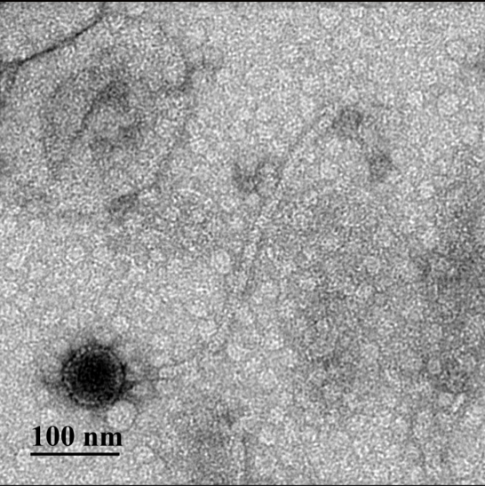

Genome summary:

Phage name | INSDC | Size (Kb) | GC% | Protein | Overall % DNA sequence identity (*) | Overall % homologous proteins (**)
Gordonia phage Sidious | MK967384.1 | 51.79 | 66.6 | 79 | 100 | 100
(*) determined using BLASTn [1] or VIRIDIC [2]
(**) determined using CoreGenes 3.5 [5]

VIRIDIC heat map: VIRIDIC (Virus Intergenomic Distance Calculator; VIRIDIC (Virus Intergenomic Distance Calculator; [2]; http://rhea.icbm.uni-oldenburg.de/VIRIDIC/) computes pairwise intergenomic distances/similarities amongst phage genomes. The black box delineates strains.

Phylogeny: The phylogenetic tree was constructed using the TerL proteins from Sidious and related phages with phylogeny.fr in “one click” mode [6]. The members of the Sidiousvirus are indicated with a blue rectangle.

References
- Sayers EW, Beck J, Bolton EE, Bourexis D, Brister JR, Canese K, Comeau DC, Funk K, Kim S, Klimke W, Marchler-Bauer A, Landrum M, Lathrop S, Lu Z, Madden TL, O'Leary N, Phan L, Rangwala SH, Schneider VA, Skripchenko Y, Wang J, Ye J, Trawick BW, Pruitt KD, Sherry ST. Database resources of the National Center for Biotechnology Information. Nucleic Acids Res. 2021 Jan 8;49(D1):D10-D17. doi: 10.1093/nar/gkaa892. PMID: 33095870
- Moraru C, Varsani A, Kropinski AM. VIRIDIC-A Novel Tool to Calculate the Intergenomic Similarities of Prokaryote-Infecting Viruses. Viruses. 2020 Nov 6;12(11):1268. doi: 10.3390/v12111268. PMID: 33172115; PMCID: PMC7694805. http://kronos.icbm.uni-oldenburg.de/viridic/
- Nishimura Y, Yoshida T, Kuronishi M, Uehara H, Ogata H, Goto S. ViPTree: the viral proteomic tree server. Bioinformatics. 2017; 33(15):2379-2380. doi:10.1093/bioinformatics/btx157. PubMed PMID: 28379287. https://www.genome.jp/viptree/
- Rohwer F, Edwards R. The Phage Proteomic Tree: a genome-based taxonomy for phage. J Bacteriol. 2002 Aug;184(16):4529-35. PubMed PMID: 12142423
- Turner D, Reynolds D, Seto D, Mahadevan P. CoreGenes3.5: a webserver for the determination of core genes from sets of viral and small bacterial genomes. BMC Res Notes. 2013;6:140. doi: 10.1186/1756-0500-6-140. PMID: 23566564.
- Dereeper A, Guignon V, Blanc G, Audic S, Buffet S, Chevenet F, Dufayard JF, Guindon S, Lefort V, Lescot M, Claverie JM, Gascuel O. Phylogeny.fr: robust phylogenetic analysis for the non-specialist. Nucleic Acids Res. 2008;36(Web Server issue):W465-9. doi: 10.1093/nar/gkn180. Epub 2008 Apr 19. PMID: 18424797.
- Anisimova M, Gascuel O. Approximate likelihood-ratio test for branches: A fast, accurate, and powerful alternative. Syst Biol. 2006;55(4):539-52. PMID: 16785212. DOI: 10.1080/10635150600755453.
- Turner D, Kropinski AM, Adriaenssens EM. A Roadmap for Genome-Based Phage Taxonomy. Viruses. 2021 Mar 18;13(3):506. doi: 10.3390/v13030506. PMID: 33803862; PMCID: PMC8003253.
- O'Leary NA, Wright MW, Brister JR, Ciufo S, Haddad D, McVeigh R, et al. Reference sequence (RefSeq) database at NCBI: current status, taxonomic expansion, and functional annotation. Nucleic Acids Res. 2016;44(D1):D733-45. doi: 10.1093/nar/gkv1189. PMID: 26553804.
- Olsen NS, Hendriksen NB, Hansen LH and Kot W. A New High-Throughput Screening Method for Phages: Enabling Crude Isolation and Fast Identification of Diverse Phages with Therapeutic Potential. Phage (New Rochelle) 1 (3), 137-148 (2020) https://www.liebertpub.com/doi/10.1089/phage.2020.0016

