

**Part 1:** **TITLE, AUTHORS, APPROVALS, etc**

|  |  |  |
| --- | --- | --- |
| **Code assigned:** | ***2022.085B*** |  |
| **Short title:** Create a new family (*Stanwilliamsviridae*) with two subfamilies (*Boydwoodruffvirinae &* *Loccivirinae*) and nine (9) genera (*Caudoviricetes*) | | |
|  | | |

**Author(s) and email address(es)**

|  |  |
| --- | --- |
|  |  |
| Kurtböke I, Moraru C, Adriaenssens EM, Kropinski AM, Turner D | ikurtbok@usc.edu.au; liliana.cristina.moraru@uol.de; evelien.adriaenssens@quadram.ac.uk; Phage.Canada@gmail.com; Dann2.Turner@uwe.ac.uk |

**Author(s) institutional address(es) (optional)**

|  |
| --- |
| University of the Sunshine Coast, Australia [IK]  University of the West of England, Bristol, UK [DT]  Carl von Ossietzky Universität Oldenburg, Germany [CM]  Quadram Institute Bioscience, UK [EMA]  University of Guelph, Canada [AMK] |

**Corresponding author**

|  |
| --- |
| Andrew M. Kropinski |

**List the ICTV Study Group(s) that have seen this proposal**

|  |
| --- |
| Bacterial Viruses Subcommittee, Actinophage Study Group |

**ICTV Study Group comments and response of proposer**

|  |
| --- |
|  |

**ICTV Study Group votes on proposal**

|  |  |  |  |
| --- | --- | --- | --- |
| **Study Group** | **Number of members** | | |
| **Votes support** | **Votes against** | **No vote** |
|  |  |  |  |
|  |  |  |  |

**Authority to use the name of a living person**

|  |  |
| --- | --- |
| **Is any taxon name used here derived from that of a living person (Y/N)** | N |

|  |  |  |
| --- | --- | --- |
| **Taxon name** | **Person from whom the name is derived** | **Permission attached (Y/N)** |
|  |  |  |
|  |  |  |
|  |  |  |

**Submission dates**

|  |  |
| --- | --- |
| Date first submitted to SC Chair |  |
| Date of this revision (if different to above) |  |

**ICTV-EC comments and response of the proposer**

|  |
| --- |
|  |

**Part 2:** **NON-TAXONOMIC PROPOSAL**

**Text of proposal**

|  |
| --- |
|  |

**Part 3:** **TAXONOMIC PROPOSAL**

**Name of accompanying Excel module**

|  |
| --- |
| 2022.085B.N.v1.Stanwilliamsviridae_nf_2nsf_4ng_6nsp.xlsx |

**Abstract**

|  |
| --- |
| We have characterized a large group of lytic Streptomyces siphophages and created a new family with two subfamilies and nine genera. The average member of this taxon possesses 130.25 kb genomes (49.3 mol%G+C, which is significantly less than that of their hosts) encoding for 233 proteins and 38 tRNA. While the phages which make up this taxon share a high number of homologous proteins, phylogenetic (vConTACT, ViPTree, and phylogenetic trees) all indicate that this group of viruses is cohesive and significantly different from other phages. |

**Text of proposal**

|  |  |
| --- | --- |
| |  | | --- | | **Species demarcation criteria:** Two phages are assigned to the same species if their genomes are more than 95% identical over their genome length for isolates.  These values can be calculated by a number of tools, such as BLASTn [1] – usually calculated using intergenomic distance calculator VIRIDIC [2].  **Genus demarcation criteria:** In search for criteria that create cohesive and distinct genera that are reproducible and monophyletic, the Bacterial Viruses Subcommittee has established 70% nucleotide identity of the genome length as the cut-off for genera. Genus-level groupings should always be monophyletic in the signature genes, as tested with a phylogenetic tree. [8]  **Subfamily demarcation criteria:** Subfamilies are to be created when two or more genera are related below the family level. In practical terms, this usually means that they share a low degree of sequence similarity (usually about 40-50%) and that the genera form a clade in a marker tree phylogeny. [8]  **Family demarcation criteria:** The family is represented by a cohesive and monophyletic group in the main predicted proteome-based clustering tools (ViPTree, GRAViTy dendrogram, vConTACT2 network). Members of the family share a significant number of orthologous genes (the number will depend on the genome sizes and number of coding sequences of members of the family). [8] | |

**Supporting evidence**

**VIRIDIC heat map:** VIRIDIC (Virus Intergenomic Distance Calculator; VIRIDIC (Virus Intergenomic Distance Calculator; [2]; http://rhea.icbm.uni-oldenburg.de/VIRIDIC/) computes pairwise intergenomic distances/similarities amongst phage genomes. The black box delineates strains. The Rhodococcus phages are outliers sharing ≤ 2.2% DNA sequence similarity. The original Excel spreadsheet is attached to this application.



**ViPTree analysis:** ViPTree analysis (https://www.genome.jp/viptree/; [3]) is based upon Rohwer and Edwards (2002) famous Phage Proteomic Tree [4]. The phages of interest are indicated with are indicated with a **blue rectangle**. The Rhodococcus phages are outliers sharing ≤ 2.2% DNA sequence similarity.

  


**vConTACT v.2.0:** is a network-based application utilizing whole genome gene-sharing profiles for virus taxonomy that integrates distance-based hierarchical clustering and confidence scores for all taxonomic predictions [11-13]. SEED KM652554 which contains 15 members VC_971_2 is indicated with a **red arrowhead**

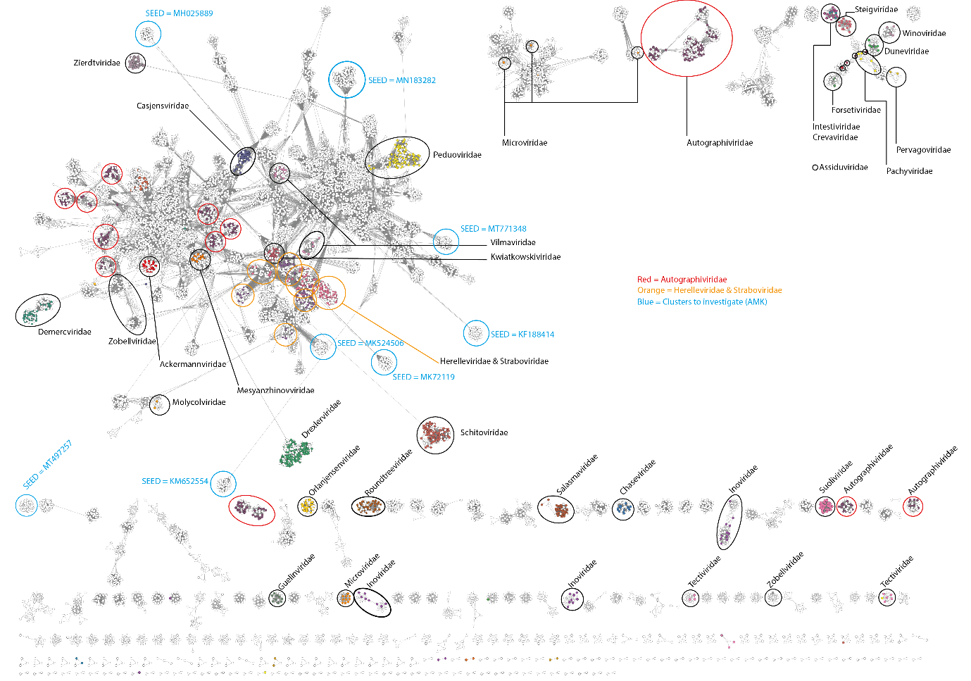

**Phylogeny:** The phylogenetic tree was constructed using the MCP proteins from these and related phages with phylogeny.fr in “one click” mode [6]. The usual bootstrapping procedure is replaced by a new confidence index that is much faster to compute. See Anisimova M., Gascuel O. Approximate likelihood ratio test for branches: A fast, accurate and powerful alternative [7] for details. The members of the *Stanwilliamviridae* are indicated with a **blue rectangle**. The outliers are the Rhodococcus phages.



**Proposals:**

1. **Create a new genus, *Tomasvirus* with a single species**
2. **Create a new genus, *Coruscantvirus* with a single species**
3. **Move** ***Karimacvirus,* *Samistivirus,Tomasvirus and Coruscantvirus* to *Boydwoodruffvirinae***
4. **Create a new genus, *Faustvirus*, with two species**
5. **Create a new genus, *Wakandavirus*, with two species**
6. **Create a new subfamily,** ***Loccivirinae*, for these genera**
7. **Move *Wilnyevirus, Gilsonvirus* and *Annadreamyvirus* to *Loccivirinae***
8. **Create a new family, *Stanwilliamsviridae***
9. **Create a new genus, *Tomasvirus* with a single species**

**Origin of the name of this taxon:** This taxon is named after Streptomyces phage Tomas

**Historical aspects:** Lytic siphophage Tomas was isolated in 2020 by Shelby Harris (University of North Texas, Lake Worth, TX USA) against Streptomyces sanglieri UNT16F27A from soil as part of the Science Education Alliance-Phage Hunters Advancing Genomics and Evolutionary Science program. The genome has 12757 bp direct terminal repeats. The Actinobacteriophage Database classified Tomas to Cluster BE/Subcluster BE2. Our data indicates that it is sufficiently different from most of the other BE2 phages to deserve classification to a unique genus.

**Electron micrograph:** N/A

**Genome summary:**

|  |  |  |  |  |  |  |  |
| --- | --- | --- | --- | --- | --- | --- | --- |
| Phage name | INSDC | Size (Kb) | GC% | Protein | tRNA | Overall % DNA sequence identity (*) | Overall % homologous proteins (**) |
| Streptomyces phage Tomas | [OL829978.1](https://www.ncbi.nlm.nih.gov/nuccore/OL829978.1) | 134.46 | 48.2 | [237](https://www.ncbi.nlm.nih.gov/genome/browse/#!/proteins/111561/1806858|Streptomyces phage Tomas/viral segment/) | 45 | 100 | 100 |

**(*) determined using BLASTn [1] or VIRIDIC [2]**

**(**) determined using CoreGenes 3.5 [5]**

1. **Create a new genus, *Coruscantvirus* with a single species**

**Origin of the name of this taxon:** This taxon is named after Streptomyces phage Coruscant

**Historical aspects:** Lytic siphophage Coruscant was isolated in from German soil against Streptomyces venezuelae ATCC 10712 by staff from the Biotechnology Institute of Bio- and Geosciences, Forschungszentrum Juelich, Wilhelm-Johnen-Strasse, Juelich 52425, Germany. The nature of the genome termini is not presented. The Actinobacteriophage Database has yet to classify this phage

**Electron micrograph:** N/A

**Genome summary:**

|  |  |  |  |  |  |  |  |
| --- | --- | --- | --- | --- | --- | --- | --- |
| Phage name | INSDC | Size (Kb) | GC% | Protein | tRNA | Overall % DNA sequence identity (*) | Overall % homologous proteins (**) |
| Streptomyces phage Coruscant | [MT711976.1](https://www.ncbi.nlm.nih.gov/nuccore/MT711976.1) | 133.7 | 48.4 | [248](https://www.ncbi.nlm.nih.gov/genome/browse/#!/proteins/94258/980535|Streptomyces phage Coruscant/viral segment/) | 42 | 100 | 100 |

**(*) determined using BLASTn [1] or VIRIDIC [2]**

**(**) determined using CoreGenes 3.5 [5]**

1. **Move *Karimacvirus,* *Samistivirus,Tomasvirus and Coruscantvirus* to *Boydwoodruffvirinae***

**Origin of the name of this taxon:** N/A

**Rationale:** The *Karimacvirus* and *Samistivirus* taxa were created through Taxonomy Proposals 2020.081B and 2018.055B, respectively. Based upon overall DNA sequence similarity viruses belonging to this subfamily (*Tomasvirus, Coruscantvirus, Karimacvirus* and *Samistivirus*) share ≥35.2% overall sequence similarity. Their genomes are on average 133.4 kb (49.0 mol%G+C) and encode 238 proteins and 42-45 tRNA.

1. **Create a new genus, *Faustvirus*, with two species**

**Origin of the name of this taxon:** This taxon is named after Streptomyces phage Faust

**Historical aspects:** Lytic siphophage Faust was isolated in 2019 by Meher Arora and Bronson Burke (Chesterfield, MO, USA) against Streptomyces lividans JI 1326 as part of the Science Education Alliance-Phage Hunters Advancing Genomics and Evolutionary Science program. Its genome possesses 772 bp direct terminal repeats. The Actinobacteriophage Database classifies this phage to Cluster BK, Subcluster BK1. Our data suggests that this subcluster should be split.

**Electron micrograph:** Electron micrographs of negatively stained Streptomyces phage Faust (https://phagesdb.org/phages/Faust/). Limited permission was granted by The Actinobacteriophages Database (https://phagesdb.org/), funded by the Howard Hughes Medical Institute, to use this electron micrograph for this taxonomy proposal; it cannot be reused without permission of The Actinobacteriophages Database.

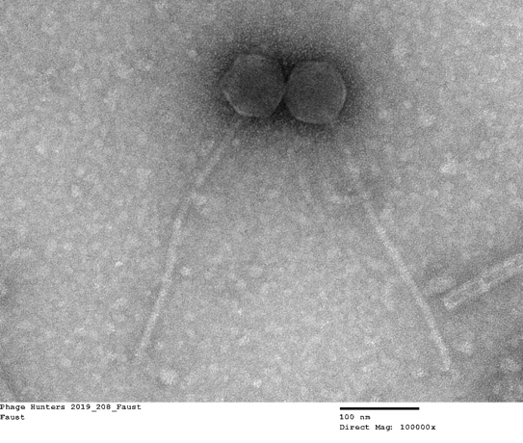

**Genome summary:**

|  |  |  |  |  |  |  |  |
| --- | --- | --- | --- | --- | --- | --- | --- |
| Phage name | INSDC | Size (Kb) | GC% | Protein | tRNA | Overall % DNA sequence identity (*) | Overall % homologous proteins (**) |
| Streptomyces phage Faust | [MT684598.1](https://www.ncbi.nlm.nih.gov/nuccore/MT684598.1) | 130.67 | 47.2 | [239](https://www.ncbi.nlm.nih.gov/genome/browse/#!/proteins/94609/986827|Streptomyces phage Faust/viral segment/) | 33 | 100 | 100 |
| Streptomyces phage TunaTartare | [MW822145.1](https://www.ncbi.nlm.nih.gov/nuccore/MW822145.1) | 130.93 | 46.9 | [234](https://www.ncbi.nlm.nih.gov/genome/browse/#!/proteins/103861/1646693|Streptomyces phage TunaTartare/viral segment/) | 33 | 71.3 | 81.2 |

**(*) determined using BLASTn [1] or VIRIDIC [2]**

**(**) determined using CoreGenes 3.5 [5]**

1. **Create a new genus, *Wakandavirus*, with two species**

**Origin of the name of this taxon:** This taxon is named after Streptomyces phage Wakanda

**Historical aspects:** Lytic siphophage Wakanda was isolated in 2019 by Ketsia Kankolongo (University of North Texas, Lewisville, TX, USA) against Streptomyces sanglieri UNT16F27A as part of the Science Education Alliance-Phage Hunters Advancing Genomics and Evolutionary Science program. Its genome possesses 1773 bp direct terminal repeats. The Actinobacteriophage Database classifies this phage to Cluster BK, Subcluster BK2. Our data suggests that this subcluster should be split.

**Electron micrograph:** N/A

**Genome summary:**

|  |  |  |  |  |  |  |  |
| --- | --- | --- | --- | --- | --- | --- | --- |
| Phage name | INSDC | Size (Kb) | GC% | Protein | tRNA | Overall % DNA sequence identity (*) | Overall % homologous proteins (**) |
| Streptomyces phage Wakanda | [MT024865.1](https://www.ncbi.nlm.nih.gov/nuccore/MT024865.1) | 126.61 | 52.6 | [228](https://www.ncbi.nlm.nih.gov/genome/browse/#!/proteins/88402/838863|Streptomyces phage Wakanda/viral segment/) | 34 | 100 | 100 |
| Streptomyces phage Muntaha | [MT024872.1](https://www.ncbi.nlm.nih.gov/nuccore/MT024872.1) | 127.55 | 52.6 | [233](https://www.ncbi.nlm.nih.gov/genome/browse/#!/proteins/88404/838865|Streptomyces phage Muntaha/viral segment/) | 34 | 94.8 | 96.5 |

**(*) determined using BLASTn [1] or VIRIDIC [2]**

**(**) determined using CoreGenes 3.5 [5]**

1. **Create a new subfamily, *Loccivirinae*, for these genera**
2. **Move *Wilnyevirus, Gilsonvirus* and *Annadreamyvirus* to *Loccivirinae***

**Origin of the name of this taxon:** This taxon is named in honour of Professor Romano Locci (b.1937 Tolmino (Slovenia) - d. 2010, Udine, Italy). “A graduate (1959) of the University of Milan, by 1972, soon after being awarded the "Justus von Liebig-Auslandsstipendium" by the University of Cologne, he became full professor of Mycology at the Faculty of Agriculture in Milan. There, his laboratory soon became a reference point in the study of the biology of actinomycetes. By studying their micromorphology and applying the emerging technique of numerical taxonomy, Romano contributed significantly to the revision of streptomycetes, mycobacteria, as well as the nocardy- form and coryneform bacteria. In 1983 Romano became the Head of the Institute of Plant Pathology in Milan. He served in that capacity for only one year before moving to Udine where he was invited to join the newly founded University. Here, he soon organized a young team of researchers that approached new themes while not neglecting actinomycetes. In addition to being author and co-author of over 300 papers, at various periods of his career Professor Locci was editor of the Rivista di Patologia Vegetale and "The Actinomycetes", editor-in-chief of "Actinomycetes", senior editor of the "Journal of Plant Pathology", Scientific Director of the "Gjornal Furlan des Siencis" and member of the Editorial Board of several other scientific journals. He was also elected member of the Subcommittee on the Taxonomy of the Actinomycetales of the International Committee on the Systematics of Prokaryotes, where he served as secretary from 1970 to 1974 and as president from 1982 to 1990.” [14]



**Rationale:** The *Wilnyevirus, Gilsonvirus* and *Annadreamyvirus* taxa were created through Taxonomy Proposals 2018.060B, 2020.062B and 2020.019B, respectively. Based upon overall DNA sequence similarity viruses belonging to this subfamily share ≥32.1% overall sequence similarity. Their genomes are on average 127.7kb (49.5 mol%G+C) and encode 229 proteins and 33-35 tRNA.

1. **Create a new family, *Stanwilliamsviridae***

**Origin of the name of this taxon:** This taxon is named in honour of Stanley Thomas Williams (1937 – 2004). “Born in the UK Stan was awarded three degrees by the University of Liverpool, a BSc in 1959, a PhD in 1962 and a DSc in 1985. 1964 he took up an appointment there as an Assistant Lecturer. He was awarded a Personal Chair in the Department of Botany in 1987. Over the years, Stan's research interests were many and varied, as exemplified by his studies on heterothallism in fungi, bacteriophage ecology, the role of micro-organisms in the decomposition of organic matter and nutrient cycling in soil and on the production of tastes and odours in drinking water. He was also a pioneer in the development of techniques for scanning electron microscopy of microbes.”



(reproduced from: https://www.microbiologyresearch.org/content/journal/ijsem/10.1099/ijs.0.63576-0)

**Rationale:** Collectively these phages exhibit ≥10.9 DNA sequence overall similarity while at the protein level using the Bidirectional Best Hit algorithm with CoreGenes 5.0 (<https://coregenes.ngrok.io/>) we found 55 homologs (23.6% conserved proteins). The latter include: glucosyltransferase, ribonucleotide reductase, capsid maturation protease, major capsid protein, tail assembly chaperone, tape measure protein, DNA helicase, DNA primase, DNA binding protein, RecA, Holliday junction resolvase, terminase large subunit, RNA ligase, thioredoxin,

**References**

1. Sayers EW, Beck J, Bolton EE, Bourexis D, Brister JR, Canese K, Comeau DC, Funk K, Kim S, Klimke W, Marchler-Bauer A, Landrum M, Lathrop S, Lu Z, Madden TL, O'Leary N, Phan L, Rangwala SH, Schneider VA, Skripchenko Y, Wang J, Ye J, Trawick BW, Pruitt KD, Sherry ST. Database resources of the National Center for Biotechnology Information. Nucleic Acids Res. 2021 Jan 8;49(D1):D10-D17. doi: 10.1093/nar/gkaa892. PMID: 33095870
2. Moraru C, Varsani A, Kropinski AM. VIRIDIC-A Novel Tool to Calculate the Intergenomic Similarities of Prokaryote-Infecting Viruses. Viruses. 2020 Nov 6;12(11):1268. doi: 10.3390/v12111268. PMID: 33172115; PMCID: PMC7694805. <http://kronos.icbm.uni-oldenburg.de/viridic/>
3. Nishimura Y, Yoshida T, Kuronishi M, Uehara H, Ogata H, Goto S. ViPTree: the viral proteomic tree server. Bioinformatics. 2017; 33(15):2379-2380. doi:10.1093/bioinformatics/btx157. PubMed PMID: 28379287. <https://www.genome.jp/viptree/>
4. Rohwer F, Edwards R. The Phage Proteomic Tree: a genome-based taxonomy for phage. J Bacteriol. 2002 Aug;184(16):4529-35. PubMed PMID: 12142423
5. Turner D, Reynolds D, Seto D, Mahadevan P. CoreGenes3.5: a webserver for the determination of core genes from sets of viral and small bacterial genomes. BMC Res Notes. 2013;6:140. doi: 10.1186/1756-0500-6-140. PMID: 23566564.
6. Dereeper A, Guignon V, Blanc G, Audic S, Buffet S, Chevenet F, Dufayard JF, Guindon S, Lefort V, Lescot M, Claverie JM, Gascuel O. Phylogeny.fr: robust phylogenetic analysis for the non-specialist. Nucleic Acids Res. 2008;36(Web Server issue):W465-9. doi: 10.1093/nar/gkn180. Epub 2008 Apr 19. PMID: 18424797.
7. Anisimova M, Gascuel O. Approximate likelihood-ratio test for branches: A fast, accurate, and powerful alternative. Syst Biol. 2006;55(4):539-52. PMID: 16785212. DOI: 10.1080/10635150600755453.
8. Turner D, Kropinski AM, Adriaenssens EM. A Roadmap for Genome-Based Phage Taxonomy. Viruses. 2021 Mar 18;13(3):506. doi: 10.3390/v13030506. PMID: 33803862; PMCID: PMC8003253.
9. O'Leary NA, Wright MW, Brister JR, Ciufo S, Haddad D, McVeigh R, et al. Reference sequence (RefSeq) database at NCBI: current status, taxonomic expansion, and functional annotation. Nucleic Acids Res. 2016;44(D1):D733-45. doi: 10.1093/nar/gkv1189. PMID: 26553804.
10. Olsen NS, Hendriksen NB, Hansen LH and Kot W. A New High-Throughput Screening Method for Phages: Enabling Crude Isolation and Fast Identification of Diverse Phages with Therapeutic Potential. Phage (New Rochelle) 1 (3), 137-148 (2020) <https://www.liebertpub.com/doi/10.1089/phage.2020.0016>
11. Bin Jang H, Bolduc B, Zablocki O, Kuhn JH, Roux S, Adriaenssens EM, Brister JR, Kropinski AM, Krupovic M, Lavigne R, Turner D, Sullivan MB. Taxonomic assignment of uncultivated prokaryotic virus genomes is enabled by gene-sharing networks. Nat Biotechnol. 2019 Jun;37(6):632-639. doi: 10.1038/s41587-019-0100-8. Epub 2019 May 6. PMID: 31061483.
12. Bolduc B, Jang HB, Doulcier G, You ZQ, Roux S, Sullivan MB. vConTACT: an iVirus tool to classify double-stranded DNA viruses that infect Archaea and Bacteria. PeerJ. 2017 May 3;5:e3243. doi: 10.7717/peerj.3243. PMID: 28480138; PMCID: PMC5419219.
13. vConTACT2 User Guide <https://bitbucket.org/MAVERICLab/vcontact2/wiki/Home>
14. Gobbi E, Torelli E, Firrao G. ROMANO LOCCI (1937-2010). Journal of Plant Pathology, Vol. 92, No. 2 pp. 283-284, July 2010.