

**Part 1:** **TITLE, AUTHORS, APPROVALS, etc**

|  |  |  |
| --- | --- | --- |
| **Code assigned:** | ***2022.087B*** |  |
| **Short title:** Creation of new genera and species in the family *Straboviridae* (*Caudoviricetes*) | | |
|  | | |

**Author(s) and email address(es)**

|  |  |
| --- | --- |
| Millard A, Puxty R | Adm39@le.a.cuk;r.puxty@warwick.ac.uk; |

**Author(s) institutional address(es) (optional)**

|  |
| --- |
| University of Leicester,UK [AM]  University of Warwick, UK [RP] |

**Corresponding author**

|  |
| --- |
| Andrew Millard |

**List the ICTV Study Group(s) that have seen this proposal**

|  |
| --- |
| Bacterial Viruses Subcommittee, Tevenvirinae Study Group |

**ICTV Study Group comments and response of proposer**

|  |
| --- |
|  |

**ICTV Study Group votes on proposal**

|  |  |  |  |
| --- | --- | --- | --- |
| **Study Group** | **Number of members** | | |
| **Votes support** | **Votes against** | **No vote** |
| Teven phages | 2 | 0 | 0 |
|  |  |  |  |

**Authority to use the name of a living person**

|  |  |
| --- | --- |
| **Is any taxon name used here derived from that of a living person (Y/N)** | N |

|  |  |  |
| --- | --- | --- |
| **Taxon name** | **Person from whom the name is derived** | **Permission attached (Y/N)** |
|  |  |  |
|  |  |  |
|  |  |  |

**Submission dates**

|  |  |
| --- | --- |
| Date first submitted to SC Chair | May 2022 |
| Date of this revision (if different to above) |  |

**ICTV-EC comments and response of the proposer**

|  |
| --- |
|  |

**Part 2:** **NON-TAXONOMIC PROPOSAL**

**Text of proposal**

|  |
| --- |
|  |

**Part 3:** **TAXONOMIC PROPOSAL**

**Name of accompanying Excel module**

|  |
| --- |
| 2022.087B.N.v1.Straboviridae_update.xlsx |

**Abstract**

|  |
| --- |
| Building on the recent description of the *Straboviridae* family, this adds further species to existing genera within the *Straboviridae.* |

**Text of proposal**

|  |  |
| --- | --- |
| |  | | --- | | **Species demarcation criteria:** Two phages are assigned to the same species if their genomes are more than 95% identical over their genome length for isolates using VIRIDIC  **Genus demarcation criteria:** In search for criteria that create cohesive and distinct genera that are reproducible and monophyletic, the Bacterial Viruses Subcommittee has established 70% nucleotide identity of the genome length as the cut-off for genera. Genus-level groupings should always be monophyletic in the signature genes, as tested with a phylogenetic tree [1]. Comparative genomic similarity was calculated with VIRIDIC[2]. Trees were created using ViPTree standalone version, using default settings [3], that builds on the original Phage Proteomic tree developed by Rohwer and Edwards [4] | |

**Supporting evidence**

**Origin of the name of this taxon:**

*Kanagawavirus threeohfive (*Kosakonia phage 305)

*Kanagawavirus eclm (*Enterobacter phage vB_EclM_Q7622)

*Kanagawavirus mime (*Enterobacter phage vB_EhoM-IME523)

Genome summary:

|  |  |  |  |  |  |  |
| --- | --- | --- | --- | --- | --- | --- |
| Phage name | INSDC | Size (Kb) | GC% | CDS | tRNA | Overall % homologous proteins (**) |
| Kosakonia phage 305 | MZ348423 | 174.78 | 40 | 292 | 7 | 47 |
| Enterobacter phage vB_EclM_Q7622 | MN087708 | 172.763 | 40 | 298 | 8 | 47 |
| Enterobacter phage vB_EhoM-IME523 | OL989991 | 173.871 | 40 | 305 | 8 | 47 |

Top BLASTn hits of Kosakonia phage 305 .

|  |  |  |  |  |  |
| --- | --- | --- | --- | --- | --- |
| Description | Query Cover | Per. Ident | Acc. Len | Accession | ICTV Taxa |
|  |  |  |  |  |  |
| Enterobacter phage vB_EclM_Q7622, complete genome | 90% | 95.05% | 173871 | OL989991.1 |  |
| Enterobacter phage vB_EhoM-IME523 | 90% | 95.21% | 172763 | MN087708.1 |  |
| Enterobacter phage vB_EclM_CIP9, complete genome | 89% | 92.73% | 174924 | NC_048849.1 | Kanagawavirus |
| Enterobacter phage ENC9, partial genome | 89% | 94.77% | 173639 | OL355124.1 |  |
| Pectobacterium bacteriophage PM2, complete genome | 29% | 77.64% | 170286 | KF835987.1 |  |
|  |  |  |  |  |  |

**VIRIDIC heat map:** VIRIDIC (Virus Intergenomic Distance Calculator) heatmap was computed using genomes that are currently within the genus *Kanagawaviru*s and top blast hits.



**Phylogenetic analysis**

Phylogenetic analysis was carried out with VipTree [3] using default settings, and visualised in iTOL [5]. Phages 305, vB_EclM_Q7622 and vB_EhoM-IME523 form a monophyletic clade with other phages in the genus *Kanagawavirus* [Green shaded box]. Combined with the VIRIDIC analysis above, three new species within the genus *Kanagawavirus* are described. Phages within this genus share a core-gene content of 47 genes as determined by analysis using ROARY with settings of 90% identity [6].

## Origin of the name of this taxon:

“Moonvirus kayemsixteen” named after the isolate Salmonella phage KM16 within the genus Moonvirus

VIRIDIC heat map:VIRIDIC (Virus Intergenomic Distance Calculator) heatmap was computed using genomes that are currently within the genus Moon*virus* which were identified by comparison of the genome by mash analysis against a database of compete phage genomes [7].

|  |  |  |  |  |
| --- | --- | --- | --- | --- |
| genome | KT001915 | MW325771.1 | KM236240 | MG250484 |
| KT001915 | 100 | 83.097 | 85.368 | 87.337 |
| **MW325771.1\*** | 83.097 | 100 | 85.66 | 86.87 |
| KM236240 | 85.368 | 85.66 | 100 | 89.471 |
| MG250484 | 87.337 | 86.87 | 89.471 | 100 |

KM16 has >70% ANI with other phages classified within Moonvirus and <95% ANI with any phage assigned an existing species

## Genome summary:

|  |  |  |  |  |  |  |
| --- | --- | --- | --- | --- | --- | --- |
| Phage name | INSDC | Size (Kb) | GC% | Protein | tRNA | Overall % homologous proteins (**) |
| Salmonella phage KM16 | MW325771 | 170.126 | 38.613 | 278 | 14 | 175 |

Phylogenetic analysis was carried out with VipTree [3] using default settings, and visualised in iTOL [5]. Phage KM16 forms a monophyletic clade with phage Merlin, Moon and CF1 [Pink shaded box]. Combined with the VIRIDIC analysis above phage KM16 represents the first isolate of a new species within the genus Moonvirus. The four phages within this gene share a core-gene content of 173 genes as determined by analysis using ROARY with settings of 90% identity [6]

**Origin of the name of this taxon:**

Creation of one new species within the genus Gaprivervirus

*Gaprivervirus arezed*

**Genome summary:**

|  |  |  |  |  |  |  |
| --- | --- | --- | --- | --- | --- | --- |
| Phage name | INSDC | Size (Kb) | GC% | Protein | tRNA | Overall % homologous proteins (**) |
| Escherichia phage vB_EcoM_RZ | MW598459 | 170318 | 40.147 | 290 | 2 | 140 |

**VIRIDIC heat map:** VIRIDIC (Virus Intergenomic Distance Calculator) heatmap was computed using genomes that are currently within the genus Gaprivervirus.

Phages have >70% ANI with other phages classified within Gaprivervirus and <95% ANI



Phylogenetic analysis was carried out with VipTree [3] using default settings, and visualised in iTOL [5]. A phylogeny was constructed from top hits from mash analysis and all phages currently classified within the genus Gaprivervirus. The new genomes form a single clade with other phages classified as Gaprivervirus [Pinkish shaded box below]. Genomic comparison of all genomes in this monophyletic group using ROARY with settings of 90% identity [6], results in a core set of 140 genes.

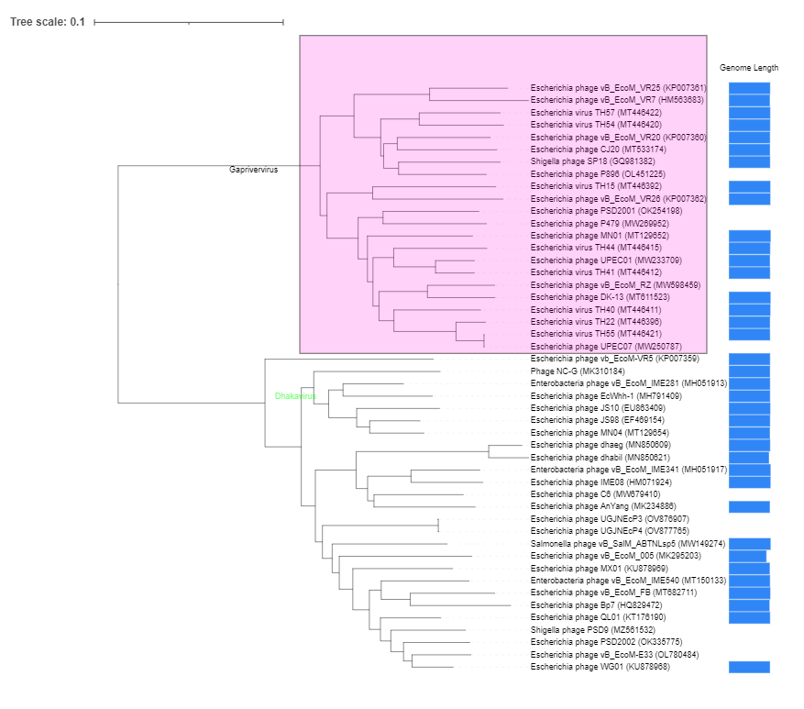

**References**

1. Turner D, Kropinski AM, Adriaenssens EM (2021) A roadmap for genome-based phage taxonomy. Viruses 13:. https://doi.org/10.3390/v13030506

2. Moraru C, Varsani A, Kropinski AM (2020) VIRIDIC — A Novel Tool to Calculate the Intergenomic Similarities of. Viruses 12:1268

3. Nishimura Y, Yoshida T, Kuronishi M, et al (2017) ViPTree: The viral proteomic tree server. Bioinformatics. https://doi.org/10.1093/bioinformatics/btx157

4. Rohwer F, Edwards R (2002) The phage proteomic tree: A genome-based taxonomy for phage. J Bacteriol. https://doi.org/10.1128/JB.184.16.4529-4535.2002

5. Letunic I, Bork P (2007) Interactive Tree Of Life (iTOL): An online tool for phylogenetic tree display and annotation. Bioinformatics 23:127–128. https://doi.org/10.1093/bioinformatics/btl529

6. Page AJ, Cummins C a., Hunt M, et al (2015) Roary: rapid large-scale prokaryote pan genome analysis. Bioinformatics 31:3691–3693. https://doi.org/10.1093/bioinformatics/btv421

7. Cook R, Brown N, Redgwell T, et al (2021) INfrastructure for a PHAge REference Database: Identification of Large-Scale Biases in the Current Collection of Cultured Phage Genomes. PHAGE. https://doi.org/10.1089/phage.2021.0007