

**Part 1:** **TITLE, AUTHORS, APPROVALS, etc**

|  |  |  |
| --- | --- | --- |
| **Code assigned:** | ***2022.088B*** |  |
| **Short title:** Create one new genus (*Syrbvirus*) including one new species (*Caudoviricetes*) | | |
|  | | |

**Author(s) and email address(es)**

|  |  |
| --- | --- |
| Zheng H, Liu B, Xu Y, Zhang Z, Man H, Liu J, Chen F. | zhenghr163@163.com (Zheng HR); lbbkk187@163.com (Liu BB); xuyongle@sdu.edu.cn (Xu YL); zfengbio@126.com (Zhang ZF); 15898836092@163.com (Man HC); liujihua1982@foxmail.com (Liu JH); chenf@umces.edu (Chen F) |

**Author(s) institutional address(es) (optional)**

|  |
| --- |
| Shandong University [ZHR, LBB, XYL, ZZF, MHC, LJH]  University of Maryland Center for Environmental Science [CF] |

**Corresponding author**

|  |
| --- |
| Shandong University [XYL] |

**List the ICTV Study Group(s) that have seen this proposal**

|  |
| --- |
| *Caudoviricetes* Study Group |

**ICTV Study Group comments and response of proposer**

|  |
| --- |
|  |

**ICTV Study Group votes on proposal**

|  |  |  |  |
| --- | --- | --- | --- |
| **Study Group** | **Number of members** | | |
| **Votes support** | **Votes against** | **No vote** |
|  |  |  |  |
|  |  |  |  |

**Authority to use the name of a living person**

|  |  |
| --- | --- |
| **Is any taxon name used here derived from that of a living person (Y/N)** | N |

|  |  |  |
| --- | --- | --- |
| **Taxon name** | **Person from whom the name is derived** | **Permission attached (Y/N)** |
|  |  |  |
|  |  |  |
|  |  |  |

**Submission dates**

|  |  |
| --- | --- |
| Date first submitted to SC Chair | May 2022 |
| Date of this revision (if different to above) |  |

**ICTV-EC comments and response of the proposer**

|  |
| --- |
|  |

**Part 2:** **NON-TAXONOMIC PROPOSAL**

**Text of proposal**

|  |
| --- |
|  |

**Part 3:** **TAXONOMIC PROPOSAL**

**Name of accompanying Excel module**

|  |
| --- |
| 2022.088B.N.v1.Syrbvirus_ng.xlsx |

**Abstract**

Please provide a concise summary of your taxonomic proposal (maximum 150 words).

|  |
| --- |
| We isolated a novel inducible prophage vB_MoxS-R1 from *Microbacterium* strain R1. According to the recognized virus classification standards, viruses in the same genus should share >50% similarity in nucleotide sequence or >40% ORF homologs, we proposed that vB_MoxS-R1 is a new bacteriophage genus. |

**Text of proposal**

|  |  |
| --- | --- |
| |  | | --- | | **Species demarcation criteria:** Two phages are assigned to the same species if theirgenomes are more than 95% identical over their genome length for isolates. These values can be calculated by a number of tools, such as BLASTn [1]–usually calculated using intergenomic distance calculator VIRIDIC [2].  **Genus demarcation criteria:** In search for criteria that create cohesive and distinct genera that are reproducible and monophyletic, the Bacterial Viruses Subcommittee has established 70% nucleotide identity of the genome length as the cut-off for genera. Genus-level groupings should always be monophyletic in the signature genes, as tested with a phylogenetic tree [3]. | |

**Supporting evidence**

vB_MoxS-R1 was isolated by mitomycin C induction of *Microbacterium* sp. R1, which was isolated from a *Synechococcus* sp. CBW1107 culture [4]. The TEM observations revealed that vB_MoxS-R1 was a siphovirus with an isometric icosahedral head (approximately 61 nm in diameter) and a long flexible tail (approximately 178 nm in length and 11 nm in width) (Figure 1).

Viral genome network analysis between vB_MoxS-R1 and those in the Viral RefSeq database showed that vB_MoxS-R1 was only related to vB_Mox-S1 (a prophage-like region in *Microbacterium* sp. UCD-TDU) (Figure 2).

Considering that the Viral RefSeq database only contains limited number of *Microbacterium* phages, further network analysis was performed between vB_MoxS-R1, 341 *Microbacterium* phages and two *Mycobacterium* phages (Figure 3). Only three phages (*Microbacterium* phage Squash, *Microbacterium* phage Nike and vB_Mox-S1) were found related to vB_MoxS-R1 in this viral network (Figure 3).

Comparative analysis on genomic nucleotide similarity and ORF homology of vB_MoxS-R1 with three related phages, five EH cluster phages and two Mycobacterium phages that are related to vB_Mox-S1 showed that, the genome sequence similarities between vB_MoxS-R1 and these phages were 0.2-20.2% (Figure 4) and ORF homologs take up 2.6-31.2% of the total vB_MoxS-R1 ORFs (Table 1). Furthermore, except for vB_Mox-S1, only two to four ORFs in the other nine phage genomes showed homology with those of vB_MoxS-R1. The ORF amino acid identities between vB_MoxS-R1 and its related phages (33.6-54.9%) were generally higher than those between vB_MoxS-R1 and vB_Mox-S1 related phages (21.8-43.4%) (Table 1). According to the recognized virus classification standards, viruses in the same genus should share >50% similarity in nucleotide sequence or >40% ORF homologs [2,3], so we proposed that vB_MoxS-R1 is a new bacteriophage genus and named ‘*Syrbvirus’*.

Phylogenetic relationships between vB_MoxS-R1, vB_Mox-S1, other *Microbacterium* phages and two *Mycobacterium* phages were assessed using the major capsid and terminase large subunit sequences (Figure 5). Phylogenetic analyses of both genes revealed that vB_MoxS-R1 and vB_Mox-S1 clustered together with EH cluster but formed two deep branches.

The whole-genome-wide phylogeny was constructed for all phages included the phylogenetic analysis of the major capsid and terminase large subunit. In this phylogenetic tree, vB_MoxS-R1 and vB_Mox-S1 formed different branches with EA cluster, EH cluster and two *Mycobacterium* phages and were not closely related to any known clusters (Figure 6).

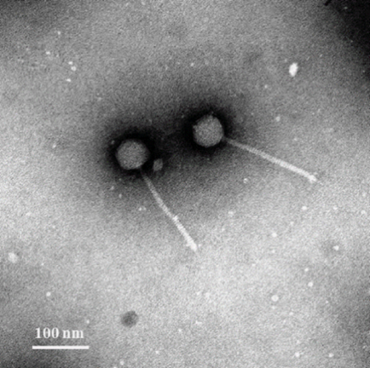

Figure 1. Transmission electron microscopy image of vB_MoxS-R1. Scale bar = 100 nm.

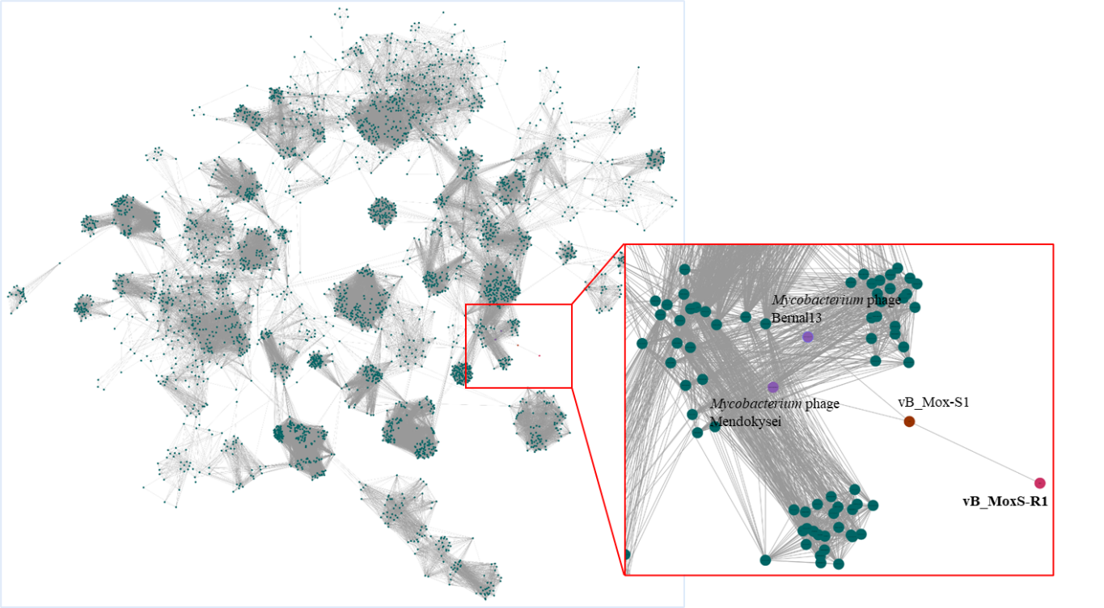

Figure 2. Protein-sharing viral network of vB_MoxS-R1, vB_Mox-S1 and ViralRefSeq database viruses with a pairing-similarity score >1. vConTACT 2.0 was used to calculate the similarity score between each pair of viral genomes, and ClusterONE was used to identify the viral cluster [5,6]. The network was visualized using Cytoscape 3.8.2 [7,8]. Each node represents the genome of a phage. Edges represent interaction between pairs of viruses. The nodes of vB_MoxS-R1, vB_Mox-S1 and their related phages are colored in different colors.

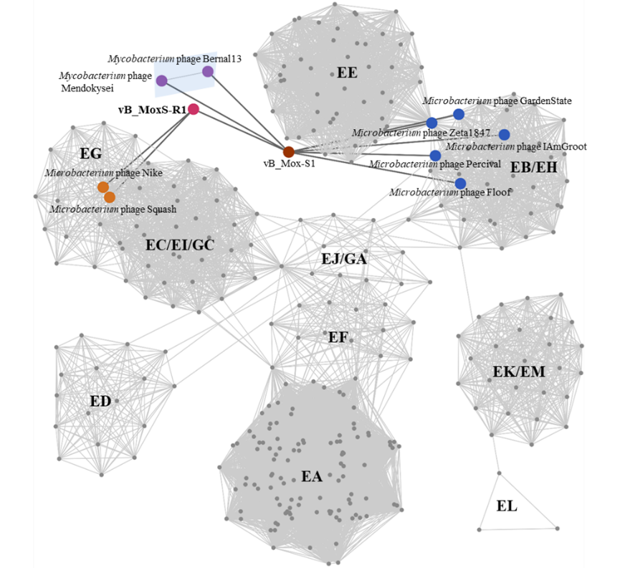

Figure 3. Protein-sharing viral network of vB_MoxS-R1, vB_Mox-S1, 341 *Microbacterium* phages and two *Mycobacterium* phages with a pairing-similarity score >1. vConTACT 2.0 was used to calculate the similarity score between each pair of viral genomes, and ClusterONE was used to identify the viral cluster [5,6]. The network was visualized using Cytoscape 3.8.2 [7,8]. Each node represents the genome of a phage. Edges represent the similarity scores of shared proteins between phages, and edges related to vB_MoxS-R1 and vB_Mox-S1 are displayed in bold and colored in dark gray. The nodes of vB_MoxS-R1, vB_Mox-S1 and their related phages are enlarged in different colors according to their phylotypes. Group names of the *Microbacterium* phages are shown on each cluster, and the *Mycobacterium* phages are indicated in a light blue shadow.

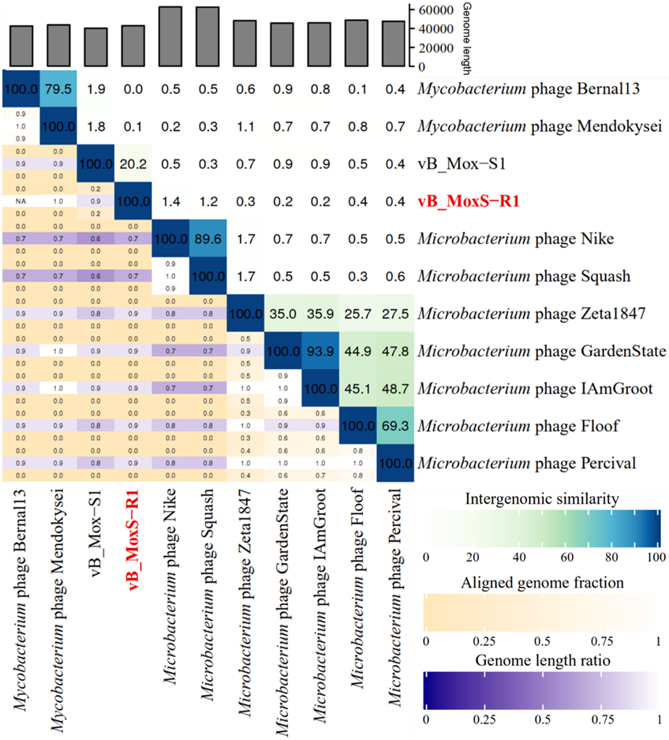

Figure 4. Intergenomic similarity between vB_MoxS-R1 and vB_Mox-S1 and their network-related phages calculated using VIRIDIC [2]. The right half of this heatmap represents the similarity values between genomes, with higher number and darker color indicating the more closely-related the genome. The left half of this heatmap represents the align genome fraction and genome length ratio.

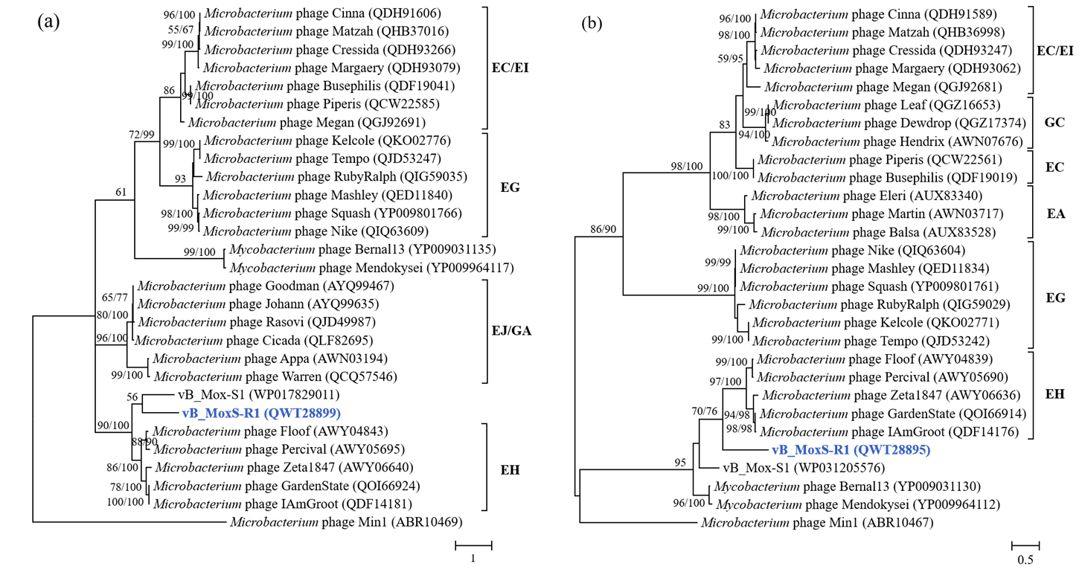

Figure 5. Unrooted maximum-likelihood phylogenetic trees of the major capsid protein (a) and terminase large subunit (b) of vB_MoxS-R1, other *Microbacterium* phages and two *Mycobacterium* phages based on the amino acid sequences. Mega7.0 software package was used for phylogenetic analyses, in which ClustalW was used for amino acid sequence alignment, and Jones Taylor Thornton (JTT) model was used to construct the trees [9]. The bootstrap values (Maximum-likelihood/Neighbor-joining) are shown near each node. Number of bootstrap replicates = 1,000.

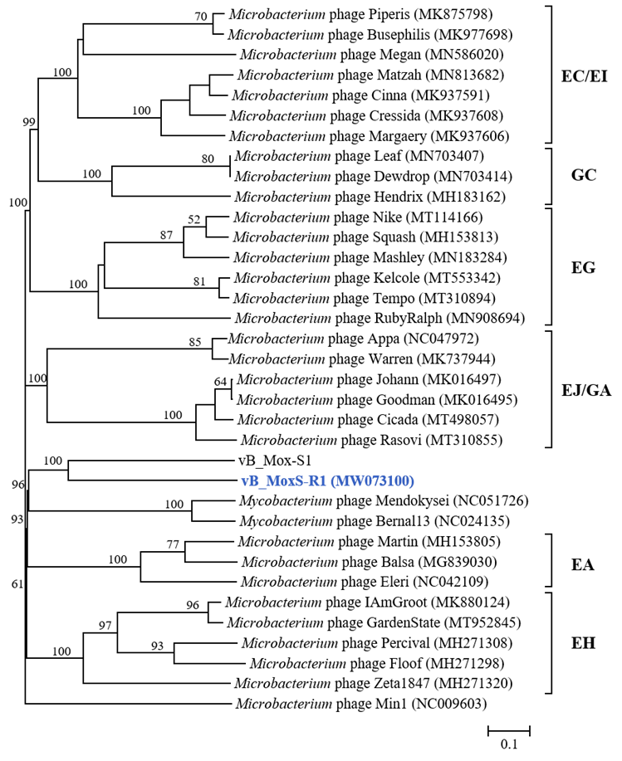

Figure 6. The genome-wide phylogenetic tree of 35 phages based on nucleotide sequence. This tree was conducted using the Genome-BLAST Distance Phylogeny (GBDP) method, and the number of nodes was the GBDP pseudo-bootstrap support values from 100 replications (only show values > 50%). The GBDP tree is reconstructed by VICTOR [10].

Table 1. ORF homology comparative analyses of vB_MoxS-R1 and ten phages .



**References**

1. Sayers EW, Beck J, Bolton EE, Bourexis D, Brister JR, Canese K, Comeau DC, FunkK, Kim S, Klimke W, Marchler-Bauer A, Landrum M, Lathrop S, Lu Z, Madden TL,O'Leary N, Phan L, RangwalaSH, Schneider VA, Skripchenko Y, Wang J, Ye J,Trawick BW, Pruitt KD, Sherry ST. Database resources of the National Center for Biotechnology Information. Nucleic Acids Res. 2021 Jan 8;49(D1):D10-D17. doi:10.1093/nar/gkaa892. PMID: 330958702.
2. Moraru C, Varsani A, Kropinski AM. VIRIDIC-A Novel Tool to Calculate the Intergenomic Similarities of Prokaryote-Infecting Viruses. Viruses. 2020 Nov 6;12(11):1268. doi: 10.3390/v12111268. PMID: 33172115.
3. Turner D, Kropinski AM, Adriaenssens EM. A Roadmap for Genome-Based Phage Taxonomy. Viruses. 2021 Mar 18;13(3):506. doi: 10.3390/v13030506. PMID:33803862.
4. Xu Y, Jiao N, Chen F. Novel psychrotolerant picocyanobacteria isolated from Chesapeake Bay in the winter. J Phycol. 2015 Aug;51(4):782-90. doi: 10.1111/jpy.12318. PMID: 26986796.
5. Jang HB, Bolduc B, Zablocki O, Kuhn JH, Roux S, Adriaenssens E.M, Brister JR, Kropinski AM, Krupovic M, Lavigne R. Taxonomic assignment of uncultivated prokaryotic virus genomes is enabled by gene-sharing networks. Nat. Biotechnol. 2019 Jun;37(6):632–639. doi: 10.1038/s41587-019-0100-8. PMID: 31061483.
6. Zhang Z, Qin F, Chen F, Chu X, Luo H, Zhang R, Du S, Tian Z, Zhao Y. Culturing novel and abundant pelagiphages in the ocean. Environ. Microbiol. 2021 Feb; 23(2):1145–1161. doi: 10.1111/1462-2920.15272. PMID: 33047445.
7. Kohl M, Wiese S, Warscheid B. Cytoscape: Software for visualization and analysis of biological networks. Methods Mol. Biol. 2011; 696:291–303. doi: 10.1007/978-1-60761-987-1_18. PMID: 21063955.
8. Ma R, Lai J, Chen X, Wang L, Yang Y, Wei S, Jiao N, Zhang R. A novel phage infecting Alteromonas represents a distinct group of siphophages infecting diverse aquatic copiotrophs. mSphere. 2021 Jun;6(3):e0045421. doi: 10.1128/mSphere.00454-21. PMID: 34106770.
9. Sudhir K, Glen S, Koichiro T. MEGA7: Mega7: Molecular evolutionary genetics analysis version 7.0 for bigger datasets. Mol. Biol. Evol. 2016 Jul; 33(7):1870–1874. doi: 10.1093/molbev/msw054. PMID: 27004904.
10. Meier-Kolthoff JP, Göker M. VICTOR: Genome-based phylogeny and classification of prokaryotic viruses. Bioinformatics. 2017 Nov 1; 33(21):3396–3404. doi: 10.1093/bioinformatics/btx440. PMID: 29036289.