

**Part 1:** **TITLE, AUTHORS, APPROVALS, etc**

|  |  |  |
| --- | --- | --- |
| **Code assigned:** | ***2022.095B*** |  |
| **Short title:** Create one new genus (*Youngvirus*) including one new species in the *Autographiviridae* (*Caudoviricetes*) | | |
|  | | |

**Author(s) and email address(es)**

|  |  |
| --- | --- |
| Jing Wang, Zekun Liu, Shixuan Huang | 1546750609@qq.com;  lzk_98@foxmail.com;  nhuhuganaxis@outlook.com; |

**Author(s) institutional address(es) (optional)**

|  |
| --- |
| South China Agricultural University, China [WJ, LZK, HSX]  Guangdong Institute of Microbiology, China [WJ, LZK, HSX] |

**Corresponding author**

|  |
| --- |
| Jing Wang, Zekun Liu |

**List the ICTV Study Group(s) that have seen this proposal**

|  |
| --- |
| Bacterial Viruses Subcommittee,  Autographiviridae Study Group |

**ICTV Study Group comments and response of proposer**

|  |
| --- |
|  |

**ICTV Study Group votes on proposal**

|  |  |  |  |
| --- | --- | --- | --- |
| **Study Group** | **Number of members** | | |
| **Votes support** | **Votes against** | **No vote** |
|  |  |  |  |
|  |  |  |  |

**Authority to use the name of a living person**

|  |  |
| --- | --- |
| **Is any taxon name used here derived from that of a living person (Y/N)** | N |

|  |  |  |
| --- | --- | --- |
| **Taxon name** | **Person from whom the name is derived** | **Permission attached (Y/N)** |
|  |  |  |
|  |  |  |
|  |  |  |

**Submission dates**

|  |  |
| --- | --- |
| Date first submitted to SC Chair | May 2022 |
| Date of this revision (if different to above) |  |

**ICTV-EC comments and response of the proposer**

|  |
| --- |
|  |

**Part 3:** **TAXONOMIC PROPOSAL**

**Name of accompanying Excel module**

|  |
| --- |
| 2022.095B.N.v1.Youngvirus_ng.xlsx |

**Abstract**

|  |
| --- |
| We have created a new genus of *Vibrio* phages, *Youngvirus*. |

**Text of proposal**

|  |  |
| --- | --- |
| |  | | --- | | **Species demarcation criteria:** We have chosen 95% DNA sequence identity as the criterion for demarcation of species in this new genus. The proposed species differs from the others with more than 5% at the DNA level as confirmed with the BLASTN algorithm. | |

**Supporting evidence**

**Source of the name of this taxon:** This genus is named after the word ‘young' where, in 2021, Vibrio phage vB_VpP_G1 was isolated in the Huangsha aquatic products trading market, Guangzhou, China.

**VIRIDIC heat map:** VIRIDIC (Virus Intergenomic Distance Calculator; [1]) computes pairwise intergenomic distances/similarities amongst phage genomes. VIRDIC analysis of strains with high similarity after BLAST comparison showed that Vibrio phage vB_VpP_G1 had the highest similarity with Yersinia phage phiR8-01 and vB_YenP_ISAO8, but both were well below the generic level similarity threshold. (The black box)

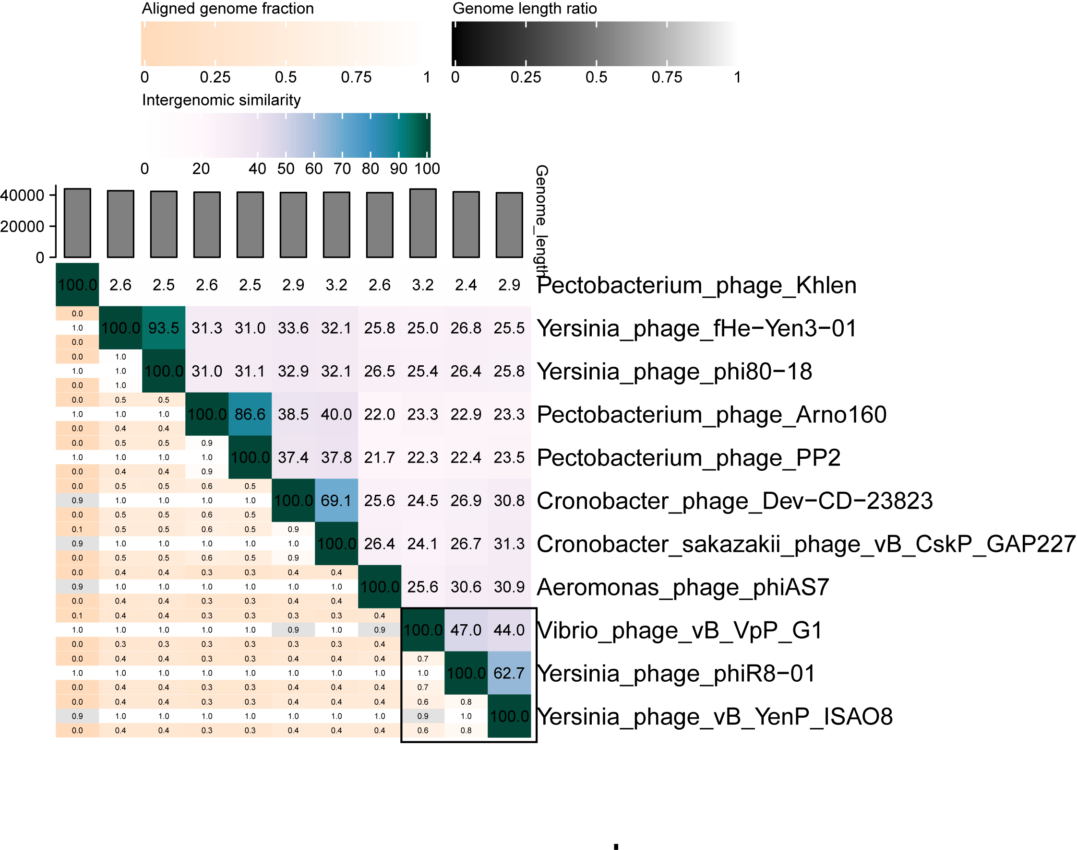

**vConTACT2 analysis:** vConTACT2 [2] is a uses genome-wide gene sharing mapping for virus classification. Red lines show strains associated with vB_VpP_G1, most of which are unclassified (gray), while vB_YenP_ISAO8 strains show the strongest association (red solid line). Associated groups include *Teseptimavirus* (green), *Phikmvvirus* (blue), *Bifseptvirus* (red), *Aqualcavirus* (orange), *Napahaivirus* (yellow) and *Peadovirus* (pink).

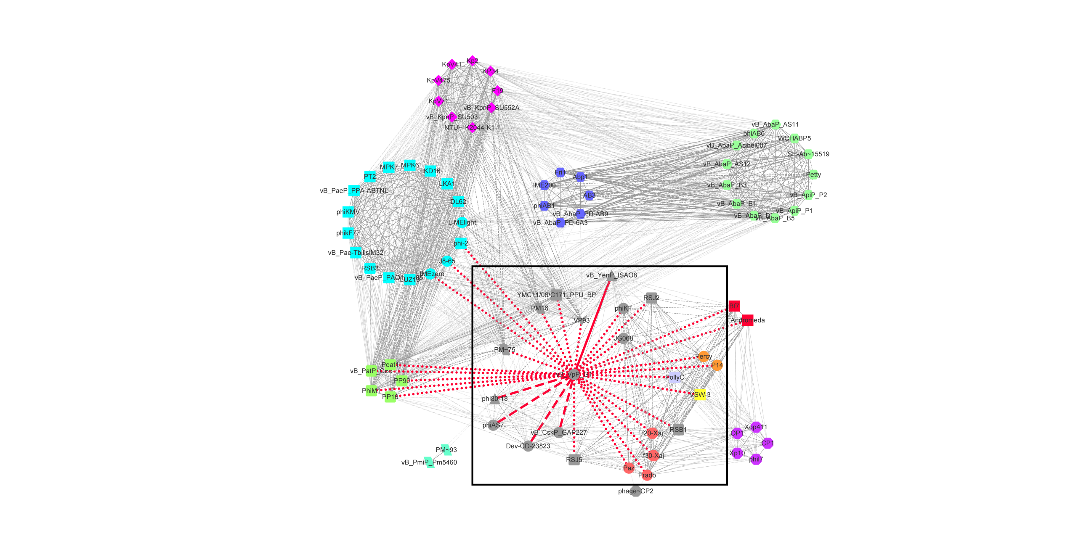

**GenBank Summary:**

|  |  |  |  |  |  |
| --- | --- | --- | --- | --- | --- |
| Phage name | INSDC | Size (Kb) | GC% | Protein | tRNAs |
| Vibrio phage vB_VpP_G1 | MZ592920.1 | 43.8 | 47.22% | 51 | 0 |

**Electron micrograph:**

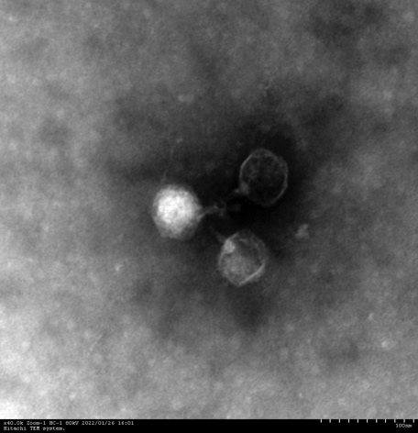

**References**

1. Sayers EW, Agarwala R, Bolton EE, Brister JR, Canese K, Clark K, et al. Database resources of the National Center for Biotechnology Information. Nucleic Acids Res. 2019;47(D1):D23-D28. doi: 10.1093/nar/gkz899. PMID: 31602479.
2. Bin Jang H, Bolduc B, Zablocki O, et al. Taxonomic assignment of uncultivated prokaryotic virus genomes is enabled by gene-sharing networks. Nat Biotechnol. 2019;37(6):632-639. doi:10.1038/s41587-019-0100-8 PMID: 31061483