

**Part 1:** **TITLE, AUTHORS, APPROVALS, etc**

|  |  |  |
| --- | --- | --- |
| **Code assigned:** | ***2023.005B*** |  |
| **Short title:** Assign two new species, *Andromedavirus novomoskovsk* and *Andromedavirus* *bolokhovo*, to the genus *Andromedavirus*, class *Caudoviricetes.* | | |
|  | | |

**Author(s) and email address(es)**

|  |  |
| --- | --- |
| Skorynina AV, Koposova ON, Kazantseva OA, Piligrimova EG, Shadrin AM | [s_an.net@mail.ru](mailto:s_an.net@mail.ru); [galeolya@mail.ru](mailto:galeolya@mail.ru); [olesyakazantseva@bk.ru](mailto:olesyakazantseva@bk.ru); [e.piligrimova@ibpm.ru](mailto:e.piligrimova@ibpm.ru); andrey2010s@gmail.com |

**Author(s) institutional address(es) (optional)**

|  |
| --- |
|  |

**Corresponding author**

|  |
| --- |
| Kazantseva OA  Piligrimova EG |

**List the ICTV Study Group(s) that have seen this proposal**

|  |
| --- |
|  |

**ICTV Study Group comments and response of proposer**

|  |
| --- |
|  |

**ICTV Study Group votes on proposal**

|  |  |  |  |
| --- | --- | --- | --- |
| **Study Group** | **Number of members** | | |
| **Votes support** | **Votes against** | **No vote** |
|  |  |  |  |
|  |  |  |  |

**Authority to use the name of a living person**

|  |  |
| --- | --- |
| **Is any taxon name used here derived from that of a living person (Y/N)** | N |

|  |  |  |
| --- | --- | --- |
| **Taxon name** | **Person from whom the name is derived** | **Permission attached (Y/N)** |
|  |  |  |
|  |  |  |
|  |  |  |

**Submission dates**

|  |  |
| --- | --- |
| Date first submitted to SC Chair | May 2023 |
| Date of this revision (if different to above) |  |

**ICTV-EC comments and response of the proposer**

|  |
| --- |
|  |

**Part 2:** **NON-TAXONOMIC PROPOSAL**

**Text of proposal**

|  |
| --- |
|  |

**Part 3:** **TAXONOMIC PROPOSAL**

**Name of accompanying Excel module**

|  |
| --- |
| 2023.005B.N.v1.Andromedavirus_ new_species.xlsx |

**Abstract**

|  |
| --- |
| We propose creating two species, *Andromedavirus novomoskovsk* and *Andromedavirus bolokhovo,* in the genus *Andromedavirus*, to formally classify two novel virulent siphoviruses infecting Bacillus pumilus. |

**Text of proposal**

|  |  |
| --- | --- |
| |  | | --- | | Bacillus phages Novomoskovsk and Bolokhovo were isolated from soil samples collected in the Tula region, Russian Federation. On the propagating host strain B. pumilusAVS-01, both phages formed transparent plaques surrounded by turbid halos [1]. The lengths of the Bolokhovo and Novomoskovsk genomes were found to be 49683 bp and 49258 bp, respectively. The number of predicted protein-coding genes was 48 for Bolokhovo and 43 for Novomoskovsk. No integrase genes were predicted, suggesting a virulent lifestyle.  We chose the previously established cut-offs of 95% DNA sequence identity as the criterion for species demarcation, and 70% nucleotide identity as the genus demarcation threshold [2]. The closest to Novomoskovsk was Bacillus phage Finn, with nucleotide identity of 83.4%, as determined with EMBOSS Stretcher. In the case of Bolokhovo, the closest relative was *Bacillus* phage Curly (92.4% nucleotide identity). Both Finn and Curly are members of *Andromedavirus*, therefore, Bolokhovo and Novomoskovsk should be classified as two new species of the genus. | |

**Supporting evidence**

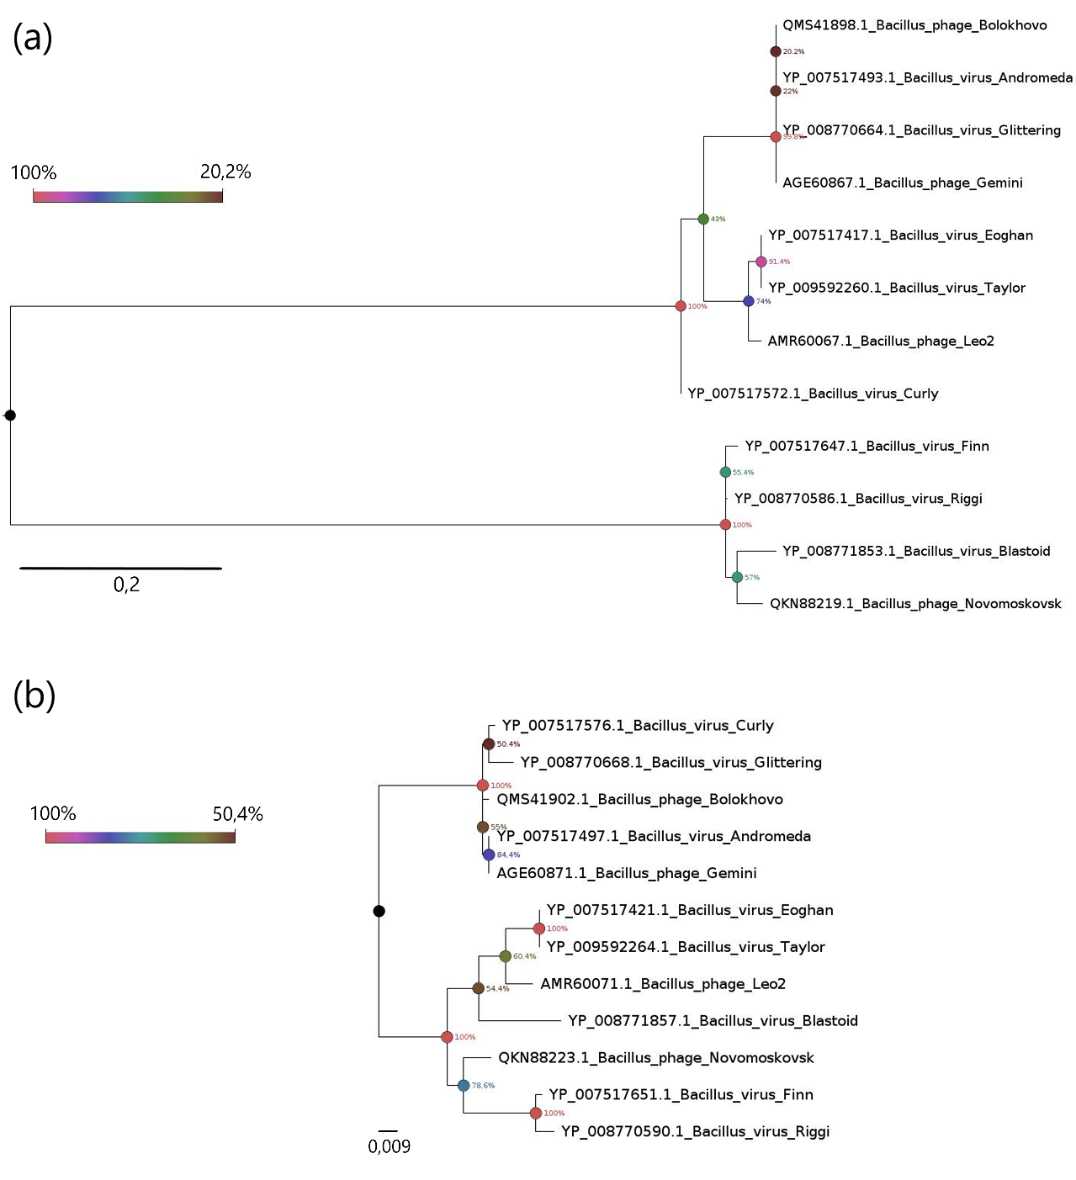

Figure 1 - Phylogenetic analysis of the depolymerases **(a)** and endolysins **(b)** of Novomoskovsk, Bolokhovo and the members of *Andromedavirus*. The phylograms were constructed using the Maximum Likelihood method with 500 bootstrap replicates, the nodes are colored in accordance with the bootstrap support values. The scale bars represent the number of amino acid substitutions per site.

**References**

1) Skorynina AV, Koposova ON, Kazantseva OA, Piligrimova EG, Ryabova NA, Shadrin AM (2020) Isolation and Characterization of Two Novel Siphoviruses Novomoskovsk and Bolokhovo, Encoding Polysaccharide Depolymerases Active against Bacillus pumilus. IJMS. 23(21):12988.

<https://doi.org/10.3390/ijms232112988>

2) Turner D, Kropinski AM, Adriaenssens EM (2021) A roadmap for genome-based phage taxonomy. Viruses 13.3: 506.

<https://doi.org/10.3390/v13030506>