

**Part 1:** **TITLE, AUTHORS, APPROVALS, etc**

|  |  |  |
| --- | --- | --- |
| **Code assigned:** | ***2023.006B*** |  |
| **Short title:** Create a new genus (*Aquaneticvirus*) with one species in the class *Caudoviricetes* | | |
|  | | |

**Author(s) and email address(es)**

|  |  |
| --- | --- |
| Cebeci A, Türe M, Alemdağ M, Altinok I | [lisenye28@gmail.com](mailto:lisenye28@gmail.com); [mustafa61ture@gmail.com](mailto:mustafa61ture@gmail.com); [alemdag.melike@hotmail.com](mailto:alemdag.melike@hotmail.com); [ialtinok@gmail.com](mailto:ialtinok@gmail.com) |

**Author(s) institutional address(es) (optional)**

|  |
| --- |
| Fish Health Department, Central Fisheries Research Institute, 61250 Yomra, Trabzon, Türkiye (AC, MT, MA)  Aquatic Animal Health and Molecular Genetic laboratory, Department of Chemistry C Block, Karadeniz Technical University, 61080, Trabzon, Türkiye (IA) |

**Corresponding author**

|  |
| --- |
| Ilhan ALTINOK |

**List the ICTV Study Group(s) that have seen this proposal**

|  |
| --- |
| Caudoviricetes Study Group |

**ICTV Study Group comments and response of proposer**

|  |
| --- |
|  |

**ICTV Study Group votes on proposal**

|  |  |  |  |
| --- | --- | --- | --- |
| **Study Group** | **Number of members** | | |
| **Votes support** | **Votes against** | **No vote** |
|  |  |  |  |
|  |  |  |  |

**Authority to use the name of a living person**

|  |  |
| --- | --- |
| **Is any taxon name used here derived from that of a living person (Y/N)** | N |

|  |  |  |
| --- | --- | --- |
| **Taxon name** | **Person from whom the name is derived** | **Permission attached (Y/N)** |
|  |  |  |
|  |  |  |

**Submission dates**

|  |  |
| --- | --- |
| Date first submitted to SC Chair | May 2023 |
| Date of this revision (if different to above) |  |

**ICTV-EC comments and response of the proposer**

|  |
| --- |
|  |

**Part 2:** **NON-TAXONOMIC PROPOSAL**

**Text of proposal**

|  |
| --- |
|  |

**Part 3:** **TAXONOMIC PROPOSAL**

**Name of accompanying Excel module**

|  |
| --- |
| 2023.006B.N.v1.Aquaneticvirus_ng.xlsx |

**Abstract**

|  |
| --- |
| Aeromonas phage APT65 (OP491958.1) is distantly related to species classified within the genus *Lahexavirus*. BLASTN analysis reveals that APT65 falls considerably below the nucleotide similarity criteria for inclusion within the *Lahexavirus.* It is proposed that APT65 represents a new species within its own genus. We propose that the name for the APT65 should be *Caudoviricetes* (Class), *Aquaneticvirus* (Genus), and *Aquaneticvirus APT65* (species). |

**Text of proposal**

|  |  |
| --- | --- |
| |  | | --- | | **Species demarcation criteria:** Two phages are assigned to the same species if their genomes are more than 95% identical over their genome length for isolates.  These values can be calculated by a number of tools, such as BLASTn (Sayers et al., 2021) – usually calculated using intergenomic distance calculator Virus Intergenomic Distance Calculator (VIRIDIC= (Moraru et al., 2020).  **Genus demarcation criteria:** In search for criteria that create cohesive and distinct genera that are reproducible and monophyletic, the Bacterial Viruses Subcommittee has established 70% nucleotide identity of the genome length as the cut-off for genera. Genus-level groupings should always be monophyletic in the signature genes, as tested with a phylogenetic tree. | |

**Supporting evidence**

**Isolation**

A T65 strain of bacteriophage was isolated from municipal water in Trabzon, Turkey, and the T65 phage was strongly lytic against *Aeromonas hydrophila*. Therefore, the bacteriophage strain T65 was named *Aeromonas* phage T65 (APT65). The whole genome sequence of APT65 was deposited in GenBank under the accession number OP491958.1 (Cebeci et al. 2023).

**Morphology**

The transmission electron microscopy images of negatively stained phage revealed that APT65 had an icosahedral head 60 nm in diameter and a long contractile tail 170 nm in length (Fig. 2). According to its morphology, the APT65 phage belongs to the Caudoviricetes class.

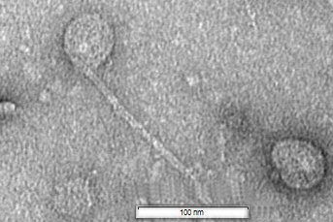

**Figure 1.** Transmission electron (TEM) microscopy image of APT65 phage. The phages were negatively stained with 2% (wt/vol) uranyl acetate and observed using TEM JEM-2100 (JEOL, Tokyo, Japan) at 200 kV.

**Table 1. Summary characteristics**

|  |  |  |  |  |  |
| --- | --- | --- | --- | --- | --- |
| **Phage name** | **INSDC Accession** | **Size (Kb)** | **GC%** | **No. of proteins** | **No. of tRNAs** |
| [*Aeromonas* phage T65](https://www.ncbi.nlm.nih.gov/Taxonomy/Browser/wwwtax.cgi?id=2982914) | OP491958.1 | 85.2 | 39.41 | 105 | 12 |

**Nucleotide and Protein similarity**

BLASTN analysis of APT65 revealed low sequence similarity between APT65 and members of the genera *Lahexavirus*. Using VIRIDIC, APT65 falls below the nucleotide similarity threshold for inclusion within the genus *Lahexavirus* (Figure 2). The Bacterial and Archaeal Viruses Subcommittee of the International Committee on the Taxonomy of Viruses (ICTV) recommends an identity threshold of 95% for the species level and 70% for the genus level. However, the similarity of the APT65 phage to other phages at the species or genus level was lower than that recommended by ICTV.

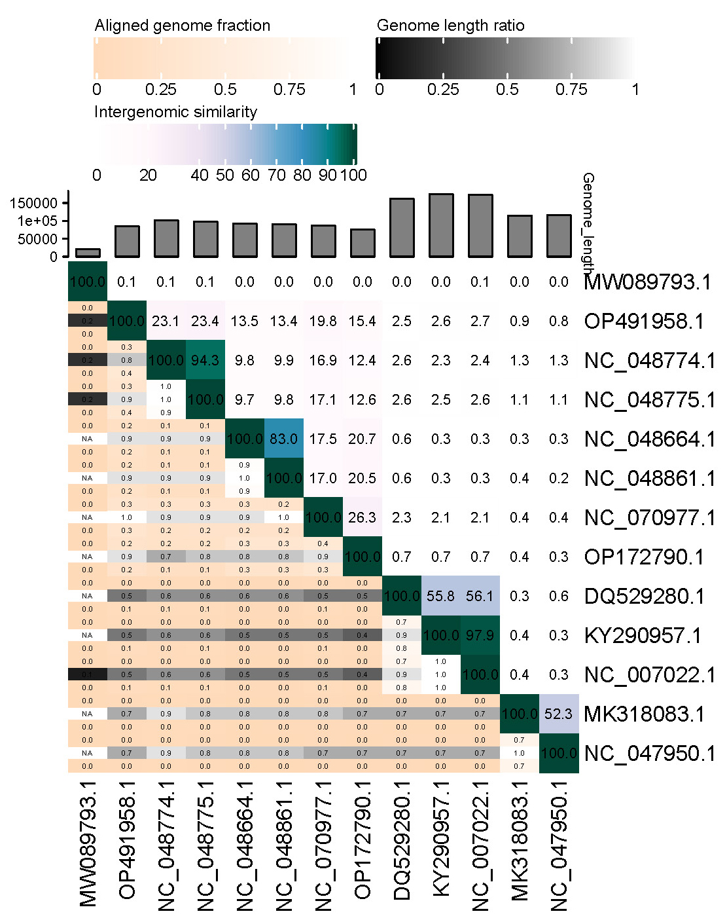

**Figure 2.** A heatmap illustrating the intergenomic similarities between APT65 and distantly related bacteriophage genomes was constructed using the Virus Intergenomic Distance Calculator (VIRIDIC). The right side of the visual representation illustrates the degree of intergenomic similarity across the 13 genomes. This is shown by a gradient scale ranging from white to dark green, where deeper colors indicate a higher percentage of intergenomic similarity. The left half of the representation illustrates three distinct values: the aligned genome fraction for the genome located in the top row, the genome length ratio in the center, and the aligned genome fraction for the genome located in the column. These values are graded on a scale from 0 to 1, with 1 being represented by the color white.

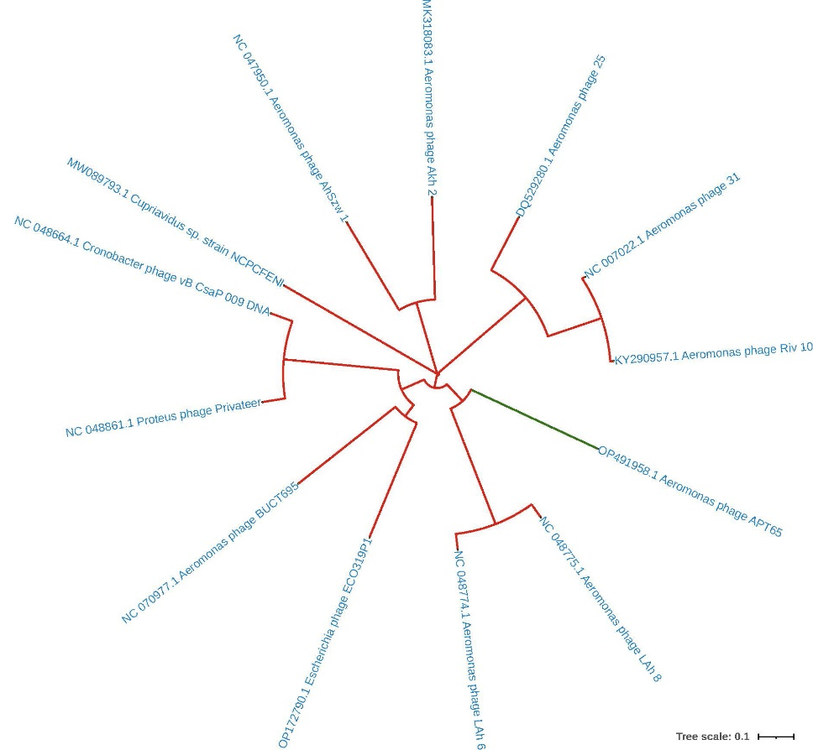

**Figure 3**. A phylogenetic tree demonstrating the genomic relationships between APT65 and other bacteriophages that are distantly related. The comparative analysis of whole genome sequences was performed using the ClustalW program. Subsequently, a phylogenetic tree was created employing the neighbor-joining approach, accompanied by 1000 bootstrap repeats.

**Whole proteome comparisons and phylogenetic analysis**

The classification criteria for intermediate-level rank are being developed. They should be based on complete viral proteomes and take into consideration shared orthologous proteins (Turner et al. 2021). The genome clustering protein map indicated that the APT65 phage belongs to a distinct clade (Figure 4) and shared 41 proteins with other bacteriophages (Table 1). It does not belong to *Lahexavirus*; hence, it should belong to a different genus and species.

Based on these data we propose that APT65 phage should be classified as a species, *Aquaneticvirus APT65* within a new genus *Aquaneticvirus*.

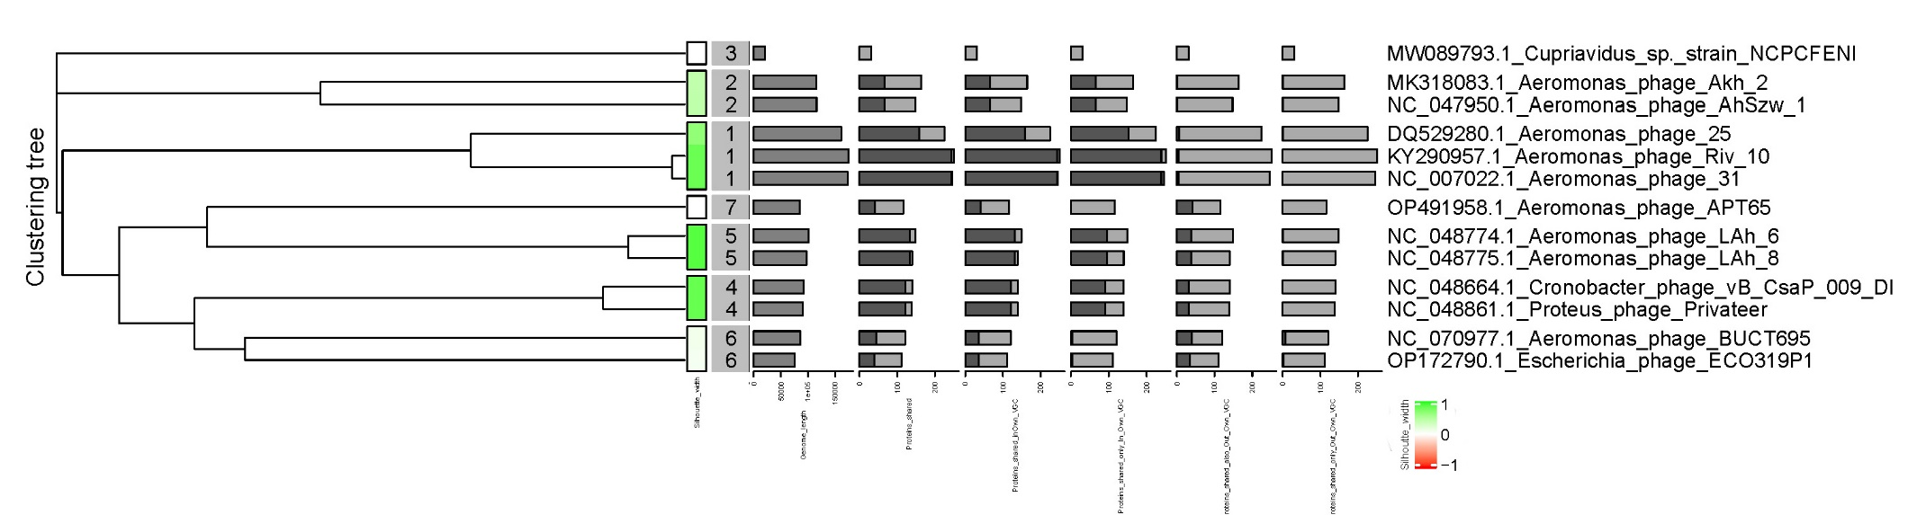

**Figure 4.** VirCLUST bacteriophage protein clustering. Proteins were initially grouped into protein clusters (PCs) by the use of reciprocal BLASTP similarities. Subsequently, these PCs were further grouped into protein superclusters based on their Hidden Markov Model (HMM) similarities. The VirClust algorithm was used to analyze a dataset including whole viral genomes derived from both Aeromonas and non-Aeromonas-related phages. Hierarchical clustering tree was calculated using the PC based intergenomic distances. The genome clustering was done using PCs and a bootstrapping of 1000 replicates. The tree obtained was partitioned into VGCs (viral genome clusters) by using a threshold of 0.9 for intergenomic distance. The Aeromonas phage APT65 forms a unique cluster (cluster 7), which is distantly related to the Aeromonas phages Lah6 and Lah8 (cluster 5).

Table 1. Comparison of the proteins of the APT65 phage to those of other bacteriophages obtained from NCBI.

|  |  |  |  |  |  |  |  |  |  |  |  |
| --- | --- | --- | --- | --- | --- | --- | --- | --- | --- | --- | --- |
| **Genome Cluster ID** | **Genome Name** | **Length** | **Gene count** | **Proteins shared** | **Single Proteins** | **Proteins shared in Own GC** | **Proteins shared only In Own GC** | **Proteins shared also Out Own GC** | **Proteins shared only Out Own GC** | **Silhouette neighbor** | **Silhouette width** |
| 1 | DQ529280.1_Aeromonas_phage_25 | 161475 | 225 | 159 | 66 | 158 | 153 | 6 | 1 | 5 | 0.66 |
| 1 | KY290957.1_Aeromonas_phage_Riv_10 | 174311 | 251 | 244 | 7 | 244 | 239 | 5 | 0 | 5 | 0.82 |
| 2 | MK318083.1_Aeromonas_phage_Akh_2 | 114901 | 164 | 67 | 97 | 66 | 66 | 1 | 1 | 5 | 0.41 |
| 3 | MW089793.1_Cupriavidus_sp._strain_NCPCFENI | 21286 | 31 | 0 | 31 | 0 | 0 | 0 | 0 | 1 | 0 |
| 1 | NC_007022.1_Aeromonas_phage_31 | 172963 | 246 | 244 | 2 | 244 | 239 | 5 | 0 | 5 | 0.82 |
| 2 | NC_047950.1_Aeromonas_phage_AhSzw_1 | 115739 | 148 | 67 | 81 | 66 | 66 | 1 | 1 | 1 | 0.42 |
| 4 | NC_048664.1_Cronobacter_phage_vB | 92122 | 140 | 122 | 18 | 122 | 90 | 32 | 0 | 6 | 0.83 |
| 5 | NC_048774.1_Aeromonas_phage_LAh_6 | 101390 | 149 | 133 | 16 | 132 | 95 | 38 | 1 | 7 | 0.88 |
| 5 | NC_048775.1_Aeromonas_phage_LAh_8 | 97408 | 140 | 133 | 7 | 132 | 95 | 38 | 1 | 7 | 0.88 |
| 4 | NC_048861.1_Proteus_phage_Privateer | 90710 | 139 | 122 | 17 | 122 | 90 | 32 | 0 | 6 | 0.83 |
| 6 | NC_070977.1_Aeromonas_phage_BUCT695 | 86289 | 121 | 44 | 77 | 36 | 4 | 40 | 8 | 4 | 0.1 |
| 6 | OP172790.1_Escherichia_phage_ECO319P1 | 75333 | 111 | 39 | 72 | 36 | 4 | 35 | 3 | 4 | 0.07 |
| 7 | OP491958.1_Aeromonas_phage_APT65 | 85188 | 116 | 41 | 75 | 41 | 0 | 41 | 0 | 5 | 0 |

**References**

Cebeci A, Ture M, Alemdağ M, Altinok I (2023) Whole genome sequence of novel bacteriophage APT65 infecting *Aeromonas hydrophila*. PHAGE: Ther Appl Res 4:46-50. https://doi.org/10.1089/phage.2022.0037

Moraru C, Varsani A, Kropinski AM. (2020) VIRIDIC-A novel tool to calculate the intergenomic similarities of prokaryote-infecting viruses. Viruses12(11):1268. doi: 10.3390/v12111268. PMID: 33172115; PMCID: PMC7694805. http://kronos.icbm.uni-oldenburg.de/viridic/

Moraru C. (2021): VirClust, a tool for hierarchical clustering, core gene detection and annotation of (prokaryotic) viruses. In BioRxiv. https://doi.org/10.1101/2021.06.14.448304

Sayers EW, Beck J, Bolton EE, Bourexis D, Brister JR, Canese K, Comeau DC, Funk K, Kim S, Klimke W, Marchler-Bauer A, Landrum M, Lathrop S, Lu Z, Madden TL, O'Leary N, Phan L, Rangwala SH, Schneider VA, Skripchenko Y, Wang J, Ye J, Trawick BW, Pruitt KD, Sherry ST. Database resources of the National Center for Biotechnology Information. Nucleic Acids Res. 2021 Jan 8;49(D1):D10-D17. https://doi.org/10.1093/nar/gkaa892. PMID: 33095870

Turner D, Kropinski AM, Adriaenssens EM. (2021) A Roadmap for genome-based phage taxonomy. Viruses13(3):506. https://doi.org/10.3390/v13030506. PMID: 33803862; PMCID: PMC8003253.