

**Part 1:** **TITLE, AUTHORS, APPROVALS, etc**

|  |  |  |
| --- | --- | --- |
| **Code assigned:** | ***2023.007B*** |  |
| **Short title:** To create a new genus, *Aquingentivirus*, in the class *Caudovircetes* containing seven new species | | |
|  | | |

**Author(s) and email address(es)**

|  |  |
| --- | --- |
| Shareefdeen H, Buttimer C, Denise R, Kropinski A, Turner D, Draper L-A, Ross R-P, Hill C | 121126201@umail.ucc.ie; colin.buttimer@ucc.ie; rdenise@ucc.ie;  phage.canada@gmail.com;  Dann2.Turner@uwe.ac.uk; l.draper@ucc.ie,  p.ross@ucc.ie; c.hill@ucc.ie |

**Author(s) institutional address(es) (optional)**

|  |
| --- |
|  |

**Corresponding author**

|  |
| --- |
| Colin Buttimer |

**List the ICTV Study Group(s) that have seen this proposal**

|  |
| --- |
|  |

**ICTV Study Group comments and response of proposer**

|  |
| --- |
|  |

**ICTV Study Group votes on proposal**

|  |  |  |  |
| --- | --- | --- | --- |
| **Study Group** | **Number of members** | | |
| **Votes support** | **Votes against** | **No vote** |
|  |  |  |  |
|  |  |  |  |

**Authority to use the name of a living person**

|  |  |
| --- | --- |
| **Is any taxon name used here derived from that of a living person (Y/N)** | N |

|  |  |  |
| --- | --- | --- |
| **Taxon name** | **Person from whom the name is derived** | **Permission attached (Y/N)** |
|  |  |  |
|  |  |  |
|  |  |  |

**Submission dates**

|  |  |
| --- | --- |
| Date first submitted to SC Chair | May 2023 |
| Date of this revision (if different to above) |  |

**ICTV-EC comments and response of the proposer**

|  |
| --- |
|  |

**Part 2:** **NON-TAXONOMIC PROPOSAL**

**Text of proposal**

|  |
| --- |
|  |

**Part 3:** **TAXONOMIC PROPOSAL**

**Name of accompanying Excel module**

|  |
| --- |
| 2023.007B.A.v1.Aquingentivirus_ng.xlsx |

**Abstract**

|  |
| --- |
| Phylogenetic analysis of a newly isolated phage HS5 which infects *Listeria monocytogenes* suggests that this phage and phage A500 form a new proposed genus, *Aquingentivirus* in the class *Caudoviricetes*. Based on the phylogenetic trees we have constructed, the genus contains 7 species of A500-like phages are all temperate siphoviruses infecting *Listeria monocyotgenes*. |

**Text of proposal**

|  |  |
| --- | --- |
| |  | | --- | | **Species demarcation criteria**: We have chosen 95% DNA sequence identity as the criterion for demarcation of species in this new genus. Each of the proposed species differs from the others with more than 5% at the DNA level as confirmed with the BLASTN algorithm.  Micrographs of phage HS5 show the phage is a siphovirus-like phage of the B1 morphotype with an isometric head and a flexible non-contractile tail. The tail length is approximately 222 nm and the diameter of the capsid is approximately 55nm.    **Genus demarcation**: *Listeria* phages HS5, A500, PSU-VKH-LP040, LP-030-3, HB17054, vB_LmoS_P7, vB_LmoS_293 are all phages of *Listeria monocytogenes*. Phylogenetic and BLASTN analyses indicate that the proposed genus (Table 1 and Figure 2), *Aquingentivirus*, is cohesive and distinct from other genera. On average, the genomes of members of this genus are roughly 65 kb and encode between 62 and 69 proteins (Table 1). Bioinformatics analysis of these phage genomes show that these are temperate phages, and we show that there is at least 60% nucleotide identity with a conserved gene content (Table 1 and Figure 3)  Additional analysis to place the proposed genus in relation to existing genera has shown that “*Aquingentivirus*” falls outside of the existing genera on the ICTV database. Using “tax_myPhage” (https://github.com/amillard/tax_myPHAGE), our genomes of interest were compared to similar genomes in the set of currently classified ICTV genomes that are present in the VMR. When compared to its closest relatives at the suggested MASH distances of 0.2, “*Aquingentivirus*” falls outside of existing genera and when MASH distances were increased to 0.3, the closest genera were *Psavirus*, *Slepowronvirus* and *Jelitavirus*. The closest genus based on the MASH distances of 0.2 is *Psavirus*, which does not currently fall into any existing subfamily. The other genera fall into the subfamily “Trabyvirinae”. Based on this information, as well as the tree inferred using the large terminase protein, we propose that “*Aquintgentivirus*” is a new distinct genus that does not fall into any current subfamily.    **Source of the name of this taxon:** The genus is named after the first representative isolate of the proposed taxa, *Listeria* phage A500 [1].  **History:**  Isolation source of phages of the proposed genus of *Aquingentivirus*:   * Phage A500 was isolated from sewage [1]. * HS5 was isolated in Ireland from cheese [2]. * *Listeria* phage PSU-VKH-LP040 was isolated from seafood [3] * *Listeria* phage LP-030-3 was isolated from silage [4] * *Listeria* phage HB17054 was isolated from Wuhan, China. * Phage vB_LmoS_P7 was isolated from silage [5]. * *Listeria* phage vB_LmoS_293 was isolated from mushroom compost [6]. | |

**Supporting evidence:**

**Electron microscopy:**

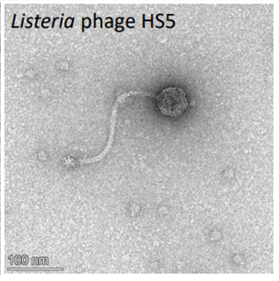

**Fig 1.** Transmission electron micrograph of newly isolated *Listeria* phage HS5 stained with 2% (w/v) uranyl acetate*.* The scale bar represents 100 nm [2]

**GenBank Summary:**

**Table 1.** Properties of the seven phages representing the species belonging to the genus

“Aquingentivirus”

|  |  |  |  |  |  |  |  |
| --- | --- | --- | --- | --- | --- | --- | --- |
| **Phage name** | **Accession** | **Size (Kbp)** | **GC%** | **Protein** | **tRNAs** | **Overall DNA sequence identity (*)** | **% common proteins (**)** |
| Listeria Phage A500 | DQ003637 | 38.86 | 36.7 | 63 | 0 | 100 | 100 |
| Listeria Phage HS5 | OP894077 | 39.93 | 37 | 62 | 0 | 75.21 | 70 |
| Listeria phage PSU-VKH-LP040 | MH341452 | 39.56 | 37.1 | 67 | 0 | 67.45 | 67 |
| Listeria phage LP-030-3 | KJ094022 | 41.16 | 36.6 | 73 | 0 | 67.34 | 76 |
| Listeria phage HB17054 | ON456151 | 42.08 | 36.7 | 69 | 0 | 66.24 | 62 |
| Listeria phage vB_LmoS_P7 | MZ361827 | 42.55 | 36.6 | 67 | 0 | 61.88 | 62 |
| Listeria phage vB_LmoS_293 | KP399678 | 40.76 | 36.9 | 72 | 0 | 61.29 | 62 |

* Determined using BLASTN [7]; ** Determined using CoreGenes 5 [8]

**Phylogeny:**

**Figure 2.** (next page) Identity matrix and tree of “*Aquingentivirus*” in relation to the closest existing genera.

A. Matrix summarizing the identity between the phage genomes of proposed genus “Aquingentivirus” and related phages from the current ICTV database using tax_myPhage software. B. Tree inferred using the large terminase protein of the same phage genomes (closest relative from ICTV [9], with the addition of 7 phage genomes of the Listeria phages). We aligned the sequences using MAFFT v 7.508 (linsi algorithm) [10] and inferred the maximum-likelihood tree from these alignments with IQ-TREE v2.2.0.3 [11] using the best evolutionary model, options -MF, BIC criterion, -allnni, -ntop 1000). The support values displayed at the branches of the tree were estimated using the option -bb 1000 for ultrafast bootstraps [12], the color of the branch corresponds to the bootstrap value (red = 0 and green = 100). The root was inferred using the outgroup of Trabyvirinae. The color of circles at the tip of the tree corresponds to different phage genus. The comparison of the different genomes was made by a blastn v 2.12.0+ all vs all (option -max_target_seqs 25000) [13]. The different genomes are represented as a line and the genes are represented as an arrow. The direction of the arrow depends on the strand where the gene is located. The percentage of identity between genes is represented by a parallelogram and the color of the parallelogram which corresponds to the percentage of identity between the two genes.

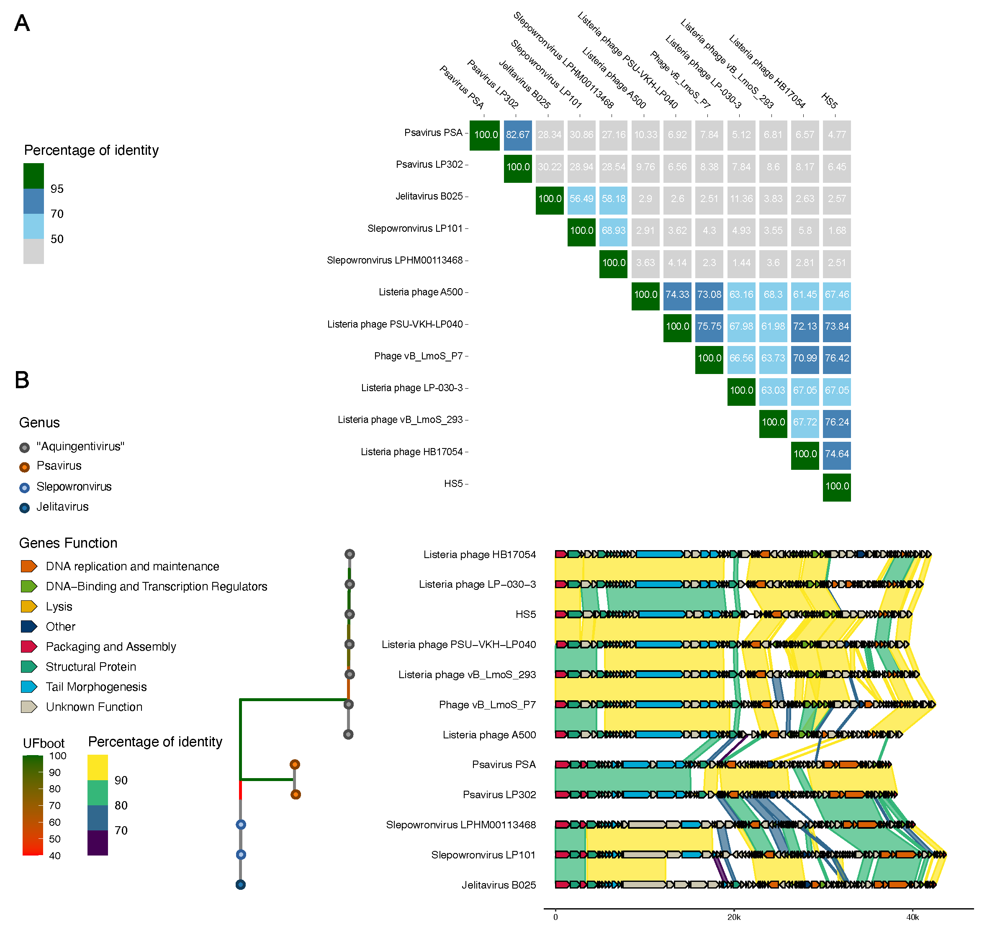

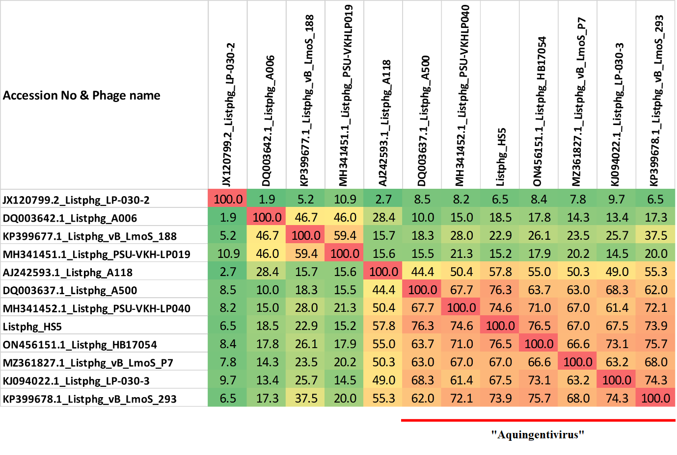

**Figure 3.** Heatmap showing nucleotide similarity of the *Listeria* phages in this proposal including the newly isolated phage HS5, other members of the proposed genus and other *Listeria* phages as calculated with VIRIDIC [14].

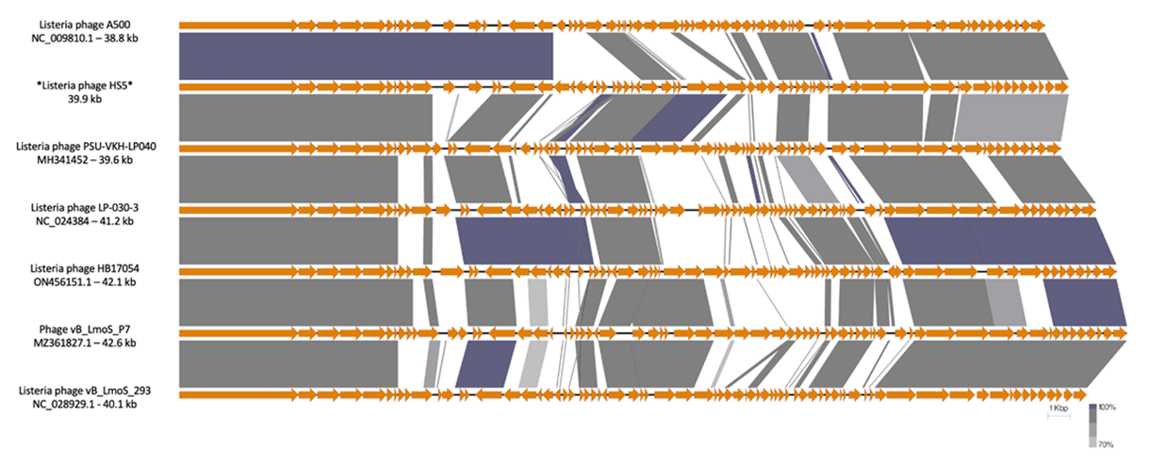

**Figure 4.** Genome map comparison of the genomes of *Listeria* phages in the proposed genus employing BLASTN and visualisation with Easyfig [15] . The genome maps display arrows indicating the locations and orientation of ORFs among different phage genomes. The tail tape measure protein was set as the first gene among all genomes.

**References**

1. Loessner MJ, Busse M (1990) Bacteriophage Typing of Listeria Species

2. Shareefdeen H, Buttimer C, Denise R, et al (2022) Isolation and Characterization of Novel Phages Infecting Listeria Monocytogenes, *in preparation*

3. Vu HTK, Stasiewicz MJ, Benjakul S, Vongkamjan K (2018) Genome Sequences of Listeria Phages Induced from Lysogenic Isolates of Listeria monocytogenes from Seafood and a Seafood Processing Environment in Thailand. Genome Announc 6:. https://doi.org/10.1128/GENOMEA.00546-18

4. Denes T, Vongkamjan K, Ackermann HW, et al (2014) Comparative genomic and morphological analyses of Listeria phages isolated from farm environments. Appl Environ Microbiol 80:4616–4625. https://doi.org/10.1128/AEM.00720-14/SUPPL_FILE/ZAM999105517SO1.PDF

5. Stone E (2021) Understanding and exploiting bacteriophage-host interactions for the control and detection of listeria monocytogenes. Queen’s University Belfast,

6. Casey A, Jordan K, Coffey A, McAuliffe O (2015) Complete Genome Sequences of vB_LmoS_188 and vB_LmoS_293, Two Bacteriophages with Specificity for Listeria monocytogenes Strains of Serotypes 4b and 4e. Genome Announc 3:. https://doi.org/10.1128/GENOMEA.00040-15

7. Altschul SF, Gish W, Miller W, et al (1990) Basic local alignment search tool. J Mol Biol 215:403–410. https://doi.org/10.1016/S0022-2836(05)80360-2

8. Turner D, Reynolds D, Seto D, Mahadevan P (2013) CoreGenes3.5: a webserver for the determination of core genes from sets of viral and small bacterial genomes

9. Cook R, Brown N, Redgwell T, et al (2021) INfrastructure for a PHAge REference Database: Identification of Large-Scale Biases in the Current Collection of Cultured Phage Genomes. PHAGE: Therapy, Applications, and Research 2:214–223. https://doi.org/10.1089/PHAGE.2021.0007/SUPPL_FILE/SUPPLEMENTARY_TABLES4.XLSX

10. Katoh K, Standley DM (2013) MAFFT Multiple Sequence Alignment Software Version 7: Improvements in Performance and Usability. Mol Biol Evol 30:772–780. https://doi.org/10.1093/MOLBEV/MST010

11. Minh BQ, Schmidt HA, Chernomor O, et al (2020) IQ-TREE 2: New Models and Efficient Methods for Phylogenetic Inference in the Genomic Era. Mol Biol Evol 37:1530–1534. https://doi.org/10.1093/MOLBEV/MSAA015

12. Hoang DT, Chernomor O, von Haeseler A, et al (2018) UFBoot2: Improving the Ultrafast Bootstrap Approximation. Mol Biol Evol 35:518–522. https://doi.org/10.1093/MOLBEV/MSX281

13. Camacho C, Coulouris G, Avagyan V, et al (2009) BLAST+: Architecture and applications. BMC Bioinformatics 10:1–9. https://doi.org/10.1186/1471-2105-10-421/FIGURES/4

14. Moraru C, Varsani A, Kropinski AM (2020) VIRIDIC—A novel tool to calculate the intergenomic similarities of prokaryote-infecting viruses. Viruses 12:. https://doi.org/10.3390/v12111268

15. Sullivan MJ, Petty NK, Beatson SA (2011) Easyfig: a genome comparison visualizer. BIOINFORMATICS APPLICATIONS NOTE 27:1009–1010. <https://doi.org/10.1093/bioinformatics/btr039>

16. O'Leary NA, Wright MW, Brister JR, Ciufo S, Haddad D, McVeigh R, et al. Reference sequence (RefSeq) database at NCBI: current status, taxonomic expansion, and functional annotation. Nucleic Acids Res. 2016;44(D1):D733-45. doi: 10.1093/nar/gkv1189. PMID: 26553804.

17. Sayers EW, Beck J, Bolton EE, Bourexis D, Brister JR, Canese K, Comeau DC, Funk K, Kim S, Klimke W, Marchler-Bauer A, Landrum M, Lathrop S, Lu Z, Madden TL, O'Leary N, Phan L, Rangwala SH, Schneider VA, Skripchenko Y, Wang J, Ye J, Trawick BW, Pruitt KD, Sherry ST. Database resources of the National Center for Biotechnology Information. Nucleic Acids Res. 2021 Jan 8;49(D1):D10-D17. doi: 10.1093/nar/gkaa892. PMID: 33095870