

The International Committee on Taxonomy of Viruses

Taxonomy Proposal Form, 2024

**Part 1a: Details of taxonomy proposals**

|  |  |  |
| --- | --- | --- |
| **Title:** | Create one new species in the genus *Machlomovirus* (*Tolivirales*: *Tombusviridae*) | |
| **Code assigned:** | 2024.018P.N.v1.Tombusviridae_1nsp |

|  |  |  |  |
| --- | --- | --- | --- |
| **Author(s), affiliation and email address(es):** | | | |
| **Name** | **Affiliation** | **Email address** | **Corresponding author(s)** |
| Maclot F | Plant Pathology Laboratory, TERRA Gembloux Agro-Bio Tech, University of Liege, Belgium | francois.maclot@uliege.be |  |
| Massart S | Plant Pathology Laboratory, TERRA Gembloux Agro-Bio Tech, University of Liege, Belgium | sebastien.massart@uliege.be | **X** |
|  |  |  |  |
|  |  |  |  |
|  |  |  |  |
|  |  |  |  |
|  |  |  |  |
|  |  |  |  |

**Part 1b: Taxonomy Proposal Submission**

|  |  |  |  |
| --- | --- | --- | --- |
| **ICTV Subcommittee:** | | | |
| Animal DNA Viruses and Retroviruses |  | Bacterial viruses |  |
| Animal minus-strand and dsRNA viruses |  | Fungal and protist viruses |  |
| Animal positive-strand RNA viruses |  | Plant viruses | **X** |
| Archaeal viruses |  | General |  |

|  |
| --- |
| **List the ICTV Study Group(s) that have seen or have been involved in creating this proposal:** |
| *Tombusviridae* SG |

|  |  |  |  |
| --- | --- | --- | --- |
| **Optional – complete only if formally voted on by an ICTV Study Group:** | | | |
| **Study Group** | **Number of members** | | |
| **Votes in support** | **Votes against** | **No vote** |
|  |  |  |  |
|  |  |  |  |

|  |  |
| --- | --- |
| **Submission date:** | 21/06/2024 |

**Part 1c: Feedback from ICTV Executive Committee (EC) meeting**

|  |  |
| --- | --- |
| **Executive Committee Meeting Decision code:** | **X** |
| A – Accept | **X** |
| Ac – Accept subject to revision by relevant subcommittee chair. No further vote required |  |
| U – Accept without revision but with re-evaluation and email vote by the EC |  |
| Uc – Accept subject to revision and re-evaluation and email vote by the EC |  |
| Ud – Deferred to the next EC meeting, with an invitation to revise based on EC comments |  |
| J - Reject |  |
| W - Withdrawn |  |

|  |
| --- |
| **Comments from the Executive Committee:** |
|  |

**Part 1d: Revised Taxonomy Proposal Submission**

|  |
| --- |
| **Response of proposer:** |
|  |

|  |  |
| --- | --- |
| **Revision date:** | DD/MM/YYYY |

**Part 3:** **TAXONOMIC PROPOSAL**

|  |
| --- |
| **Name of accompanying Excel module:** |
| 2024.018P.A.v1.Tombusviridae_1nsp.xlsx |

|  |  |  |  |
| --- | --- | --- | --- |
| **Taxonomic changes proposed:** | | | |
| Establish new taxon | **X** | Split taxon |  |
| Abolish taxon |  | Merge taxon |  |
| Move taxon |  | Promote taxon |  |
| Rename taxon |  | Demote taxon |  |
| Move and rename |  |

|  |  |  |
| --- | --- | --- |
| **Is any taxon name used here derived from that of a living person:** | | **N** |
| **Taxon name** | **Person from whom the name is derived** | **Attached X** |
|  |  |  |
|  |  |  |
|  |  |  |

|  |
| --- |
| **Abstract of Taxonomy Proposal:** |
| *Taxonomic rank(s) affected*:  Genus *Machlomovirus* (*Tolivirales*: *Tombusviridae*)  *Description of current taxonomy*:  One virus species, *Machlomovirus zeae,* is currently described within the genus *Machlomovirus*.    *Proposed* *taxonomic change(s):*  We propose to create a second species (*Machlomovirus liegense*) in the genus *Machlomovirus* to accommodate a recently identified virus in the wild grass common bent (*Agrostis capillaris*), named Poaceae Liege machlomovirus - PoLMV.  *Justification*:  Analysis of PoLMV genomic structure and phylogenetic analyses of its full sequence and specific genes (polymerase and coat protein) placed PoLMV as a novel species in the genus *Machlomovirus.* |

|  |
| --- |
| **Text of Taxonomy proposal:** |
| Machlomoviruses (*Tombusviridae* family) are currently represented by one virus, maize chlorotic mottle virus (MCMV), classified in the species *Machlomovirus zeae*, which presents the following characteristics:   * Virions are approximately 30 nm in diameter and exhibit icosahedral symmetry. * Their genome is a linear single strand (ss) positive-sense RNA molecule of approximately 4.4 kb length and containing four ORFs. The RNA does not contain a 3’-terminal poly(A) tract. Either a 1470 or an 1100 nt sgRNA is also packaged into virions at a very low level (Figure 1). * The overall size and organization of the genome is quite similar to that of the genus *Panicovirus*. However, genome of machlomoviruses encodes an additional 5′-proximally located ORF (ORF1) coding for a 32 kDa protein of unknown function. ORF2 can encode a 48 kDa protein. Readthrough of the ORF2 amber termination codon allows for translation to continue into ORF2-RT, yielding a 112 kDa protein which shares sequence similarities with polymerase proteins of other members of the family. ORF3 encodes a 7 kDa protein whose carboxyl- terminus is like those of the MP1 proteins encoded by the similarly located small ORFs in the genomes of carmoviruses, necroviruses and panicoviruses. If the ORF3 opal termination codon is read through, a 33 kDa protein would be produced. ORF4 encodes the 25 kDa CP and appears to be translated from the 1.47 kb sgRNA. A second 0.34 kb sgRNA is made in vivo; however, it is not known if it acts as a mRNA. * Virions are moderately to highly immunogenic. Serological variants have been identified. * The virus is restricted to monocotyledonous hosts (Poaceaefamily). * Mechanical and seed transmission, and/or by different insects (beetles, thrips) depending on the virus isolate. * MCMV can cause a mild mosaic on maize, as well as a severe necrotic disease when co-infected with Poaceae-specific potyviruses [named as corn lethal necrosis (CLN), or more recently as maize lethal necrosis disease (MLND)].     Fig.1. Typical genome organization of maize chlorotic mottle virus genome (ICTV 2011).  Species demarcation criteria  There is no formal species demarcation criteria for the genus *Machlomovirus* proposed by ICTV. For the closest genera (*Panicovirus, Necrovirus, Alphacarmovirus, Betacarmovirus* and *Gammacarmovirus*), there are not species demarcation criteria applicable for the panicoviruses; for necroviruses these criteria are 93% amino acid identity of the polymerase and 87% amino acid identity of the coat protein; for carmoviruses, these criteria are 57% amino acid identity of the polymerase and 52% amino acid identity of the coat protein. Natural host range can also be considered for the novel species demarcation.  Description of the new species candidate  So far, only one machlomovirus species (*Machlomovirus zeae*) was identified (ICTV 2023). Recently, a machlomo-like sequence has been identified by HTS in another member of the family Poaceae, the common bents (*Agrostis capillaris,*), collected in a pasture and a grassland located in Antheit and Heron respectively, within the Belgian Natural Park Burdinale-Mehaigne. The genome is 4266 nt long and its organization is similar to machlomoviruses and panicoviruses (ON137711; Maclot et al. 2023). BLASTN analysis showed closest hit with maize chlorotic mottle virus (69% identity). This novel virus species has been named *Machlomovirus liegense*, with the epithet chosen from Liege which is the place of isolation of the virus (exemplar name Poaceae Liege machlomovirus, PoLMV).  ClustalW multiple alignment analyses of PoLMV and relatives from the genera *Machlomovirus* and *Panicovirus* were performed on nucleotide sequences (full genome) and on amino-acid sequences of viral polymerase (ORF2 and ORF2-RT) and coat protein (ORF4). Outgroups from two other *Tombusviridae* members (carnation mottle virus for the genus *Alphacarmovirus*; and tobacco necrosis virus A for the genus *Alphanecrovirus*) were used for the phylogenetic trees.  Multiple alignment analyses revealed 50.9% nt identities between PoLMV and MCMV for the complete sequence (Table 1), and 49.4% and 36.2% amino acid identities between PoLMV and MCMV for polymerase and coat protein respectively (Table 2 and 3). Phylogenetic analysis based on the amino acid sequence of the polymerase showed that PoLMV clustered with MCMV (Figure 2). As PoLMV shows a different natural host range and presents amino acid identity levels far below the species demarcation criteria used for other *Tombusviridae* members, PoLMV can be recognized as a member of the novel virus species *Machlomovirus liegense.* |

|  |
| --- |
| **References:** |
| ICTV Ninth Report, Taxonomy Release (2011), <https://ictv.global/report_9th/RNApos/Tombusviridae>  Maclot F et al (2023). Long-Term Anthropogenic Management and Associated Loss of Plant Diversity Deeply Impact Virome Richness and Composition of Poaceae Communities. Microbiol Spectr 11:e0485022. DOI: 10.1128/spectrum.04850-22. PMID: 36916941 |

|  |
| --- |
| **Tables, Figures:** |

**Table 1**. Identity percentages determined between nucleotide sequences of viral genomes of recognized machlomoviruses, panicoviruses and the tentative new Poaceae Liege machlomovirus*.* Tobacco necrosis A and carnation mottle virus are used as other *Tombusviridae* members (*Alphanecrovirus* and *Alphacarmovirus* genera respectively). Multiple sequence alignment was obtained using ClustalW algorithm.

**Table 2**. Identity percentages determined between amino acid sequences or viral polymerase extracted from the genomes of recognized machlomoviruses, panicoviruses and the tentative new Poaceae Liege machlomovirus*.* Tobacco necrosis A and carnation mottle virus are used as other *Tombusviridae* members (*Alphanecrovirus* and *Alphacarmovirus* genera respectively). Multiple sequence alignment was obtained using ClustalW algorithm.

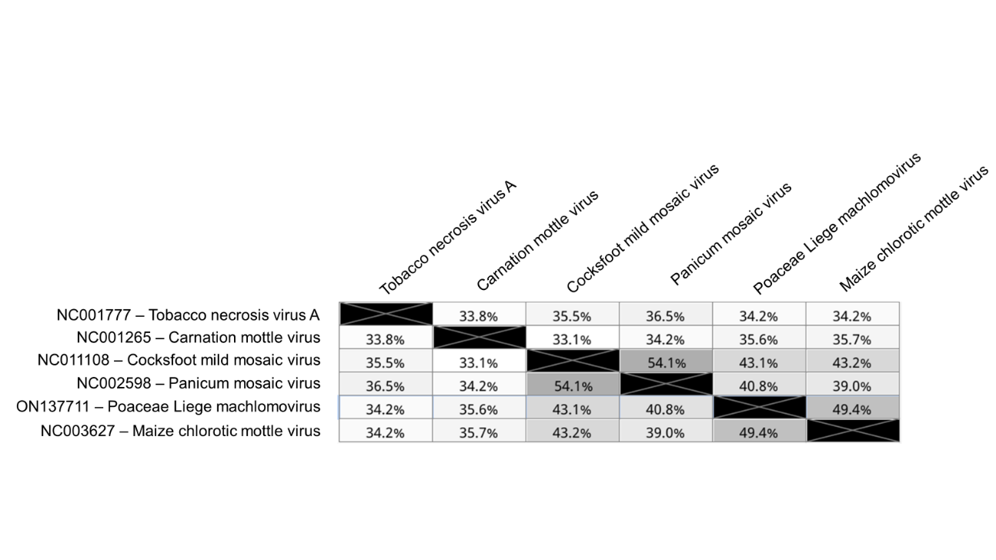

**Table 3**. Identity percentages determined between amino acid sequences or viral coat protein extracted from the genomes of recognized machlomoviruses, panicoviruses and the tentative new *Machlomovirus liegense.* Tobacco necrosis A and carnation mottle virus are used as other *Tombusviridae* members (*Alphanecrovirus* and *Alphacarmovirus* genera, respectively). Multiple sequence alignment was obtained using ClustalW algorithm

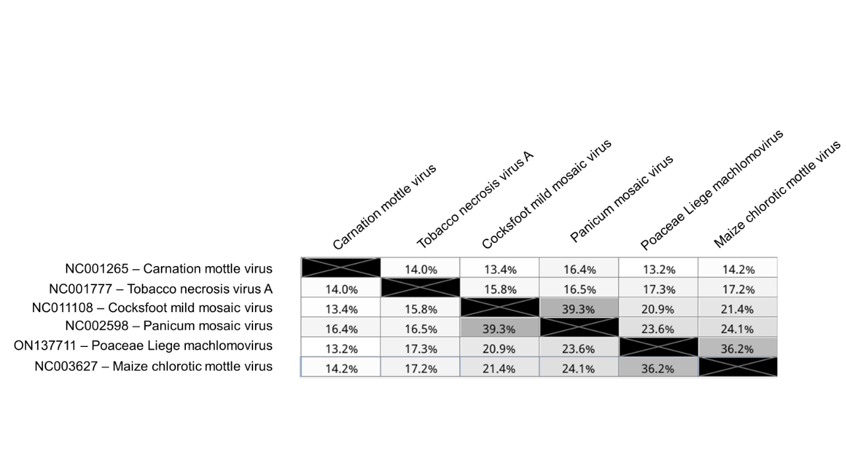

**Figure 2**. Phylogenetic tree base on multiple alignment of polymerase sequences of recognized machlomoviruses, panicoviruses and the tentative new *Machlomovirus liegense,* generated using Neighbor-Jointing Method (1000 bootstraps). Tobacco necrosis A and carnation mottle virus were used as other *Tombusviridae* members (*Alphanecrovirus* and *Alphacarmovirus* genera respectively). Hepatitis C virus H77 RdRp (aa 2421-3011, AF01175) was used as outgroup. Branch labels indicate substitutions per site.

