

The International Committee on Taxonomy of Viruses
Taxonomy Proposal Form, 2026

Part 1a: Details of taxonomy proposals

Title: | Create a new family (Megarnaviridae) including one genus (Alphamegarnavirus) and one species (Alphamegarnavirus gigas) in the order Nidovirales
Code assigned: | 2026.004S.N.v1.Nidovirales_1nfam_1ngen_1nsp

Author(s), affiliation and email address(es):
Given name (+middle initial(s)) | Surname | Affiliation | Email address | Corr. author(s)
Kevin X. | Zhong | Department of Earth, Ocean, and Atmospheric Sciences, The University of British Columbia, Vancouver, BC V6T 1Z4, Canada | xzhong@eoas.ubc.ca | X
Alexander E. | Gorbalenya | Leiden University Center of Infectious Diseases, Leiden University Medical Center, Leiden 2333 ZA, The Netherlands | a.e.gorbalenya@lumc.nl
Curtis A. | Suttle | Department of Earth, Ocean, and Atmospheric Sciences, Botany, Microbiology and Immunology, and the Institute for the Oceans and Fisheries, The University of British Columbia, Vancouver, BC V6T 1Z4, Canada | suttle@science.ubc.ca
Chris | Lauber | Institute for Experimental Virology, TWINCORE Centre for Experimental and Clinical Infection Research, a Joint Venture between the Hannover Medical School and the Helmholtz Centre for Infection Research, Hannover 30625, Germany; Cluster of Excellence 2155 RESIST, Hannover 30625, Germany | chris.lauber@twincore.de | X

Part 1b: Taxonomy Proposal Submission
ICTV Subcommittee:
Animal DNA Viruses and Retroviruses |  | Bacterial viruses
Animal minus-strand and dsRNA viruses |  | Fungal and protist viruses
Animal positive-strand RNA viruses | X | Plant viruses
Archaeal viruses |  | General -

List the ICTV Study Group(s) that have seen or have been involved in creating this proposal:
ICTV Nidovirales Study Group

Optional – complete only if formally voted on by an ICTV Study Group:
Study Group | Number of members
Study Group | Votes in support | Votes against | No vote
ICTV Nidovirales Study Group | 10 | 0 | 1

Submission date:

Part 1c: Feedback from ICTV Executive Committee (EC) meeting
Executive Committee Meeting Decision code: | X
A – Accept
Ac – Accept subject to revision by relevant subcommittee chair. No further vote required
U – Accept without revision but with re-evaluation and email vote by the EC
Uc – Accept subject to revision and re-evaluation and email vote by the EC
Ud – Deferred to the next EC meeting, with an invitation to revise based on EC comments
J - Reject
W - Withdrawn

Comments from the Executive Committee:

Part 1d: Revised Taxonomy Proposal Submission
Response of proposer:
Revision date:

Part 3: TAXONOMIC PROPOSAL
https://ictv.global/taxonomy/templates

Taxonomic changes proposed:
Establish new taxon | X | Split taxon
Abolish taxon |  | Merge taxon
Move taxon |  | Promote taxon
Rename taxon |  | Demote taxon
Move and rename

Etymology (origin) of proposed taxonomic names:
Taxon name | Etymology of the term
Megarnaviridae | The family name Megarnaviridae is derived from Greek μέγα [méga], meaning “large” and “rna”, highlighting the exceptionally long RNA genome (≈64.3 kb) of viruses in this family. The name underscores the distinctive genomic length and RNA nature of these viruses, which sets them apart from other classified viruses in the order Nidovirales and all other RNA viruses.
Alphamegarnavirus | Etymology identical to that of family Megarnaviridae with the addition of Greek prefix άλφα [alpha], meaning “leader” and referring to the first letter in the Greek alphabet. This genus naming approach is in line with the current practice in other nidovirus families, for instance the family Coronaviridae.
Alphamegarnavirus gigas | Binomial Latinized species name consisting of the genus name and a species epithet, gigas. The species epithet is derived from Magallana gigas, which is the species of the viral host, the Pacific oyster.

Permission for use of names derived from a living person:
Taxon name | Full name of person from whom the name is derived | Attached

Abstract of Taxonomy Proposal:
Description of current taxonomy: Order Nidovirales (Riboviria: Orthornavirae: Pisuviricota: Pisoniviricetes) currently includes 14 families distributed among 8 suborders.

Proposed taxonomic change(s): Expansion of the order by a new family (Megarnaviridae), including one new genus (Alphamegarnavirus) including one new species (Alphamegarnavirus gigas) for Pacific oyster nidovirus 1 (PONV1).

Demarcation criteria for new taxon/taxa: Only one virus is proposed to be classified. Consequently, species and genus demarcation criteria could not yet be established. Family demarcation was established using coding-complete nidovirus genome sequences and a threshold of patristic pairwise distances (PPD) of 3.18 with a clustering cost (CC) of 0.

Justification: Establishment of a new virus family within the order Nidovirales is based on the presence of five nidovirus-wide conserved replicative protein domains, RNA-dependent RNA polymerase (RdRp) phylogeny, and sequence-based hierarchical classification using DivErsity pArtitioning by hieRarchical Clustering (DEmARC).

- Text of Taxonomy proposal:

Description of current taxonomy: Order Nidovirales (Riboviria: Orthornavirae: Pisuviricota: Pisoniviricetes) currently includes 14 families distributed among 8 suborders.

Proposed taxonomic change(s):
Expansion of the order by a new family (Megarnaviridae), including one new genus (Alphamegarnavirus) including one new species (Alphamegarnavirus gigas) for Pacific oyster nidovirus 1 (PONV1). The new family is not assigned to a suborder.

Demarcation criteria: Only one virus is proposed to be classified. Consequently, species and genus demarcation criteria could not yet be established. Family demarcation was established using coding-complete nidovirus genome sequences and a threshold of patristic pairwise distances (PPD) of 3.18 with a clustering cost (CC) of 0.

Justification: Nidoviruses are recognized based on the presence of five conserved replicative domains and RNA-dependent RNA polymerase (RdRp) phylogeny. The current hierarchical classification of nidoviruses has been developed by applying DivErsity pArtitioning by hieRarchical Clustering (DEmARC) to the conserved replicative domains [1-5]. The proposed taxa are represented by a single virus, Pacific oyster nidovirus 1 (PONV1), described by Zhong et al. 2025 [6] (NCBI accessions: PQ030832 and PV579160). A closely related variant of the same virus, Crassostrea gigas nidovirus (CGNV), was independently described by Neuman et al. 2025 [7] (NCBI accessions: BK070331 and BK070332). In this taxonomy proposal, PONV1 was chosen to represent this virus and its species; all features described below for PONV1 apply also to CGNV.

PONV1 has a bisegmented, positive-sense, single-stranded RNA genome of ≈64.3 kb and was identified in the Pacific oyster (Magallana gigas; Crassostrea gigas is a junior synonym). The sequences of the genomic segments of PONV1 are coding-complete and thus this virus qualifies for classification. As detailed in [6, 7], segment 1 encodes the non-structural/replicative protein domains, whereas segment 2 encodes structural proteins and putative accessory proteins. For both segments, the protein-coding region is flanked by 5’ and 3’ untranslated regions (UTRs). The PONV1 genome encodes the following protein domains characteristic of nidoviruses: 3C-like protease (3CLpro), nucleotidyltransferase (NiRAN), RdRp, Zinc-binding domain (ZBD), and superfamily 1 helicase (HEL1) (Figure 1). This synteny of 5 protein domains is a hallmark feature of nidoviruses and has not been observed in viruses from other orders. These 5 domains include the nidovirus genetic markers NiRAN and ZBD linked to HEL1 [8]. In addition, the PONV1 genome encodes exoribonuclease (ExoN), guanine-N7-methyltransferase (NMT), and ribose 2’-O-methyltransferase (OMT) domains downstream of HEL1, like other long-genome nidoviruses of invertebrates, as well as several specific domains (Figure 1, Supplementary Table 1). Combined, these results show that PONV1 is a nidovirus.

For further demarcation, we used a value/threshold of patristic pairwise distances (PPD) that were calculated using IQ-TREE [9] (maximum likelihood phylogeny reconstruction tool) based on a multiple sequence alignment of RdRp amino acid sequences used in [6]. We considered candidate PPD thresholds that were selected based on local minima in the clustering cost (CC) distribution, with optimal thresholds having a CC=0 if all intra-cluster PPD values of all taxa are smaller than the threshold and all inter-cluster PPD values are larger than the threshold. One PPD threshold (value of 3.18) with a CC=0 resulted in 15 clusters, each forming a monophyletic lineage in the RdRp phylogeny reconstructed using PhyML v3.1 (Figure 2A). These 15 clusters were: the outgroup (picornaviruses), a cluster formed by PONV1, and 13 clusters that match the recognized nidoviral families with one single exception – arteriviruses and olifoviruses were merged into a single cluster. The latter deviation from the ICTV taxonomy could be explained by lineage-specific evolutionary rates due to shorter genome lengths, the restriction of the analysis to a single protein (RdRp), or other factors. Notably, the smallest inter-cluster (e.g., inter-family) pairwise distance involving PONV1 and any other virus in the dataset was considerably larger than all intra-cluster distances of previously established families (Figure 2B, red bar). Moreover, an RdRp-based phylogenetic tree reconstructed with another tool (IQ-TREE 2) [10] and involving the assessment of branching support demonstrates that PONV1 forms a well-supported, long-branch monophyletic lineage within the order Nidovirales (Figure 3). The large evolutionary distances separating PONV1 from all other known nidoviruses are associated with a distinct genomic organization and unusual proteome components in both variants of the virus (Figure 1). The two studies reporting the discovery of PONV1 variants also recognized independently that this virus is the founder of a new family in the order Nidovirales. This conclusion was based on RdRp-based phylogenetic analysis involving sequences from 129 representatives of virus species from all 14 recognized nidoviral families, and sequences of two picornaviruses (human poliovirus 1, and hepatitis A virus) as the outgroup [6, 7]. The proposed taxonomic classification was prepared using the sequence-based computational framework of DEmARC [5], as detailed in taxonomic proposals filed in 2017–2021 and approved by ICTV, and was accompanied by standard comparative genomics and phylogenetic analyses. Together, these results justify the creation of a new virus family within the order Nidovirales.

The CGNV and PONV1 genome sequences are colinear and share≈96% pairwise nucleotide identity, as determined using Vclust [11], MMseqs2 [12], checkV scripts [13], and pairwise alignment in Geneious Prime v.2023.2. Based on the species demarcation criteria for best sampled nidoviral species established in prior studies (species threshold: ≈92% pairwise amino acid identity in the most conserved proteins), we considered this high similarity to reflect intra-species variation. Consequently, CGNV and PONV1 represent variants of the same virus species, which we propose to name Alphamegarnavirus gigas.
References:
1. Siddell SG, Walker PJ, Lefkowitz EJ, Mushegian AR, Adams MJ, Dutilh BE, et al. Additional changes to taxonomy ratified in a special vote by the International Committee on Taxonomy of Viruses (October 2018). Arch Virol. 2019;164(3):943-6. DOI: 10.1007/s00705-018-04136-2. PMID: 30663020.

2. Walker PJ, Siddell SG, Lefkowitz EJ, Mushegian AR, Adriaenssens EM, Dempsey DM, et al. Changes to virus taxonomy and the Statutes ratified by the International Committee on Taxonomy of Viruses (2020). Arch Virol. 2020;165:2737–2748. DOI: 10.1007/s00705-020-04752-x. PMID: 32816125.

3. Walker PJ, Siddell SG, Lefkowitz EJ, Mushegian AR, Adriaenssens EM, Alfenas-Zerbini P, et al. Recent changes to virus taxonomy ratified by the International Committee on Taxonomy of Viruses (2022). Arch Virol. 2022;167(11):2429-40. DOI: 10.1007/s00705-022-05516-5. PMID: 35999326.

4. Lauber C, Ziebuhr J, Junglen S, Drosten C, Zirkel F, Nga PT, et al. Mesoniviridae: a proposed new family in the order Nidovirales formed by a single species of mosquito-borne viruses. Arch Virol. 2012;157(8):1623-8. DOI: 10.1007/s00705-012-1295-x. PMID: 22527862.

5. Lauber C, Gorbalenya AE. Partitioning the genetic diversity of a virus family: approach and evaluation through a case study of picornaviruses. J Virol. 2012;86(7):3890-904. DOI: 10.1128/JVI.07173-11. PMID: 22278230.

6. Zhong KX, Chan AM, Miller KM, Saunders R, Suttle CA. Evolutionarily divergent nidovirus with an exceptionally large genome identified in Pacific oysters undergoing mass mortality. Proc Natl Acad Sci U S A. 2025;122(33):e2426923122. DOI: 10.1073/pnas.2426923122. PMID: 40758866.

7. Neuman BW, Smart A, Gilmer O, Smyth RP, Vaas J, Boker N, et al. Giant RNA genomes: Roles of host, translation elongation, genome architecture, and proteome in nidoviruses. Proc Natl Acad Sci U S A. 2025;122(7):e2413675122. DOI: 10.1073/pnas.2413675122. PMID: 39928875.

8. Gulyaeva AA, Gorbalenya AE. A nidovirus perspective on SARS-CoV-2. Biochem Biophys Res Commun. 2021;538:24-34. DOI: 10.1016/j.bbrc.2020.11.015. PMID: 33413979.

9. Nguyen LT, Schmidt HA, Von Haeseler A, Minh BQ. IQ-TREE: a fast and effective stochastic algorithm for estimating maximum-likelihood phylogenies. Mol Biol Evol. 2015;32(1):268-74. DOI: 10.1093/molbev/msu300. PMCID: PMC4271533.

10. Minh BQ, Schmidt HA, Chernomor O, Schrempf D, Woodhams MD, Von Haeseler A, Lanfear R. IQ-TREE 2: new models and efficient methods for phylogenetic inference in the genomic era. Mol Biol Evol. 2020;37(5):1530-4. DOI: 10.1093/molbev/msaa015. PMCID: PMC7182206.

11. Zielezinski A, Gudys A, Barylski J, Siminski K, Rozwalak P, Dutilh BE, et al. Ultrafast and accurate sequence alignment and clustering of viral genomes. Nat Methods. 2025;22(6):1191-4. DOI: 10.1038/s41592-025-02701-7. PMID: 40374946.

12. Steinegger M, Soding J. MMseqs2 enables sensitive protein sequence searching for the analysis of massive data sets. Nat Biotechnol. 2017;35(11):1026-8. DOI: 10.1038/nbt.3988. PMID: 29035372.

13. Nayfach S, Camargo AP, Schulz F, Eloe-Fadrosh E, Roux S, Kyrpides NC. CheckV assesses the quality and completeness of metagenome-assembled viral genomes. Nat Biotechnol. 2021;39(5):578-85. DOI: 10.1038/s41587-020-00774-7. PMID: 33349699.

14. Jones P, Binns D, Chang H-Y, Fraser M, Li W, McAnulla C, et al. InterProScan 5: genome-scale protein function classification. Bioinformatics. 2014;30:1236-40. DOI: 10.1093/bioinformatics/btu031. PMID: 24451626.

15. Marchler-Bauer A, Bo Y, Han L, He J, Lanczycki CJ, Lu S, et al. CDD/SPARCLE: functional classification of proteins via subfamily domain architectures. Nucl Acids Res. 2017;45:D200-3. DOI: 10.1093/nar/gkw1129. PMID: 27899674.

16. Söding J, Biegert A, Lupas AN. The HHpred interactive server for protein homology detection and structure prediction. Nucl Acids Res. 2005;33:W244-8. DOI: 10.1093/nar/gki408. PMID: 15980461.

17. Van Kempen M, Kim SS, Tumescheit C, Mirdita M, Lee J, Gilchrist CL, Söding J, Steinegger M. Fast and accurate protein structure search with Foldseek. Nature Biotechnol. 2024;42:243-6. DOI: 10.1038/s41587-023-01773-0. PMID: 37156916.

18. Babaian A, Edgar R. Ribovirus classification by a polymerase barcode sequence. PeerJ. 2022;10:e14055. DOI: 10.7717/peerj.14055. PMID: 36258794.

19. Edgar RC, Taylor B, Lin V, Altman T, Barbera P, Meleshko D, et al. Petabase-scale sequence alignment catalyses viral discovery. Nature. 2022;602(7895):142-7. DOI: 10.1038/s41586-021-04332-2. PMID: 35082445.

Accompanying files:
Filename | Description of contents
2025.0xxS.N.v3.Nidovirales_1nf_1ng_1nsp.xlsx | Excel module
2025.0xxS.N.v3.Nidovirales_1nf_1ng_1nsp_TableS1.xlsx | Genomic coordinates and names of predicted protein domains encoded by the virus proposed to be classified

Tables, Figures:

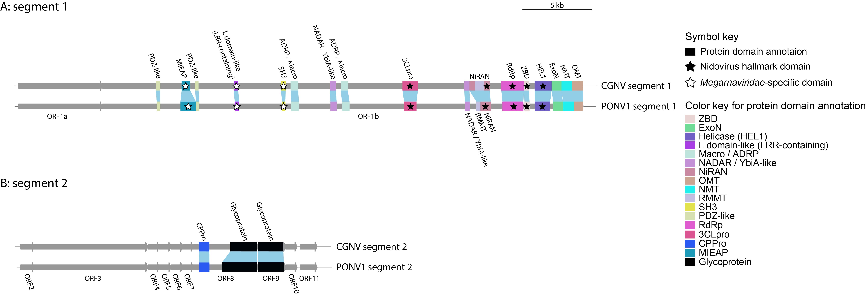

Figure 1. Genomic map of Crassostrea gigas nidovirus (CGNV) and Pacific oyster nidovirus 1 (PONV1), variants of the proposed species “Alphamegarnavirus gigas” (proposed genus “Alphamegarnavirus” and proposed family “Megarnaviridae”). Panel A shows segment 1 of the two viruses, while panel B indicates segment 2. The linear representation outlines the genome organization, with the scale bar indicating the genome length in kilobases. Grey arrows along the genome line represent predicted coding sequences (CDS) or polyproteins. Conserved domains within these CDS or polyproteins are depicted by colored bars, illustrating the structural and functional diversity across the nidoviral genome landscape. Similar domains shared by the two neighboring genomes were connected by blue areas. The predicted protein domains include ExoN (nidovirus 3'-5' exoribonuclease), HEL1 (superfamily 1 helicase), ZBD (zinc-binding domain), RdRp (RNA-directed RNA polymerase), NiRAN (nidovirus RdRp-associated nucleotidyltransferase), 3CLpro (3C-like protease), MIEAP (mitochondria-eating protein), NADAR (NAD and ADP-ribose), YbiA-like (currently grouped into NADAR), Macro (a.k.a., ADRP [ADP-ribose hydrolase/phosphatase]), SH3 (Src Homology 3), L domain-like (Late domain-like), LRR (leucine-rich repeat), PDZ-like (PSD-95/Dlg1/ZO-1), CPPro (capsid protein with protease activity), glycoprotein, and several SAM-dependent methyltransferase domains, namely RMMT (restriction–modification methyltransferase), NMT (N⁷-methyltransferase), and OMT (2’-O-methyltransferase) (Supplementary Table 1). Domains were predicted using InterProScan [14][10], NCBI CD-Search [15], HHpred [16], and Foldseek [17] as detailed in Neuman et al. (2025) [7][1] and Zhong et al. (2025) [6][2].

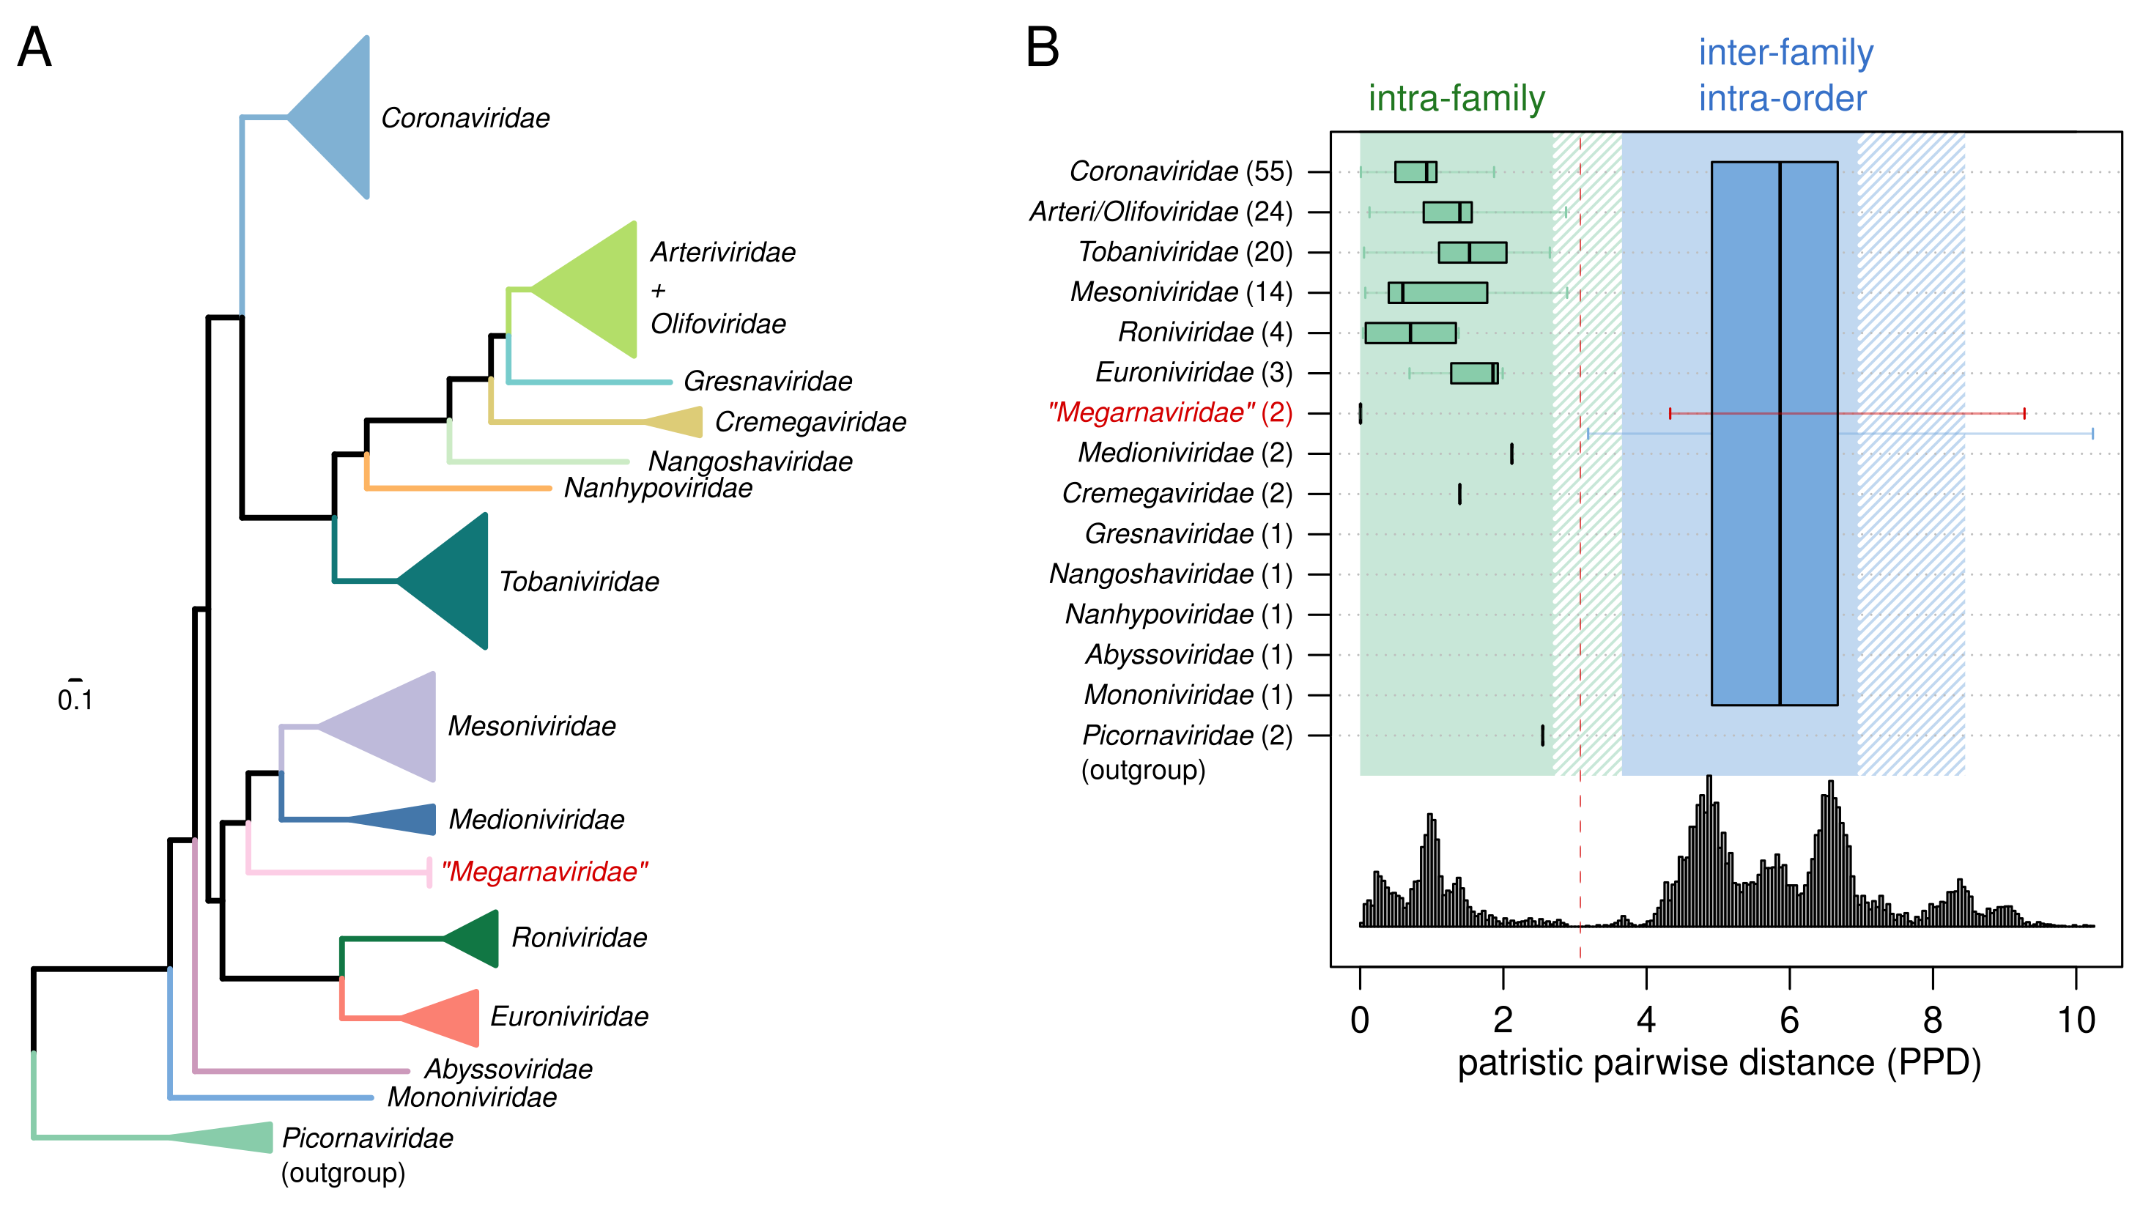
Figure 2. DEmARC-based classification of the two ”Alphamegarnavirus gigas” variants into the family “Megarnaviridae”. (A) Mapping of DEmARC family classification results on the RdRp-based nidoviral phylogeny, which was reconstructed using PhyML v3.1 and involved 129 nidoviral species representatives from all 14 families, the two ”Alphamegarnavirus gigas” variants, and two picornaviral outgroup sequences (see also Figure 3). Family clusters delineated by DEmARC are shown in separate colors and labeled using family names. Only the merge of representatives from the Arteriviridae and Olifoviridae families deviates from the current nidoviral ICTV taxonomy at the family rank. The tree branches reflect average substitutions per site. (B) Intra-group genetic divergence in taxa at the family rank (green) and inter-family divergence (blue) as determined by DEmARC [5]. PPD ranges that are demarcated according to the PPD threshold (red vertical dashed line) are highlighted with distinct colors. The red horizontal bar indicates the range of inter-family PPD values involving the two ”Alphamegarnavirus gigas” variants (“Megarnaviridae”). The frequency distribution of the PPD value is shown at the bottom. The identities of family clusters are indicated via family names (y-axis); numbers of analyzed virus species representatives of the respective family are shown in brackets. All identified family clusters correspond to monophyletic groups in the phylogenetic tree in panel A. Box-and-whisker graphs were used to plot distributions of distances between viruses belonging to the same taxon. The boxes span from the first to the third quartile and include the median (bold line); and the whiskers (dashed lines) extend to the extreme values. No box-and whisker graphs are provided for singleton taxa that include a single species representative.

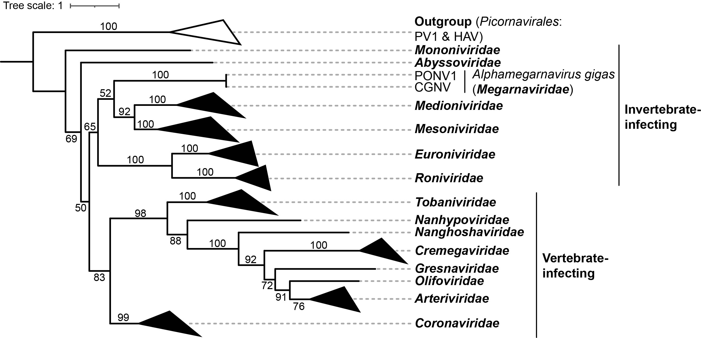

Figure 3. Phylogenetic relationships of the proposed family “Megarnaviridae” (represented by CGNV and PONV1 variants of the proposed species “Alphamegarnavirus gigas”) with recognized virus families in the order Nidovirales and statistical assessment of its uncertainty via bootstrap support values. The phylogenetic analysis is based on sequences available in the current database (ICTV, release 40). The rooted maximum-likelihood (ML) tree is based on the inferred amino acid sequences of the RdRp domain and reconstructed using IQ-TREE v2.2.0.3 [10]. RdRp sequences containing the conserved palm motifs (A, B, and C) were identified using Palmscan [18, 19]. The analysis includes representative viruses from all ICTV-recognized nidoviral families (release 40). Members of the family Picornaviridae of the order Picornavirales (Hepatitis A virus [HAV, NC_001489] and Human poliovirus 1 [PV1, NC_002058]) were used as the outgroup. Phylogenetic clades are collapsed into slanted triangles, with base width proportional to the sequence diversity within each family. Node labels indicate bootstrap support values. The scale bar represents the relative rate of amino acid substitutions per site. Details of tree construction are provided in Zhong et al. (2025) [6].

