

The International Committee on Taxonomy of Viruses
Taxonomy Proposal Form, 2026

Part 1a: Details of taxonomy proposals

Title: | Add two new species to the genus Chaphamavirus
Code assigned: | 2026.001D.N.v1.Chaphamavirus_2nsp

Author(s), affiliation and email address(es):
Given name (+middle initial(s)) | Surname | Affiliation | Email address | Corr. author(s)
Lavel C. | Moonga | Dept. of Paraclinical Studies, University of Zambia, Lusaka, Zambia | lavel.moonga@unza.zm
Jones | Chipinga | Vaughan Regional Medical Center, Selma, AL, USA | chipingajoe2019@gmail.com
John P. | Collins | Center for Infection and Immunity, Columbia University, New York, NY, USA | jc5966@cumc.columbia.edu
Vishal | Kapoor | Center for Infection and Immunity, Columbia University, New York, NY, USA | vk2040@cumc.columbia.edu
Ngonda | Saasa | Dept of Disease Control, University of Zambia, Lusaka, Zambia | nsaasa@gmail.com
King S. | Nalubamba | Dept. of Clinical Studies, University of Zambia, Lusaka, Zambia | king.nalubamba@unza.zm
Bernard M. | Hang'ombe BM | Dept. of Paraclinical Studies, University of Zambia, Lusaka, Zambia | mudenda68@yahoo.com
Boniface | Namangala | Dept. of Paraclinical Studies, University of Zambia, Lusaka, Zambia | b.namangala@unza.zm
Tapiwa | Lundu | Dept. of Biomedical Sciences, University of Zambia, Lusaka, Zambia | tapiwalundu@gmail.com
Xiang-Jun | Lu | Center for Infection and Immunity, Columbia University, New York, NY, USA | xl2134@columbia.edu
Samuel | Yingst | Center for Infection and Immunity, Columbia University, New York, NY, USA | sy3229@cumc.columbia.edu
J. Kenneth | Wickiser | Center for Infection and Immunity, Columbia University, New York, NY, USA | jkw2161@cumc.columbia.edu
Thomas | Briese | Center for Infection and Immunity, Columbia University, New York, NY, USA | tb2047@cumc.columbia.edu | x

Part 1b: Taxonomy Proposal Submission
ICTV Subcommittee:
Animal DNA Viruses and Retroviruses | x | Bacterial viruses
Animal minus-strand and dsRNA viruses |  | Fungal and protist viruses
Animal positive-strand RNA viruses |  | Plant viruses
Archaeal viruses |  | General -

List the ICTV Study Group(s) that have seen or have been involved in creating this proposal:
Parvoviridae Study Group

Optional – complete only if formally voted on by an ICTV Study Group:
Study Group | Number of members
Study Group | Votes in support | Votes against | No vote
Parvoviridae Study Group

Submission date: | 13/10/2025

Part 1c: Feedback from ICTV Executive Committee (EC) meeting
Executive Committee Meeting Decision code: | X
A – Accept
Ac – Accept subject to revision by relevant subcommittee chair. No further vote required
U – Accept without revision but with re-evaluation and email vote by the EC
Uc – Accept subject to revision and re-evaluation and email vote by the EC
Ud – Deferred to the next EC meeting, with an invitation to revise based on EC comments
J - Reject
W - Withdrawn

Comments from the Executive Committee:

Part 1d: Revised Taxonomy Proposal Submission
Response of proposer:
Revision date: | 09/02/2026

Part 3: TAXONOMIC PROPOSAL
https://ictv.global/taxonomy/templates

Taxonomic changes proposed:
Establish new taxon | x | Split taxon
Abolish taxon |  | Merge taxon
Move taxon |  | Promote taxon
Rename taxon |  | Demote taxon
Move and rename

Etymology (origin) of proposed taxonomic names:
Taxon name | Etymology of the term
Chaphamavirus rodent3 | ‘rodent’ after presumed host of virus and analogous to existing species names Chaphamavirus rodent1, and Chaphamavirus rodent2
Chaphamavirus rodent4

Permission for use of names derived from a living person:
Taxon name | Full name of person from whom the name is derived | Attached

Abstract of Taxonomy Proposal:
Description of current taxonomy:
Monodnaviria, Shotokuvirae, Cassaviricota, Quintoviricetes, Piccovirales, Parvoviridae, Hamavirinae, Chaphamavirus.
The genus Chaphamavirus is currently comprised of 70 species that include two viruses from rodents; mouse kidney parvovirus, representing the species Chaphamavirus rodent1, and rat parvovirus 2, representing the species Chaphamavirus rodent2.

Proposed taxonomic change(s):
Create two new species Chaphamavirus rodent3 and Chaphamavirus rodent4 for Mwangazi virus and Nyamadzi virus, respectively, in the genus Chaphamavirus.

Demarcation criteria for new taxon/taxa:
Mwangazi and Nyamadzi virus are most closely related to existing species Chaphamavirus rodent1 (mouse kidney parvovirus, MKPV), Chaphamavirus primate1 (capuchin kidney parvovirus , CKPV), Chaphamavirus carnivoran3 (Ursus americanus parvovirus, UaPV), and Chaphamavirus dasyurid2 (Tasman devil-associated chapparvovirus 2, TdChPV2). However, they are separated by an amino acid sequence identity of their NS1 of less than 85% compared to the established species as well as to each other (Table 1). Likewise, they branch with comparable phylogenetic distance from each other and from the classified species as those existing species from each other (Figure 1).

Justification:
Like other members of the subfamily Hamavirinae, Mwangazi and Nyamadzi virus lack a conserved phospholipase A2 domain in their capsid protein (VP). The NS1 amino acid identity between Mwangazi and Nyamadzi virus is 74%, and it is less than 85% with NS1 of any other virus of the classified species in the genus Chaphamavirus. Furthermore, they cluster closely with, but separate from, species Chaphamavirus rodent1, Chaphamavirus primate1, Chaphamavirus carnivoran3, and Chaphamavirus dasyurid2 in phylogenetic analysis of their NS1 sequence.

Text of Taxonomy proposal:

Description of current taxonomy:
The genus Chaphamavirus, subfamily Hamavirinae, family Parvoviridae, is currently comprised of 70 species (Pénzes et al.,2025), of which four, Chaphamavirus rodent1, Chaphamavirus primate1, Chaphamavirus carnivoran3, and Chaphamavirus dasyurid2, include viruses most related to Mwangazi and Nyamadzi virus.

Proposed taxonomic change(s):
Add two new species Chaphamavirus rodent3 for Mwangazi virus and Chaphamavirus rodent4 for Nyamadzi virus in the genus Chaphamavirus of the family Parvoviridae.

Demarcation criteria for new taxon/taxa:
Mwangazi and Nyamadzi virus are most closely related to existing species Chaphamavirus rodent1 (mouse kidney parvovirus, MKPV), Chaphamavirus primate1 (capuchin kidney parvovirus , CKPV), Chaphamavirus carnivoran3 (Ursus americanus parvovirus, UaPV), and Chaphamavirus dasyurid2 (Tasman devil-associated chapparvovirus 2, TdChPV2). However, they are separated by an amino acid sequence identity of their NS1 of less than 85% compared to the established species as well as to each other (Table 1). Likewise, they branch with comparable phylogenetic distance from each other and from the classified species as those existing species from each other (Figure 1).

Justification:
Mwangazi and Nyamadzi virus show a genome length and organization, sequence, and motifs characteristic for parvoviruses of the genus Chaphamavirus in the subfamily Hamavirinae, including a phospholipase A2-lacking VP and a NS1 with conserved Walker motifs in the SF3 helicase (Moonga et al.). Mwangazi and Nyamadzi virus both contain a 5'-p10 open reading frame, and cluster in phylogenetic analysis of their NS1 amino acid sequence with, but separate from, the other described 5'-p10-containing viruses of the species Chaphamavirus rodent1, Chaphamavirus primate1, and Chaphamavirus dasyurid2. The amino acid identity of their NS1 sequence is below the species demarcation threshold of 85% between each other and compared to the existing species, which warrants classification of Mwangazi and Nyamadzi virus in two new species according to current criteria proposed for the family Parvoviridae (Pénzes et al. 2020, 2025).

References:
Pénzes, J.J.; Canuti, M.; Söderlund-Venermo, M.; Francois, S.; Tijssen, P.; Qiu, J.; Eis-Hübinger, A.M. Abolition of a subfamily, establishment of four new subfamilies and classifying 39 new species in the Parvoviridae family. TaxoProp 2025.005D.Ac.v4.Parvoviridae_1absf_4nsf_39ns. 2025

Pénzes, J.J.; Söderlund-Venermo, M.; Canuti, M.; Eis-Hübinger, A.M.; Hughes, J.; Cotmore, S.F.; Harrach, B. Reorganizing the Family Parvoviridae: A Revised Taxonomy Independent of the Canonical Approach Based on Host Association. Arch. Virol. 2020, 165, 2133–2146.

Moonga LC, Chipinga J, Collins JP, Kapoor V, Saasa N, Nalubamba KS, Hang'ombe BM, Namangala B, Lundu T, Lu XJ, Yingst S, Wickiser JK, Briese T (2024) Application of a sensitive capture sequencing approach to reservoir surveillance detects novel viruses in Zambian wild rodents. Viruses 16: 1754. PMID: 39599868, doi: 10.3390/v16111754.

Tables, Figures:

Table 1 Pairwise distance matrix for NS1 amino acid sequence of Nyamadzi and Mwangazi virus, and other viruses in the genus Chaphamavirus.
 | Nyamadzi | MKPV | Mwangazi | UaPV | CKPV | TdChPV2
Nyamadzi
MKPV | 78.1
Mwangazi | 73.6 | 76.8
UaPV | 73.6 | 73.4 | 71.8
CKPV | 71.2 | 71.5 | 74.5 | 74.2
TdChPV2 | 69.2 | 73.4 | 70.9 | 71.8 | 70.6

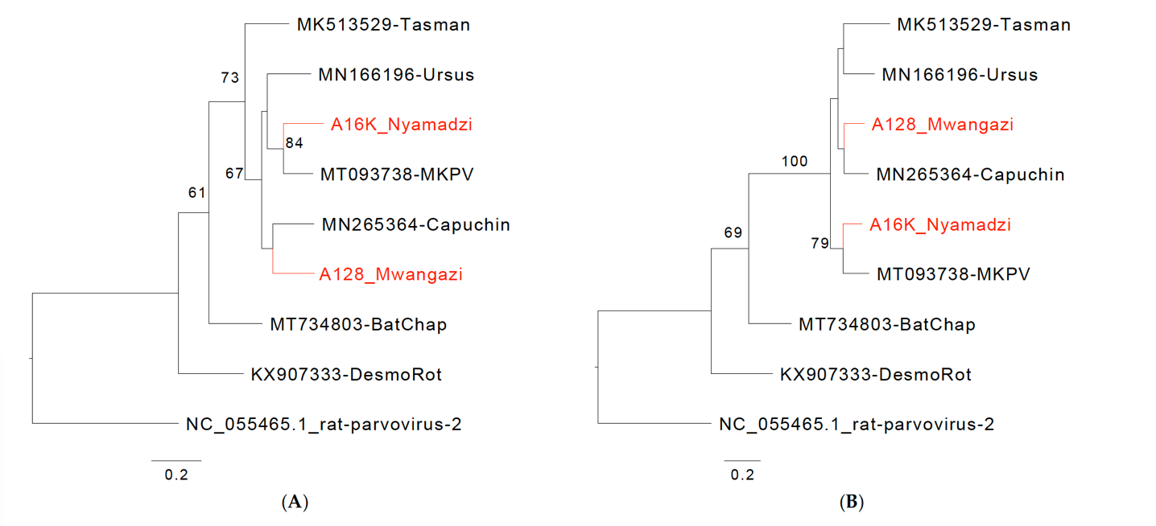
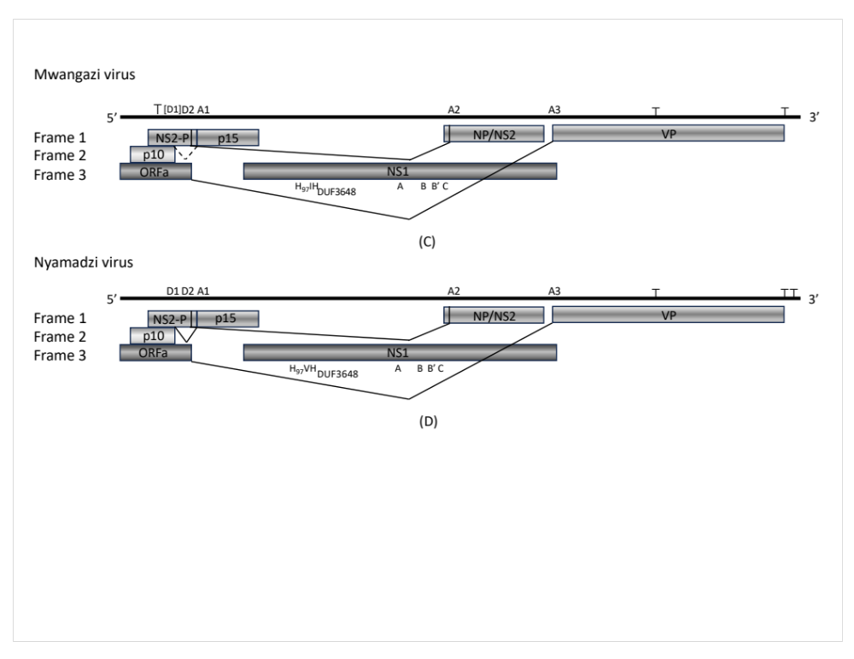
Figure 1. Chaphamaviruses from Zambia. Phylogenetic relationship of Mwangazi and Nyamadzi viruses to other viruses in the genus Chaphamavirus based on NS1 (A) and VP (B) amino acid sequences. Phylogeny was reconstructed with the maximum likelihood method by applying a JTT+G4 substitution model for NS1 and a Q.yeast+F+G4 substitution model for VP1, selected by Model Finder implemented in IQtree; bootstrap values (>60%) resulting from 1000 pseudoreplicates are indicated at the respective nodes; the scale bars indicate the number of amino acid substitutions per site, and GenBank accession numbers are given next to the branches. The red font indicates viruses described in this study. (C) Schematic of Mwangazi virus genome organization. (D) Schematic of Nyamadzi virus genome organization. Gray shading indicates the three possible reading frames. Predicted major splice sites (donor sites D1, D2, and acceptor sites A1–A3), polyadenylation signals (T), SF3 helicase (H97), Walker A, B, B’, C, and domain of unknown function (DUF) 3648 motifs are indicated.

