

The International Committee on Taxonomy of Viruses
Taxonomy Proposal Form, 2026

Part 1a: Details of taxonomy proposals

Title: | Establish 29 species in the genus Circovirus and 31 species in the genus Cyclovirus
Code assigned: | 2026.002D.N.v2.Circoviridae_60nsp

Author(s), affiliation and email address(es):
Given name (+middle initial(s)) | Surname | Affiliation | Email address | Corr. author(s)
Arvind | Varsani | The Biodesign Center for Fundamental and Applied Microbiomics, Center for Evolution and Medicine, School of Life sciences, Arizona State University, Tempe, AZ 85287-5001, USA | arvind.varsani@asu.edu | x
Elise | Paietta | The Biodesign Center for Fundamental and Applied Microbiomics, Center for Evolution and Medicine, School of Life sciences, Arizona State University, Tempe, AZ 85287-5001, USA | epaietta@asu.edu
Simona | Kraberger | The Biodesign Center for Fundamental and Applied Microbiomics, Center for Evolution and Medicine, School of Life sciences, Arizona State University, Tempe, AZ 85287-5001, USA | simona.kraberger@asu.edu
Balázs | Harrach | Veterinary Medical Research Institute, Budapest 1143, Hungary | balazs.harrach@gmail.com
Mária | Benkő | Veterinary Medical Research Institute, Budapest 1143, Hungary | maribenko@gmail.com
Mya | Breitbart | College of Marine Science, University of South Florida, Saint Petersburg, FL 33701, USA | mya@usf.edu
Eric | Delwart | Department of Laboratory Medicine, University of California San Francisco, San Francisco, CA 94118, USA | delwarte@medicine.ucsf.edu
Giovanni | Franzo | Dipartimento di Medicina Animale, Produzione e Salute, Università di Padova, Viale dell’Università 16, 35020 Legnaro, Italy | giovanni.franzo@unipd.it
Subir | Sarker | School of Biomedical Sciences & Molecular Biology, College of Medicine and Dentistry, James Cook University, Townsville, QLD 4814, Australia | subir.sarker@jcu.edu.au
Joaquim | Segalés | UAB, Centre de Recerca en Sanitat Animal (CReSA, IRTAUAB), Campus de la Universitat Autònoma de Barcelona, Bellaterra, 08193 Barcelona, Spain | joaquim.segales@uab.cat
Mart | Krupovic | Institut Pasteur, Université Paris Cité, Cell Biology and Virology of Archaea Unit, 25 rue du Dr. Roux, 75015 Paris, France | mart.krupovic@pasteur.fr

Part 1b: Taxonomy Proposal Submission
ICTV Subcommittee:
Animal DNA Viruses and Retroviruses | x | Bacterial viruses
Animal minus-strand and dsRNA viruses |  | Fungal and protist viruses
Animal positive-strand RNA viruses |  | Plant viruses
Archaeal viruses |  | General -

List the ICTV Study Group(s) that have seen or have been involved in creating this proposal:
Circoviridae study group

Optional – complete only if formally voted on by an ICTV Study Group:
Study Group | Number of members
Study Group | Votes in support | Votes against | No vote

Submission date: | 13

Part 1c: Feedback from ICTV Executive Committee (EC) meeting
Executive Committee Meeting Decision code: | X
A – Accept
Ac – Accept subject to revision by relevant subcommittee chair. No further vote required
U – Accept without revision but with re-evaluation and email vote by the EC
Uc – Accept subject to revision and re-evaluation and email vote by the EC
Ud – Deferred to the next EC meeting, with an invitation to revise based on EC comments
J - Reject
W - Withdrawn

Comments from the Executive Committee:

Part 1d: Revised Taxonomy Proposal Submission
Response of proposer:
Revision date:

Part 3: TAXONOMIC PROPOSAL
https://ictv.global/taxonomy/templates

Taxonomic changes proposed:
Establish new taxon | X | Split taxon
Abolish taxon |  | Merge taxon
Move taxon |  | Promote taxon
Rename taxon |  | Demote taxon
Move and rename

Etymology (origin) of proposed taxonomic names:
Taxon name | Etymology of the term
Circovirus andira | bat (Desmodus rotundus) in Tupi-Guarani
Circovirus lince | lynx (Lynx pardinus) in Spanish
Circovirus dormouse | common name for host (English) - hazel dormouse
Circovirus netopir | bat in Slovenian
Circovirus denever | bat in Hungarian (denevér)
Circovirus minxazhinga | duck in Omaha (minxazhinga / miⁿxazhiⁿga)
Circovirus khuffash | bat in Arabic
Circovirus panya | rat/rodent in Swahili
Circovirus arvicanthis | host genus genitive - Arvicanthis (1st/3rd decl., -is stays -is)
Circovirus bingboe | bat in Northern Min/Jian'ou (bing-boe)
Circovirus rhinolophi | host genus genitive (Latin, 2nd decl. -us -> -i)
Circovirus netopier | bat in Slovak
Circovirus cat | common name for host (English)
Circovirus egel | hedgehog in Dutch
Circovirus chujing | shrew in Mandarin (qu jing)
Circovirus dofen | French Antillean Creole / French Caribbean: dofen (Creole)
Circovirus skaana | killer whale in Haida (Ska-ana)
Circovirus gans | goose in German
Circovirus bagoly | owl in Hungarian
Circovirus barnowl | common name for host (English)
Circovirus turbot | common name for host (English)
Circovirus fushe | pit viper in Mandarin (fu she)
Circovirus tsitsidy | Malagasy word for mouse lemur, the sample source of the virus
Circovirus voalavo | Malagasy word for rat, the sample source of the virus
Circovirus canauhtli | duck in Nahuatl (canauhtli)
Circovirus mida | duck in Hidatsa (mida)
Circovirus nena | duck in Arapaho (ne'na)
Circovirus akak | duck in Sahaptin/Yakama (akak)
Circovirus kawonu | duck in Cherokee (kawonu / kawonu)
Cyclovirus shrew | common name for host (English)
Cyclovirus fledermaus | bat in German
Cyclovirus fladdermus | bat in Swedish
Cyclovirus chamgadar | bat in Hindi
Cyclovirus ilulwane | bat in Zulu
Cyclovirus fidmeer | bat in Somali (fiidmeer)
Cyclovirus adan | bat in Yoruba
Cyclovirus bienghok | bat in Eastern Min/Fuzhou (bieng-hok) - Rhinolophus pusillus
Cyclovirus bianfuyi | bat in Cantonese (bin1 fuk1) + Mandarin 'yi' for 1
Cyclovirus bianfuer | bat in Cantonese (bin1 fuk1) + Mandarin 'er' for 2
Cyclovirus bianfusan | bat in Cantonese (bin1 fuk1) + Mandarin 'san' for 3
Cyclovirus bianfusi | bat in Cantonese (bin1 fuk1) + Mandarin 'si' for 4
Cyclovirus bianfuwu | bat in Cantonese (bin1 fuk1) + Mandarin 'wu' for 5
Cyclovirus bianfuliu | bat in Cantonese (bin1 fuk1) + Mandarin 'liu' for 6
Cyclovirus bianfuchi | bat in Cantonese (bin1 fuk1) + Mandarin "chi" for 7
Cyclovirus bianfuba | bat in Cantonese (bin1 fuk1) + Mandarin 'ba' for 8
Cyclovirus bianfujiu | bat in Cantonese (bin1 fuk1) + Mandarin 'jiu' for 9
Cyclovirus bianfushi | bat in Cantonese (bin1 fuk1) + Mandarin 'shi' for 10
Cyclovirus bianfushiyi | bat in Cantonese (bin1 fuk1) + Mandarin 'shiyi' for 11
Cyclovirus pianghogyi | bat in Teochew (piang1 hog4) + Mandarin 'yi' for 1
Cyclovirus pianghoger | bat in Teochew (piang1 hog4) + Mandarin 'er' for 2
Cyclovirus pianghogsan | bat in Teochew (piang1 hog4) + Mandarin 'san' for 3
Cyclovirus pianghogsi | bat in Teochew (piang1 hog4) + Mandarin 'si' for 4
Cyclovirus pianghogwu | bat in Teochew (piang1 hog4) + Mandarin 'wu' for 5
Cyclovirus pianghogliu | bat in Teochew (piang1 hog4) + Mandarin 'liu' for 6
Cyclovirus pianghogchi | bat in Teochew (piang1 hog4) + Mandarin "chi" for 7
Cyclovirus pianghogba | bat in Teochew (piang1 hog4) + Mandarin 'ba' for 8
Cyclovirus pianghogjiu | bat in Teochew (piang1 hog4) + Mandarin 'jiu' for 9
Cyclovirus musarana | shrew in Spanish
Cyclovirus tenaz | derived from Tenia and Arizona (AZ)
Cyclovirus pueng | honey bee in Thai (phueng)

Permission for use of names derived from a living person:
Taxon name | Full name of person from whom the name is derived | Attached

Abstract of Taxonomy Proposal:
Description of current taxonomy:
Floreoviria; Shotokuvirae; Cressdnaviricota; Arfiviricetes; Cirlivirales; Circoviridae
Family Circoviridae comprises two genera, Circovirus and Cyclovirus, which include 70 and 90 established species, respectively.

Proposed taxonomic change(s):
Classify new circovirids into 29 new species in the genus Circovirus, and 31 in the genus Cyclovirus.

Demarcation criteria for new taxon/taxa:
Viruses in the family Circoviridae are classified into genera based on the phylogeny of the replication associated protein. Within the two genera, circovirids are classified into species based on their genome-wide pairwise identities with established members of genera, with a species demarcation threshold of 80% identity coupled with phylogenetic support [1, 2].

Justification:
Over the last couple of years, a number of new circovirid genomes have been identified from various sample types from diverse hosts. Many of these cannot be assigned to currently established species. Based on replication-associated protein phylogeny coupled with pairwise identity analysis, we propose classifying 29 viruses into new species in the genus Circovirus and 31 in the genus Cyclovirus.

Text of Taxonomy proposal:

Description of current taxonomy:
Floreoviria; Shotokuvirae; Cressdnaviricota; Arfiviricetes; Cirlivirales; Circoviridae
Family Circoviridae comprises two genera, Circovirus and Cyclovirus, which include 70 and 90 established species, respectively.

Proposed taxonomic change(s):
Classify new circovirids into 29 new species in the genus Circovirus and 31 in the genus Cyclovirus.

Demarcation criteria for new taxon/taxa:
Viruses in the family Circoviridae are classified into genera based on the phylogeny of the replication associated protein. Within the two genera, circovirids are classified into species based on their genome-wide pairwise identities with established members of genera, with a species demarcation threshold of 80% identity coupled with phylogenetic support [1, 2].

Justification:
Over the last couple of years, a number of new circovirid genomes have been identified from diverse sample types from various hosts. Many of these cannot be assigned to currently established species. Based on replication-associated protein phylogeny coupled with pairwise identity analysis, we propose classifying 29 viruses into new species in the genus Circovirus, and 31 in the genus Cyclovirus. The genomes of these 60 circovirids that represent 60 new species all share <80% genome-wide pairwise identity as determined using Sequence Demarcation Tool (SDT) v1.2 [3] (Figure 1).

The species epithets have been derived from names of the host in local languages coupled with numbers being spelt out in that language.

The classification of the new species is supported by maximum likelihood phylogenetic trees (with TIM+F+I+G4 and TIM2+F+I+G4 substitution models for Circovirus and Cyclovirus members, respectively) inferred using IQTree 2 [4] from genomes aligned with MAFFT v7 [5] (Figure 2 and 3).

References:
1. Rosario K, Breitbart M, Harrach B, Segalés J, Delwart E, Biagini P, Varsani A (2017) Revisiting the taxonomy of the family Circoviridae: establishment of the genus Cyclovirus and removal of the genus Gyrovirus. Arch Virol 162:1447-1463
2. Varsani A, Harrach B, Roumagnac P, Benkő M, Breitbart M, Delwart E, Franzo G, Kazlauskas D, Rosario K, Segalés J, Dunay E, Rukundo J, Goldberg TL, Fehér E, Kaszab E, Bányai K, Krupovic M (2024) 2024 taxonomy update for the family Circoviridae. Arch Virol 169:176
3. Muhire BM, Varsani A, Martin DP (2014) SDT: a virus classification tool based on pairwise sequence alignment and identity calculation. PLoS One 9:e108277
4. Minh BQ, Schmidt HA, Chernomor O, Schrempf D, Woodhams MD, von Haeseler A, Lanfear R (2020) IQ-TREE 2: New Models and Efficient Methods for Phylogenetic Inference in the Genomic Era. Mol Biol Evol 37:1530-1534
5. Katoh K, Standley DM (2013) MAFFT multiple sequence alignment software version 7: improvements in performance and usability. Mol Biol Evol 30:772-780
6. Castro-Scholten S, Vasinioti VI, Caballero-Gómez J, García-Bocanegra I, Pellegrini F, Salvaggiulo A, Odigie AE, Diakoudi G, Camero M, Decaro N, Martella V, Lanave G (2024) Identification and characterization of a novel circovirus in Iberian lynx in Spain. Res Vet Sci 176:105336
7. Buigues J, Viñals A, Martínez-Recio R, Monrós JS, Sanjuán R, Cuevas JM (2024) Full-genome sequencing of dozens of new DNA viruses found in Spanish bat feces. Microbiol Spectr 12:e0067524
8. Olivo D, Kraberger S, Collins D, De Koch MD, Moore J, Klassen C, Fyffe N, Matos C, Ochs M, Varsani A (in review) Cloacal sampling of waterfowl across two North American flyways reveals novel circoviruses. Virology
9. Wang D, Yang X, Ren Z, Hu B, Zhao H, Yang K, Shi P, Zhang Z, Feng Q, Nawenja CV, Obanda V, Robert K, Nalikka B, Waruhiu CN, Ochola GO, Onyuok SO, Ochieng H, Li B, Zhu Y, Si H, Yin J, Kristiansen K, Jin X, Xu X, Xiao M, Agwanda B, Ommeh S, Li J, Shi ZL (2024) Substantial viral diversity in bats and rodents from East Africa: insights into evolution, recombination, and cocirculation. Microbiome 12:72
10. Wang Y, Xu P, Han Y, Zhao W, Zhao L, Li R, Zhang J, Zhang S, Lu J, Daszak P, Jin Q, Wu Z (2024) Unveiling bat-borne viruses: a comprehensive classification and analysis of virome evolution. Microbiome 12:235
11. Vasinioti VI, Salvaggiulo A, Pellegrini F, Diakoudi G, Camero M, Mesquita JR, Gomes-de-Sá S, Buzdugan I, Savuţa G, Elia G, Decaro N, Martella V, Lanave G (2025) Feline Circovirus-1 in domestic cats: A multicentric European epidemiological study. Res Vet Sci 196:105920
12. Mulder KP, Pasmans F, van Nieuwerburgh F, Terriere N, Kelly M, Bregman S, Verbrugghe E, Martel A (2024) High Prevalence of a Novel Circovirus in the European Hedgehog (Erinaceus europaeus), a Common Species in Decline. Transbound Emerg Dis 2024:4670252
13. Feng Y, Kuang G, Pan Y, Wang J, Yang W, Wu WC, Pan H, Wang J, Han X, Yang L, Xin GY, Shan YT, Gou QY, Liu X, Guo D, Liang G, Holmes EC, Gao Z, Shi M (2025) Small mammals in a biodiversity hotspot harbor viruses of emergence risk. Natl Sci Rev 12:nwae463
14. De Koch MD, Kraberger S, Fielding R, Smith K, Schiavone K, Hall KR, Reid VS, Boyea D, Smith EL, Schmidlin K, Fontenele RS, Martin DP, Krupovic M, Varsani A (2026) Novel circoviruses identified in short-finned pilot whale and orca from the North Atlantic Ocean. Virology 615:110768
15. Pataki A, Máté D, Kaszab E, Bali K, Ursu K, Fehér E (2026) Occurrence of diverse circoviruses in wild birds in Hungary. Vet Res 57:28
16. Oh YE, Lee YJ, Lee EJ, Kang BK, Jun LJ, Jeong JB (2026) First report of turbot circovirus in cultured turbot (Scophthalmus maximus) in Korea. Aquaculture 612:743228
17. Tian Z, Luo S, Li J, Liu X, Huang Y, Fan Y, Zhou C, Guo P, Hu X (2025) Novel snake Circovirus from alpine pit viper (Gloydius strauchi) in China: evidence of a mammal-avian genetic recombinant. Front Microbiol 16:1725961
18. Paietta EN, Johnston RA, Kraberger S, Randrianarisoa SF, Razanamahenina TT, Ramboninarimalala A, Velontsara JB, Raherinirina TG, Raveloson L, Finley NL, Baitchman E, McAdoo BG, Yoder AD, Varsani A (2026) Mammal-infecting DNA viruses identified in lemurs and rodents in Madagascar mirror the evolutionary history of their hosts. Microb Genom 12:001728
19. Sasaki M, Orba Y, Ueno K, Ishii A, Moonga L, Hang'ombe BM, Mweene AS, Ito K, Sawa H (2015) Metagenomic analysis of the shrew enteric virome reveals novel viruses related to human stool-associated viruses. J Gen Virol 96:440-452
20. Buigues J, Viñals A, Martínez-Recio R, Monrós JS, Sanjuán R, Cuevas JM (2024) Complete Genomes of DNA Viruses in Fecal Samples from Small Terrestrial Mammals in Spain. Viruses 16:1885
21. Žuštra A, Howard A, Schwartz K, Day R, Dietrich J, Sobotyk C, Kraberger S, Varsani A (2025) Three Distinct Circovirids Identified in a Tapeworm Recovered from a Bobcat (Lynx rufus). Viruses 17:745

Accompanying files:
Filename | Description of contents
2026.002D.Circoviridae_60nsp_v2 | Excel taxonomy module

Tables, Figures:

Table 1: Details of the representative members of the new species.
Species | Accession | Virus name | Isolate | Sampling date | Location | Host source | Reference
“Circovirus andira” | OR434196 | Circovirus sp. ViroVet DR9i | ViroVet DR9i | 2019 | Brazil | Desmodus rotundus | -
“Circovirus lince” | OR714537 | Iberian lynx associated circovirus 1 | SPA/2023/Iberian lynx/296.29 | 2023 | Spain | Lynx pardinus | [6]
“Circovirus dormouse” | PP259108 | Hazel dormouse circovirus | 2016-17 | Mar-2016/Mar-2017 | United Kingdom | Muscardinus avellanarius | -
“Circovirus netopir” | PP410064 | Barbastella barbastellus feces associated circovirus 2 | MAVG5 | Aug-2022 | Spain | Barbastella barbastellus | [7]
“Circovirus denever” | PP410067 | Eptesicus serotinus feces associated circovirus | MAVG35 | 2022 | Spain | Eptesicus serotinus | [7]
“Circovirus minxazhinga” | PP626432 | Spata circovirus | CC02_KD | 31-Oct-2021 | USA: Arizona | Spatula clypeata | [8]
“Circovirus khuffash” | PP711955 | Rousettus bat circovirus | 13A/Uganda/URA8SL/2018 | 2018 | Uganda | Rousettus aegyptiacus | [9]
“Circovirus panya” | PP711969 | Gerbilliscus rat circovirus | 5A/Kenya/RNALIV2048/2016 | 2016 | Kenya | Gerbilliscus vicinus | [9]
“Circovirus arvicanthis” | PP711970 | Arvicanthis rat circovirus | 6A/Kenya/RNAKID1997/2016 | 2016 | Kenya | Arvicanthis niloticus | [9]
“Circovirus bingboe” | PP744710 | Circovirus sp. 262_34939 | 262_34939 | 2016 | China | Myotis adversus | [10]
“Circovirus rhinolophi” | PP744716 | Circovirus sp. 338_574993 | 338_574993 | 2021 | China | Rhinolophus macrotis | [10]
“Circovirus netopier” | PP751788 | Myotis daubentonii feces-associated circovirus 1 | MAVG51 | Aug-2022 | Spain | Myotis daubentonii | [7]
“Circovirus cat” | PP795594 | Cat associated circovirus 1 | 11 | 2015 | Portugal | Felis catus | [11]
“Circovirus egel” | PQ261159 | Hedgehog associated circovirus | GB01 | Jul-2021 | Belgium | Erinaceus europaeus | [12]
“Circovirus chujing” | PQ678078 | Wufeng shrew circovirus 1 | HHMIX-YNSP119 | 2021 | China: Yunnan | Anourosorex squamipes | [13]
“Circovirus dofen” | PV388451 | Shofin circovirus | USW10_Orca1_1855_FG | 22-Sep-2015 | Saint Vincent and the Grenadines | Globicephala macrorhynchus | [14]
“Circovirus skaana” | PV388454 | Orcin circovirus | USW4_Orca3_1791_FG | 26-Aug-2015 | Saint Vincent and the Grenadines | Orcinus orca | [14]
“Circovirus gans” | PV793852 | Circovirus sp. | CircoviridaeGoosefe86 | Jan-24 | China | Anser sp. | -
“Circovirus bagoly” | PV972686 | Long-eared owl-associated circovirus 1 | le-owlCV1-Hun1 | 2023 | Hungary | Asio otus | [15]
“Circovirus barnowl” | PV972688 | Barn owl-associated circovirus 1 | barn-owlCV1-Hun2 | 2024 | Hungary | Tyto alba | [15]
“Circovirus turbot” | PV976730 | Turbot circovirus | TCV-KJ1 | Mar-2025 | South Korea: Jeju | Scophthalmus maximus | [16]
“Circovirus fushe” | PX310168 | Snake circovirus | GsCV1 | Jan-2023 | China | Gloydius strauchi | [17]
“Circovirus tsitsidy” | PX705252 | Circovirus sp. MNB22_048_18166 | MNB22_048_18166 | 26-Oct-2022 | Madagascar: Manombo Special Reserve | Microcebus sp. | [18]
“Circovirus voalavo” | PX705265 | Circovirus sp. MNB23_267_4974 | MNB23_267_4974 | 18-Jul-2023 | Madagascar: Manombo Special Reserve | Eliurus webbi | [18]
“Circovirus canauhtli” | PX705359 | Ameon circovirus | CBAZ_Bird_26_1702 | 13-Dec-2023 | USA: Arizona, Cibola | Mareca americana | [8]
“Circovirus mida” | PX705360 | Amwig circovirus | CBAZ_Bird_26_1708 | 13-Dec-2023 | USA: Arizona, Cibola | Mareca americana | [8]
“Circovirus nena” | PX705364 | Grewin circovirus | CO_Bird_88_1714 | 23-Sep-2023 | USA: Colorado, Saguache | Anas carolinensis | [8]
“Circovirus akak” | PX705367 | Maruta circovirus | NM_Bird_32_1722 | 29-Jan-2024 | USA: New Mexico, Bosque del Apache | Anas acuta | [8]
“Circovirus kawonu” | PX705369 | Nortail circovirus | NM_Bird_81_1705 | 29-Jan-2024 | USA: New Mexico, Bosque del Apache | Anas acuta | [8]
“Cyclovirus shrew” | AB937982 | Cyclovirus ZM36a | ZM36a | May-2012 | Zambia | Crocidura hirta | [19]
“Cyclovirus fledermaus” | PP410066 | Myotis capaccinii feces associated cyclovirus 2 | MAVG32 | Jun-2022 | Spain: Murcia | Myotis capaccinii | [7]
“Cyclovirus fladdermus” | PP410084 | Myotis mistacinus feces associated cyclovirus 2 | MAVG11 | Aug-2022 | Spain | Myotis mystacinus | [7]
“Cyclovirus chamgadar” | PP711956 | Miniopterus bat circovirus | 14A/Kenya/BAT2999/2015 | 2015 | Kenya | Miniopterus sp. clade 1 TD-2020 | [9]
“Cyclovirus ilulwane” | PP711966 | Miniopterus bat circovirus | 3A/Kenya/BAT2988/2015 | 2015 | Kenya | Miniopterus sp. clade 1 TD-2020 | [9]
“Cyclovirus fidmeer” | PP711973 | Miniopterus bat circovirus | 8A/Kenya/BAT2997/2015 | 2015 | Kenya | Miniopterus sp. clade 1 TD-2020 | [9]
“Cyclovirus adan” | PP711975 | Coleura bat circovirus | 9A/Kenya/BAT260/2015 | 2015 | Kenya | Coleura afra | [9]
“Cyclovirus bienghok” | PP744717 | Cyclovirus sp. 075_128373 | 075_128373 | 2017 | China | Rhinolophus pusillus | [10]
“Cyclovirus bianfuyi” | PP744721 | Cyclovirus sp. 125_14387 | 125_14387 | 2016 | China | Tylonycteris fulvida | [10]
“Cyclovirus bianfuer” | PP744722 | Cyclovirus sp. 125_51826 | 125_51826 | 2016 | China | Tylonycteris fulvida | [10]
“Cyclovirus bianfusan” | PP744725 | Cyclovirus sp. 128_31572 | 128_31572 | 2016 | China | Tylonycteris fulvida | [10]
“Cyclovirus bianfusi” | PP744728 | Cyclovirus sp. 130_22078 | 130_22078 | 2017 | China | Tylonycteris fulvida | [10]
“Cyclovirus bianfuwu” | PP744730 | Cyclovirus sp. 131_46647 | 131_46647 | 2017 | China | Tylonycteris fulvida | [10]
“Cyclovirus bianfuliu” | PP744731 | Cyclovirus sp. 131_46650 | 131_46650 | 2017 | China | Tylonycteris fulvida | [10]
“Cyclovirus bianfuchi” | PP744732 | Cyclovirus sp. 133_7747 | 133_7747 | 2018 | China | Tylonycteris fulvida | [10]
“Cyclovirus bianfuba” | PP744737 | Cyclovirus sp. 138_38119 | 138_38119 | 2016 | China | Tylonycteris fulvida | [10]
“Cyclovirus bianfujiu” | PP744740 | Cyclovirus sp. 141_47117 | 141_47117 | 2016 | China | Tylonycteris fulvida | [10]
“Cyclovirus bianfushi” | PP744741 | Cyclovirus sp. 142_93272 | 142_93272 | 2017 | China | Tylonycteris fulvida | [10]
“Cyclovirus bianfushiyi” | PP744745 | Cyclovirus sp. 150_24791 | 150_24791 | 2016 | China | Tylonycteris fulvida | [10]
“Cyclovirus pianghogyi” | PP744746 | Cyclovirus sp. 153_17811 | 153_17811 | 2016 | China | Pipistrellus abramus | [10]
“Cyclovirus pianghoger” | PP744747 | Cyclovirus sp. 155_1893 | 155_1893 | 2017 | China | Pipistrellus abramus | [10]
“Cyclovirus pianghogsan” | PP744749 | Cyclovirus sp. 172_2272 | 172_2272 | 2017 | China | Scotophilus kuhlii | [10]
“Cyclovirus pianghogsi” | PP744750 | Cyclovirus sp. 172_5685 | 172_5685 | 2017 | China | Scotophilus kuhlii | [10]
“Cyclovirus pianghogwu” | PP744754 | Cyclovirus sp. 235_32704 | 235_32704 | 2017 | China | Tylonycteris tonkinensis | [10]
“Cyclovirus pianghogliu” | PP744755 | Cyclovirus sp. 235_399 | 235_399 | 2017 | China | Tylonycteris tonkinensis | [10]
“Cyclovirus pianghogchi” | PP744757 | Cyclovirus sp. 238_12407 | 238_12407 | 2016 | China | Tylonycteris tonkinensis | [10]
“Cyclovirus pianghogba” | PP744758 | Cyclovirus sp. 240_207682 | 240_207682 | 2016 | China | Tylonycteris tonkinensis | [10]
“Cyclovirus pianghogjiu” | PP744760 | Cyclovirus sp. 257_13925 | 257_13925 | 2017 | China | Myotis siligorensis | [10]
“Cyclovirus musarana” | PQ576920 | Crocidura russula feces associated cyclovirus | MAVG5 | Jun-2022 | Spain: Valencia | Crocidura russula | [20]
“Cyclovirus tenaz” | PV339924 | Tenaz virus | AZBC88_Tworm_1572 | 31-Jan-2024 | USA: Arizona | Tenia sp. | [21]
“Cyclovirus pueng” | PX628457 | Apis cerana associated cyclovirus 1 | Ac1 | 10-Dec-2024 | Thailand: San Pa Tong, Chiang Mai | Apis cerana | -

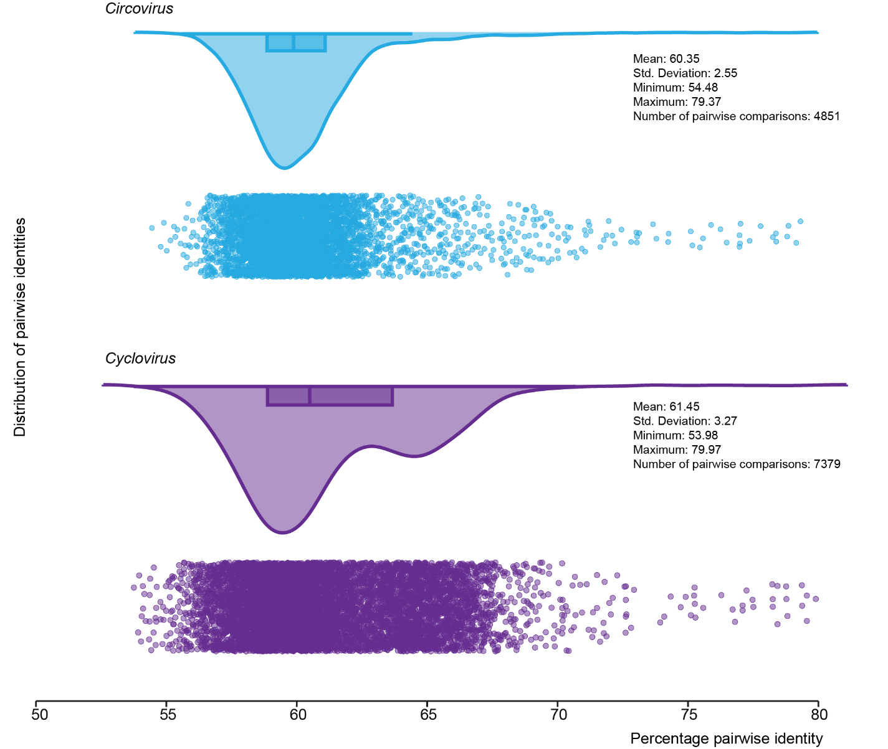
Figure 1: Raincloud plots showing the distribution of the pairwise identities of the representative members of each species determined using SDT v1.2 [3].

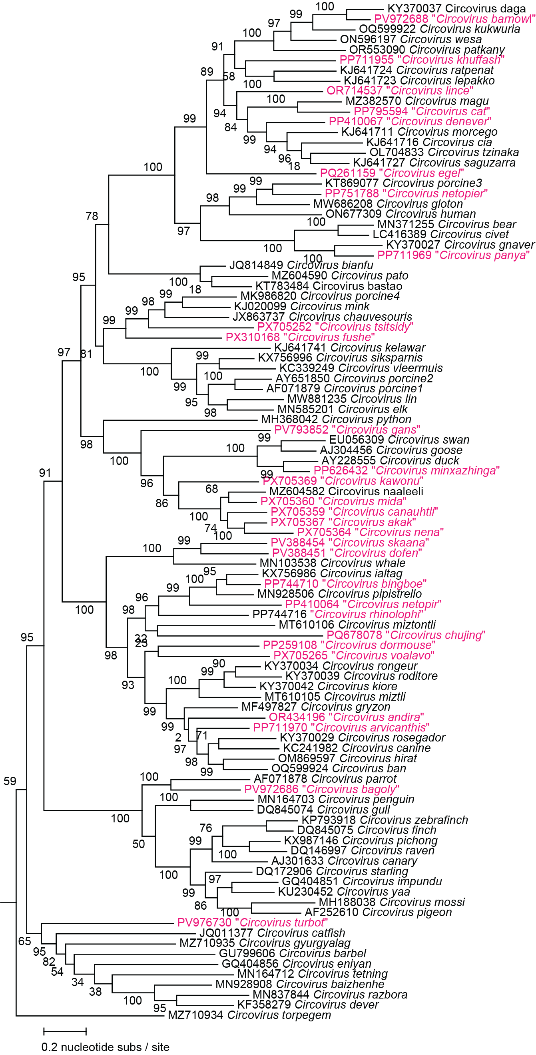

Figure 2: Maximum likelihood phylogenetic tree of representative species members of the genus Circovirus and the new proposed species (pink font).

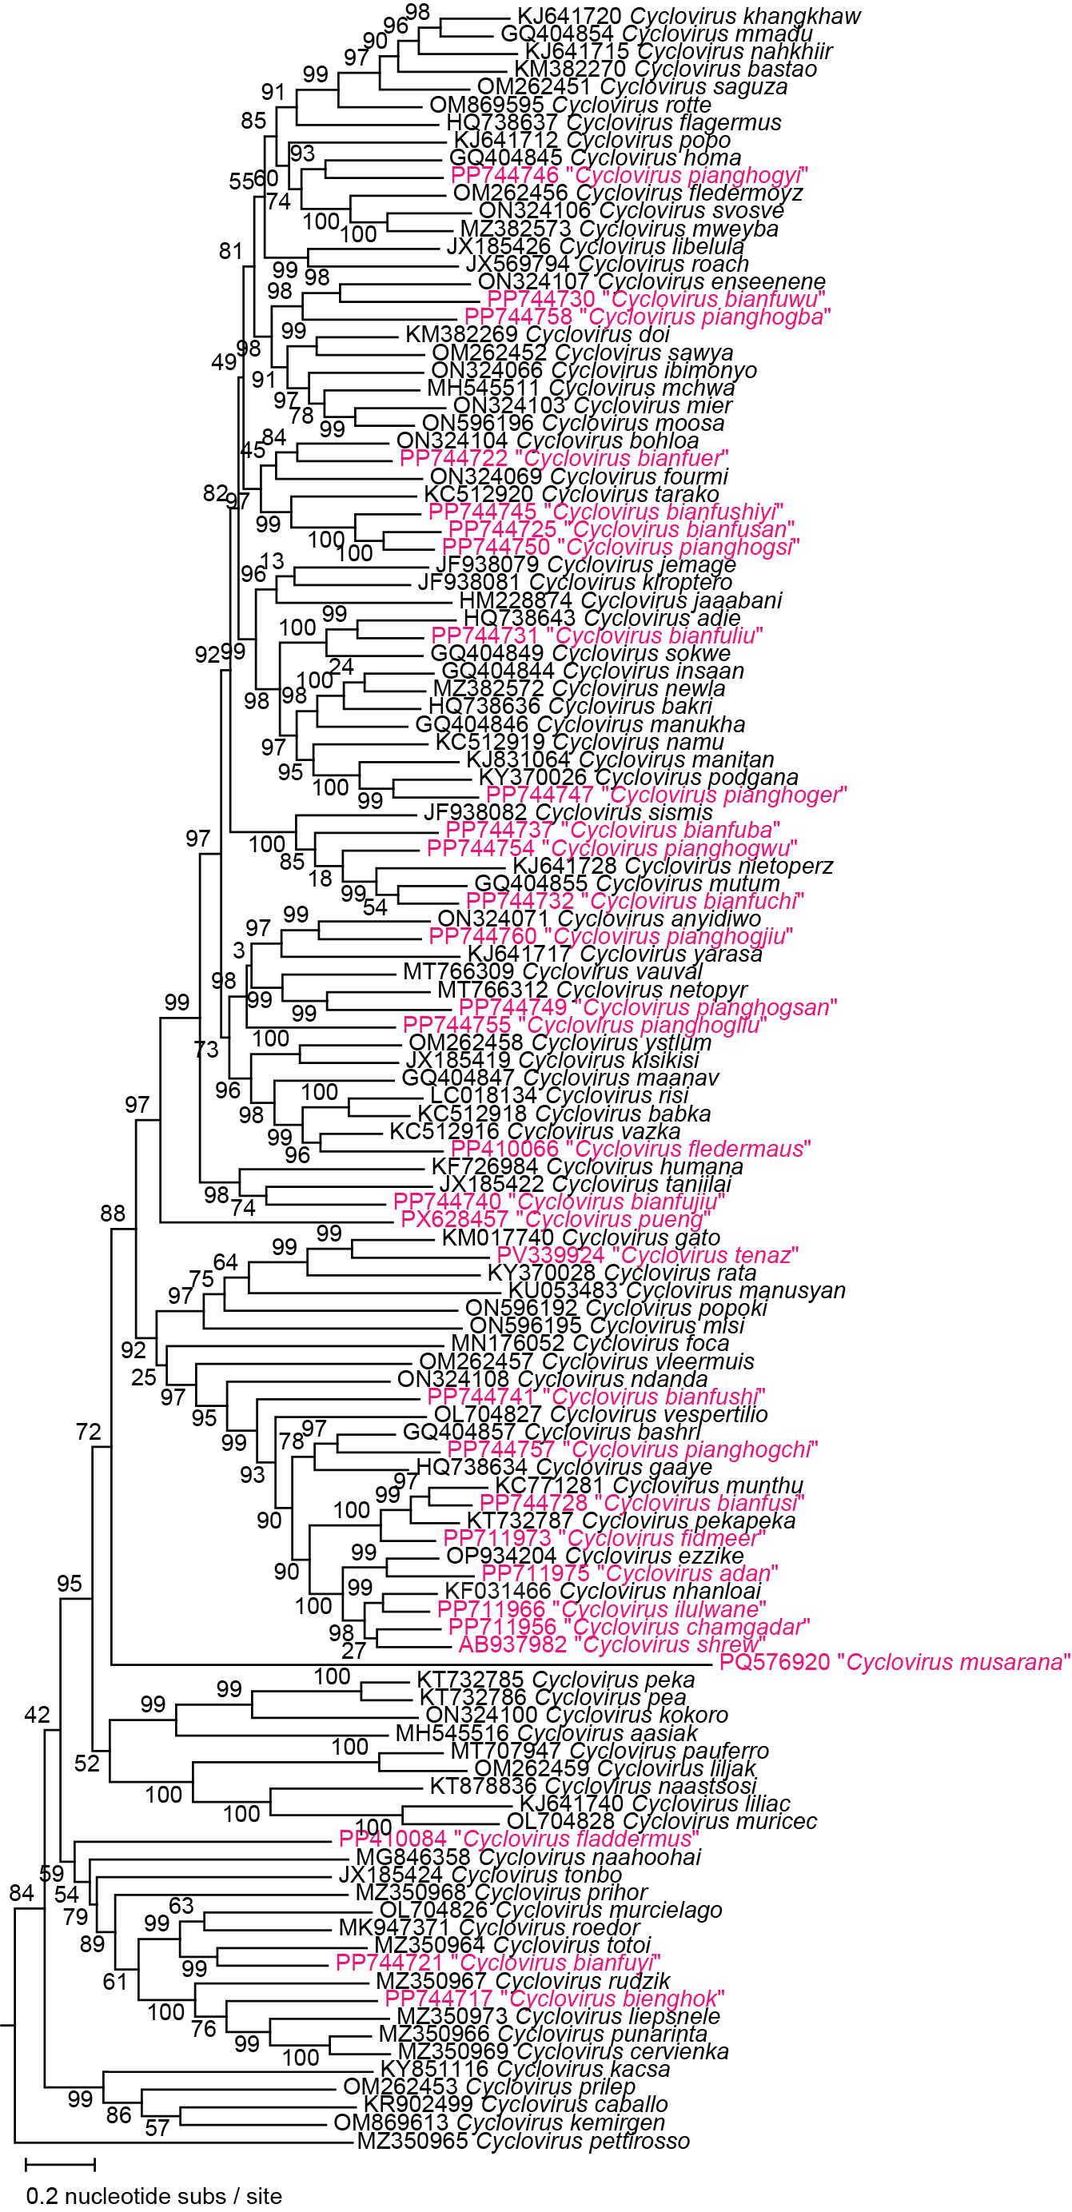

Figure 3: Maximum likelihood phylogenetic tree of representative species members of the genus Cyclovirus and the new proposed species (pink font).

