

The International Committee on Taxonomy of Viruses
Taxonomy Proposal Form, 2026

Part 1a: Details of taxonomy proposals

Title: | Create 1 new genus, 11 new species and rename 14 species in the family Adenoviridae (Rowavirales)
Code assigned: | 2026.003D.N.v1.Adenoviridae_1ng_11ns_14rn

Author(s), affiliation and email address(es):
Given name (+middle initial(s)) | Surname | Affiliation | Email address | Corr. author
Balázs | Harrach | HUN-REN Veterinary Medical Research Institute, Budapest, Hungary | harrach.balazs@vmri.hu | X
Niklas | Arnberg | Umeå University, Umeå, Sweden | niklas.arnberg@umu.se
Mária | Benkő | HUN-REN Veterinary Medical Research Institute, Budapest, Hungary | maribenko@gmail.com
Andor | Doszpoly | HUN-REN Veterinary Medical Research Institute, Budapest, Hungary | doszpoly.andor@vmri.hu
Michael | Hess | Histovac GmbH, Klosterneuburg, Austria | michael.hess@histovac.com
Győző L. | Kaján | HUN-REN Veterinary Medical Research Institute, Budapest, Hungary | kajan.gyozo@vmri.hu
Adriana | Kajon | Lovelace Respiratory Research Institute, Albuquerque, NM, USA | akajon@lovelacebiomedical.org
Suresh K. | Mittal | Purdue University, West Lafayette, IN, USA | mittal@purdue.edu
Iva I. | Podgorski | Ruđer Bošković Institute, Zagreb, Croatia | ivapodgorski@gmail.com
Thomas S. | Postler | Vaccine Design and Development Lab, IAVI, Jersey City, NJ, USA | TPostler@iavi.org
Carmen | San Martin | Centro Nacional de Biotecnología (CNB-CSIC), Madrid, Spain | carmen@cnb.csic.es
Tohru | Mekata | Okayama University of Science, Imabari, Japan | t-mekata@ous.ac.jp
Arvind | Varsani | The Biodesign Center for Fundamental and Applied Microbiomics, Arizona State University, Tempe, Arizona, USA | arvind.varsani@asu.edu
Márton Z. | Vidovszky | HUN-REN Veterinary Medical Research Institute, Budapest, Hungary | vidovszky.marton@vmri.hu
Göran | Wadell | Umeå University, Umeå, Sweden | goran.wadell@umu.se
Hidemi | Watanabe | Hokkaido University, Sapporo, Japan | watanabe@ist.hokudai.ac.jp

Part 1b: Taxonomy Proposal Submission
ICTV Subcommittee:
Animal DNA Viruses and Retroviruses | X | Bacterial viruses
Animal minus-strand and dsRNA viruses |  | Fungal and protist viruses
Animal positive-strand RNA viruses |  | Plant viruses
Archaeal viruses |  | General -

List the ICTV Study Group(s) that have seen or have been involved in creating this proposal:
Adenoviridae SG

Optional – complete only if formally voted on by an ICTV Study Group:
Study Group | Number of members
Study Group | Votes in support | Votes against | No vote

Submission date: | 13/08/2026

Part 1c: Feedback from ICTV Executive Committee (EC) meeting
Executive Committee Meeting Decision code: | X
A – Accept
Ac – Accept subject to revision by relevant subcommittee chair. No further vote required
U – Accept without revision but with re-evaluation and email vote by the EC
Uc – Accept subject to revision and re-evaluation and email vote by the EC
Ud – Deferred to the next EC meeting, with an invitation to revise based on EC comments
J - Reject
W - Withdrawn

Comments from the Executive Committee:

Part 1d: Revised Taxonomy Proposal Submission
Response of proposer:
Revision date:

Part 3: TAXONOMIC PROPOSAL
https://ictv.global/taxonomy/templates

Taxonomic changes proposed:
Establish new taxon | X | Split taxon
Abolish taxon |  | Merge taxon
Move taxon |  | Promote taxon
Rename taxon | X | Demote taxon
Move and rename

Etymology (origin) of proposed taxonomic names:
Taxon name | Etymology of the term
“Aviadenovirus limosae” | from the Latin limosa, meaning "muddy" (from the Latin limus, meaning "mud") and referring to the genus of the host Hudsonian godwit Limosa haemastica, a large shorebird
“Aviadenovirus raptoris” | the term raptor is from the Latin rapio, meaning “to seize or take by force", syn. birds of prey (Accipitriformes and Strigiformes) referring to raptor adenovirus 3 (AdV-3, black kite, Milvus migrans, Accipitriformes)
“Aviadenovirus spheniscidae” | after the family name Spheniscidae of the host Adélie penguin (Pygoscelis adeliae)
“Barthadenovirus antarcticaense” | from the English name (and location) of the host Antarctic tern (Sterna vittata); antarctic coming from Middle French antartique or antarctique ('opposite to the Arctic') and, in turn, the Latin antarcticus ('opposite to the north'), derived from the Greek ἀντι- ('anti-') and ἀρκτικός (arktikos, 'of the Bear [Ursa Major], northern', a constellation in the Northern Sky)
“Mastadenovirus atri” | from the Latin ater, meaning "dull black" referring to the English name of host black rat (Rattus rattus)
“Mastadenovirus belangeri” | after the species epithet of the host northern treeshrew (Tupaia belangeri)
“Mastadenovirus bovisundecimum” | from the Latin bos, meaning “cow”, and the Latin undecimum, meaning “eleventh” (referring to bovine AdV-11)
“Mastadenovirus caudatae” | after the species epithet of the host Marmota caudata (long-tailed marmot) from the Latin cauda, meaning "(animal) tail"
“Piscadenovirus” | from the Latin piscis, meaning "fish" and referring to the single known host red seabream (Pagrus major)
“Piscadenovirus sparidae” | from the family name Sparidae, a family of seabreams and porgies (ray-finned fishes)
“Siadenovirus limosae” | from the Latin limosa, meaning "muddy" (from the Latin limus, meaning "mud") and referring to the genus of the host Hudsonian godwit Limosa haemastica, a large shorebird
“Siadenovirus milvi” | after the genus name of the host black kite Milvus migrans (Accipitriformes)
“Aviadenovirus gallopavonisprimum” | correction of a minor Latin declension mistake
“Aviadenovirus gallopavonisquartum” | correction of a minor Latin declension mistake
“Aviadenovirus gallopavonisquintum” | correction of a minor Latin declension mistake
“Barthadenovirus bovisquartum” | correction of a minor Latin declension mistake
“Barthadenovirus bovisseptimum” | correction of a minor Latin declension mistake
“Barthadenovirus bovissextum” | correction of a minor Latin declension mistake
“Mastadenovirus bovisdecimum” | correction of a minor Latin declension mistake
“Mastadenovirus bovisprimum” | correction of a minor Latin declension mistake
“Mastadenovirus bovistertium” | correction of a minor Latin declension mistake
“Mastadenovirus porcitertium” | correction of a minor Latin declension mistake
“Mastadenovirus porciquartum” | correction of a minor Latin declension mistake
“Mastadenovirus porciquintum” | correction of a minor Latin declension mistake
“Mastadenovirus simiaevigesimum” | correction of a minor Latin declension mistake
“Siadenovirus gallopavonistertium” | correction of minor Latin declension mistakes

Permission for use of names derived from a living person:
Taxon name | Full name of person from whom the name is derived | Attached

Abstract of Taxonomy Proposal:
Description of current taxonomy:
145 species in 6 genera in the family Adenoviridae.

Proposed taxonomic change(s):
Adding 1 new genus (“Piscadenovirus”) and 11 new species: 3 to genus Aviadenovirus, 1 to Barthadenovirus, 4 to Mastadenovirus, 1 to “Piscadenovirus”, 2 to Siadenovirus; correcting 14 species names with minor Latin declension mistakes.

Demarcation criteria for new taxon/taxa:
Species demarcation (at least two of the following characteristics):
phylogenetic distance (>10–15%, based on maximum likelihood analysis of the DNA polymerase amino acid sequences),
genome organization (characteristically in the right terminal region),
host range,
nucleotide composition.

Proposed genus demarcation
Both of the following characteristics required:
phylogenetic distance (>55-60%, based on maximum likelihood analysis of the DNA polymerase amino acid sequences) of members of a monophyletic group,
genome organization (characteristically in the terminal regions).

Justification:
11 novel adenoviruses (AdVs) from 4 mammalian, 6 avian and 1 ray-finned fish species merit the establishment according to phylogenetic calculations and other demarcation criteria. The AdV genome from moribund red seabreams (Pagrus major) has the fiber gene on its left end, but no homologs were identified upstream of IVa2 and downstream of 100K. The evolutionary distance (calculated phylogeny) suggests the need to establish a new genus for it. The red seabream AdV-1 polymerase shows less than 40% identity in the DNA polymerase amino acid sequence to other AdVs, thus fulfilling all the proposed general genus demarcation criteria.

Text of Taxonomy proposal:
Description of current taxonomy:
Six genera and 145 species in the family Adenoviridae:
genus Mastadenovirus: 79 species,
genus Aviadenovirus: 29 species,
genus Barthadenovirus: 21 species,
genus Siadenovirus: 14 species,
genus Ichtadenovirus: 1 species,
genus Testadenovirus: 1 species
(https://sites.google.com/site/adenoseq).

Proposed taxonomic change(s):
Establish a new (seventh) genus and a species for a newly identified fish adenovirus recovered by metagenomics from moribund red seabreams (Pagrus major).
Establish 10 further new species (total species number in the family: 156):
genus Mastadenovirus: 4 new species (2 viruses from rodents, 1 from cattle, 1 from treeshrew) total virus species in the genus: 83,
genus Aviadenovirus: 3 new species (AdVs from Adélie penguin, black kite, Hudsonian godwit) total 32,
genus Barthadenovirus: 1 new species (for an Antarctic tern AdV) total 22,
genus Siadenovirus: 2 new species (for AdVs from Hudsonian godwit and black kite) total 16.

Correcting 14 species names with minor Latin declension mistakes (3 in Aviadenovirus, 3 in Barthadenovirus, 7 in Mastadenovirus, and 1 Siadenovirus).

Demarcation criteria for new taxon/taxa:
Genus demarcation criteria
Both of the following characteristics required:
phylogenetic distances (>55-60%, based on maximum likelihood analysis of the DNA polymerase amino acid sequence) of members of a monophyletic group,
genome organization (characteristically in the terminal regions).

Species demarcation criteria
In the family Adenoviridae, species demarcation depends on at least two of the following characteristics (Benkő et al., 2022):
phylogenetic distance (>10–15%, based on maximum likelihood analysis of the DNA polymerase amino acid sequences),
genome organization (characteristically in the right terminal region),
host range,
nucleotide composition,
cross-neutralization.

Justification:
In recent years, several new adenovirid genomes have been sequenced completely or almost completely from mammalian AdVs: including black rat AdV-2 (Adhikari et al., 2026), marmot AdV-2 (PP098962), bovine AdV-11 (Sui et al., 2026), treeshrew AdV-2 (Lian et al., 2025). Similarly, adenovirus (AdV) genomes have been described from birds, and these AdVs belong either to the genus Aviadenovirus, like the Adélie penguin AdV-1 (PX870632), raptor AdV-3 (from black kite; Sahnan et al., 2026) and Hudsonian godwit AdV-1 (Gutiérrez et al., 2026), or to the genus Barthadenovirus, like Antarctic tern AdV-1 (PX870867), or to the genus Siadenovirus, like Hudsonian godwit AdV-2 (Gutiérrez et al., 2026) and raptor AdV-4 (from black kite; Sahnan et al., 2026).

A very interesting finding was the recovery of an AdV genome by metagenomics from moribund red seabreams (Pagrus major; Ishibashi et al., 2026). This is a ray-finned fish species (an actinopterygian). The genome has the fiber gene on its left end, like in the other classified fish AdV, the white sturgeon AdV-1 (genus Ichtadenovirus), but no homologs were identified upstream of IVa2 and downstream of 100K. The different genome organizations of selected members of the genera are shown in Fig. 1. These novel genome end genes of this new AdV showed no homology to any known genes in GenBank. On the other hand, the core genes of Adenoviridae are conserved in its genome, except the 22K/33K and the pVIII. Similarly, a pairwise comparison of the polymerase genes (Fig. 2) and the evolutionary distance (calculated phylogeny) suggest the need to establish not only a new species, but also a new genus for the red seabream AdV-1 (Fig. 3). The two fish AdV polymerases are not even monophyletic. The genus demarcation criterion is suggested herein to be 40-45% identity in Adenoviridae. The red seabream AdV-1 polymerase shows less than 40% identity to those of other AdVs (Fig. 2).

Eleven new AdVs merit the establishment of new species: 3 aviadenoviruses, 1 barthadenovirus, 4 mastadenoviruses, 1 “piscadenovirus”, and 2 siadenoviruses. They had more than 10% difference in their DNA polymerase (amino acid) sequence to the closest related members of accepted species, or, in case of 11-15% difference, other criteria (e.g., different host species, genome organization or whole-genome GC% difference) and the monophyletic clustering of the available DNA polymerase sequences helped to classify the adenoviruses into species (Fig. 3).

The ICTV requires the application of a binomial species naming system. For adenovirid species, we use Latinized species epithets derived by applying various approaches (Benkő et al., 2022; Postler et al., 2022).

References:
Adhikari A, Feng KH, Shrestha A, Rodriguez CE, Nolan EC, Pye GW, Gauger PC, Denagamage T, Holmes EC, Allison AB (2026) Zoological transmission of encephalomyocarditis virus in the United States: Virus evolution, host ecology, and capsid antigenicity derived from an outbreak. PLoS Pathog 22 (2) e1013861. PMID: 41701746, doi: 10.1371/journal.ppat.1013861
Benkő M, Aoki K, Arnberg N, Davison AJ, Echavarría M, Hess M, Jones MS, Kaján GL, Kajon AE, Mittal SK, Podgorski II, San Martín C, Wadell G, Watanabe H, Harrach B (2022) ICTV Virus Taxonomy Profile: Adenoviridae 2022. J Gen Virol 103: 001721, PMID: 35262477, doi: 10.1099/jgv.0.001721
Gilchrist CLM, Chooi Y-H (2021) clinker & clustermap.js: automatic generation of gene cluster comparison figures. Bioinformatics 37 (16) 2473-2475. PMID: 33459763, doi: 10.1093/bioinformatics/btab007
Gutiérrez J, Vergara-Amado J, Martorell C, Navedo JG, Wille M, Guajardo-Leiva S, Castro-Nallar E, Verdugo C (2026) Functional shifts in the gut DNA virome in a long-distance migratory shorebird during the pre-migratory fattening. Mol Ecol 35: e70315. PMID: 41881804, doi: 10.1111/mec.70315
Ishibashi N, Akase Y, Ito A, Kishimoto K, Watanabe S, Yokoyama H, Mekata T (2026) Genome characterization and environmental DNA-based detection of a novel adenovirus from red seabream (Pagrus major). Arch Virol 171 (5) 165. PMID: 41986587, doi: 10.1007/s00705-026-06631-3
Lian ZH, You Z, Han PY, Qiu Y, Zhang YZ, Ge XY (2025) Decoding the virome reveals diverse novel viruses in tree shrews (Tupaia belangeri) in Yunnan Province. Virol Sin 40 (3) 314-323. PMID: 40460917, doi: 10.1016/j.virs.2025.05.011
Muhire BM, Varsani A, Martin DP (2014) SDT: a virus classification tool based on pairwise sequence alignment and identity calculation. PLoS One. 9 (9) e108277, PMID: 25259891, doi: 10.1371/journal.pone.0108277
Postler TS, Rubino L, Adriaenssens EM, Dutilh BE, Harrach B, Junglen S, Kropinski AM, Krupovic M, Wada J, Crane A, Kuhn JH, Mushegian A, Rumnieks J, Sabanadzovic S, Simmonds P, Varsani A, Zerbini M, Callanan J, Draper LA, Hill C, Stockdale RR (2022) Guidance for creating individual and batch latinized binomial virus species names. J Gen Virol 103: 001800, PMID: 36748479, doi: 10.1099/jgv.0.001800
Sahnan S, Morandini V, Ferrer M, Kaján GL, Harrach B, Varsani A, Kraberger S (2026) Four lineages of adenoviruses identified in raptors sampled in Spain. Virology 623: 110990. PMID: 42251775, doi: 10.1016/j.virol.2026.110990
Sui J, Wang S, Pan Z, Wang K (2026) Identification and characterization of a novel bovine adenovirus which represents a distinct evolutionary branch. Viruses 18 (5) 522. PMID: 42198725, doi: 10.3390/v18050522

Accompanying files:
Filename | Description of contents

Tables, Figures:

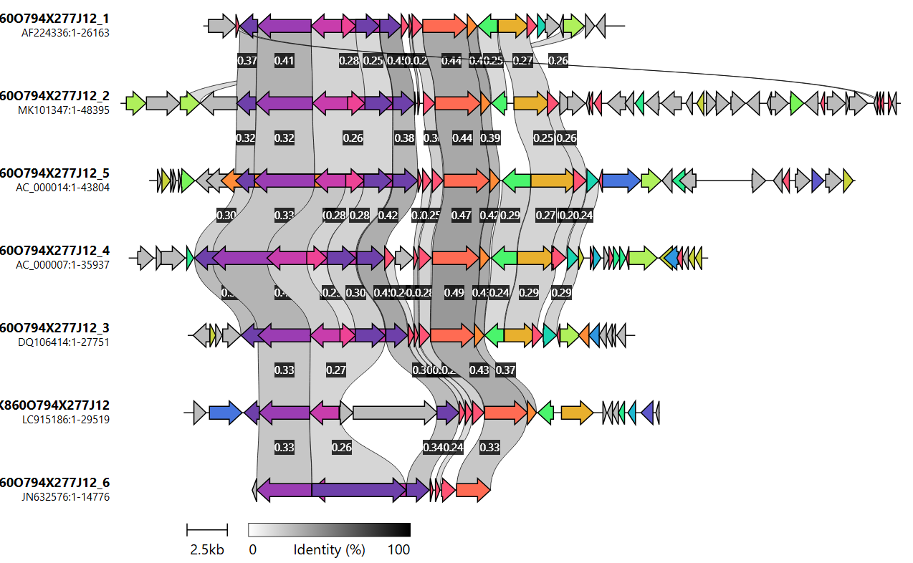
fib1 fib2
fiber
IVa2 pol pTP 52K III pX pVI prot 100K pVIII fiber
100K
fiber
red-eared slider
(partial)
Testadenovirus
red seabream
“Piscadenovirus”
snake-1
Barthadenovirus
human-2
Mastadenovirus
fowl-1
Aviadenovirus
pIIIa pVII hexon DBP 33K U-exon
frog-1
Siadenovirus
white sturgeon
Ichtadenovirus

Fig. 1. The different genome organization of the red seabream adenovirus compared to those of representative members of the other genera. (Testadenovirus is represented by a partial genome.) Clinker; the grey color scale indicates the degree of identity of automatically identified homologs; the colors show proteins found to be homologous by the program (Gilchrist and Chooi, 2021; https://cagecat.bioinformatics.nl/tools/clinker). The fiber gene is on the left end of the red seabream adenovirus genome, but no homologs were identified upstream of IVa2 and downstream of 100K. Minimum alignment sequence identity: 0.20. Identity threshold for the figure: 0.23.

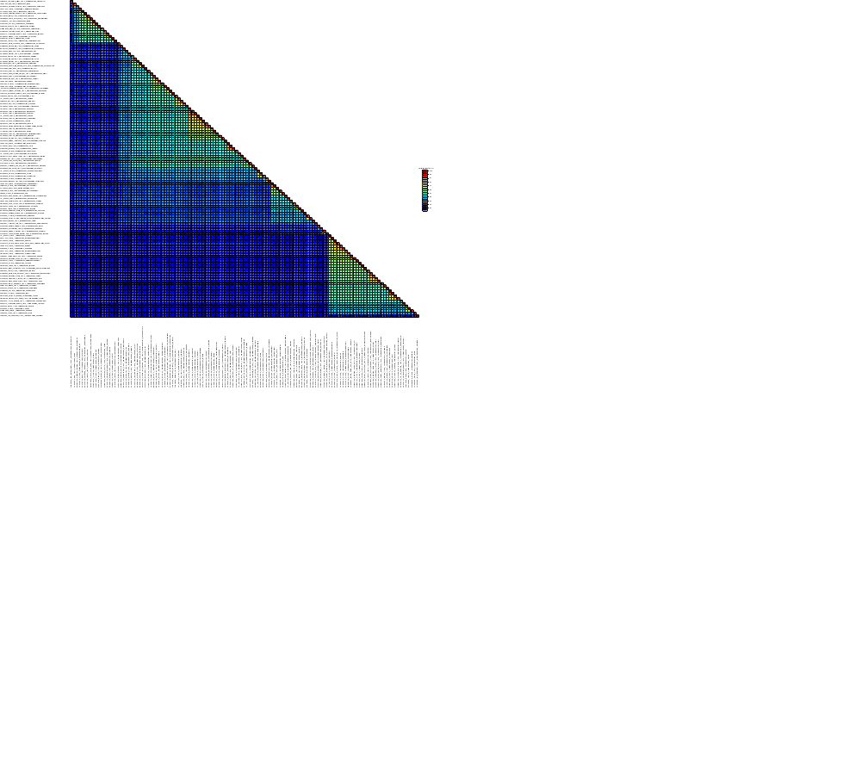

Fig. 2. Pairwise comparison of the DNA polymerase amino acid sequences of selected representatives of the different official or proposed (in quotations) AdV species. The red seabream AdV is clearly different from all other AdVs showing less than 40% identity. Sequence demarcation tool v1.3 (Muhire et al., 2014). Alignment: Muscle. Full color mode.

A
"Piscadenovirus"
LC915186 red seabream “Piscadenovirus sparidae”
Testadenovirus
JN632576 red eared slider adenovirus 1 Testadenovirus trachemysi
Ichtadenovirus
MK101347 white sturgeon adenovirus 1 Ichtadenovirus acipenseris
AF224336 frog adenovirus 1 Siadenovirus ranae
PQ083072 Sulawesi tortoise adenovirus 1 Chinese soft shelled turtle Siadenovirus sulawense
FJ849795 great tit adenovirus 1 Siadenovirus paridae
MW508338 great tit adenovirus 3 Siadenovirus carbocapituli
PP999621 pigeon adenovirus 4 Siadenovirus columbae
MN480433 common murre adenovirus 1 Siadenovirus uriae
PX216771 Hudsonian godwit adenovirus 2 “Siadenovirus limosae”
HM585353 South Polar skua adenovirus 1 Siadenovirus stercoraciidae
EU715130 raptor adenovirus 1 Siadenovirus raptoris
MK695679 psittacine adenovirus 5 Siadenovirus viridis
MK227353 psittacine adenovirus 7 Siadenovirus sanguineae
KP144329 chinstrap penguin adenovirus 2 Siadenovirus spheniscidae
PV175342 quail adenovirus 1 Siadenovirus coturnicis
AF074946 turkey adenovirus 3 “
PX870635 raptor adenovirus 4 “Siadenovirus milvi”
MZ562791 psittacine adenovirus 2 Siadenovirus cinerei
Siadenovirus
LC469780 crane adenovirus 1 Aviadenovirus gruis
JF510462 goose adenovirus 4 Aviadenovirus anseris
MW380865 duck adenovirus 5 Aviadenovirus anatidae
KJ469653 duck adenovirus 2 Aviadenovirus anatis
PX216770 Hudsonian godwit adenovirus 1 “Aviadenovirus limosae”
PX870632 Adélie penguin adenovirus 1 “Aviadenovirus spheniscidae”
MZ819701 black naped oriole adenovirus Aviadenovirus orioli
MT138100 Naumann s thrush adenovirus 1 Aviadenovirus turdi
MT138099 Eurasian siskin adenovirus 2 Aviadenovirus spinus
MN153802 white eyed parakeet adenovirus 2 Aviadenovirus leucophthalmi
ON642334 tawny frogmouth Aviadenovirus podargidae
KX121164 pigeon adenovirus 2 Aviadenovirus columbidae
FN824512 pigeon adenovirus 1 Aviadenovirus columbae
PX870634 raptor adenovirus 3 “Aviadenovirus raptoris”
OR871655 psittacine adenovirus 12 lovebird Aviadenovirus roseae
OR096706 Timneh grey parrot adenovirus 1 Aviadenovirus cinerei
MH580295 psittacine adenovirus 1 Aviadenovirus senegalense
KX577802 psittacine adenovirus 4 Aviadenovirus rubri
ON843719 Eurasian scops owl adenovirus 1 Aviadenovirus oti
LC638697 Indian eagle owl adenovirus 1 Aviadenovirus bubonis
GU936707 turkey adenovirus 1 “”
HE608152 fowl adenovirus 4 Aviadenovirus hydropericardii
MK757473 duck adenovirus 6 Cherry valley Pekin duck Aviadenovirus cerasi
KC493646 fowl adenovirus 5 Aviadenovirus quintum
KF477312 turkey adenovirus 4 “
AF083975 fowl adenovirus 9 Aviadenovirus gallinae
KT862808 fowl adenovirus 6 Aviadenovirus hepatitidis
AC 000014 fowl adenovirus 1 Aviadenovirus ventriculi
KF477313 turkey adenovirus 5 “
MT138102 white backed woodpecker adenovirus
OM367996 falcon adenovirus 1 American kestrel Aviadenovirus falconis
OR529407 great cormorant adenovirus Aviadenovirus phalacrocoracidae
Aviadenovirus
OQ986611 grey warbler adenovirus 1 Barthadenovirus gerygones
MT674683 eastern spinebill adenovirus 1 Barthadenovirus mellis
MT138097 pine grosbeak adenovirus
MT138103 Radde s warbler adenovirus 1 Barthadenovirus schwarzi
MT138101 yellow browed warbler adenovirus 1 Barthadenovirus inornati
PX870867 Antarctic tern adenovirus “Barthadenovirus antarcticaense”
BK066675 varanus adenovirus Barthadenovirus varani
MT050041 bearded dragon adenovirus 1 Barthadenovirus draconis
BK066448 viviparous lizard adenovirus 1 Barthadenovirus zootocae
KJ156523 lizard adenovirus 2 Barthadenovirus lacertae
DQ106414 snake adenovirus 1 Barthadenovirus serpentis
OQ792214 agile wallaby adenovirus 1 Barthadenovirus macropodidae
KY748210 deer adenovirus 1 Barthadenovirus cervi
AF036092 bovine adenovirus 4 “
JQ345700 bovine adenovirus 6 “
U40839 ovine adenovirus 7 Barthadenovirus ovis
LC597488 bovine adenovirus 7 “
MT138098 psittacine adenovirus 11 blue throated macaw Barthadenovirus caerulei
MN025529 white eyed parakeet adenovirus 1 Barthadenovirus amazonae
KJ675568 psittacine adenovirus 3 Barthadenovirus amazonae
AC 000004 duck adenovirus 1 Barthadenovirus galloanserae
OL692338 common tern adenovirus 1 Barthadenovirus sternae
OR233592 scaly thrush adenovirus Barthadenovirus zootherae
Barthadenovirus
Mastadenovirus
100
99
100
100
92
99
100
92
97
100
98
99
100
16
10
94
78
95
98
84
99
100
97
65
100
100
96
99
100
95
100
100
91
96
100
97
91
99
100
23
24
98
39
65
95
67
48
64
81
97
96
100
100
84
100
99
75
99
100
93
100
99
99
77
98
100
100
86
19
98
100
99
99
100
0.10
MN733730 duck adenovirus 4 Aviadenovirus cairinae
B
"Piscadenovirus"
LC915186 red seabream “Piscadenovirus sparidae”
Testadenovirus
JN632576 red eared slider adenovirus 1 Testadenovirus trachemysi
Ichtadenovirus
MK101347 white sturgeon adenovirus 1 Ichtadenovirus acipenseris
Siadenovirus
Aviadenovirus
Barthadenovirus
MN986926 Guinea pig adenovirus 1 Mastadenovirus caviae
BK067721 kangaroorat adenovirus 1 Mastadenovirus dipodomysis
PP098962 marmot adenovirus 2 ”Mastadenovirus caudatae”
PV872404 black rat adenovirus 2 ”Mastadenovirus atri”
PQ855829 treeshrew adenovirus 2 ”Mastadenovirus belangeri”
PQ490628 murine adenovirus 4 Mastadenovirus mastomysis
AC_000012 murine adenovirus 1 Mastadenovirus encephalomyelitidis
EU835513 murine adenovirus 3 Mastadenovirus cordis
PQ678060 tanezumi rat adenovirus 1 Mastadenovirus rattasiense
HM049560 murine adenovirus 2 Mastadenovirus muris
KT160425 equine adenovirus 2 Mastadenovirus equidae
KY427939 red squirrel adenovirus 1 Mastadenovirus sciuri
PP098964 marmot adenovirus 1 Mastadenovirus marmotae
PP098963 marmot adenovirus 3
BK066403 vole adenovirus 1 Mastadenovirus arvicolinae
PQ678115 Kachin red backed vole adenovirus Mastadenovirus eothenomysis
PQ576919 garden dormouse adenovirus Mastadenovirus eliomysis
LT841149 bottlenose dolphin adenovirus 1 Mastadenovirus delphini
KY352473 harbour porpoise adenovirus 1 Mastadenovirus phocoenae
KR024710 bottlenose dolphin adenovirus 2 Mastadenovirus delphinidae
AF289262 porcine adenovirus 5 ””
AF252854 bovine adenovirus 2 Mastadenovirus bovidae
PX277336 bovine adenovirus 11 ”Mastadenovirus bovisundecimum”
BD269513 bovine adenovirus 1 ””
BK066828 roe deer adenovirus 2 Mastadenovirus capreoli
PV383552 bat adenovirus F45 Mastadenovirus portugalense
OR998961 Himalayan whiskered bat adenovirus 1 Mastadenovirus himalaiense
BK066631 bat adenovirus 33390 Mastadenovirus vespertilionis
MK472072 Gould's wattled bat adenovirus Mastadenovirus chalinolobi
PP297886 common noctule adenovirus Quixote Mastadenovirus noctulae
PP410068 Kuhl's pipistrelle adenovirus MAG44 Mastadenovirus kuhlii
BK066905 vampire bat adenovirus Mastadenovirus desmodi
PP711818 heartnosed bat adenovirus Mastadenovirus cardiodermatis
PP711819 Hildegarde's tomb bat adenovirus
JN418926 equine adenovirus 1 Mastadenovirus equi
KP238322 skunk adenovirus 1 Mastadenovirus trianonense
GU226970 bat adenovirus 3 Mastadenovirus musauriti
KX961095 bat adenovirus 9 WIV17 Mastadenovirus pteropodidae
JN252129 bat adenovirus 2 Mastadenovirus pipistrelli
AC_000003 canine adenovirus 1 Mastadenovirus canidae
LC385827 Asian particolored bat adenovirus Vs9 Mastadenovirus asiense
AC_000190 treeshrew adenovirus 1 Mastadenovirus tupaiae
KT698853 bat adenovirus 4 WIV9 Mastadenovirus rhinolophidae
PP410069 greater horseshoe bat adenovirus MAG47 Mastadenovirus ferrumequini
OQ081771 grey mouse lemur adenovirus Mastadenovirus lamiae
KJ563221 California sea lion adenovirus 1 Mastadenovirus otariidae
MK774519 porcine adenovirus 4 ””
ON217544 bovine adenovirus 10 ””
OR998962 Leschenault's_rousette adenovirus Mastadenovirus fructus
MF773580 polar bear adenovirus 1 Mastadenovirus ursi
OR998830 intermediate roundleaf bat adenovirus
OR998870 greater bamboo bat adenovirus 1 Mastadenovirus arundinis
OR998808 lesser bamboo bat adenovirus1
AP018374 straw colored fruit bat adenovirus Mastadenovirus_eidoli
KX961095 bat adenovirus 9 WIV17 Mastadenovirus pteropodidae
MG551742 Egyptian fruit bat adenovirus Mastadenovirus aegyptiaci
KT698856 bat adenovirus 7 WIV12 Mastadenovirus miniopteridae
KT698852 bat adenovirus 8 WIV13 Mastadenovirus humile
AC_000189 porcine adenovirus 3 “”
MK518392 ovine adenovirus 8 Mastadenovirus ovisoctavum
AF030154 bovine adenovirus 3 ””
MZ507556 reindeer adenovirus Mastadenovirus tarandri
KY306667 deer adenovirus 2 Mastadenovirus cervi
HQ913600 titi monkey adenovirus 1 Mastadenovirus simuli
MN017133 squirrel monkey adenovirus 1 Mastadenovirus simuli
PP985428 simian adenovirus 58 black and white colobus Mastadenovirus pollicis
KX505867 simian adenovirus 55 golden snub nosed monkey Mastadenovirus flavi
AY598782 simian adenovirus 3 rhesus Mastadenovirus simiae
HQ605912 simian adenovirus 20 grivet “”
KP329563 simian adenovirus 13 macaque Mastadenovirus macacae
KM190146 simian adenovirus 54 rhesus 23336 Mastadenovirus rhesi
KP329564 simian adenovirus 16 grivet Mastadenovirus alienum
KP329561 simian adenovirus 8 cynomolgus monkey Mastadenovirus longumcaudae
PQ490717 simian adenovirus 64 gelada baboon Mastadenovirus sanguineicordis
PQ490713 simian adenovirus 65 gelada baboon Mastadenovirus geladae
KP329566 simian adenovirus 17 grivet Mastadenovirus chlorocebi
L19443 human adenovirus 40 Mastadenovirus faecale
DQ923122 human adenovirus 52 Mastadenovirus russelli
KP329565 simian adenovirus 19 yellow baboon Mastadenovirus cynocephali
PQ490709 simian adenovirus 60 gelada baboon Mastadenovirus bestiae
PQ490710 simian adenovirus 61 gelada baboon Mastadenovirus aethiopiense
GU191019 human adenovirus 18 Mastadenovirus adami
AC 000008 human adenovirus 5 Mastadenovirus ceasari
OP921948 simian adenovirus 57 gibbon Mastadenovirus hylobatidae
AB448767 human adenovirus 8 Mastadenovirus dominans
AY487947 human adenovirus 4 Mastadenovirus exoticum
DQ086466 human adenovirus 3 Mastadenovirus blackbeardi
Mastadenovirus
100
100
86
19
98
100
98
100
97
85
100
100
100
54
93
100
58
96
99
99
93
100
99
86
99
44
91
82
100
99
63
100
100
92
98
100
91
99
97
99
100
100
100
37
81
99
100
46
98
24
97
99
97
99
0
91
95
100
83
100
86
91
70
49
100
100
100
99
99
99
100
0
42
75
97
84
84
100
85
99
100
99
96
100
89
100
80
92
96
64
100
99
99
0.10
Fig. 3. Phylogenetic tree of representative members of accepted and proposed adenovirid species based on complete DNA-dependent DNA polymerase amino acid sequences. A: the cluster Mastadenovirus is collapsed for clarity, B: the other genera are collapsed. Official species are designated by colored dots, proposed species are signed by colored circles and emphasized in red letters. Viruses with no complete genome (but complete polymerase gene) are shown without dots or circle signs. The species names in blue are those with proposed minor corrections in the Latin declension. Multiple alignment: MultAlin; manual edition: BioEdit 7.2.5 (the length of the edited alignment was 1006 amino acids), model selection: ProtTest 2.4; maximum likelihood calculation: PhyML 3.1 with model LG+I+G and branch support Shimodaira-Hasegawa (SH) on the Galaxy/Pasteur platform. Unrooted calculation; the phylogenetic tree was visualized using MEGA11, red seabream adenovirus 1 was selected as outgroup for visualization. The bar indicates 10% difference between two neighboring sequences. SH branch support values are shown at the nodes. Viruses are represented by GenBank accession number, virus name (with type or strain designation, sometimes also with the actual host), and species name if available or proposed. The proposed genus and species names are in quotation marks.

